Linking the spatiotemporal distribution of static stress drops to source faults in a fluid-driven earthquake swarm, northeastern Noto Peninsula, central Japan

Mitsuteru Fukuoka¹, Yoshihiro Hiramatsu*², Takuji Yamada³

¹Graduate School of Natural Science and Technology, Kanazawa University, Kanazawa, 920-1192, Japan

²Faculty of Geosciences and Civil Engineering, Institute of Science and Engineering, Kanazawa University, Kanazawa 920-1192, Japan

³Faculty of Science, Graduate School of Science and Engineering, Ibaraki
University, Ibaraki 310‑8512, Japan

*Corresponding author (yoshizo@staff.kanazawa-u.ac.jp)

Contents:
Figure S1: (upper panels) Frequency distribution of the number of EGF earthquakes as a function of the distance between a EGF and a TEQ (a) of P-waves and (b) S-waves. (lower panels) Relationship between magnitude and $∆f_{CT}$ of (c) P-waves and (d) S-waves. $∆f_{CT}$ is the difference between the average $f_{CT}$ over EGFs and $∆f_{CT}$ of each EGF for a given TEQ.
Figure S2: Relationship between magnitude and static stress drop of different time windows for events on the source faults used in the analysis along the L1–3 profiles (upper panels) for P-waves and (lower panels) for S-waves.
Figure S3: Frequency distribution of the number of EGF earthquakes used for each TEQ.
Figure S4: Relationship between corner frequency and seismic moment.
Figure S5: Comparison of corner frequency between the Boatwright spectral model and Brune spectral model.
Figure S6: Relationship between source depth and static stress drop of events in cluster N.
Figure S7: Relationship between magnitude and static stress drop of events in cluster N.
Figure S8: Spatial distribution of static stress drop estimated from S-wave in vertical cross sections along the L1 and L3 profiles in the cluster N.
Figure S9: Temporal variation in static stress drop of events on each source fault in the L1–3 profiles.
Figure S10: Spatial distribution of static stress drop estimated from P-wave in vertical cross sections along the L1–3 profiles in the cluster N.
Figure S11: Comparison of the frequency distribution of static stress drop from P-wave analysis.
Figure S12: Comparison of the frequency distribution of static stress drop for a EGF selection radius of 0.5 km and 0.3 km.
Figure S13: Comparison of the frequency distribution of static stress drop estimated from EGFs with a magnitude difference of 1.0 and greater.
Figure S14: Comparison of the frequency distribution of static stress drop estimated from the Brune spectral model.
Figure S15: Temporal variation in static stress drop in the entire analyzed region.
Figure S16: Temporal variation in static stress drop in each cluster.

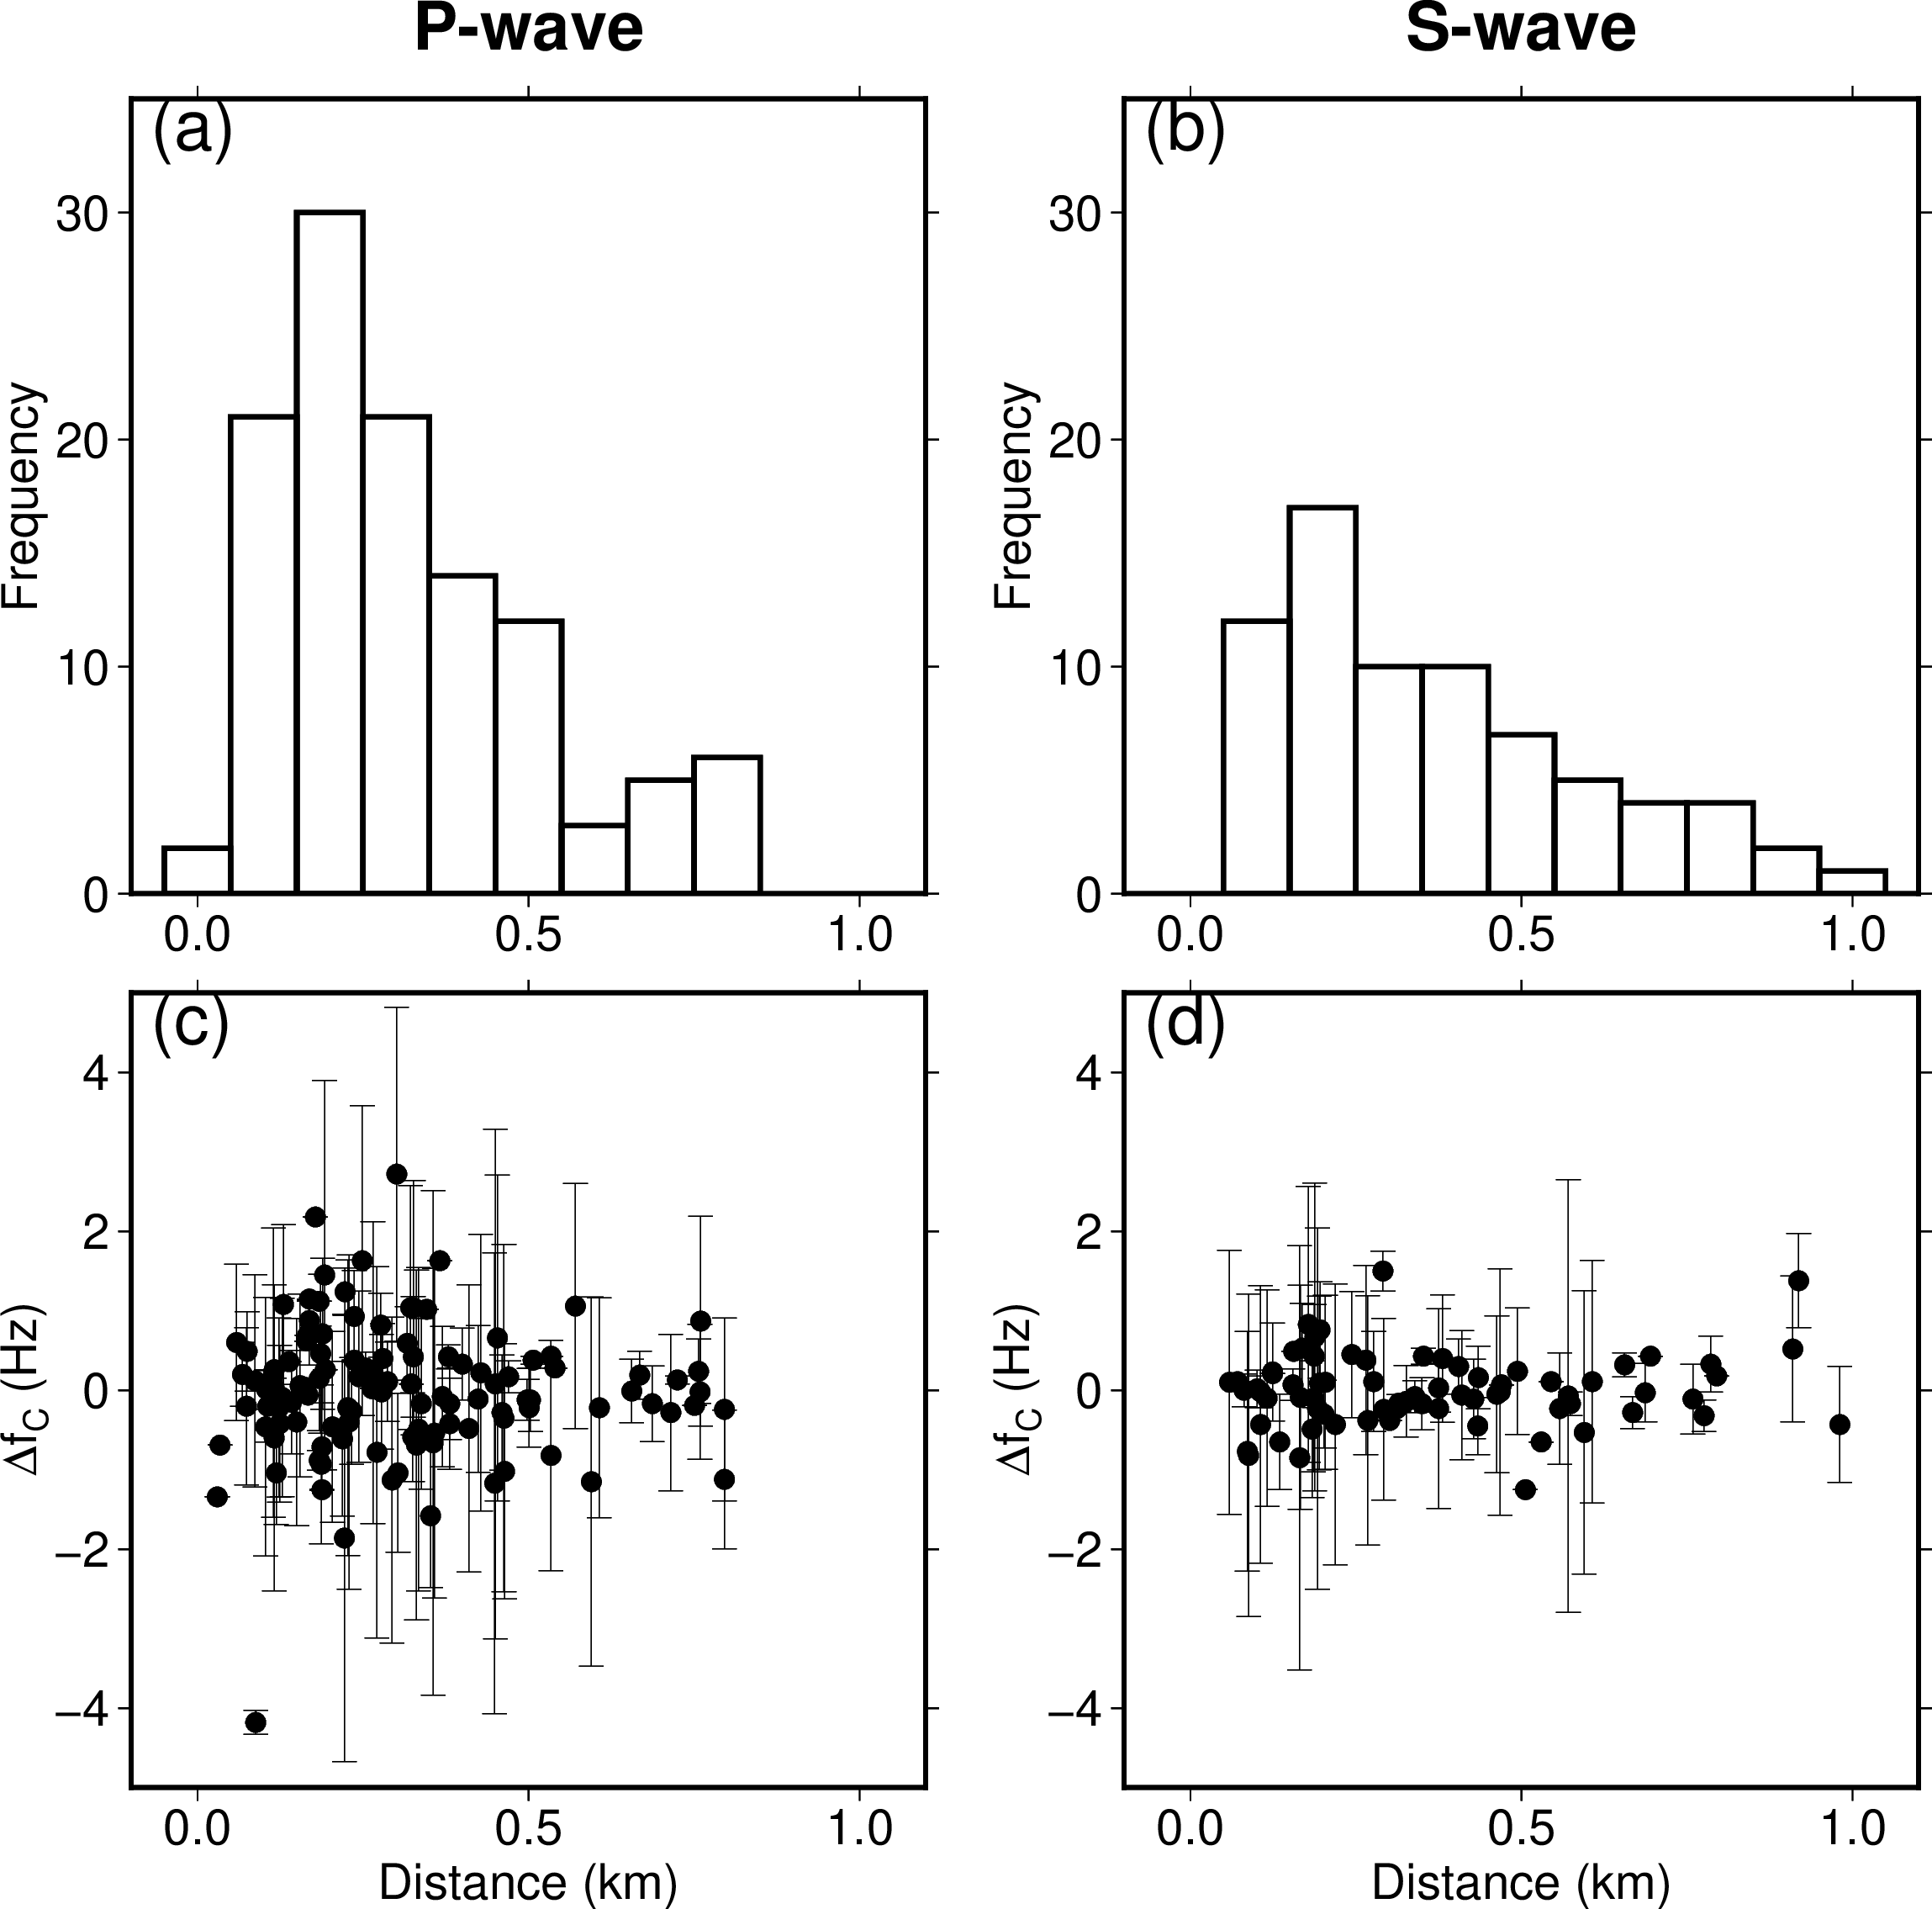

Figure S1: (upper panels) Frequency distribution of the number of EGF earthquakes as a function of the distance between a EGF and a TEQ of (a) P-waves and (b) S-waves. (lower panels) Relationship between magnitude and $∆f_{CT}$ of (c) P-waves and (d) S-waves. $∆f_{CT}$ is the difference between the average $f_{CT}$ over EGFs and $∆f_{CT}$ of each EGF for a given TEQ.

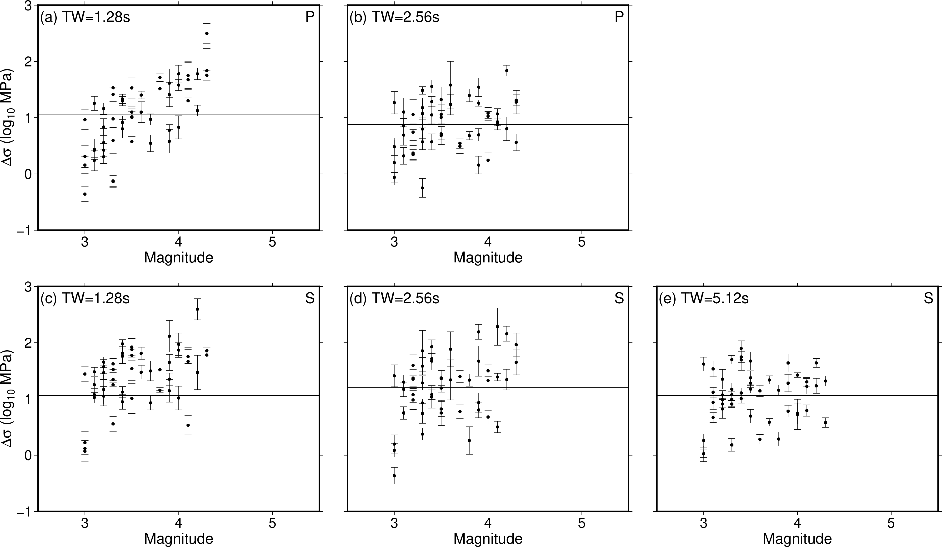

Figure S2: Relationship between magnitude and static stress drop of different time windows for events on the source faults used in the analysis along the L1, L2, and L3 profiles (upper panels) for P-waves and (lower panels) for S-waves.

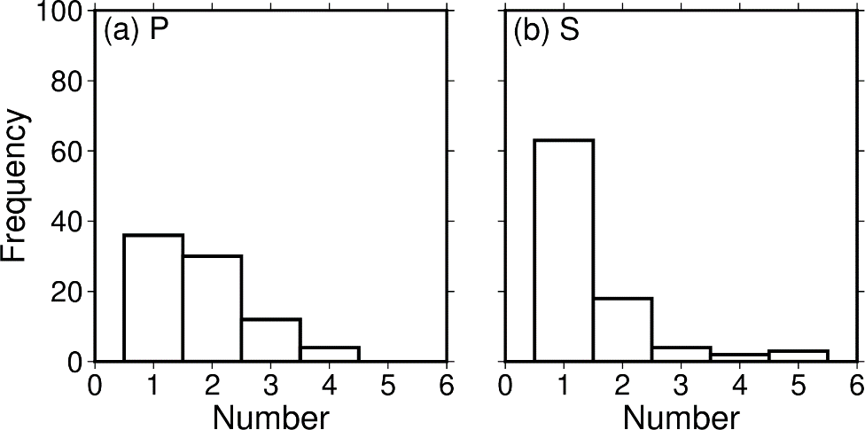
Fig. S3 Frequency distribution of the number of EGF earthquakes used for each target earthquake for (a) P-wave and (b) S-wave analyses.

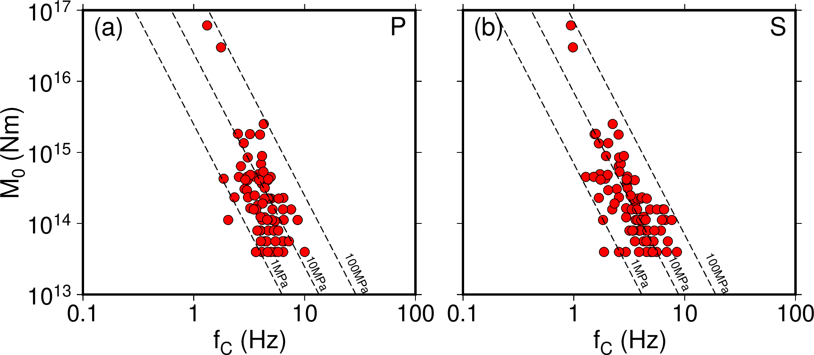

Fig. S4 Plots of the corner frequency versus the seismic moment for (a) P-waves and (b) S-waves. Dashed lines indicate constant static stress drops of 1, 10, and 100 MPa.

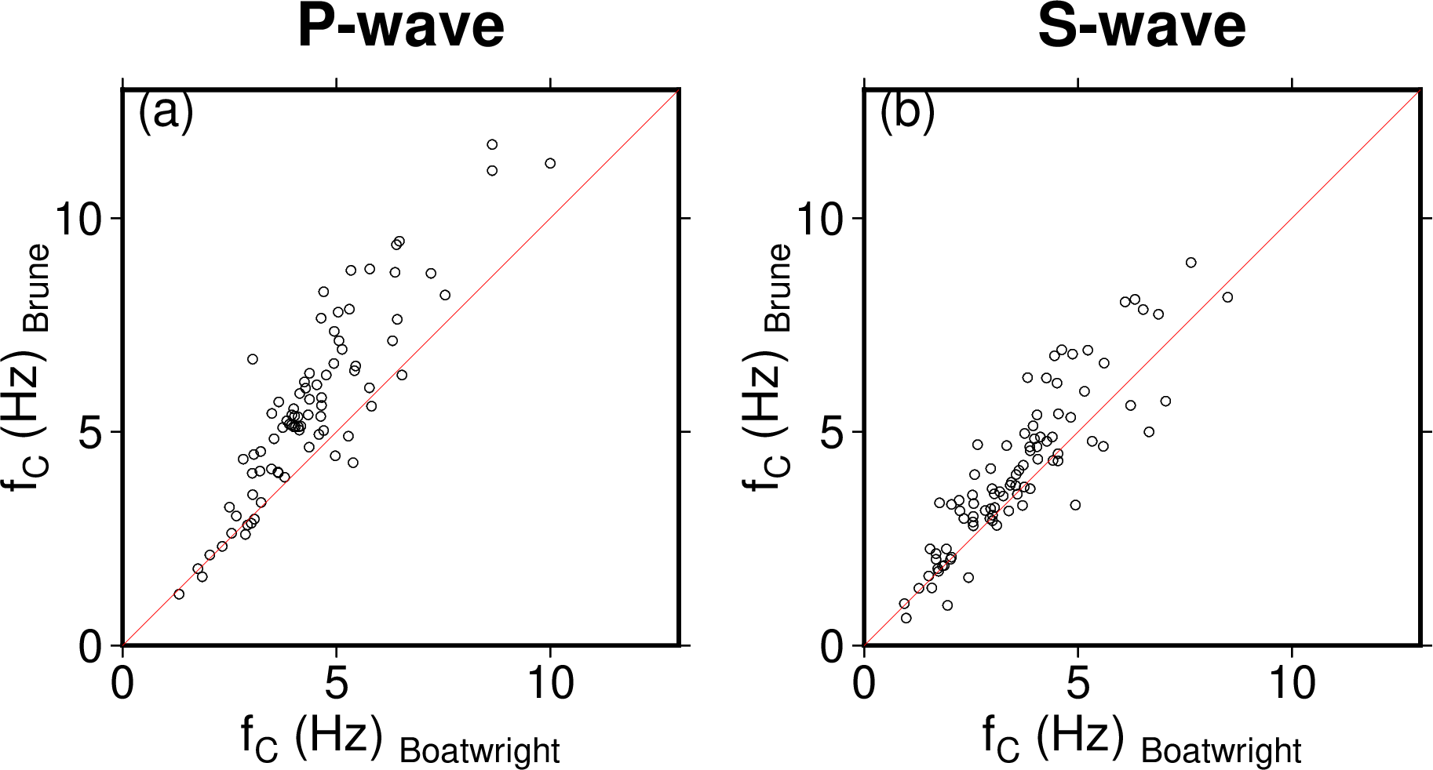

Figure S5: Comparison of corner frequency between the Boatwright spectral model and Brune spectral model.

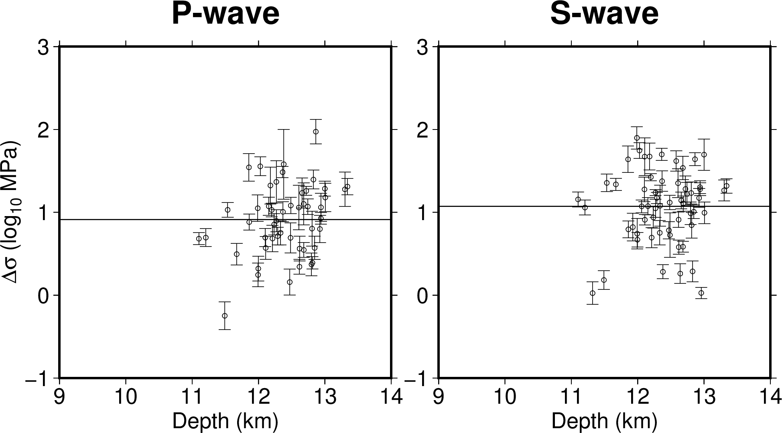

Figure S6: Relationship between source depth and static stress drop of events in cluster N.

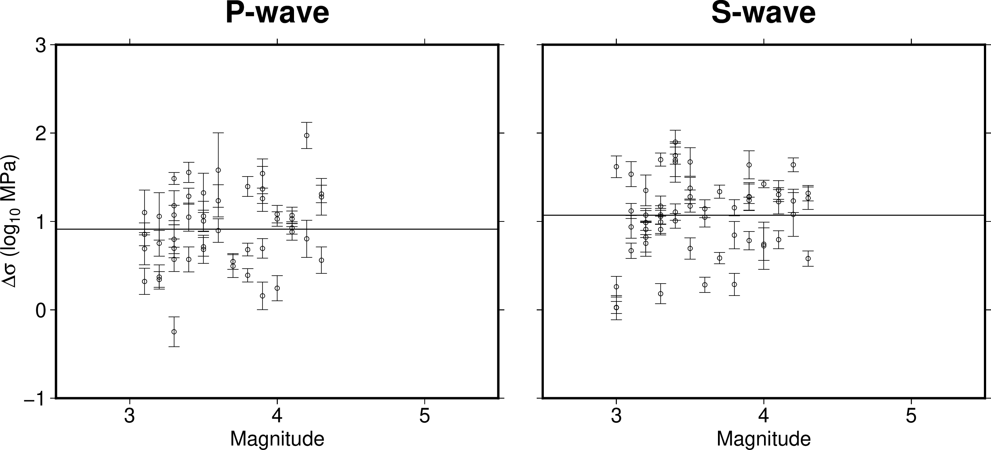

Figure S7: Relationship between magnitude and static stress drop of events in cluster N.

Fig. S8 The spatial distribution of static stress drops estimated from S-waves in vertical cross sections along profiles L1 and L3 in cluster N (Figs. 1b, 3). Symbols are as in Fig. 4.

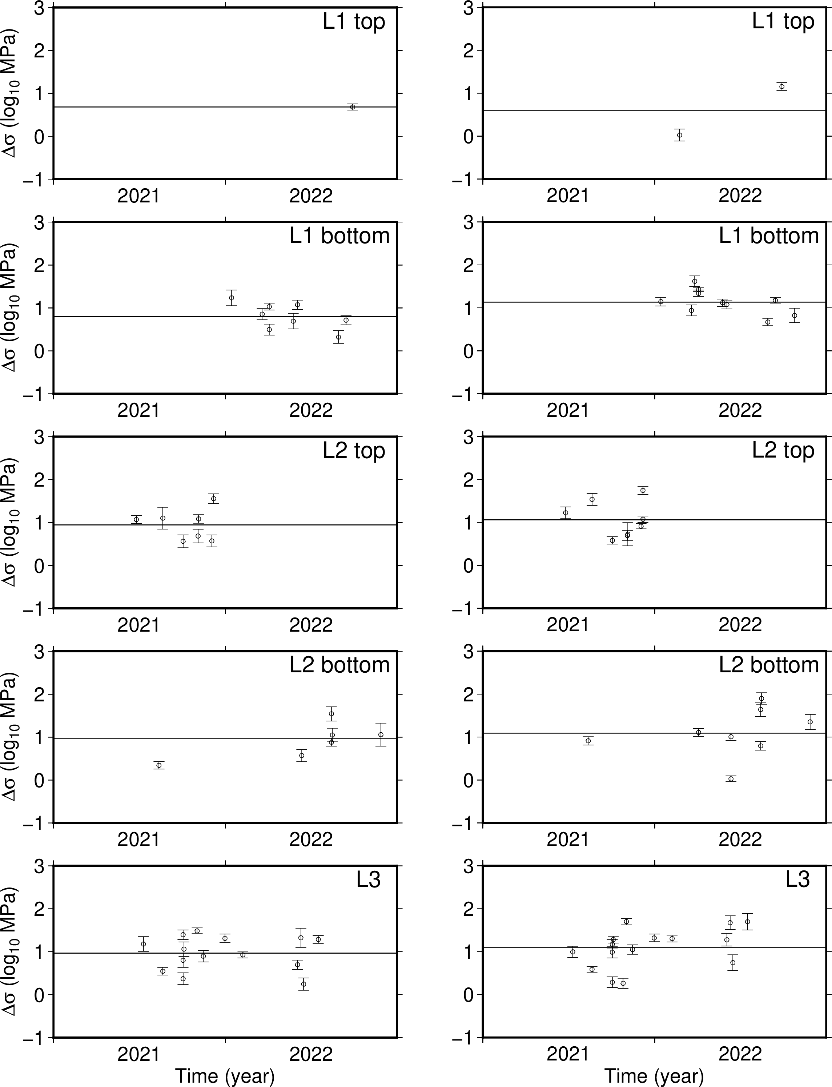

Figure S9: Temporal variation in static stress drop of events on each source fault along the L1, L2, and L3 profiles in cluster N.

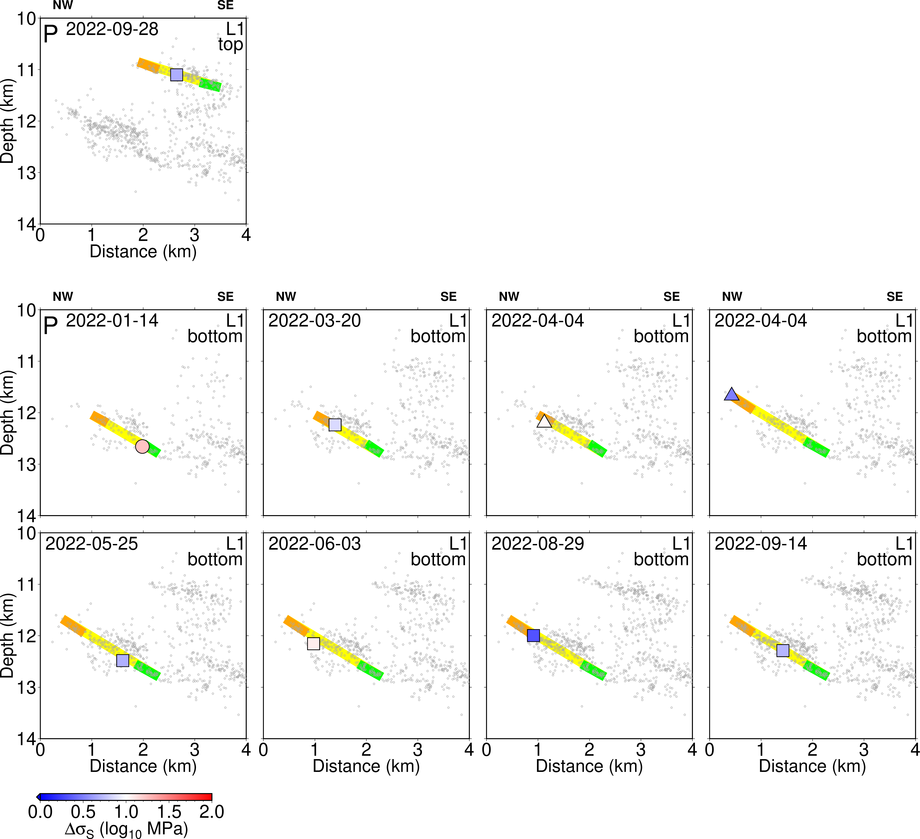

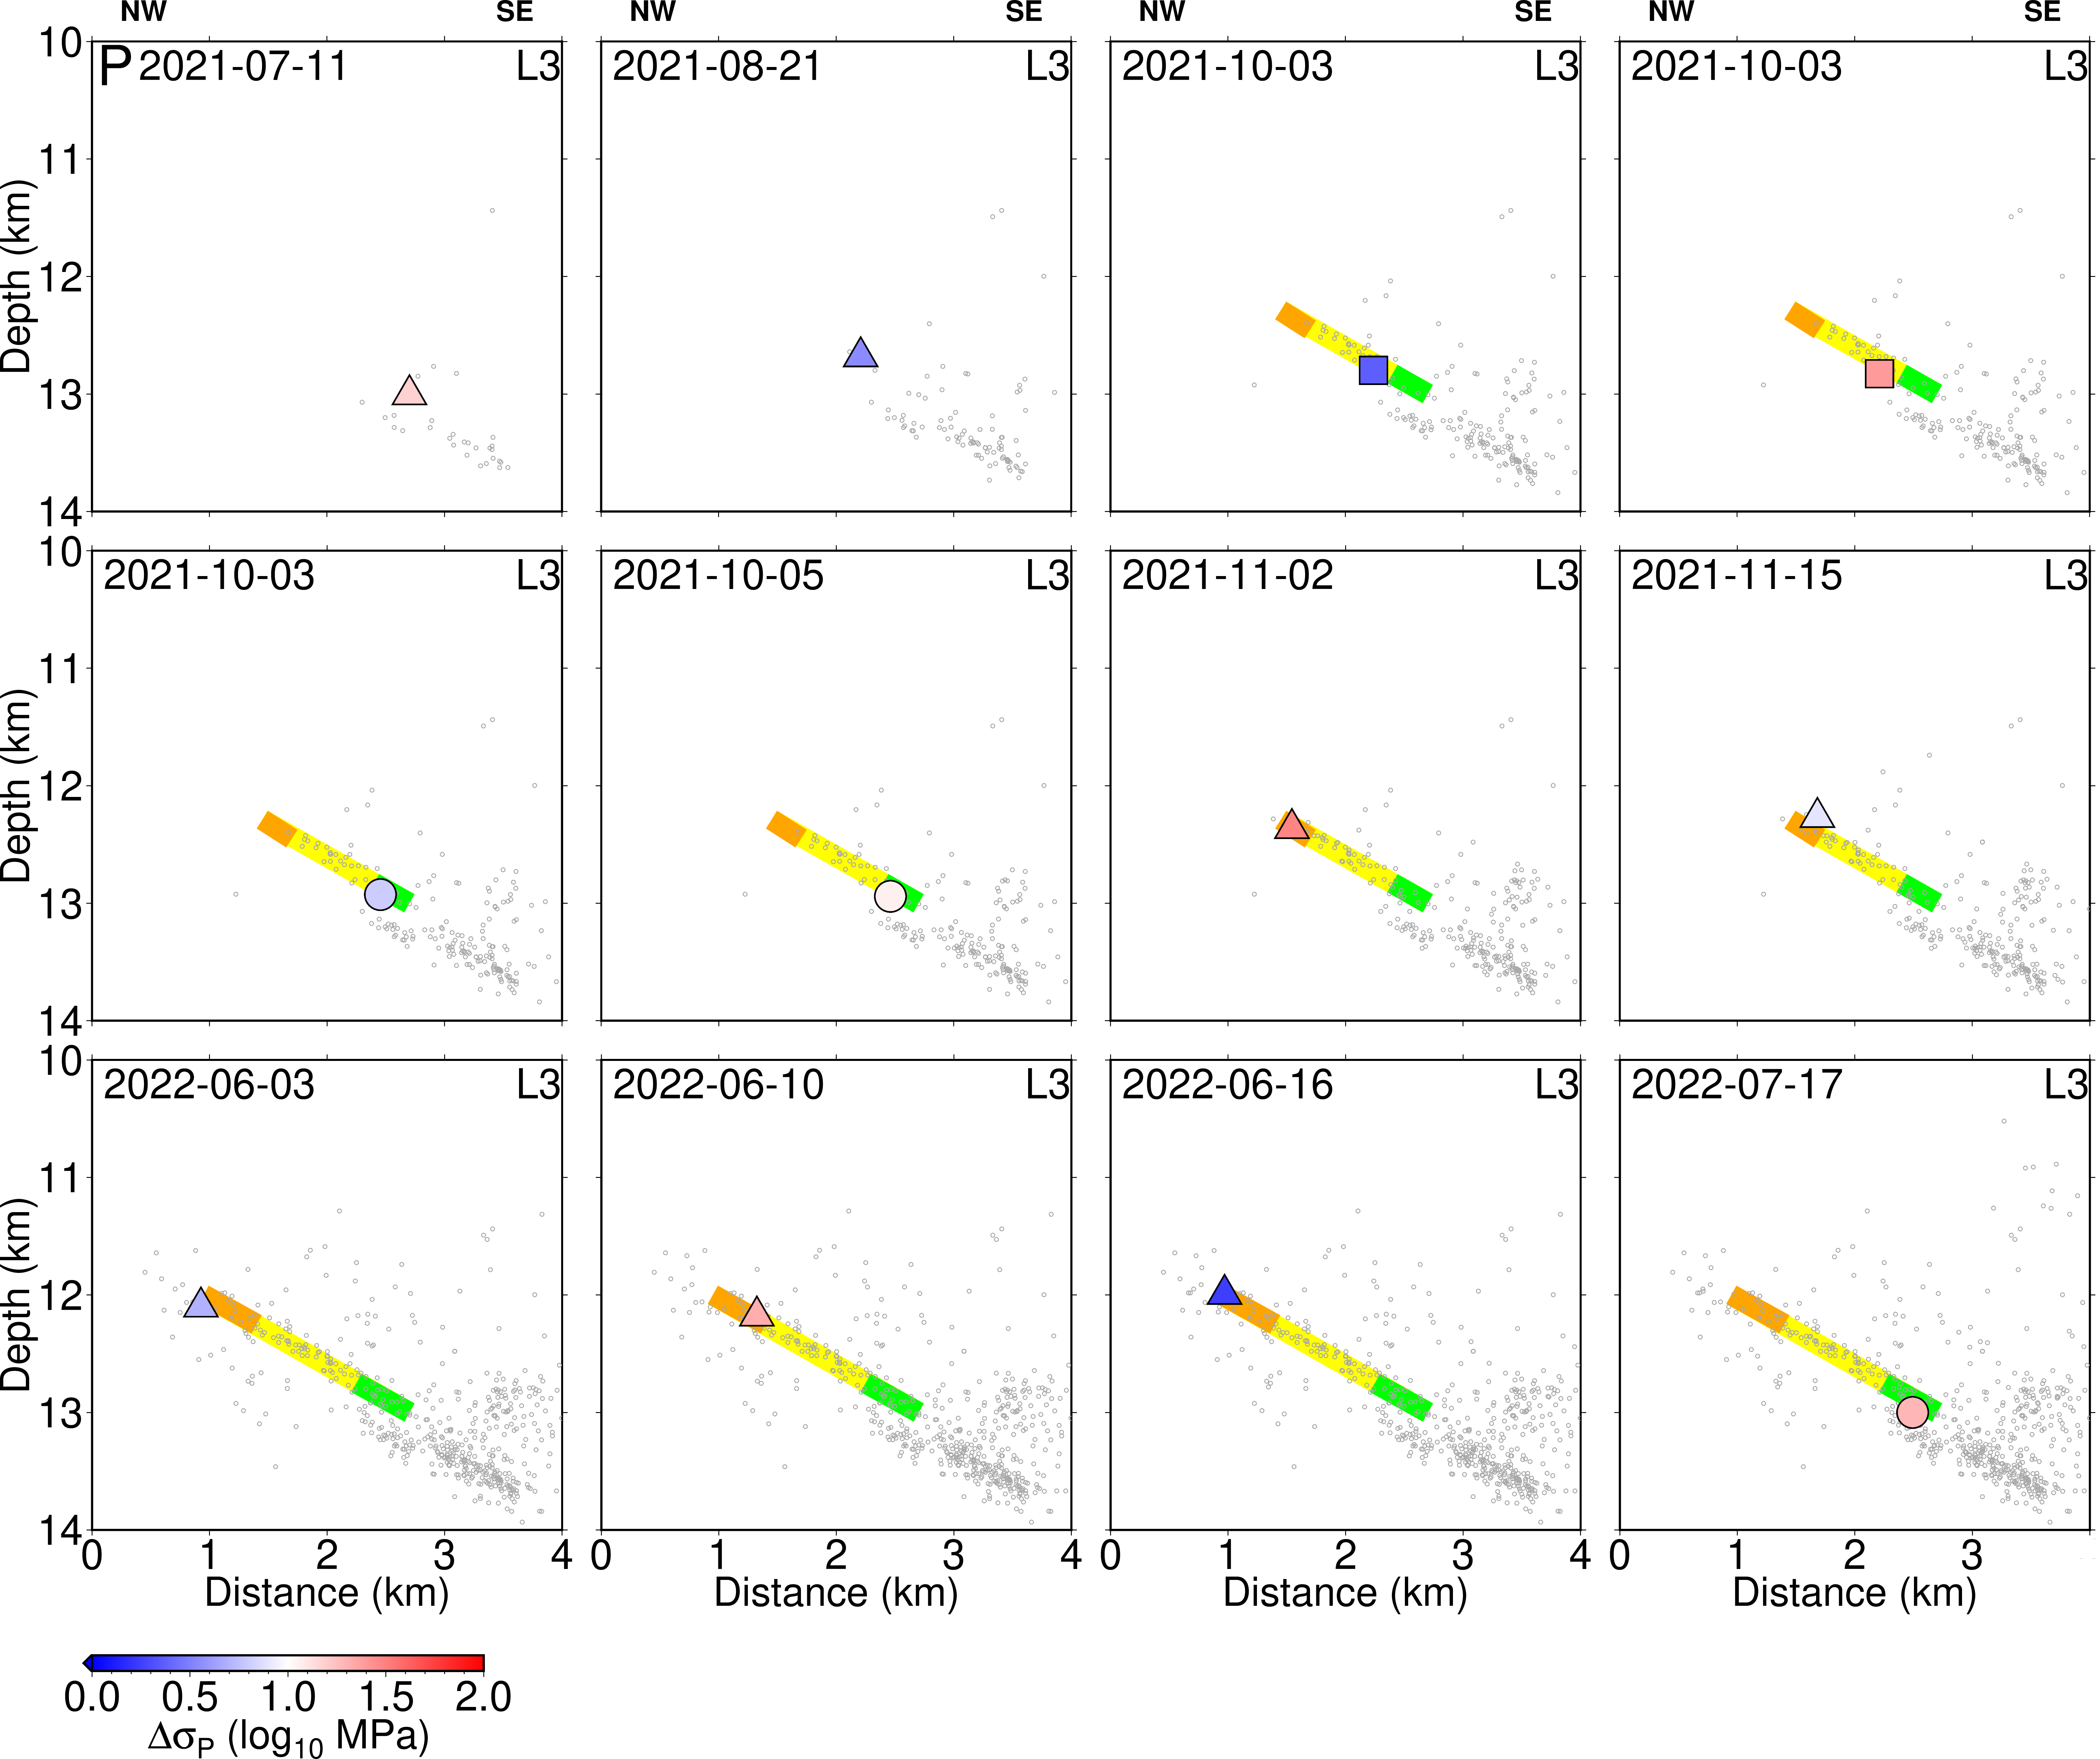

Fig. S10 The spatial distribution of static stress drops estimated from P-waves in vertical cross sections along the L1, L2, and L3 profiles in cluster N. Symbols are as in Fig. 4.

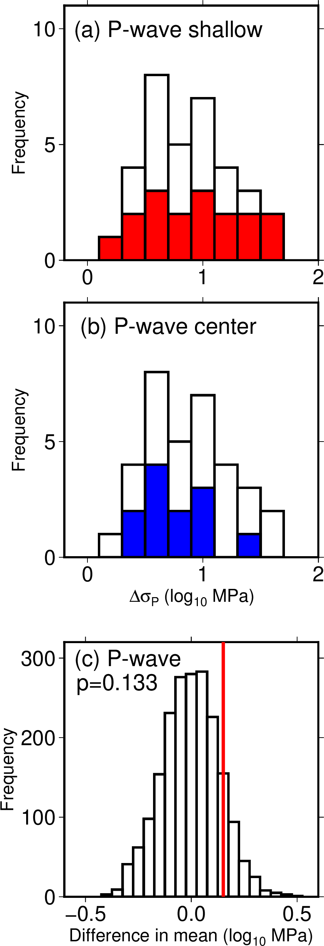

Fig. S11. Comparison of the frequency distributions of static stress drops estimated from our P-wave analysis for events on source faults along the L1, L2, and L3 profiles in cluster N. Colors are as in Fig. 5.

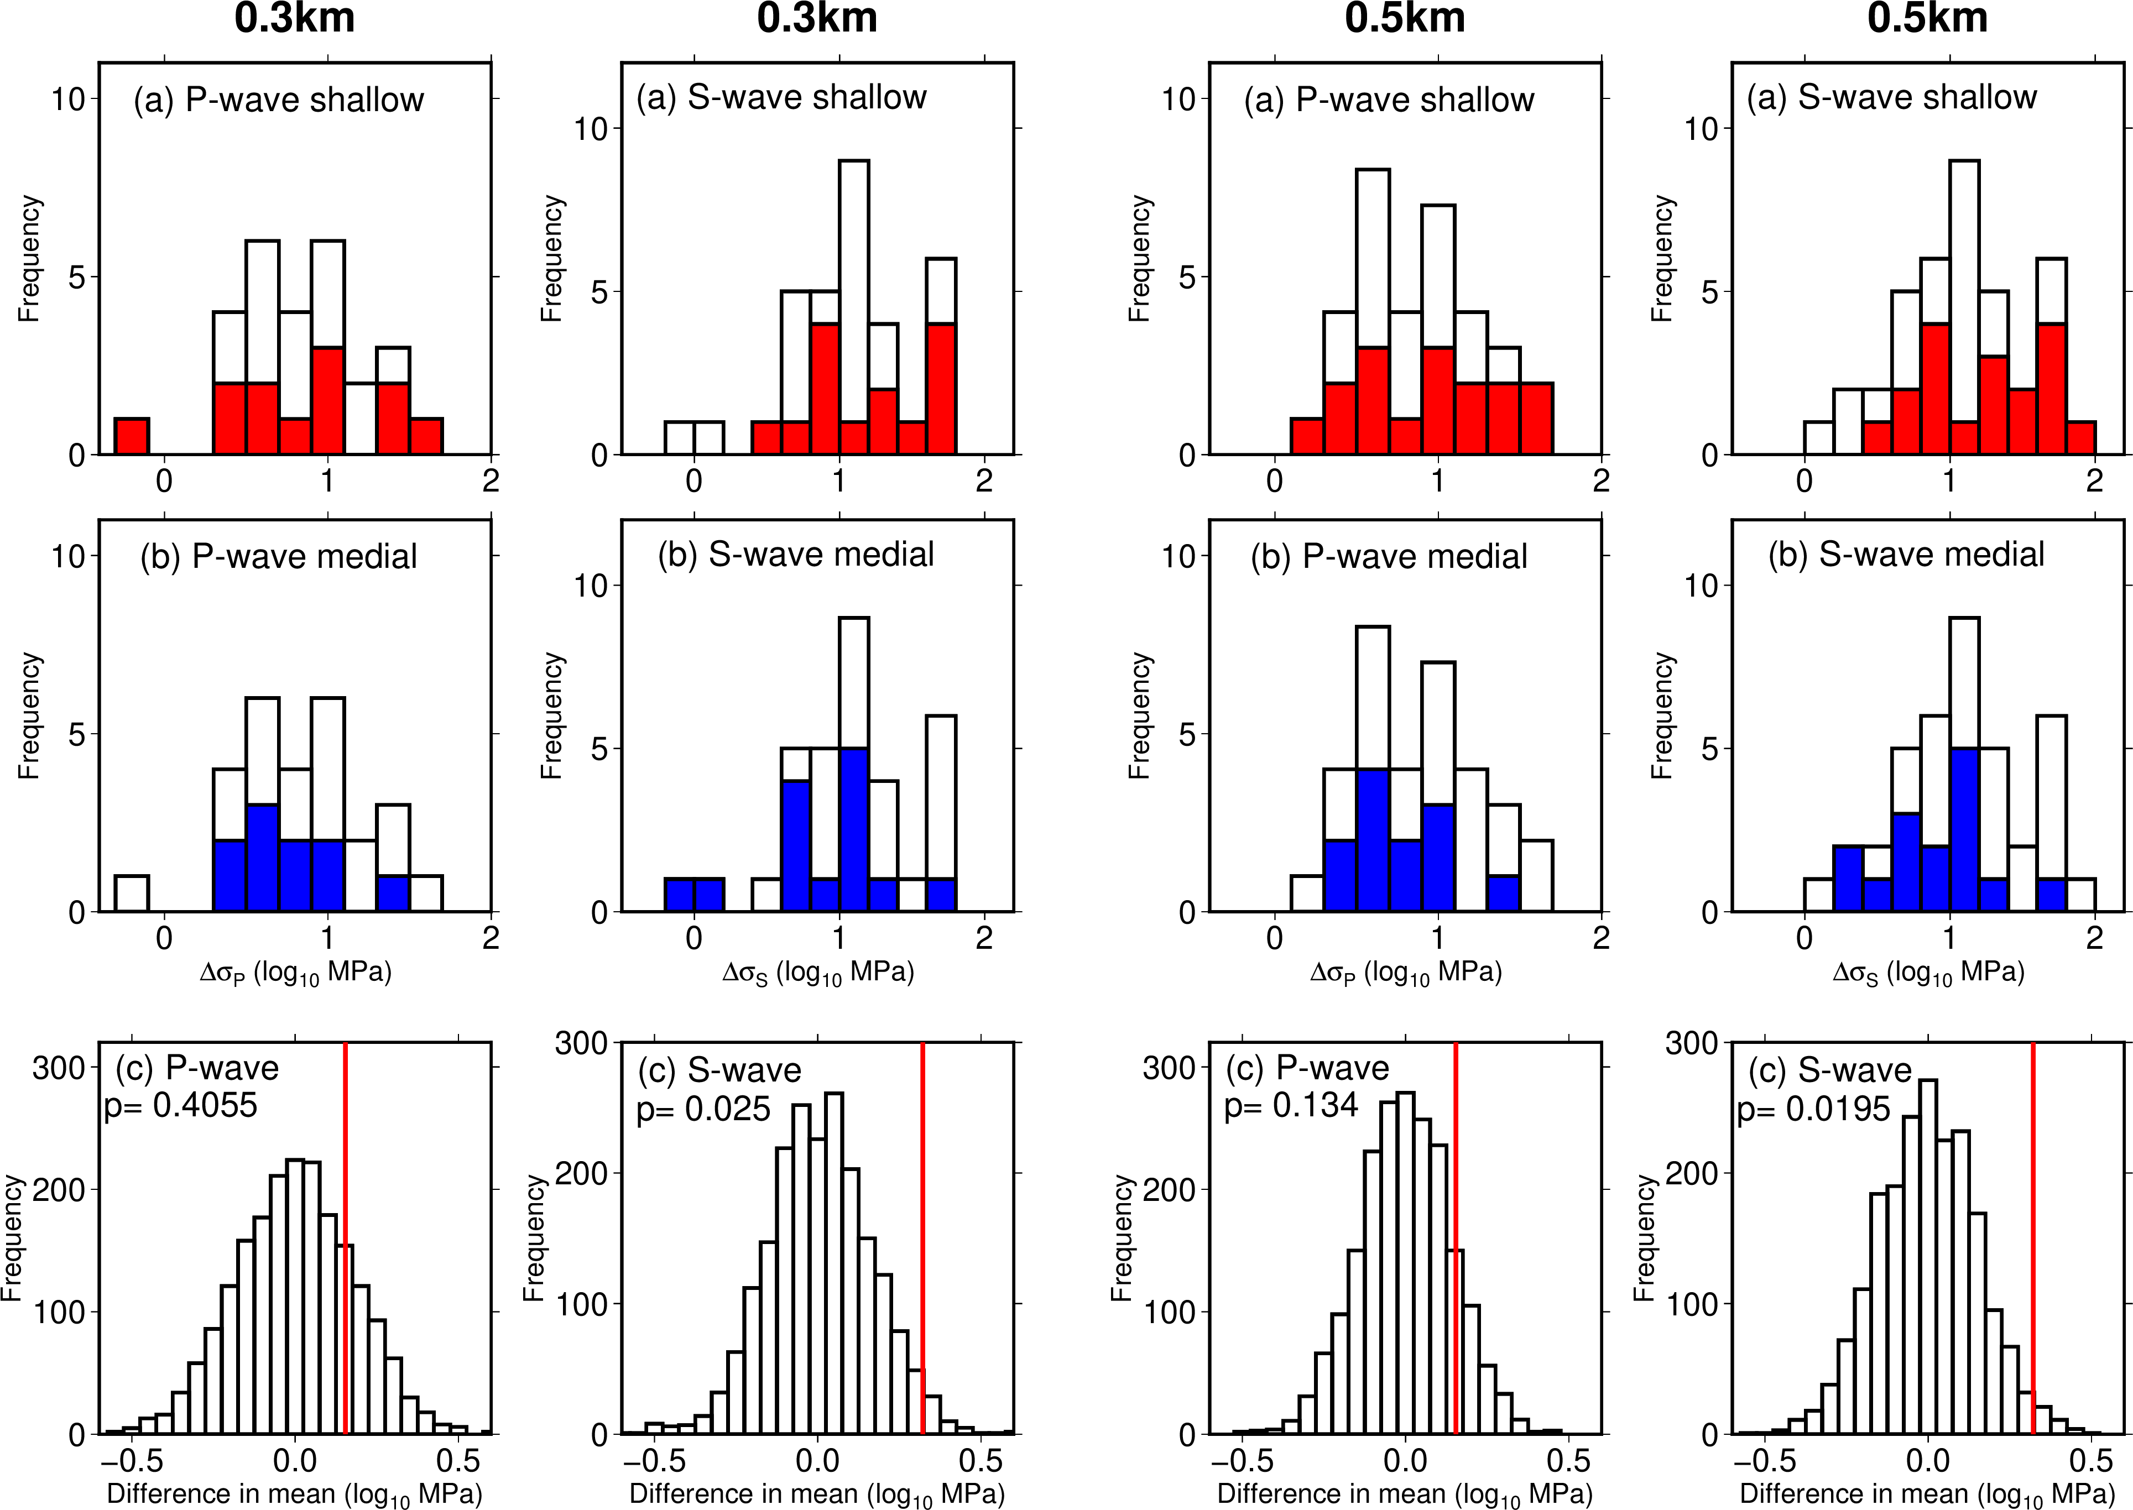

Figure S12: Comparison of the frequency distribution of static stress drop for a EGF selection radius of (left panels) 0.3 km and (right panels) 0.5 km for events on source faults along the L1, L2, and L3 profiles in cluster N. Colors are as in Fig. 5.

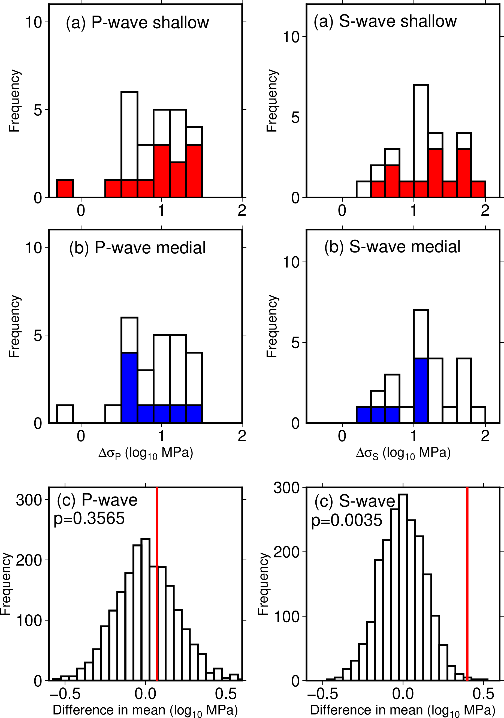

Figure S13: Comparison of the frequency distribution of static stress drop estimated from EGFs with a magnitude difference of 1.0 and greater for events on source faults along the L1, L2, and L3 profiles in cluster N. Colors are as in Fig. 5.

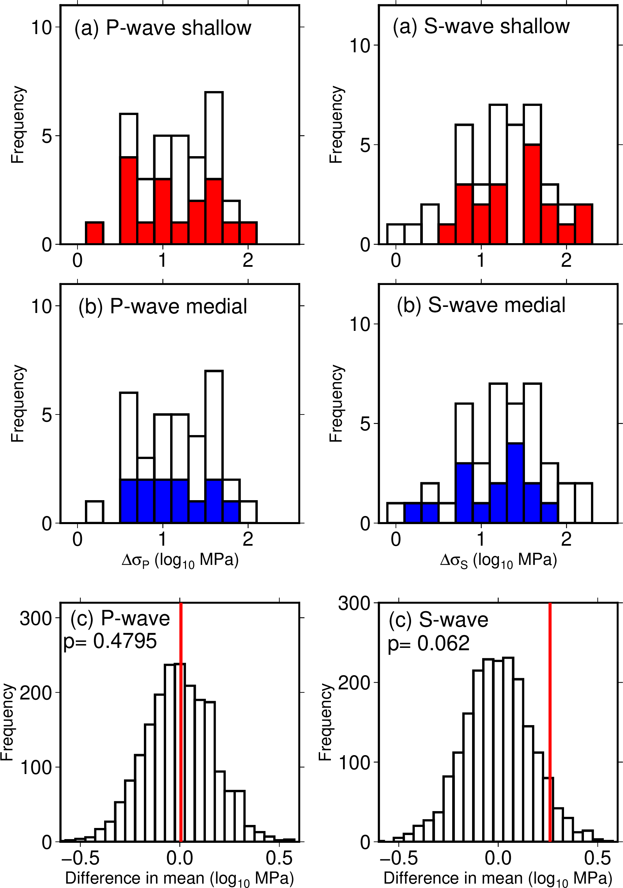

Figure S14: Comparison of the frequency distribution of static stress drop estimated from the Brune spectral model for events on source faults along the L1, L2, and L3 profiles in cluster N. Colors are as in Fig. 5.

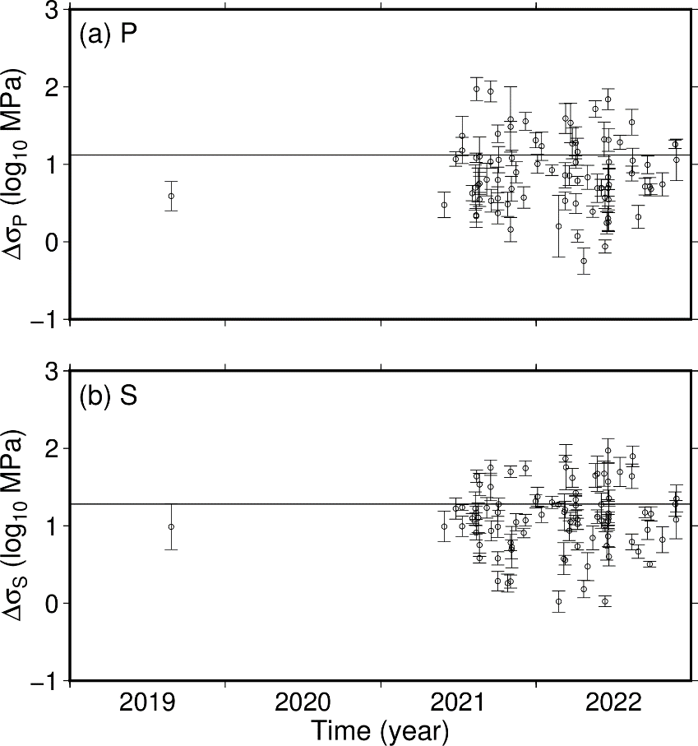

Fig. S15 Temporal variations of static stress drops estimated from (a) P-waves and (b) S-wave over the entire study area. The horizontal line in each panel represents the logarithmic mean value. Error bars indicates two standard deviations on each estimate.
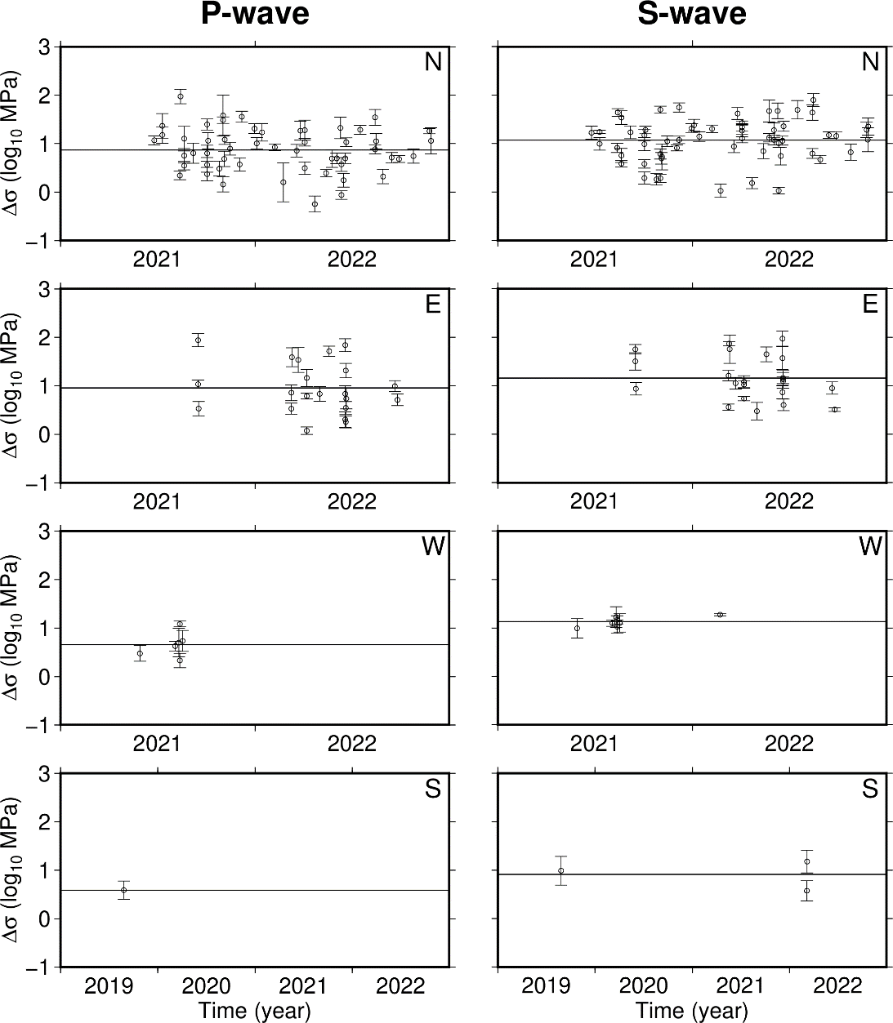

Fig. S16 Temporal variations of static stress drops estimated from P-waves (left panels) and S-waves (right panels) in each cluster (Fig. 1b). The horizontal line in each panel represents the logarithmic mean value. Error bars indicates two standard deviations on each estimate.

