List of Additional Figures
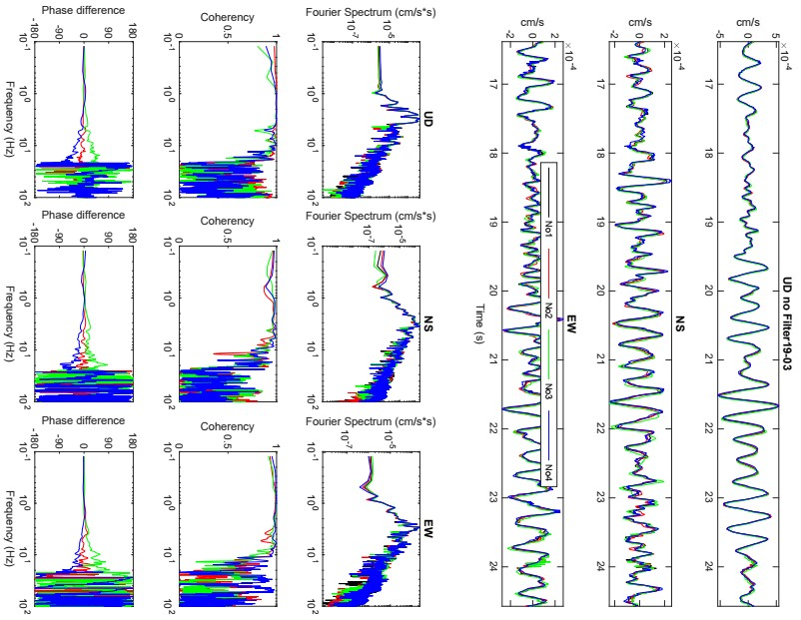
Fig S1. Multiplexed time series and huddle test at site Th6. The multiplexed time series of all three components along with Fourier spectra, coherencies and phase difference for the same time series are shown. The greater the dispersed lines, the lesser is the consistency of the instruments at the site.

List of Additional Tables
Table S1. NEHRP site classification system (Building Seismic Safety Council -BSSC 2003) based on Vs30.
Site class | Average shear wave velocity Vs30 | Remarks
A | Vs30>1500m/s | Hard rock
B | 760<Vs30<1500 m/s | Rock
C | 360<Vs30<760 m/s | Very dense soil or soft rock
D | 180<Vs30<360 m/s | Stiff soil
E | Vs30<180 m/s | Soft soil
F | Vs30<180 m/s | Soil requiring site-specific evaluation

Table S2. Vs30 values of some sites from previous studies, closer to our observation sites are compared with those from present study. These results are comparable though their technique and method for obtaining Vs30 are different.

Site | Vs30 from previous studies (m/s) | Vs30 from Konno and Kataoka’s method (m/s) | Vs30 from inversion (m/s)
Th15 | 198 (De Risi et al. 2021) | 198 | 209
Th4 | 170 (De Risi et al. 2021 ) | 189 | 191
B7 | 216 (De Risi et al. 2021 ) | 267 | 220
C11 | 203 (De Risi et al. 2021) | 216 | 222
Th4 | 150 (Takai et al. 2015) | 189 | 191

