The role of fluids in earthquake swarms in northeastern Noto Peninsula, central Japan: Insights from source mechanisms

Sayaka Takano¹, Yoshihiro Hiramatsu^{*2}, Yohei Yukutake³

¹Graduate School of Natural Science and technology, Kanazawa University, Kanazawa 920-1192, Japan
e-mail: sayaka0701@stu.kanazawa-u.ac.jp

²Yoshihiro Hiramatsu
Faculty of Geosciences and Civil Engineering, Institute of Science and Engineering, Kanazawa University, Kanazawa 920-1192, Japan
e-mail: yoshizo@staff.kanazawa-u.ac.jp

³Yohei Yukutake
Earthquake Research Institute, the University of Tokyo, Bunkyo-ku 113-0032, Japan
e-mail: yukutake@eri.u-tokyo.ac.jp

*Correspondence: (yoshizo@staff.kanazawa-u.ac.jp)

Contents:
Text S1: Nonparametric bootstrap test.
Figure S1: M–T diagrams in each cluster.
Figure S2: Frequency distribution of the magnitudes of earthquakes.
Figure S3: Classification of focal mechanisms of each cluster.
Figure S4: Distribution of focal mechanisms and relocated hypocenters within the cross-sectional views along the profiles shown in Fig. 2.
Figure S5: Mohr diagrams using the nodal planes with highest $T_{S}$ as the fault plane.
Figure S6: Mohr diagrams using the nodal planes with highest I as the fault plane.
Figure S7: Temporal variations in $T_{S}$, I, and misfit angle.
Table S1: List of focal mechanisms.
Table S2: Results of stress tensor inversion.

Text S1

To examine the statistical significance of temporal variations in fault instability, slip tendency, and misfit angle, a nonparametric bootstrap test was applied. For data divided into two parts, the differences in the means of fault instability, slip tendency, and misfit angle between the two datasets were tested. The null hypothesis was that the true difference in means is equal to 0. With a significance threshold of 0.05, a p-value less than 0.05 rejects the null hypothesis, indicating a statistically significant difference in means. The bootstrap sample size was the same as the observed size. The p-value was calculated from 2,000 bootstrap estimations. For earthquakes deeper than 15 km in cluster S, the earthquakes were divided into those occurring in 2020 (sample size of 5) and those after 2021(sample size of 6). The bootstrap test showed p-values of 0.448, 0.0715, 0.0095 for fault instability, slip tendency, and misfit angle, respectively, indicating that the difference in the means of the misfit angles was statistically significant. In the same way, the temporal variations in fault instability, slip tendency, and misfit angle for cluster E were tested. The earthquakes in cluster E were divided into those occurring in 2021 (sample size of 13) and those in 2022 (sample size of 39). The p-values for fault instability, slip tendency, and misfit angle were 0.081, 0.0515, 0.242, respectively, indicating no statistically significant differences.

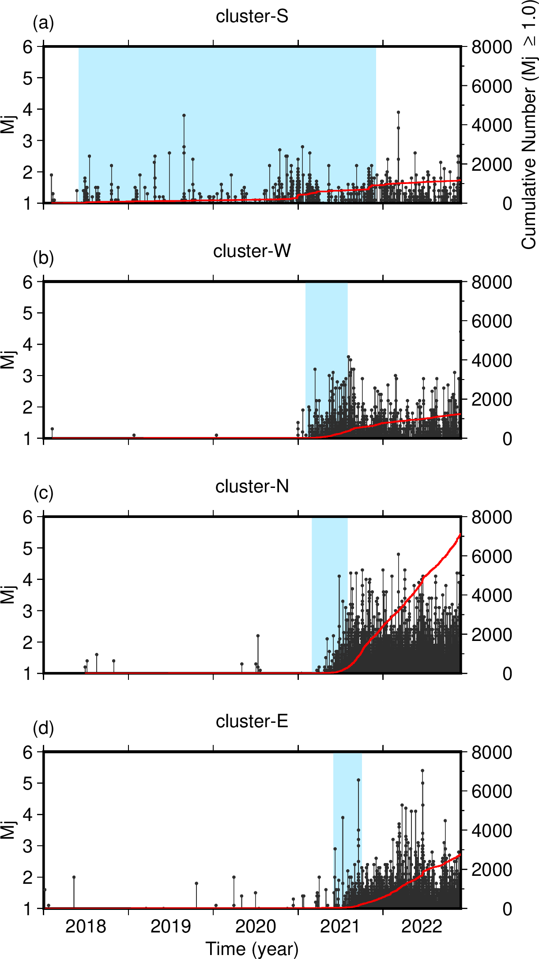

Fig. S1. M–T diagram in each cluster: (a) cluster S, (b) cluster W, (c) cluster E, and (d) cluster E. A red curve shows a cumulative number of earthquakes (Mj ≥ 1.0). A light-blue area in each panel indicates the initial activity period.

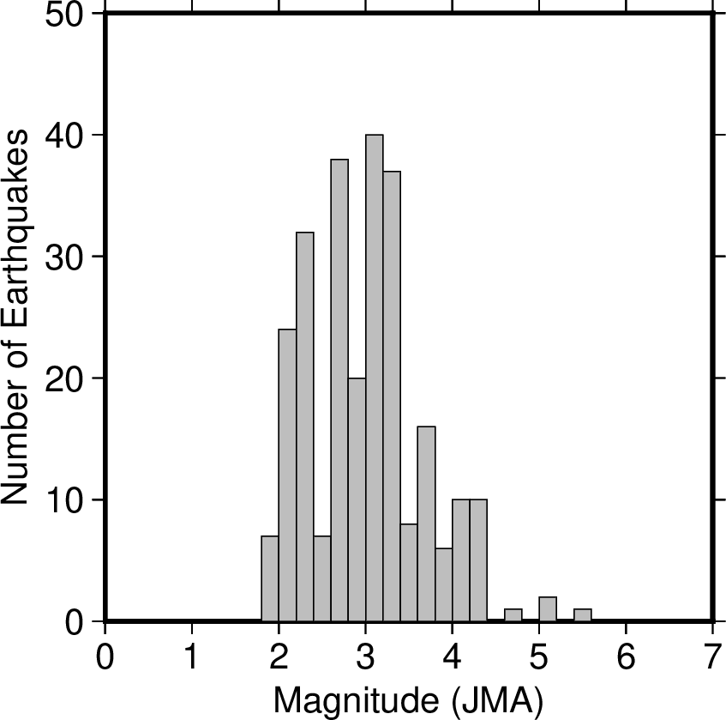

Fig. S2. A frequency distribution of the magnitudes of earthquakes analyzed in this study.

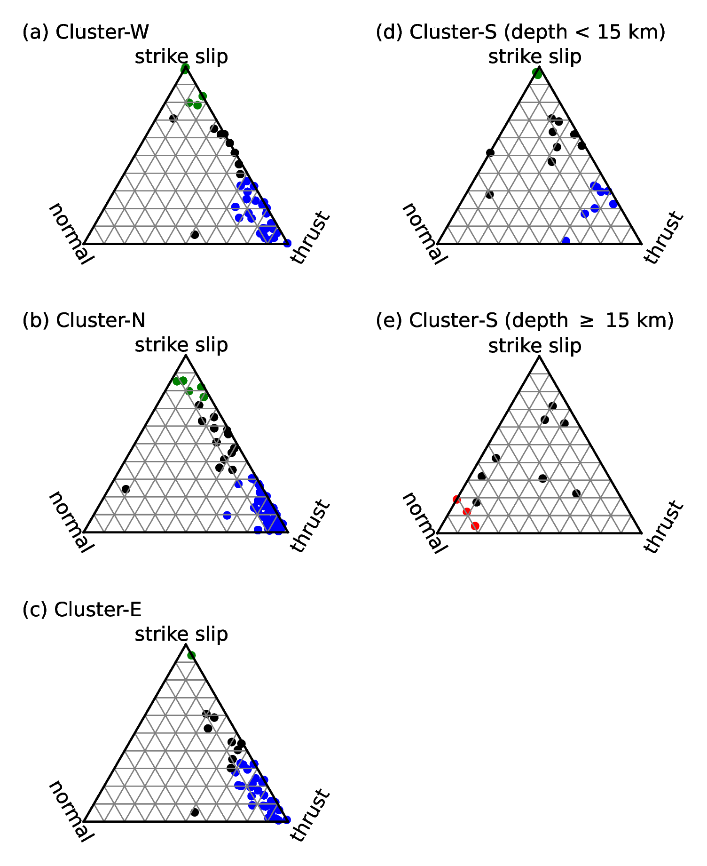

Fig. S3. Focal mechanisms classified based on the criteria of Frohlich (1992). Red, normal fault; blue, reverse fault; green, strike-slip fault; black, other intermediate fault mechanisms.

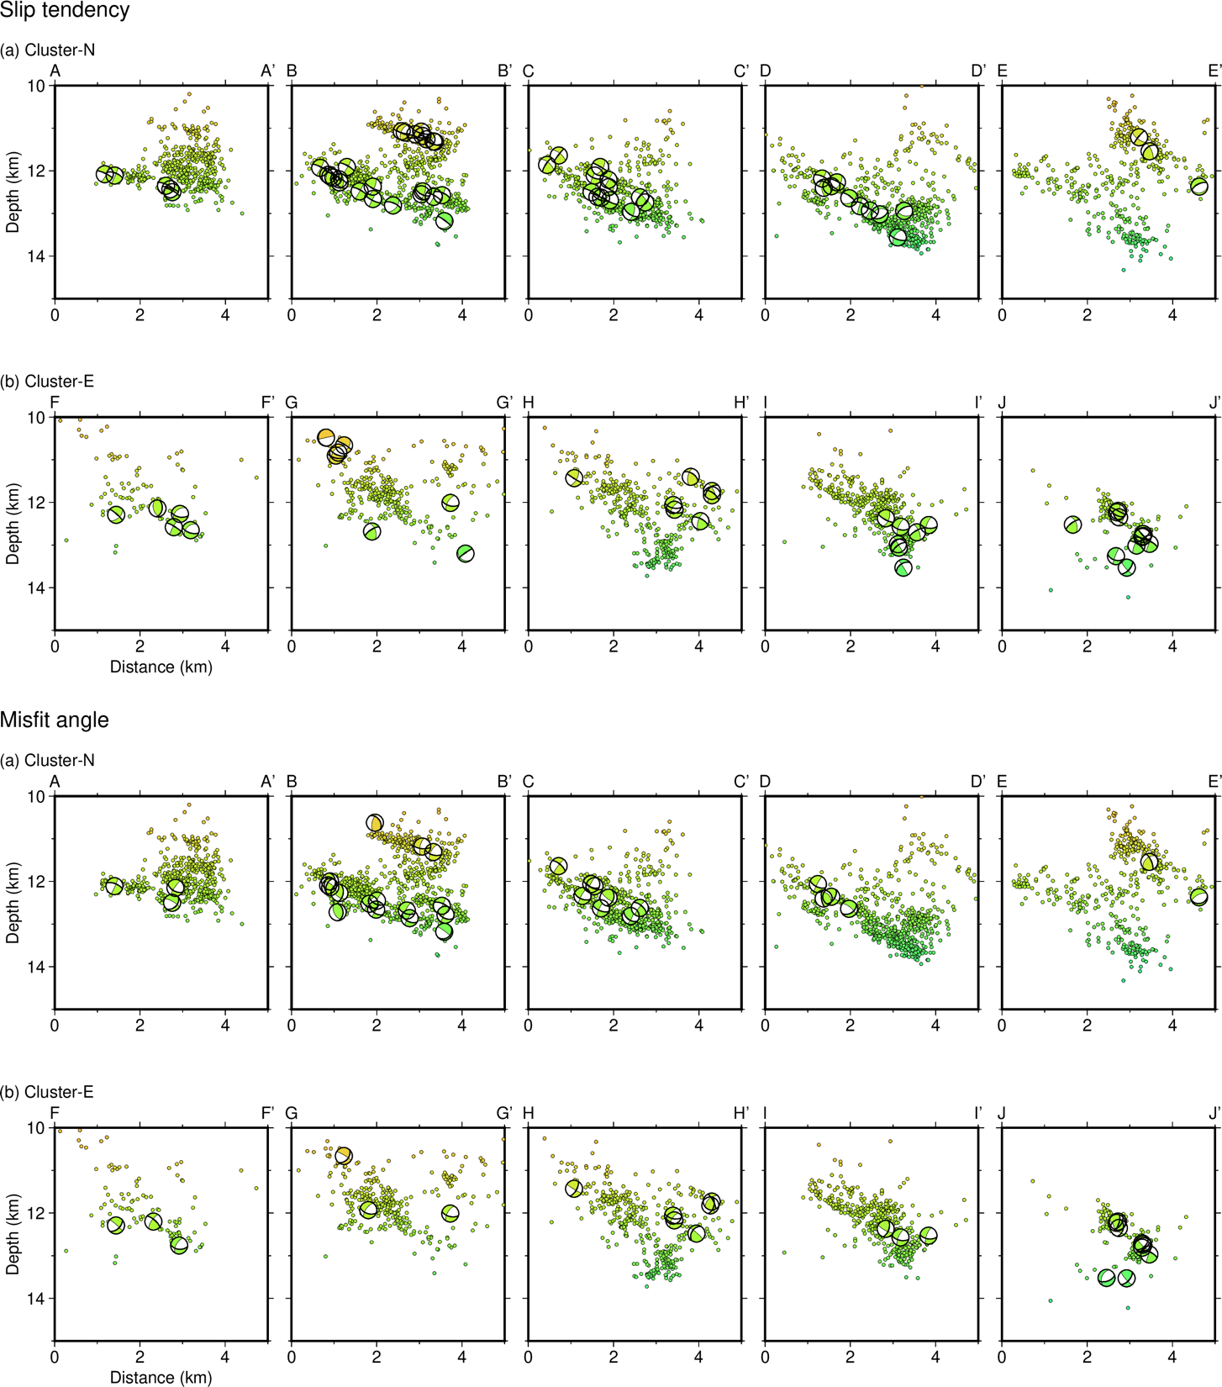

Fig. S4. The distribution of focal mechanisms (beach ball diagrams) and relocated hypocenters within the cross-sectional views along the profiles shown in Fig. 2 for (a) cluster N and (b) cluster E. Bold lines in the beach ball diagrams indicate nodal planes with the highest $T_{S}$ or the lowest misfit angle for earthquakes with a difference in $T_{S}$ ≥ 0.1 or misfit angle ≤ 20°.
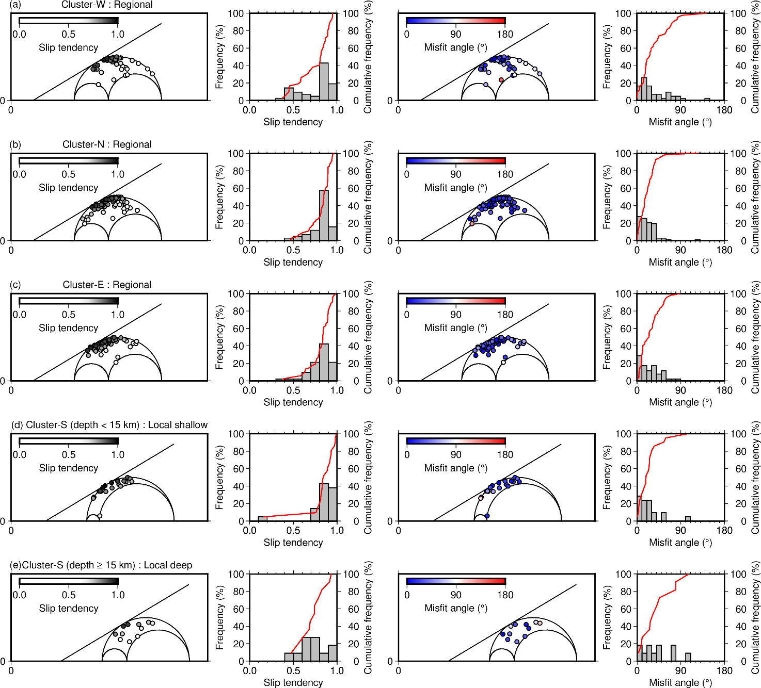

Fig. S5. Mohr diagrams, using the nodal planes with the highest $T_{S}$ as the fault plane, for earthquakes of (a) cluster W, (b) cluster N, and (c) cluster E for the regional stress field. Earthquakes in cluster S are split between (d) source depths <15 km and (e) source depths ≥15 km. In (d) and (e), Mohr diagrams were drawn for the local stress fields. All panels, symbols, and lines are the same as those in Fig. 5.

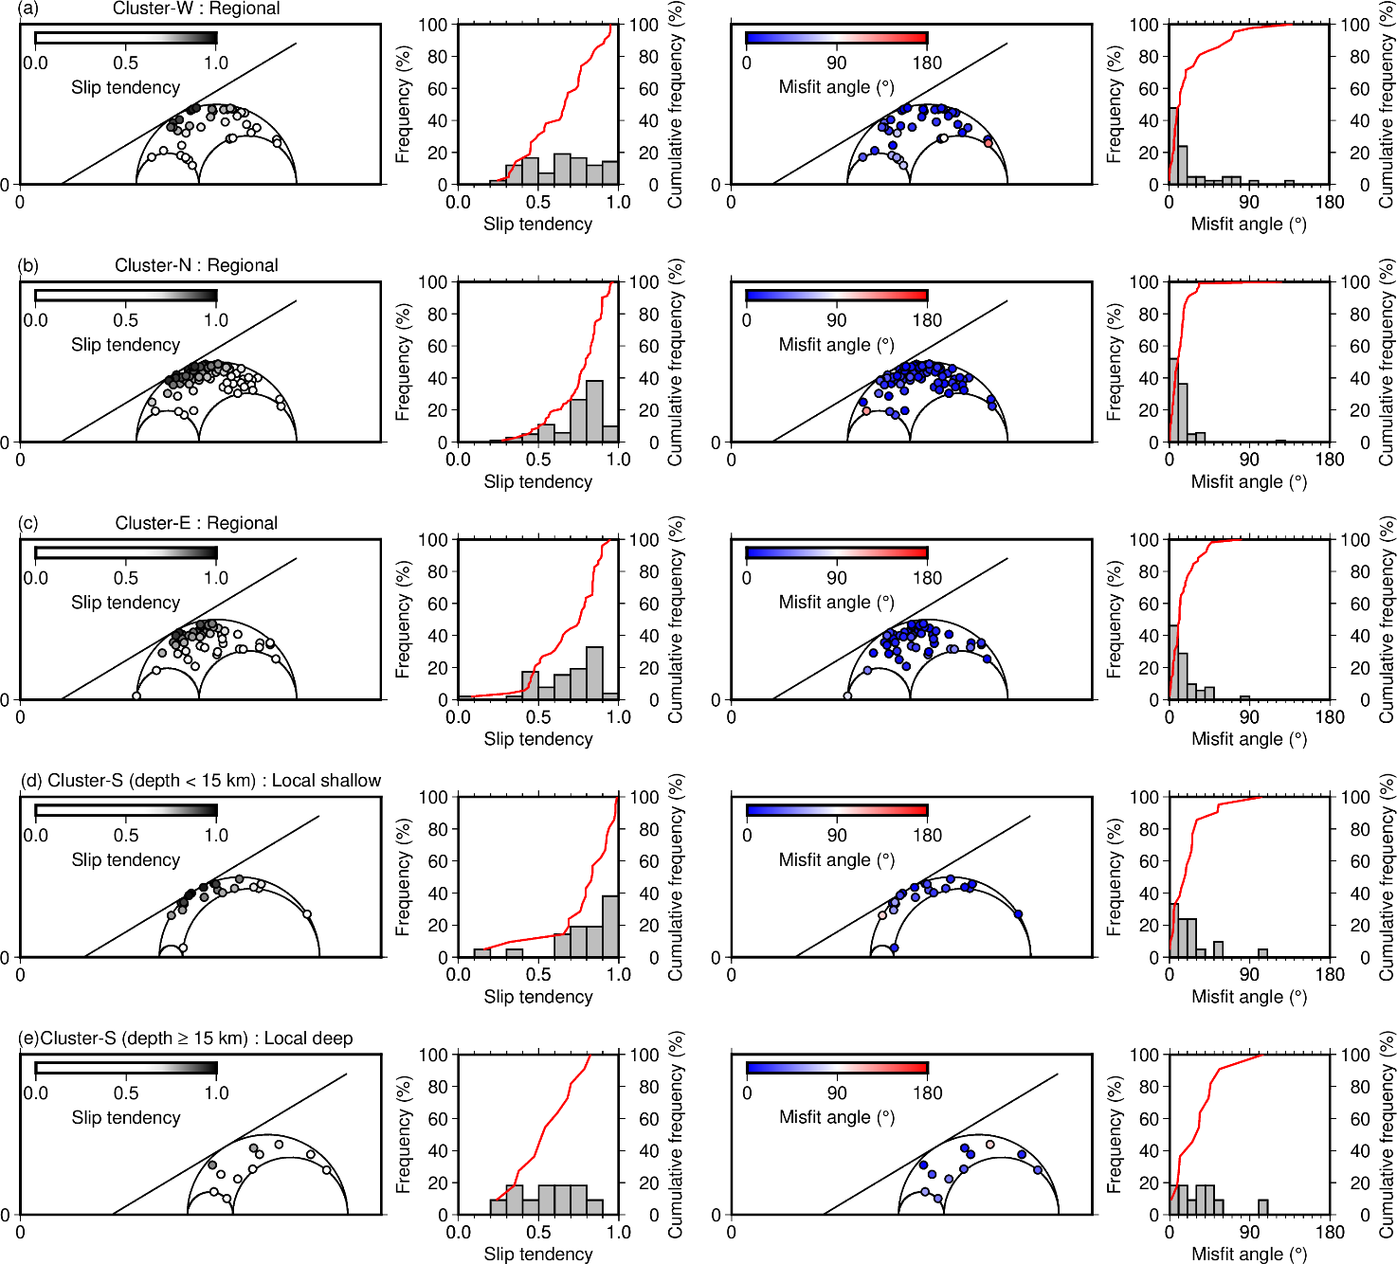
Fig. S6. Mohr diagrams, using the nodal planes with the smallest misfit angle as the fault plane, for earthquakes of (a) cluster W, (b) cluster N, and (c) cluster E for the regional stress field. Earthquakes in cluster S are split between (d) source depths <15 km and (e) source depths ≥15 km. In (d) and (e), Mohr diagrams were drawn for the local stress fields. All panels, symbols, and lines are the same as those in Fig. 5.

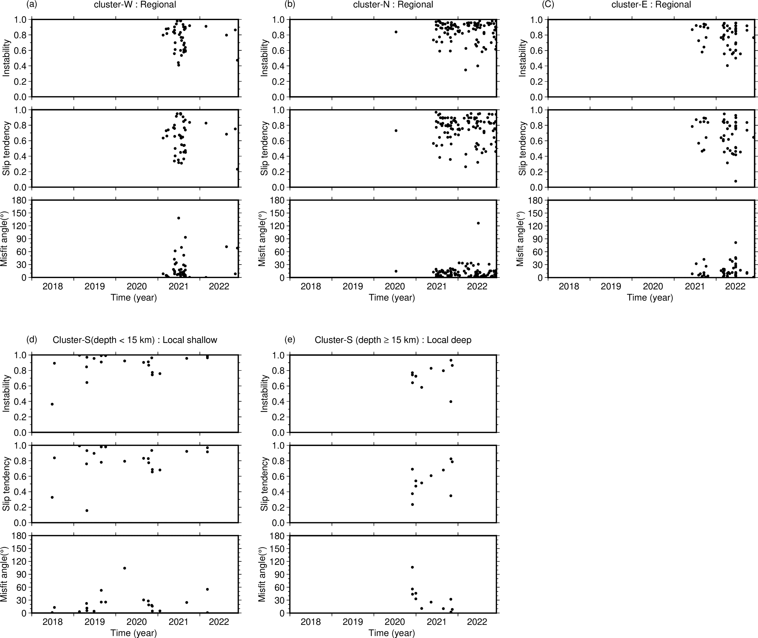

Fig. S7. Temporal variations in I, $T_{S}$, and misfit angle in each cluster. The I, $T_{S}$, and misfit angles are calculated for the nodal planes with the lowest misfit angle. The calculations for the nodal planes with the highest $T_{S}$ or I show similar temporal variations.

Table S1. List of earthquake origin times (JST), depths, M_{w} (moment magnitude), and information describing the two nodal planes (strike, dip, and slip).

See Table_S1.xlsx.

Table S2. Summary of the results of our stress tensor inversion. $σ_{1}$, $σ_{2}$, and $σ_{3}$ are the maximum, intermediate, and minimum principal stresses, respectively. R is the stress ratio, defined as ${\left(σ_{1}-σ_{2}\right)}/{\left(σ_{1}-σ_{3}\right)}$. The errors are the maximum differences between the results calculated for the noise-free and noisy focal mechanisms with 1000 random realizations.

 | Number | R | $σ_{1}$: Azimuth/Plunge | $σ_{2}$: Azimuth/Plunge | $σ_{3}$: Azimuth/Plunge
All | 228 | 0.64 ± 0.097 | 320.0°/11.7° ±4.7° | 227.1°/13.9° ±15.5° | 88.7°/71.7° ±15.3°
Local: shallow  Cluster S  (depth < 15 km) | 21 | 0.85 ± 0.24 | 300.8°/31.7° ±8.8° | 187.1°/33.1° ±40.4° | 62.9°/40.8° ±40.4°
Local: deep  Cluster S  (depth ≥ 15 km) | 11 | 0.72 ± 0.57 | 166.2°/47.3° ±22.1° | 335.1°/42.2° ±38.3° | 70.1°/5.5° ±36.6°
Cluster W | 42 | 0.71 ± 0.18 | 308.6°/4.4° ±8.0° | 38.6°/0.069° ±13.9° | 129.5°/85.6° ±13.8°
Cluster N | 102 | 0.58 ± 0.098 | 326.4°/13.7° ±7.4° | 235.4°/4.3° ±18.2° | 128.2°/75.6° ±18.6°
Cluster E | 52 | 0.68 ± 0.14 | 326.6°/8.4° ±6.9° | 236.0°/4.1° ±15.9° | 120.0°/80.7° ±16.2°
Regional  Clusters W, N, E | 196 | 0.61 ± 0.072 | 321.8°/10.6° ±5.2° | 52.2°/1.3° ±8.6° | 149.1°/79.3° ±8.7°

