Supplementary Material 2 for

Terrestrial-origin O⁺ ions below 1 keV near the Moon measured with the Kaguya satellite

D. Yamauchi¹, M. Nosé^{1,2}, Y. Harada³, K. Yamamoto¹, K. Keika⁴, A. Nagamatsu⁵,
S. Yokota⁶, Y. Saito⁷, and A. Glocer⁸

¹ Institute for Space-Earth Environmental Research, Nagoya University, Nagoya, Japan
² School of Data Science, Nagoya City University, Nagoya, Japan
³ Graduate School of Science, Kyoto University, Kyoto, Japan
⁴ Graduate School of Science, The University of Tokyo, Japan
⁵ Tsukuba Space Center, Japan Aerospace Exploration Agency, Ibaraki, Japan
⁶ Graduate School of Science, Osaka University, Osaka, Japan
⁷ Institute of Space and Astronautical Science, Japan Aerospace Exploration Agency,
Sagamihara, Japan
⁸ NASA Goddard Space Flight Center, Greenbelt, MD, USA

Contents of this file
Figures S1 and S2

Introduction
This supplementary material presents Kaguya data (Figure S1) and a stack plot of E_{SW}, B_{z}, P_{SW}, and the SME index (Figure S2) for interval 3 (14:00–24:00 UT on June 7, 2009).

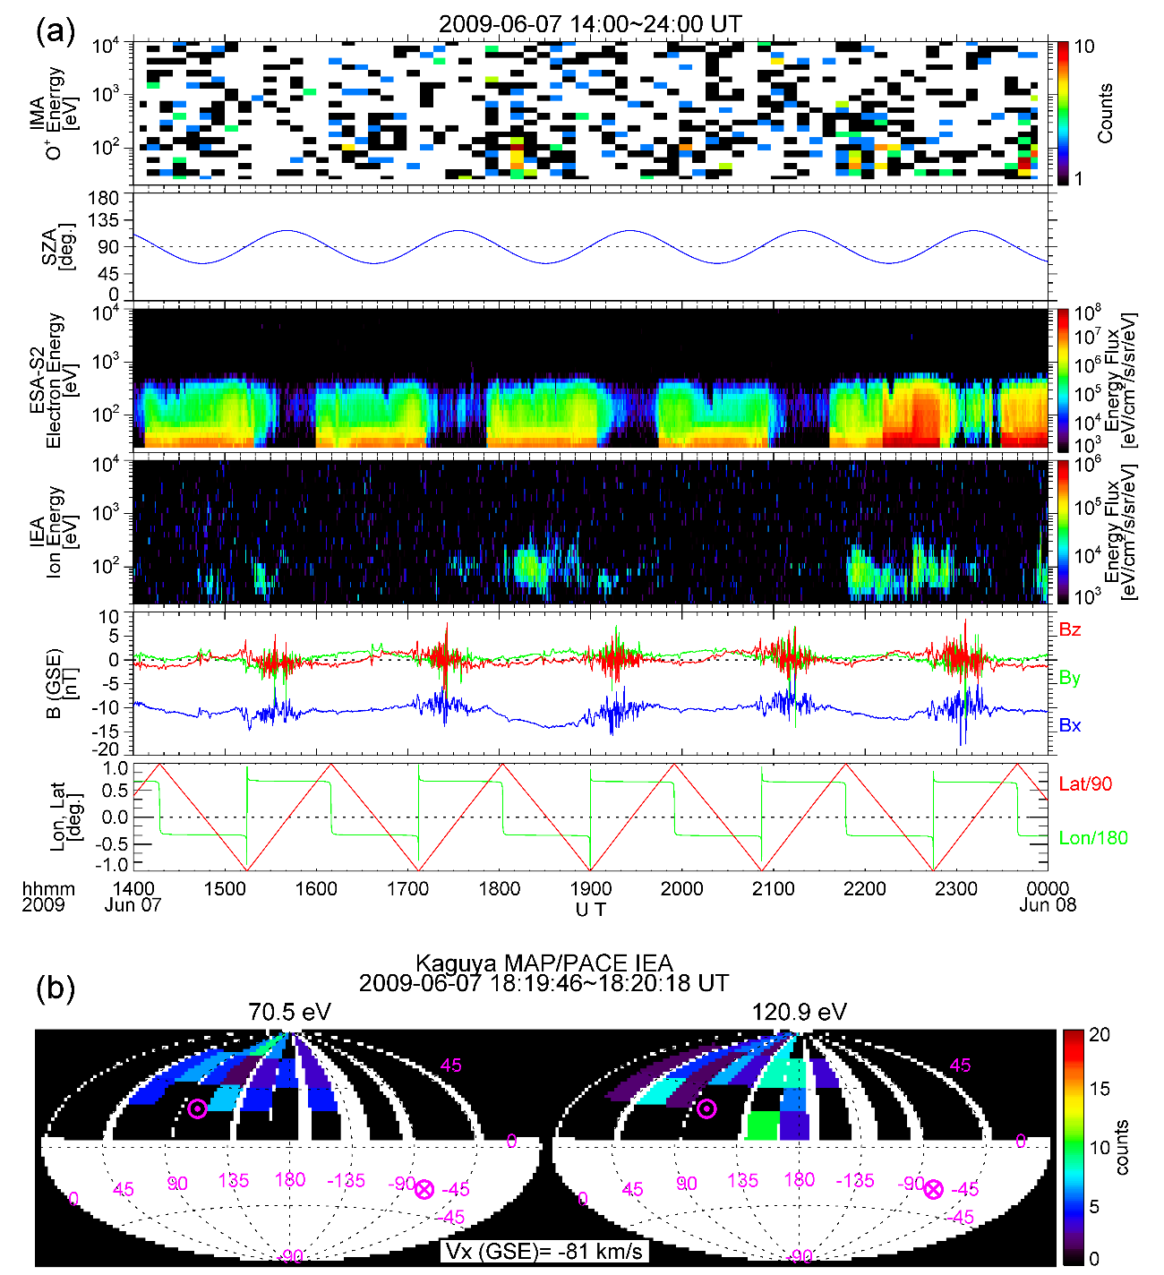
Figure S1. (a) Kaguya observations of terrestrial-origin O⁺ ions in the lobe for 14:00–24:00 UT on June 7, 2009. From top to bottom, the panels display the IMA O⁺ ion energy-time (E-t) spectrogram, SZA, ESA-S2 electron E-t spectrogram, IEA ion E-t spectrogram, the magnetic field in GSE coordinates, and Kaguya’s location. (b) The IEA 3-D velocity distribution of the ions at 18:20 UT. A circle dot symbol indicates the direction of the magnetic field lines.

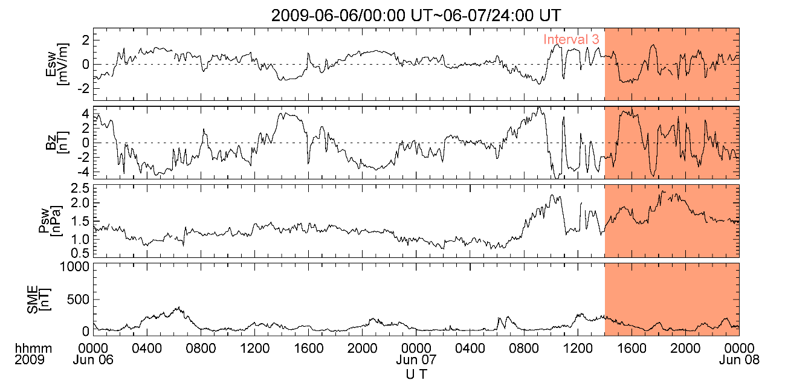
Figure S2. E_{SW}, B_{z}, P_{SW}, and the SME index for June 6–7, 2009, with interval 3 highlighted in orange.

