Supplementary materials (Hashiguchi et al.)

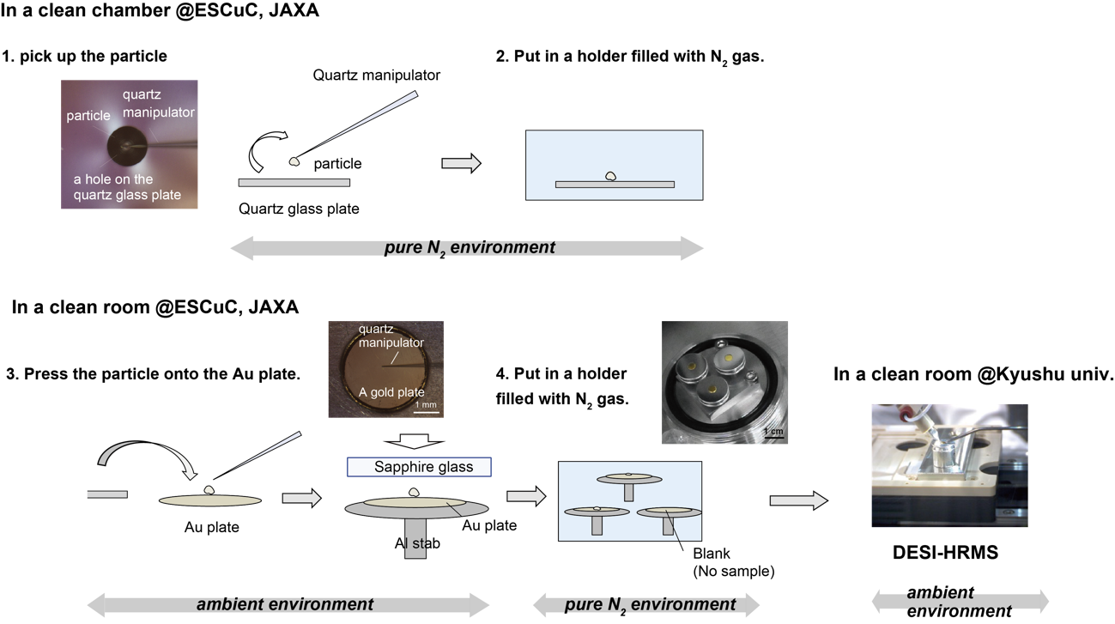
Figure S1.
Sample preparation and transfer protocols from picking up the particle from a clean chamber at ESCuC, JAXA, to pressing the particles onto the gold plate for DESI-HRMS imaging at Kyushu University.
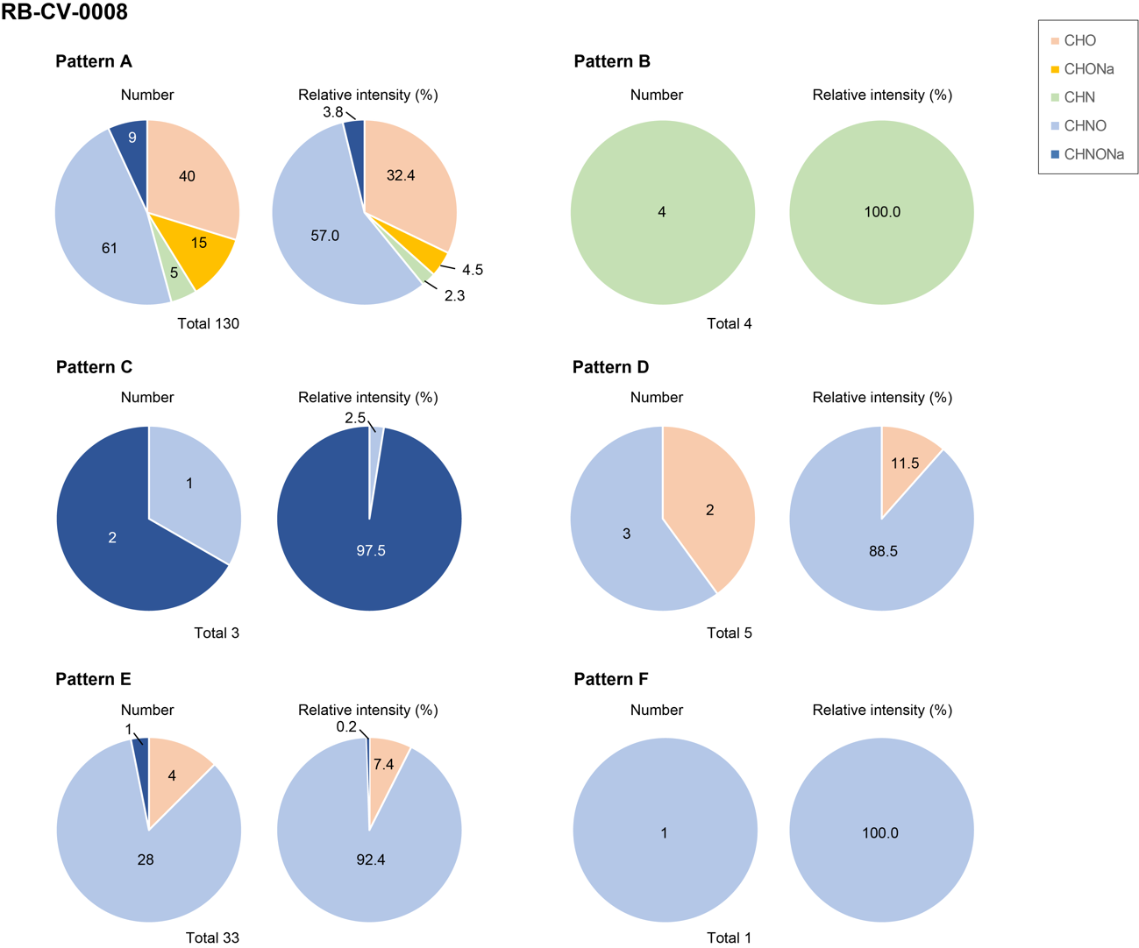
Figure S2.
Fractions of the number and relative intensity of positive ions with each assigned formula identified from RB-CV-0008 by DESI-HRMS imaging, described for each classified distribution pattern.

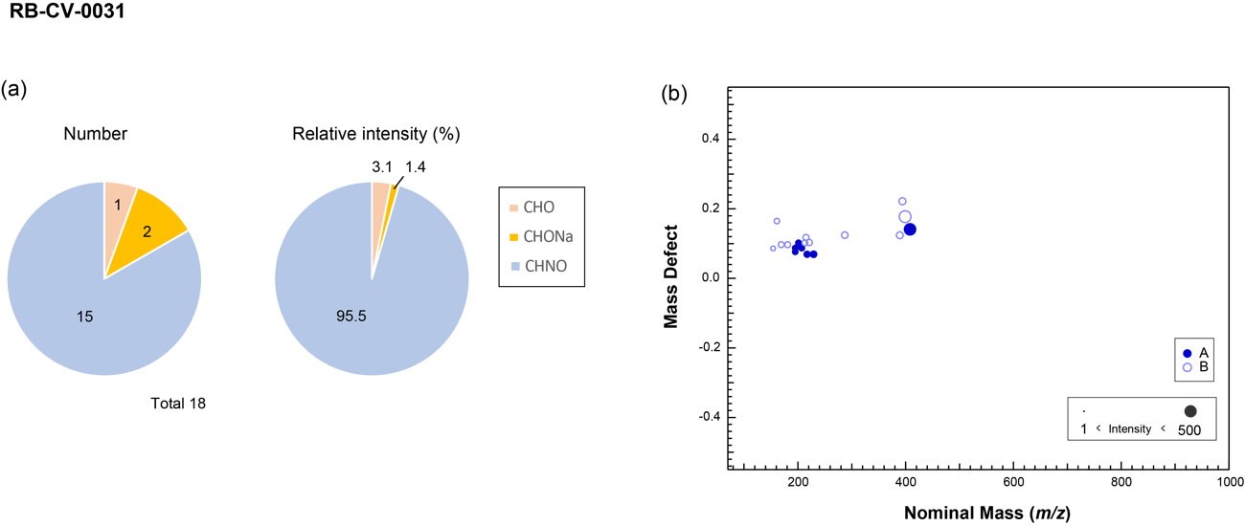

Figure S3. (a) Fraction of the number and relative intensity of positive ions with each assigned formula of RB-CV-0031. (b) MD plot of 18 identified positive ions from RB-CV-0031.

Table S1. The top 15 most intense ions identified from each sample by DESI-HRMS imaging (the relative intensity corresponds to the total number of ions identified from the ROI for each sample).
RB-CV-0008
m/z | Assigned Formula | Relative intensity (%) | distribution pattern
291.1124 | C₁₈H₁₅N₂O₂⁺ | 10.9 | E
521.3303 | C₂₄H₄₇N₃O₉⁺ | 5.9 | A
579.3716 | C₂₇H₅₆O₁₁Na⁺ | 5.7 | A
263.1176 | C₁₇H₁₅N₂O⁺ | 4.7 | A
574.4163 | C₄₂H₅₄O⁺ | 4.3 | A
637.4129 | C₄₂H₅₅NO₄⁺ | 3.6 | A
632.4576 | C₄₃H₅₈N₃O⁺ | 3.5 | A
516.3743 | C₂₅H₅₃N₂O₇Na⁺ | 3.2 | A
213.1346 | C₉H₁₇N₄O₂⁺ | 2.9 | A
169.0971 | C₈H₁₃N₂O₂⁺ | 2.8 | A
181.0971 | C₉H₁₃N₂O₂⁺ | 2.4 | A
690.4987 | C₃₁H₇₀N₄O₁₂⁺ | 2.2 | A
748.5400 | C₄₉H₇₃O₄Na⁺ | 1.8 | A
171.1856 | C₁₀H₂₃N₂⁺ | 1.5 | B
922.6675 | C₆₀H₉₀O₇⁺ | 1.4 | A

RB-CV-0031
m/z | Assigned Formula | Relative intensity (%) | distribution pattern
201.1023 | C₁₂H₁₃N₂O⁺ | 49.4 | A
195.0877 | C₈H₁₁N₄O₂⁺ | 27.2 | A
217.0694 | C₇H₁₁N₃O₅⁺ | 7.2 | A
195.0765 | C₉H₁₁N₂O₃⁺ | 4.5 | A
207.0875 | C₈H₁₅O₆⁺ | 3.0 | A
229.0693 | C₈H₁₁N₃O₅₊ | 1.8 | A
399.1778 | C₂₁H₂₈O₆Na⁺ | 1.0 | B
161.1648 | C₈H₂₁N₂O⁺ | 0.8 | B
411.1490 | C₁₆H₂₇O₁₂⁺ | 0.7 | A
213.1345 | C₁₃H₁₃N₂O⁺ | 0.4 | B
408.1412 | C₂₁H₂₃NO₆Na⁺ | 0.3 | A
154.0863 | C₈H₁₂NO₂⁺ | 0.3 | B
181.0971 | C₉H₁₃N₂O₂⁺ | 0.3 | B
154.0863 | C₈H₁₂NO₂⁺ | 0.2 | B
181.0971 | C₉H₁₃N₂O₂⁺ | 0.2 | B

Chelyabinsk
m/z | Assigned Formula | Relative intensity (%)
97.0284 | C₅H₅O₂⁺ | 17.8
87.0553 | C₃H₇ON₂⁺ | 12.9
182.1903 | C₁₂H₂₄N⁺ | 10.3
163.1328 | C₈H₁₉O₃⁺ | 7.1
149.0233 | C₈H₅O₂⁺ | 6.0
79.0179 | C₅H₃O⁺ | 3.9
130.1591 | C₈H₂₀N⁺ | 3.6
114.0913 | C₆H₁₂ON⁺ | 3.5
104.0366 | C₆H₄N₂⁺ | 3.4
148.108 | C₅H₁₄O₂N₃⁺ | 3.0
74.0601 | C₃H₈ON⁺ | 2.6
561.0939 | C₃₄H₁₃O₅N₆⁺ | 2.5
185.1147 | C₆H₁₃ON₆⁺ | 2.3
138.0526 | C₄H₁₀O₅⁺ | 1.9
171.1491 | C₉H₁₉ON₂⁺ | 1.7

VITON |  |  | VECTRAN
m/z | Assigned Formula | Relative intensity (%) | m/z | Assigned Formula | Relative intensity (%)
217.1046 | C₈H₁₈O₅Na⁺ | 6.9 | 87.0550 | C₃H₇N₂O⁺ | 97.3
88.0757 | C₄H₁₀NO⁺ | 6.7 | 149.0229 | C₈H₅O₃⁺ | 53.4
149.0296 | C₂H₈NO₅Na⁺ | 4.0 | 74.0600 | C₃H₈NO⁺ | 39.0
301.1408 | C₁₆H₂₂O₄Na⁺ | 3.8 | 182.1900 | C₁₂H₂₄N⁺ | 27.5
80.0344 | C₂H₅N₂Na⁺ | 2.7 | 163.1331 | C₉H₁₈NNa⁺ | 22.0
138.0527 | C₅H₉NO₂Na⁺ | 2.5 | 114.0910 | C₆H₁₂NO⁺ | 21.9
82.0138 | CH₃N₂ONa⁺ | 2.1 | 157.0830 | C₆H₁₄O₃Na⁺ | 17.4
523.3041 | C₃₀H₄₁N₃O₅⁺ | 2.0 | 100.1121 | C₆H₁₄N⁺ | 17.1
185.1148 | C₈H₁₈O₃Na⁺ | 2.0 | 118.0860 | C₅H₁₂NO₂⁺ | 12.4
261.1306 | C₁₀H₂₂O₆Na⁺ | 1.4 | 173.0780 | C₆H₁₄O₄Na⁺ | 12.4
131.0191 | C₂H₆NO₄Na⁺ | 1.4 | 185.1140 | C₆H₁₆N₃O₂Na⁺ | 11.9
181.0557 | C₃H₁₂NO₆Na⁺ | 1.4 | 117.1019 | C₅H₁₃N₂O⁺ | 8.3
567.3298 | C₃₂H₄₈O₇Na⁺ | 1.3 | 171.1489 | C₉H₁₉N₂O⁺ | 7.9
317.1147 | C₁₉H₁₈O₃Na⁺ | 1.2 | 109.0370 | C₂H₇NO₄⁺ | 7.9
181.1699 | C₁₁H₂₁N₂⁺ | 1.1 | 199.1690 | C₁₂H₂₃O₂⁺ | 6.4

Nylon-6 |  |  | Acryl
m/z | Assigned Formula | Relative intensity (%) | m/z | Assigned Formula | Relative intensity (%)
475.3247 | C₃₅H₄₁N⁺ | 10.5 | 306.2765 | C₁₇H₃₈O₄⁺ | 33.3
362.2409 | C₆H₁₅NO₅⁺ | 8.8 | 278.2451 | C₁₅H₃₄O₄⁺ | 16.7
88.0756 | C₄H₁₀NO⁺ | 7.0 | 318.2399 | C₁₇H₃₄O₅⁺ | 5.0
249.1569 | C₁₁H₂₃NO₅⁺ | 5.6 | 352.2456 | C₁₇H₃₆O₇⁺ | 3.9
87.0522 | C₃H₇N₂O⁺ | 4.6 | 284.2943 | C₁₈H₃₈NO⁺ | 3.0
130.1590 | C₈H₂₀N⁺ | 4.4 | 587.6078 | C₃₄H₇₇N₅O₂⁺ | 2.1
90.0912 | C₄H₁₂NO⁺ | 4.0 | 587.5481 | C₃₅H₇₃NO₅⁺ | 1.8
97.0283 | C₅H₅O₂⁺ | 3.5 | 587.5476 | C₃₃H₇₁N₄O₄⁺ | 1.8
701.4911 | C₆H₁₂N₂O₃⁺ | 3.4 | 589.5631 | C₃₃H₇₃N₄O₄⁺ | 1.7
363.2439 | C₅H₁₃NO₅⁺ | 3.0 | 256.2530 | C₁₆H₃₄ON⁺ | 1.7
476.3274 | C₉H₁₁O₂⁺ | 2.9 | 320.2555 | C₁₇H₃₆O₅⁺ | 1.4
113.0596 | C₆H₉O₂⁺ | 1.7 | 302.2452 | C₁₇H₃₄O₄⁺ | 0.6
100.1120 | C₆H₁₄N⁺ | 1.6 | 561.5350 | C₃₁H₆₉N₄O₄⁺ | 0.6
246.1485 | C₁₅H₂₀NO₂⁺ | 1.5 | 590.5673 | C₄₂H₇₂N⁺ | 0.6
114.0913 | C₆H₁₂NO⁺ | 0.9 | 295.1151 | C₁₃H₂₀O₆Na⁺ | 0.5

