Supplementary information

Additional file 1: SubfaultParameter_2024Noto_PFM_dip5_30.txt
Estimated mean slip model of Figure 2(a), which is assumed dip-4=45°, dip-5=30°, and dip-6=45°. The columns indicate the longitude and the latitude of fault center (deg), the depth of the fault top edge (km), the fault strike (deg), the fault dip (deg), the fault rake angle (deg), the fault length (km), the fault width (km), and slip amount (m).

Additional file 2: SubfaultParameter_2024Noto_PFM_dip5_45.txt
Estimated mean slip model of Figure 2(b), which is assumed dip-4=45°, dip-5=45°, and dip-6=45°. The file format is same as Additional file 1.

Additional file 3: SubfaultParameter_2024Noto_PFM_dip5_60.txt
Estimated mean slip model of Figure 2(c), which is assumed dip-4=45°, dip-5=60°, and dip-6=45°. The file format is same as Additional file 1.

Additional file 4: SubfaultParameter_2024Noto_LFM_dip5_60_25.txt
Estimated mean slip model of Figure 7, which is assumed dip-4=45°, dip-5s=60°, dip-5d=25°, and dip-6=45°. The file format is same as Additional file 1.

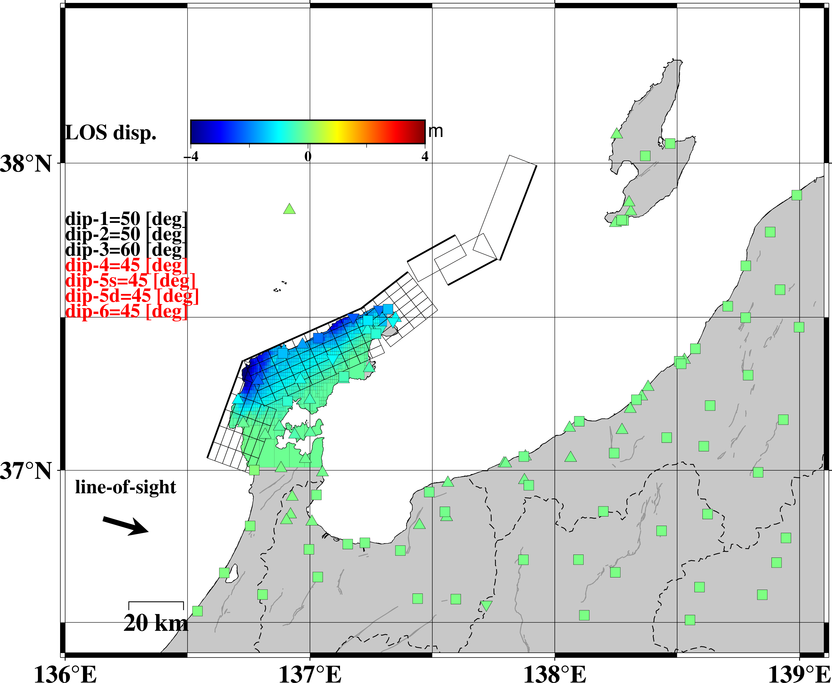

Figure S1
The displacement filed projected on the line-of-sight (LOS) direction. The triangles, inverted triangles, and squares represent stations operated by SoftBank Corp., universities, and GEONET, respectively.

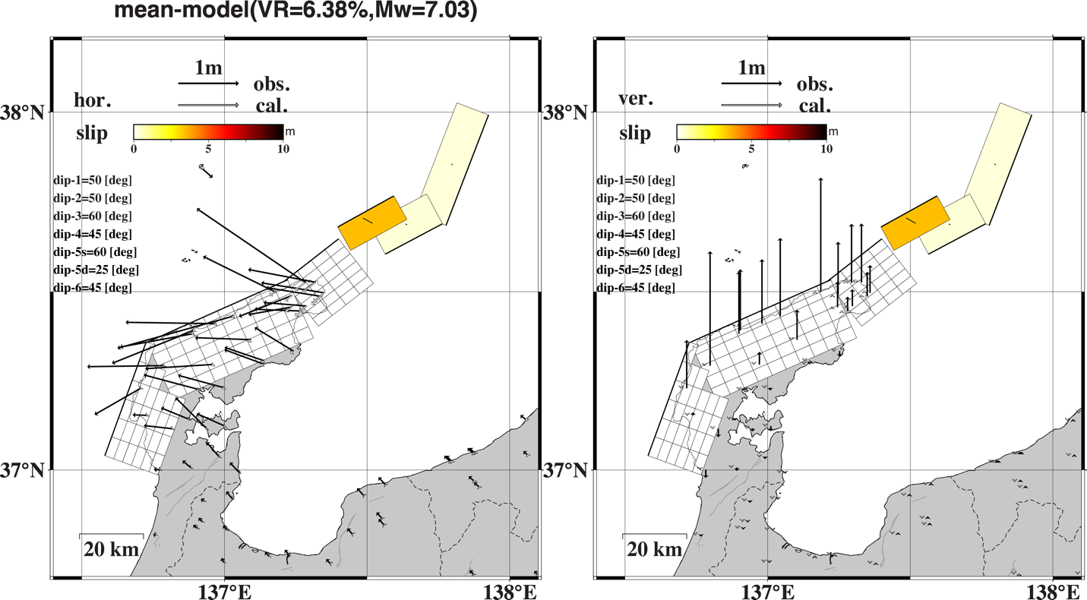

Figure S2
Surface displacements are calculated by only the offshore faults. The Left and Right figures show the horizontal and vertical displacements, respectively. Black and white arrows show the observed and calculated displacements, respectively.

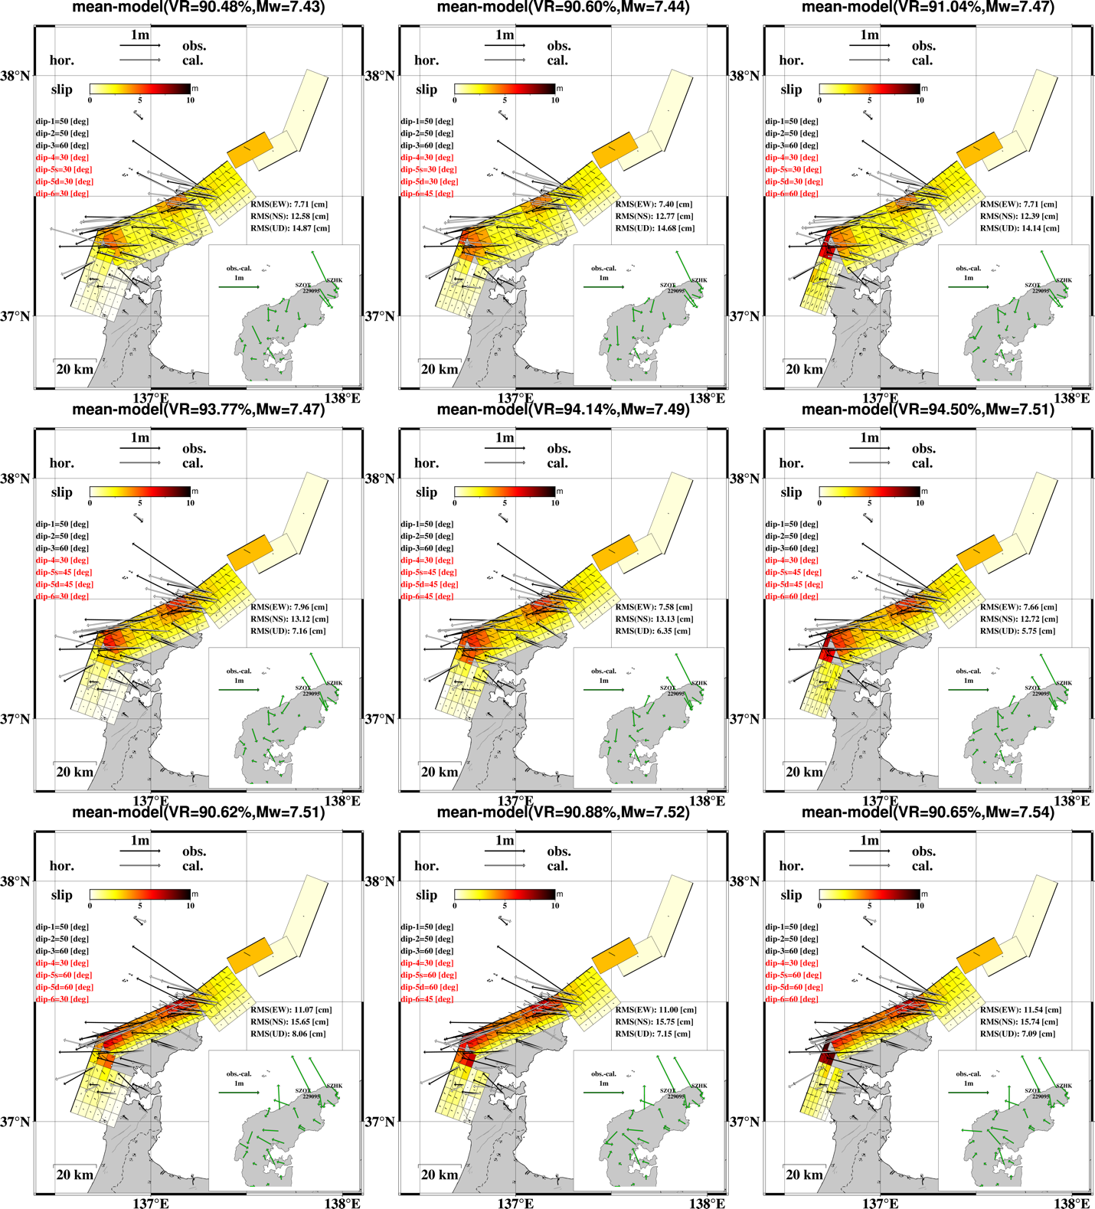

Figure S3(a)
Estimated mean models and confidence intervals (CIs) for different dip angles. Figures (a–c) and (d–f) show the horizontal and vertical displacements calculated by the mean model, respectively. Figures (g–i) and (j–l) show the CIs of the strike- and dip-slips, respectively. The 27 models whose dip-4,-5, and -6 are equivalent to 30°, 45°, and 60° were chosen here. The assumed dip angles are noted in each figure. Note that the models of dip-4=45°, dip-6=45° and dip-5 = 30°, 45°, 60° are correspond to the models in Figure 2.

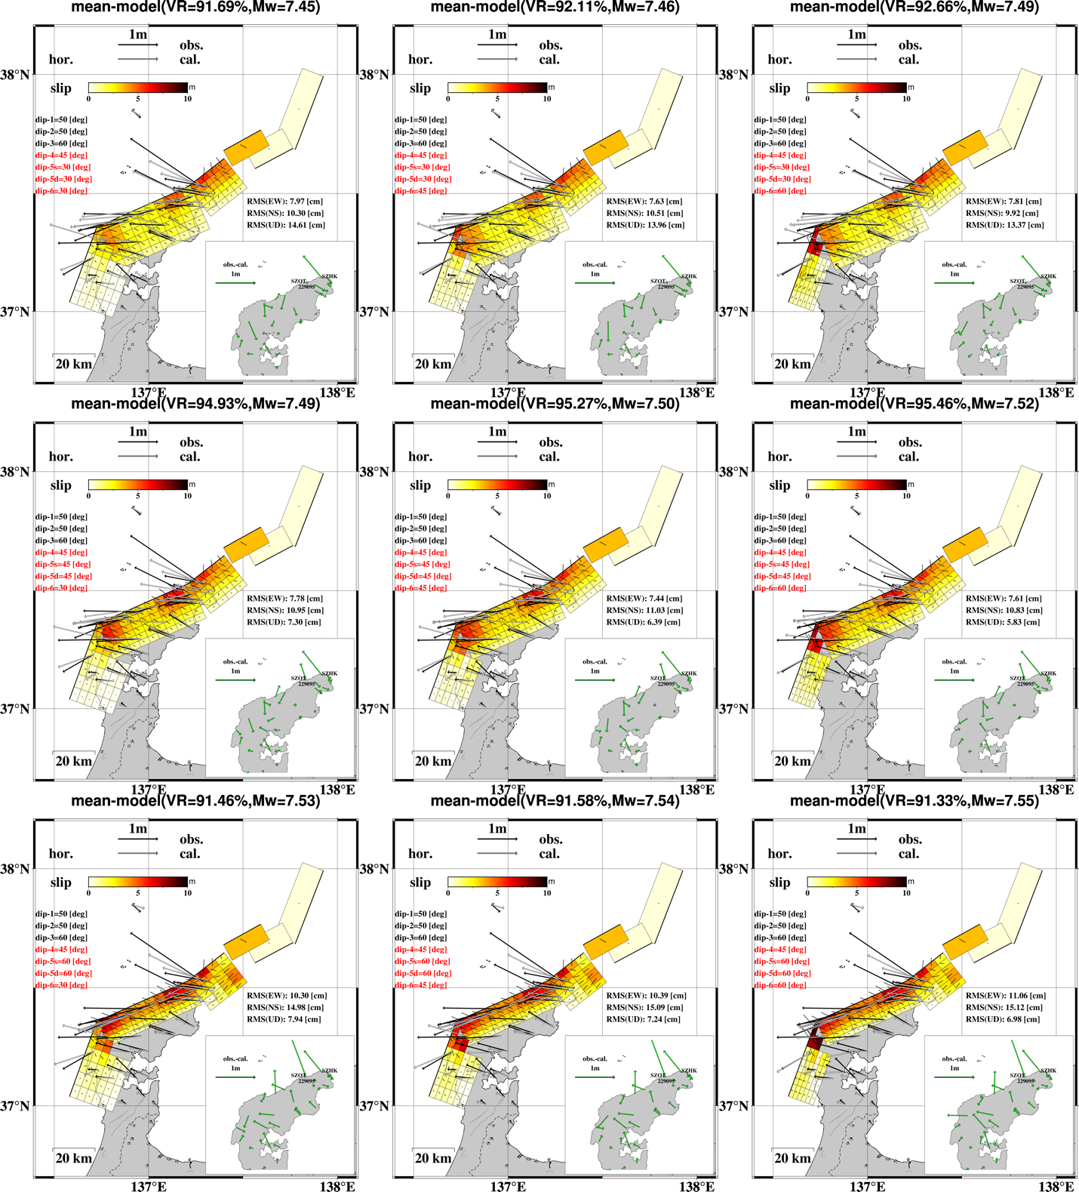

Figure S3(b) The caption is given in Figure S3(a).

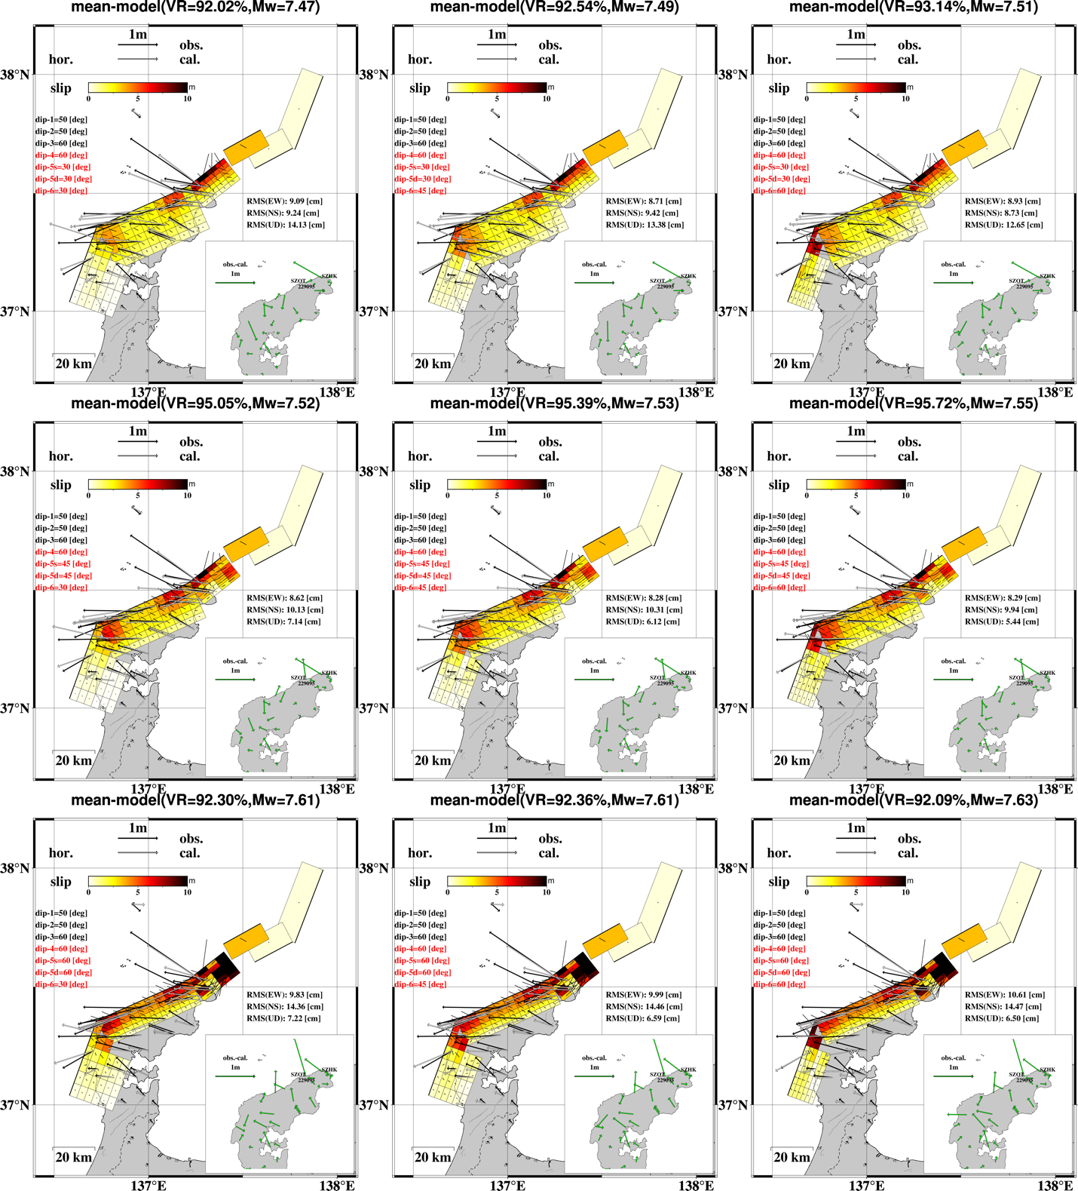

Figure S3(c) The caption is given in Figure S3(a).

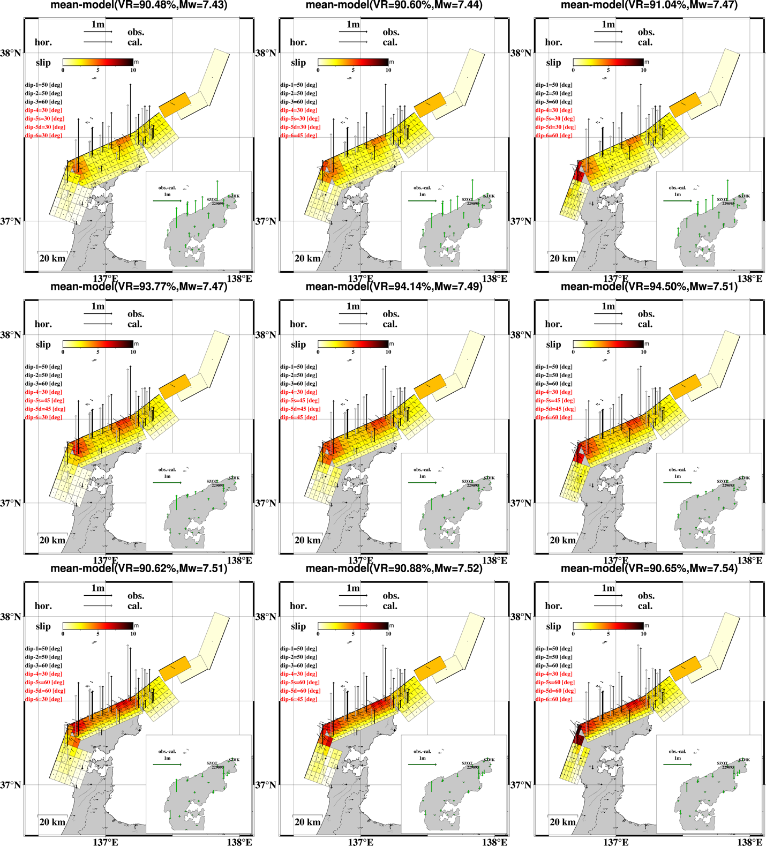

Figure S3(d) The caption is given in Figure S3(a).

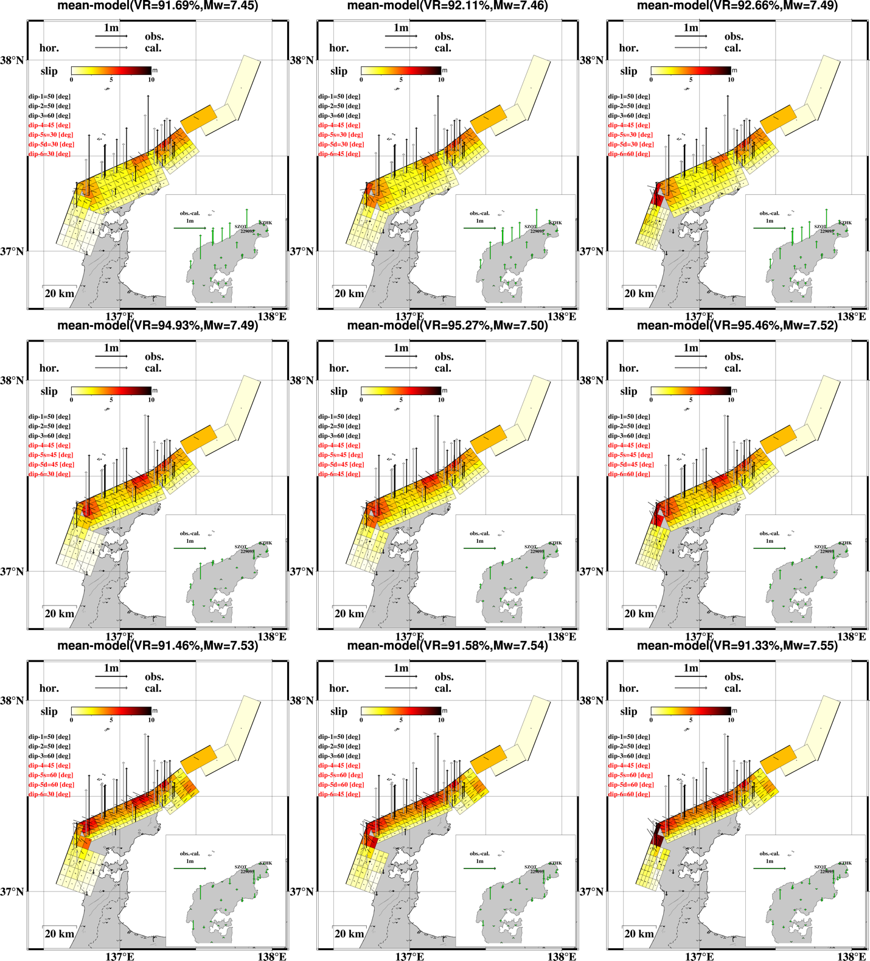

Figure S3(e) The caption is given in Figure S3(a).
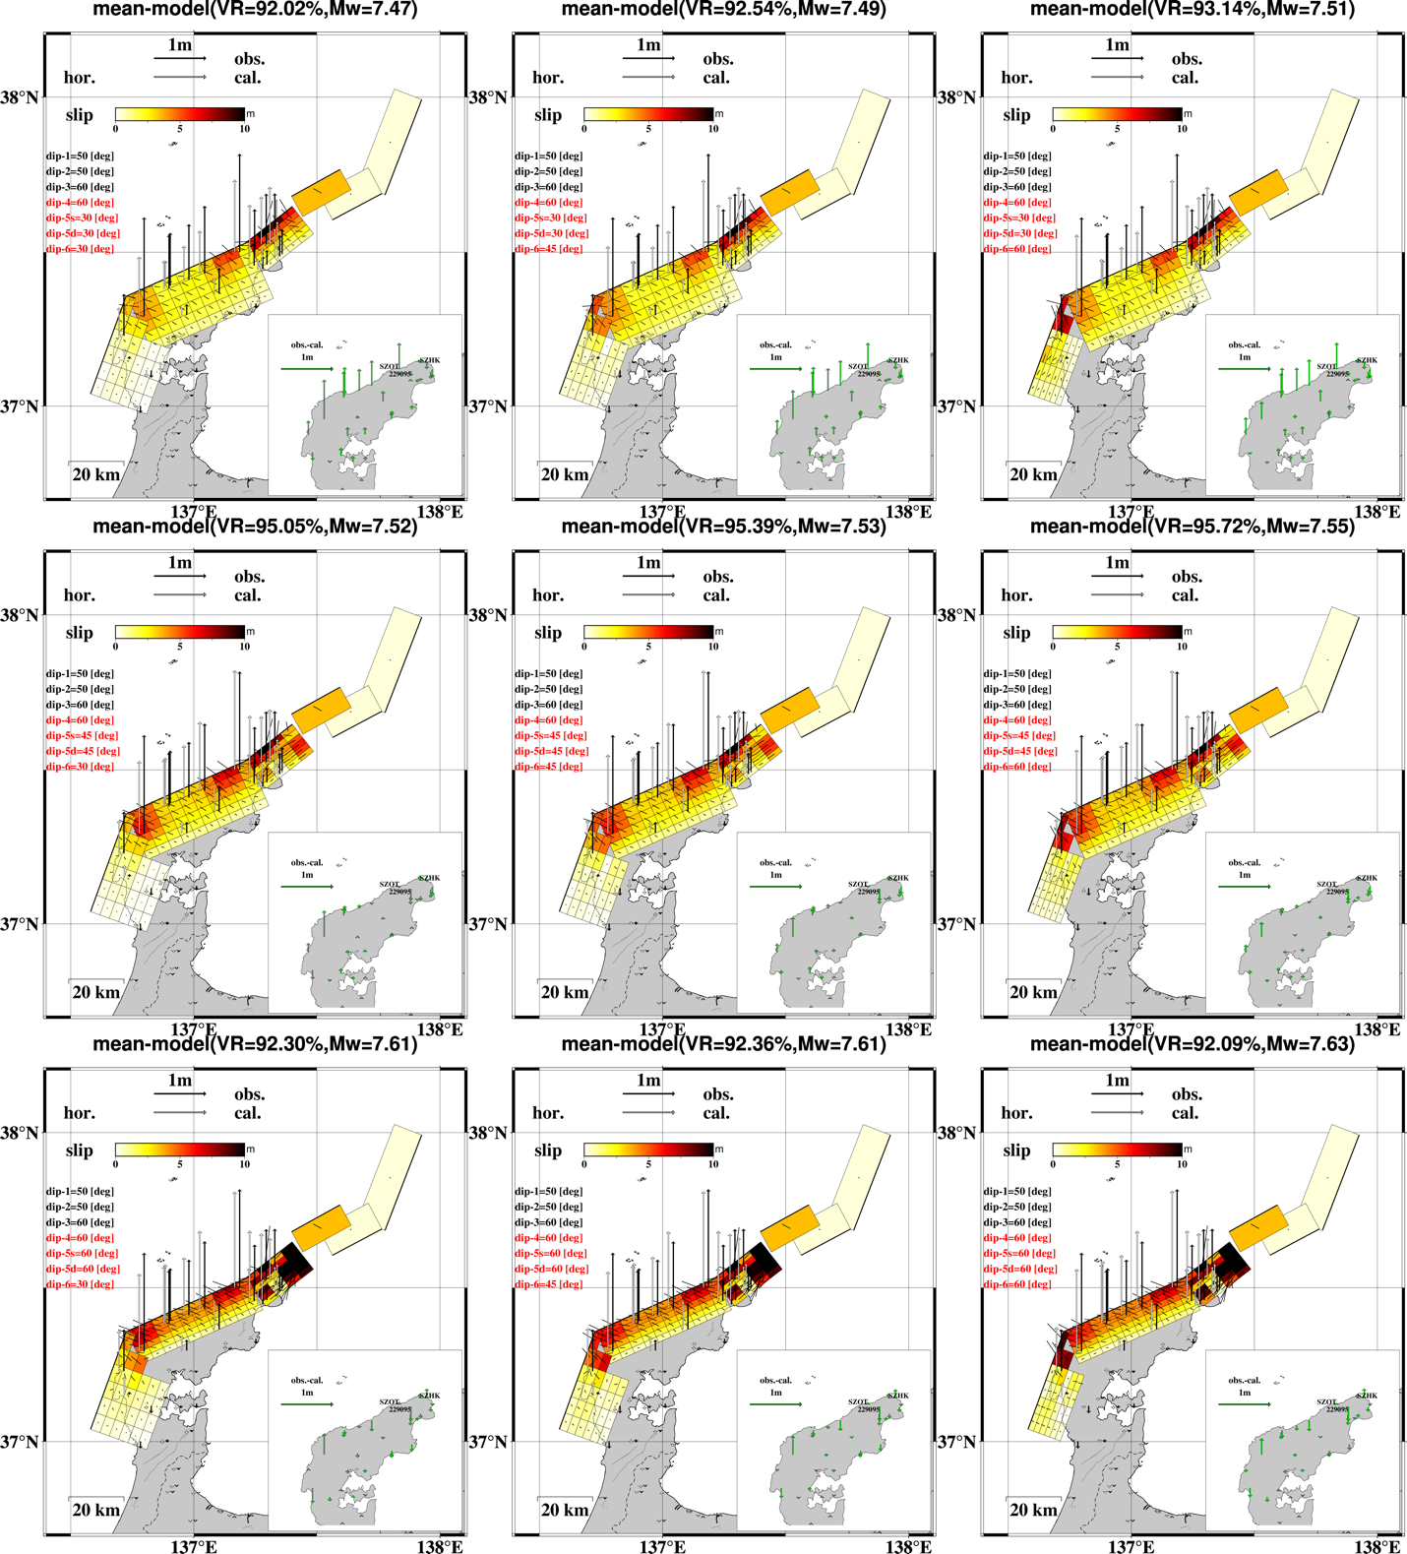

Figure S3(f) The caption is given in Figure S3(a).
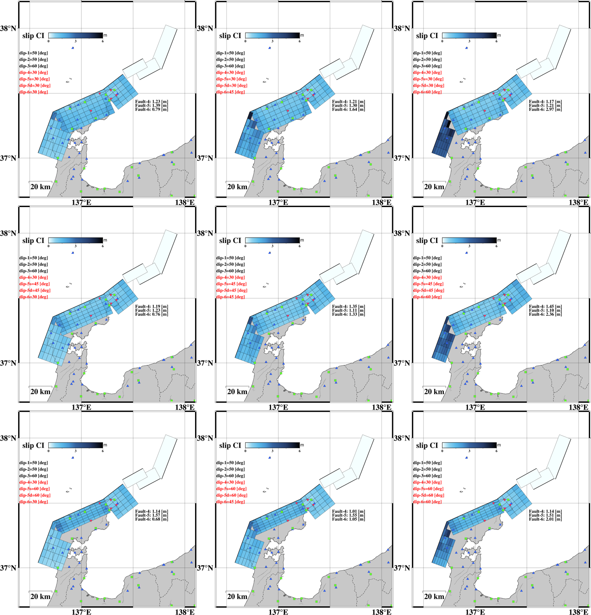

Figure S3(g) The caption is given in Figure S3(a).
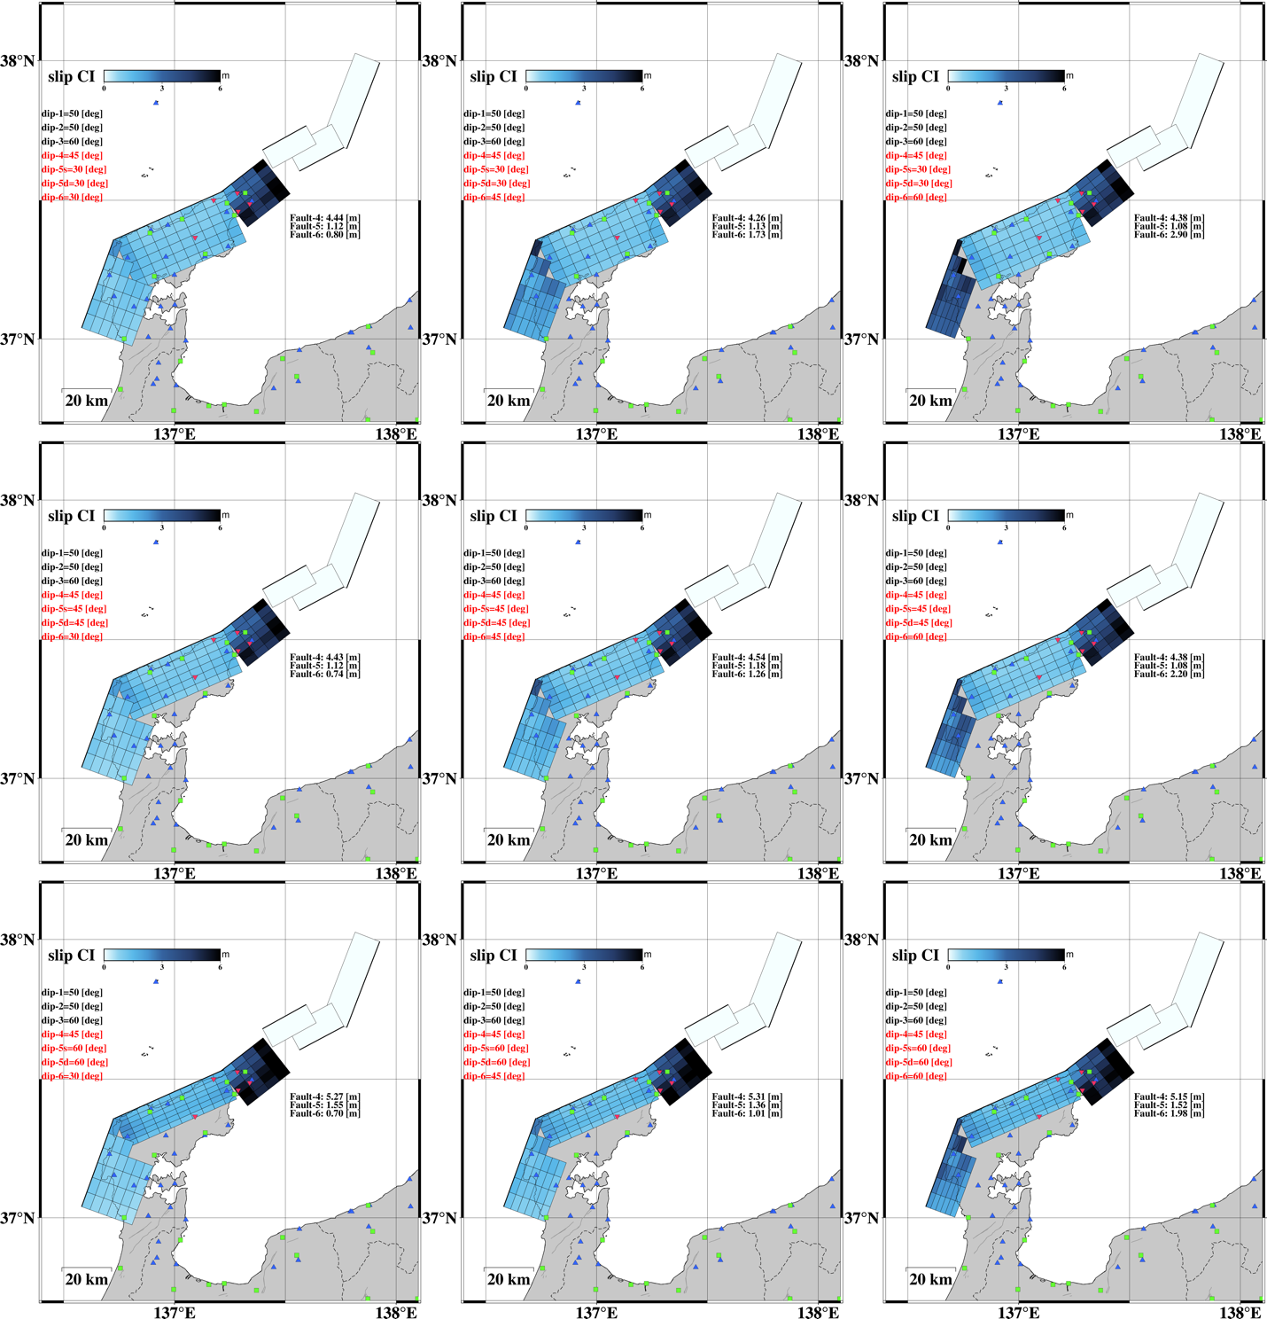

Figure S3(h) The caption is given in Figure S3(a).
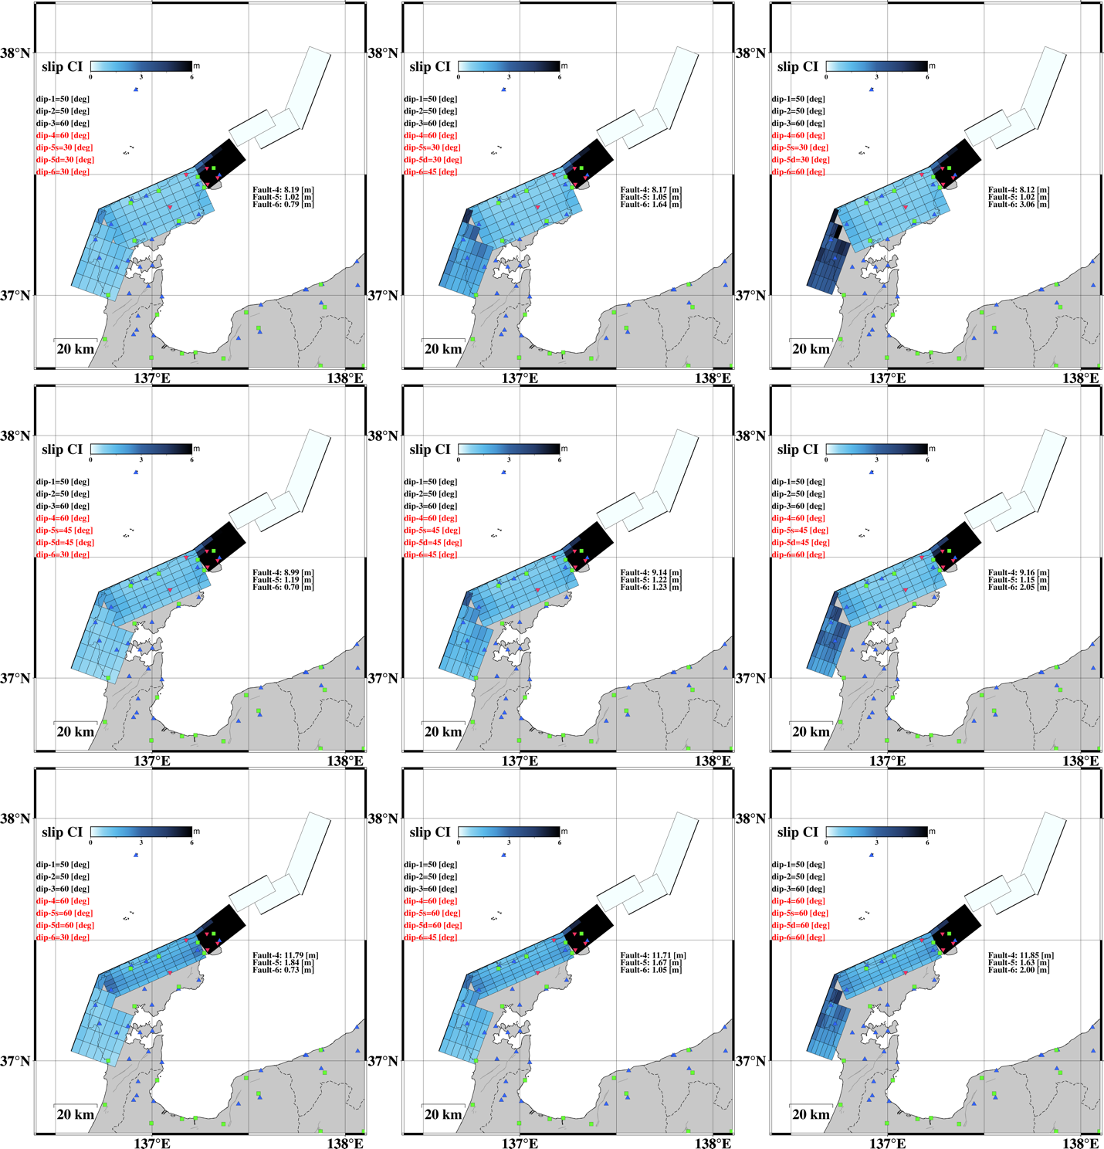

Figure S3(i) The caption is given in Figure S3(a).
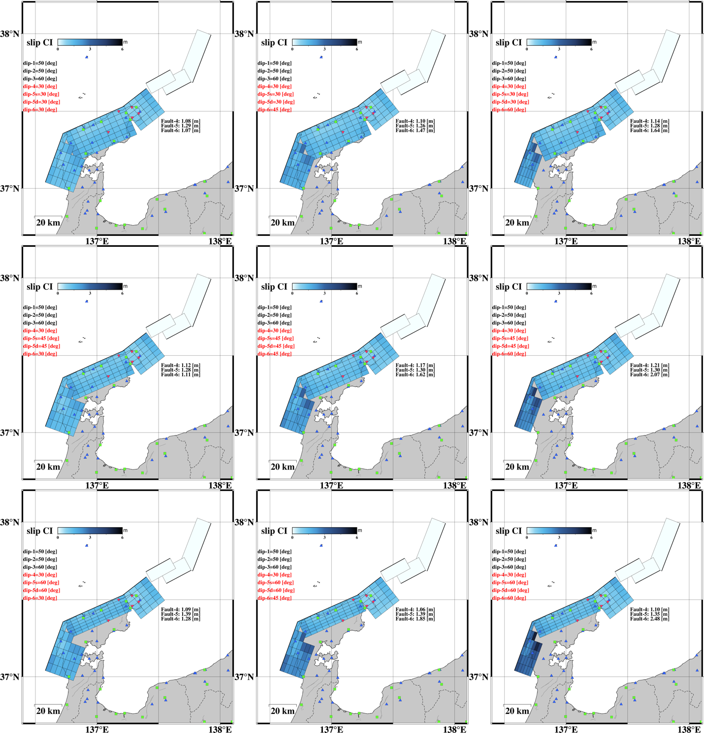

Figure S3(j) The caption is given in Figure S3(a).
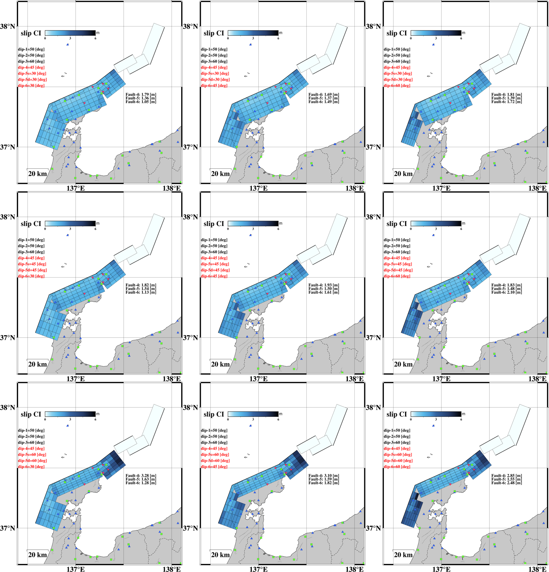

Figure S3(k) The caption is given in Figure S3(a).
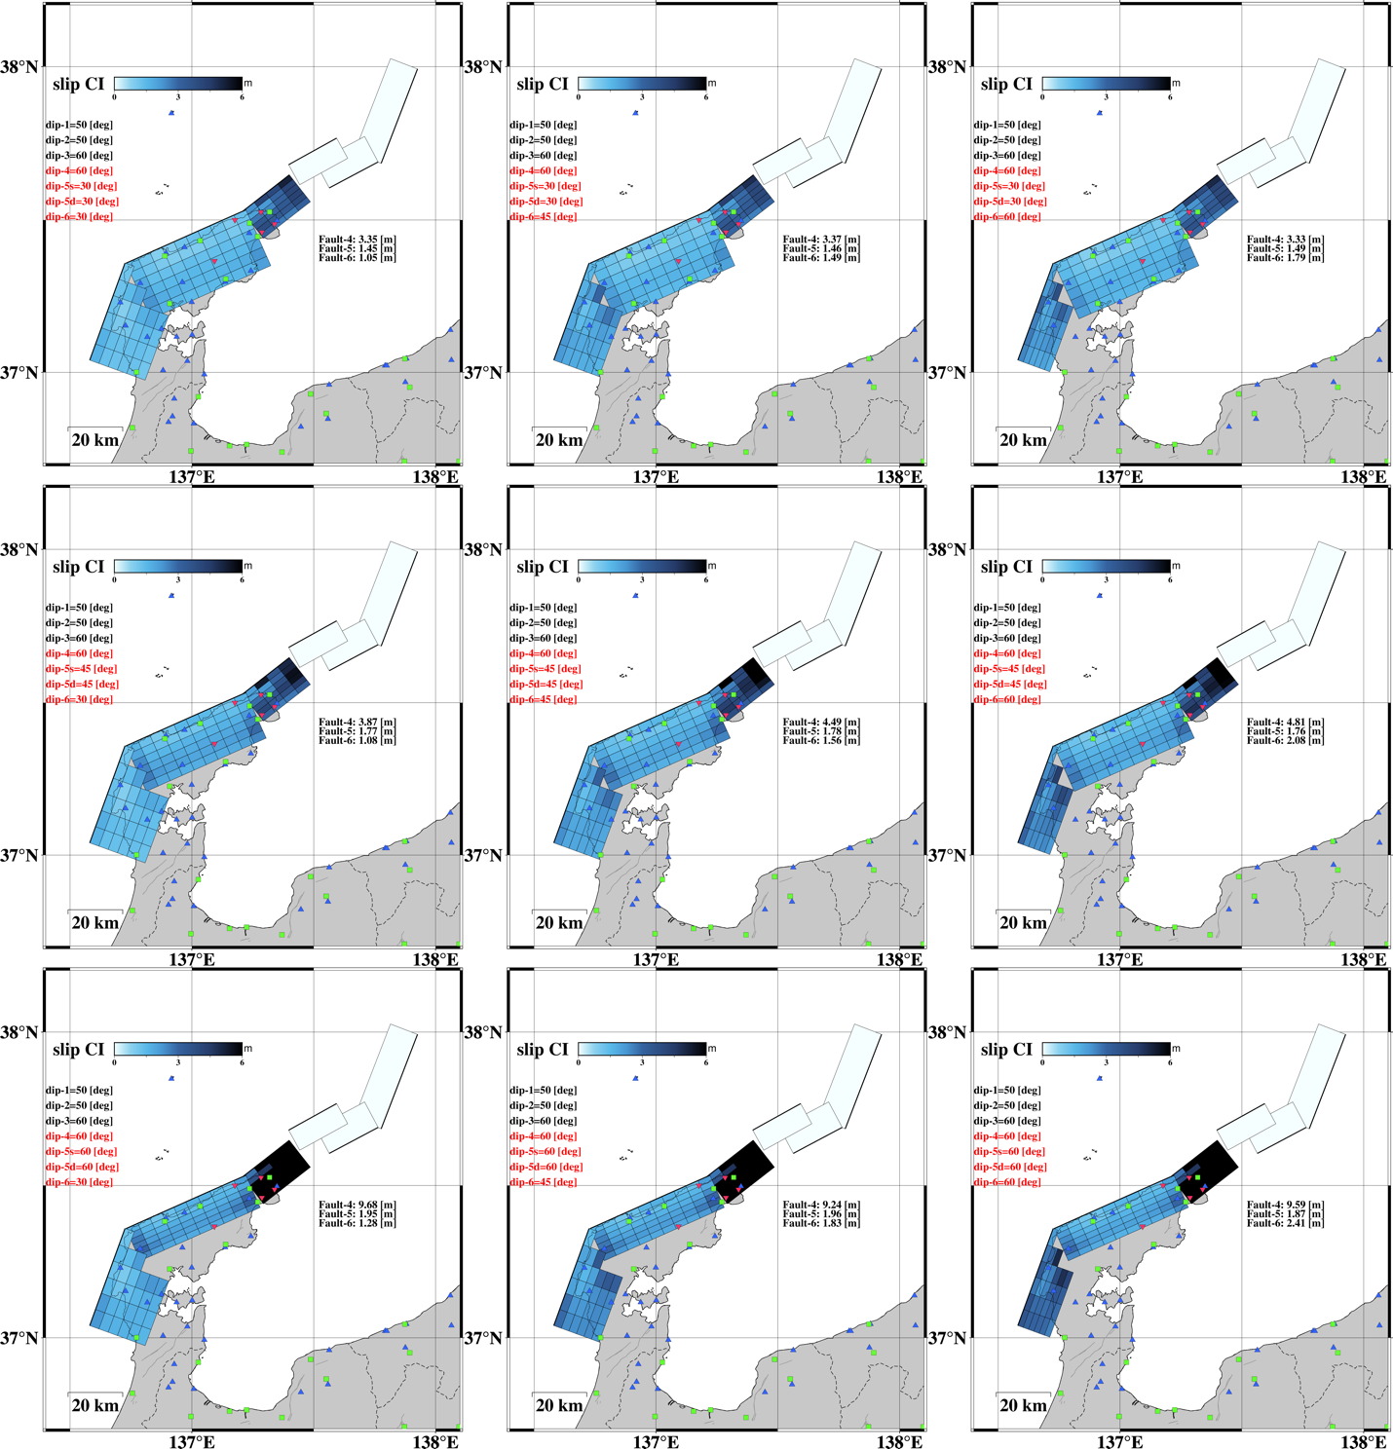

Figure S3(l) The caption is given in Figure S3(a).

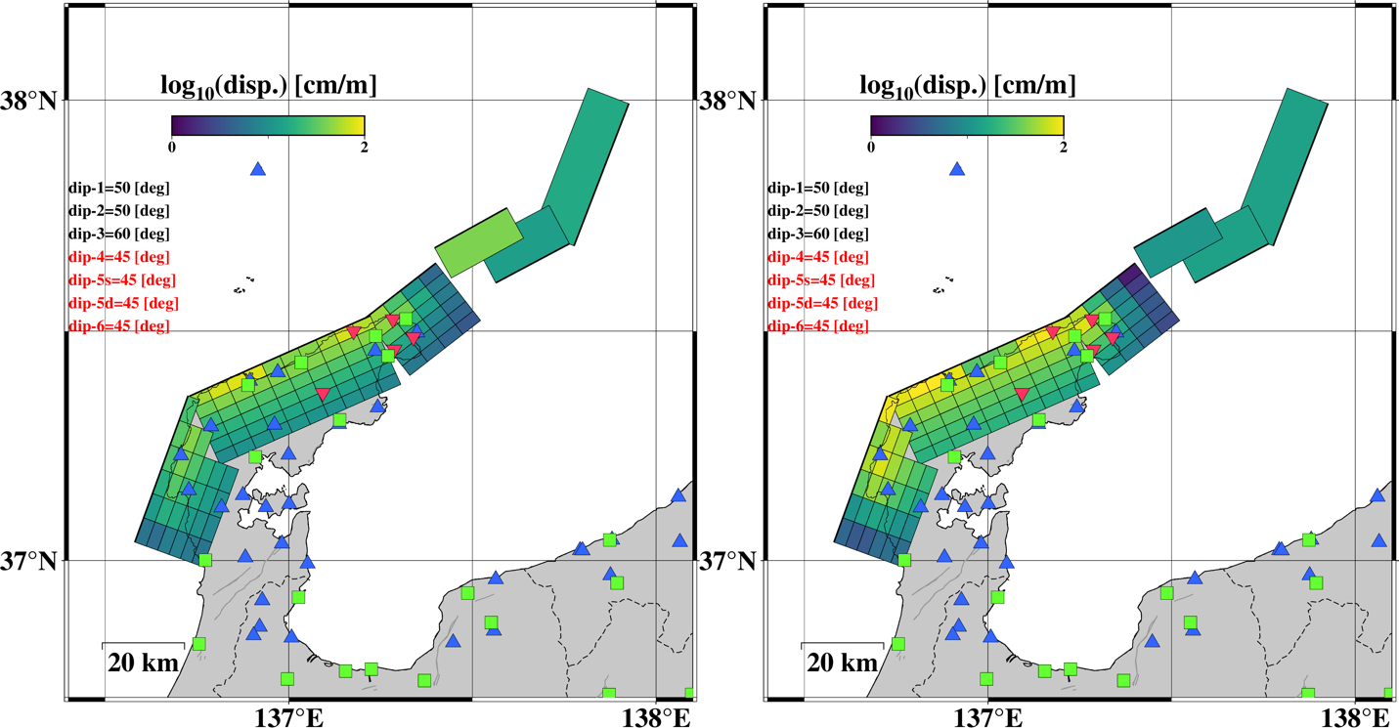

Figure S4
The sensitivity of the observation for each subfault. Total displacement norms at all stations and line-of-sight (LOS) points generated by (left) unit strike-slip and (right) unit dip-slip are displayed as "sensitivity". Blue triangles, red inverted triangles, and green squares indicate the stations operated by SoftBank, Universities, and GEONET, respectively. Note that the LOS point used in sensitivity calculation is hidden to avoid complication in the figure.

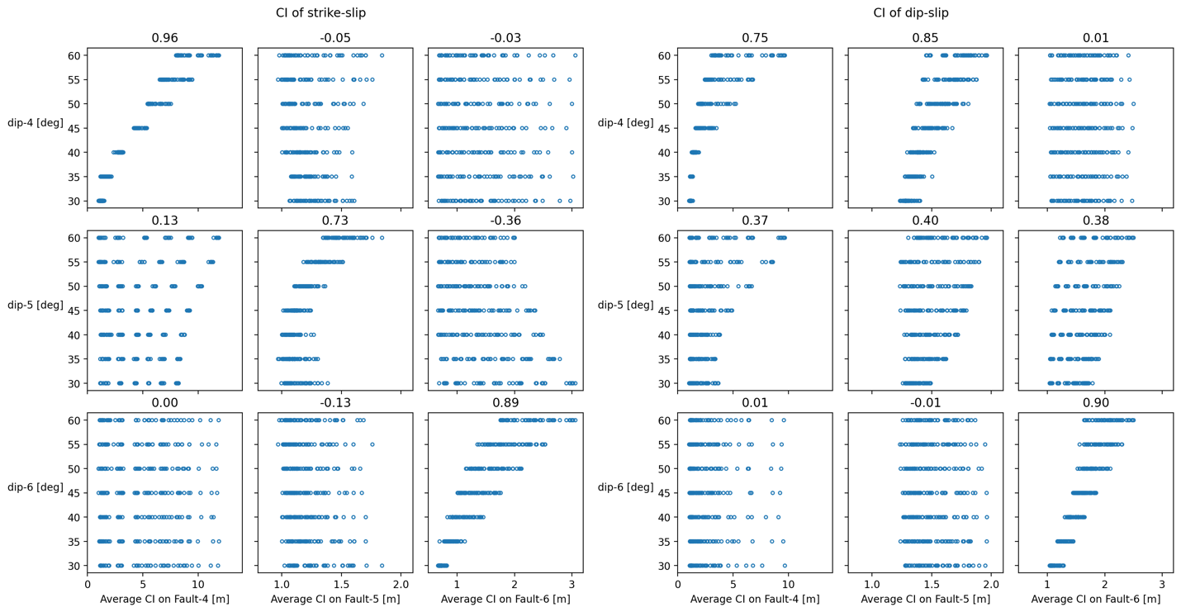

Figure S5
Averages of CI for all plain fault models. Panels (a, b) show the average of 60% CI of strike- and dip-slip, respectively, in the Fault 4, 5, and 6.

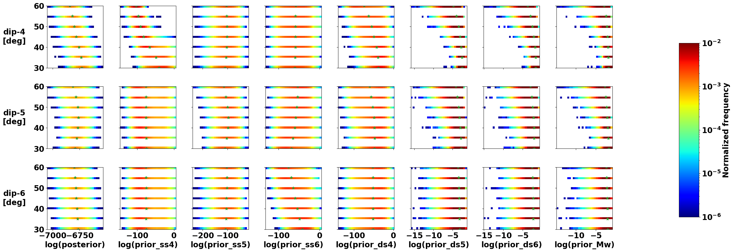

Figure S6
Two-dimensional histograms among assumed dip angles and each parameter in the inversion. Each panel shows the frequency in Markov chain Monte Carlo (MCMC) sampling by the color (warmer colors are higher). Green stars show the mean value in each dip angle. First column: a realization of the logarithmic posterior probability of each sample. 2–4th column: a realization of the logarithmic prior probability of the spatial smoothing for strike-slip on Fault i (i=4–6 corresponding to the Faults 4–6). 5–7th column: a realization of the logarithmic prior probability of the spatial smoothing for dip-slip on Fault i; 8th column: a realization of the logarithmic prior probability of the moment magnitude.

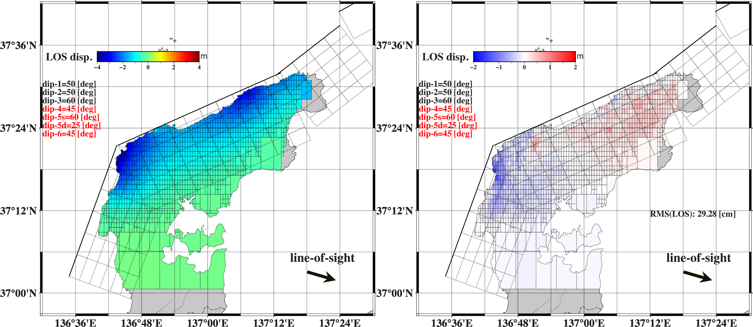

Figure S7
LOS displacements for the listric fault model. The Left and right panels show the calculation using the mean slip model in Figure 7 and the residual distribution subtracting calculation from observation, respectively.
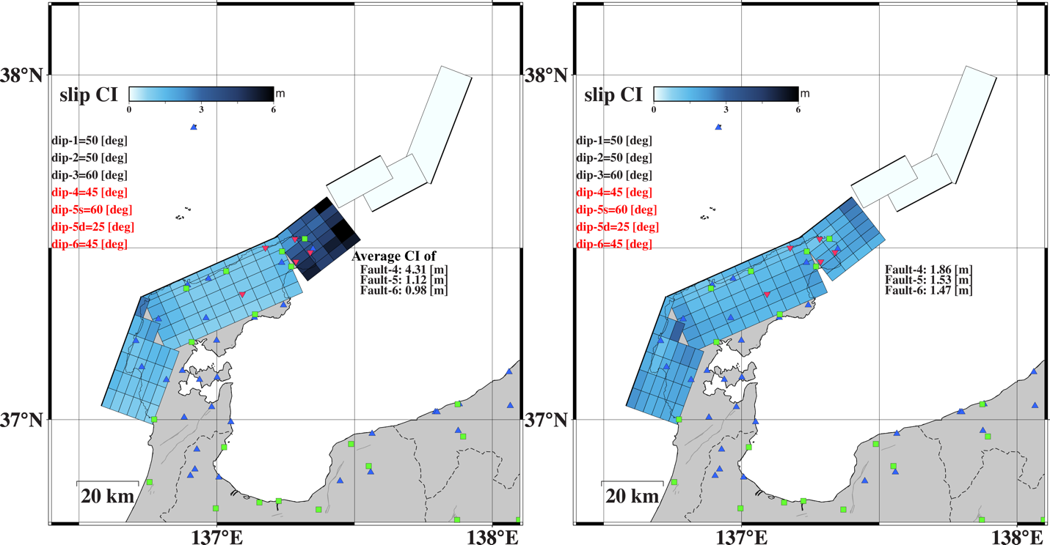

Figure S8
60% CI of the listric fault model. Left and right panels show the CI of strike- and dip-slip, respectively. GNSS stations are shown by the marker same as Figure S4.

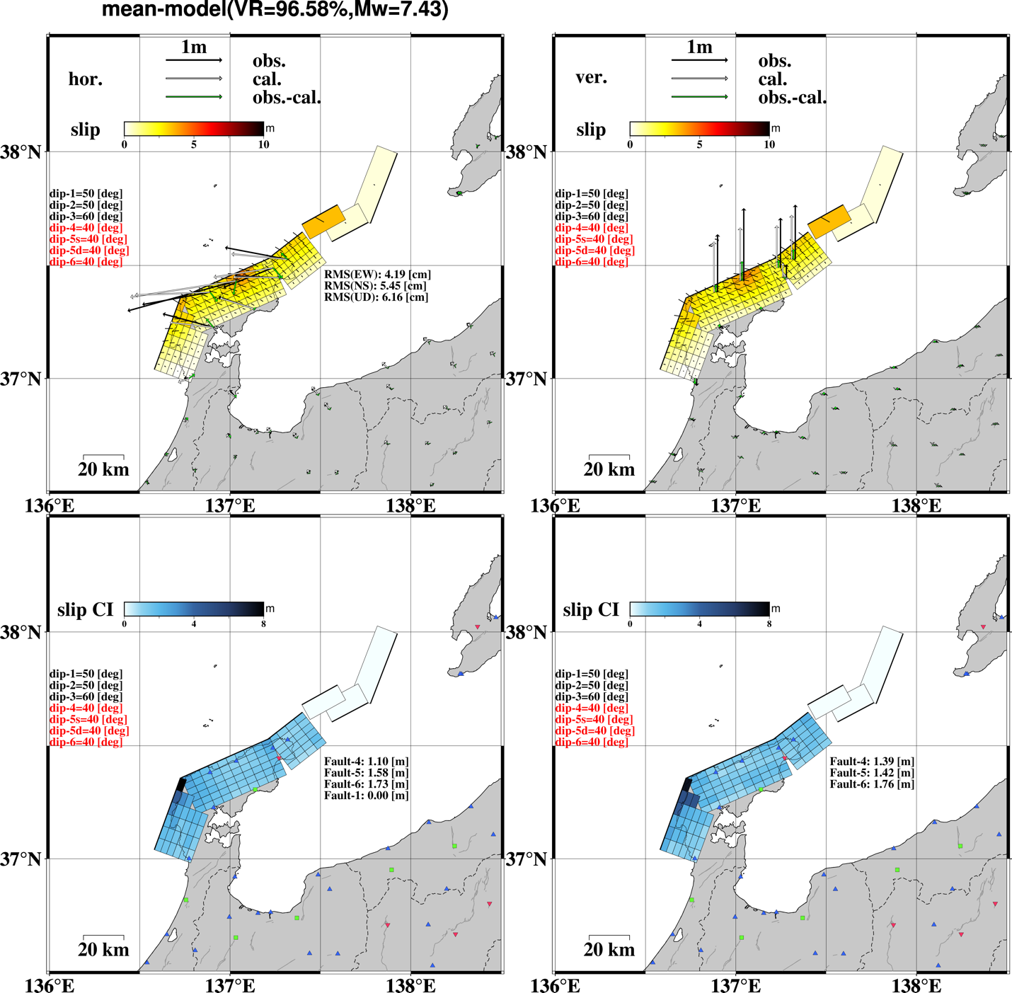

Figure S9
The results used only the GEONET stations. The top left and right panels show the horizontal and vertical models with mean slip models, respectively. The bottom left and right panels show the 60%CI of the strike- and dip-slip, respectively. The results are the case of 40° dip angle for dip-4, -5, -6. The objects follow the format of Figure S3.

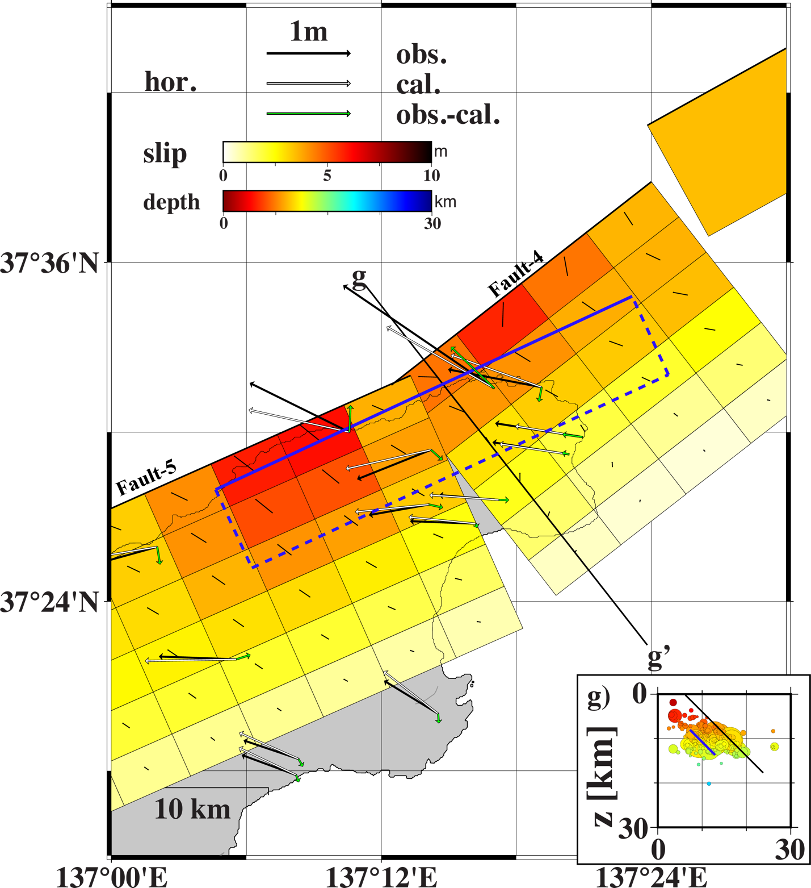

Figure S10
Simple validation with the additional rectangular fault. The warmer color painted on subfaults are coincident with the slip model in Figures 2(b, e). The additional fault is shown by the blue rectangular and the solid line indicates its top edge. The inset shows the cross section along line e-e'. The black and blue lines in the inset indicates Fault 4 and the additional fault projected e-e'.

