Supplement

Title: Ground deformation after the 2015 phreatomagmatic eruption at Kuchino-Erabujima Volcano, Japan detected by InSAR time series analysis with ALOS-2

Authors: Misa Ichimura, Kano Mikihara, Masayoshi Ishimoto, Tomokazu Kobayashi, and Hiroshi Munekane

Text S1
Fig. S1
Fig. S2

Text S1: Efficiency of the stacking-correction method

First, we confirmed the efficiency of the stacking-correction method. The gray dots in Fig. 5 are the results without stacking correction, and the green, blue, and black dots are those with stacking correction. It is evident that stacking correction successfully reduced temporal fluctuations, which may correspond to noise. The correction was large, especially on the last observation date, September 2021, in the descending orbit. In the results without this correction (gray dots in Fig. 5a), the LOS lengthening at Points A and B in 2021 is synchronized with that at Point C, which is thought to have little deformation because it is far from the active crater. Therefore, these can be considered as apparent displacements, rather than volcanic deformations, in 2021. However, in the results with stacking correction (green, blue, and black dots in Fig. 5a), the displacement of each point was corrected by the amount of displacement observed at Point C without the correction. This indicates that the stacking correction can remove the apparent displacement around the summit, which cannot be reduced even by phase optimization.
Deviations in displacement between the InSAR time series analysis without stacking correction and the GNSS observations were observed in August and November 2019, June 2020, and September 2021 in the descending orbit (gray points in Fig. 6a). This is thought to be due to noise in the interferograms caused by increased water content in the atmosphere and soil, which is characteristic of summer. In the displacement with stacking correction, these effects were removed, and the deviation from the GNSS observation was smaller (green, blue, and black dots in Fig. 6a). Thus, the results of the InSAR time series analysis with stacking correction in this study are consistent with the GNSS observations.

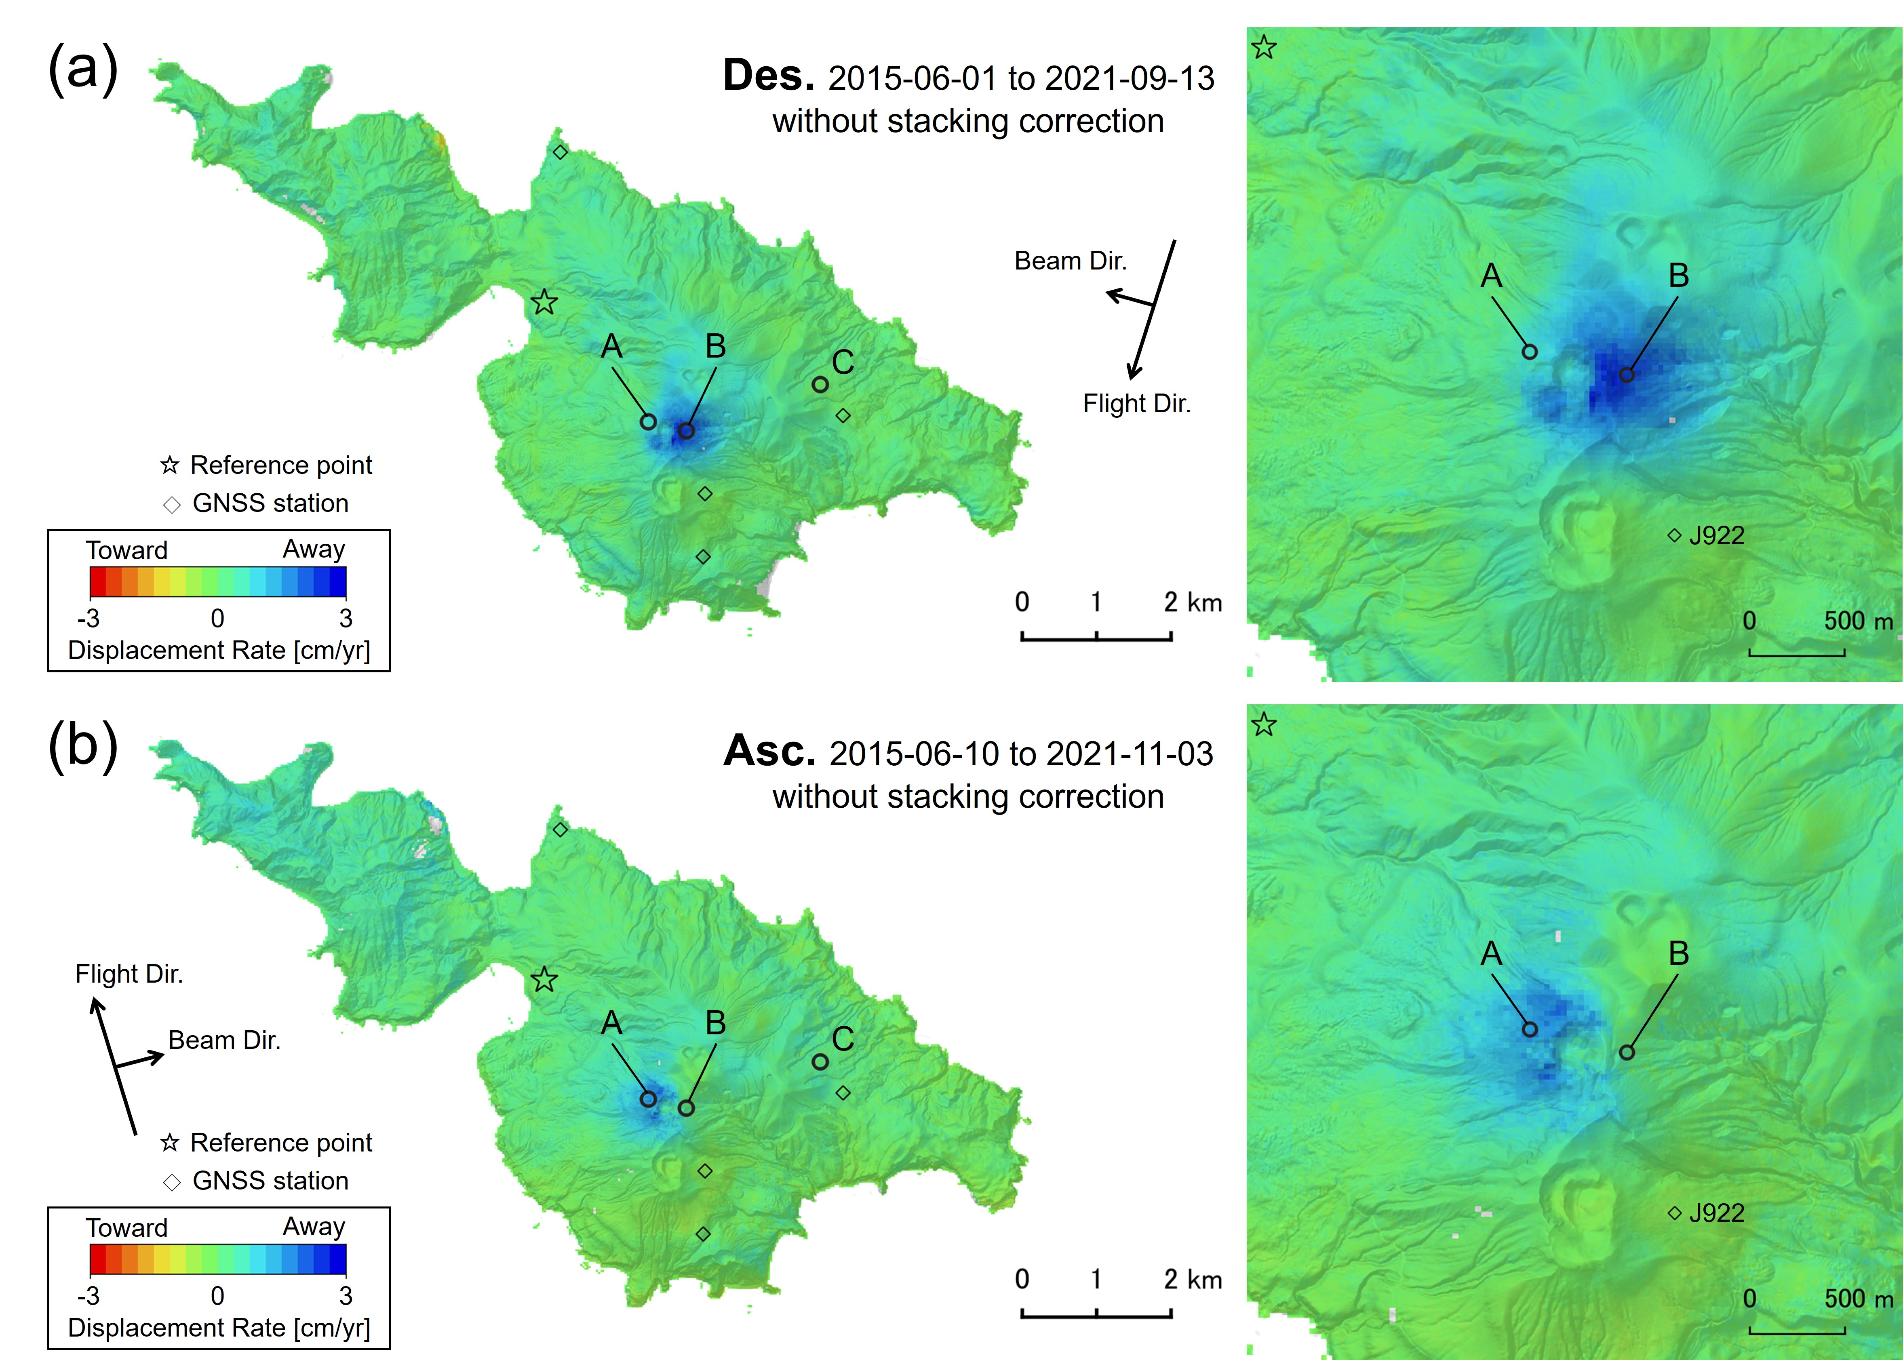
Fig. S1: Distribution of displacement rate in LOS direction without stacking correction. (a) the descending and (b) the ascending orbit. Legend is the same as in Fig. 3.

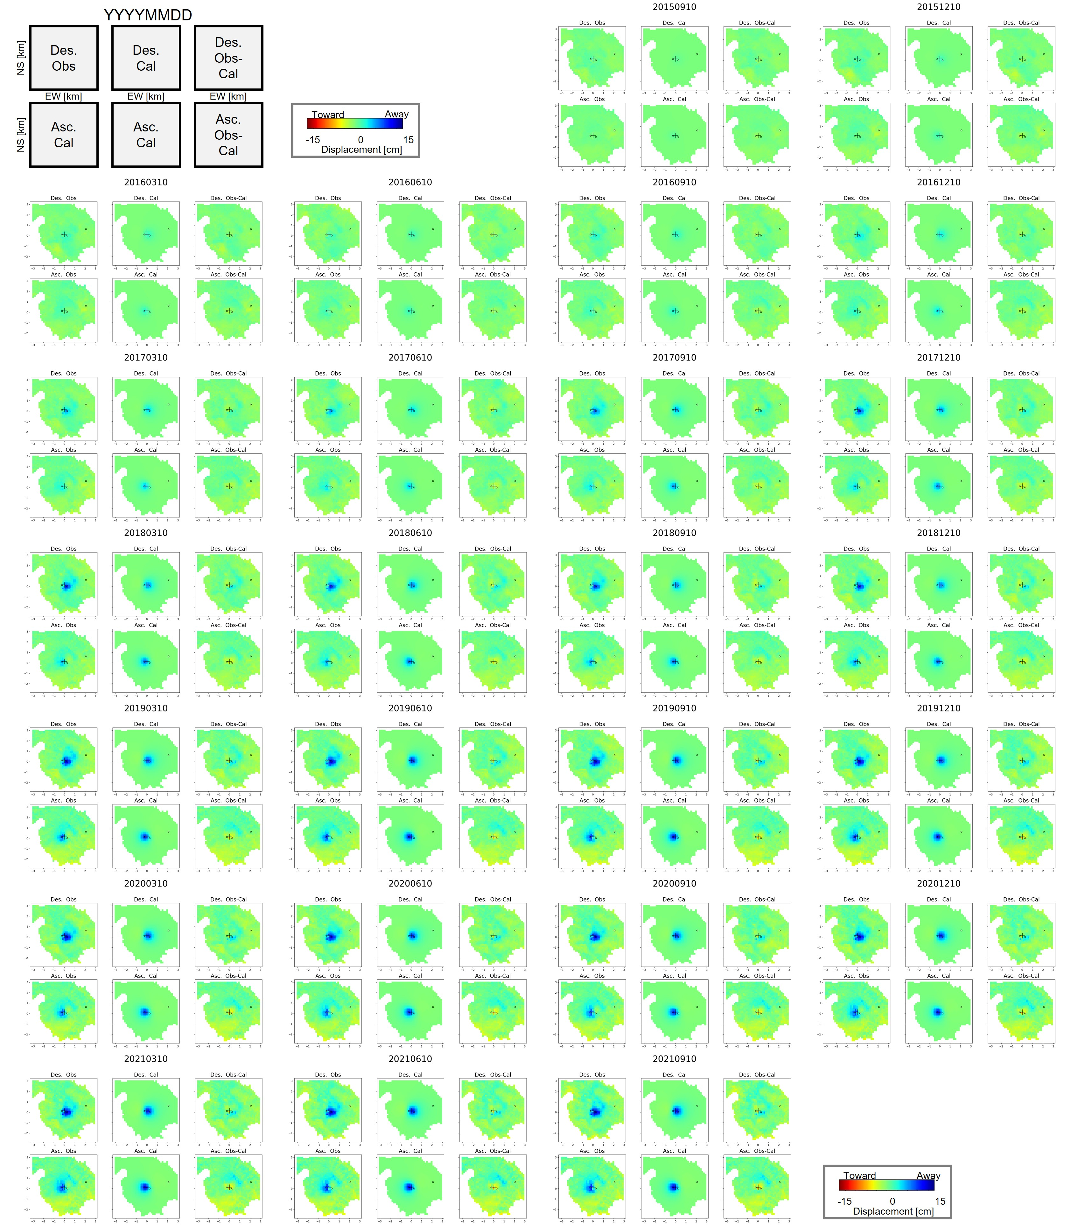
Fig. S2: Comparison of LOS displacements for each epoch in the estimation of source volume change. For each epoch, the left, middle, and right figures show the observed, modeled, and residual displacement in (upper) the descending and (lower) the ascending orbit, respectively. The vertical and horizontal axes represent the distance from the center of the summit crater of Shin-dake. A cross represents the location of the fixed pressure source (Fig. 8a). The color shows the amount of displacement since June 2015. Open circles show Points A and B in Fig. 3.

