Supplementary material to:
Steep reverse faulting adjacent to the hypocenter of the 1923 Kanto earthquake: The Mw 5.0 western Kanagawa earthquake in eastern Japan on 9 August 2024

*Yasunori Sawaki^{1,2}, Takahiro Shiina², and Takahiko Uchide²

¹College of Science and Engineering, Ritsumeikan University, Kusatsu, Japan
²Geological Survey of Japan, National Institute of Advanced Industrial Science and Technology (AIST), Tsukuba, Japan
Correspondence to Yasunori Sawaki (sawaki-y@fc.ritsumei.ac.jp)

Introduction
This supplementary material consists of five tables (Table S1–S5), and six figures (Figs. S1–S6). Tables S1, S2, S4, and S5 are in the additional files 2–5 in CSV format, respectively.

Tables and table descriptions
Table S1 Seismic station list used in this study (cf. Additional file 2).
Table S2 The relocated hypocenters using hypoDD (cf. Additional file 3).
Table S3 Parameters used for calculating PCNVs, clustering, and controlling the quality of fault planes.
Steps | Notation | Description | Values
STEP 1:  PCNV | $$k^{NV}$$ | Number of nearest neighbors for performing PCA | 150
STEP 1:  PCNV | $$r^{NV}$$ | Maximum radius to find nearest neighbors for performing PCA | 0.4 km
STEP 2:  Clustering  (HDBSCAN) | $$m_{pts}$$ | Number of nearest neighbors to calculate a core distance | 5
STEP 2:  Clustering  (HDBSCAN) | $$m_{clSize}$$ | Minimum size to be considered a cluster | 5
STEP 3:  Quality control | $$θ^{EV}$$ | Angular threshold to preserve the consistency between PCNVs and the fault normal | 30$°$
STEP 3:  Quality control | $$N_{min}$$ | Minimum number of points in a cluster | 20
Table S4 Clustering result with hypocenters for each cluster (Additional file 4 in CSV format).
Table S5 Clustering result with fault parameters of the extracted fault planes (Additional file 5 in CSV format).

Figures
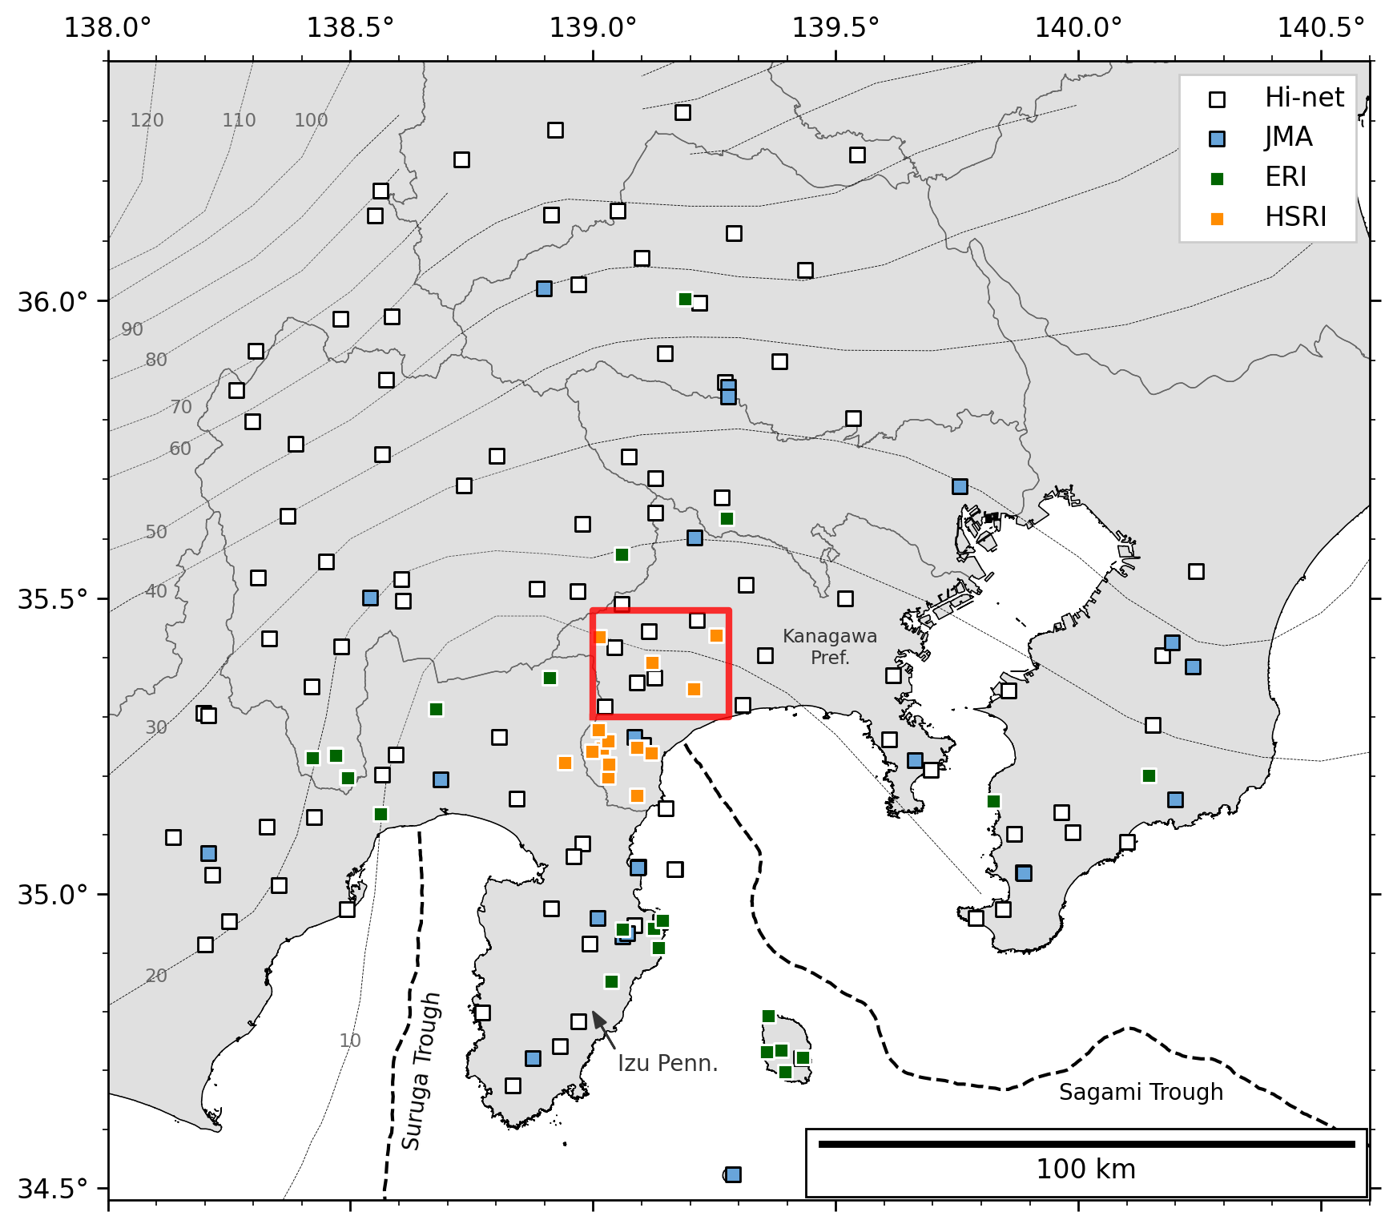
Fig. S1 Map showing seismic stations used in this study. White, blue, green, and orange squares denote stations from the National Research Institute for Earth Science and Disaster Resilience (NIED) Hi-net (NIED 2019), the Japan Meteorological Agency (JMA), Earthquake Research Institute, the University of Tokyo (ERI), and Hot Springs Research Institute of Kanagawa Prefecture (HSRI), respectively. The list of stations in this study is in Table S1. Black and gray dashed lines denote the top surface of PHS from Hirose et al. (2008b, a) and Nakajima et al. (2009), respectively. The red box is the same as that shown in Fig. 1a.
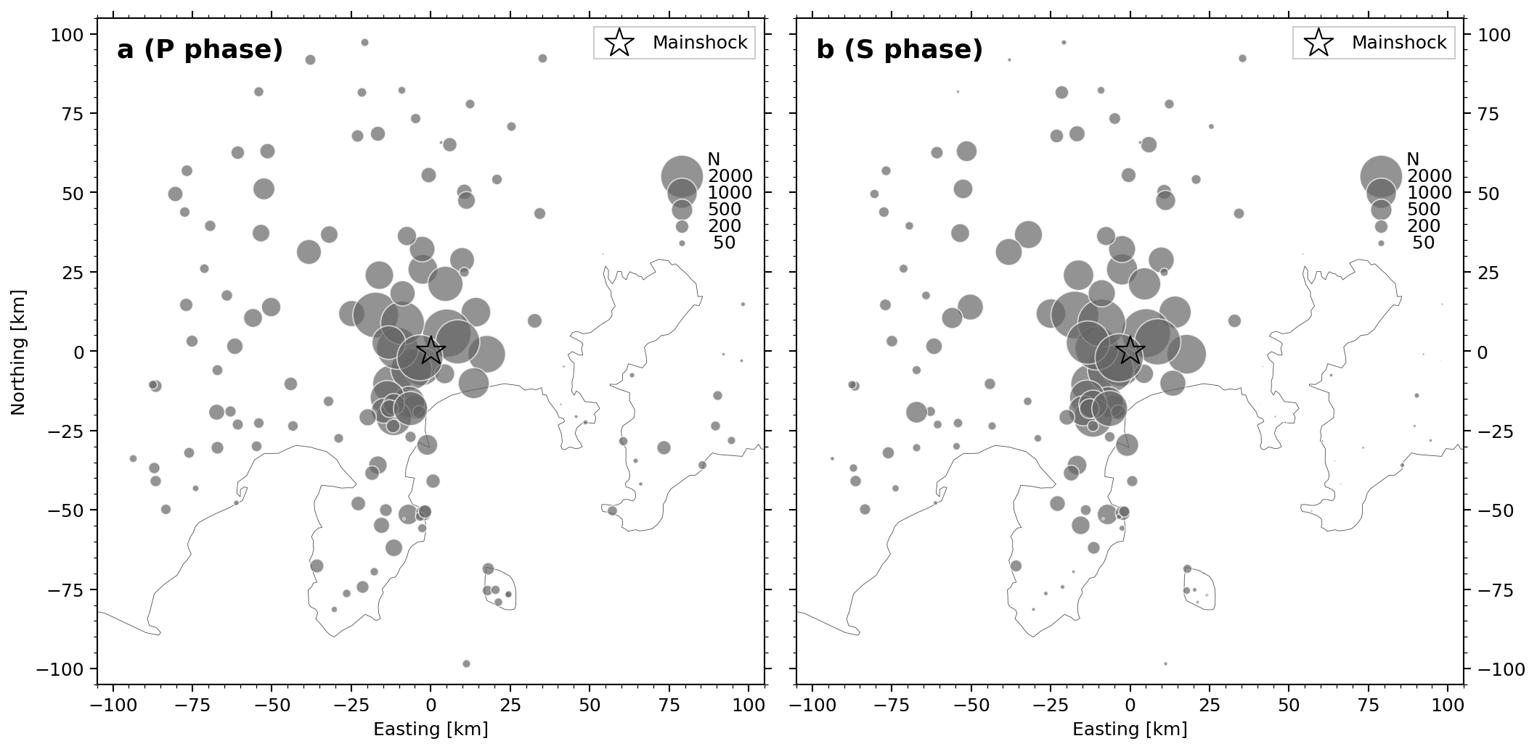
Fig. S2 Map showing the total number of picks in this study for (a) P and (b) S phases in each station. The radius of a solid circle corresponds to the number of picks at each station. The star indicates the epicenter of the Mw 5.0 earthquake.
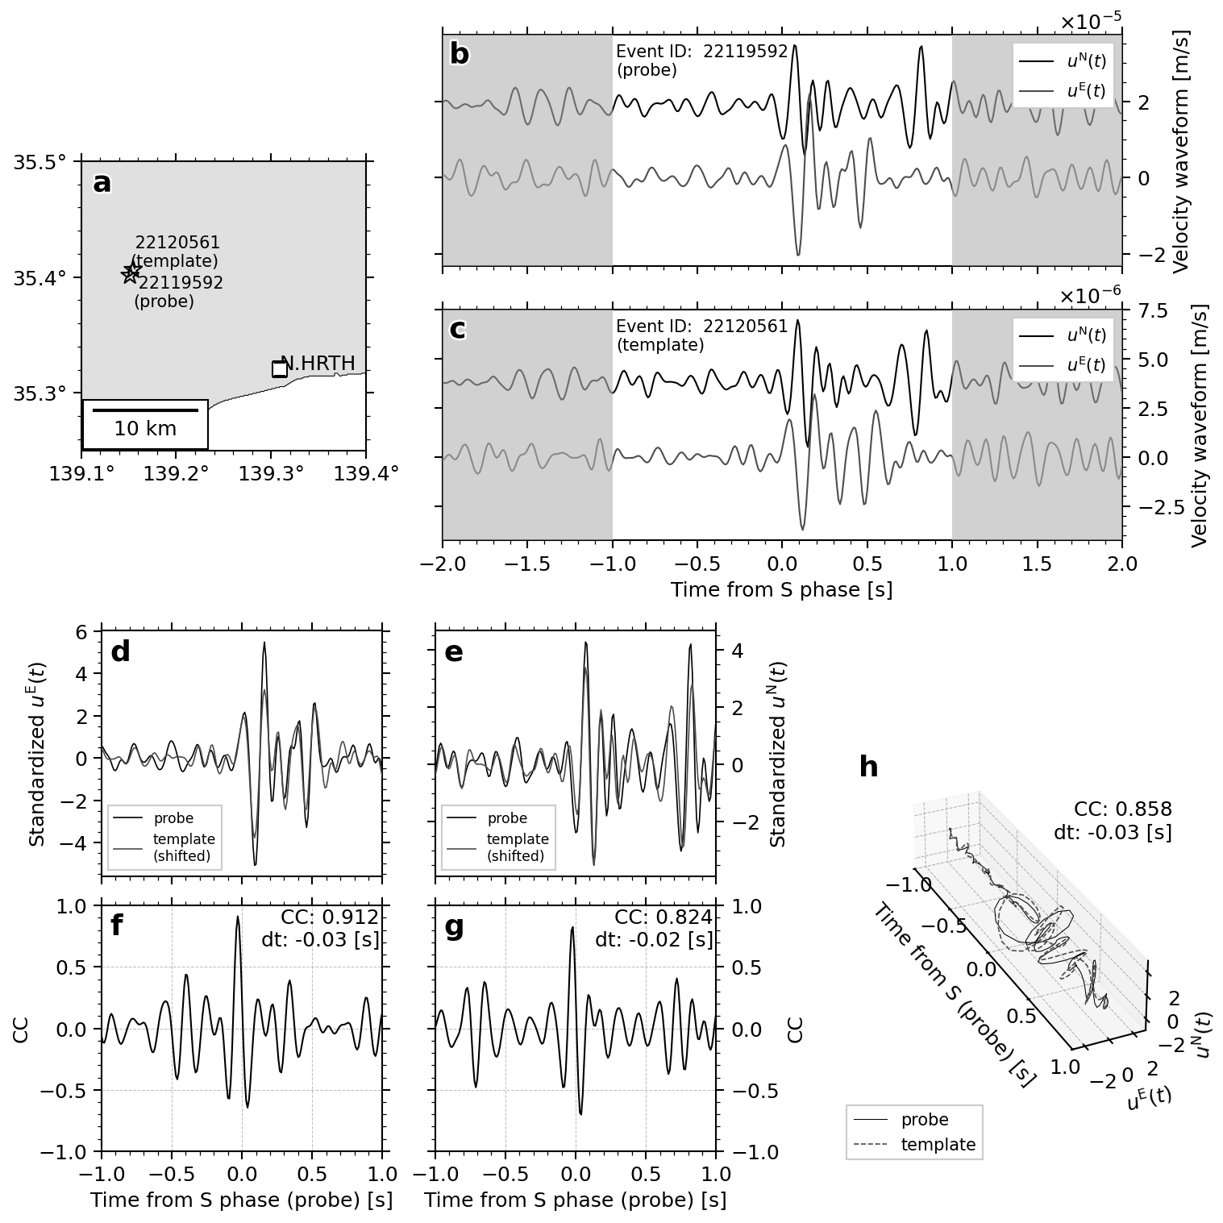
Fig. S3 Comparison of the horizontal-component cross correlation between two event waveforms. (a) Map showing the station (N.HRTH) and target events. (b, c) Waveforms around the S phase for (b) probe and (b) template events, respectively. Black and gray waveforms correspond to N- and E-component waveforms, respectively. (d, e) Standardized E- and N-component waveforms, respectively. Black and gray waveforms are for fixed and moving (time shift applied) events, respectively. (f, g) CC functions for E and N components, respectively. (h) The particle motion over time.
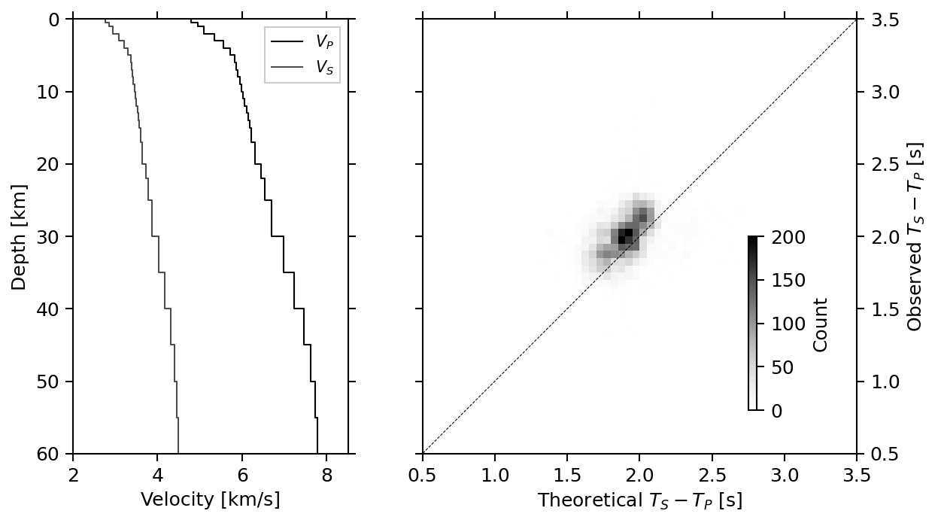
Fig. S4 Heatmap comparing theoretical and observed S−P times of detected events at stations within 10 km of the mainshock epicenter. The slight excess in observed values likely reflects limitations in the velocity model and the effect of station corrections, though any resulting depth bias would be no more than 1 km. The left panel shows the JMA2001 one-dimensional velocity model (Ueno et al. 2002), used for hypoDD and calculation of theoretical S−P times.
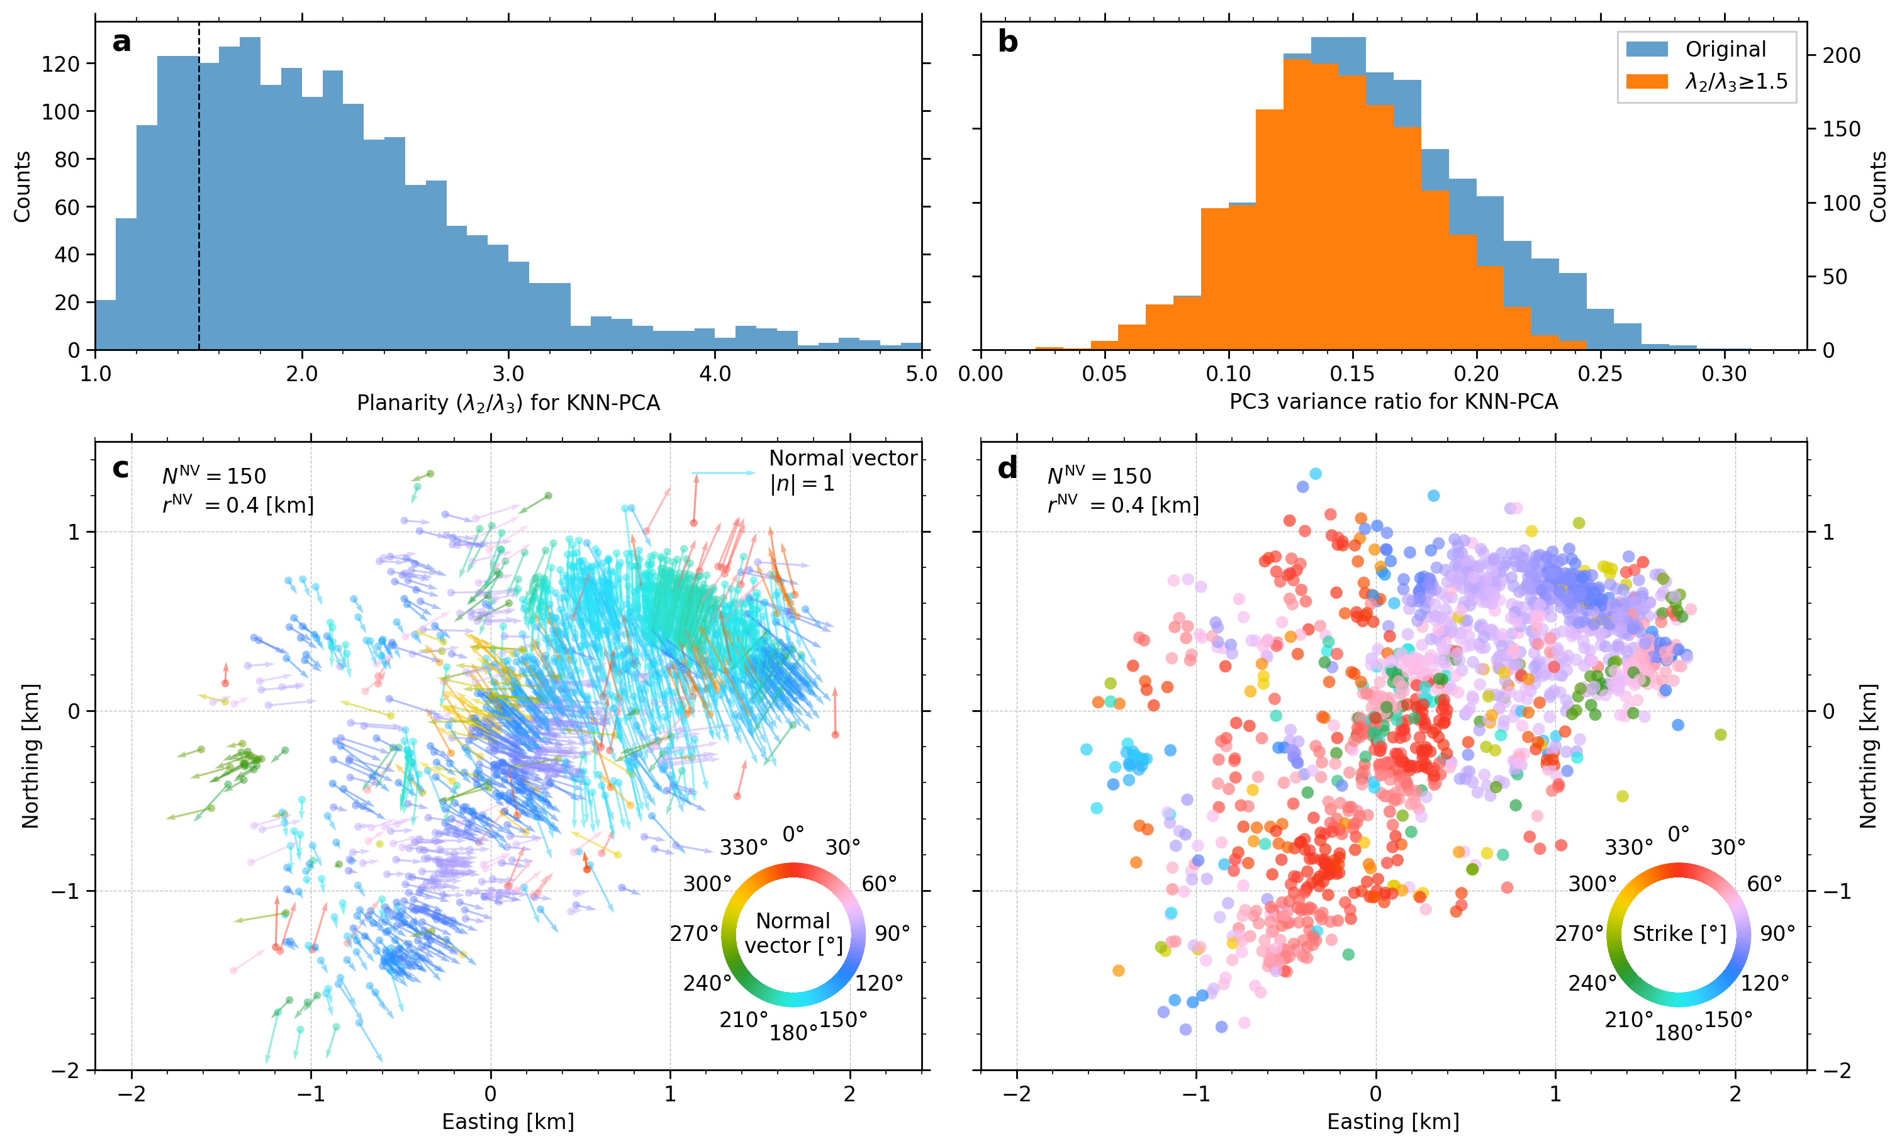
Fig. S5 Distribution of PCNVs. (a) Histogram showing planarity of PCNVs. The dashed line denotes the threshold, below which PCNVs were discarded. Note that planarity greater than 5.0 is not shown. (b) Histogram showing variance ratio for PC3 component. Blue and orange bars for all data and data selected by planarity control, respectively. (c) Calculated PCNVs with colors coded by horizontal azimuths. Arrow lengths represent the horizontal size of PCNVs. (d) Apparent strike converted from horizontal azimuth of PCNVs. It is defined by the horizontal azimuth of PCNV counterclockwise rotated by 90 degrees.
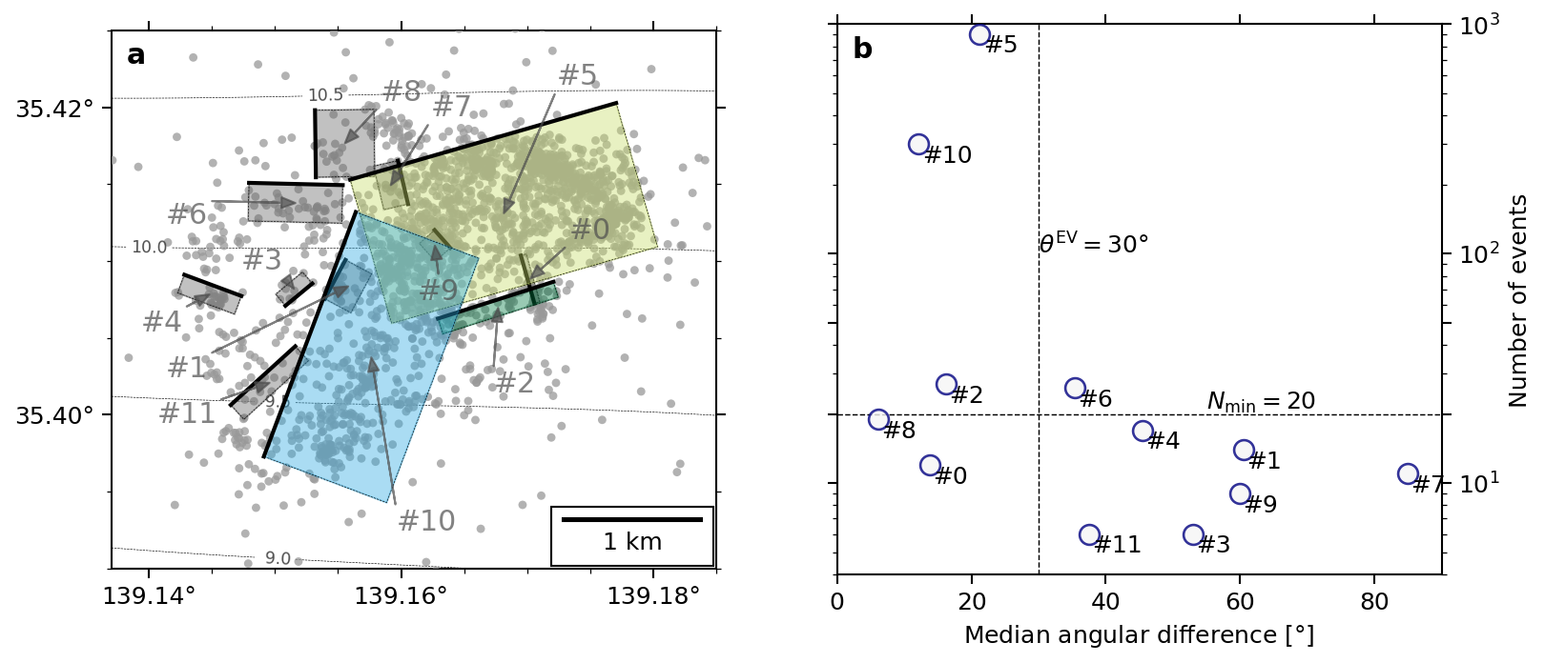
Fig. S6 Hypocenter clustering result with all clusters. (a) Fault plane for each cluster. Planes with dark gray (#0, #1, #3, #4, #6, #7, #8, #9, and #11) were rejected clusters by quality control, shown in (b).

References​
Hirose F, Nakajima J, Hasegawa A (2008a) Three-dimensional seismic velocity structure and configuration of the Philippine Sea slab in southwestern Japan estimated by double-difference tomography. J Geophys Res Solid Earth 113:B09315. https://doi.org/10.1029/2007JB005274
Hirose F, Nakajima J, Hasegawa A (2008b) Three-Dimensional Velocity Structure and Configuration of the Philippine Sea Slab beneath Kanto District, Central Japan, Estimated by Double-Difference Tomography [in Japanese with English abstract]. Zisin (Journal of the Seismological Society of Japan 2nd ser) 60:123–138. https://doi.org/10.4294/zisin.60.123
Nakajima J, Hirose F, Hasegawa A (2009) Seismotectonics beneath the Tokyo metropolitan area, Japan: Effect of slab-slab contact and overlap on seismicity. J Geophys Res 114:B08309. https://doi.org/10.1029/2008JB006101
National Research Institute for Earth Science and Disaster Resilience (2019) NIED Hi-net. https://doi.org/10.17598/nied.0003
Sawaki Y, Sato Y, Uchide T (2025a) FaultNVC: Earthquake Fault Plane Extractor through Point-Cloud Normal Vector Clustering for Hypocenter Distributions. Open-File Report of the Geological Survey of Japan, AIST no. 759. https://www.gsj.jp/publications/pub/openfile/openfile0759.html
Sawaki Y, Shiina T, Sagae K, et al (2025b) Fault Geometries of the 2024 Mw 7.5 Noto Peninsula Earthquake from Hypocenter-Based Hierarchical Clustering of Point-Cloud Normal Vectors. J Geophys Res Solid Earth 130:e2024JB030233. https://doi.org/10.1029/2024JB030233
Ueno H, Hatakeyama S, Aketagawa T, et al (2002) Improvement of hypocenter determination procedures in the Japan Meteorological Agency (in Japanese with English abstract). Quarterly Journal of Seismology 65:123–134

