Supporting Information for article
“A DGRF 2020 candidate model only based on Swarm ASM experimental vector mode data improved through a dedicated post-calibration strategy”

Gauthier Hulot, Université Paris Cité, Institut de physique du globe de Paris, CNRS, F-75005 Paris, France, gh@ipgp.fr
Louis Chauvet, Université Paris Cité, Institut de physique du globe de Paris, CNRS, F-75005 Paris, France, lchauvet@ipgp.fr
Robin Deborde, Université Paris Cité, Institut de physique du globe de Paris, CNRS, F-75005 Paris, France, deborde@ipgp.fr
Jean-Michel Léger, Département Système, CEA-Leti, Université Grenoble Alpes, MINATEC 17, rue des Martyrs, 38054, Grenoble Cedex 9, France, jean-michel.leger@cea.fr
Thomas Jager, Département Système, CEA-Leti, Université Grenoble Alpes, MINATEC 17, rue des Martyrs, 38054, Grenoble Cedex 9, France, thomas.jager@cea.fr
Martin Fillion, Université Paris Cité, Institut de physique du globe de Paris, CNRS, F-75005 Paris, France, fillion@ipgp.fr
Pierdavide Coïsson, Université Paris Cité, Institut de physique du globe de Paris, CNRS, F-75005 Paris, France, coisson@ipgp.fr

Corresponding author: Gauthier Hulot, gh@ipgp.fr

Abstract
This document provides supplementary figures to the article “A DGRF 2020 candidate model only based on Swarm ASM experimental vector mode data improved through a dedicated post-calibration strategy”.

Figure legends
Figure S1: Alpha satellite $ΔY_{ASM}=Y_{ASM}-Y_{ASM_Model}$ residuals of the $Y_{ASM}$ ASM-V component data with respect to the $Y_{ASM_Model}$ value predicted by the initial ASM-V parent model in the ASM reference frame, as a function of $Y_{ASM_Model}$. Each panel is for one one-hour interval of the LT at the location of data acquisition specified in the title of each panel. Best linear fit (equation (2)) in the least-square sense is shown in red solid line (2σ of data distribution about the best fit shown in magenta solid lines), with corresponding equation shown as inset. Note that only LT bins between 17 and 7 are shown for which enough data are available to provide meaningful results.
Figure S2: Bravo satellite $ΔY_{ASM}=Y_{ASM}-Y_{ASM_Model}$ residuals of the $Y_{ASM}$ ASM-V component data with respect to the $Y_{ASM_Model}$ value predicted by the initial ASM-V parent model in the ASM reference frame, as a function of $Y_{ASM_Model}$. Same plotting convention as in Figure S1.
Figure S3: Alpha satellite $ΔY_{VFM}=Y_{VFM}-Y_{VFM_Model}$ residuals of the $Y_{VFM}$ VFM component data with respect to the $Y_{VFM_Model}$ value predicted by the initial VFM parent model in the VFM reference frame, as a function of $Y_{VFM_Model}$. Same plotting convention as in Figure S1.
Figure S4: Bravo satellite $ΔY_{VFM}=Y_{VFM}-Y_{VFM_Model}$ residuals of the $Y_{VFM}$ VFM component data with respect to the $Y_{VFM_Model}$ value predicted by the initial VFM parent model in the VFM reference frame, as a function of $Y_{VFM_Model}$. Same plotting convention as in Figure S1.
Figure S5: Global linear regressions ${∆Y}_{ASM}=A_{ASM} Y_{ASM_Model}+B_{ASM}$ (equation (4)) and ${∆Y}_{VFM}=A_{VFM} Y_{VFM_Model}+B_{VFM}$ (equation (5)) of the ${∆Y}_{ASM}$ and ${∆Y}_{VFM}$ residuals from the initial ASM-V and VFM twin parent models, with respect to the $Y_{ASM_Model}$ and $Y_{VFM_Model}$ field components predicted by these models. All data residuals are used in those regressions, with no LT distinction. Each regression is done independently for the Alpha and Bravo satellites (see panel title). Best fit in the least-square sense is shown in red solid line with 2$σ$ of data distribution about this best fit shown in magenta solid lines. The grey line highlights the zero value reference. Values of the $A$ and $B$ regression parameters together with their 1$σ$ uncertainties are provided in the inset of each panel.
Figure S6: Same as Figure S5 when considering data after the first post-calibration step $and$the ASM-V and VFM twin parent models built using those data.

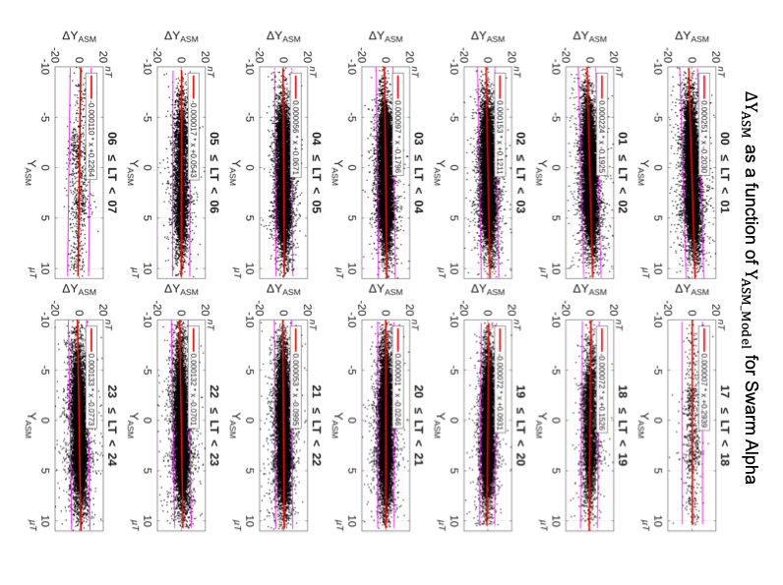
Figure S1

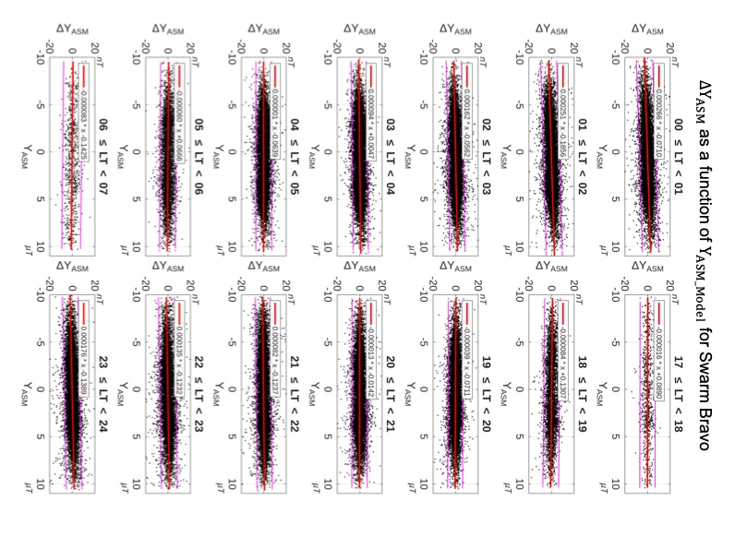
Figure S2

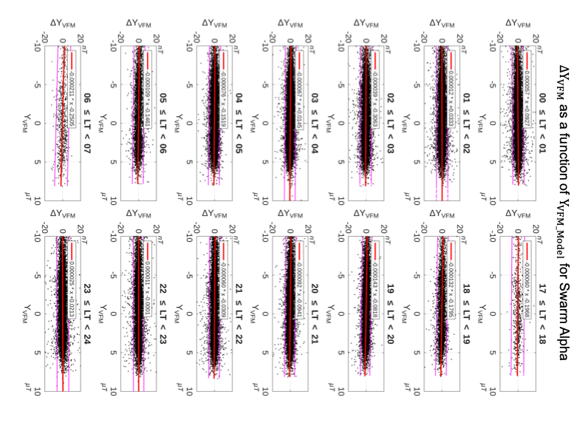
Figure S3

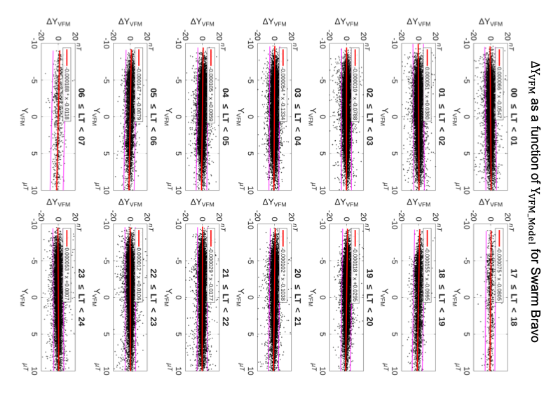
Figure S4

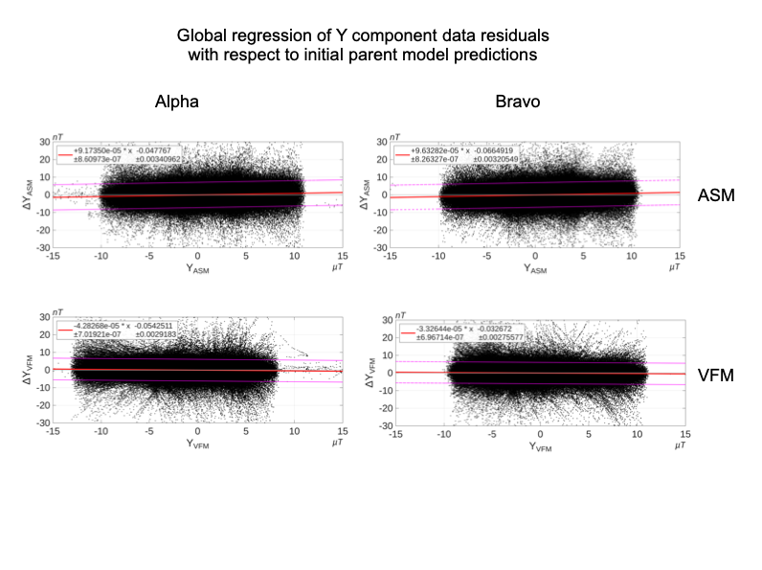
Figure S5

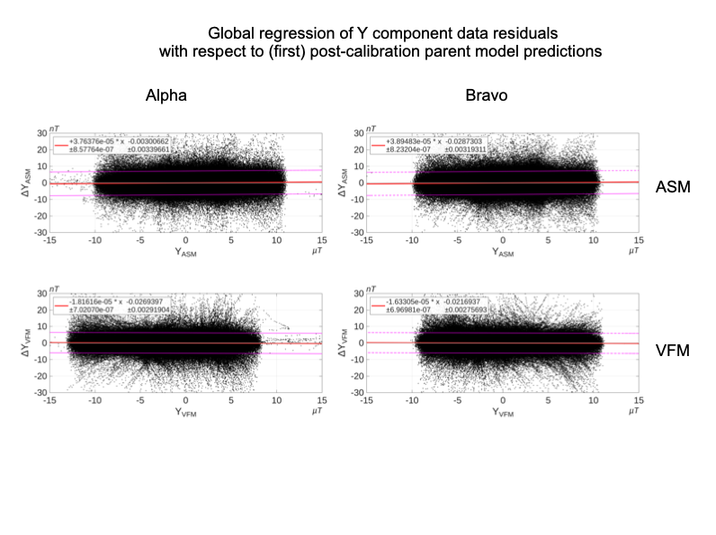
Figure S6

