Text S1. Derivation of Eq. (5)

To make the aspect ratio of the window close to 1:

$$\begin{aligned}n_{win_rg}p_{sp_rg}=n_{win_az}p_{sp_az}\#\left(S1\right)\end{aligned}$$
$$\begin{aligned}n_{win_rg}=n_{win_az}AR\#\left(S2\right)\end{aligned}$$

To get equivalent $σ_{po}$ with two different modes (i.e., different pixel spacing) under the same $γ$, from Eq. (4):

$$\begin{aligned}\frac{p_{spa1}}{\sqrt{L_{1}}}=\frac{p_{spa2}}{\sqrt{L_{2}}}\#\left(S3\right)\end{aligned}$$

Because $L∝n_{win_{rg}}n_{win_{az}}=n_{win_{az}}^{2}AR$:

$$\begin{aligned}\frac{p_{spa1}}{n_{win_az1}\sqrt{AR_{1}}}=\frac{p_{spa2}}{n_{win_az2}\sqrt{AR_{2}}}\#\left(S4\right)\end{aligned}$$
$$\begin{aligned}\frac{n_{win_az2}}{n_{win_az1}}=\frac{p_{sp_az2}}{p_{sp_az1}}\sqrt{\frac{AR_{1}}{AR_{2}}}\#\left(5\right)\end{aligned}$$

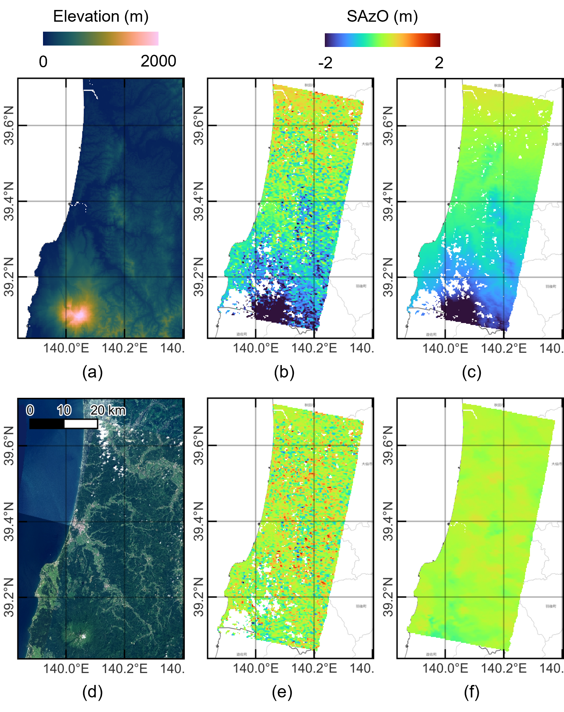
Figure S1. Example of SAzO processing (3 October 2023, descending, path 019, frame 2820, beam 6, right-looking). (a) Elevation (Copernicus GLO-90 DEM). (b) Raw SAzO. (c) Model SAzO composed of a topography-correlated component and ramp estimated from (b) after median filtering. (d) Optical image from GSI tiles (https://maps.gsi.go.jp/development/ichiran.html#seamlessphoto). (e) Corrected SAzO (i.e., (b)-(c)). (f) Final SAzO (i.e., median filtered (e)).

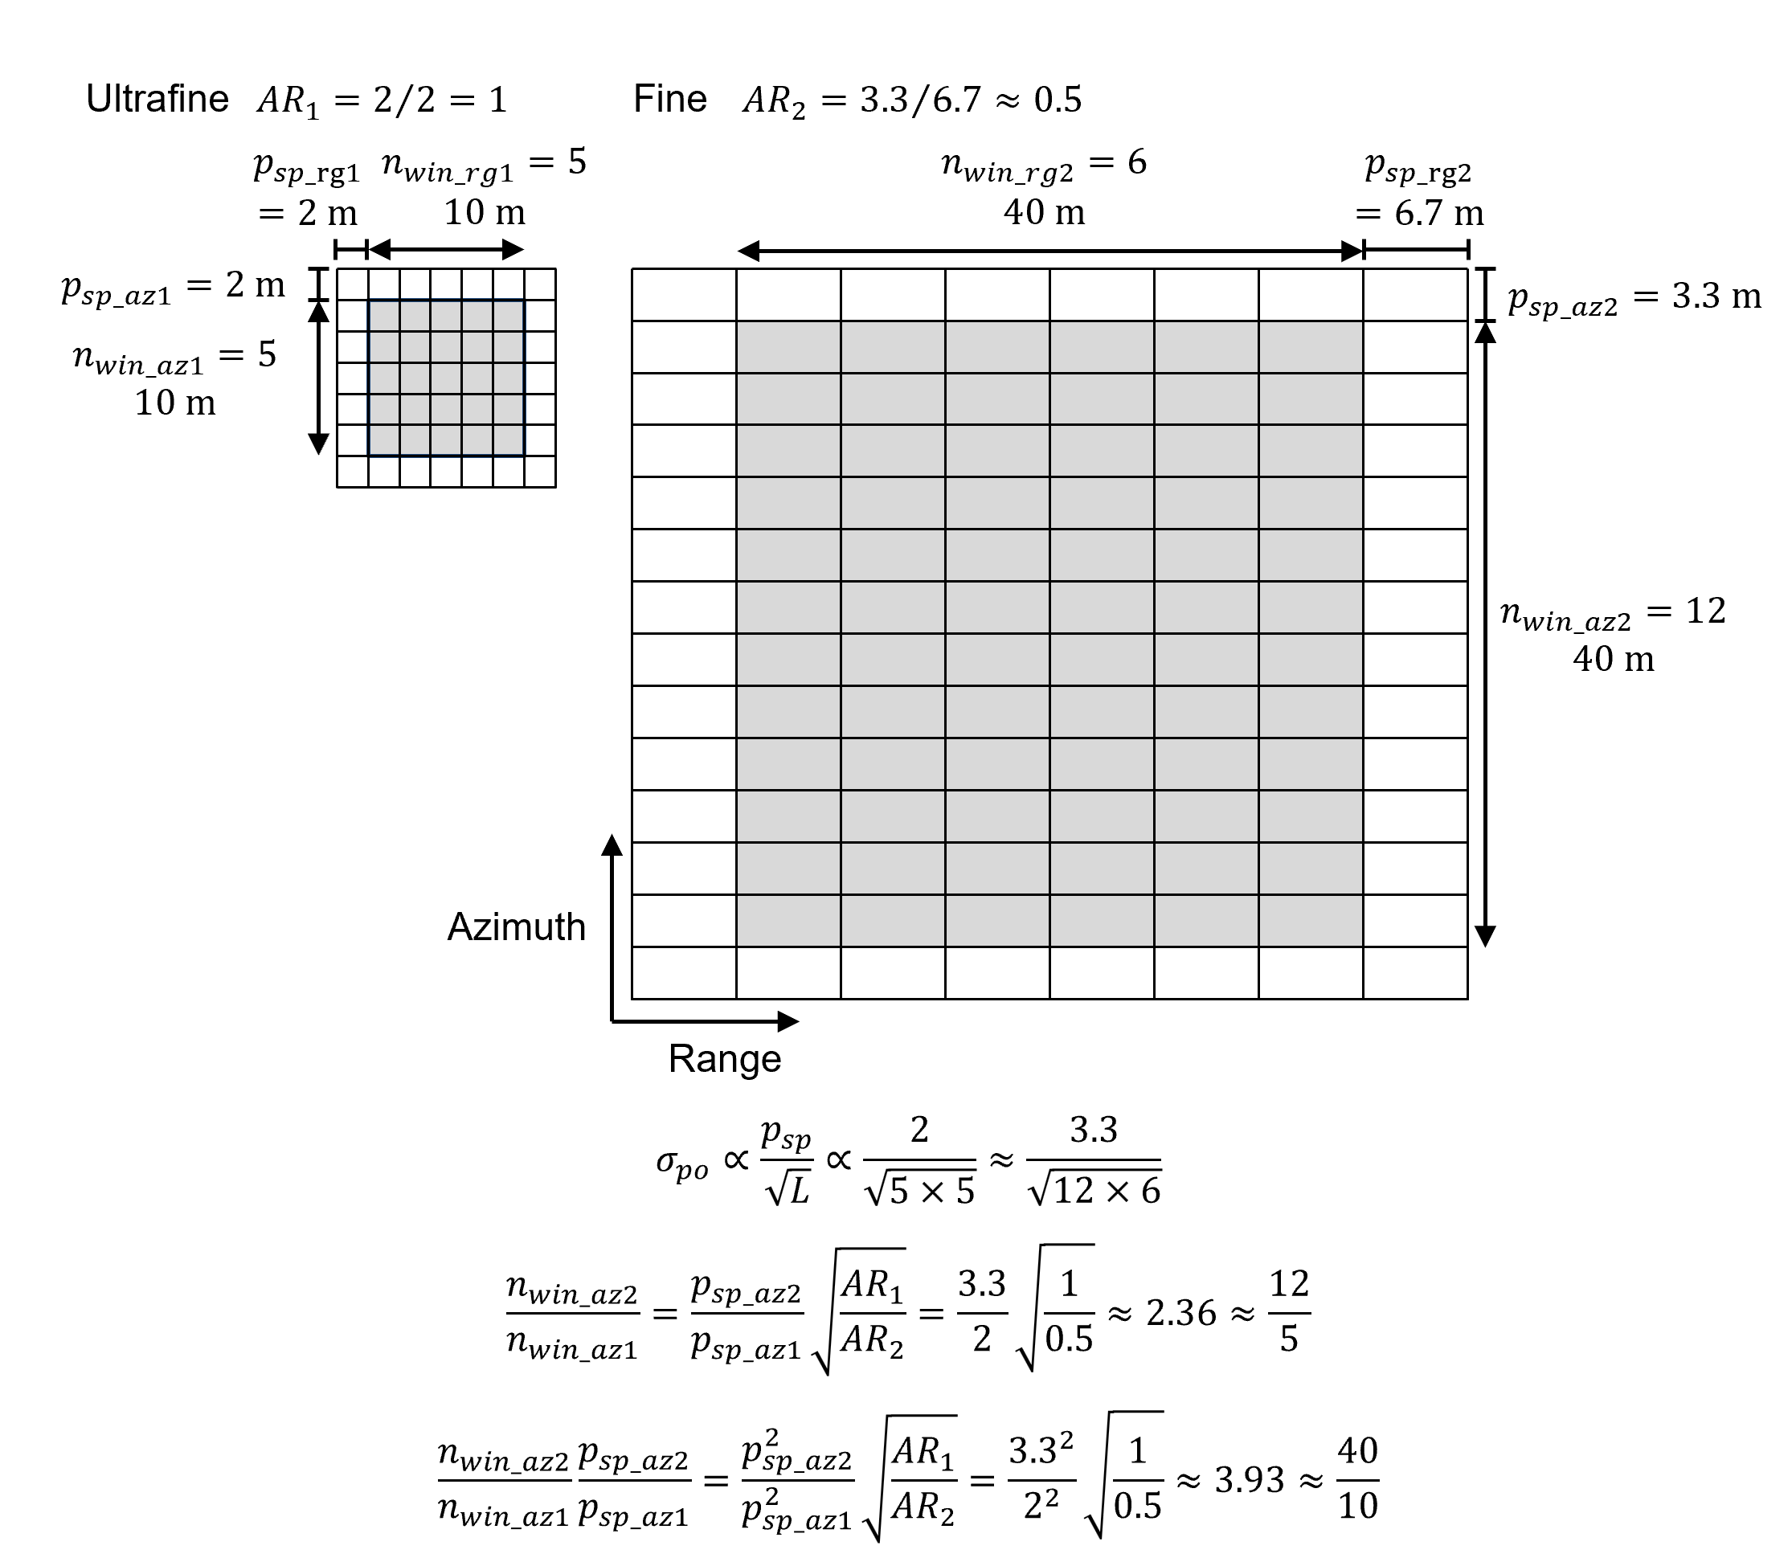
Figure S2. Example of the ratio of the number of window pixels in azimuth and the ratio of the spatial resolution of the PO result between U and F modes to get equivalent $σ_{po}$.
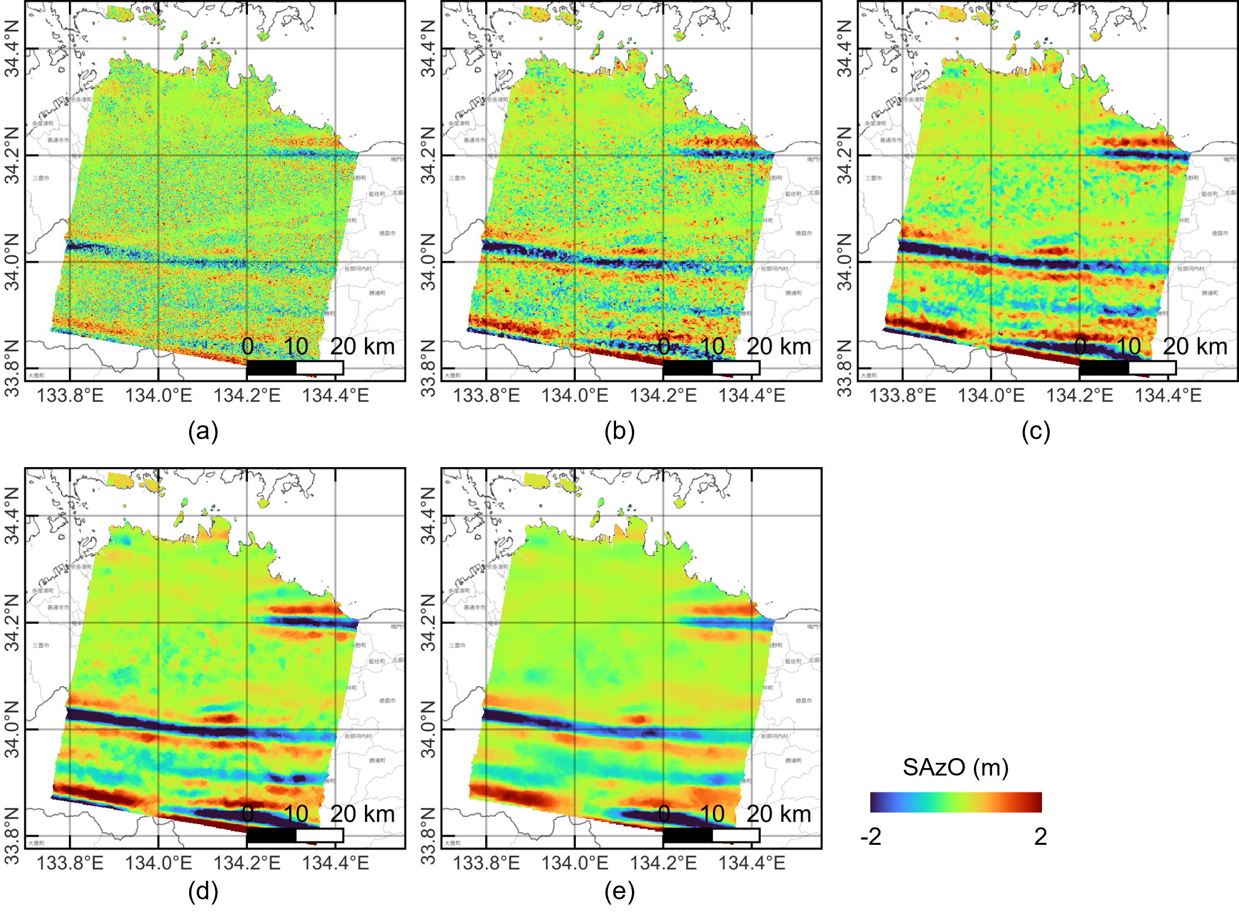
Figure S3. SAzO results with various window sizes (U mode, 26 June 2020, descending, path 021, frame 2930, beam 8, right-looking). (a) $n_{win_az}=16$. (b) $n_{win_az}=32$. (c) $n_{win_az}=64$. (d) $n_{win_az}=128$. (e) $n_{win_az}=256$ (same as Fig. 7(a)).
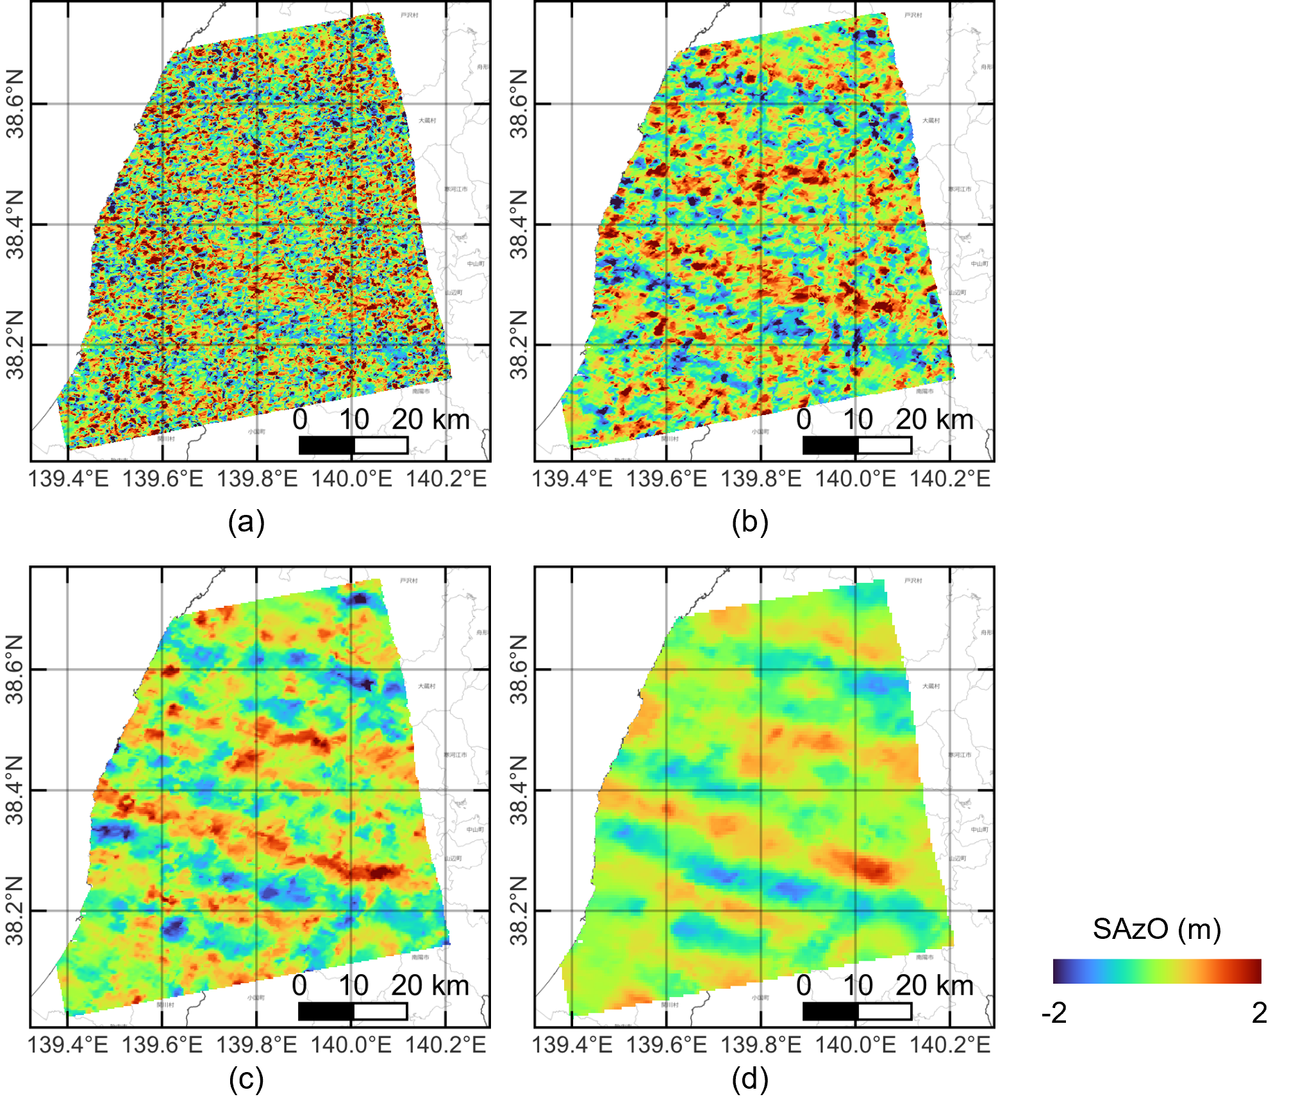
Figure S4. SAzO results with various window sizes (F mode, 19 July 2022, ascending, path 124, frame 0760, beam 5, right-looking). (a) $n_{win_az}=16$. (b) $n_{win_az}=32$. (c) $n_{win_az}=64$. (d) $n_{win_az}=128$.

