Supplementary material
Table S1. Starting model and inversion parameters used in the OCCAM1D inversions. For each layer, the table lists the layer thickness in meters, the starting inversion parameter value in log10(resistivity), the fixed resistivity value (0 indicates the layer is not hard-fixed), the roughness penalty weight applied across each layer boundary, the preference (prejudice) value in log10(resistivity), and the penalty applied to the preference value. The a priori constraints on the uppermost crustal layer and ~20 km lithospheric depth are implemented via preference values and roughness penalties rather than hard-fixing layer resistivities. All inversions employ a second-differencing roughness penalty and a target RMS misfit of 1.0.
Thickness | Starting value | Fix value | Penalty | Preference (prejudice) | Penalty of preference
1000 | 2 | 0 | 1 | 1 | 1
1000 | 2 | 0 | 1 | 1 | 1
1000 | 2 | 0 | 1 | 1 | 1
1000 | 2 | 0 | 1 | 0 | 0
1000 | 2 | 0 | 1 | 0 | 0
1029 | 2 | 0 | 1 | 0 | 0
1242 | 2 | 0 | 1 | 0 | 0
1497 | 2 | 0 | 1 | 0 | 0
1805 | 2 | 0 | 1 | 0 | 0
2177 | 2 | 0 | 1 | 0 | 0
2626 | 2 | 0 | 1 | 0 | 0
3166 | 2 | 0 | 1 | 3 | 1
3818 | 2 | 0 | 1 | 3 | 1
4604 | 2 | 0 | 1 | 3 | 1
5553 | 2 | 0 | 1 | 0 | 0
6695 | 2 | 0 | 1 | 0 | 0
8075 | 2 | 0 | 1 | 0 | 0
9736 | 2 | 0 | 1 | 0 | 0
11742 | 2 | 0 | 1 | 0 | 0
14160 | 2 | 0 | 1 | 0 | 0
17075 | 2 | 0 | 1 | 0 | 0
12201 | 2 | 0 | 1 | 0 | 0
13691 | 2 | 0 | 1 | 0 | 0
15361 | 2 | 0 | 1 | 0 | 0
17236 | 2 | 0 | 1 | 0 | 0
19338 | 2 | 0 | 1 | 0 | 0
21699 | 2 | 0 | 1 | 0 | 0
24346 | 2 | 0 | 1 | 0 | 0
27316 | 2 | 0 | 1 | 0 | 0
30650 | 2 | 0 | 1 | 0 | 0
34389 | 2 | 0 | 1 | 0 | 0
38586 | 2 | 0 | 1 | 0 | 0
43294 | 2 | 0 | 1 | 0 | 0
48576 | 2 | 0 | 1 | 0 | 0
54504 | 2 | 0 | 1 | 0 | 0
61154 | 2 | 0 | 1 | 0 | 0
68616 | 2 | 0 | 1 | 0 | 0
76988 | 2 | 0 | 1 | 0 | 0
86383 | 2 | 0 | 1 | 0 | 0
96922 | 2 | 0 | 1 | 0 | 0
108750 | 2 | 0 | 1 | 0 | 0

Table S2. Using the periods of tidal constituents, line spectra from magnetic and electric field time series are removed, as reported by Shimizu et al. (2011).
Tidal constituent | Period (hour) | Tidal constituent | Period (hour)
Q1 | 26.868 | S1 | 24.000
O1 | 25.819 | S2 | 12.000
M1 | 24.833 | S3 | 8.000
P1 | 24.066 | S4 | 6.000
K1 | 23.935 | S5 | 4.800
J1 | 23.098 | S6 | 4.000
OO1 | 22.306 | S7 | 3.4286
2N2 | 12.872 | S8 | 3.000
N2 | 12.658
M2 | 12.421
L2 | 12.192
K2 | 11.967

Table S3. Conductivity estimates for 83–100 km depth layer of the 1D model.
Basin | Site | Lower 95% limit (S/m) | Lower 68% limit (S/m) | Mode  (S/m) | Upper 68% limit (S/m) | Upper 95% limit (S/m)
WPB | S05 | 0.003 | 0.013 | 0.028 | 0.028 | 0.036
WPB | U01 | 0.006 | 0.024 | 0.045 | 0.044 | 0.066
WPB | T05 | 0.016 | 0.040 | 0.045 | 0.056 | 0.077
WPB | T01 | 0.014 | 0.043 | 0.071 | 0.084 | 0.132
WPB | T02 | 0.030 | 0.059 | 0.071 | 0.084 | 0.112
WPB | T04 | 0.035 | 0.066 | 0.071 | 0.090 | 0.136
WPB | T04a | 0.033 | 0.065 | 0.071 | 0.093 | 0.133
WPB | T04b | 0.037 | 0.072 | 0.090 | 0.101 | 0.144
SPVB | B01 | 0.001 | 0.009 | 0.023 | 0.027 | 0.033
SPVB | T06 | 0.003 | 0.019 | 0.036 | 0.039 | 0.057
SPVB | T07 | 0.011 | 0.035 | 0.045 | 0.054 | 0.072
SPVB | T08 | 0.012 | 0.032 | 0.045 | 0.051 | 0.075
SPVB | T09 | 0.001 | 0.008 | 0.023 | 0.032 | 0.043
SPVB | T10 | 0.019 | 0.040 | 0.045 | 0.054 | 0.079
SPVB | T12 | 0.001 | 0.008 | 0.023 | 0.030 | 0.040
SPVB | T13 | 0.001 | 0.009 | 0.023 | 0.027 | 0.033
SPVB | T14 | 0.002 | 0.015 | 0.036 | 0.038 | 0.054

Table S4. Water contents of MORB source.
Sample | Mantle water content (ppm) | References
MORB from incompatible-element-depleted upper mantle | 100 - 180 | Michael (1988)
MORB from  enriched upper mantle | 250 - 450 | Michael (1988)
Depleted MORB | 80 - 330 | Sobolev & Chaussidon (1996)
MORB from  Northern East Pacific rise (EPR) & South East Indian Ridge | 264 - 517 | Danyushevsky et al. (2000)
MORB | 142±85 | Saal et al. (2002)
MORB from  Salas y Gómez mantle plume | 750±210 | Simons et al. (2002)
MORB from  East Pacific Rise (EPR) | 120±27 | Simons et al. (2002)
Depleted MORB mantle source (DMM) | 54±12 | Simons et al. (2002)
MORB | 116 | Salters & Stracke (2004)
DMM | 70 - 160 | Workman & Hart (2005)

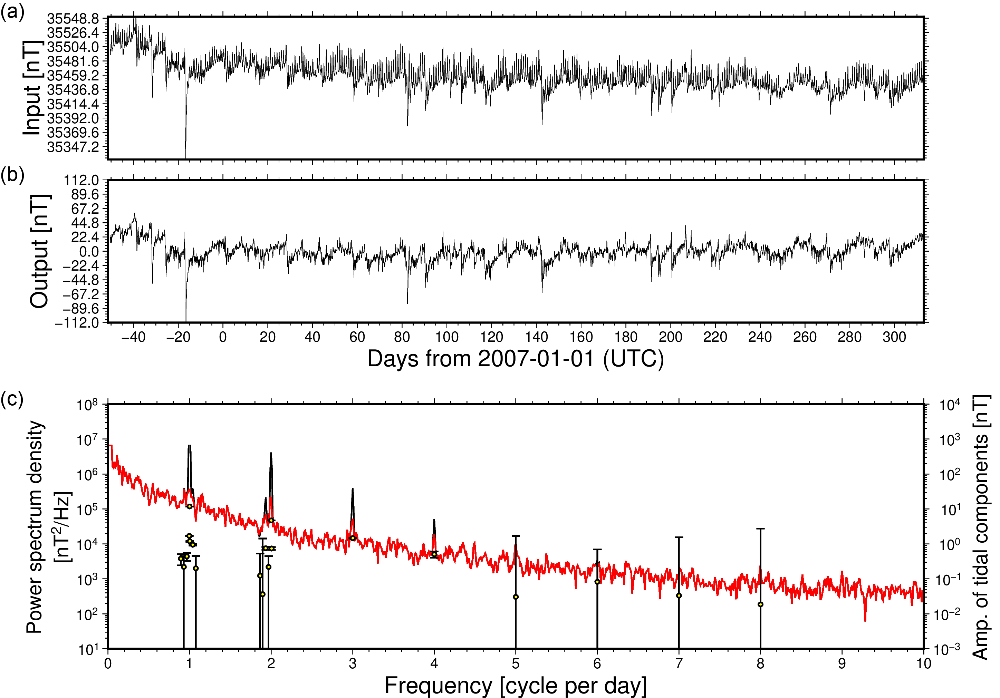
Figure S1. Time series and power spectra of the magnetic north component at site T10. (a) and (b) show the observed (input) and de-tided (output) time series, respectively. (c) Power spectra of the observed (black) and de-tided (red) data are plotted along with the amplitudes of the removed tidal components (yellow circles). Frequency is shown in cycles per day.

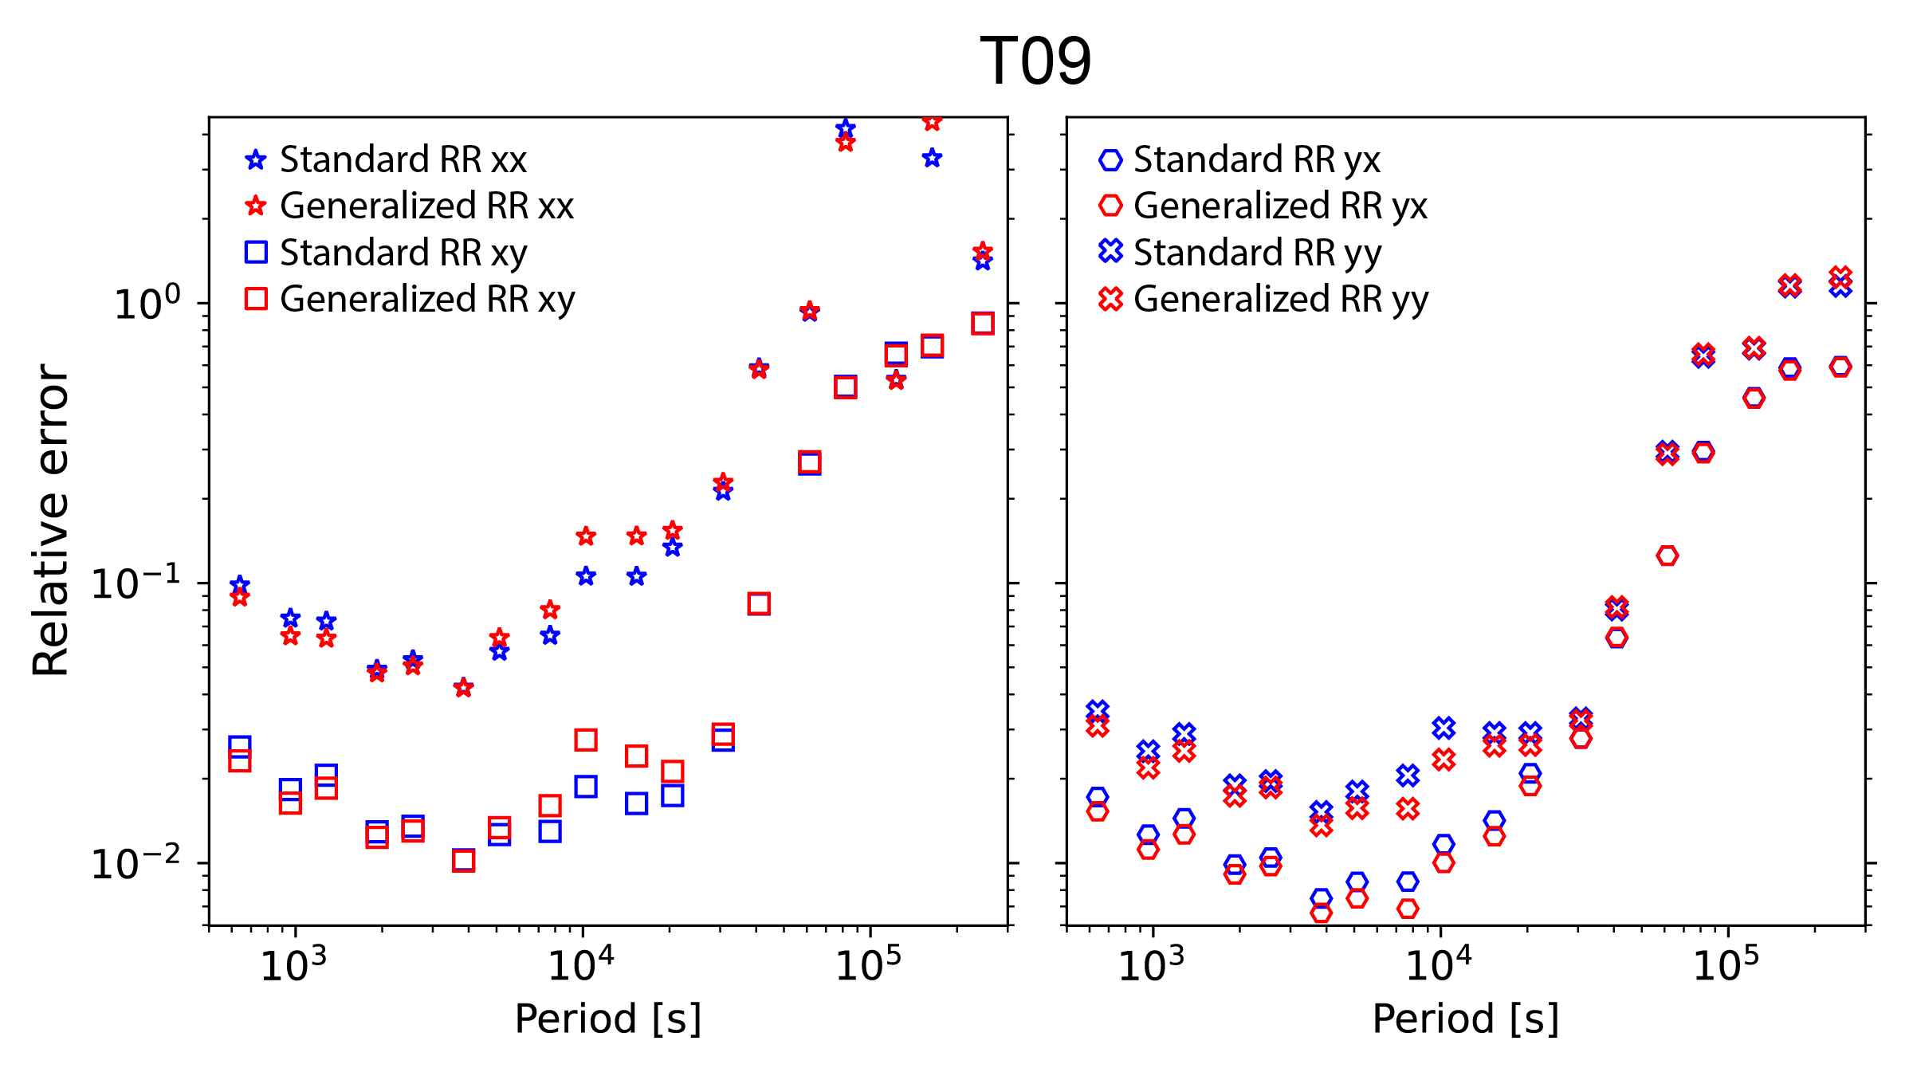
Figure S2. Relative errors of the MT impedance at site T09. Left panels show the xx and xy elements, while right panels display the yx and yy elements.

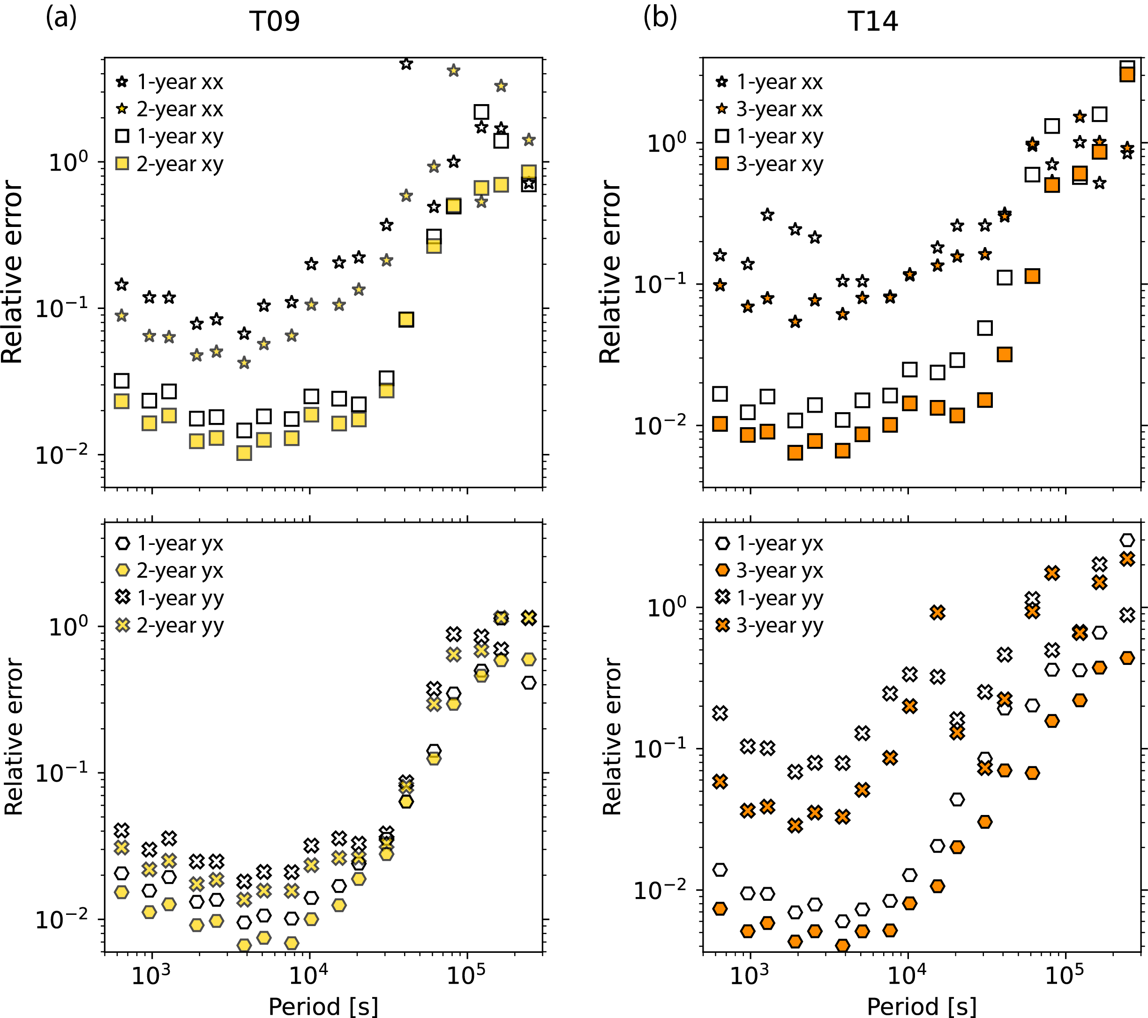
Figure S3. Relative error of site (a) T09 and (b) T14. The MT impedance estimated using 1-, 2-, or 3-year length data are shown in white, yellow, and orange, respectively.

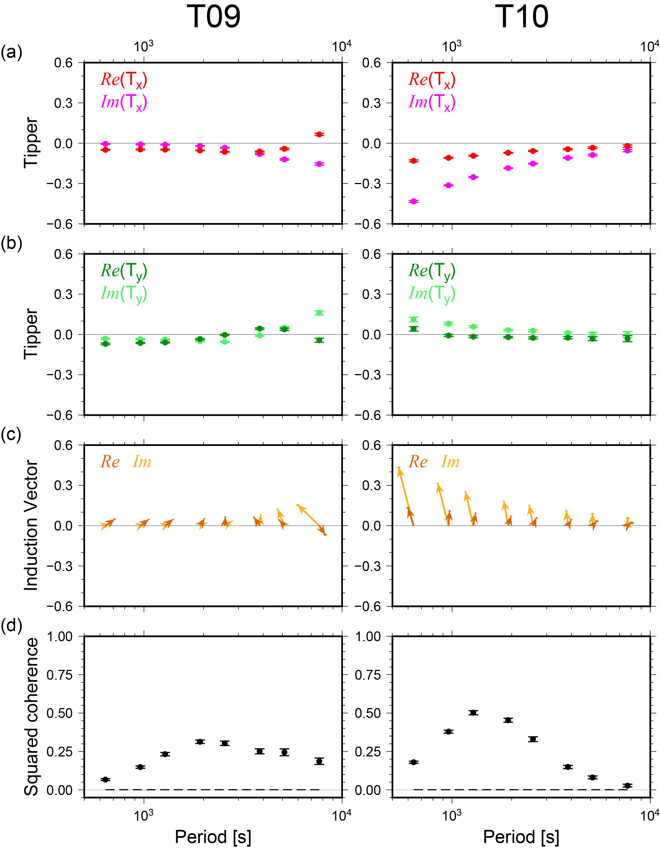
Figure S4. Tipper and induction vector with coherence evaluation for sites T09 and T10. Panels (a) and (b) show the observed Tx and Ty components of tippers (also called geomagnetic transfer functions), where x and y represent the geomagnetic north and east directions, respectively. Dark colors represent the real part, while light colors indicate the imaginary part. Panel (c) presents the induction vectors following the Parkinson convention, with north pointing upwards. Ellipses at the arrow tips indicate the 95% confidence limits. Panel (d) shows the squared coherence between the observed and predicted vertical magnetic fields. Dashed lines close to zero represent the theoretical zero coherence value, which is calculated based on the random coherence expected from the number of windows used at the 95% confidence level. Error bars represent 95% confidence intervals.
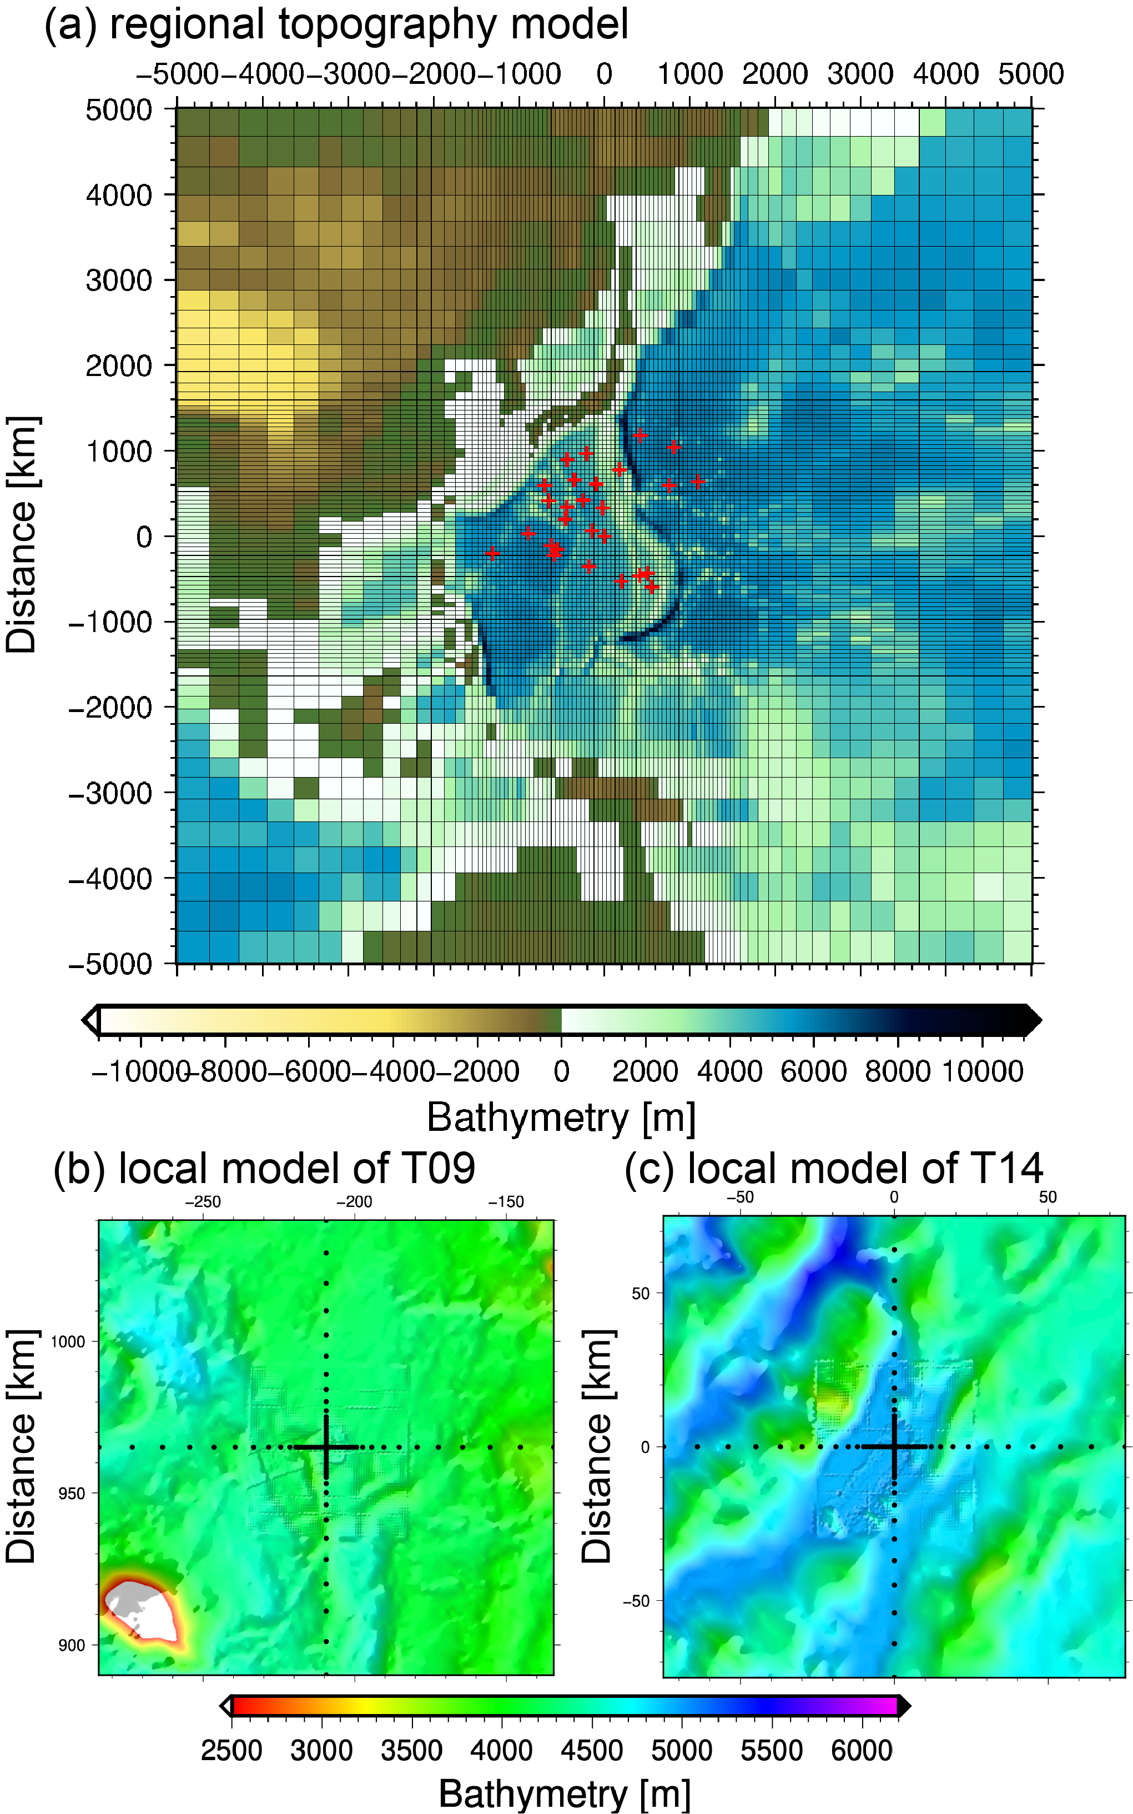
Figure S5. Model of evaluated topography effect. (a) Regional large-scale topography model; the horizontal origin is at site T14, and the vertical origin is sea level (0 m). (b) Local small-scale topography model of site T09, and (c) local small-scale topography model of site T14. The model discretized on a center-refined grid; black dots in panel (b, c) mark the horizontal mesh nodes. Within each cell, bathymetry will be spatially averaged to define the effective depth.
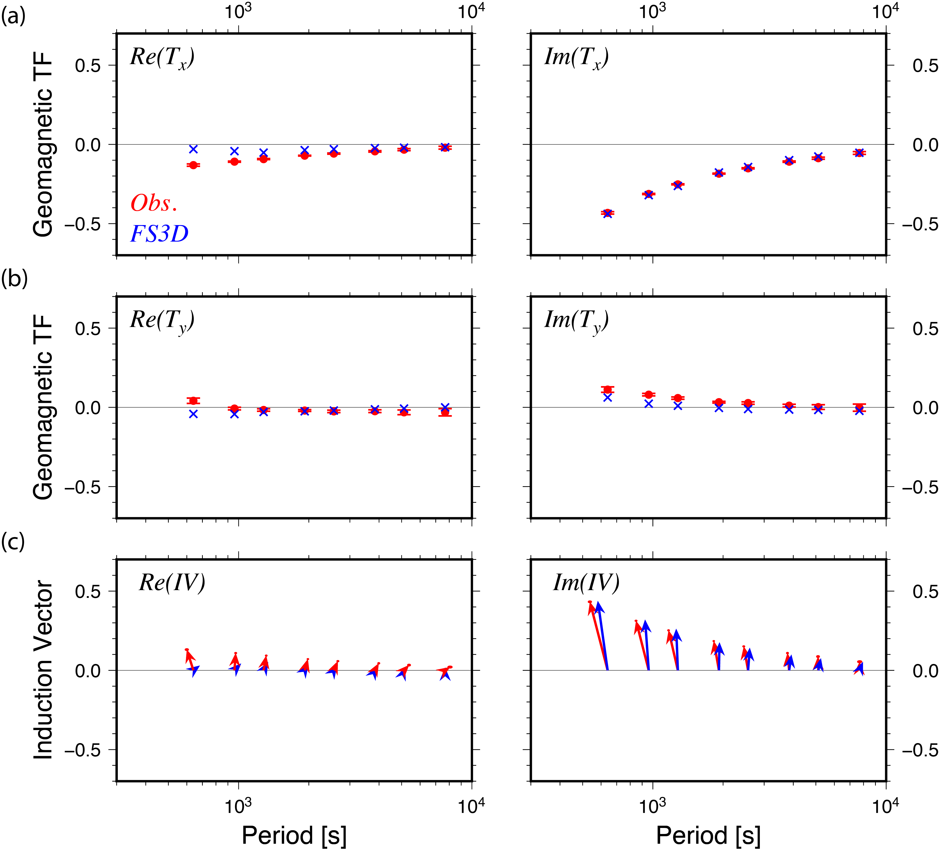
Figure S6. Tipper and induction vector comparison at site T10. Red and blue denote observed and modeled values, respectively. Real and imaginary parts are shown in left and right panels. (a) and (b) display Tx and Ty components (north and east directions), with 95% confidence error bars. Panel (c) presents the induction vector following the Parkinson convention, with north pointing upwards. The ellipses at the tips of arrows represent the 95% confidence limits.

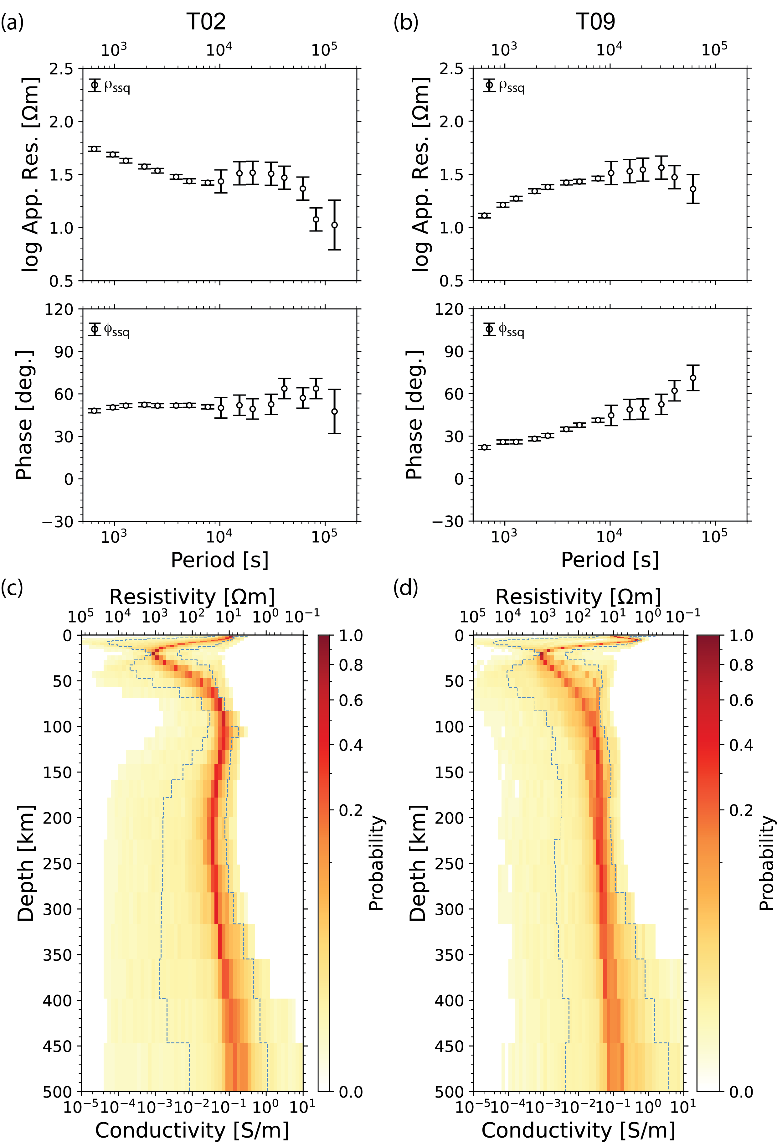
Figure S7. Probability distributions of layer conductivities at sites (a) T02 and (b) T09. In panels (c), the red and white colors indicate higher and lower probabilities, respectively. Blue dashed lines mark the 2.5th and 97.5th percentiles at each depth, corresponding to the 95% uncertainty limits.

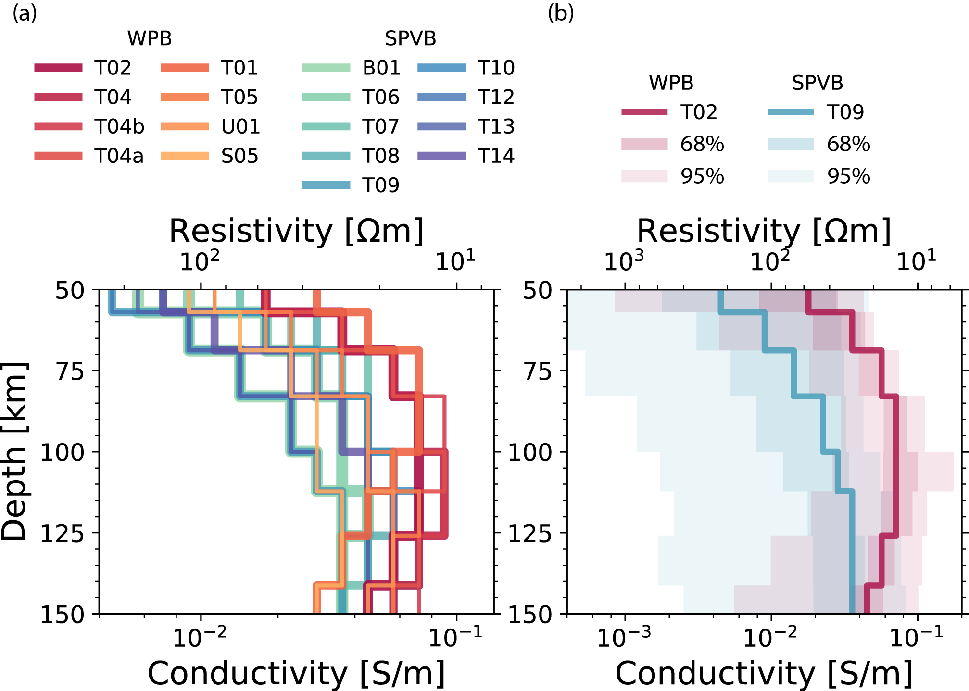
Figure S8. (a) Zoomed view of 1D electrical conductivity models (from Figure 5) between 50–150 km depth interval, showing stations in both WPB and SPVB. (b) Zoomed view of 1D conductivity models (from Figure S7) with 68% (dark shading) and 95% (light shading) uncertainty limits for sites T02 and T09.

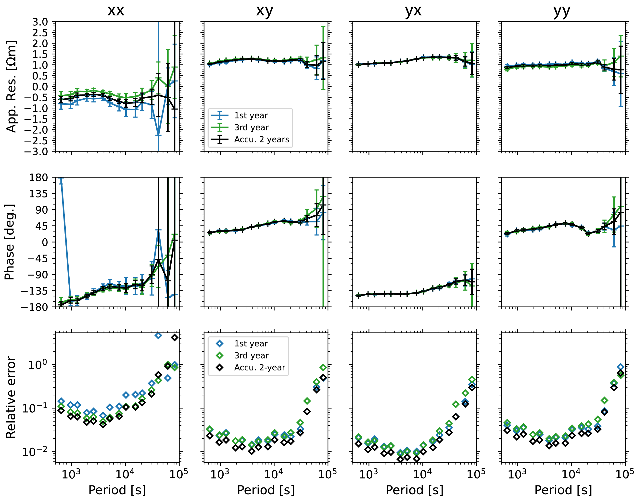
Figure S9. Temporal stability of MT responses at site T09. Apparent resistivity, phase and relative error of site T09. Comparison of impedance tensor estimates from individual survey years (blue: year 1; green: year 3) and accumulated two-year data (black) Top: apparent resistivity; middle: phase; bottom: relative error. The accumulated dataset shows improved consistency and reduced errors, demonstrating enhanced reliability from longer recording durations. Error bars are 95% confidence intervals.

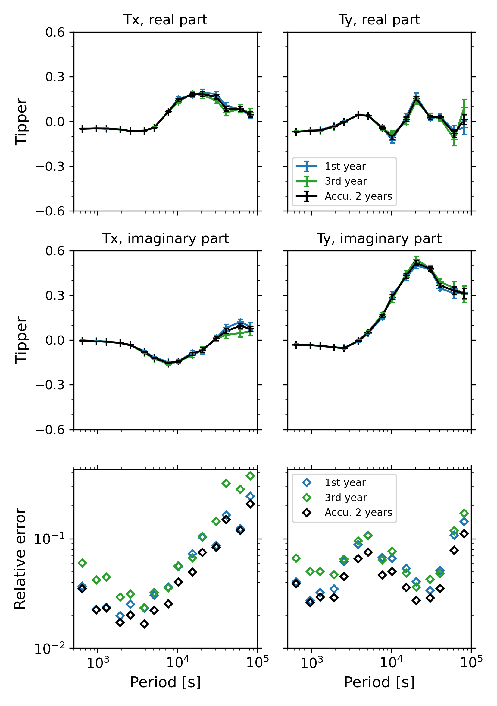
Figure S10. Temporal stability of tippers at site T09. The tipper components Tx and Ty (where x and y represent geomagnetic north and east directions, respectively) are shown for their real parts (top panels), imaginary parts (middle panels), and relative errors (bottom panels). Blue symbols show estimates from the first survey year, green symbols from the third survey year, and black symbols from the accumulated two-year dataset. The accumulated dataset demonstrates improved consistency and reduced uncertainties compared to individual year estimates, with year-to-year measurements showing consistent features. Error bars represent 95% confidence intervals.

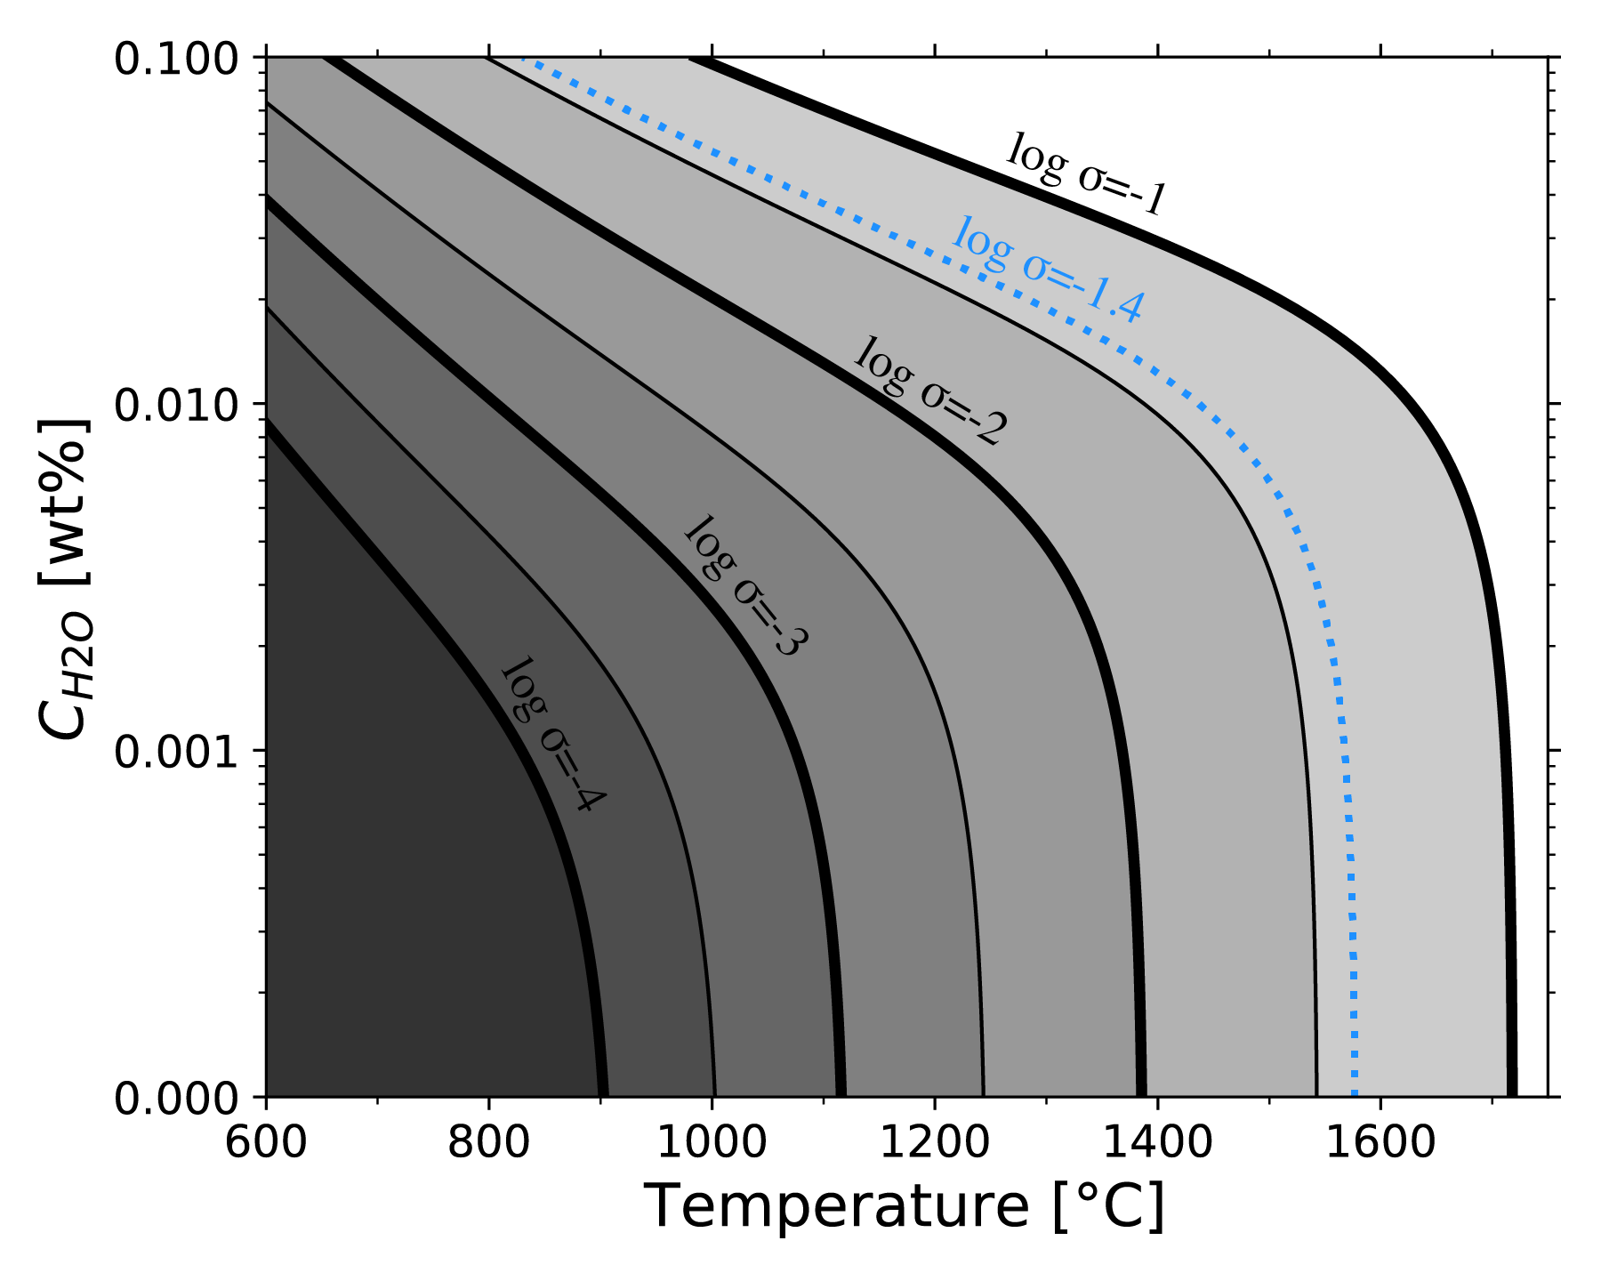
Figure S11. Conductivity of hydrous olivine. Conductivity (log σ, with σ in S/m) map as a function of temperature and water concentration. The blue dashed curve marks the σ=0.04 S/m, which is the approximate value conductivity value of WPB and SPVB at a depth of 70 - 300 km.

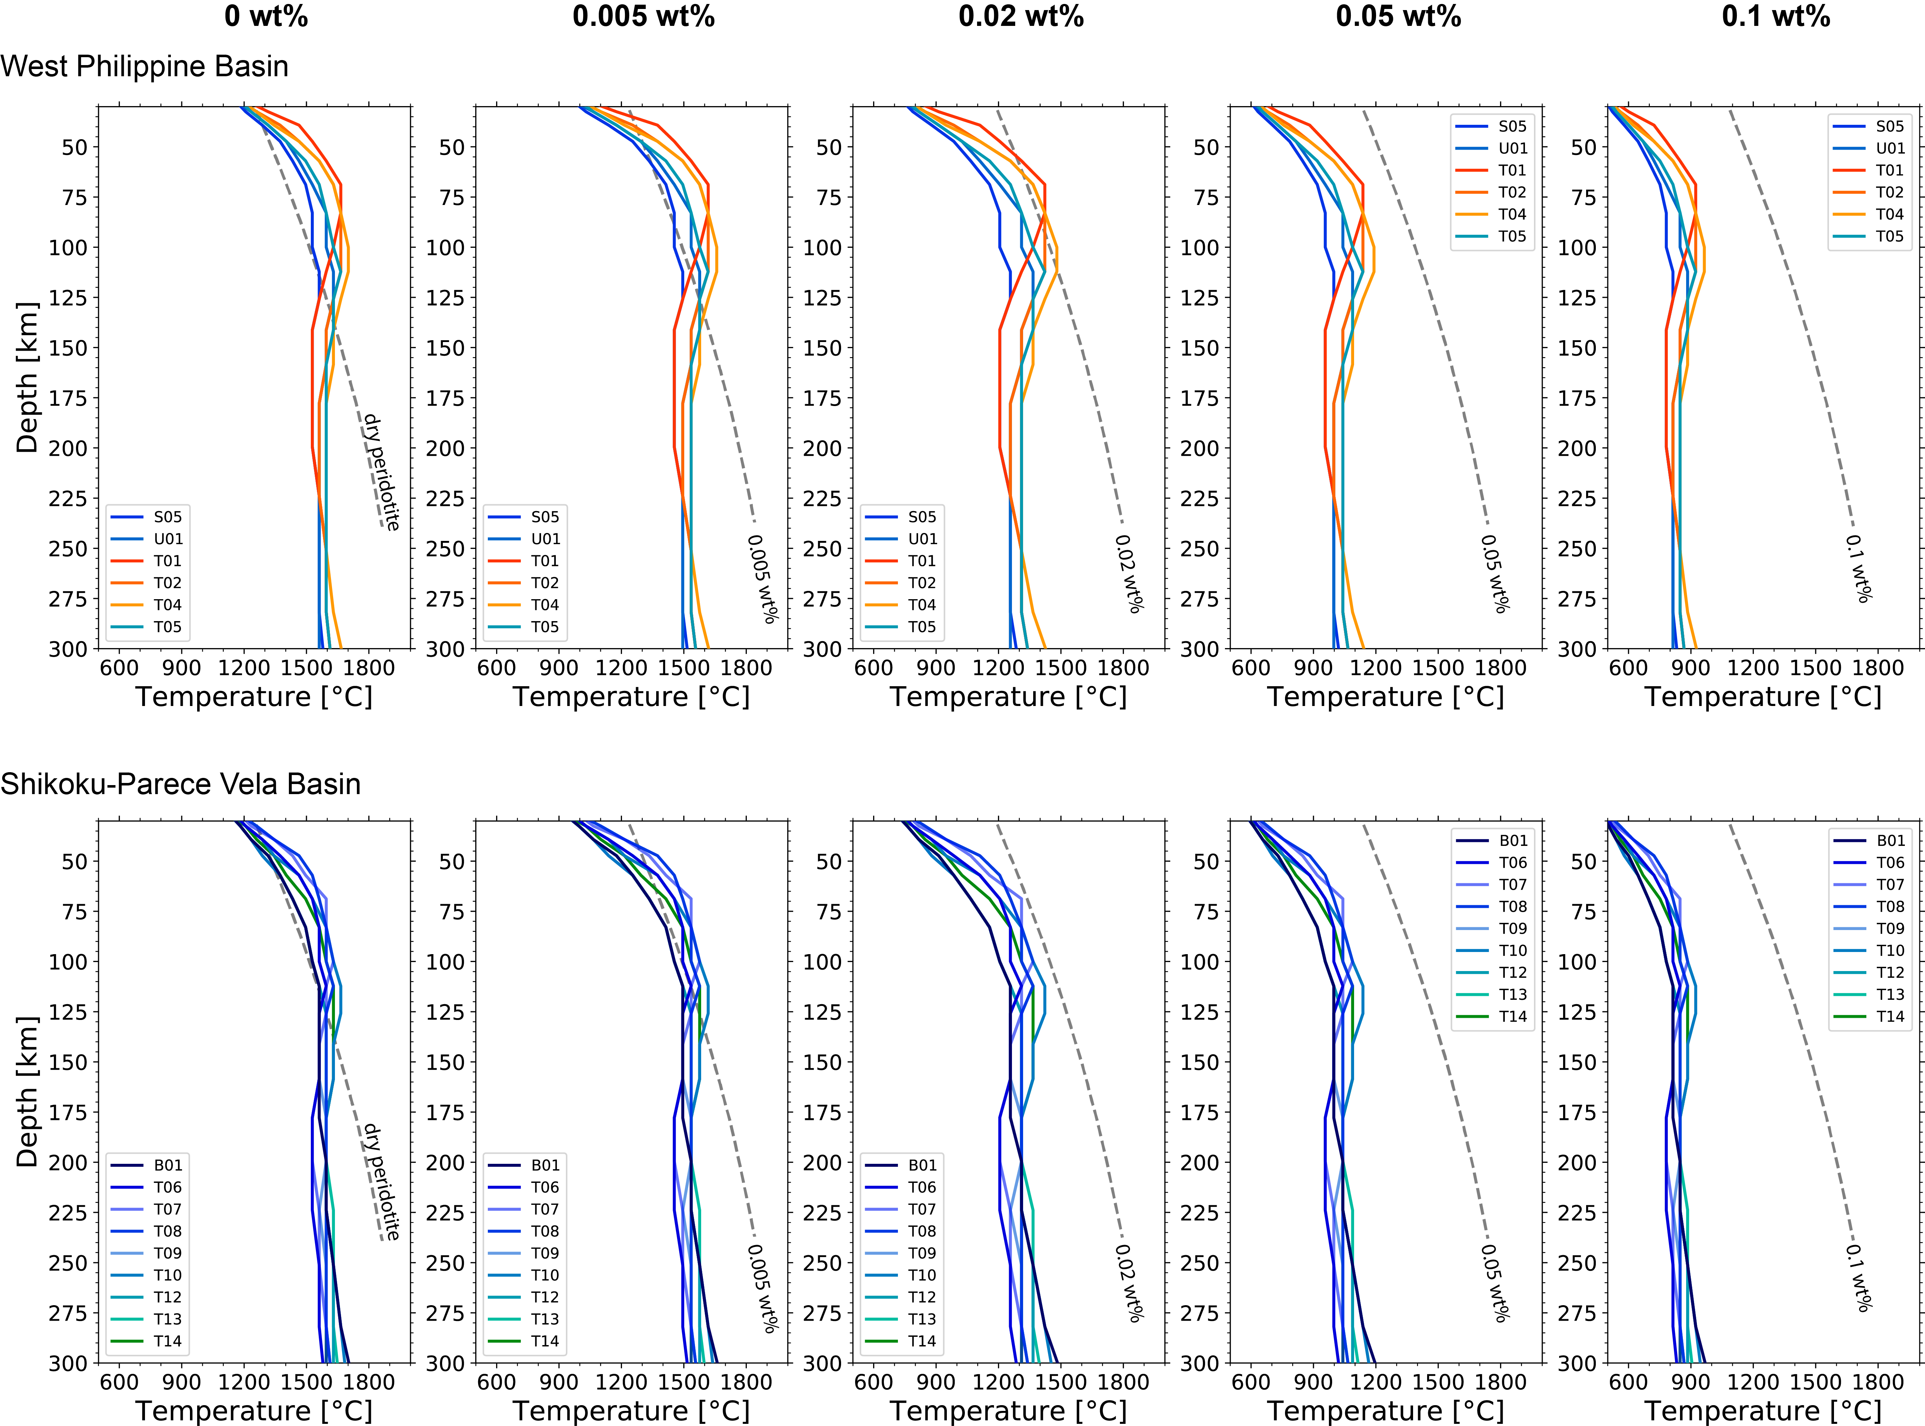
Figure S12 Temperature 1D profiles for the West Philippine Basin (WPB) and Shikoku-Parece Vela Basin (SPVB). The upper panel shows the WPB, and the lower panel displays the SPVB. Temperature profiles are based on the experimental model for hydrous olivine conductivity by Gardés et al. (2014). Dashed lines indicate the mantle peridotite solidus corresponding to the specified water content (Aubaud et al. 2004).

References
Aubaud C, Hauri EH, Hirschmann MM (2004) Hydrogen partition coefficients between nominally anhydrous minerals and basaltic melts. Geophys Res Lett 31:. https://doi.org/10.1029/2004GL021341
Danyushevsky L V., Eggins SM, Falloon TJ, Christie DM (2000) H2O Abundance in Depleted to Moderately Enriched Mid-ocean Ridge Magmas; Part I: Incompatible Behaviour, Implications for Mantle Storage, and Origin of Regional Variations. Journal of Petrology 41:1329–1364. https://doi.org/10.1093/petrology/41.8.1329
Gardés E, Gaillard F, Tarits P (2014) Toward a unified hydrous olivine electrical conductivity law. Geochemistry, Geophysics, Geosystems 15:4984–5000. https://doi.org/10.1002/2014GC005496
Michael PJ (1988) The concentration, behavior and storage of H2O in the suboceanic upper mantle: Implications for mantle metasomatism. Geochim Cosmochim Acta 52:555–566. https://doi.org/10.1016/0016-7037(88)90110-X
Saal AE, Hauri EH, Langmuir CH, Perfit MR (2002) Vapour undersaturation in primitive mid-ocean-ridge basalt and the volatile content of Earth’s upper mantle. Nature 419:451–455. https://doi.org/10.1038/nature01073
Salters VJM, Stracke A (2004) Composition of the depleted mantle. Geochemistry, Geophysics, Geosystems 5:. https://doi.org/10.1029/2003GC000597
Shimizu H, Yoneda A, Baba K, et al (2011) Sq effect on the electromagnetic response functions in the period range between 104 and 105 s. Geophys J Int 186:193–206. https://doi.org/10.1111/j.1365-246X.2011.05036.x
Simons K, Dixon J, Schilling J, et al (2002) Volatiles in basaltic glasses from the Easter‐Salas y Gomez Seamount Chain and Easter Microplate: Implications for geochemical cycling of volatile elements. Geochemistry, Geophysics, Geosystems 3:1–29. https://doi.org/10.1029/2001gc000173
Sobolev A V., Chaussidon M (1996) H2O concentrations in primary melts from supra-subduction zones and mid-ocean ridges: Implications for H2O storage and recycling in the mantle. Earth Planet Sci Lett 137:45–55. https://doi.org/10.1016/0012-821X(95)00203-O
Workman RK, Hart SR (2005) Major and trace element composition of the depleted MORB mantle (DMM). Earth Planet Sci Lett 231:53–72. https://doi.org/10.1016/j.epsl.2004.12.005

