Supplementary figures

Figure S-1.

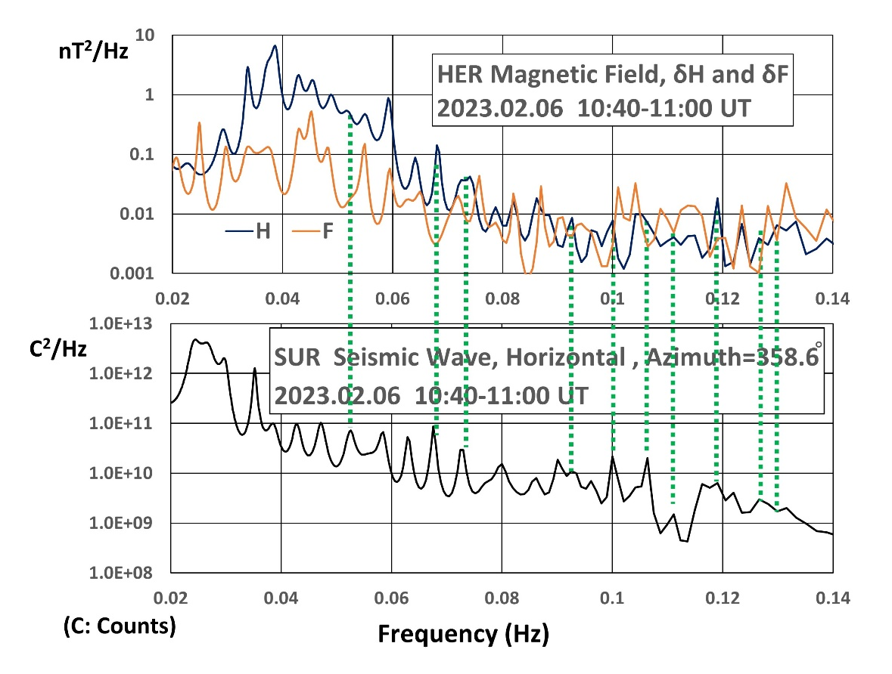

Figure S-1. PSD of HER δH and δF (upper panel) and of seismic wave data (lower panel) for 10:40:00-11:00:00 UT on Feb. 06, 2023. The vertical green dotted lines indicate the peak-to-peak correspondence between seismic wave at SUR and δH at HER but no correspondence between seismic wave and δF. That is, the spectral peaks of the sensor tremor effect do not appear in δF spectra although there exists some correspondence between them probably by chance.

Figure S-2.

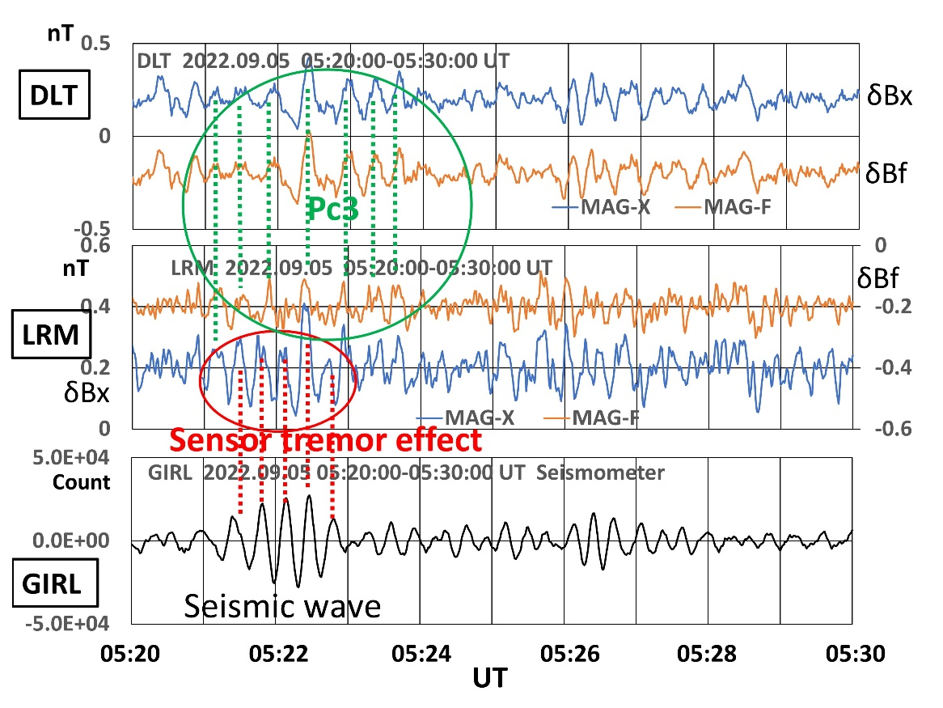
Figure S-2. An expanded plot of the data for 10 minutes taken from Figure 8 (for 60 minutes). From top to bottom panels, δBx (MAG-X) and δBf (MAG-F) at DLT, δBx (MAG-X) and δBf (MAG-F) at LRM, and seismic wave at GIRL, respectively. Sensor tremor effect is seen in δBx (MAG-X) component at LRM as indicated with vertical red dotted lines. On the other hand, a good correspondence among the peaks of δBx (MAG-X), δBf (MAG-F) at DLT and δBx (MAG-X) at LRM as indicated with vertical green dotted lines, which shows the Pc3 waves. Note that the LRM and the GIRL locate very close eaxh other, but the DLT is more than 3800 km apart from them.

Figure S-3.

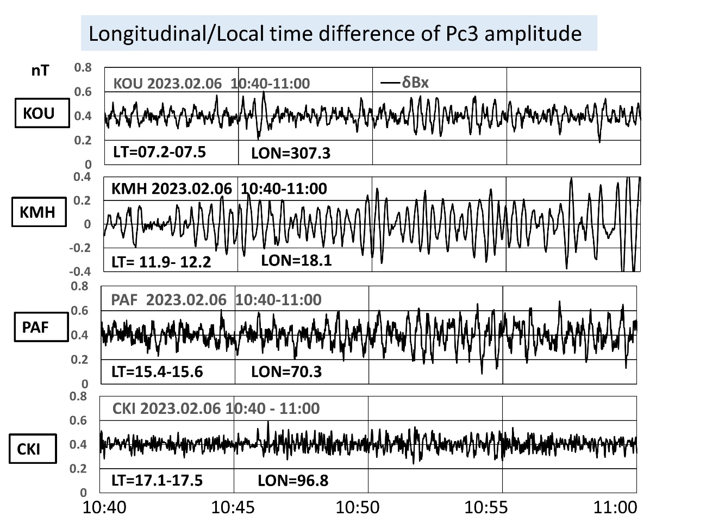

Figure S-3. Pc3 pulsations observed at four stations separated by longitude. The local time (LT) and longitude (LON) at each station are shown in each panel. The relation between wave amplitude and local time suggest the effect of ionospheric conductivity on the amplitude.

