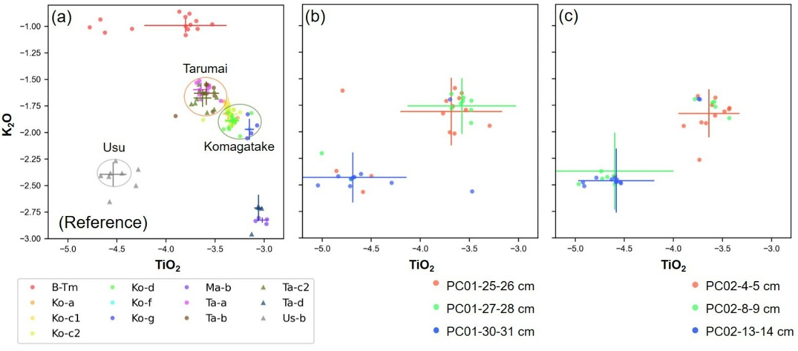
Supporting data 1
Geochemical analysis of the glass composition including 25.5 cm,27.5 cm, and 30.5 cm of the core PC01, and the 4.5cm, 8.5 cm, 13.5 cm of the core PC02.

