Figures showing modifications of the FIT magnetometer

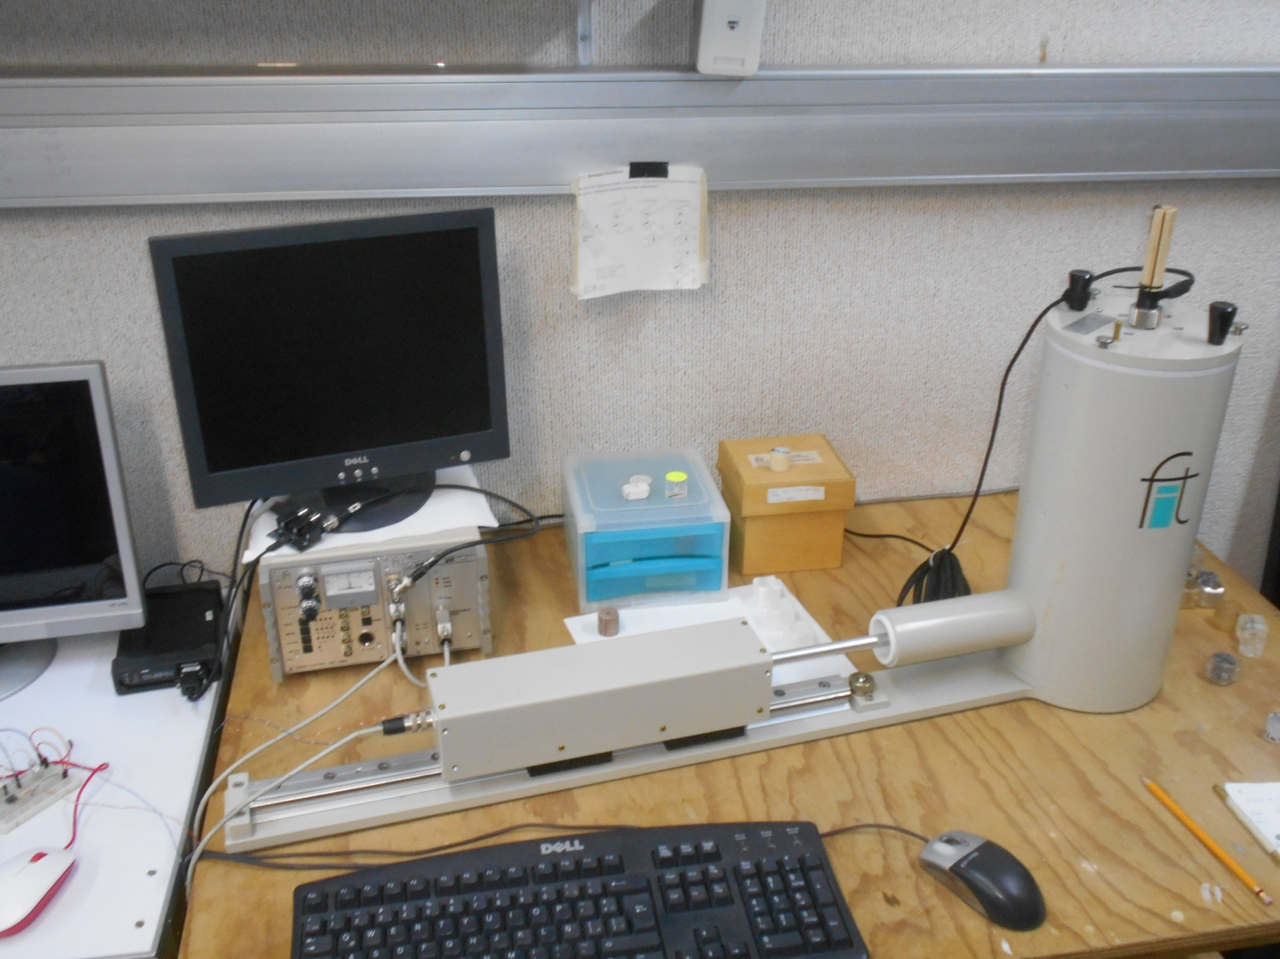
S1: Image of the modified FIT magnetometer, with the QZFM Gen-2 sensor installed on a wooden support rod which is guided through the original central hole on the magnetic shield cover. The rod can be pulled out and fixed at the desired position by compressing an O-ring with the round nut in the cover plate. Note the black QZFM electronic control unit to the left of FIT electronics.

S2. Photo of the sensors used in this work. From left to right: FLC-100, Fluxmaster, FL1-100 (all from Stefan Mayer Instruments), QZFM Gen-2 from QuSpin, Inc. The dot on the QZFM indicates the center of the vapor cell.

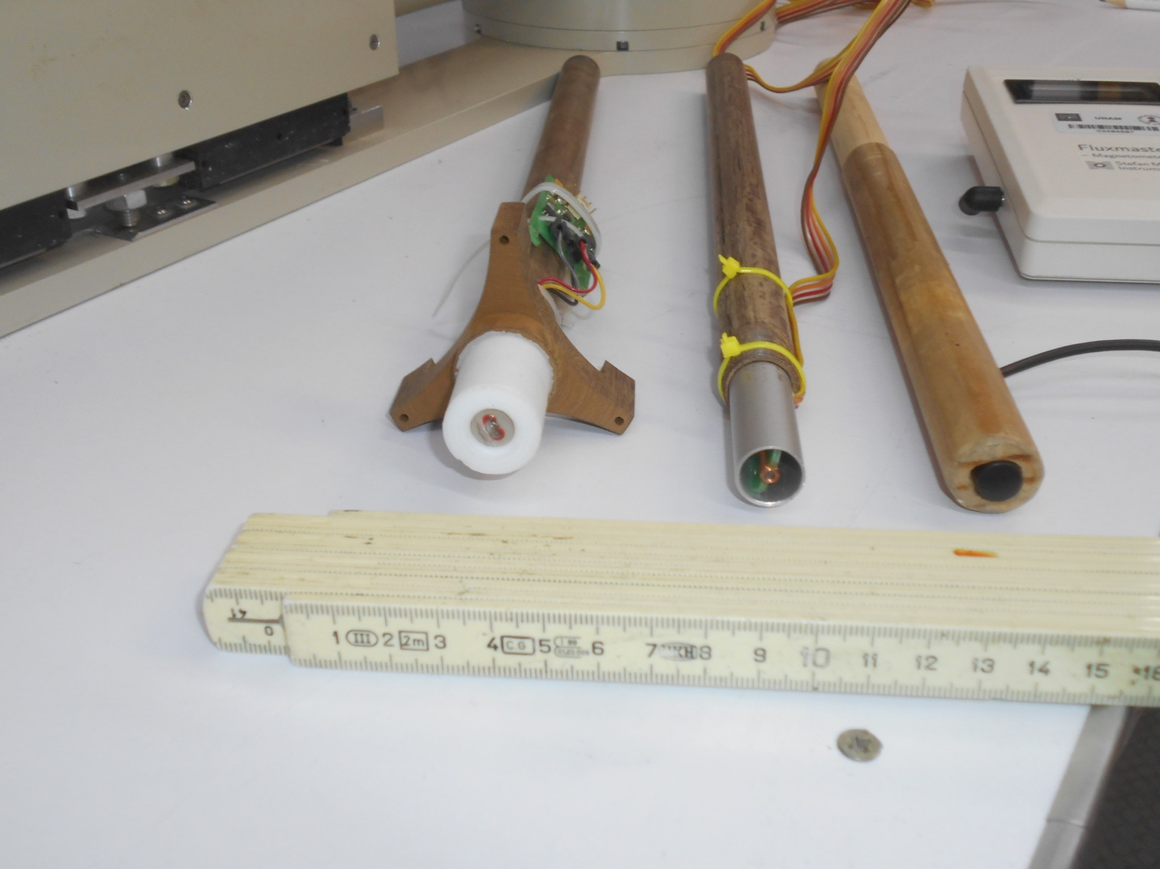
S3: Support rods of Tufnol (left and middle) as used in the original FIT magnetometers, and one made of wood, with fluxgate sensors installed; from left to right, FL1-100, FLC100, Fluxmaster.
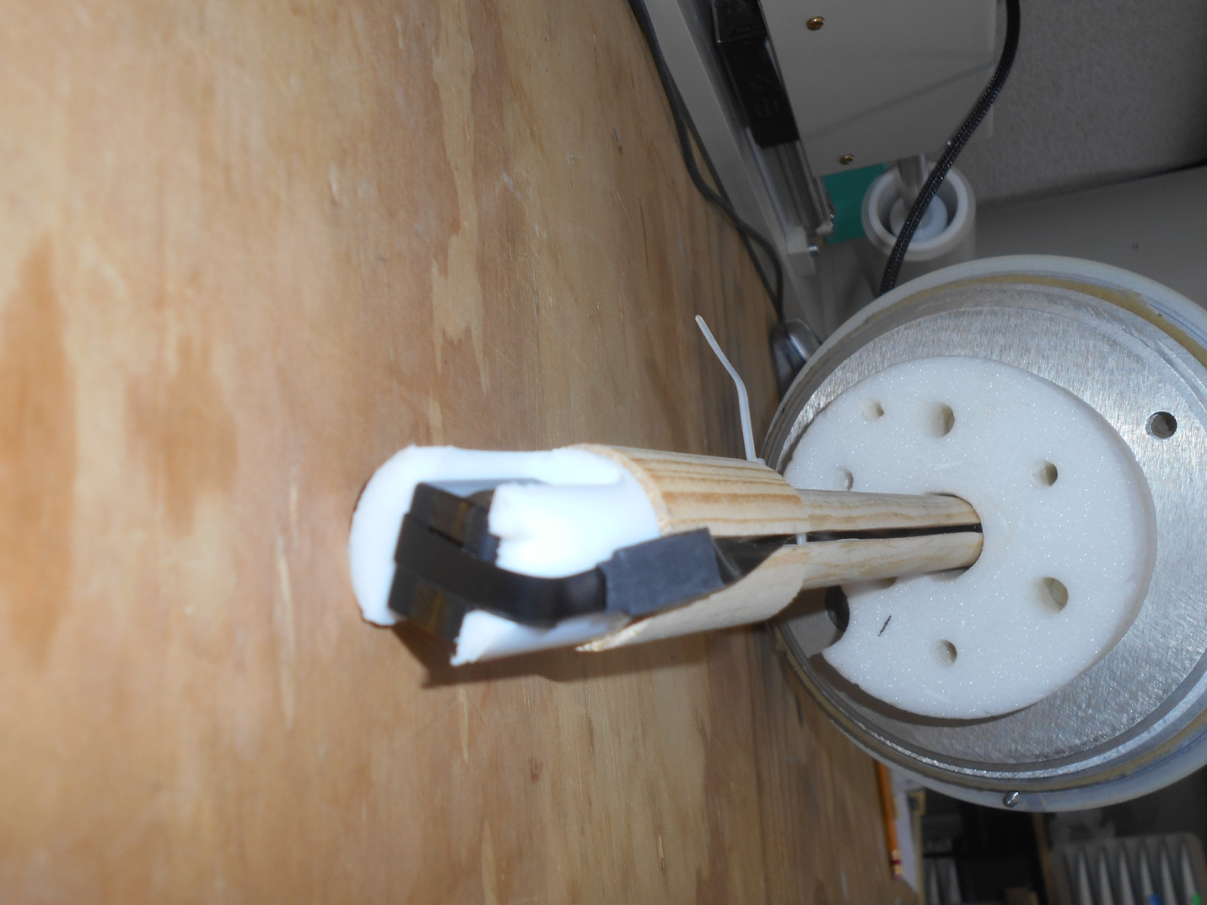
S4: View of QZFM Gen-2 sensor head installed in a Teflon holder at the tip of a wooden rod. Note the slit cut into the wood rod to guide the sensor cable through the central hole in the top cover of the magnetic shield.

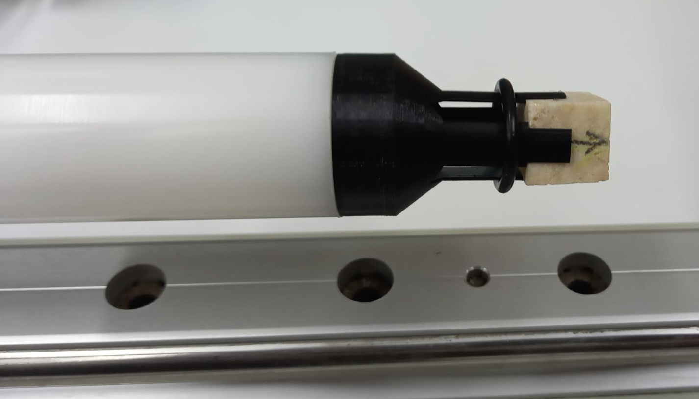
S5: View of the 15 mm cube holder for adapter-less measurements of cubic samples, with inserted stalagmite cube.

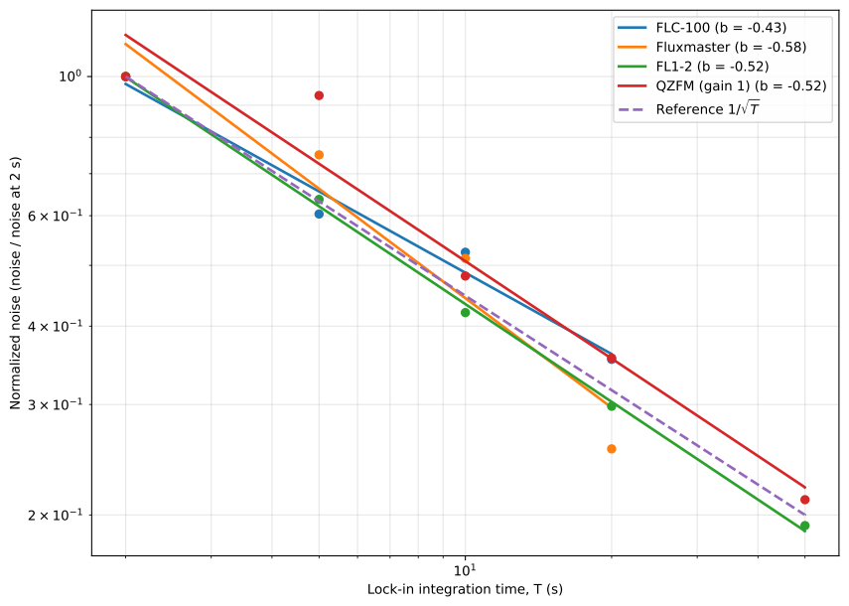
Figure S6. System noise levels against lock-in-amplifier integration time T for all sensors tested in the FIT magnetometer. The dotted pink line corresponds to the relation noise ∝ 1/√T (or noise ∝ T^{-0.5}). Noise levels scatter around this line, and best fits using the power law, noise = aT^{b} , provide exponents -0.58 ≤ b ≤ -0.43, i.e., close to b = -0.5.

