Supplementary Information for
Stabilizing REGARD with Real-Time MCMC Uncertainty Quantification and Precise Point Positioning

Keitaro Ohno*, Satoshi Abe, Naofumi Takamatsu, Takayuki Miyazaki, Koki Yoshinaga, Chinami Shodai, Mayumi Hashimoto, Riku Yamamoto, Satoshi Kawamoto, Yusaku Ohta

*Corresponding author: Keitaro Ohno, Geospatial Information Authority of Japan, 1 Kitasato, Tsukuba 305-0811, Japan, keitaro.ohno.s5@gmail.com

Table S1. 2024 Noto Peninsula earthquake. Postprocess indicates the post-processed model estimated with RUNE using R5 coordinates recovered from post-event data.

 | Mw | VR  [%] | depth  [km] | length  [km] | width  [km] | strike  [deg] | dip  [deg] | rake  [deg] | slip amount  [m]
REGARD  RUNE | 7.44 | 93.6 | 5.4 | 120.9 | 31.5 | 64.1 | 6.0 | 135.4 | 1.59
REGARD  MLE | 7.43 | 99.2 | 2.4 | 134.0 | 31.6 | 61.6 | 10.8 | 134.2 | 1.38
Postprocess | 7.40 | 91.9 | 1.6 | 80.7 | 20.0 | 60.3 | 36.2 | 132.1 | 3.24

Table S2. 2024 Hyuga-nada earthquake. Postprocess indicates the model reported by GSI (2024b).
 | Mw | VR  [%] | depth  [km] | length  [km] | width  [km] | strike  [deg] | dip  [deg] | rake  [deg] | slip amount  [m]
REGARD  RUNE | 7.15 | 52.4 | 24.8 | 30.0 | 15.7 | 215.9 | 27.8 | 80.55 | 4.79
REGARD  MLE | 6.91 | 44.4 | 15.7 | 40.4 | 12.7 | 233.0 | 25.2 | 113.9 | 1.92
Postprocess | 7.10  (μ=60GPa) | 80.2 | 13.6 | 24.5 | (L:W=  3:2) | 207.1 | 20.7 | 85.2 | 3.2

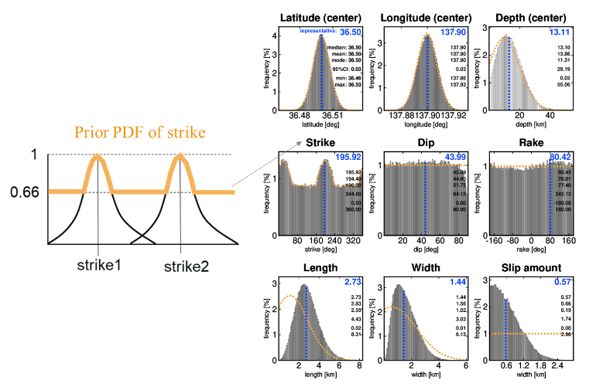
Fig. S1 Configuration of prior probability distributions in REGARD’s implementation.
Normal distributions are assigned to latitude, longitude, depth (fault‑plane center), length, and width.
Strike is assigned to a bimodal distribution corresponding to the two nodal planes from the initial mechanism. Right: posterior distribution for a noise‑dominant case with no significant displacement. The yellow curve denotes the prior.

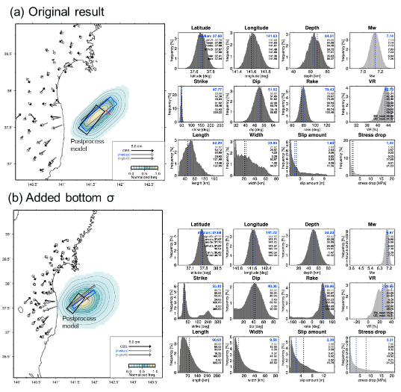
Fig. S2. RUNE results for the 2021 Fukushima-oki earthquake. (a) Results before modifying the lower bound of σ in the Gaussian likelihood. (b) Results after introducing σ floors. Blue rectangle: median model. Gray rectangle: sample with the highest VR. Black, white, and gray vectors represent observed displacement, modeled displacement from the median model, and modeled displacement from the highest-VR sample, respectively. Contours show the normalized distribution of sampled fault planes. The horizontal axis spans the search range. Black rectangle indicates the GSI (2021) model*.
*GSI (2021): https://www.gsi.go.jp/cais/topic210222-index.html.
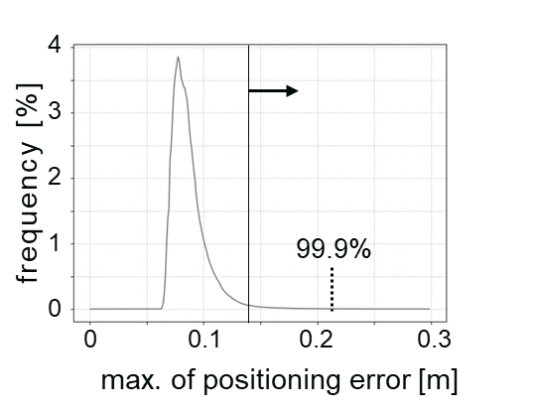
Fig. S3. Histogram of maximum positioning error for all stations, computed using two months of data (August–October 2021).

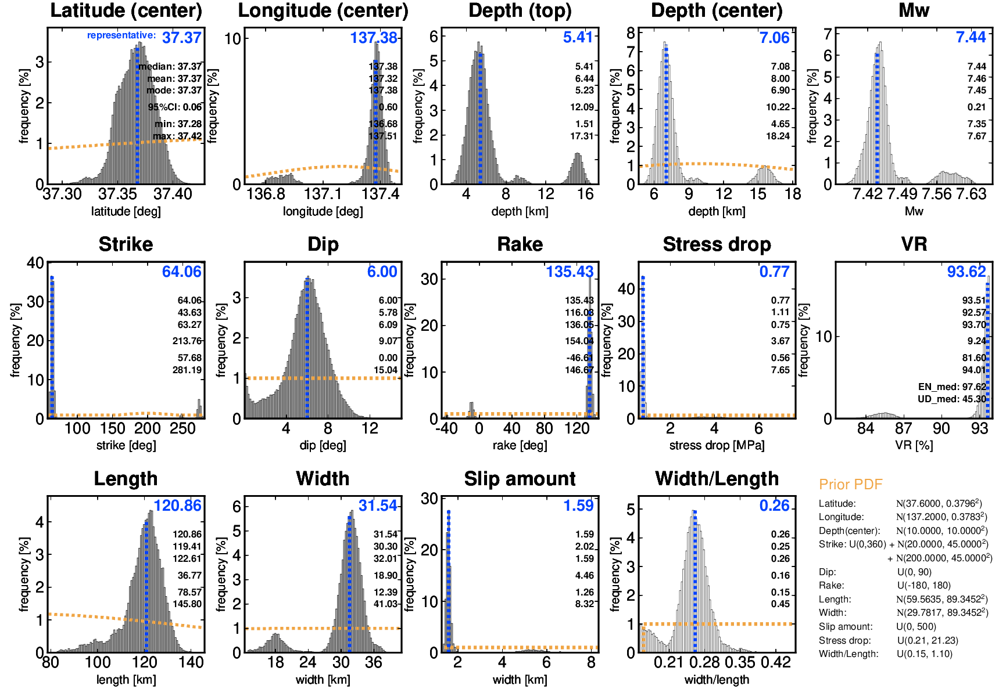
Fig. S4. RUNE results for the 2024 Noto Peninsula earthquake. Posterior PDFs. The ranges on the horizontal axis reflect the maximum search ranges. Inserted values in the upper right-hand corner denote the median, mean, mode, 95% confidence interval, minimum value, and maximum value, respectively. The yellow dot lines and inserted texts in the bottom-right indicate prior PDFs.

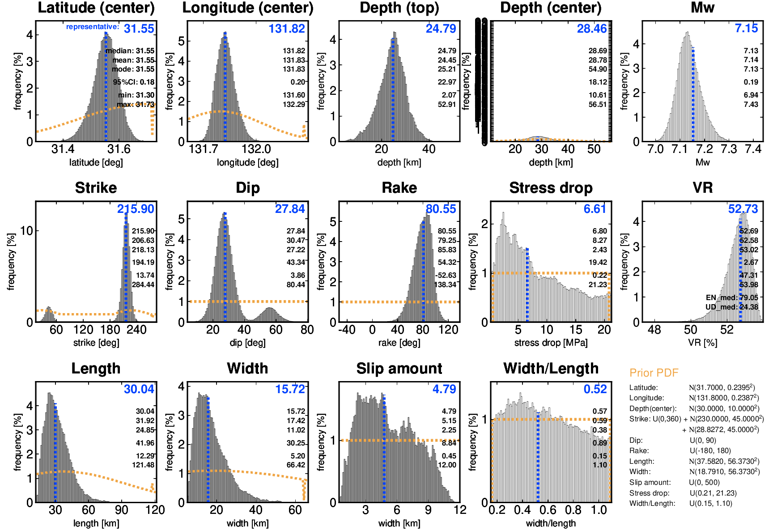
Fig. S5. RUNE estimation results for the 2024 Hyuga-nada earthquake. Posterior PDFs. The ranges on the horizontal axis reflect the maximum search ranges. Inserted values in the upper right-hand corner denote the median, mean, mode, 95% confidence interval, minimum value, and maximum value, respectively. The yellow dot lines and inserted texts in the bottom-right indicate prior PDFs.

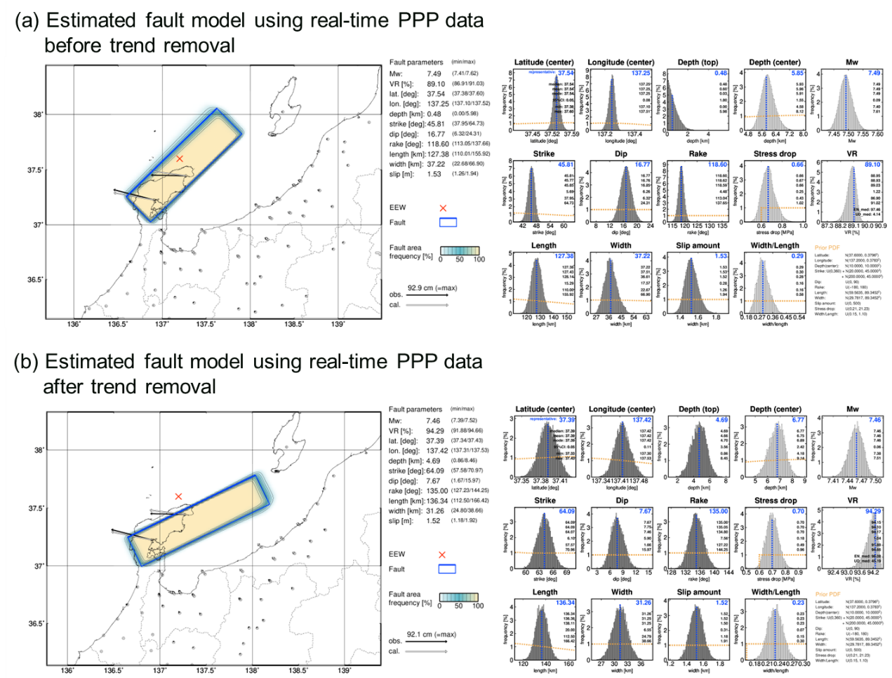
Fig. S6.1. RUNE results for the 2024 Noto Peninsula earthquake using real-time PPP. (a) Using displacement fields before trend removal. (b) Using displacement fields after trend removal.
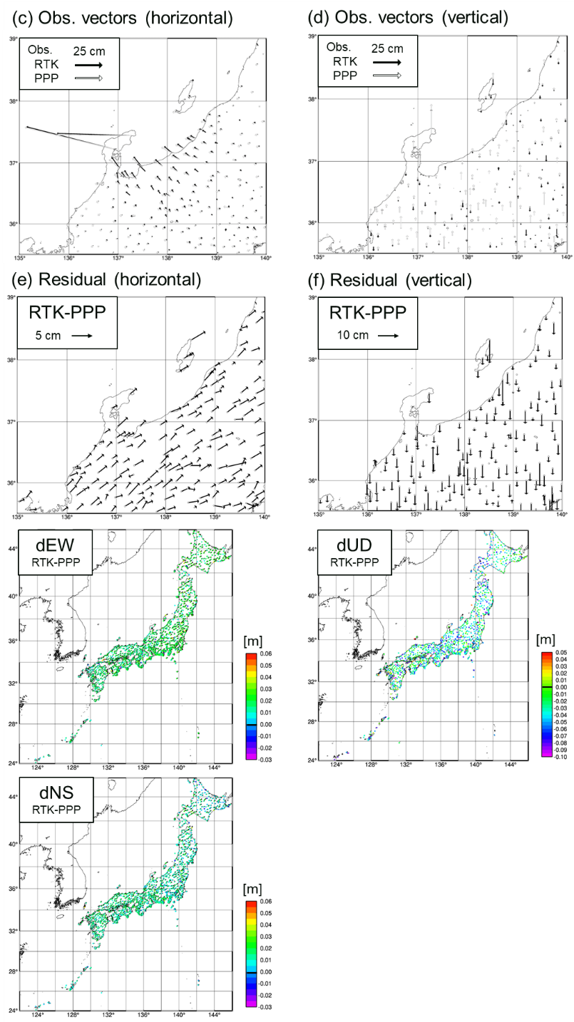
Fig. S6.2. Comparison of displacement fields for the 2024 Noto Peninsula earthquake using RTK and real-time PPP. (c) Horizontal displacement. (d) Vertical displacement. (e) Horizontal residuals. (f) Vertical residuals.
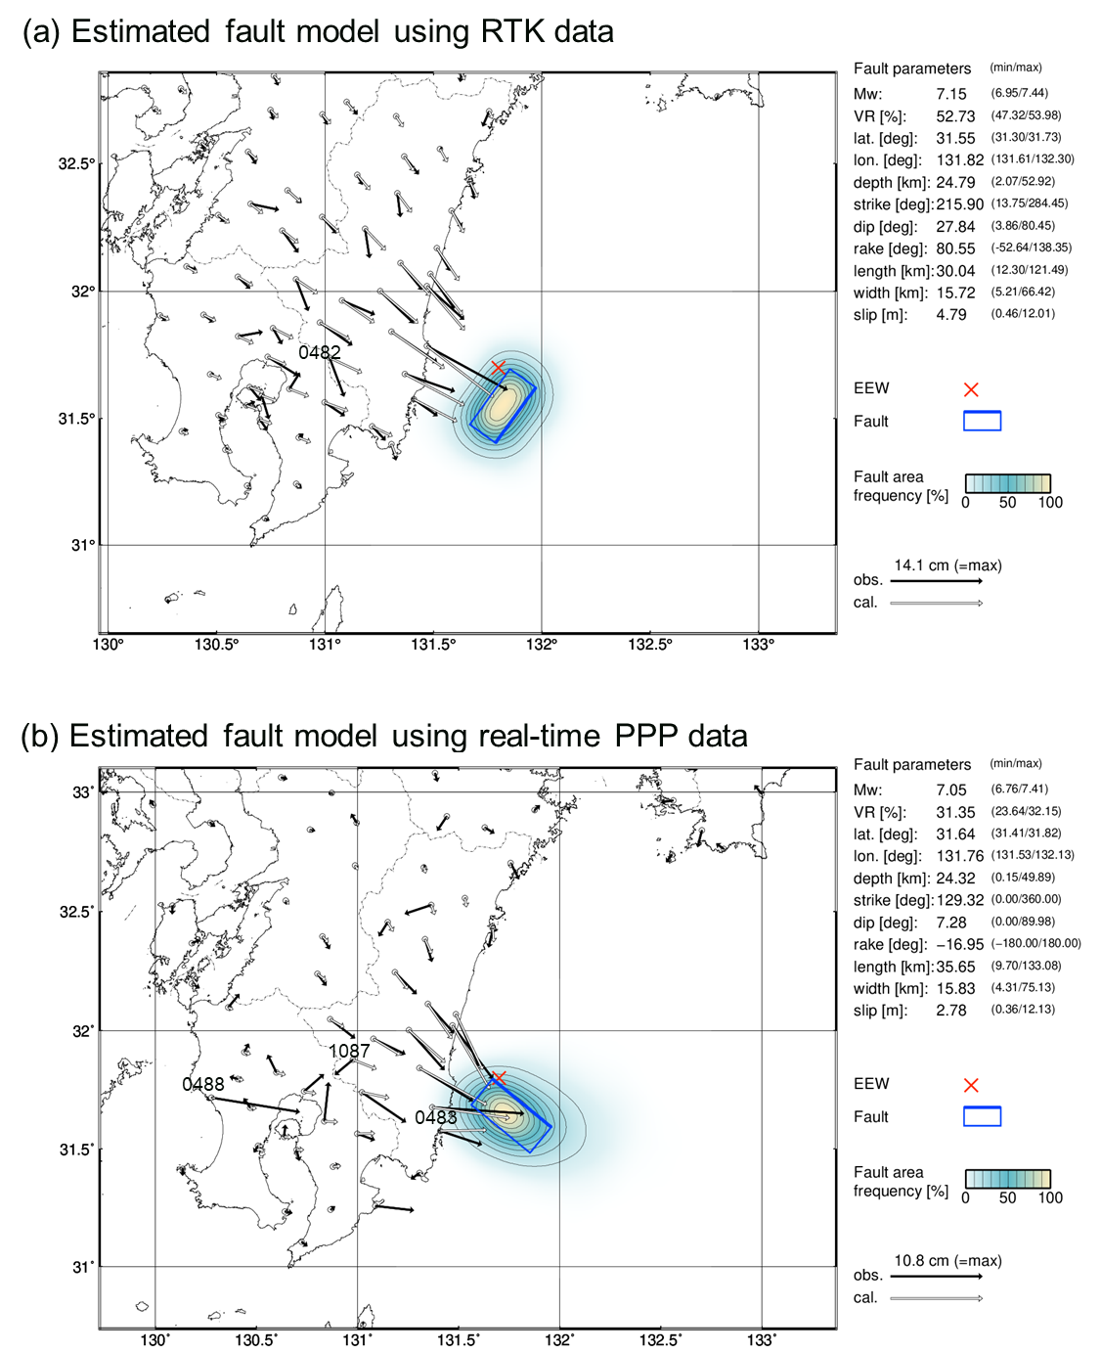
Fig. S7.1. RUNE results for the 2024 Hyuga-nada earthquake. (a) Automatic estimation using RTK. (b) Post-processed estimation using real-time PPP.

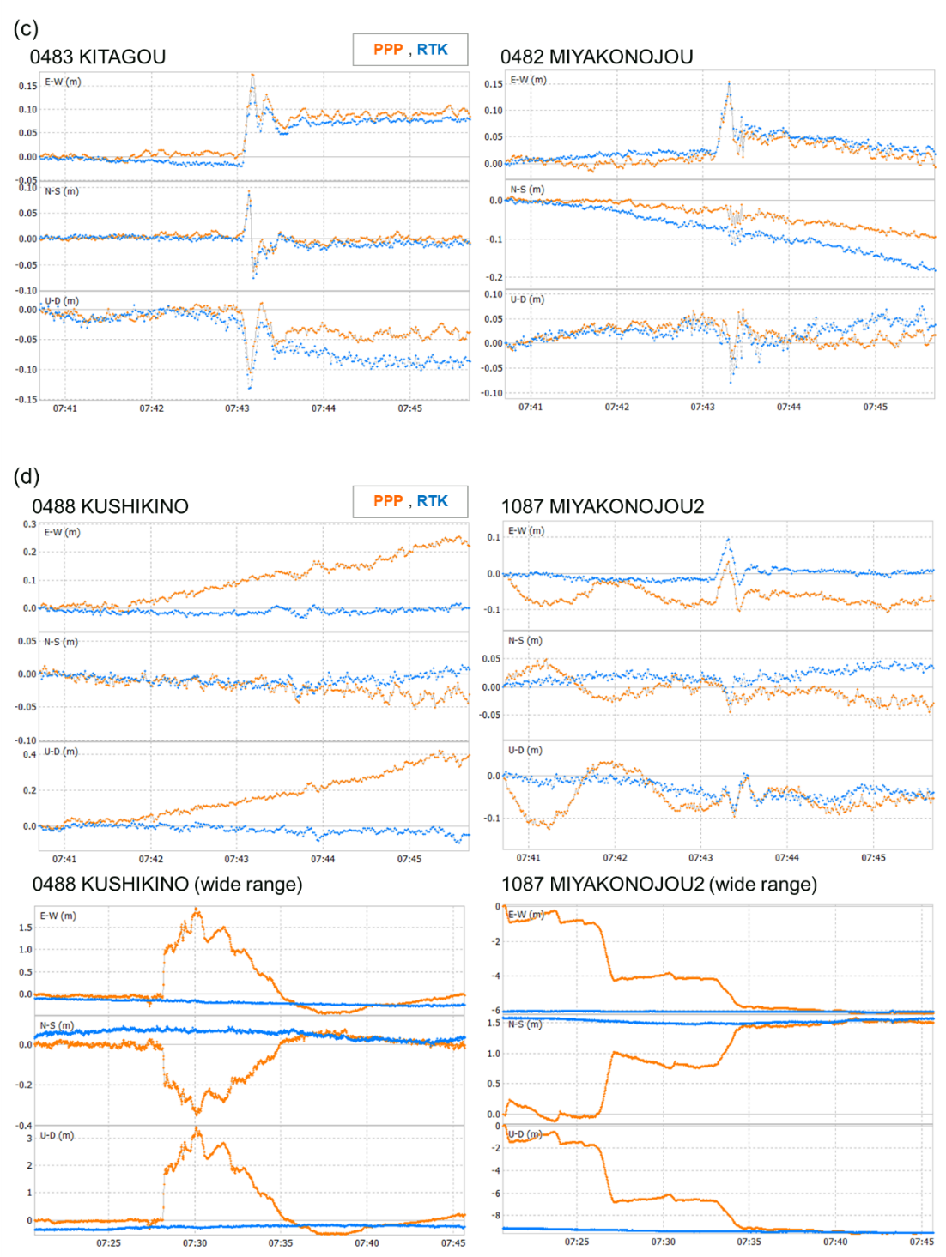
Fig. S7.2. Comparison of displacement fields for the 2024 Hyuga-nada earthquake using RTK and real-time PPP. (a) Example of large displacement at 0483 and an anomalous azimuthal pattern at 0482 in RTK. (b) Examples of stations with large PPP noise (0488, 1087). Bottom: expanded time-axis view illustrating the positioning status.

