Additional file 1

Positional Effects on the Distributions of Ventilation and End-expiratory Gas Volume in the Asymmetric Chest –A Quantitative Lung Computed Tomographic Analysis
Gustavo A. Cortes-Puentes, MD
Kenneth E . Gard, MD
Alexander B. Adams, MPH, RRT
David J. Dries, MD
Michael Quintel, MD
Richard A. Oeckler, MD, PhD
Luciano Gattinoni, MD
John J Marini, MD
Corresponding Author:
Gustavo A. Cortes-Puentes, MD
Mayo Clinic, Rochester MN, United States.
Department of Pulmonary and Critical Care Medicine
Mailing address: Mayo Clinic, 200 First Street SW, Rochester, MN 55905 USA
E-mail: CortesPuentes.Gustavo@mayo.edu

Figure S1: Chest CT Images at End-Inspiration During Supine and Prone positions. Radiopaque material indicates the location of the pleural effusion randomly instilled in the right (n=3) or left pleural (n=3) space.

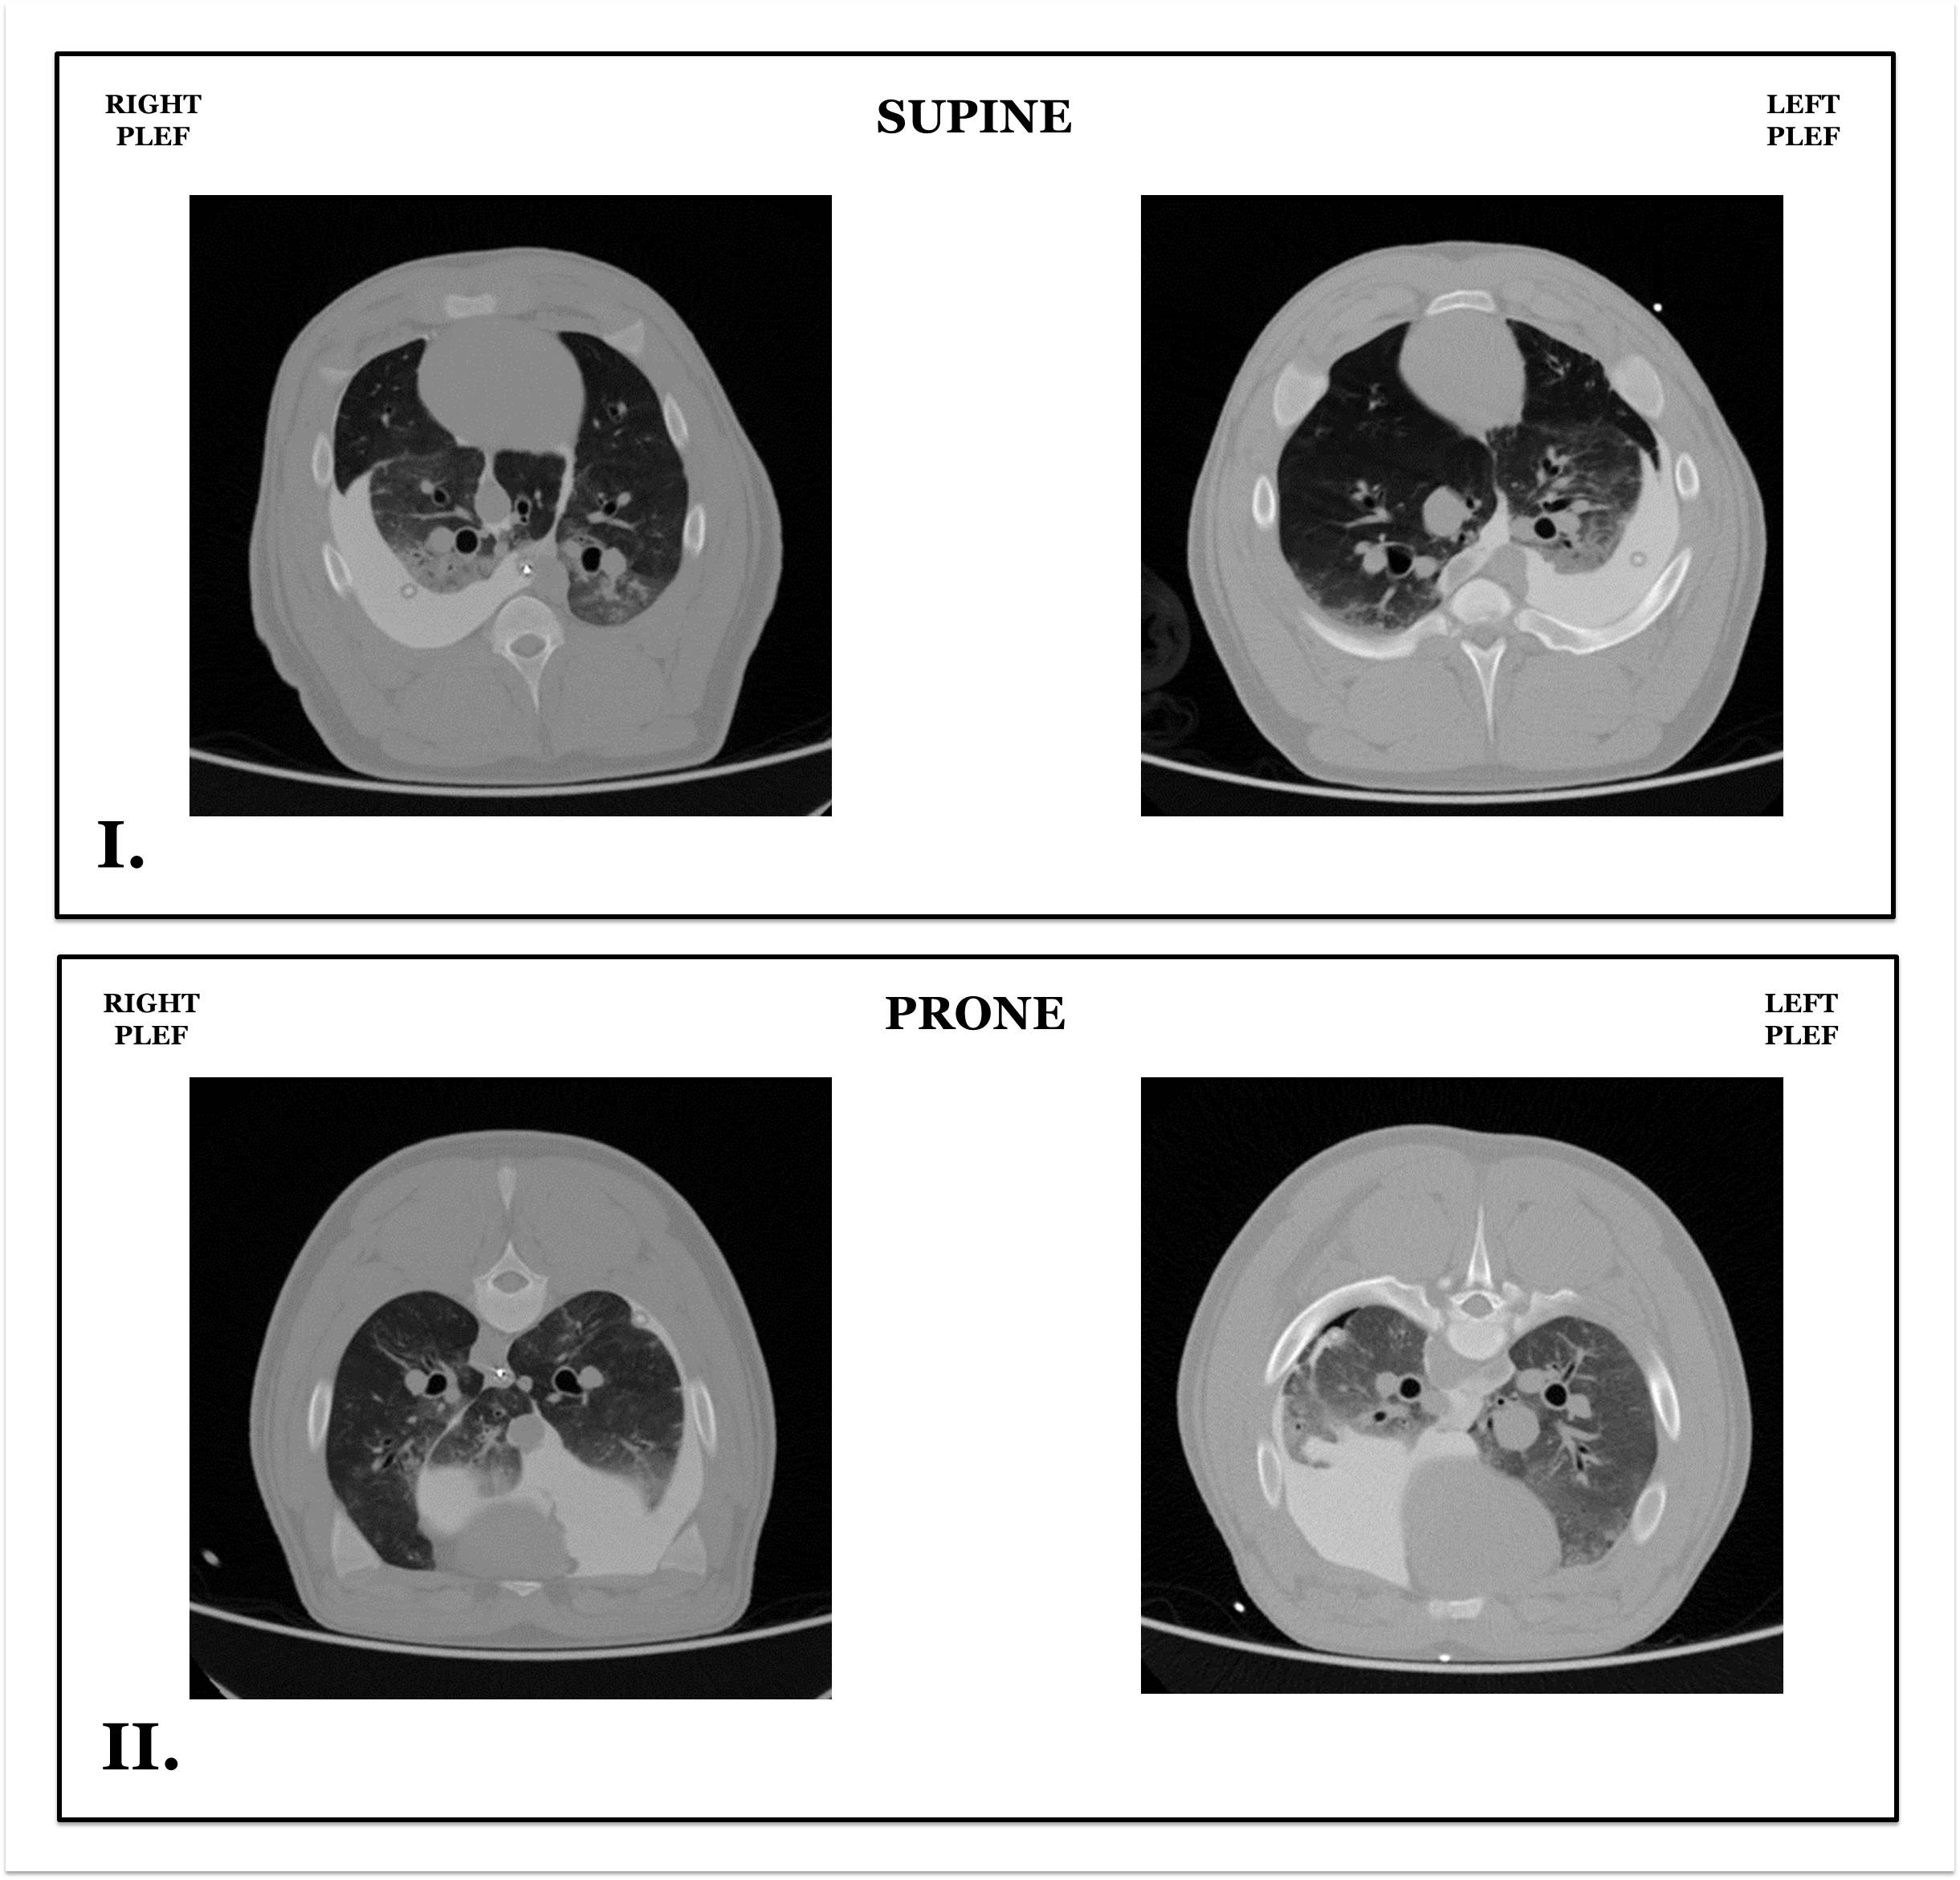

Figure S2: Chest CT Images at End-Inspiration During Lateral Positions with Dependent and Non-Dependent PLEF. Radiopaque material indicates the location of the pleural effusion randomly instilled in the right (n=3) or left pleural (n=3) space. PLEF= pleural effusion.
