Supporting Information
Complement factor D is linked to platelet activation in human and rodent sepsis.
Sommerfeld O^{1,2,+}, Dahlke K^{1,2}, Sossdorf M^{1,2}, Claus RA^{1,2}, Scherag A^{2,3}, Bauer M^{1,2}, Bloos F^{1,2,+}
¹Department of Anesthesiology and Intensive Care Medicine, Jena University Hospital, Jena, Germany
²Center for Sepsis Control and Care (CSCC), Jena University Hospital, Jena, Germany
³Institute of Medical Statistics, Computer and Data Sciences, Jena University Hospital, Jena, Germany

+Correspondence: Frank.Bloos@med.uni-jena.de and Oliver.Sommerfeld@med.uni-jena.de

Figure S1 Thromboelastometry (ROTEM, TEM) and platelet receptor surface expression (A, B and D to F) EXTEM, INTEM and FIBTEM test were performed. (A and B) Clotting time (ct) in fD^{-/-} mice (fD-/-) was prolonged and (D to F) maximum clot firmness (mcf) was reduced in both groups after sepsis onset. (C) Plasma D-dimer increased over time in both groups after CLP. (G and H) Plasma cytokine levels of TNF-α and IL-10 increased three hours after CLP. (I) Platelet surface expression of P-selectin increased in both groups after CLP.
Statistics: *significant to fD^{-/-} sham control (crtl) or wild-type (wt) sham control (crtl) and §significant to 6 hours wild-type after CLP with p<0.05, (A, B and D to H) Wilcoxon-Mann-Whitney test or (C and I) Kruskal-Wallis test (Dunn´s test correction). #Statistical significance (p<0.05) between fD^{-/-} and wild-type (wt) by means of (E) Wilcoxon-Mann-Whitney test. 3 to 12 mice/group.

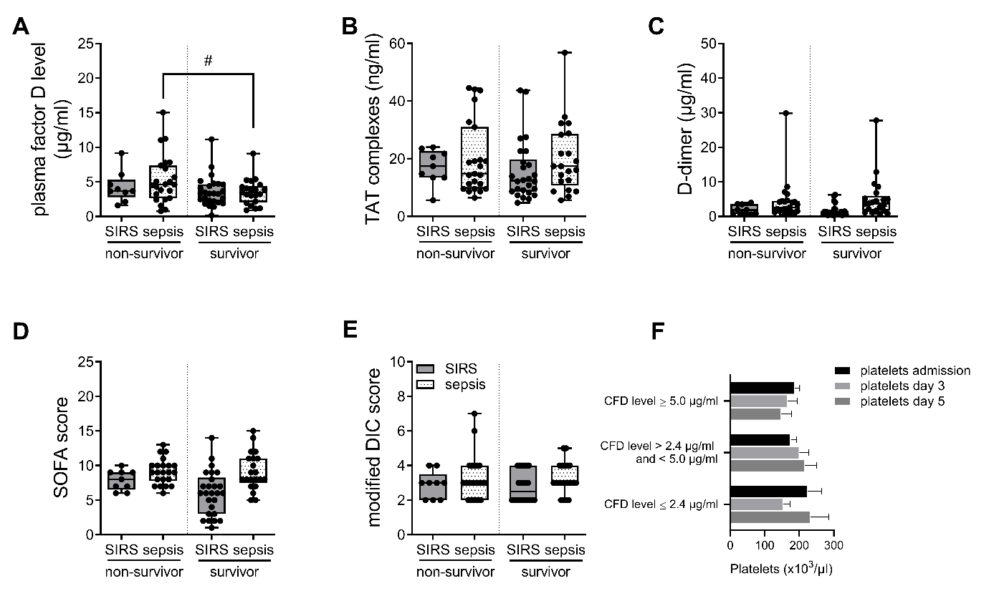
Figure S2 Coagulation parameters and clinical scores (A) Complement factor D (CFD): Worst outcome was associated with significant higher complement factor D level in septic non-survivors compared to survivor group (SIRS and sepsis). (B and C) Minor differences were observed for TAT complexes, whereas D-dimer were higher in septic patient (survivor and non-survivor) compared to SIRS survivor group. (D and E) Higher SOFA score were found in septic patient (survivor and non-survivor) compared to SIRS survivor group. DIC score showed no difference between all groups. (F) Platelet count at ICU admission, day 3 and 5 showed minor differences depending to low (≤2.4µg/ml), mid (>2.4 µg/ml and <5.0 µg/ml) or high (≥5.0 µg/ml) CFD plasma concentration.
Statistics: #Statistical significance (p<0.05) between non-survivor (sepsis) and survivors (sepsis and SIRS) by means of (A) Student’s t-test or (B to E) Wilcoxon-Mann-Whitney. In total 79 patients.

 |  | Complement factor D | TAT complexes | D-dimer | Platelets | SOFA score | DIC score (modified)
Complement factor D | Pearson correlation | 1 | .101 | -.083 | -.096 | .328** | -.057
Complement factor D | p value |  | .376 | .468 | .399 | .003 | .617
Complement factor D | N | 79 | 79 | 79 | 79 | 79 | 79
TAT complexes | Pearson correlation | .101 | 1 | .051 | .321** | .082 | -.071
TAT complexes | p value | .376 |  | .658 | .004 | .472 | .536
TAT complexes | N | 79 | 79 | 79 | 79 | 79 | 79
D-dimer | Pearson correlation | -.083 | .051 | 1 | .141 | .195 | .433**
D-dimer | p value | .468 | .658 |  | .216 | .085 | .000
D-dimer | N | 79 | 79 | 79 | 79 | 79 | 79
Platelets | Pearson correlation | -.096 | .321** | .141 | 1 | -.234* | -.232*
Platelets | p value | .399 | .004 | .216 |  | .038 | .040
Platelets | N | 79 | 79 | 79 | 79 | 79 | 79
SOFA score | Pearson correlation | .328** | .082 | .195 | -.234* | 1 | .330**
SOFA score | p value | .003 | .472 | .085 | .038 |  | .003
SOFA score | N | 79 | 79 | 79 | 79 | 79 | 79
DIC score  (modified) | Pearson correlation | -.057 | -.071 | .433** | -.232* | .330** | 1
DIC score  (modified) | p value | .617 | .536 | .000 | .040 | .003
DIC score  (modified) | N | 79 | 79 | 79 | 79 | 79 | 79

Table S1 Results of Pearson correlation analyses of several candidates such as Complement factor D (CFD) level, TAT complexes, D-dimer, platelet count, SOFA score and modified DIC score are plotted in the table. Statistics: **(p value ≤0,01) and *(to p value ≤0.05) statistical differences for several variables by means of bivariate Pearson correlation coefficients.

Figure S3 Correlation analyses Complement factor D and platelet count showed no correlation. In contrast, complement factor D showed positive correlation to SOFA score. Statistics: All significances are plotted in table S1. Bivariate Pearson correlation coefficients and percentiles (1: 25%, 2: 50% and 3: 75%) are individually marked on the graphs.

