Additional file 1

A Closed-loop Ventilation Mode that Targets the Lowest Work and Force of Breathing Reduces the Transpulmonary Driving Pressure in Subjects with moderate-to-severe ARDS—a singlecenter randomized crossover clinical trial

Laura A. Buiteman-Kruizinga, David M.P. van Meenen, Lieuwe D.J. Bos,
Pim L.J. van der Heiden, Frederique Paulus, Marcus J. Schultz

Table of contents

Additional Tables
Table S1 3
Table S2 4
Additional Figures
Figure S1 5
Figure S2 6
Figure S3 7
Figure S4 8
Figure S5 9
Figure S6 10
Figure S7 11
Figure S8 12
Figure S9 13
Figure S10 14
Figure S11 15
Figure S12 16
Figure S13 17
Additional Tables
Table S1. List of significant pairwise comparisons per time point, significance was determined at a P value < 0.003
 | n = 13
ΔP_{RS} (cm H₂O) | None
ΔP_{TP} (cm H₂O) | 2,3,7,9,10
P_{TPinsp} | 1,2,3,5,7,8,9,11
V_{T} (ml/kg PBW) | 2,5,6,9,11,12,13,15
RR (/min) | All
MP_{RS} (J/min) | None
MP_{TP} (J/min) | 1,3,4,5,8,10
ΔP_{RS}: driving pressure of the respiratory system; ΔP_{TP}: transpulmonary driving pressure; P_{TPinsp}: inspiratory transpulmonary pressure; V_{T}: tidal volume; PBW: predicted body weight; cm H₂O: centimeters of water; RR: respiratory rate; MP_{RS}: mechanical power of the respiratory system; MP_{TP}: transpulmonary mechanical power

Table S2. Specification of the generalized linear mixed model analysis
 | Fixed effects | 95% CI | P value
Primary endpoint
ΔP_{TP} (cm H₂O) | Mode 1.41  Time point –0.07  Mode * time point –0.03 | 0.99 to 1.84  –0.12 to 0.03  –0.07 to 0.02 | < 0.001  0.15  0.249
Secondary endpoint
ΔP_{RS} (cm H₂O) | Mode –0.15  Time point –0.05  Mode * time point –0.007 | –0.46 to 0.17  –0.08 to 0.015  –0.04 to 0.03 | 0.36  0.06  0.68
V_{T} (mL/kg PBW) | Mode –0.25  Time point –0.013  Mode * time point –0.004 | –0.38 to –0.12  –0.03 to 0.0006  –0.02 to 0.009 | 0.0002  0.06  0.557
RR (breaths / min) | Mode 1.17  Time point 0.003  Mode * time point 0.002 | 0.93 to 1.42  0.004 to 0.06  –0.02 to 0.03 | < 0.001  0.0225  0.82
MP_{TP} (J/min) | Mode 1.42  Time point –0.02  Mode * time point –0.04 | 0.82 to 1.47  –0.05 to 0.02  –0.08 to –0.008 | < 0.001  0.3003  0.0162
MP_{RS} (J/min) | Mode 0.44  Time point –0.008  Mode * time point –0.04 | 0.06 to 0.83  –0.05 to 0.03  –0.08 to 0.005 | 0.024  0.68  0.09
Abbreviations: ΔP_{RS}: respiratory system driving pressure; ΔP_{TP}: transpulmonary driving pressure; MP_{RS}: mechanical power of the respiratory system; MP_{TP}: transpulmonary mechanical power; V_{T}: tidal volume; PBW: predicted body weight; cm H₂O: centimeters of water; RR: respiratory rate; CI: confidence interval

Additional Figures

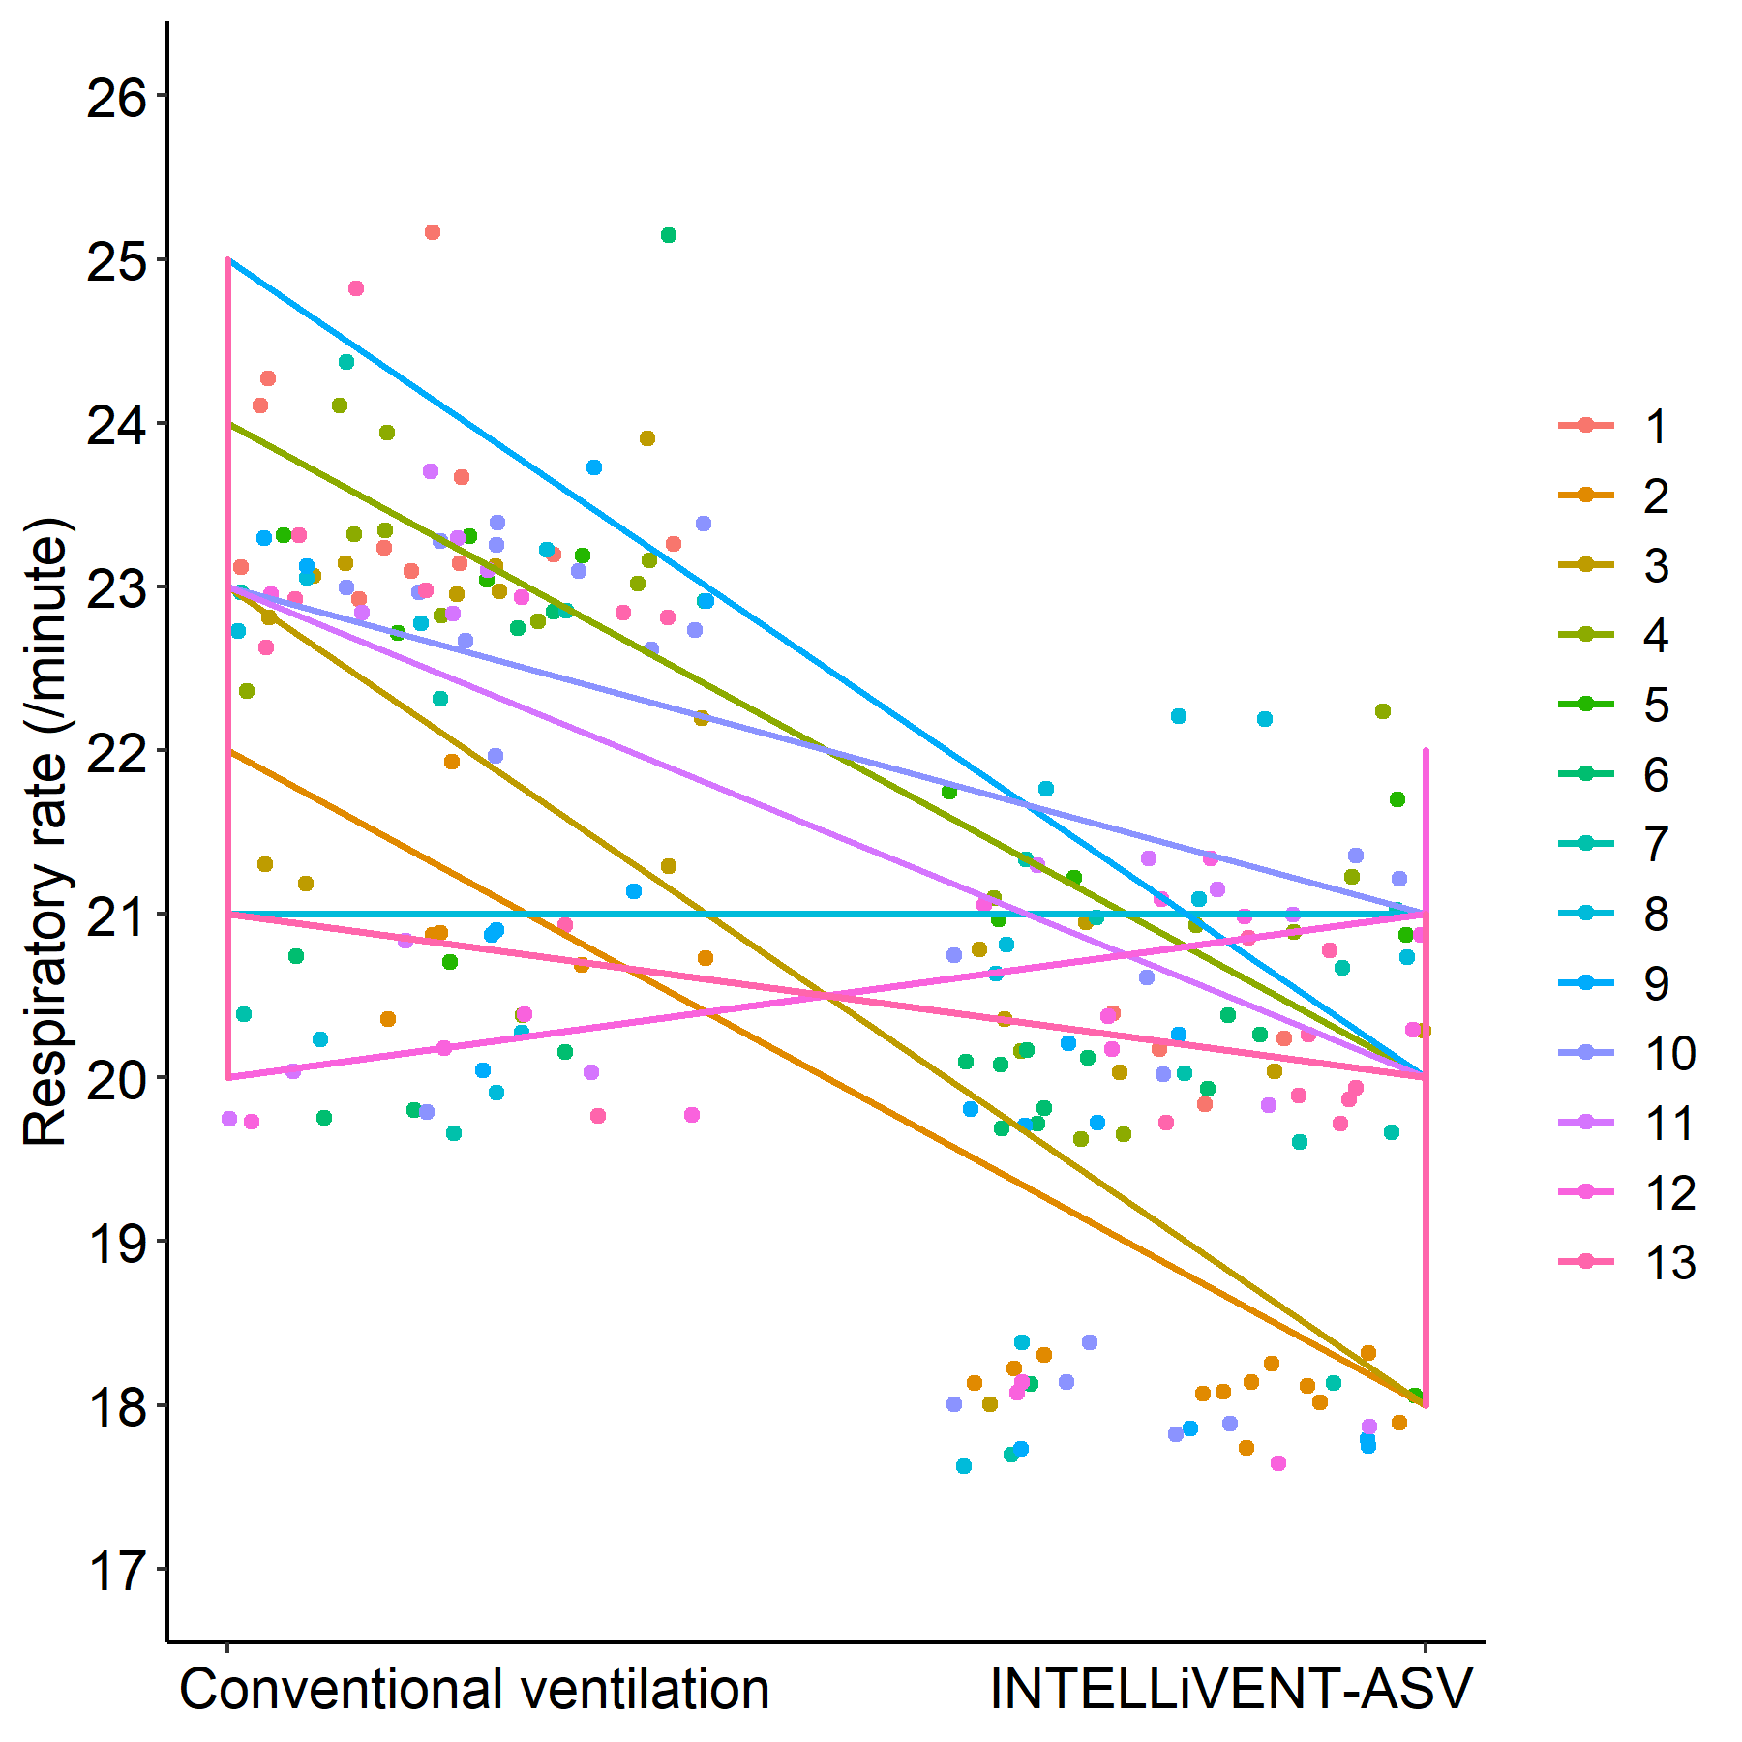
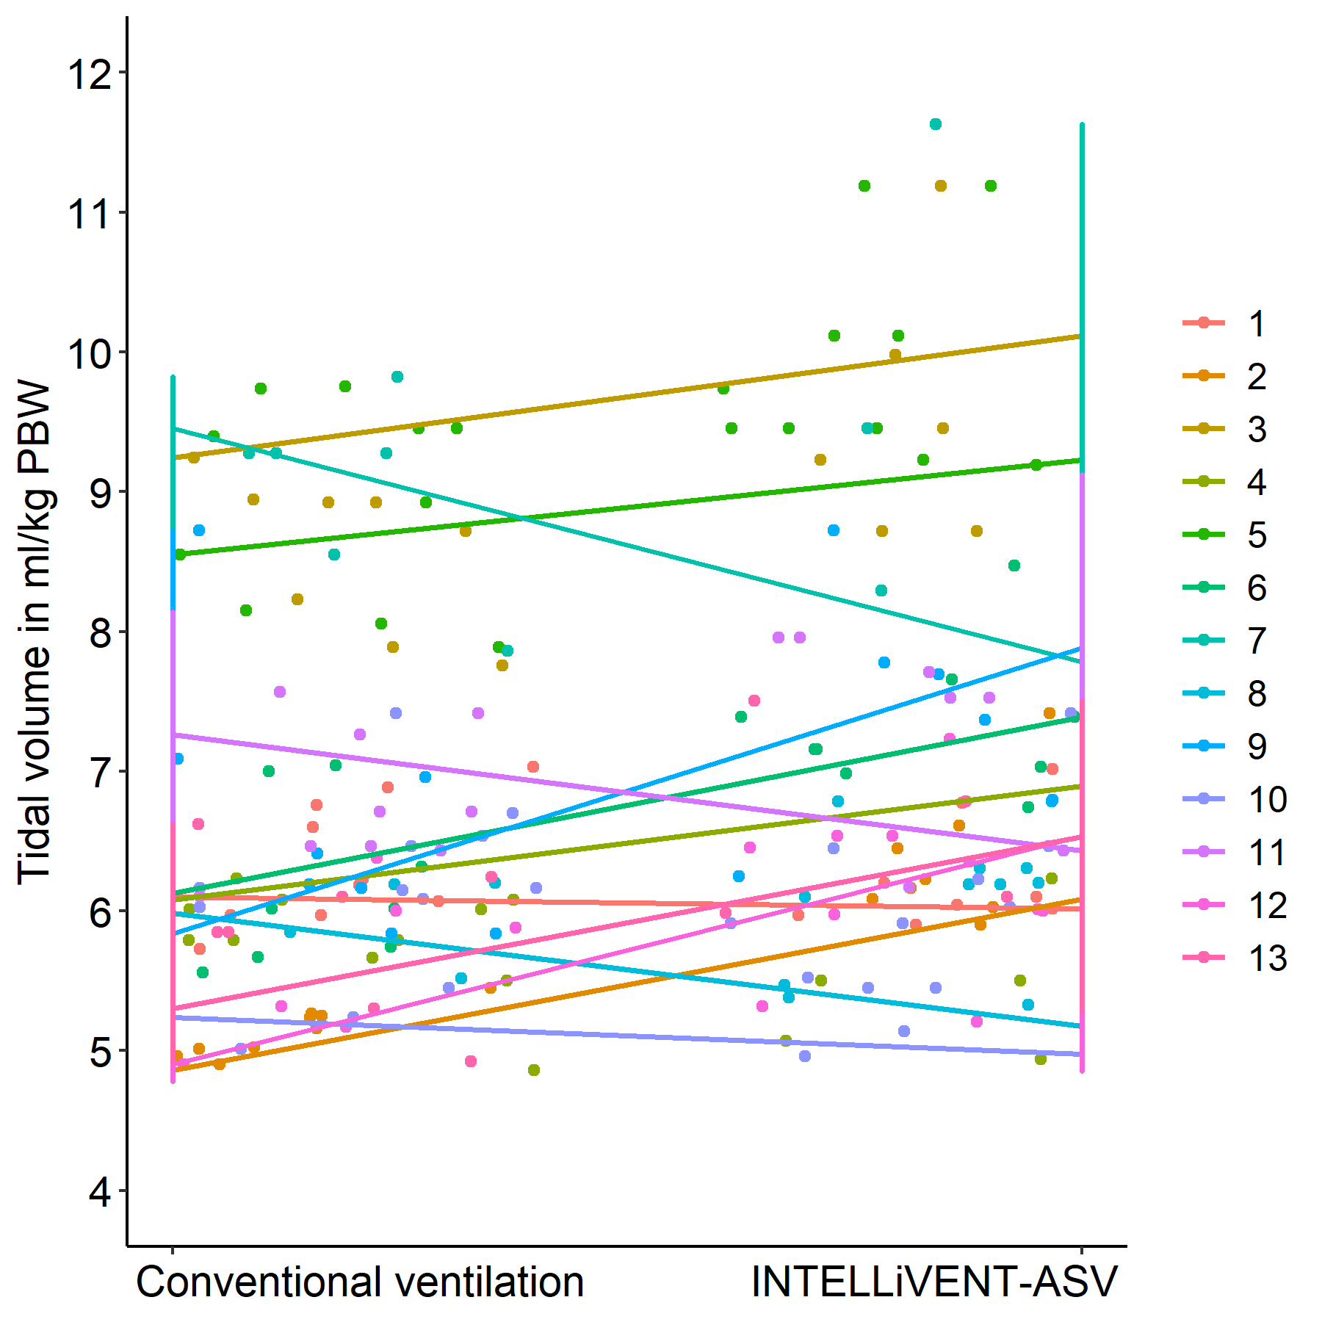
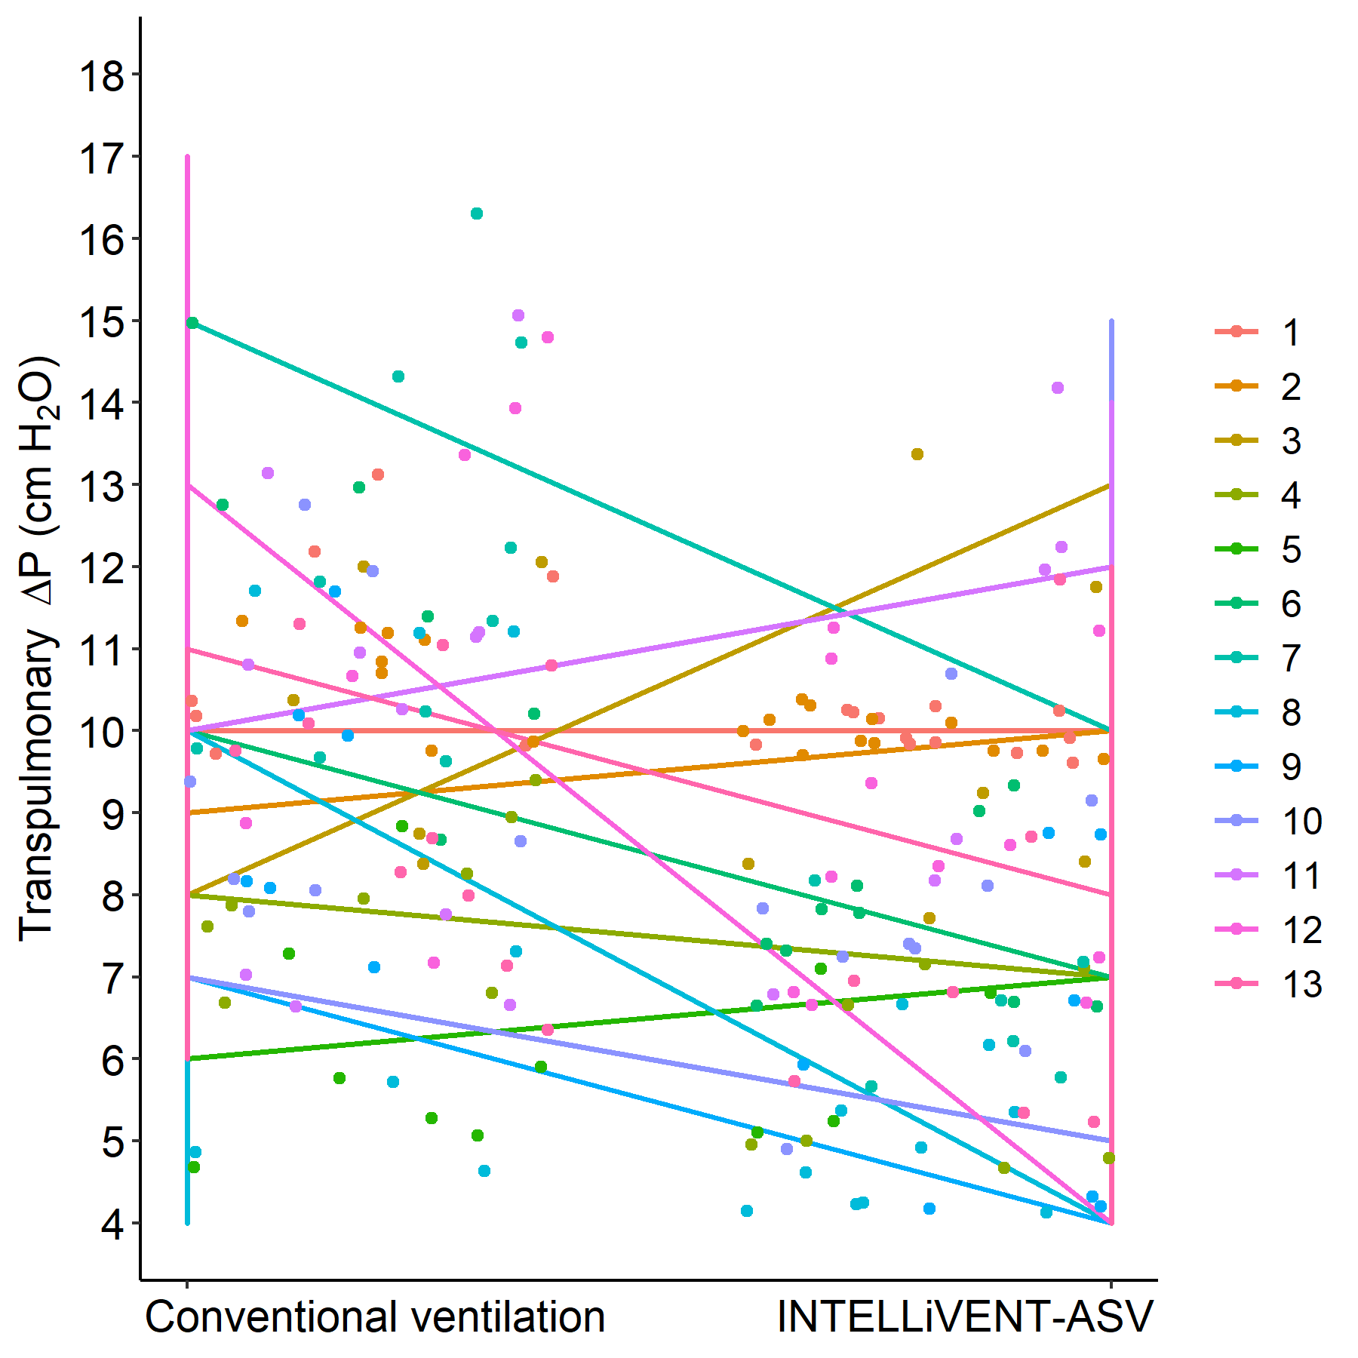
Figure S1

Figure S1. Line plots showing the mean changes and individual changes over time of transpulmonary ΔP, V_{T} and RR during the two study blocks of the two ventilation modes in the study.

Figure S2

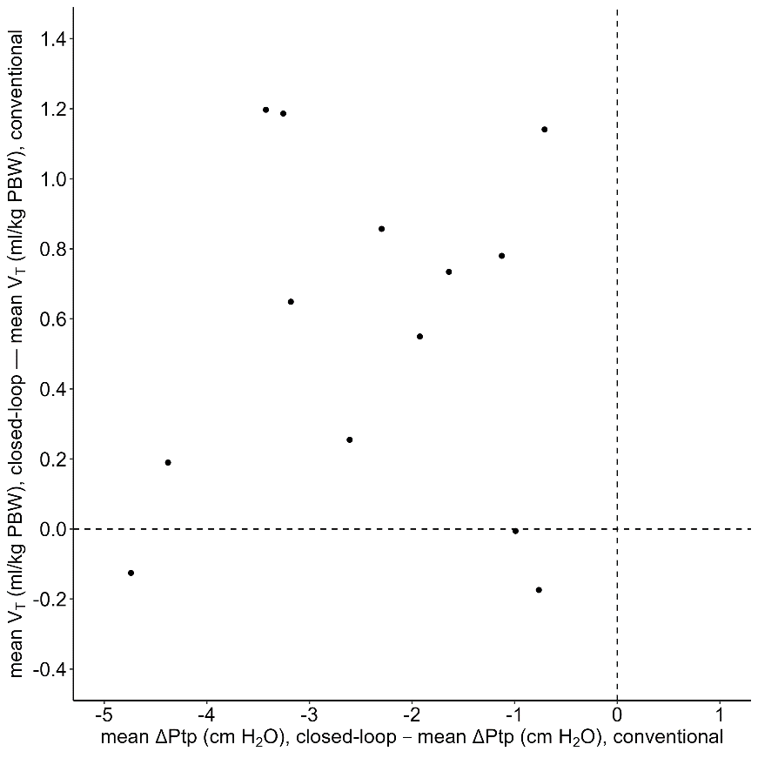
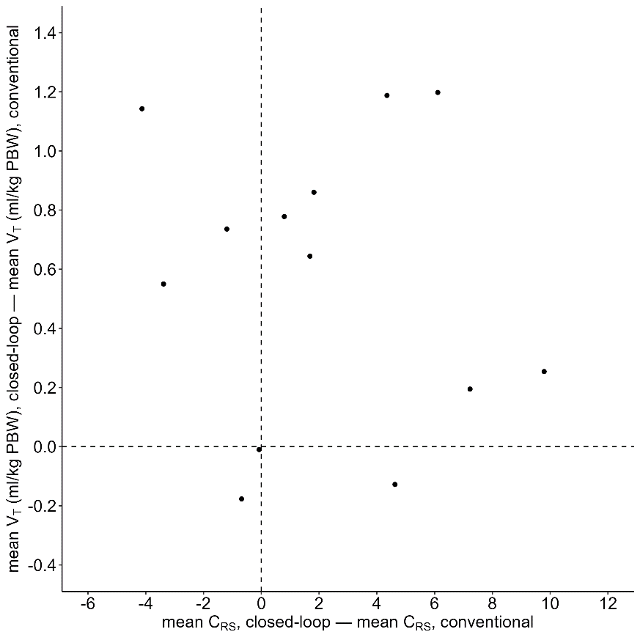

Figure S2. C_{RS} vs V_{T} between closed-loop ventilation and conventional ventilation, and transpulmonary ΔP vs V_{T} between closed-loop ventilation and conventional ventilation. A negative value means that the parameter decreased with closed-loop ventilation, and a higher value means that the parameter increased with closed-loop ventilation. All dots represent the mean value of an individual patient.

Figure S3

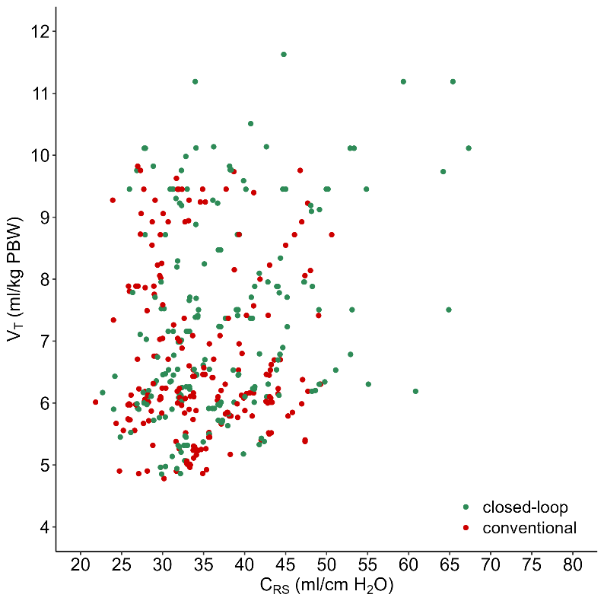
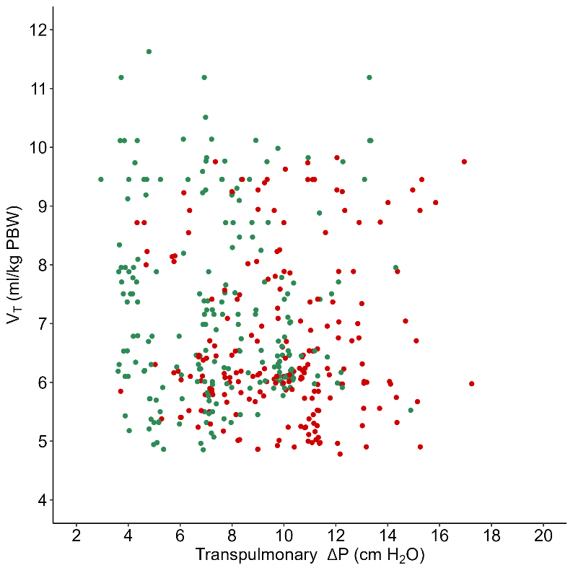

Figure S3. Scatterplots of C_{RS} vs V_{T} and transpulmonary ΔP vs V_{T} with closed–loop ventilation and conventional ventilation. Each dot was characterized by a single data point.

Figure S4

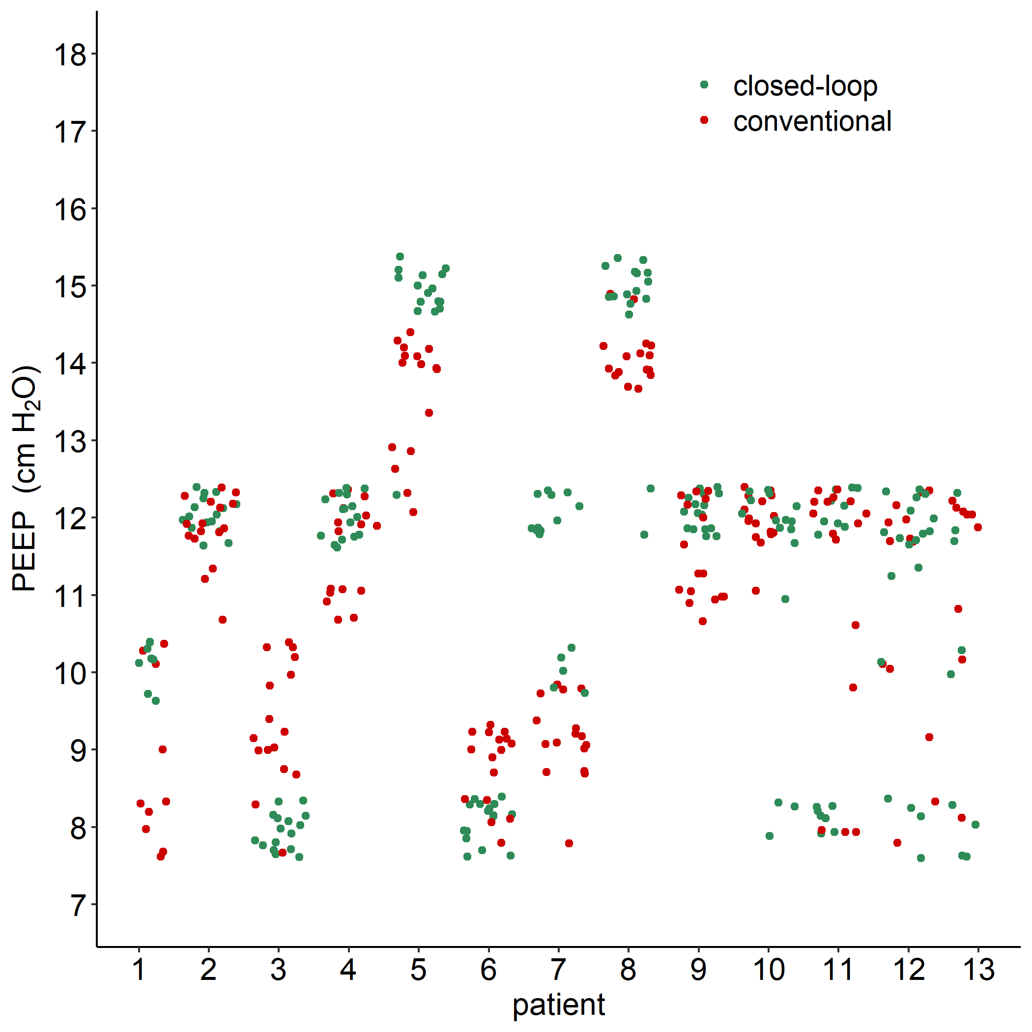
Figure S4. Showing individual patient data of the effect of the change of the ventilation mode on PEEP setting.

Figure S5
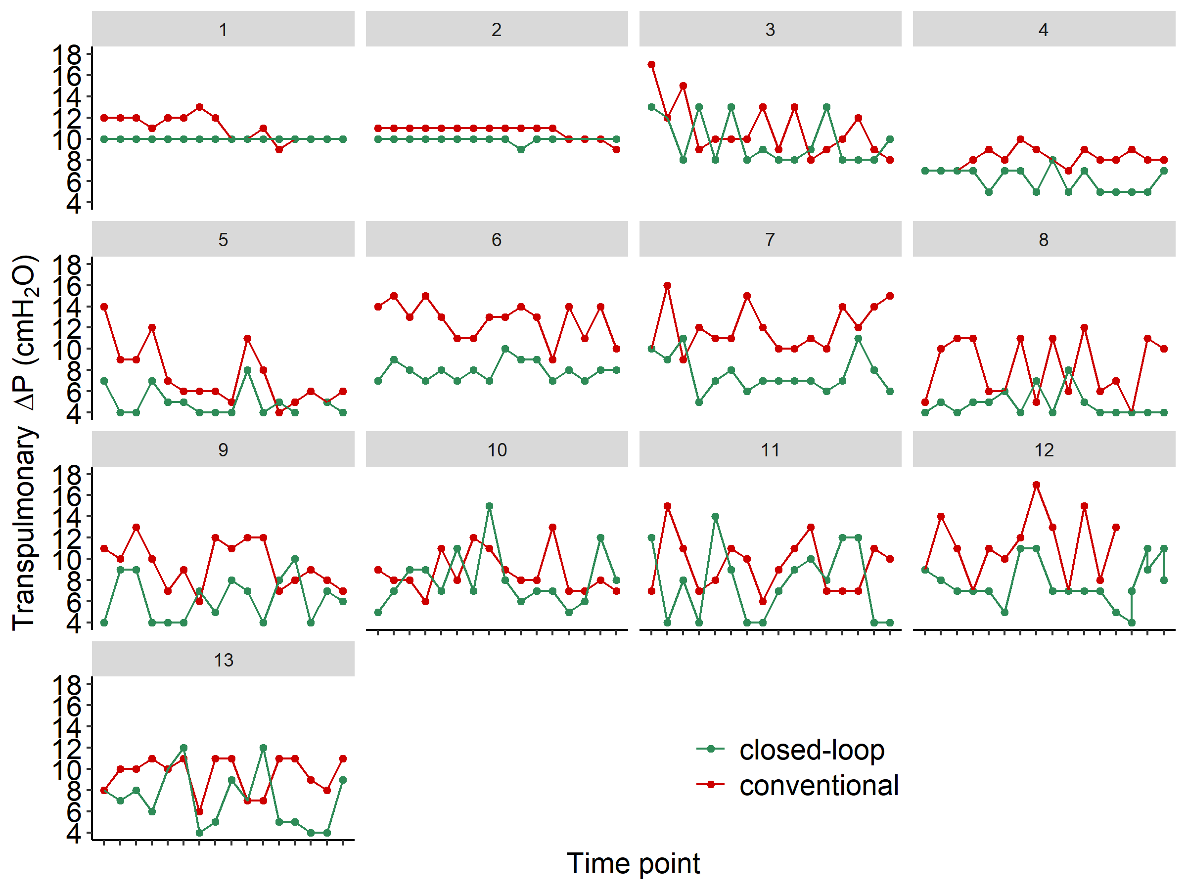

Figure S5. Showing transpulmonary ΔP per patient during every time point, with closed−loop ventilation and conventional ventilation. The head with number represents the corresponding patient, the x-axis represent the 16 time points per block.

Figure S6
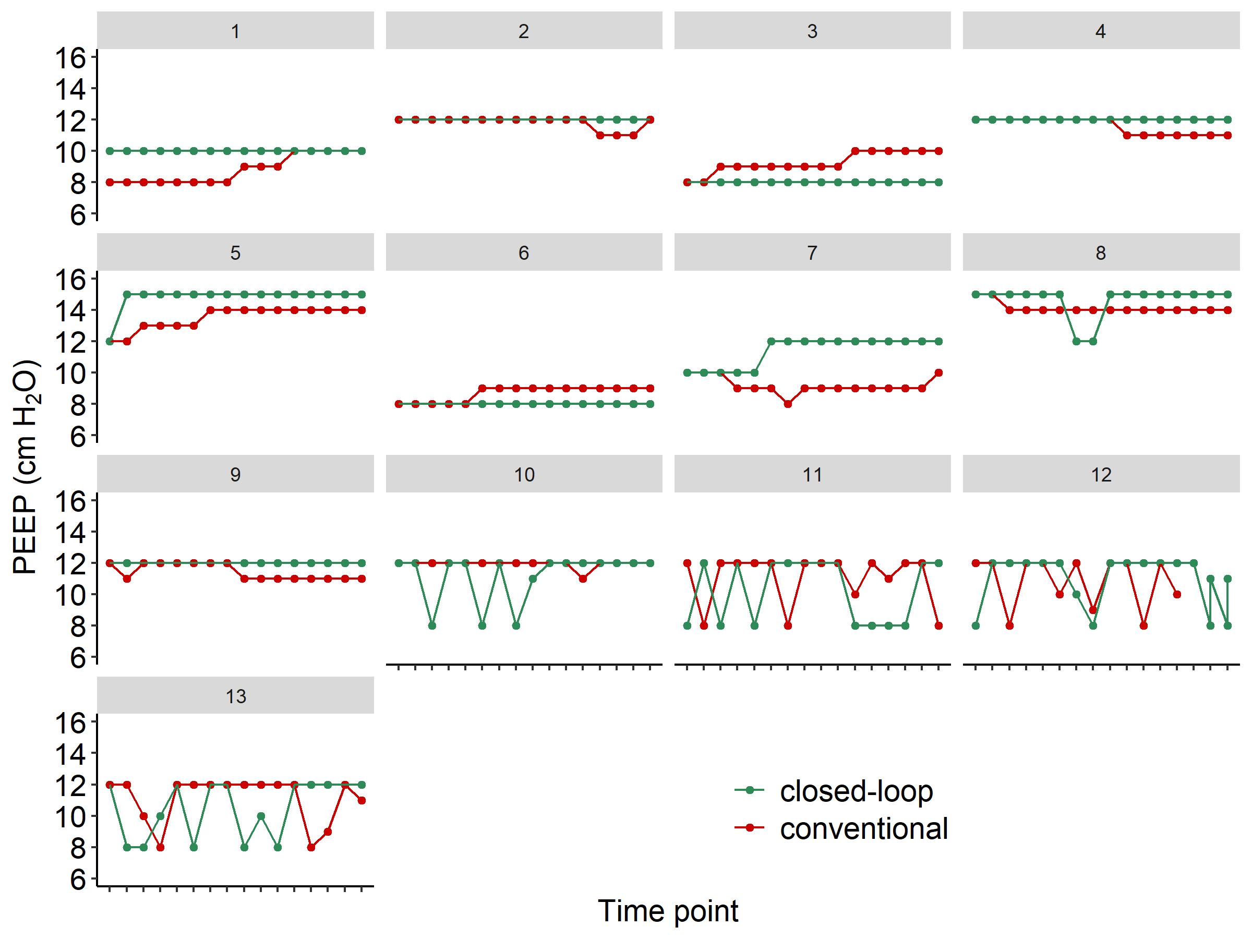

Figure S6. Showing PEEP per patient during every time point, with closed−loop ventilation and conventional ventilation. The head with number represents the corresponding patient, the x-axis represent the 16 time points per block.

Figure S7
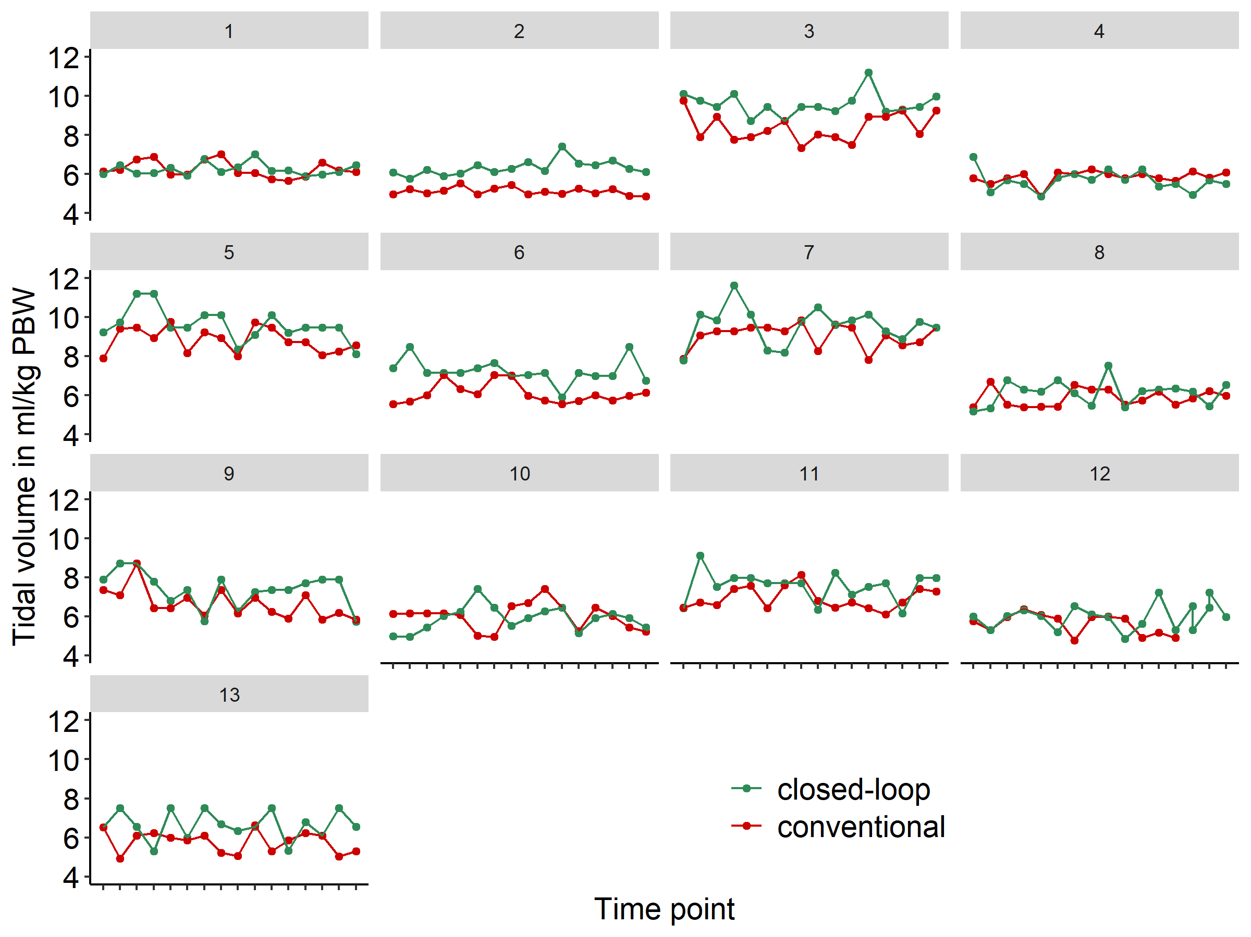
Figure S7. Showing the tidal volume (ml/kg PBW) per patient during every time point, with closed−loop ventilation and conventional ventilation. The head with number represents the corresponding patient, the x-axis represent the 16 time points per block.

Figure S8

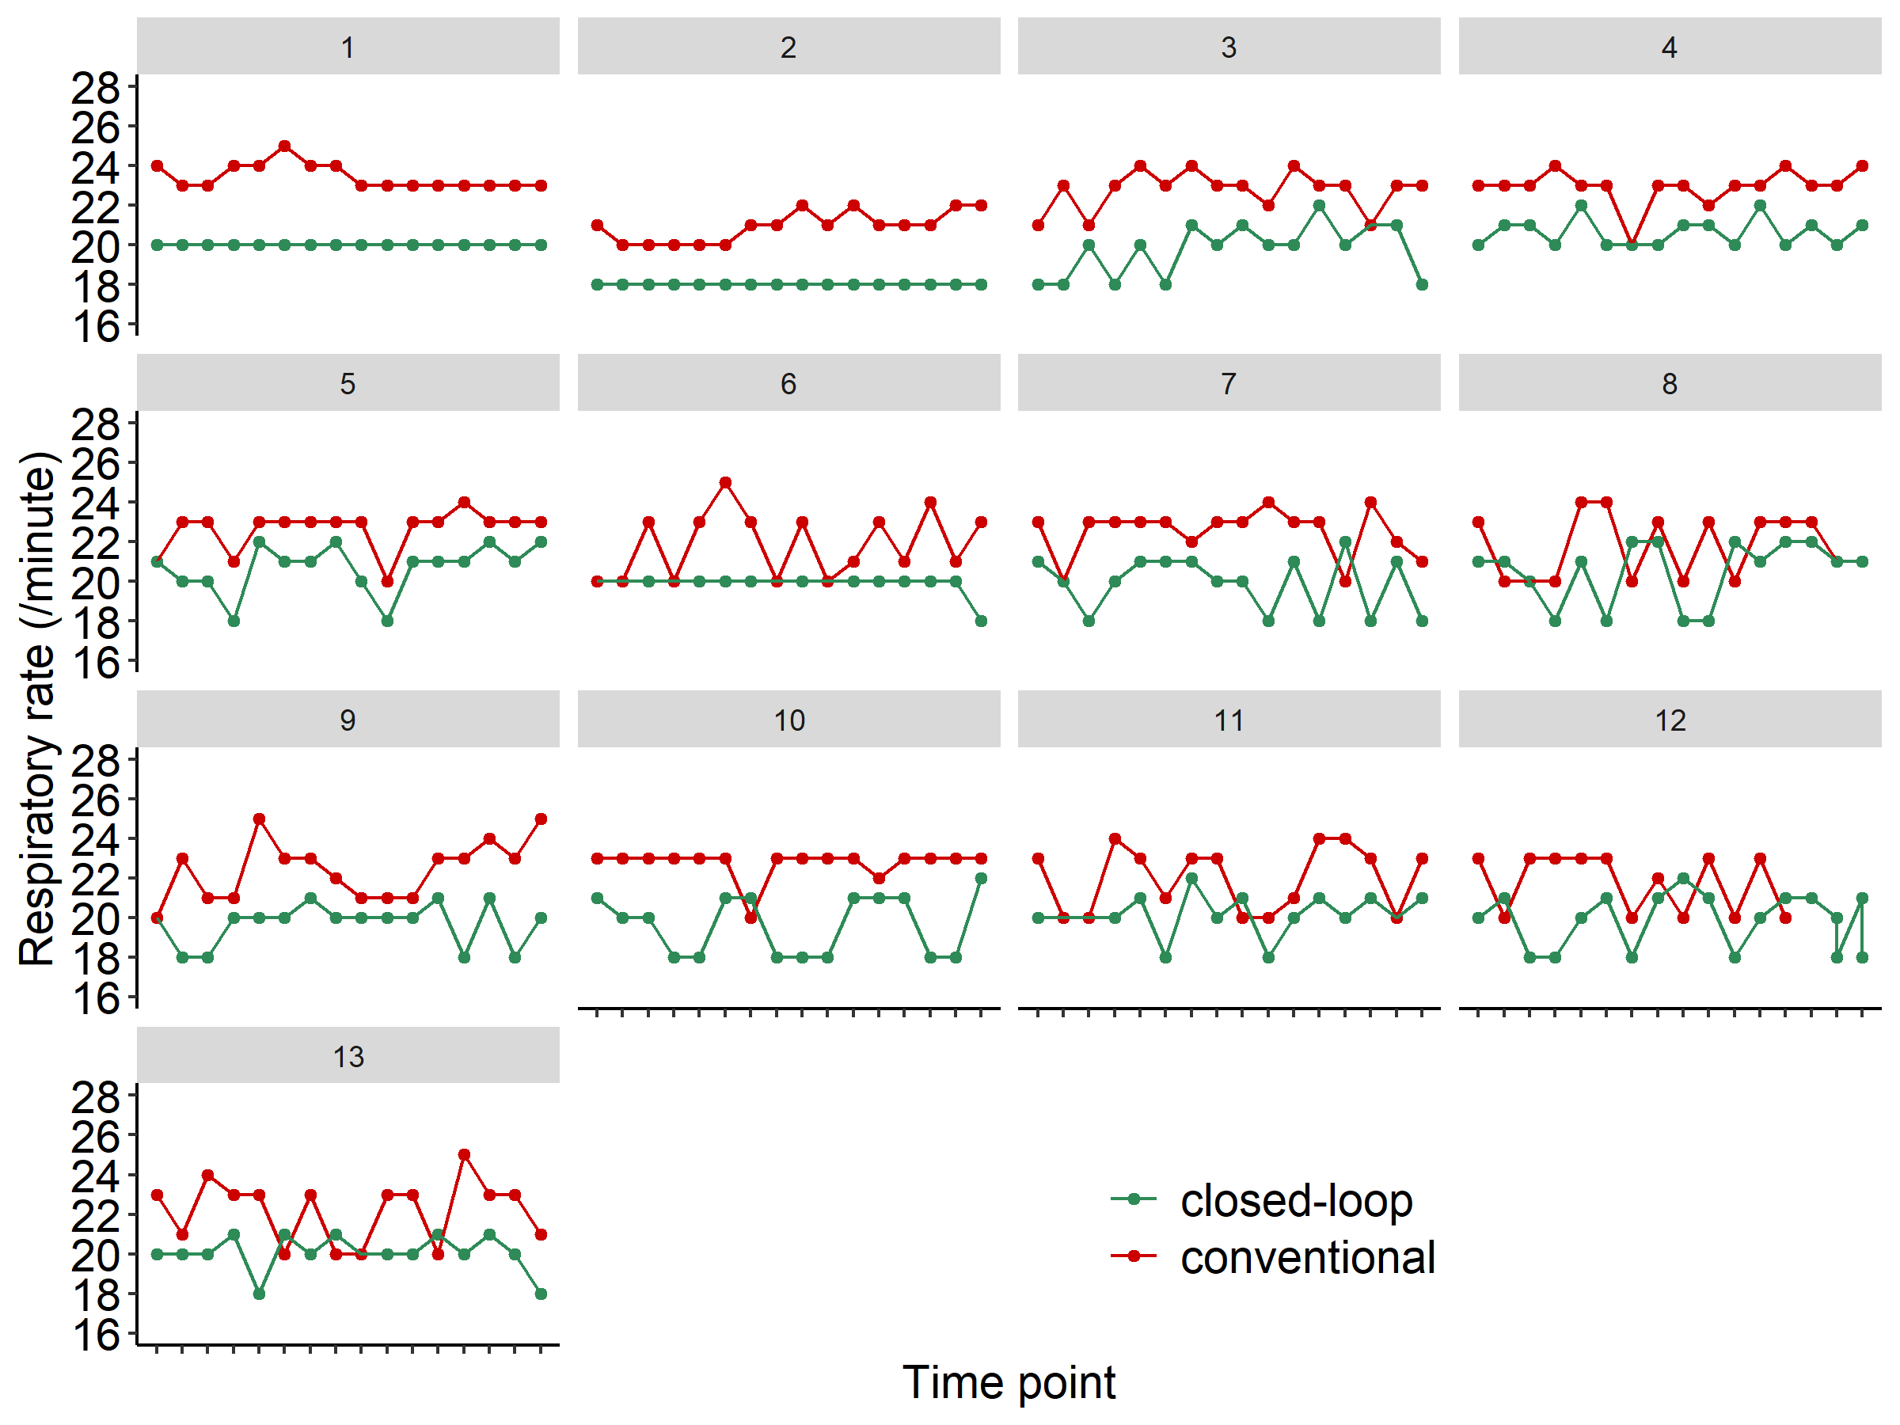

Figure S8. Showing the respiratory rate (per minute) per patient during every time point, with closed−loop ventilation and conventional ventilation. The head with number represents the corresponding patient, the x-axis represent the 16 time points per block.

Figure S9
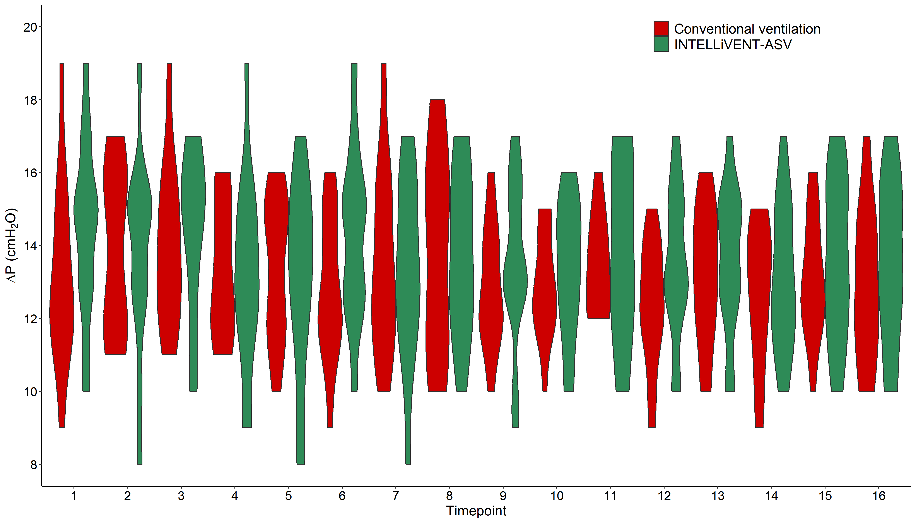

Figure S9. Violin plot of pairwise comparisons at individual time points of ΔP.

Figure S10
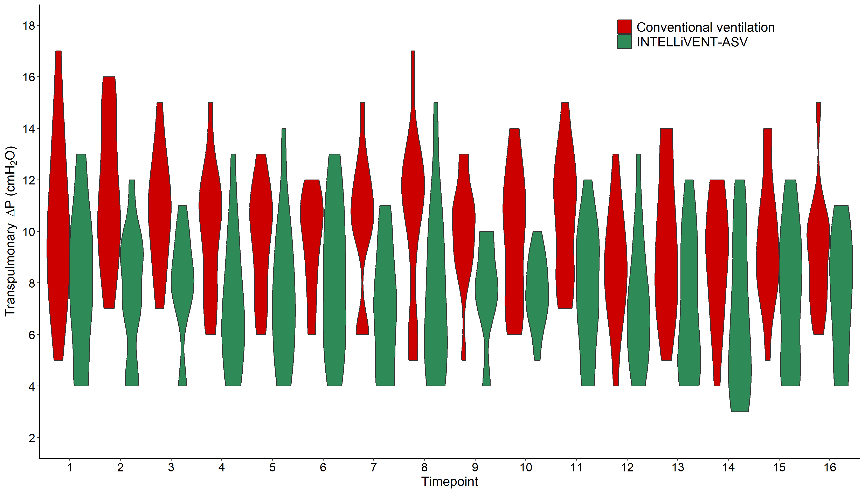

Figure S10. Violin plot of pairwise comparisons at individual time points of transpulmonary ΔP.

Figure S11
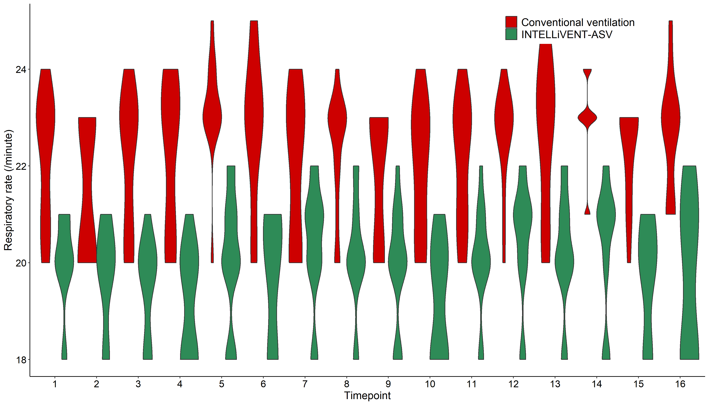

Figure S11. Violin plot of pairwise comparisons at individual time points of RR.

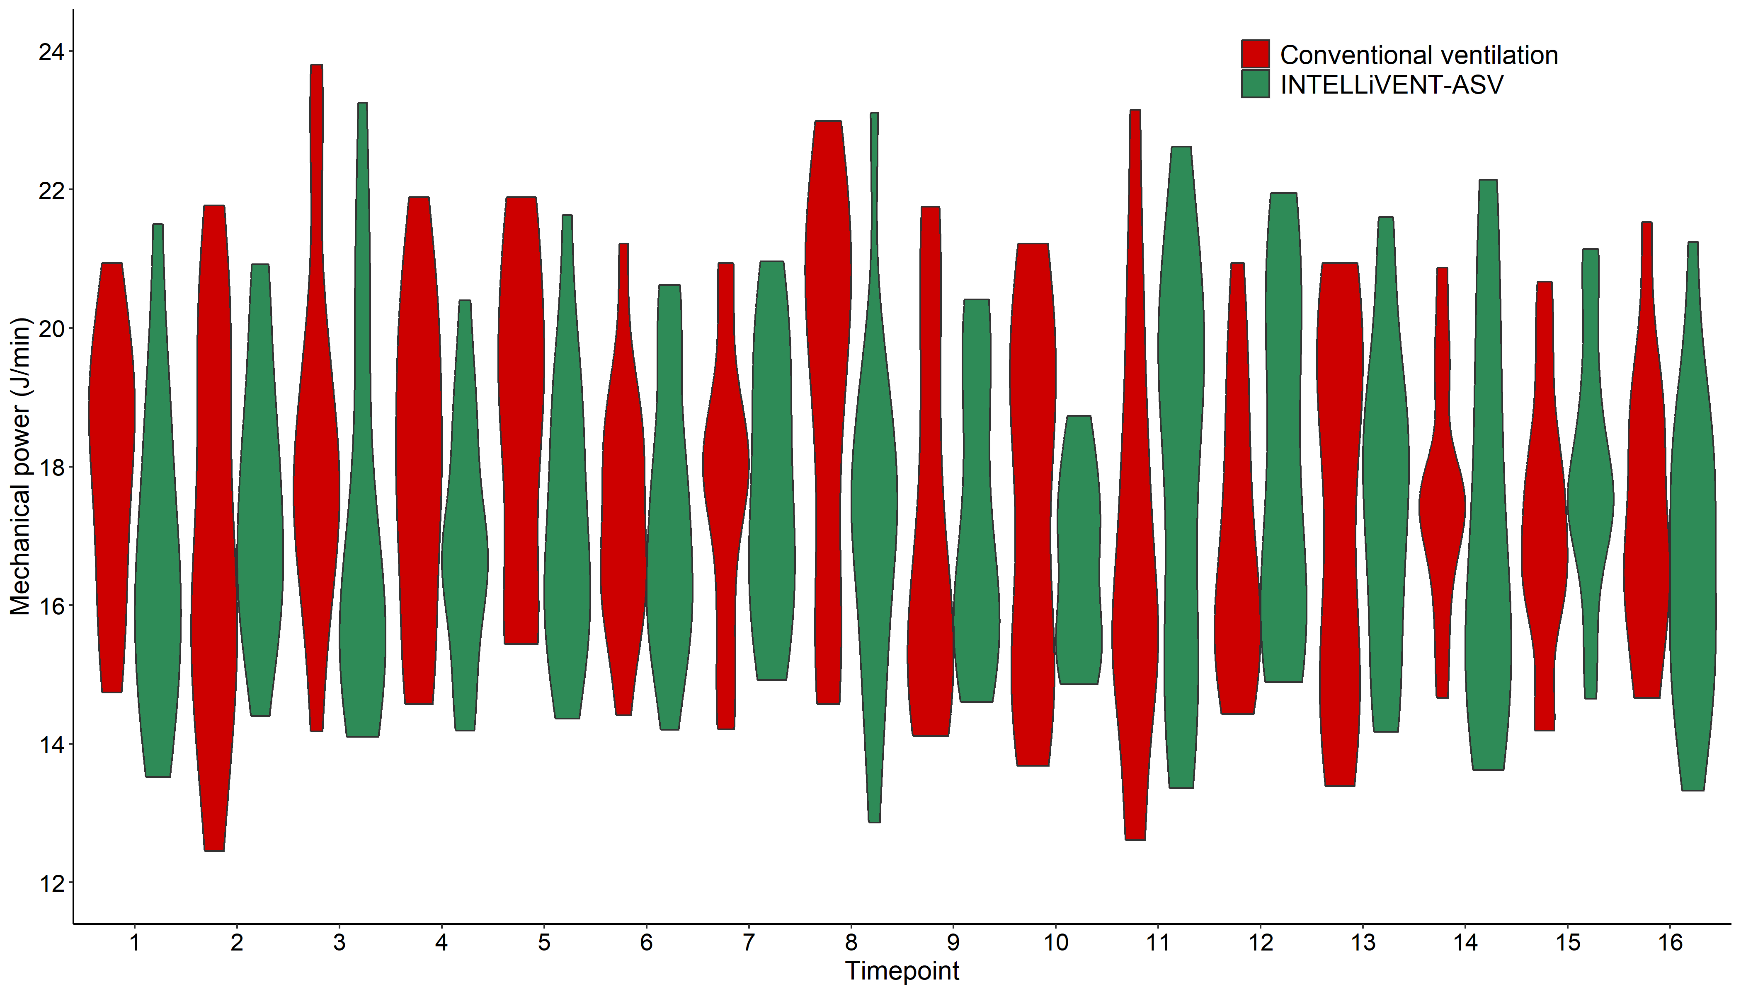
Figure S12

Figure S12. Violin plot of pairwise comparisons at individual time points of MP.

Figure S13
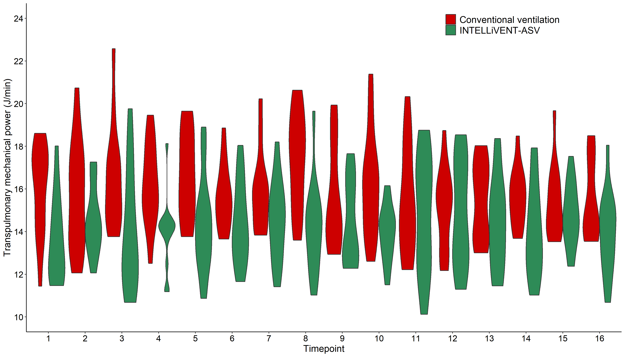

Figure S13. Violin plot of pairwise comparisons at individual time points of transpulmonary MP.

