Lung behavior during a staircase high-frequency oscillatory ventilation recruitment maneuver

Online data supplement

Pauline de Jager, MD (1)
Alette A. Koopman, MSc (1)
Dick G. Markhorst, MD PhD (2)
Martin C.J. Kneyber, MD PhD FCCM (1,3)

Figure E1
Distribution of the percentage of pressure changes in which the time constant could be calculated plotted against the normalized CDP during the inflation (A) and deflation (B) phase of the LVOM.
RIP respiratory inductance plethysmography; CDP continuous distending pressure; LVOM lung volume optimalization maneuver.
* denotes p < 0.05.
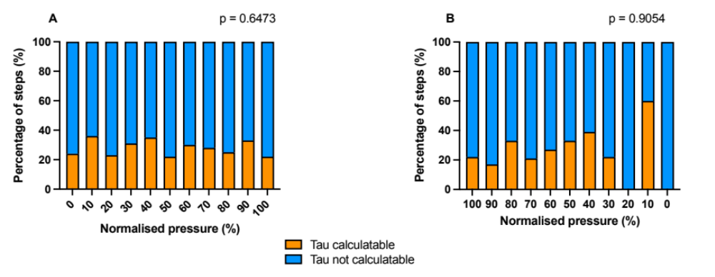

Figure E2
Distribution of pressure steps in which no time constant could be calculated because of continuous increase, continuous decrease or no change in any direction of the RIP plotted against the normalized CDP during the inflation (A) and deflation (B) phase of the LVOM.
RIP respiratory inductance plethysmography; CDP continuous distending pressure; LVOM lung volume optimalization maneuver.
* denotes p < 0.05.

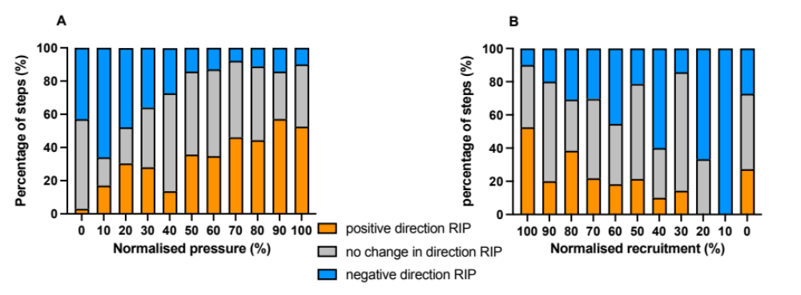

Figure E3
Stratified by age. Distribution of the percentage of pressure changes with an increase in RIP signal suggestive for lung recruitment and a decrease in RIP signal suggestive for lung derecruitment plotted against the normalized continuous distending pressure (CDP) during the inflation (left side) and deflation (right side) phase of the lung volume optimization maneuver (LVOM). Only percentage-groups including more than 3 measurements are included.
Upper panel: subjects < 6 months (A inflation phase, B deflation phase), middle panel subjects 6 – 24 months (C inflation phase, D deflation phase) and lower panel: subjects > 24 months inflation phase (E inflation phase, F deflation phase).
RIP respiratory inductance plethysmography; LVOM lung volume optimalization maneuver.
* denotes p < 0.05.

Figure E4
Stratified by age. Distribution within a pressure change of the ratio (displayed as median [IQR] of the number of 10-second periods with an increase in RIP signal suggestive for lung recruitment and a decrease in RIP signal suggestive for lung derecruitment plotted against the normalized continuous distending pressure (CDP) over the total number of 10-second periods during the inflation (left side) and deflation (right side) phase of the lung volume optimization maneuver (LVOM). Only percentage-groups including more than 3 measurements are included.
Upper panel: < 6 months (A inflation phase, B deflation phase), middle panel 6 – 24 months (C inflation phase, D deflation phase) and lower panel: > 24 months inflation phase (E inflation phase, F deflation phase).
RIP respiratory inductance plethysmography; CDP continuous distending pressure; LVOM lung volume optimalization maneuver.
* denotes p < 0.05.

Figure E5
Stratified by age.
Distribution of the phase angle plotted against the normalized CDP during the inflation (left side) and deflation (right side) phase of the LVOM. Data are displayed as median [IQR].
Upper panel: < 6 months (A inflation phase, B deflation phase), middle panel 6 – 24 months (C inflation phase, D deflation phase) and lower panel: > 24 months inflation phase (E inflation phase, F deflation phase).
RIP respiratory inductance plethysmography; CDP continuous distending pressure; LVOM lung volume optimalization maneuver.
* denotes p < 0.05.

Figure E6
Stratified by pARDS severity.
Distribution of the percentage of pressure changes with an increase in RIP signal suggestive for lung recruitment and a decrease in RIP signal suggestive for lung derecruitment plotted against the normalized continuous distending pressure (CDP) during the inflation (left side) and deflation (right side) phase of the lung volume optimization maneuver (LVOM). Only percentage-groups including more than 3 measurements are included.
Upper panel: mild pARDS (A inflation phase, B deflation phase), middle panel moderate pARDS (C inflation phase, D deflation phase) and lower panel: severe pARDS (E inflation phase, F deflation phase).
RIP respiratory inductance plethysmography; LVOM lung volume optimalization maneuver.
* denotes p < 0.05.

Figure E7
Stratified by pARDS severity.
Distribution within a pressure change of the ratio (displayed as median [IQR] of the number of 10-second periods with an increase in RIP signal suggestive for lung recruitment and a decrease in RIP signal suggestive for lung derecruitment plotted against the normalized continuous distending pressure (CDP) over the total number of 10-second periods during the inflation (left) and deflation (right) phase of the lung volume optimization maneuver (LVOM).
Upper panel: mild pARDS (A inflation phase, B deflation phase), middle panel moderate pARDS (C inflation phase, D deflation phase) and lower panel: severe pARDS (E inflation phase, F deflation phase).
RIP respiratory inductance plethysmography; CDP continuous distending pressure; LVOM lung volume optimalization maneuver.
* denotes p < 0.05.

Figure E8
Distribution of the phase angle plotted against the normalized CDP during the inflation (left side) and deflation (right side) phase of the LVOM. Data are displayed as median [IQR].
Upper panel: mild pARDS (A inflation phase, B deflation phase), middle panel moderate pARDS (C inflation phase, D deflation phase) and lower panel: severe pARDS (E inflation phase, F deflation phase).
RIP respiratory inductance plethysmography; CDP continuous distending pressure; LVOM lung volume optimalization maneuver.
* denotes p < 0.05.

