Safety of flow-controlled ventilation with positive and negative end-expiratory pressure in a swine model of intracranial hypertension

Online data supplement
Álmos Schranc¹, John Daniels¹, Roberta Südy¹, Fabienne Fontao¹, Philippe Bijlenga², Guillaume Plourde³, Hervé Quintard⁴

¹ Unit for Anaesthesiological Investigation, Department of Anaesthesiology, Pharmacology, Intensive Care and Emergency Medicine, University of Geneva, 1 rue Michel-Servet, Geneva, Switzerland
² Division of Neurosurgery, Department of Clinical Neurosciences, Geneva University Hospitals, 4 rue Gabrielle-Perret-Gentil, Geneva, Switzerland
³ Division of Intensive Care Medicine, Department of Medicine, Centre Hospitalier de l’Université de Montréal, 1051 rue Sanguinet, Montréal, Canada
⁴ Division of Intensive Care, Department of Anaesthesiology, Pharmacology, Intensive Care and Emergency Medicine, Geneva University Hospitals, 4 rue Gabrielle-Perret-Gentil, Geneva, Switzerland

Impact of FCV on cerebral autoregulation
In order to describe the effects of the different modalities on cerebral autoregulation, we realized a non-parametric correlation test (Spearman) between ΔICP and ΔMAP. The ΔICP and ΔMAP values were calculated as the changes in ICP and MAP corresponding to differing EEP levels: -3 cmH₂O to -9 cmH₂O and 3 cmH₂O to 9 cmH₂O.
No correlation between ∆ICP and ∆MAP was noted when FCV with NEEP was applied at levels of -3 to -9 cmH₂O (p=0.755; Figure S1, Graph A), and in FCV and PCV-VG when PEEP was changed from +3 to +9 cmH₂O (p=0.369; Figure S1, Graph B).
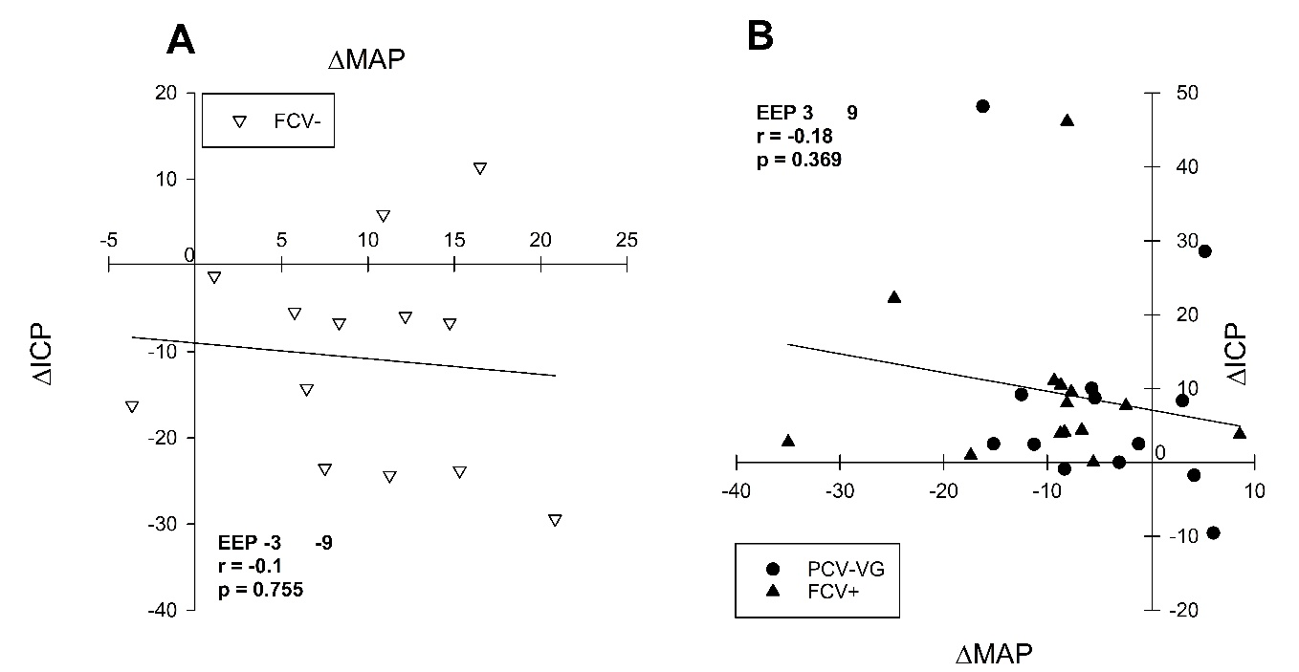
Figure S1: Correlation between changes in intracranial pressure (∆ICP) and mean arterial pressure (∆MAP). The ΔICP and ΔMAP values were calculated as the changes between EEP levels from -3 cmH₂O to -9 cmH₂O and from 3 cmH₂O to 9 cmH₂O. These changes were observed under the following ventilation modalities: pressure-controlled volume guaranteed ventilation (PCV-VG); flow-controlled ventilation with positive end-expiratory pressures (FCV +); flow-controlled ventilation with negative end-expiratory pressures (FCV -).

