Supplementary material
${CL}_{dial}=Qb×(C_{Pre}-C_{Intra})/C_{Pre}$ Eq. S1

${CL}_{cyto}=Qb×(C_{Intra}-C_{Post})/C_{Intra}$ Eq. S2

${CL}_{comb}=Qb×(C_{Pre}-C_{Post})/C_{Pre}$ Eq. S3

${Relative difference}_{dial,comb}=\left(\frac{{CL}_{dial}-{CL}_{comb}}{{CL}_{comb}}\right)$ Eq. S4

${Median relative difference}_{Pre,Intra}=Median\left(\frac{\left|C_{Pre}-C_{Intra}\right|}{C_{Pre}}\right)$ Eq. S5
${Median relative difference}_{Pre,Post}=Median\left(\frac{\left|C_{Pre}-C_{Post}\right|}{C_{Pre}}\right)$ Eq. S6
${Median relative difference}_{Intra,Post}= Median\left(\frac{\left|C_{Intra}-C_{Post}\right|}{C_{Pre}}\right)$ Eq. S7

Wilcoxon signed-rank test
Drug | Comparison | Test statistic | p-value | Result
Meropenem | Pre vs. Intra | V = 946 | 2.27E-13 | Significant difference
 | Pre vs. Post | V = 946 | 2.27E-13 | Significant difference
 | Intra vs. Post | V = 457.5 | 0.8563 | No significant difference
Piperacillin | Pre vs. Intra | V = 351 | 2.98E-08 | Significant difference
 | Pre vs. Post | V = 351 | 2.98E-08 | Significant difference
 | Intra vs Post | V = 237.5 | 0.1182 | No significant difference

Table S1: Results of the Wilcoxon signed-rank tests for meropenem and piperacillin for comparisons between Pre vs. Intra, Pre vs. Post, and Post vs. Intra with test statistic V, p-values and the results indicating the significance of differences. ￼

Wilcoxon signed-rank test with average Pre-, Intra- and Post-values per patient
Drug | Comparison | Test statistic | p value | Result
Meropenem | Pre vs. Intra | V = 120 | 6.104e-05 | Significant difference
 | Pre vs. Post | V = 120 | 6.104e-05 | Significant difference
 | Intra vs. Post | V = 42 | 0.3303 | No significant difference
Piperacillin | Pre vs. Intra | V = 45 | 0.003906 | Significant difference
 | Pre vs. Post | V = 45 | 0.003906 | Significant difference
 | Intra vs Post | V = 35 | 0.1641 | No significant difference

Table S2: Results of the Wilcoxon signed-rank tests for meropenem and piperacillin for comparisons between Pre vs. Intra, Pre vs. Post, and Post vs. Intra with test statistic V, p-values and the results indicating the significance of differences based on with average Pre-, Intra- and Post-values per patient.

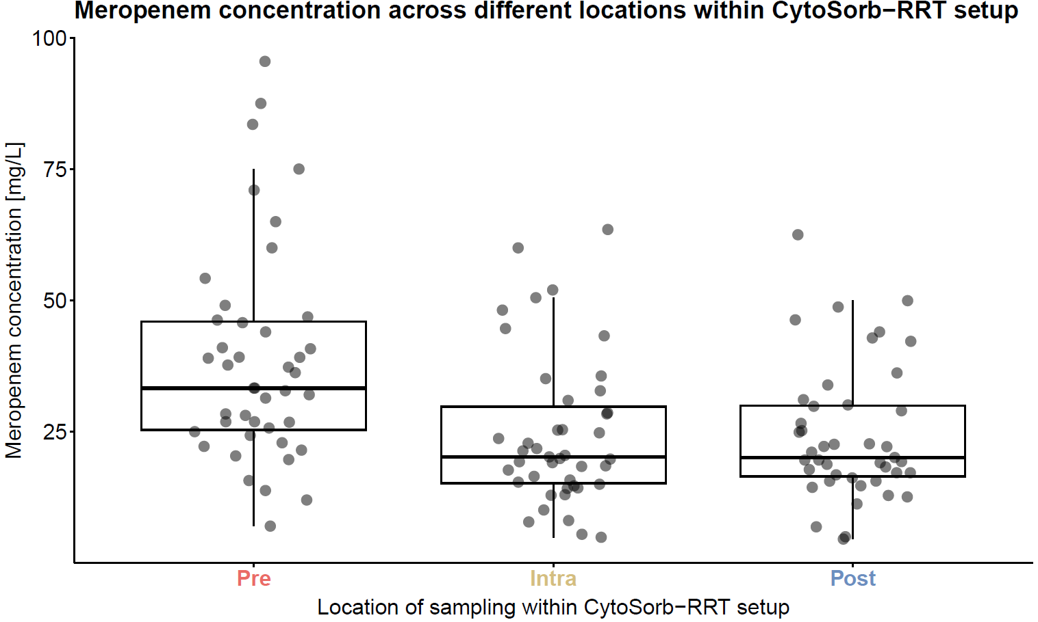
Figure S1: Meropenem concentration across different locations with CKRT-CS setup.
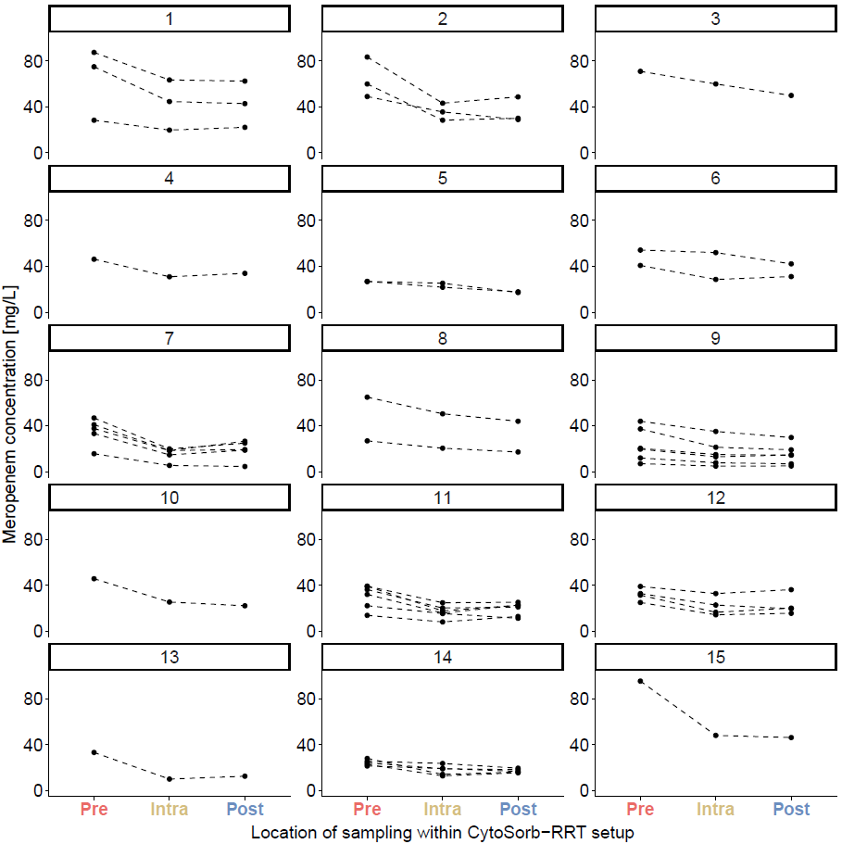
Figure S2: Meropenem concentration across different locations with CKRT-CS setup per patient.
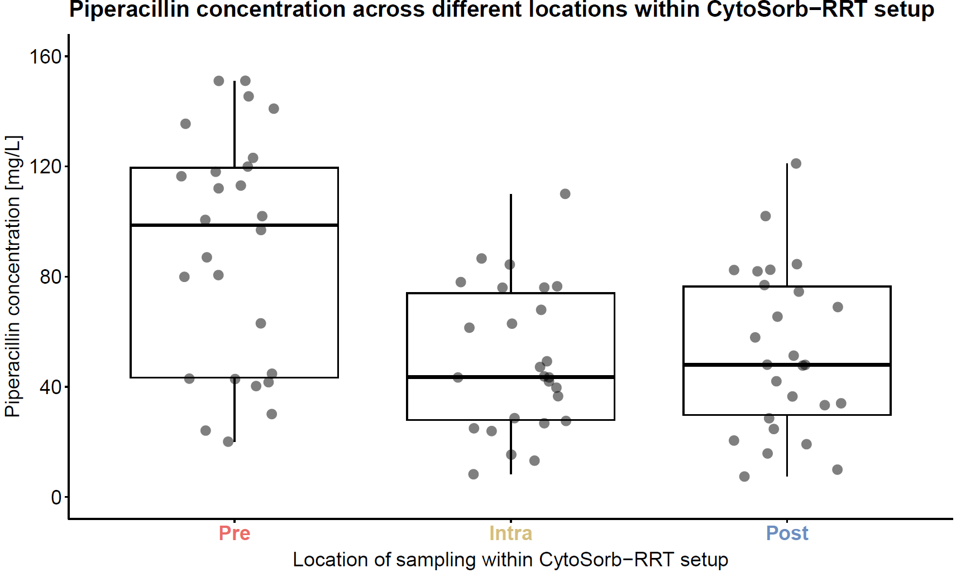
Figure S3: Piperacillin concentration across different locations with CKRT-CS set-up

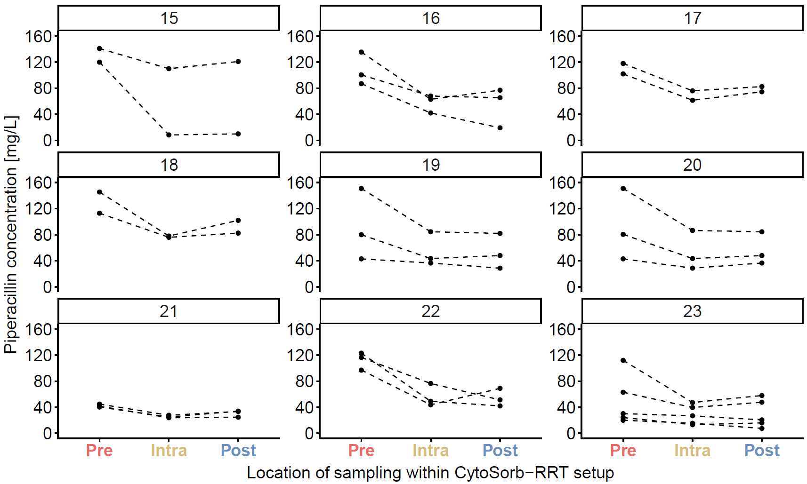
Figure S4: Piperacillin concentration across different locations with CKRT-CS set-up per patient
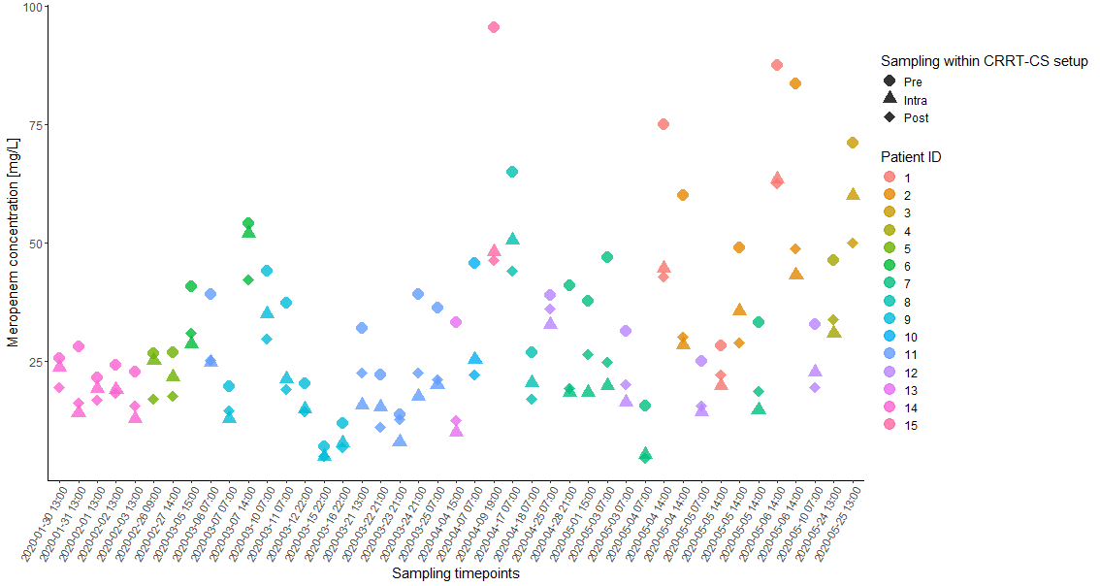
Figure S5: Meropenem concentration [mg/L] for different patients and sampling points within the study CKRT-CS setup. The plot illustrates the meropenem concentration at three different sampling points Pre, Intra, and Post taken simultaneously. Each point represents a sample collected from individual patients, with different shapes indicating the sampling location: Pre (circles), Intra (triangles), and Post (squares). The x-axis represents the specific time points of sampling, labelled chronologically. The colour of the points and lines corresponds to different patient IDs. Abbreviations: CKRT-CS setup: Continuous Renal Replacement Therapy followed by CS, Pre: before CKRT- CS setup, Intra: between CKRT and CS, Post: after CKRT-CS setup, ID: Identification number.
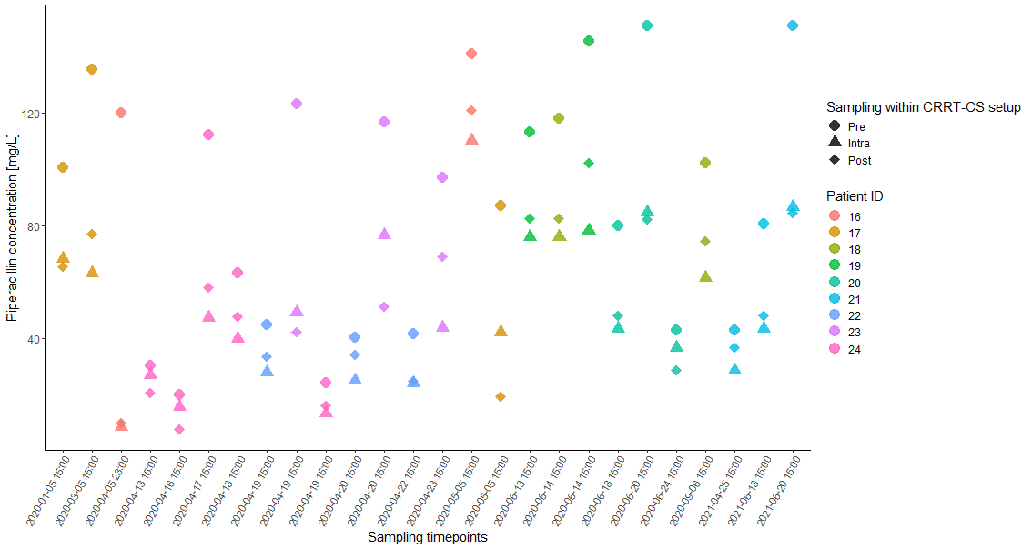
Figure S6: Piperacillin concentration [mg/L] for different patients and sampling points within the study CKRT-CS setup. The plot illustrates the piperacillin concentration at three different sampling points Pre, Intra, and Post taken simultaneously. Each point represents a sample collected from individual patients, with different shapes indicating the sampling location: Pre (circles), Intra (triangles), and Post (squares). The x-axis represents the specific time points of sampling, labelled chronologically. The colour of the points and lines corresponds to different patient IDs. Abbreviations: CKRT-CS setup: Continuous Renal Replacement Therapy followed by CS, Pre: before CKRT- CS setup, Intra: between CKRT and CS, Post: after CKRT-CS setup, ID: Identification number.

