Supplementary Material to:

Assessment of V/Q mismatch during pressure support ventilation with electrical impedance tomography:
A prospective physiological study

List of contents

Table S1. Radiological findings, primary cause of ARDS and mortality per patient
Table S2. Ventilation and perfusion distribution results from EIT data analysis at baseline
Table S3. Results of post-hoc sensitivity analysis conducted removing outliers data from the primary outcome analysis
Table S4. Ventilation and perfusion distribution results from EIT data analysis at high and low pressure support
Figure S1. Graphical visualization of V/Q patient data
Figure S2. STROBE Flow Diagram

Table S1. Radiological findings, primary cause of ARDS and mortality per patient

ID | Radiological findings at ICU admission | Cause or suspected cause of ARDS | Status at ICU discharge
1 | Chest CT scan: Multiple and diffuse areas of increased parenchymal density with a partly ground-glass and partly consolidative appearance of likely inflammatory nature, more evident in dorsal areas than in ventral areas | Aspiration pneumonia | Alive
2 | Chest CT scan: Multiple and diffuse areas of bilateral lung consolidation | Near drowning syndrome (salted water) | Alive
3 | Chest X-ray: Bilateral clouding of the lung bases, with associated vague areas of consolidation, more pronounced on the left side | Secondary to toxic epidermal necrolysis | Dead
4 | Chest CT scan: Multiple areas of increased parenchymal density, some with centrilobular extension. Small centrilobular abnormalities are also present in the lingula alongside ground-glass areas. Additional ground-glass abnormalities are seen in the left upper lobe. On the right side, there’s a more diffuse distribution of consolidative areas and crazy-paving pattern. | Influenza virus A pneumonia | Alive at ICU discharge but dead at hospital discharge
5 | Chest X-Ray: Diffuse areas of parenchymal consolidation bilaterally | Aspiration pneumonia | Alive
6 | Chest X-Ray: Bilateral opacities in the hilar regions extending to the right lower midfield | Aspiration pneumonia and/or secondary to complicated intrabdominal infection causing septic shock | Dead
7 | Chest X-Ray: Large area of ​​radiopacity with blurred margins in the middle and lower field of the right lobe, slightly present in the remaining lung areas including left side | Legionella pneumonia | Dead
8 | Chest X-Ray: Diffuse and inhomogeneous areas of parenchymal radiopacity with blurred margins and tending towards confluence are found in both hemithoraces, more evident on the left | Legionella pneumonia | Dead
9 | Chest X-Ray: Thickening of the peribronchovascular interstitium of a reticulomicronodular nature with some areas of blurred parenchymal thickening with indistinct margins in both parenchymas | Secondary to complicated intrabdominal infection causing septic shock | Dead
10 | Chest X-Ray: in an almost ubiquitous location, areas of parenchymal consolidation are found, more evident in the left middle lung field, with indistinct margins, tending towards confluence, with the air bronchogram sign in the context | Pneumocystis jirovecii pneumonia | Dead
11 | Chest X-Ray: Faint areas of subopacification with indistinct margins, tending towards confluence, in both lower lung fields bilaterally | Aspiration pneumonia | Alive
12 | Chest CT scan: multiple and ubiquitous areas of increased parenchymal density of mixed appearance, with increased consolidation component and air bronchogram in the context | Influenza virus A pneumonia | Dead
13 | Chest X-Ray: Marked and diffuse pulmonary consolidation bilaterally in all lung fields | Hydrogen sulfide asphyxiation and sewage near drowning syndrome | Alive
14 | Chest X-Ray: bilaterally, the presence of multiple areas of parenchymal consolidation is reported, with air bronchogram in the context, spread in an almost ubiquitous location, tending to confluence and with indistinct margins, more evident in the right middle-upper lung field and in the left middle lung field, where they assume a more consolidative character | Aspiration pneumonia | Alive
15 | Chest X-Ray: Marked and widespread thickening of the peribronchovascular interstitium with a reticular character and an almost ubiquitous distribution associated with some areas of parenchymal consolidation with a predominantly subpleural distribution with partial sparing of the left upper lung field | p-ANCA vasculitis with lung involvement | Dead

Table S2. Ventilation and perfusion distribution results from EIT data analysis at baseline

 |  | Median |  | 1st quartile |  | 3rd quartile
VCV V ventral (non dep) % |  | 63.321 |  | 57.804 |  |  | 65.174
VCV Q ventral (non dep)% |  | 58.855 |  | 49.259 |  |  | 62.674
VCV V dorsal (dep) |  | 36.679 |  | 34.826 |  |  | 42.196
VCV Q dorsal (dep) |  | 41.145 |  | 37.326 |  |  | 50.741
VCV Only V - dead space (%) |  | 24.163 |  | 4.677 |  |  | 28.834
VCV Only Q - shunt (%) |  | 5.263 |  | 4.454 |  |  | 15.000
VCV Only V ventral |  | 13.876 |  | 3.341 |  |  | 23.006
VCV Only Q ventral |  | 1.675 |  | 1.336 |  |  | 4.294
VCV Only V dorsal |  | 5.828 |  | 1.842 |  |  | 10.287
VCV Only Q dorsal |  | 4.032 |  | 3.589 |  |  | 10.526
VCV Matched (%) region |  | 70.574 |  | 58.065 |  |  | 81.579
VCV %V shunt ventral |  | 0.000 |  | 0.000 |  |  | 0.000
VCV %V low ventral |  | 11.041 |  | 10.992 |  |  | 13.941
VCV %V normal ventral |  | 13.945 |  | 11.756 |  |  | 15.182
VCV %V high ventral |  | 20.955 |  | 16.117 |  |  | 26.424
VCV %V dead space ventral |  | 9.831 |  | 1.503 |  |  | 20.418
VCV %V shunt dorsal |  | 0.000 |  | 0.000 |  |  | 0.000
VCV %V low dorsal |  | 8.676 |  | 8.370 |  |  | 11.992
VCV %V normal dorsal |  | 10.313 |  | 7.062 |  |  | 13.891
VCV %V high dorsal |  | 5.656 |  | 3.944 |  |  | 13.281
VCV %V dead space dorsal |  | 3.835 |  | 1.074 |  |  | 7.585
VCV %Q shunt ventral |  | 1.536 |  | 0.535 |  |  | 2.102
VCV %Q low ventral |  | 17.688 |  | 16.281 |  |  | 28.879
VCV %Q normal ventral |  | 13.747 |  | 11.909 |  |  | 15.063
VCV %Q high ventral |  | 14.207 |  | 9.821 |  |  | 14.929
VCV %Q dead space ventral |  | 0.000 |  | 0.000 |  |  | 0.000
VCV %Q shunt dorsal |  | 4.595 |  | 3.127 |  |  | 7.647
VCV %Q low dorsal |  | 17.201 |  | 11.887 |  |  | 19.537
VCV %Q normal dorsal |  | 9.795 |  | 7.173 |  |  | 13.781
VCV %Q high dorsal |  | 3.618 |  | 2.589 |  |  | 7.950
VCV %Q dead space dorsal |  | 0.000 |  | 0.000 |  |  | 0.000

Data available for n=5 patients

Table S3. Results of post-hoc sensitivity analysis conducted removing outliers data (V/Q matched regions < 27%) from the primary outcome analysis

High Pressure Support |  |  |  | Low Pressure Support |  | p | Hodges-Lehmann Estimate
Matched (%) regions  Median (IQR):  50.5 (45.7-69.1) |  |  |  | Matched (%) regions  Median (IQR):  61.8 (60.2-70.5) |  | 0.244 |  |  | -8.173
Note: N=13

Table S4. Ventilation and perfusion distribution results from EIT data analysis at high and low pressure support

 | High Pressure Support | 1st quartile | 3rd quartile | Low Pressure Support | 1st quartile | 3rd quartile | P value
Only V ventral | 16.402 | 11.033 | 16.402 | 15.056 | 9.668 | 19.688 | 0.599
Only Q ventral | 1.826 | 0.878 | 1.826 | 1.689 | 0.849 | 7.647 | 0.252
Only V dorsal | 11.264 | 5.484 | 11.264 | 14.318 | 7.010 | 20.267 | 0.679
Only Q dorsal | 6.048 | 2.663 | 6.048 | 4.196 | 2.024 | 7.621 | 0.277
%V shunt ventral | 0.000 | 0.000 | 0.000 | 0.000 | 0.000 | 0.000 | NA
%V low ventral | 13.828 | 6.698 | 13.828 | 12.429 | 9.138 | 18.855 | 0.804
%V normal ventral | 10.126 | 7.165 | 10.126 | 9.654 | 7.658 | 18.007 | 0.890
%V high ventral | 10.184 | 4.620 | 10.184 | 8.103 | 1.741 | 15.761 | 0.639
%V dead space ventral | 15.329 | 10.938 | 15.329 | 12.589 | 7.818 | 16.332 | 0.524
%V shunt dorsal | 0.000 | 0.000 | 0.000 | 0.000 | 0.000 | 0.000 | NA
%V low dorsal | 13.028 | 6.521 | 13.028 | 14.586 | 4.403 | 18.977 | 0.359
%V normal dorsal | 7.707 | 2.969 | 7.707 | 12.671 | 3.149 | 16.401 | 0.421
%V high dorsal | 2.523 | 0.881 | 2.523 | 3.816 | 2.358 | 10.193 | 0.524
%V dead space dorsal | 9.739 | 4.190 | 9.739 | 13.653 | 4.760 | 16.708 | 0.804
%Q shunt ventral | 1.346 | 0.616 | 1.346 | 0.962 | 0.578 | 13.055 | 0.389
%Q low ventral | 23.181 | 10.694 | 23.181 | 24.680 | 15.890 | 32.320 | 0.720
%Q normal ventral | 9.834 | 7.377 | 9.834 | 9.538 | 8.093 | 18.263 | 0.934
%Q high ventral | 6.558 | 3.045 | 6.558 | 5.202 | 1.262 | 9.762 | 0.679
%Q dead space ventral | 0.000 | 0.000 | 0.000 | 0.000 | 0.000 | 0.000 | NA
%Q shunt dorsal | 6.249 | 1.522 | 6.249 | 4.418 | 1.633 | 9.641 | 0.720
%Q low dorsal | 22.483 | 13.523 | 22.483 | 22.841 | 9.533 | 32.257 | 0.277
%Q normal dorsal | 8.405 | 3.250 | 8.405 | 12.327 | 3.106 | 17.339 | 0.454
%Q high dorsal | 1.938 | 0.621 | 1.938 | 2.644 | 1.631 | 6.684 | 0.389
%Q dead space dorsal | 0.000 | 0.000 | 0.000 | 0.000 | 0.000 | 0.000 | NA

Figure S1. Graphical visualization of V/Q patient data

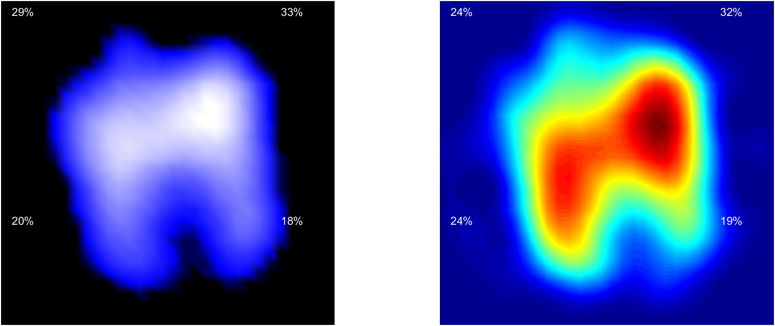

The figure shows an example of graphical visualization of a V/Q measurement from EIT patient data. Left panel refers to ventilation and right panel refers to perfusion.

Figure S2. STROBE Flow Diagram

