Supplementary Appendix

1. Supplementary Material and Methods
Power calculation and interim analysis plan

A. Power calculation for the originally planned sample
The primary endpoint was the change in brain tissue oxygenation (ΔPbtO₂, mmHg) over time, analyzed with a linear mixed-effects model adjusted for baseline.
Assumptions for the original sample size calculation were:
- Expected mean difference (treatment–control): Δ = 5 mmHg (minimal clinically important difference from prior PbtO₂-guided studies).
- Within-subject SD: σ = 6 mmHg.
- Correlation between repeated measures: ρ = 0.6.
- Number of repeated measurements per animal: m = 12.
- Dropout rate : 10%.
- Two-sided α = 0.05 (O’Brien–Fleming overall), target power = 80%.
Using these assumptions, sample size of 17 animals per arm were required to achieve 80% power at α = 0.05.

B. Interim analysis plan
One interim analysis was pre-specified after inclusion of n = 6 animals per arm. The interim analysis was unblinded, conducted by the study investigators according to the pre-specified statistical analysis plan. The interim analysis served to evaluate potential futility.
- Alpha spending: The overall two-sided α = 0.05 was preserved using an O’Brien–Fleming–type alpha spending function (interim boundary p < 0.005; final boundary p < 0.048).
- Decision rules: Futility: Stop if conditional power < 15% under the assumed treatment effect (Δ = 5 mmHg)
At the interim analysis (n = 6 per arm), no difference in PbtO₂ was observed, and the conditional power was below 15%, fulfilling the pre-specified futility criterion.
The study was therefore stopped early for futility, as planned.

2. Supplementary Tables and Figures
Figure S1: Time-course of sedation dose (Sevoflurane Minimal Alveolar Concentration), analgesia (morphine infusion rate), respiratory support (minute ventilation) and ECMO sweep gas flow throughout the experiment
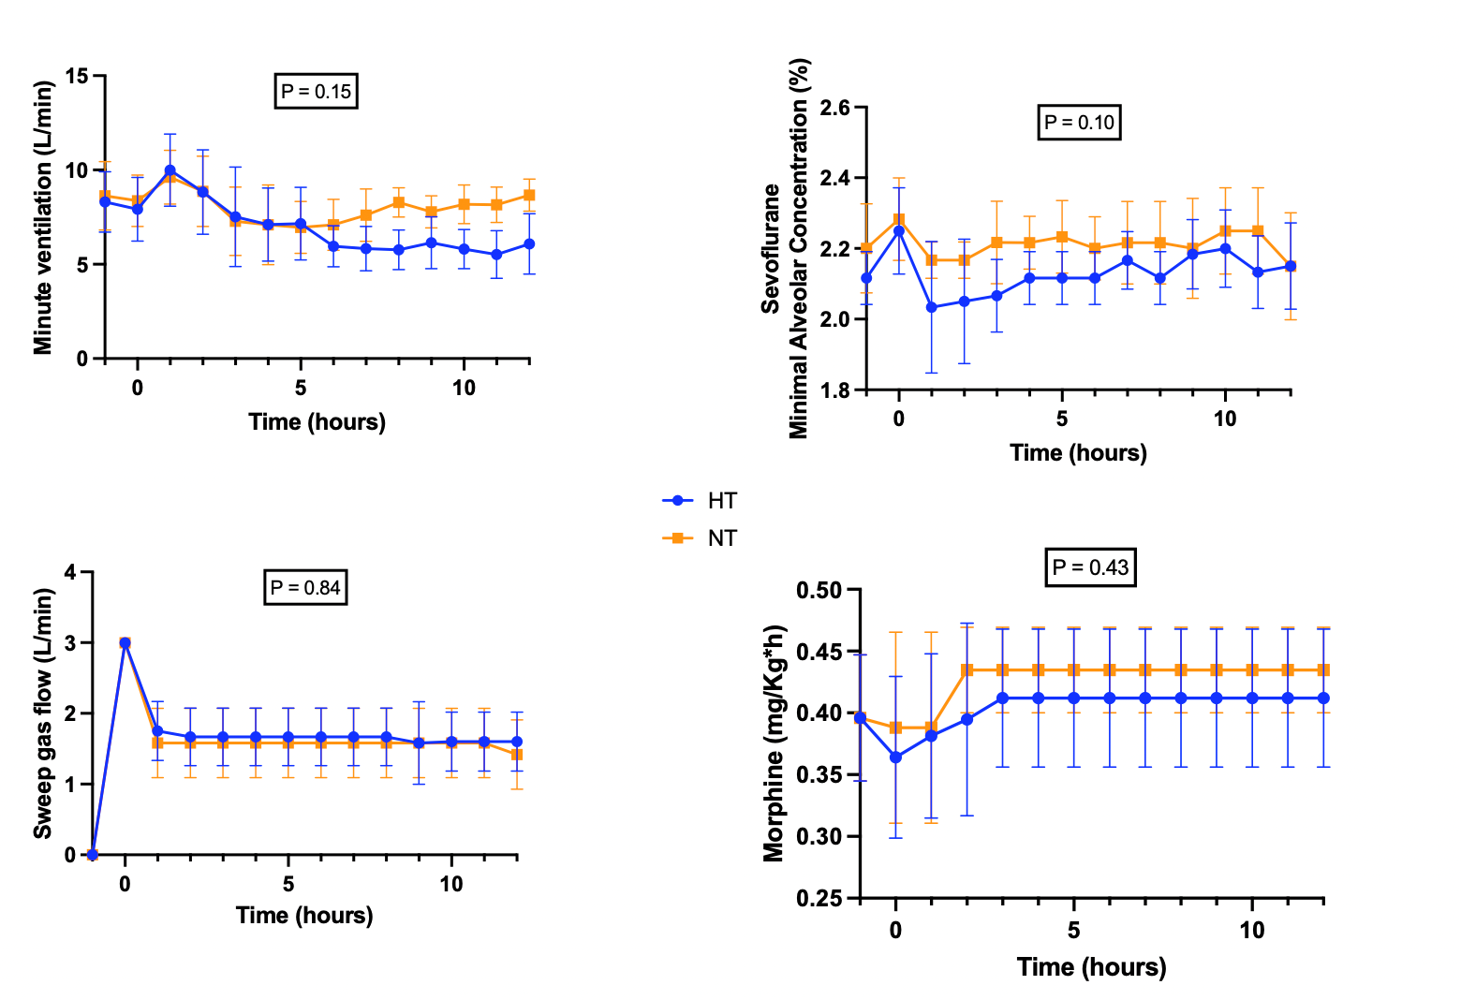

Table S2: Effect Sizes and 95% Confidence Intervals for the Temperature Variable Showing a Significant Group × Time Interaction (p group x time interaction < 0.0001)

Mean difference | SE of difference | 95% CIs
0,8429 | 0,2465 | [0,30; 1,39]
1,64 | 0,2465 | [1,10; 2,18]
2,174 | 0,2465 | [1,63; 2,72]
2,664 | 0,2465 | [2,12; 3,21]
3,567 | 0,2558 | [3,00; 4,14]
4,026 | 0,2465 | [3,48; 4,57]
4,183 | 0,2465 | [3,64; 4,73]
4,15 | 0,2558 | [3,58; 4,72]
4,255 | 0,2465 | [3,71; 4,80]
4,363 | 0,2682 | [3,76; 4,97]
4,255 | 0,2465 | [3,71; 4,80]
4,45 | 0,2558 | [3,88; 5,02]
4,323 | 0,2682 | [3,72; 4,93]
4,497 | 0,2682 | [3,89; 5,10]
4,267 | 0,2558 | [3,70; 4,84]

Table S3: Effect Sizes and 95% Confidence Intervals for the NfL Variable Showing a Significant Group × Time Interaction (p group x time interaction = 0.03)

Mean difference | SE of difference | 95% CIs
0,805 | 1,745 | [-3,09; 4,70]
-4,725 | 4,817 | [-15,47; 6,02]
-16,56 | 12,29 | [-44,34; 11,22]
-20,94 | 8,552 | [-40,01; -1,87]

Figure S4: Representative EEG Trace of an animal from the HT (A) and NT (B) Groups
