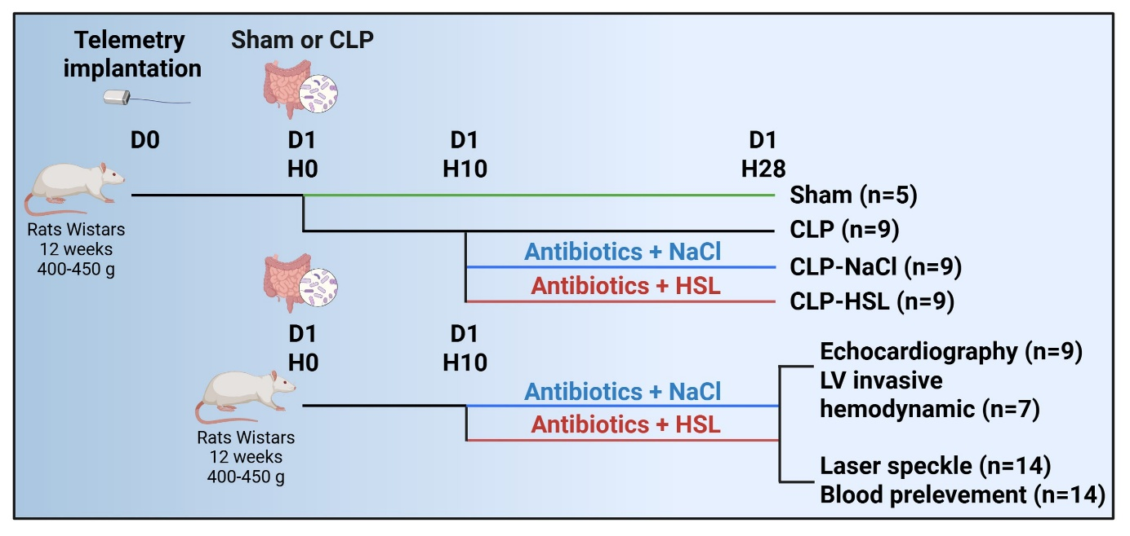
Annex 1. Experimental protocol. CLP: Caecal ligation and puncture. D: day. H: Hours. HSL: Hypertonic sodium lactate. LV: Left ventricular. NaCl: Sodium chloride.

