Additional file

The Lifelines Cohort Study: A data source available for studying informal caregivers’ experiences and the outcomes of informal caregiving

Table S1A/1B | Characteristics of caregivers in the second Lifelines follow-up questionnaire (N=11,651)
Table S2A/2B/2C | Characteristics of caregivers in Lifelines ICAS (N=965)
Table S3 | Caregiver Reaction Assessment (CRA) (N=965)
Figure S1 | Health-related quality of life (EQ-5D) of informal caregivers in Lifelines ICAS (N=965)
Figure S2 | Hours of informal care provision, per informal care task, among informal caregivers who provide the care task, in Lifelines ICAS (N=965)
Figure S3 | Percentages of informal caregivers that (strongly) agree, neither agree nor disagree, and (strongly) agree with the items of the Positive Aspects of Caregiving scale (PAC; ‘Caregiving …’), in Lifelines ICAS (N=965)

Table S1A/B: Characteristics of caregivers in the second Lifelines follow-up questionnaire (N=11,651 ª)
 | % / mean (SD)
1A. Caregiver characteristics
Age (range 20-89) | 52 (9.9)
Female, yes | 75%
Educational level ^{b}  - Primary  - Secondary  - Tertiary | 31%  41%  29%
Paid employment (≥1 hour a week), yes | 71%
Hours of paid work a week, among employed caregivers (range 1-84) | 27 (12.1)
Household equivalent net income per month (range 236-4000) ^{b, c} | 1584 (600)
Self-rated health (RAND-36)  - Poor  - Fair  - Good  - Very good  - Excellent | 1%  13%  60%  21%  5%
 | % / mean (SD)
1B. Caregiving situation
Type of care relationship ^{d}  - Spousal caregiver  - Adult-child caregiver  - Parental caregiver  - Other caregiver | 12%  64%  14%  25%
Number of care recipients  - One care recipient  - Two care recipients  - Three or more care recipients | 72%  22%  6%
Caregiver and care recipient living together, yes | 20%
Caregiving duration, in years (range 0-54) (median, IQ range) | 4 (2-10)
Provision of household care, yes | 79%
Hours of household care a week, among caregivers providing household care (range 1-168) (median, IQ range) | 2 (1-5)
Provision of personal care, yes | 39%
Hours of personal care a week, among caregivers providing personal care  (range 1-168) (median, IQ range) | 2 (1-5)
Provision of practical/other care, yes | 89%
Hours of practical care a week, among caregivers providing practical care  (range 1-136) (median, IQ range) | 2 (1-4)
Caregiver burden (range 0-100) (median, IQ range) | 15 (5-45)
Caregiver satisfaction (range 0-100) (median, IQ range) | 80 (50-90)
Abbreviations: SD = standard deviation; IQ range = Interquartile range
ª Total N can differ between variables, because of item nonresponse. ^{b} Based on baseline measurement of Lifelines Cohort Study. ^{c} Based on square root scale of OESO; 1806 (16%) respondents scored missing on household income, including 1233 respondents (68%) who answered ‘I would rather not answer this question’. ^{d} Percentages do not add up to 100% because multiple answers are possible.

Table S2: Characteristics of caregivers in Lifelines ICAS (N=965 ª)
 | % / mean (SD)
2A. Caregiver characteristics
Age (range 19-88) ^{b} | 53 (9.8)
Female ^{b} | 75%
Educational level ^{c}  - Primary  - Secondary  - Tertiary | 30%  39%  31%
Paid employment (≥1 hour a week), yes | 70%
Hours of paid work a week, among employed caregivers (range 1-70) | 26 (11.3)
Household equivalent net income per month (range 313-4000) ^{c, d} | 1574 (612)
 | % / mean (SD)
2B. Care recipient characteristics
Age (range 0-106) | 68 (23.5)
Female | 64%
Living in care institution | 13%
Causes of care need ^{e}  - Cognition problems/(starting)dementia  - Psychological problems  - Physical problems  - Intellectual problems  - Behavioral problems | 30%  22%  78%  9%  15%
Dementia | 18%
Cancer (malignant) | 12%
Stroke | 16%
2C. Caregiving situation | % / mean (SD)
Type of care relationship  - Spousal caregiver  - Adult-child caregiver  - Parental caregiver  - Other caregiver | 14%  56%  14%  16%
Caregiver and care recipient living together, yes | 25%
Relationship quality since caregiving (range 0-100) (median, IQ range) | 80 (70-90)
Change in relationship quality since caregiving  - No change  - Positive change  - Negative change | 62%  32%  6%
Caregiving duration, in years (range 0-46) (median, IQ range) | 5 (2-10)
Number of caregiving tasks (range 1-6) | 3 (1.2)
Provision of ^{e}  - Household care, yes  - Personal care, yes  - Nursing care, yes  - Emotional support and supervision, yes  - Administrative /financial help, yes  - Help with outside activities, yes | 71%  19%  17%  78%  68%  77%
Informal support available | 42%
Paid/professional support available | 53%
Abbreviations: SD = standard deviation; IQ range = Interquartile range
ª Total N can differ between variables, because of item nonresponse. ^{b} Based on baseline measurement of Lifelines Cohort Study. ^{c} Based on second Lifelines follow-up questionnaire. ^{d} Based on square root scale of OESO; 136 (14%) respondents scored missing on household income, including 105 respondents (77%) who answered ‘I would rather not answer this question’. ^{e} Percentages do not add up to 100% because multiple answers are possible.

Table S3: Caregiver Reaction Assessment (CRA) (N=965)
 | Nr. of items | Mean (SD)
Impact of caregiving on:
Disrupted schedule | 5 | 2.6 (.73)
Financial problems | 3 | 2.3 (.75)
Lack of family support | 5 | 2.3 (.72)
Health problems | 4 | 2.1 (.71)
Self-esteem | 7 | 3.9 (.27)
Note: a high score of impact of caregiving on disrupted schedule, financial problems, lack of family support, and health problems indicates a negative impact of caregiving, and a high score of impact of caregiving on self-esteem indicates a positive impact of caregiving.



Figure S1: Health-related quality of life (EQ-5D) of informal caregivers in Lifelines ICAS (N=965)
0
%
%
20
40
%
60
%
80
%
%
100
Anxiety/depression
Pain/discomfort
Usual activities
Self care
Mobility
no problems
some problems
severe problems

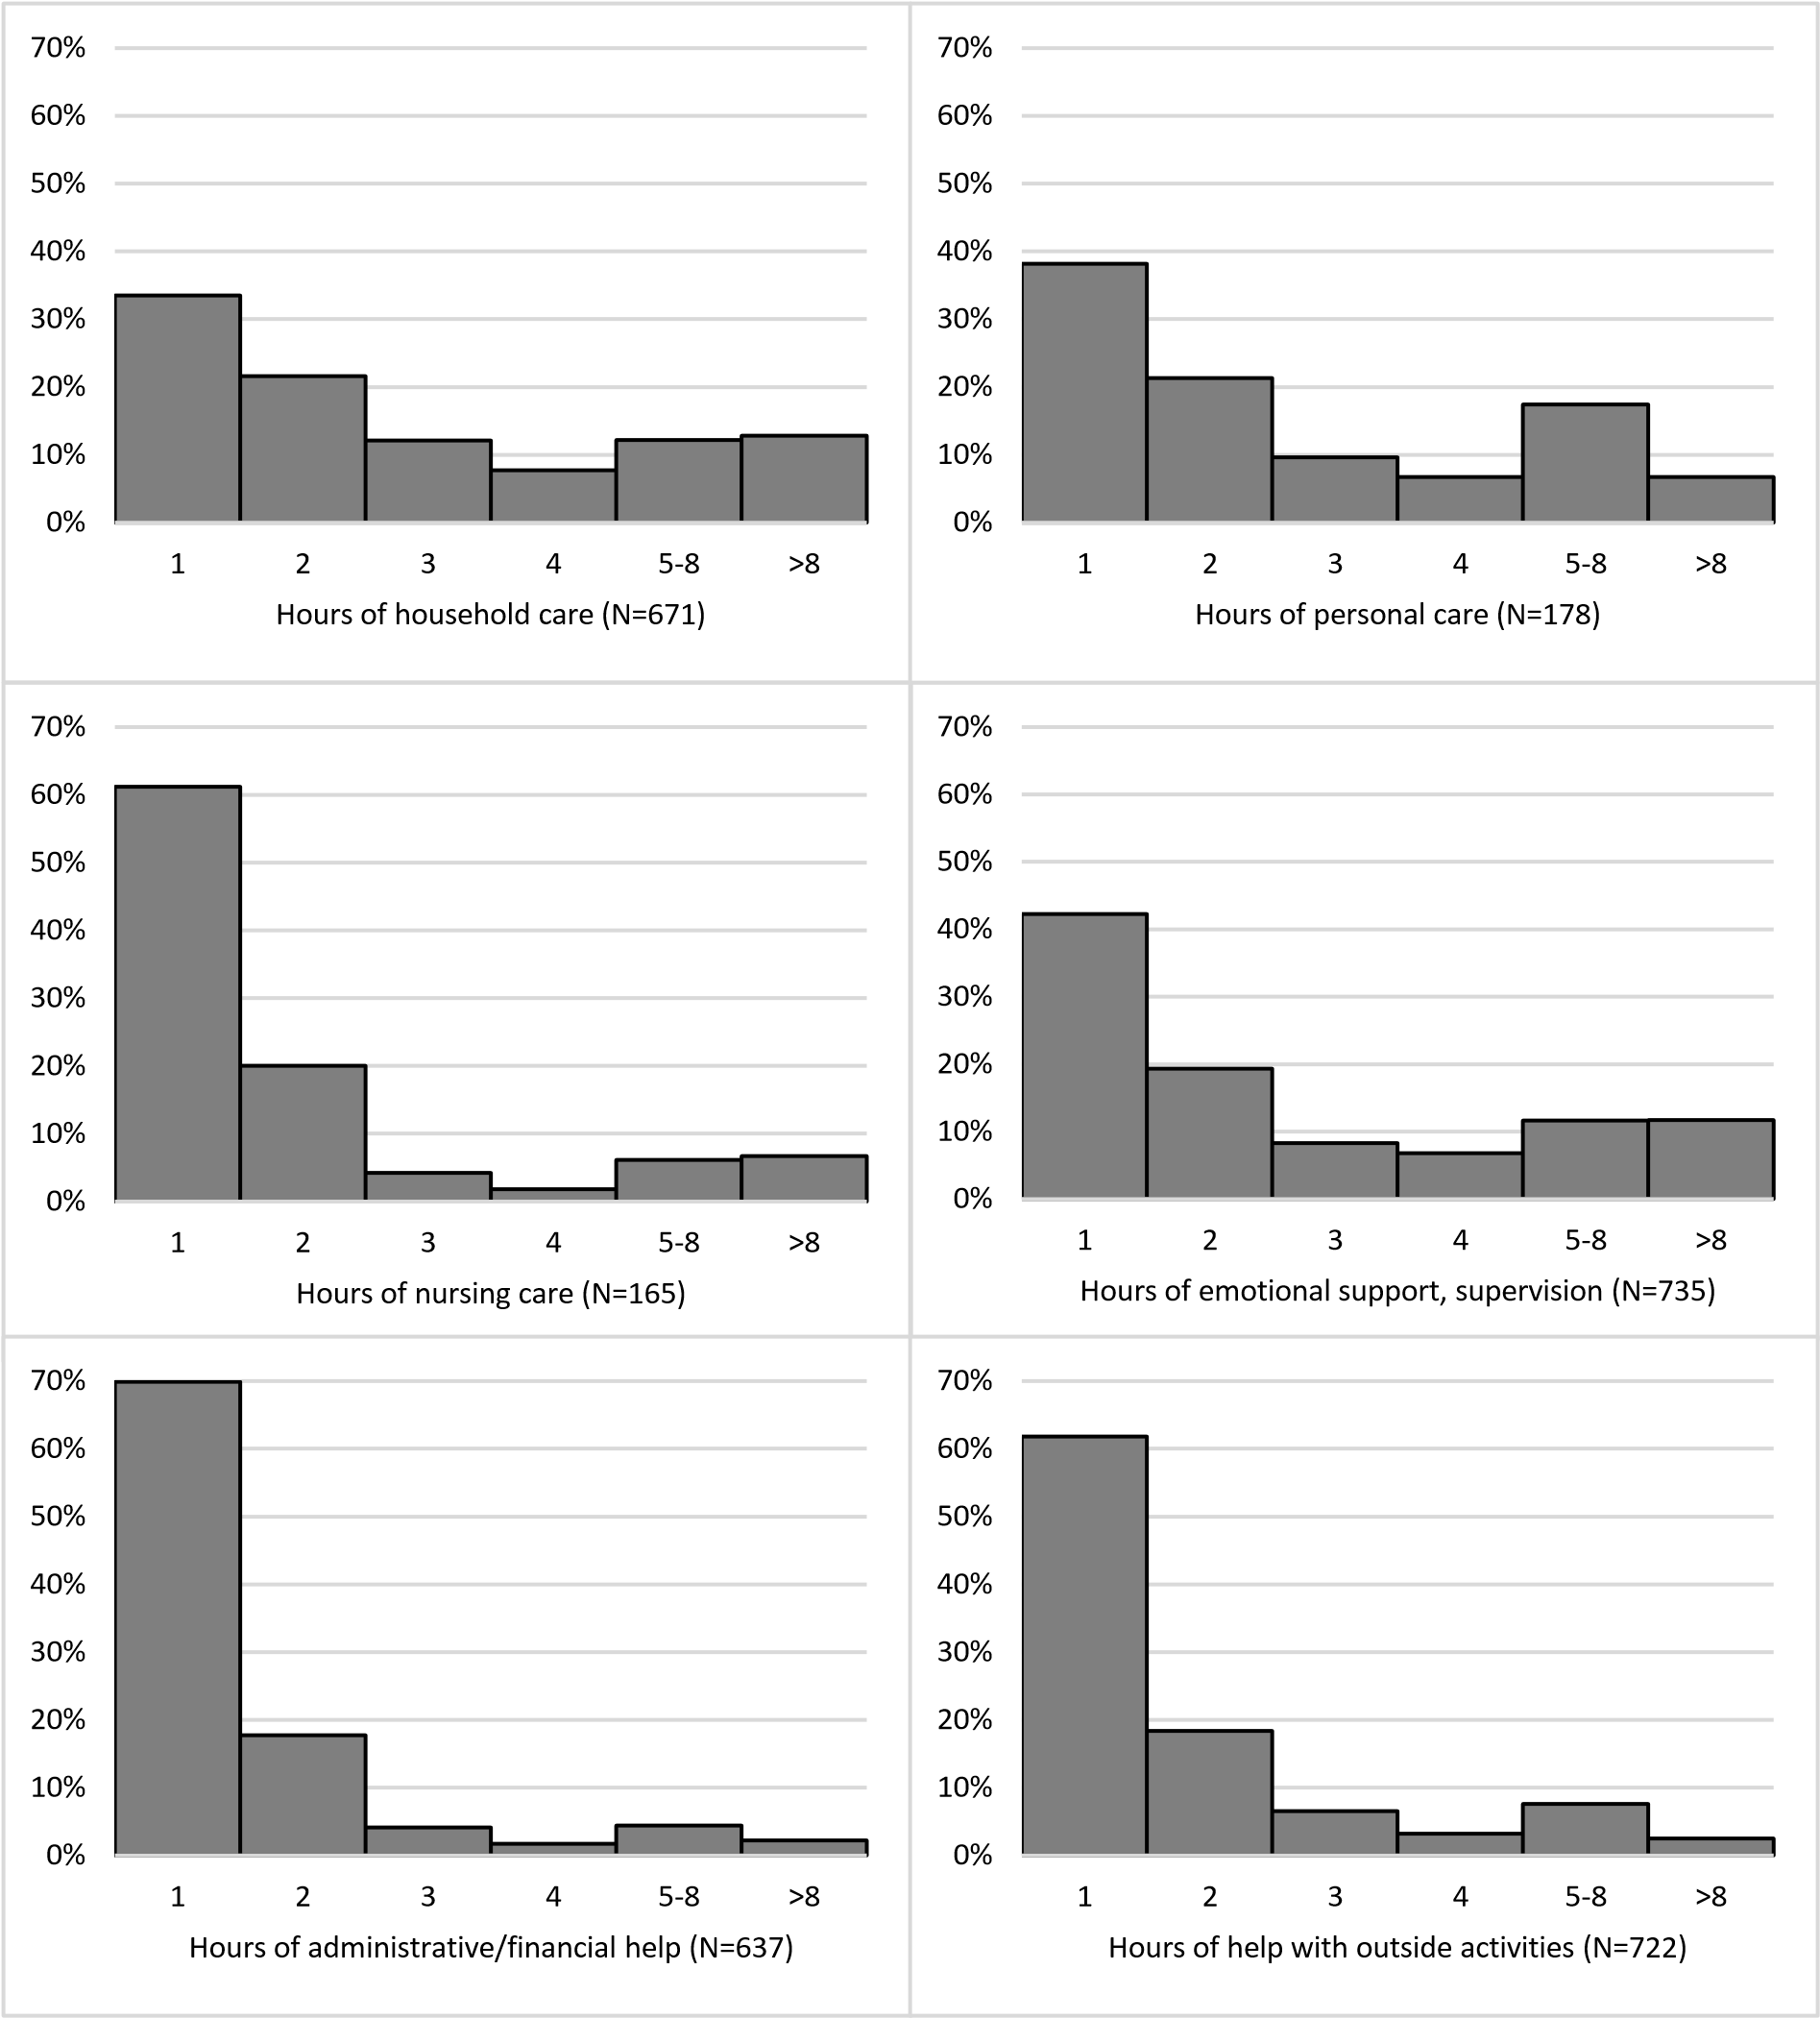
Figure S2: Hours of informal care provision, per informal care task, among informal caregivers who provide the care task, in Lifelines ICAS (N=965)



%
0
%
10
%
20
%
30
40
%
%
50
%
60
70
%
80
%
90
%
%
100
Strenghened my relationships with others
Enabled me to develop a more positive attitude toward life
Enabled me to appreciate life more
Made me feel strong and confident
Made me feel important
Made me feel appreciated
Made me feel needed
Made me feel good about myself
Made me feel useful
Strongly) disagree
(
Neither agree nor disagree
Strongly) agree
(
Figure S3: Percentages of informal caregivers that (strongly) agree, neither agree nor disagree, and (strongly) agree with the items of the Positive Aspects of Caregiving scale (PAC; ‘Caregiving …’), in Lifelines ICAS (N=965)

