Supplementary material

Marked enhancement of Acinetobacter sp. organophosphorus hydrolase
activity by a single residue substitution Ile211Ala
Jie Chen ¹, Xiao-Jing Luo ¹, Qi Chen ¹, Jiang Pan ^{1,*}, Jiahai Zhou ², Jian-He Xu ^{1,*}
1 State Key Laboratory of Bioreactor Engineering, Shanghai Collaborative Innovation Center for Biomanufacturing, East China University of Science and Technology, Shanghai 200237, China.
2 Shanghai Institute of Organic Chemistry, Chinese Academy of Sciences, Shanghai 200032, China.
* Corresponding authors. E-mails: panjiang@ecust.edu.cn (Jiang Pan); jianhexu@ecust.edu.cn (Jian-He Xu).
.

Contents
Table S1. Mutagenesis primers used in this study.
Figure S1. Multiple sequence alignment of enzymes in β-lactamase superfamily.
Figure S2. The crystallization of purified AbOPH protein.
Figure S3. Structural comparison of AbOPH with OPHC2 and MPH.
Figure S4. The positions of selected mutational amino acids in the structure of AbOPH.
Figure S5. Activities comparison of AbOPH with Ile211 variants and I211A/L156M/H268L.
Figure S6. Chemical structures of substrates used in this study.

Table S1. Mutagenesis primers used in this study.
Mutagenesis primers
N71V-forwad | 5'- CTGCTCGATGGCACTGTCTTTATGTCACCAAAC -3'
N71V-reverse | 5'- GTTTGGTGACATAAAGACAGTGCCATCGAGCAG -3'
M73L-forwad | 5'- GATGGCACTAACTTTCTTTCACCAAACTTGTTT -3'
M73L-reverse | 5'- AAACAAGTTTGGTGAAAGAAAGTTAGTGCCATC -3'
S104A-forwad | 5'- AAAGGCGTACAAACCGCTATCAATGCGTTCCTC -3'
S104A-reverse | 5'- GAGGAACGCATTGATAGCGGTTTGTACGCCTTT -3'
N106T-forwad | 5'- GTACAAACCTCTATCACTGCGTTCCTCGTTAAT -3'
N106T-reverse | 5'- ATTAACGAGGAACGCAGTGATAGAGGTTTGTAC -3'
A107G-forwad | 5'- CAAACCTCTATCAATGGGTTCCTCGTTAATATA -3'
A107G-reverse | 5'- TATATTAACGAGGAACCCATTGATAGAGGTTTG -3'
S121T-forwad | 5'- CTGATATTAATCGATACTGGTGCAGCGAGTTGT -3'
S121T-reverse | 5'- ACAACTCGCTGCACCAGTATCGATTAATATCAG -3'
S129D-forwad | 5'- GCGAGTTGTTTCGGCGATCATTTAGGTTCAGTT -3'
S129D-reverse | 5'- AACTGAACCTAAATGATCGCCGAAACAACTCGC -3'
H130T-forwad | 5'- AGTTGTTTCGGCTCAACTTTAGGTTCAGTTTTA -3'
H130T-reverse | 5'- TAAAACTGAACCTAAAGTTGAGCCGAAACAACT -3'
L156M-forwad | 5'- ATTTTACTCACACATATGCATCCCGACCATGTC -3'
L156M-reverse | 5'- GACATGGTCGGGATGCATATGTGTGAGTAAAAT -3'
C162G-forwad | 5'- CATCCCGACCATGTCGGTGGTATCAGTAAAGAT -3'
C162G-reverse | 5'- ATCTTTACTGATACCACCGACATGGTCGGGATG -3'
T207M-forwad | 5'- GCCAATTACTTAGGTATGGTTGAGAAAATTAAA -3'
T207M-reverse | 5'- TTTAATTTTCTCAACCATACCTAAGTAATTGGC -3'
T207F-forwad | 5'- GCCAATTACTTAGGTTTTGTTGAGAAAATTAAA -3'
T207F-reverse | 5'- TTTAATTTTCTCAACAAAACCTAAGTAATTGGC -3'
V208F-forwad | 5'- AATTACTTAGGTACGTTTGAGAAAATTAAACAA -3'
V208F-reverse | 5'- TTGTTTAATTTTCTCAAACGTACCTAAGTAATT -3'
I211A-forwad | 5'- GGTACGGTTGAGAAAGCTAAACAAGCGATTGCG -3'
I211A-reverse | 5'- CGCAATCGCTTGTTTAGCTTTCTCAACCGTACC -3'
F249T-forwad | 5'- CATACACCGGGGCATACTAGCTATGAGCTAAAA -3'
F249T-reverse | 5'- TTTTAGCTCATAGCTAGTATGCCCCGGTGTATG -3'
I263L-forwad | 5'- GAAAGCATCGTGTTTCTGGGAGATATTGTTCAT -3'
I263L-reverse | 5'- ATGAACAATATCTCCCAGAAACACGATGCTTTC -3'
H268L-forwad | 5'- ATTGGAGATATTGTTCTGTCACACACTGTTCAG -3'
H268L-reverse | 5'- CTGAACAGTGTGTGACAGAACAATATCTCCAAT -3'
I281T-forwad | 5'- CGGCCTGAAACTGCAACTGAATATGATATTGAC -3'
I281T-reverse | 5'- GTCAATATCATATTCAGTTGCAGTTTCAGGCCG -3'
A290V-forwad | 5'- ATTGACCCGAAAAAAGTCGTTGAAACTCGCTTA -3'
A290V-reverse | 5'- TAAGCGAGTTTCAACGACTTTTTTCGGGTCAAT -3'
P311S-forwad | 5'- CAAACCATTGCTGCAAGTCATTTACCATTTCCG -3'
P311S-reverse | 5'- CGGAAATGGTAAATGACTTGCAGCAATGGTTTG -3'

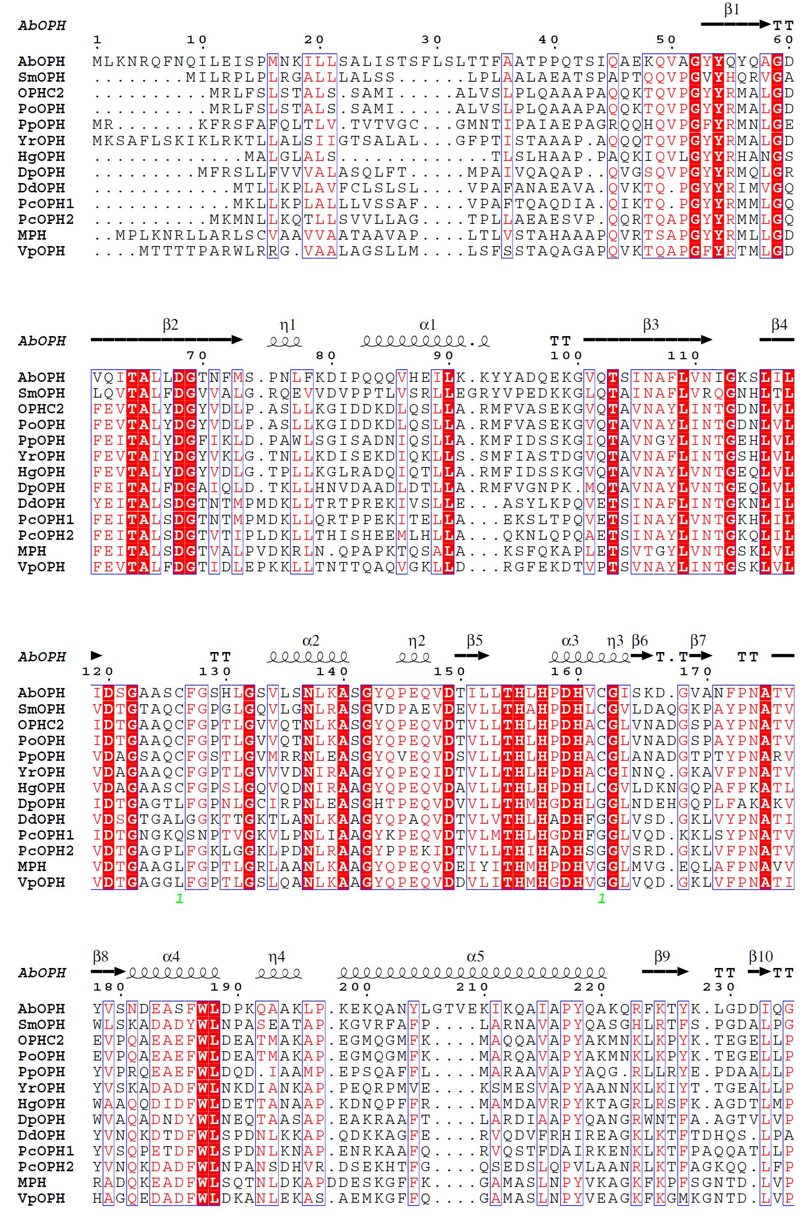

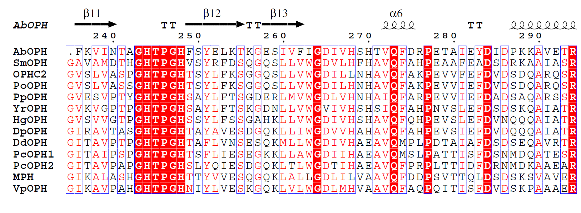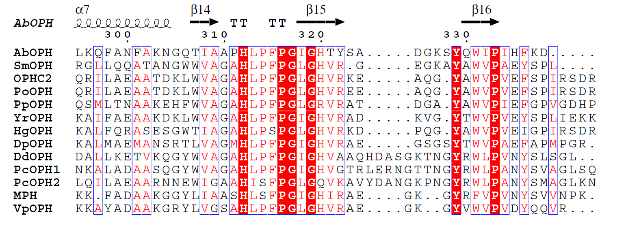
Figure S1. Multiple sequence alignment of enzymes in β-lactamase superfamily. Additional residues 206–209 are highlighted by blue box. Leu156, Ile211 and His268 are indicated with red arrows.
A

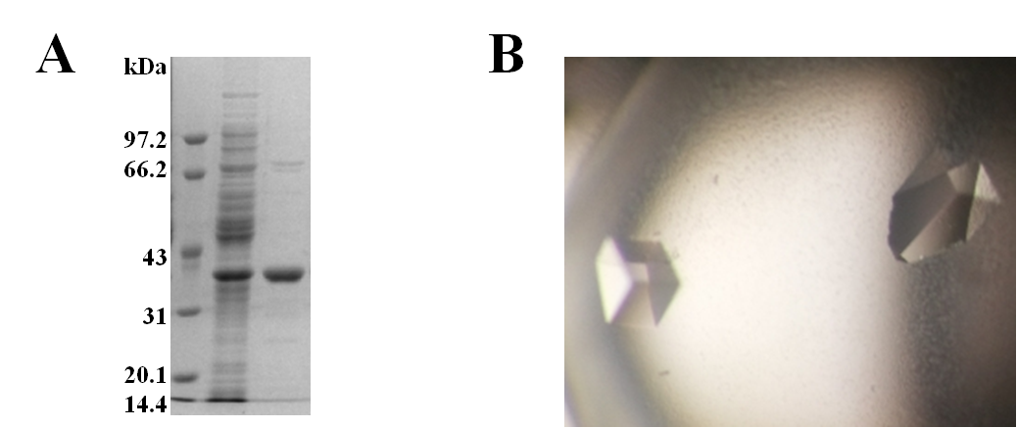

Figure S2. Crystallization of purified AbOPH protein. (A) 15% SDS–PAGE of AbOPH protein stained with Coomassie Blue. Left lane, molecular-weight markers; middle lane, crude AbOPH protein; right lane, purified AbOPH protein. (B) Crystals of AbOPH.

Figure S3. Structural comparison of AbOPH (red) with OPHC2 (yellow) and MPH (green). (A) Superposition of monomer structures. Major differences concern loops sizes and conformations. (B) Superposition of metal centers. Two zinc atoms are shown as grey spheres.

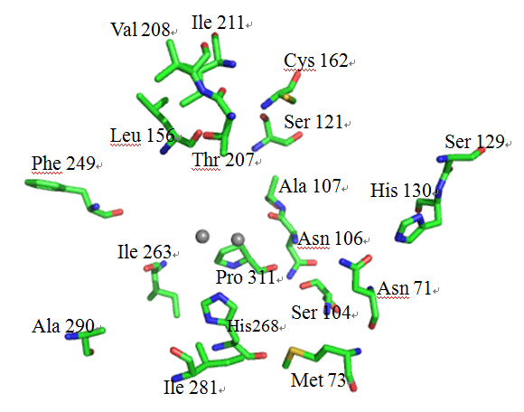

Figure S4. The positions of selected mutational amino acids in the structure of AbOPH. Two zinc atoms are shown as grey balls.

Figure S5. Activities comparison of AbOPH with Ile211 variants and I211A/L156M/H268L. Specific activities of crude enzymes toward methyl-parathion were determined. The final concentration of methyl-parathion in the activity assay was 0.5 mM. All assays were performed in triplicate.

Figure S6. (A) Chemical structures of substrates used in this study. (B) The reaction for the hydrolysis of methyl-parathion.

