Supporting Information

Exploring productive sequence space in directed evolution using binary patterning versus conventional mutagenesis strategies

Zhoutong Sun^{a,b,‖}, Pamela Torres Salas^{a,b,‖}, Elina Siirola^{a,b,‖}, Richard Lonsdale^{a,b,‖}, Manfred T. Reetz*

ªMax-Planck-Institut für Kohlenforschung, Kaiser-Wilhelm-Platz 1, 45470 Mülheim an der Ruhr, Germany
^{b}Fachbereich Chemie der Philipps-Universität, Hans-Meerwein-Strasse, 35032 Marburg, Germany

Authors and email list:
Zhoutong Sun: ztsun@kofo.mpg.de
Pamela Torres Salas: p.torres.salas@gmail.com
Elina Siirola: Elina.Siirola@matthey.com
Richard Lonsdale: richard.lonsdale@gmail.com
*Correspondence: Manfred T. Reetz: reetz@mpi-muelheim.mpg.de
‖These authors contributed equally to this work.

Table S1. Best LEH variants of library CB and AD for desymmetrization of epoxide 1.
Library | Code | Mutations | Favored enantiomer | ee% | c%
CB | SZ197 | I80V (template) | (R,R) | 72 | 93
CB | SZ198 | I80V/F134Y | (R,R) | 69 | 94
CB | SZ200 | L74H/I80V | (R,R) | 71 | 96
AD | SZ197 | I80V (template) | (R,R) | 72 | 93
 | SZ205 | L74F/L103I/F134L/I80V | (R,R) | 72 | 59
 | SZ208 | L74I/I80V | (R,R) | 68 | 88
 | SZ209 | L35A/L74F/I80V/L103I | (S,S) | 25 | 48
 | SZ222 | L74A/I80V | (R,R) | 68 | 87
 | SZ229 | I80V/L103I | (R,R) | 71 | 94

Table S2. Distances [in Å] and angles [degrees] calculated for the highest ranked docking poses calculated for cyclohexene oxide in the WT, SZ502 and SZ503 homology models of LEH.
 | O_{wat}-C₁ | O_{wat}-C₂ | O_{ep}-H_{D101} | O_{wat}-C₁-O_{ep} | O_{wat}-C₂-O_{ep} | O_{wat}-C₁- C₂ | O_{wat}-C₂- C₁
WT (1) | 3.164 | 3.435 | 1.916 | 141.6 | 122.0 | 87.1 | 66.9
WT (2) | 3.609 | 3.017 | 1.797 | 112.0 | 156.0 | 55.3 | 100.3
SZ502 | 3.339 | 2.982 | 1.689 | 116.5 | 139.4 | 63.2 | 89.9
SZ503 | 3.199 | 3.263 | 1.958 | 132.0 | 128.5 | 78.8 | 74.1

Table S3. List of primers used in this study.
Library | Primer mix | Primer name | Sequence 5’ to 3’
A | F1 | I80VDTV83SDT-F | CCGTCATGAGCVDTGATGCGSDTGAGACGTTCCATATCGGC
A | R1 | L114SDTI116VDT-R | GGAAGACTCCGAGAHBTGAAHSGTTGTAGCTCTTGCCGGTGGG
B | F2 | L74SDT-F | GCAAACTCTGGCTGGCSDTTTCACCGTCATGAGC
B | R2 | F134BWT-R | CGAATTCGCGCAGATCAWVGTAGTCACGCCAACCCGTAATCTTGC
B | F3 | L35SDT-F | GTTCATGGACGCASDTACCAGTAATGATGCTGCAAAACTC
B | R3 | L103SDT-R | GGTAGTGCGCGAHSGACATCGACACGTTCGGTGTACAC
C | F4 | I80V83GBT-F | CCGTCATGAGCGBTGATGCGGBTGAGACGTTCCATATCGGC
C | F4 | I80GBTV83HTT-F | CCGTCATGAGCGBTGATGCGHTTGAGACGTTCCATATCGGC
C | F4 | I80HTTV83GBT-F | CCGTCATGAGCHTTGATGCGGBTGAGACGTTCCATATCGGC
C | F4 | I80V83HTT-F | CCGTCATGAGCHTTGATGCGHTTGAGACGTTCCATATCGGC
C | R4 | L114I116GBT-R | GGAAGACTCCGAGAVCTGAAVCGTTGTAGCTCTTGCCGGTGGG
C | R4 | L114GBTI116HTT-R | GGAAGACTCCGAGAADTGAAVCGTTGTAGCTCTTGCCGGTGGG
C | R4 | L114HTTI116GBT-R | GGAAGACTCCGAGAVCTGAAADGTTGTAGCTCTTGCCGGTGGG
C | R4 | L114I116HTT-R | GGAAGACTCCGAGAADTGAAADGTTGTAGCTCTTGCCGGTGGG
D | F5 | L74GBT-F | GCAAACTCTGGCTGGCGBTTTCACCGTCATGAGC
D | F5 | L74HTT-F | GCAAACTCTGGCTGGCHTTTTCACCGTCATGAGC
D | R5 | F134GBT-R | CGAATTCGCGCAGATCAVCGTAGTCACGCCAACCCG
D | R5 | F134HTT-R | CGAATTCGCGCAGATCAADGTAGTCACGCCAACCCG
D | F6 | L35GBT-F | GTTCATGGACGCAGBTACCAGTAATGATGCTGCAAAACTC
D | F6 | L35HTT-F | GTTCATGGACGCAHTTACCAGTAATGATGCTGCAAAACTC
D | R6 | L103GBT-R | GGTAGTGCGCGAVCGACATCGACACGTTCGGTGTACAC
D | R6 | L103HTT-R | GGTAGTGCGCGAADGACATCGACACGTTCGGTGTACAC

Table S4. Analytic conditions of GC.
Entry | Diol | Column | Procedure | Retention time | Standard | Comment
1 | (S,S)-2, (R,R)-2 | Hydrodex-β-TBDAc, 25 m x 0.25 mm ID | 130 °C, 2.5 °C/min, 135 °C, 30 °C/min, 220 °C. H₂: 2.7 bar | (S,S)-2: 1.7 min  (R,R)-2: 1.9 min | Based on authentic racemic mixture and (S,S) chiral product | for ee screening
1 | (S,S)-2, (R,R)-2 | Hydrodex-β-TBDAc, 25 m x 0.25 mm ID | 80 °C (4min), 5 °C /min, 130 °C (4 min), 30 °C/min, 220 °C (1 min). H₂: 1.5 bar | epoxide 1: 5.6 min  (S,S)-2: 13.8 min  (R,R)-2: 14.2 min | Based on authentic racemic mixture and (S,S) chiral product | for ee and conversion
3 | (S,S)-4, (R,R)-4 | Hydrodex-β-TBDAc, 25 m x 0.25 mm ID |  | epoxide 3: 5.6 min  (S,S)-4: 16.8 min  (R,R)-4: 17.2 min | Based on authentic racemic mixture and (S,S) chiral product | for ee and conversion
5 | (S,S)-6, (R,R)-6 | Hydrodex-β-TBDAc, 25 m x 0.25 mm ID |  | epoxide 5: 5.1 min  (S,S)-6: 14.8 min  (R,R)-6: 15.5 min | Based on authentic racemic mixture and (S,S) chiral product | for ee and conversion
7 | (R,R)-8, (S,S)-8 | Hydrodex-β-TBDAc, 25 m x 0.25 mm ID | 150 °C (34 min), 50 °C/min, 220 °C. H₂: 2.0 bar | epoxide 7: 3.9 min  (R,R)-8: 32.2 min  (S,S)-8: 33.5 min | Based on authentic racemic mixture and (S,S) chiral product | for ee and conversion

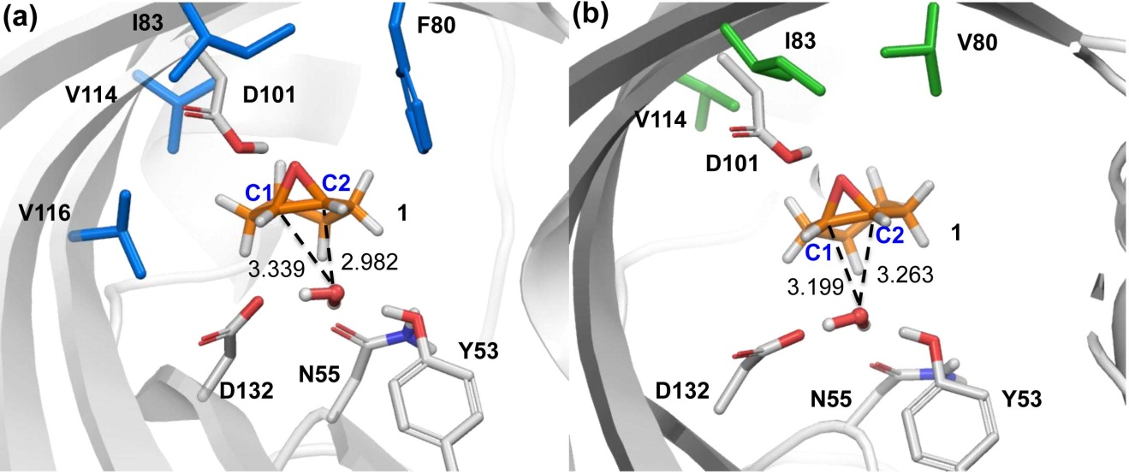

Figure S1. Highest ranked docking pose for cyclohexene oxide (1) in the (a) SZ502 and (b) SZ503 mutant homology models of LEH. The catalytic residues are shown in white stick representation. The mutated residues are shown in blue and green for the SZ502 and SZ503 mutants, respectively. Interatomic distances for these docking poses are provided in Table S2. Nucleophilic attack by the water molecule at the C1 and C2 atoms of the epoxide results in formation of the (R,R)- and (S,S)-diol products (2), respectively. The highest ranked docking pose for the SZ502 mutant places C2 closest to the nucleophilic water oxygen, consistent with the formation of the S,S-diol, as is observed experimentally. The C2 atom is closer to the water oxygen than the C1 atom by 0.357 Å. Out of the 19 docking poses found for this mutant, only the highest ranking pose contains the activating hydrogen bond to D101. In the case of the SZ503 mutant, the highest scoring docking pose meeting the reactivity requirements is consistent with the formation of (R,R)-2, however, in this case the difference in the O-C1 and O-C2 distances is small (0.06 Å) and may reflect the lower degree of selectivity for this mutant (80 % ee, compared to 98% for SZ502). It can be seen that docking of cyclohexene oxide (1) into the SZ502 and SZ503 homology models is consistent with the experimentally observed high selectivity of epoxide ring opening to form the (S,S)- and (R,R)-diol, respectively.

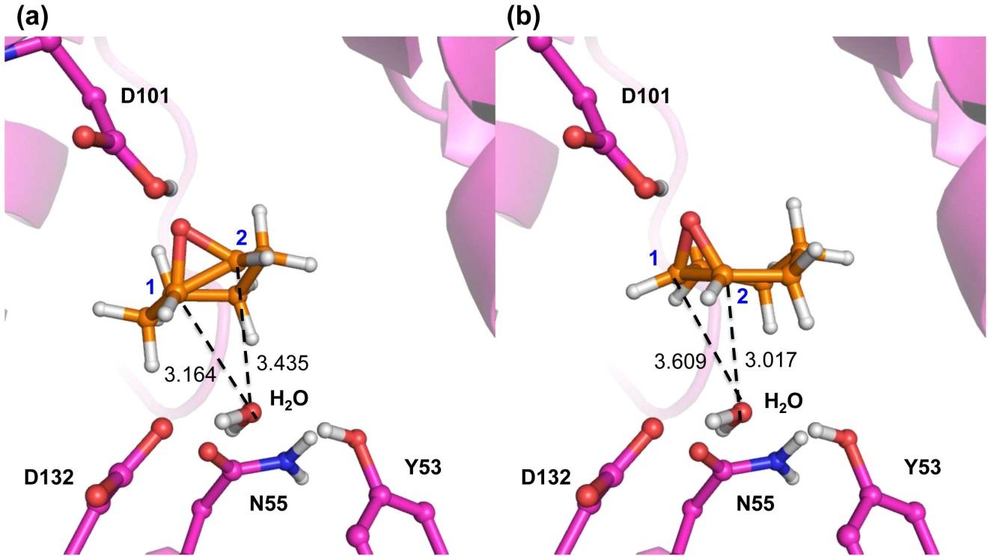

Figure S2. Docking of substrate 1 to WT LEH. (a) Highest ranked docking pose places substrate in position favoring the formation of (R,R)-2. (b) Second-highest ranked docking pose places substrate in position favoring formation of (S,S)-2. Geometric parameters are provided in Table S2.

