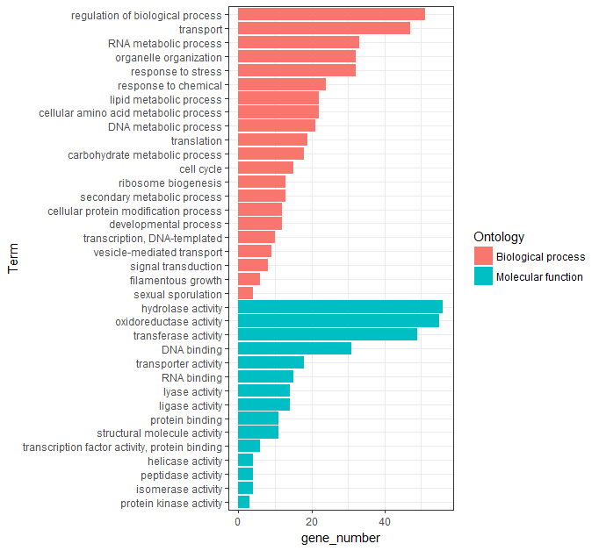
a
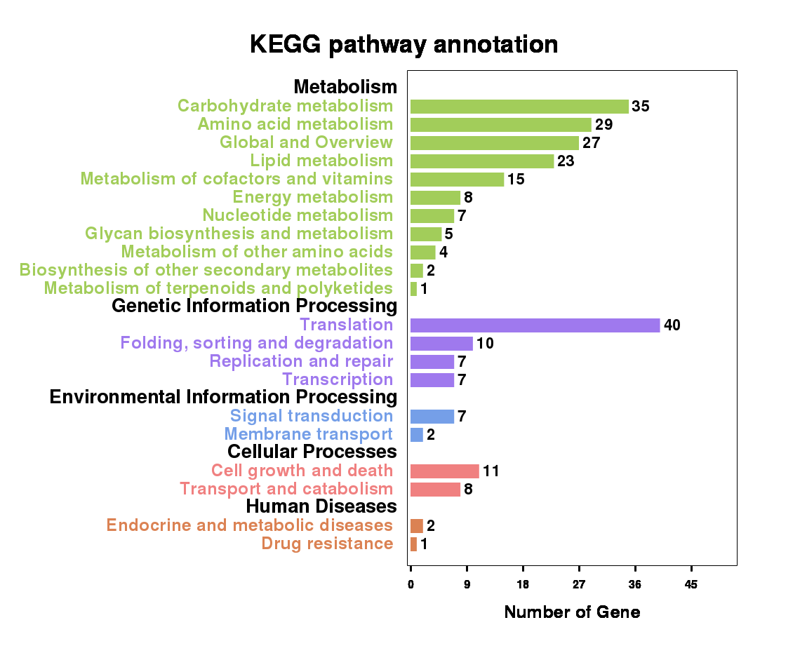
b
Fig.S2 GO (a) and KEGG (b) function enrichment analysis of all DEGs

