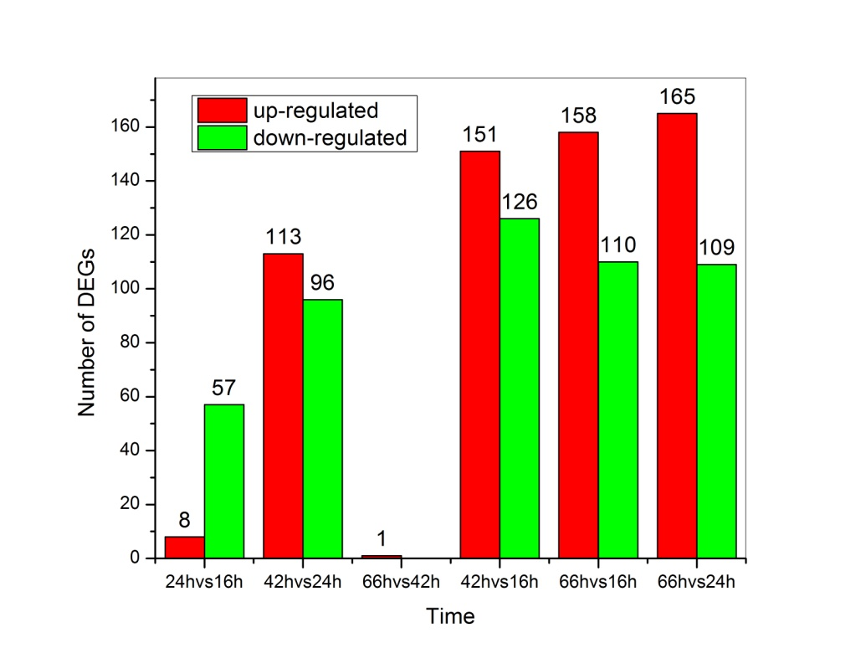

Fig.S3 DEGs generated by two-time point comparison

