Additional information for
Cross-linked enzyme-polymer conjugates with excellent stability and detergent-enhanced activity for efficient organophosphate degradation
Huan Cheng,ª Yu-Lian Zhao,ª Xiao-Jing Luo,ª Dian-Sheng Xu,ª Xun Cao,^{b} Jian-He Xu,ª Qing Dai,^{c} Xiao-Yan Zhang,^{*a} Jun Ge^{*b} and Yun-Peng Bai^{*a}

^{a.}State Key Laboratory of Bioreactor Engineering, East China University of Science and Technology, Shanghai, 200237.
^{b.}Department of Chemical Engineering, Tsinghua University, Beijing, 100084.
^{c.}Division of Nanophotonics, CAS Center for Excellence in Nanoscience, National Center for Nanoscience and Technology, Beijing, 100190.

Emails:
cheng_huan@wuxiapptec.com (H. Cheng), yulianzhao1@163.com (Y.-L. Zhao), lxjecust@126.com (X.-J. Luo), xuds@ecust.edu.cn (D.-S. Xu), cx0118@hotmail.com (X. Cao), jianhexu@ecust.edu.cn (J.-H. Xu), daiq@nanoctr.cn (Q. Dai)

*Corresponding authors:
xyzhang@ecust.edu.cn (X.-Y. Zhang),
junge@mail.tsinghua.edu.cn (J. Ge)
ybai@ecust.edu.cn (Y.-P. Bai)

Experimental
- Preparation of CLEPCs by adding Pluronic F127 in different order
PL-AS-GL. Lyophilized enzyme powders were dissolved in Tris-HCl buffer (pH 7.0) to a final concentration of 20 mg/mL, to which Pluronic F127 was slowly added to a final concentration of 80 mg/mL. The solution was then stirred at 4 ºC for 30 min. Subsequently, ammonium sulfate was slowly added into the solution to a final concentration of 0.5 g/mL to precipitate enzymes, and the suspension was continuously stirred at 4 ºC for 30 min. Glutaraldehyde was added to a final concentration of 40 mM to cross-link the aggregates and the suspension was stirred at 4 ºC for 3 h. Then, the suspension was centrifuged at 12,000 rpm for 3 min, and the precipitate was washed three times and re-suspended in 0.5 mL Tris-HCl buffer (pH 7.0).
AS-GL-PL. Lyophilized enzyme powders were dissolved in Tris-HCl buffer (pH 7.0) to a final concentration of 20 mg/mL, to which ammonium sulfate was slowly added to a final concentration of 0.5 g/mL to precipitate enzymes. The suspension was then stirred at 4 ºC for 30 min. Subsequently, glutaraldehyde was added to a final concentration of 40 mM to cross-link the aggregates and the suspension was stirred at 4 ºC for 3 h. Then, Pluronic F127 was added to a final concentration of 80 mg/mL and the suspension was continuously stirred at 4 ºC for 30 min. Then, the suspension was centrifuged at 12,000 rpm for 3 min, and the precipitate was washed three times and re-suspended in 0.5 mL Tris-HCl buffer (pH 7.0).
2. Transmission electron microscopy (TEM) assay
Samples were prepared by dispersing the CLEPC in deionized water and then a well-dispersed droplet of the sample was placed on a copper grid. Samples were then dried and analysed on a H-7650B transmission electron microscope (Tokyo, Japan).

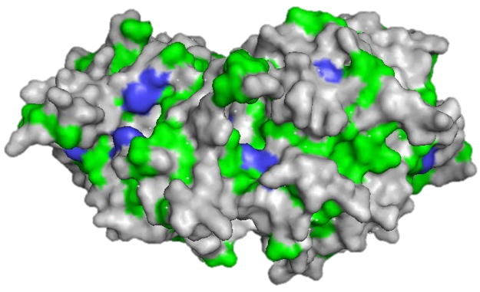
Figure S1. The hydrophobic surface of PoOPH_{M9} dimer is illustrated by Phenylalanine (blue) and other hydrophobic residues (green).

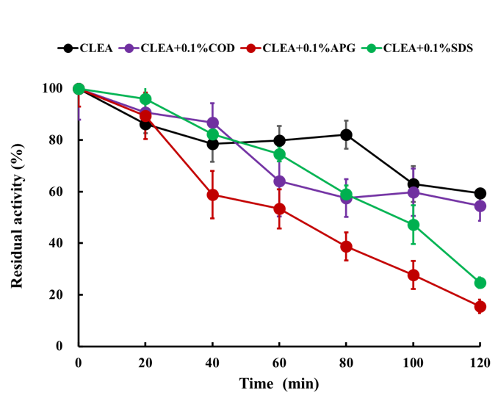
Figure S2. PoOPH_{M9} CLEA was incubated in the absence or presence of 0.1% (w/w) COD, APG or SDS, and its residual activity at different time points was measured.

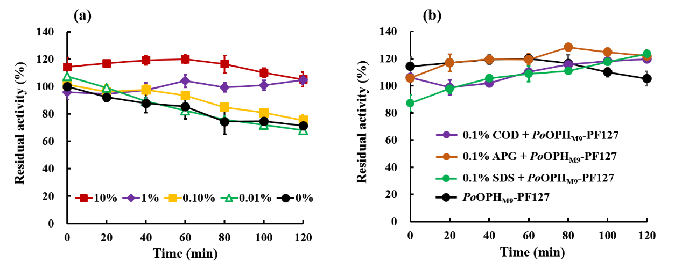
Figure S3. (a) Pluronic F127 of different concentrations were associated with the free enzyme PoOPH_{M9}. The prepared catalyst PoOPH_{M9}-PF127 were incubated at room temperature and their residual activities relative to that of the free enzyme were measured at different time points. (b) PoOPH_{M9}-PF127 was incubated with 0.1% (w/w) different detergents and its residual activity at different time points was measured and compared to that of the free enzyme.

References
- X. J. Luo, J. Zhao, C. X. Li, Y. P. Bai, M. T. Reetz, H. L. Yu and J. H. Xu, Biotechnol. Bioeng., 2016, 113, 2350-2357.

