Additional Information
Laboratory evolution of an alcohol dehydrogenase towards enantioselective reduction of difficult-to-reduce ketones
Ge Qu^{1#}, Beibei Liu^{1,2#}, Yingying Jiang¹, Yao Nie², Huilei Yu³, Zhoutong Sun^{1*}
1 Tianjin Institute of Industrial Biotechnology, Chinese Academy of Sciences, 32 West 7th Avenue, Tianjin Airport Economic Area, Tianjin 300308, China
(+86) 22-84861981; e-mail: sunzht@tib.cas.cn
2 School of Biotechnology, Key laboratory of Industrial Biotechnology, Ministry of Education, Jiangnan University, Wuxi 214122, China
3 State Key Laboratory of Bioreactor Engineering, Shanghai Collaborative Innovation Center for Biomanufacturing, East China University of Science and Technology, 130 Meilong Road, Shanghai 200237, China
*Correspondence: (+86) 22-84861981; e-mail: sunzht@tib.cas.cn
# These two authors contributed equally to this work.

Contents
Additional tables S2
Table S1. Summary of the TbSADH residues involved in this work. S2
Table S2. Rosetta docking results. S3
Table S3. List of primers for site-directed saturation mutagenesis. S4
Table S4. Analytical conditions of HPLC. S5
Table S5. Analytical conditions of GC. S6
Additional figures S7
Figure S1. SDS-PAGE analysis of the protein expression of the variants △A85 (“△” indicates deletion), △I86 and △A85/△I86. As shown, all the three variants are well expressed. M: molecular markers. Lines 2~4, 5~7, 8~10 and 11~13 represent: whole cell lysate, soluble protein, inclusion body and empty vector, respectively. BL21(DE3) harboring the empty vector pRSFDuet-1 was used as a negative control. The expected size of TbSADH (37.58 KDa) is indicated by black arrow. S7
Figure S2. The non-bonded interactions between ketone 1 and mutant A85G/I86A/Q101A, investigated by PLIP tool (Salentin et al. 2015). S8
Computational command lines for running Rosetta Docking S9
References S12

Additional tables

Table S1. Summary of the TbSADH residues involved in this work.
Residues | Properties/Functions | Reference
A85 | Activity; enantioselectivity; substrate specificity | (Agudo et al. 2013; Sun et al. 2016a; Dong et al. 2019; Li et al. 2017)
I86 | Activity; enantioselectivity; substrate specificity | (Musa et al. 2009; Agudo et al. 2013; Sun et al. 2016a; Sun et al. 2016b; Dong et al. 2019; Li et al. 2017)
S39 | Proton transfer | (Moa and Himo 2017)
W110 | Activity; enantioselectivity; substrate specificity | (Musa et al. 2007; Ziegelmann-Fjeld et al. 2007; Patel et al. 2014; Musa et al. 2015; Agudo et al. 2013; Sun et al. 2016a; Sun et al. 2016b; Musa et al. 2018)
L294 | Activity; enantioselectivity; substrate specificity | (Sun et al. 2016a; Sun et al. 2016b)
C295 | Activity; enantioselectivity; substrate specificity | (Heiss et al. 2001; Nealon et al. 2016; Agudo et al. 2013; Sun et al. 2016a; Sun et al. 2016b)
Q101 | Activity | This study

Table S2. Rosetta docking results.
Enzymes | Poses | Interface_delta_X (REUª)
A85G/I86A | 1 | -19.74
A85G/I86A | 2 | -18.52
A85G/I86A | 3 | -18.37
A85G/I86A | 4 | -18.29
A85G/I86A | 5 | -18.21
A85G/I86A/Q101A | 1 | -22.05
A85G/I86A/Q101A | 2 | -18.73
A85G/I86A/Q101A | 3 | -18.52
A85G/I86A/Q101A | 4 | -18.34
A85G/I86A/Q101A | 5 | -18.11
ª REU: Rosettta energy units.

Table S3. List of primers for site-directed saturation mutagenesis.
Primer mix | Name | Sequence(5’-3’)
F1 | TbSADH-A85-85G-F | CGCGTTGTTGTGCCAGGTATTACCCCTGATTGG
F2 | TbSADH-I86-86A-F | CGCGTTGTTGTGCCAGCTGCAACCCCTGATTGG
F3 | TbSADH-A85I86-85G86A-F | GTGGCCCCTTGCACTACCGACATTCATACCGTT
F4 | TbSADH-Q101-101A-F | CAAAGAGGATATCACGCACACTCCGGTGGAATG
F5 | TbSADH-Q101-101S-F | CAAAGAGGATATCACAGCCACTCCGGTGGAATG
F6 | TbSADH-W110-110A-F | GGAATGCTGGCAGGCGCAAAATTTTCGAATGTA
F7 | TbSADH-W110-110S-F | GGAATGCTGGCAGGCAGCAAATTTTCGAATGTA
F8 | TbSADH-L294-294A-F | ACTATAAAAGGCGGGGCATGCCCCGGTGGACGT
F9 | TbSADH-L294-294S-F | ACTATAAAAGGCGGGAGCTGCCCCGGTGGACGT
F10 | TbSADH-C295-295A-F | ATAAAAGGCGGGCTAGCACCCGGTGGACGTCTA
F11 | TbSADH-C295-295S-F | ATAAAAGGCGGGCTAAGCCCCGGTGGACGTCTA
R1 | TbSADH-R200-wt-R | ATCTACACAAACTGGTCTACTGCCTACGGCAAT
R2 | TbSADH-I345-wt-R | TATTACAACAGGTTTGATTAGGTCTTTTGGTTT

Table S4. Analytical conditions of HPLC.
Substrate | Columnª | Mobile phase | Retention time | Ref.
1 | Chiralpak AD-H  (250×4.6mm 5μm) | n-hexane:isopropanol  =90:10 | 1: 6.3 min  (S)-2: 10.6 min  (R)-2: 12.9 min | (Liu et al. 2018)
3a | Chiralpak AD-H  (250×4.6mm 5μm) | n-hexane:isopropanol  =90:10 | 3a: 5.9 min  (S)-4a: 9.8 min  (R)-4a: 12.2 min | (Liu et al. 2018)
3b | Chiralpak AD-H  (250×4.6mm 5μm) | n-hexane:isopropanol  =92:8 | 3b: 6.4 min  (R)-4b: 9.9 min  (S)-4b: 12.2 min | (Liu et al. 2018)
3c | Chiralpak AD-H  (250×4.6mm 5μm) | n-hexane:isopropanol  =92:8 | 3c: 7.2 min  (S)-4c: 11.7 min  (R)-4c: 13.5 min | (Liu et al. 2018)
3d | Chiralcel OD-H  (250×4.6mm 5μm) | n-hexane:isopropanol  =95:5 | 3d: 14.4 min  (S)-4d: 18.8 min  (R)-4d: 20.2 min | (Yang et al. 2015)
3e | Chiralpak AD-H  (250×4.6mm 5μm) | n-hexane:isopropanol  =92:8 | 3e: 6.2 min  (S)-4e: 10.9 min  (R)-4e: 13.0 min | (Liu et al. 2018)
3f | Chiralpak AD-H  (250×4.6mm 5μm) | n-hexane:isopropanol  =92:8 | 3f: 6.1 min  (S)-4f: 10.5 min  (R)-4f: 13.5 min | (Liu et al. 2018)
3g | Chiralpak AD-H  (250×4.6mm 5μm) | n-hexane:isopropanol  =92:8 | 3g: 5.9 min  (R)-4g: 9.1 min  (S)-4g: 10.0 min | (Truppo et al. 2007)
3h | Chiralpak AD-H  (250×4.6mm 5μm) | n-hexane:isopropanol  =90:10 | 3h: 6.9 min  (R)-4h: 9.6 min  (S)-4h: 14.1min | (Truppo et al. 2007)
3l | Chiralcel OD-H  (250×4.6mm 5μm) | n-hexane:isopropanol  =92:8 | 3l: 5.1 min  (R)-4l: 6.5 min  (S)-4l: 7.0 min | (Zhu et al. 2008)
3m | Chiralcel OD-H  (250×4.6mm 5μm) | n-hexane:isopropanol  =95:5 | 3m: 5.4 min  (S)-4m: 7.5 min  (R)-4m: 8.2 min | (Zhu et al. 2008)
3n | Chiralcel OD-H  (250×4.6mm 5μm) | n-hexane:isopropanol  =95:5 | 3n: 5.1 min  (S)-4n: 8.0 min  (R)-4n: 8.8 min | (Yang et al. 2015)
ªAll the analytical conditions under the same flow rate of 1 mL/min at 30°C with detection wavelength at 220 nm.

Table S5. Analytical conditions of GC.
Entry | Alcohol | Procedure | Retention time | Reference
3i | (S)-4i  (R)-4i | 100°C for 2 min, 10°C /min to 120°C, 120°C for 1 min, 2°C /min to 140°C, 140°C for 1 min, 50°C /min to 200°C.  Column: Hydrodex-β-TBDAc  (25×0.25 mm ID) | 3i: 7.8 min  (R)-3i: 8.7 min  (S)-3i: 8.8 min | based on authentic racemic mixture and enantiomeric product.
3j | (S)-4j  (R)-4j | 100°C for 2 min, 10°C /min to 120°C, 120°C for 1 min, 2°C /min to 140°C, 140°C for 1 min, 50°C /min to 200℃.  Column: Hydrodex-β-TBDAc  (25×0.25 mm ID) | 3j: 12.0 min  (S)-4j: 10.9 min  (R)-4j: 11.3 min | based on authentic racemic mixture and enantiomeric product.
3k | (S)-4k  (R)-4k | 100°C for 2 min, 10°C /min to 120°C, 120°C for 1 min, 2°C /min to 140°C, 140°C for 1 min, 50°C /min to 200°C.  Column: Hydrodex-β-TBDAc  (25×0.25 mm ID) | 3k: 5.6 min  (S)-4k: 7.9 min  (R)-4k: 8.0 min | based on authentic racemic mixture and enantiomeric product.

Additional figures
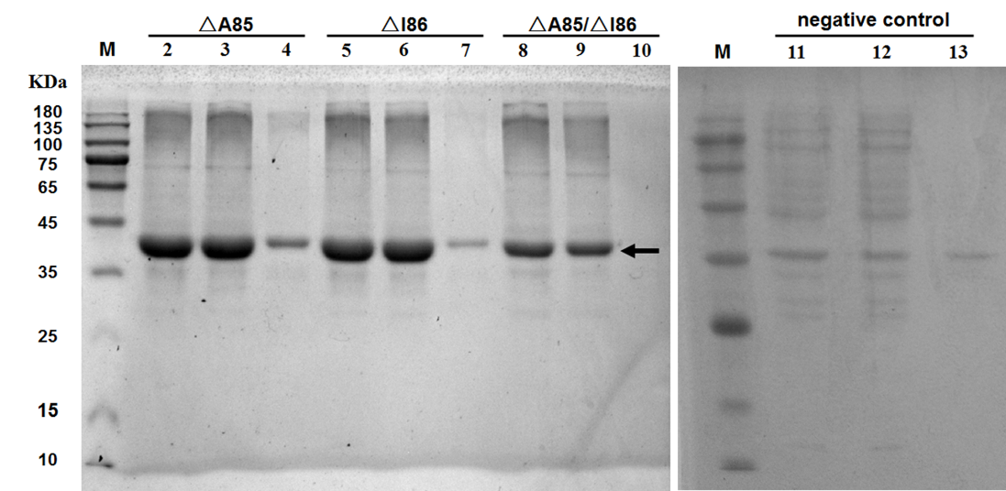

Figure S1. SDS-PAGE analysis of the protein expression of the variants △A85 (“△” indicates deletion), △I86 and △A85/△I86. As shown, all the three variants are well expressed. M: molecular markers. Lines 2~4, 5~7, 8~10 and 11~13 represent: whole cell lysate, soluble protein, inclusion body and empty vector, respectively. BL21(DE3) harboring the empty vector pRSFDuet-1 was used as a negative control. The expected size of TbSADH (37.58 KDa) is indicated by black arrow.

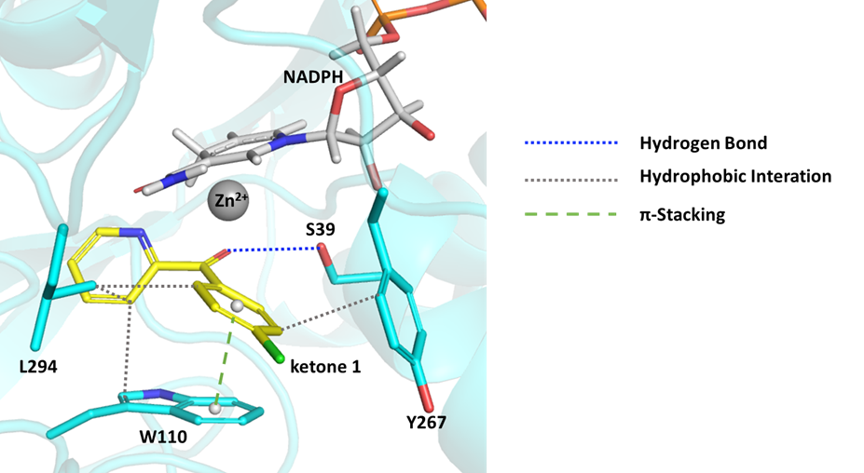

Figure S2. The non-bonded interactions between ketone 1 and mutant A85G/I86A/Q101A, investigated by PLIP tool (Salentin et al. 2015).

Computational command lines for running Rosetta Docking
Command lines: PATH_TO_ROSETTA/Rosetta/main/source/bin/rosetta_scripts.linuxgccrelease @dock_options.txt -database PATH_TO_ROSETTA/Rosetta/main/database -parser:protocol ligand_dock.xml

dock_options.txt:
-in:file:s "./protein.pdb ./ketone1.pdb"
-extra_res_fa ketone1.params NAP.params
-out:file:scorefile dock.sc
-score:weights ref2015
-ex1
-ex2
-ex1aro:level 4
-no_optH false
-flip_HNQ true
-parser:protocol "./ligand_dock.xml"
-nstruct 50
-overwrite

ligand_dock.xml：
<ROSETTASCRIPTS>
<SCOREFXNS>
<ScoreFunction name="ligand_soft_rep" weights="ref2015_soft">
<Reweight scoretype="coordinate_constraint" weight="1.0"/>
<Reweight scoretype="atom_pair_constraint" weight="1.0"/>
<Reweight scoretype="angle_constraint" weight="1.0"/>
<Reweight scoretype="dihedral_constraint" weight="1.0"/>
<Reweight scoretype="chainbreak" weight="1.0"/>
</ScoreFunction>
<ScoreFunction name="hard_rep" weights="ref2015_cst"/>
</SCOREFXNS>
<LIGAND_AREAS>
<LigandArea name="docking_sidechain" chain="X" cutoff="6.0" add_nbr_radius="true" all_atom_mode="true" minimize_ligand="10"/>
<LigandArea name="final_sidechain" chain="X" cutoff="6.0" add_nbr_radius="true" all_atom_mode="true"/>
<LigandArea name="final_backbone" chain="X" cutoff="7.0" add_nbr_radius="false" all_atom_mode="true" Calpha_restraints="0.3"/>
</LIGAND_AREAS>

<INTERFACE_BUILDERS>
<InterfaceBuilder name="side_chain_for_docking" ligand_areas="docking_sidechain"/>
<InterfaceBuilder name="side_chain_for_final" ligand_areas="final_sidechain"/>
<InterfaceBuilder name="backbone" ligand_areas="final_backbone" extension_window="3"/>
</INTERFACE_BUILDERS>

<MOVEMAP_BUILDERS>
<MoveMapBuilder name="docking" sc_interface="side_chain_for_docking" minimize_water="true"/>
<MoveMapBuilder name="final" sc_interface="side_chain_for_final" bb_interface="backbone" minimize_water="true"/>
</MOVEMAP_BUILDERS>

<SCORINGGRIDS ligand_chain="X" width="25">
<ClassicGrid grid_name="vdw" weight="1.0"/>
</SCORINGGRIDS>

<MOVERS>
<StartFrom name="start_from_X" chain="X">
<Coordinates x="55.32" y="6.59" z="19.86"/>
</StartFrom>
<Transform name="transform" chain="X" box_size="5.0" move_distance="0.1" angle="5.0" cycles="500" repeats="1" temperature="5" initial_perturb="3.0"/>
<HighResDocker name="high_res_docker" cycles="6" repack_every_Nth="3" scorefxn="ligand_soft_rep" movemap_builder="docking"/>
<FinalMinimizer name="final" scorefxn="hard_rep" movemap_builder="final"/>
<InterfaceScoreCalculator name="add_scores" chains="X" scorefxn="hard_rep" compute_grid_scores="0"/>

<ParsedProtocol name="low_res_dock">
<Add mover_name="start_from_X"/>
<Add mover_name="transform"/>
</ParsedProtocol>

<ParsedProtocol name="high_res_dock">
<Add mover_name="high_res_docker"/>
<Add mover_name="final"/>
</ParsedProtocol>

<ParsedProtocol name="reporting">
<Add mover_name="add_scores"/>
</ParsedProtocol>
</MOVERS>

<PROTOCOLS>
<Add mover_name="low_res_dock"/>
<Add mover_name="high_res_dock"/>
<Add mover_name="reporting"/>
</PROTOCOLS>
</ROSETTASCRIPTS>

References
Agudo R, Roiban GD, Reetz MT (2013) Induced axial chirality in biocatalytic asymmetric ketone reduction. J Am Chem Soc 135(5):1665-1668
Dong Y, Yao P, Cui Y, Wu Q, Zhu D, Li G, Reetz MT (2019) Manipulating the stereoselectivity of a thermostable alcohol dehydrogenase by directed evolution for efficient asymmetric synthesis of arylpropanols. Biol Chem 400(3):313-321
Heiss C, Laivenieks M, Zeikus JG, Phillips RS (2001) Mutation of cysteine-295 to alanine in secondary alcohol dehydrogenase from Thermoanaerobacter ethanolicus affects the enantioselectivity and substrate specificity of ketone reductions. Bioorg Med Chem 9(7):1659-1666
Li G, Maria-Solano MA, Romero-Rivera A, Osuna S, Reetz MT (2017) Inducing high activity of a thermophilic enzyme at ambient temperatures by directed evolution. Chem Commun 53(68):9454-9457
Liu Q, Wang C, Zhou H, Wang B, Lv J, Cao L, Fu Y (2018) Iridium-catalyzed highly enantioselective transfer hydrogenation of aryl N-heteroaryl ketones with N-oxide as a removable ortho-substituent. Org Lett 20(4):971-974
Moa S, Himo F (2017) Quantum chemical study of mechanism and stereoselectivity of secondary alcohol dehydrogenase. J Inorg Biochem 175:259-266
Musa MM, Ziegelmann-Fjeld KI, Vieile C, Zeikus JG, Phillips RS (2007) Asymmetric reduction and oxidation of aromatic ketones and alcohols using W110A secondary alcohol dehydrogenase from Thermoanaerobacter ethanolicus. J Org Chem 72(1):30-34
Musa MM, Lott N, Laivenieks M, Watanabe L, Vieille C, Phillips RS (2009) A single point mutation reverses the enantiopreference of Thermoanaerobacter ethanolicus secondary alcohol dehydrogenase. ChemCatChem 1(1):89-93
Musa MM, Patel JM, Nealon CM, Kim CS, Phillips RS, Karume I (2015) Thermoanaerobacter ethanolicus secondary alcohol dehydrogenase mutants with improved racemization activity. J Mol Catal B-Enzym 115:155-159
Musa MM, Karume I, Takahashi M, Hamdan SM, Ullah N (2018) Stereoinversion of R-configured secondary alcohols using a single enzymatic approach. Chemistryselect 3(36):10205-10208
Nealon CM, Welsh TP, Kim CS, Phillips RS (2016) I86A/C295A mutant secondary alcohol dehydrogenase from Thermoanaerobacter ethanolicus has broadened substrate specificity for aryl ketones. Arch Biochem Biophys 606:151-156
Patel JM, Musa MM, Rodriguez L, Sutton DA, Popik VV, Phillips RS (2014) Mutation of Thermoanaerobacter ethanolicus secondary alcohol dehydrogenase at Trp-110 affects stereoselectivity of aromatic ketone reduction. Org Biomol Chem 12(31):5905-5910
Salentin S, Schreiber S, Haupt VJ, Adasme MF, Schroeder M (2015) PLIP: fully automated protein-ligand interaction profiler. Nucleic Acids Res 43(W1):443-447
Sun Z, Lonsdale R, Ilie A, Li G, Zhou J, Reetz MT (2016a) Catalytic asymmetric reduction of difficult-to-reduce ketones: triple-code saturation mutagenesis of an alcohol dehydrogenase. ACS Catal 6(3):1598-1605
Sun Z, Li G, Ilie A, Reetz MT (2016b) Exploring the substrate scope of mutants derived from the robust alcohol dehydrogenase TbSADH. Tetrahedron Lett 57(32):3648-3651
Truppo MD, Pollard D, Devine P (2007) Enzyme-catalyzed enantioselective diaryl ketone reductions. Org Lett 9(2):335-338
Yang H, Huo N, Yang P, Pei H, Lv H, Zhang X (2015) Rhodium catalyzed asymmetric hydrogenation of 2-pyridine ketones. Org Lett 17(17):4144-4147
Zhu D, Yang Y, Majkowicz S, Pan TH, Kantardjieff K, Hua L (2008) Inverting the enantioselectivity of a carbonyl reductase via substrate-enzyme docking-guided point mutation. Org Lett 10(4)525-528
Ziegelmann-Fjeld KI, Musa MM, Phillips RS, Zeikus JG, Vieille C (2007) A Thermoanaerobacter ethanolicus secondary alcohol dehydrogenase mutant derivative highly active and stereoselective on phenylacetone and benzylacetone. Protein Eng Des Sel 20(2):47-55

