CAZymes Based Ranking of Fungi (CBFR)- An Interactive Web database for Finding Fungi with Extrinsic Plant Biomass Degrading Abilities
Ayyappa Kumar Sista Kameshwar ^{a b}, Luiz Periera Ramos ^{b}*, Wensheng Qin ª
ªDepartment of Biology, Lakehead University, 955 Oliver Road, Thunder Bay, Ontario, P7B 5E1, Canada, Tel: 807-343-8467.
^{b} Research Center in Applied Chemistry (CEPESQ), Department of Chemistry, Federal University of Parana UFPR P. O. Box 1908, Curitiba, Parana, Brazil, Tel: 81531-980,
Wensheng Qin * Email address: wqin@lakeheadu.ca, luiz.ramos@ufpr.br

Comparison of “CAZyme” searching steps using “CAZy” database and “Search CAZymes (S-CAZymes)” web-page
The comparison was done using a specific CAZyme “Alpha-L-arabinofuranosidase”. The objective was to find the distribution of “Alpha-L-arabinofuranosidase” in CAZy -GH classes.

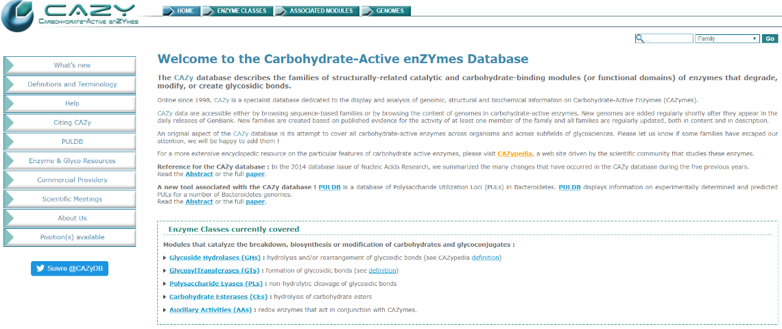
Step-2: Go to Glycoside hydrolases web-page
Step-1: Visit CAZy web-database
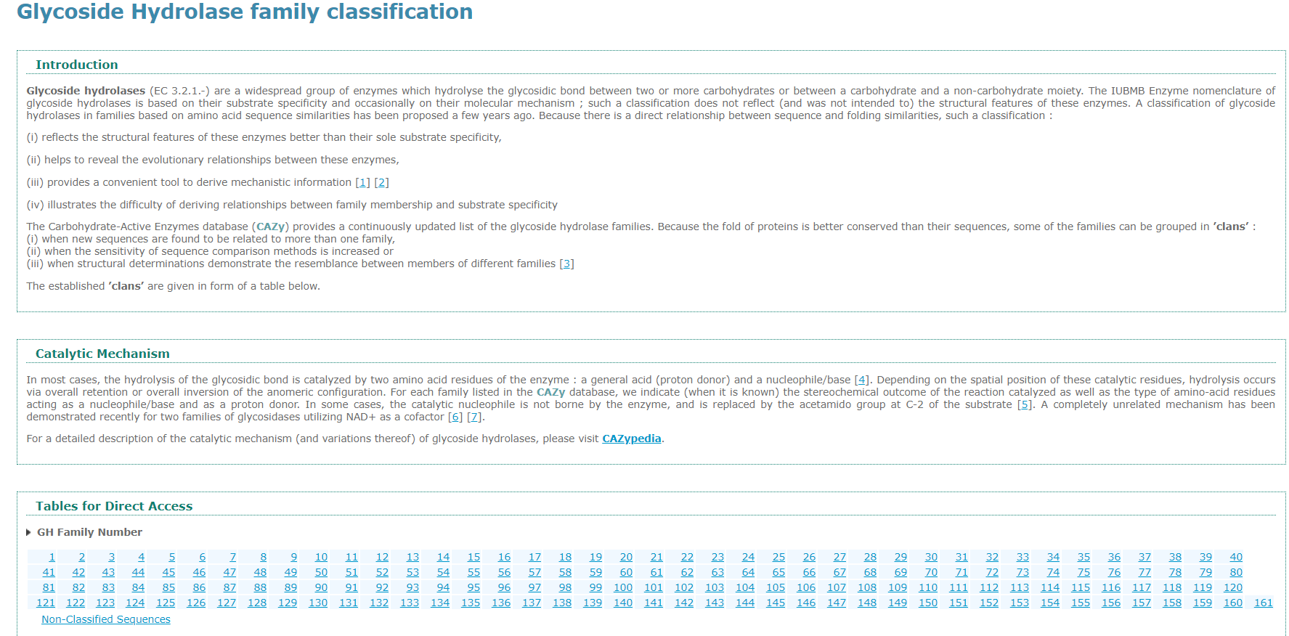
Step-3: A continuous loop of search in all 161 classes of GH pages, until we find the “Alpha-L-arabinofuranosidase” containing GH family

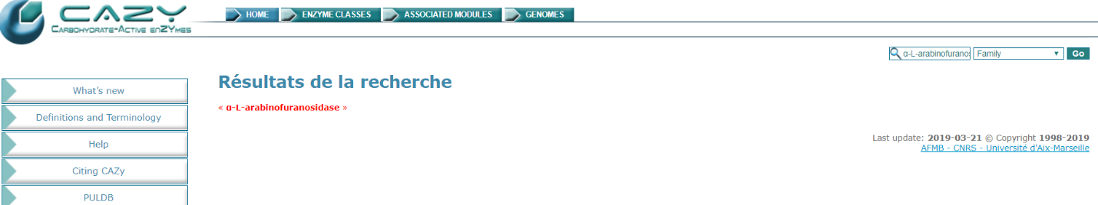
Step-4: Using the global search option of CAZy web-database
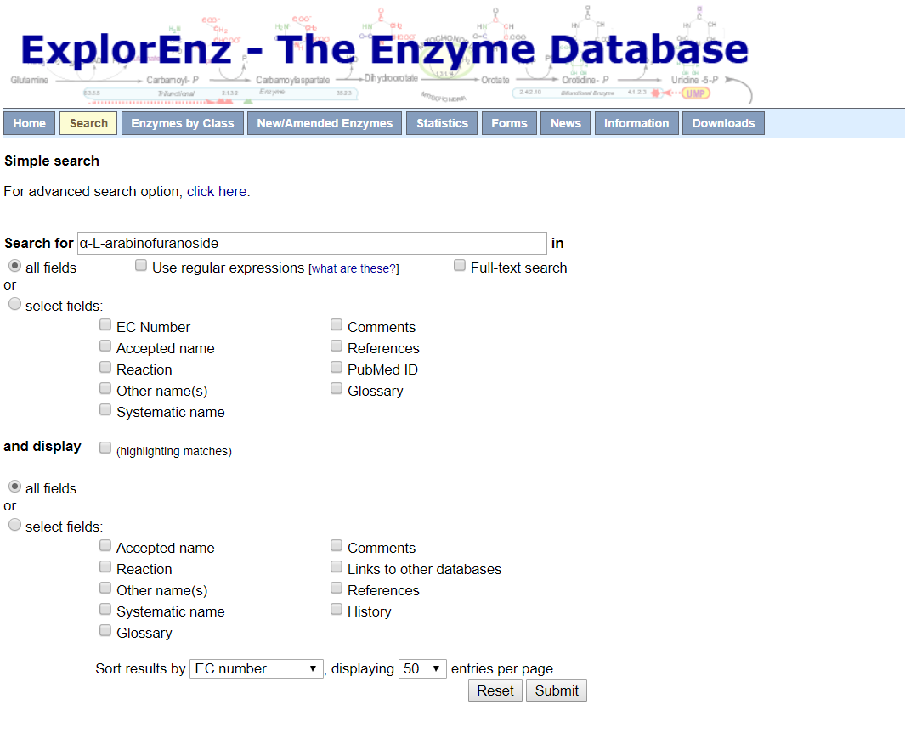
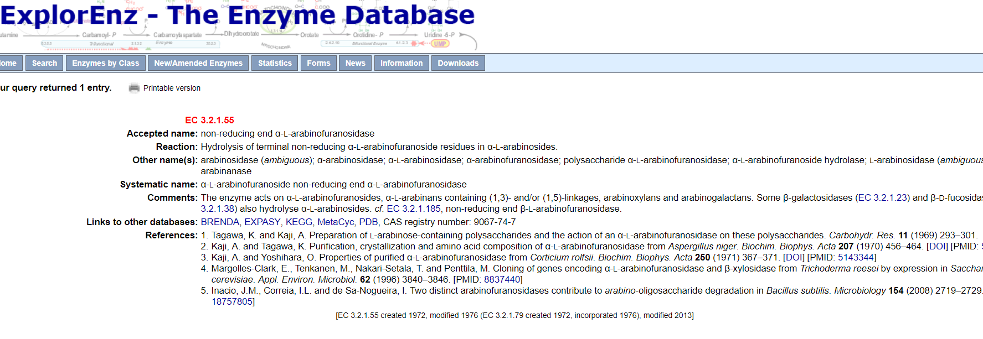
Step-1: Visit ExploreEnz database and search with the term “α-L-arabinofuranoside”
Step-2: Note the E.C, Number of the “α-L-arabinofuranoside”

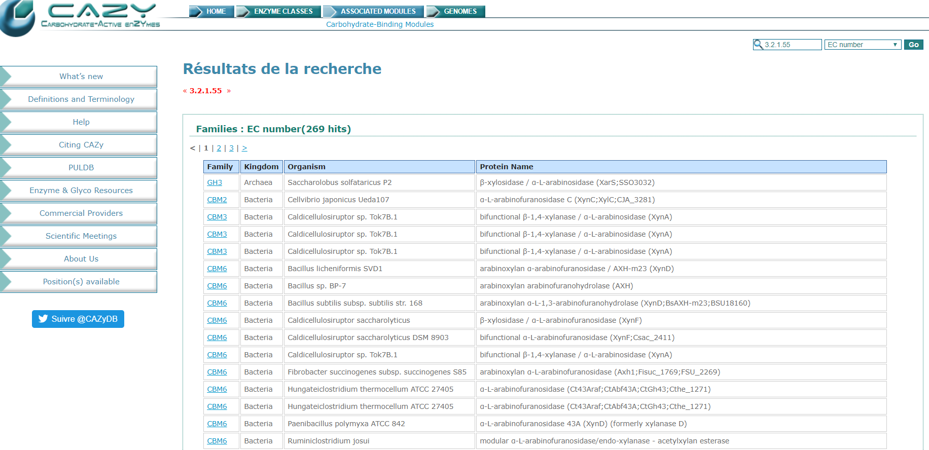
Step-3: Searching with the E.C, Number of the “α-L-arabinofuranoside” has resulted in a list of all the hits with the E.C. Number E.C3.2.1.55

Step-4: Manually skim through the records and note the classes listed and search.

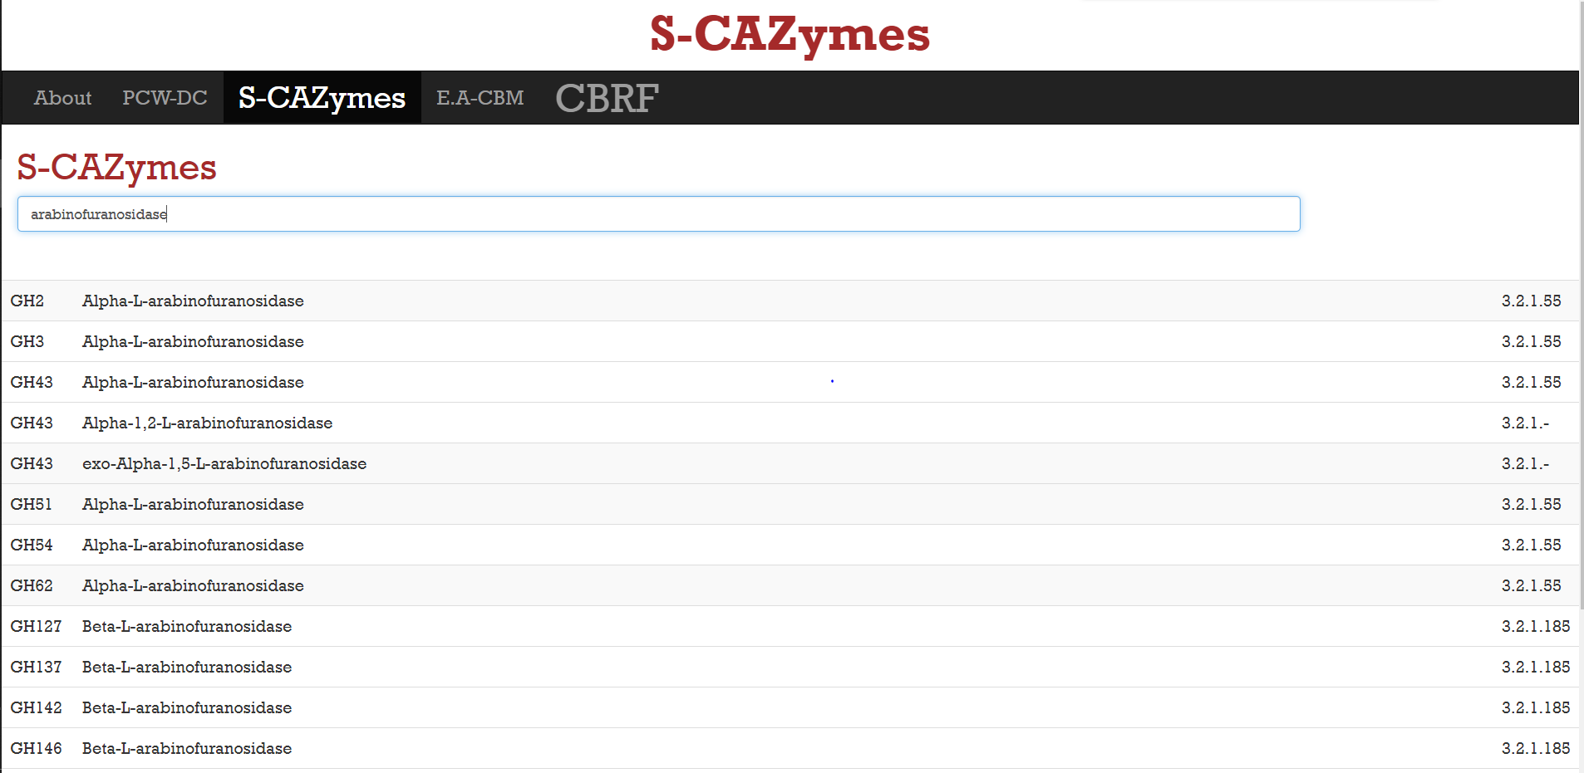
A one step search process for finding the distribution of “arabinofuranoside” in S-CAZymes resulted in GH classes.

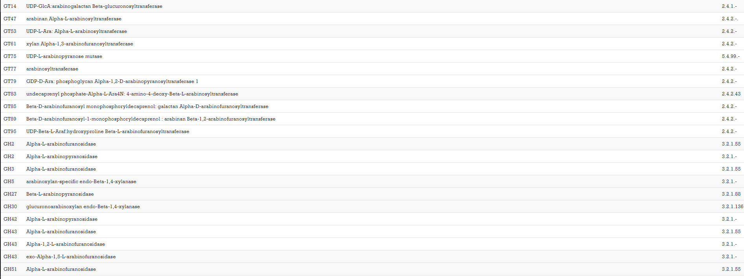
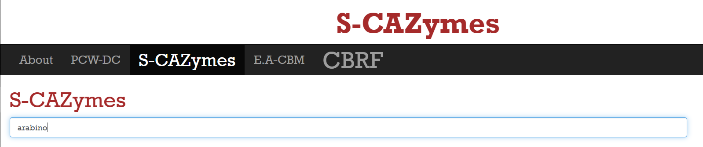
A one step search process for finding all the CAZymes involved in breakdown and synthesis of substrate can be found by searching with “Arabino”
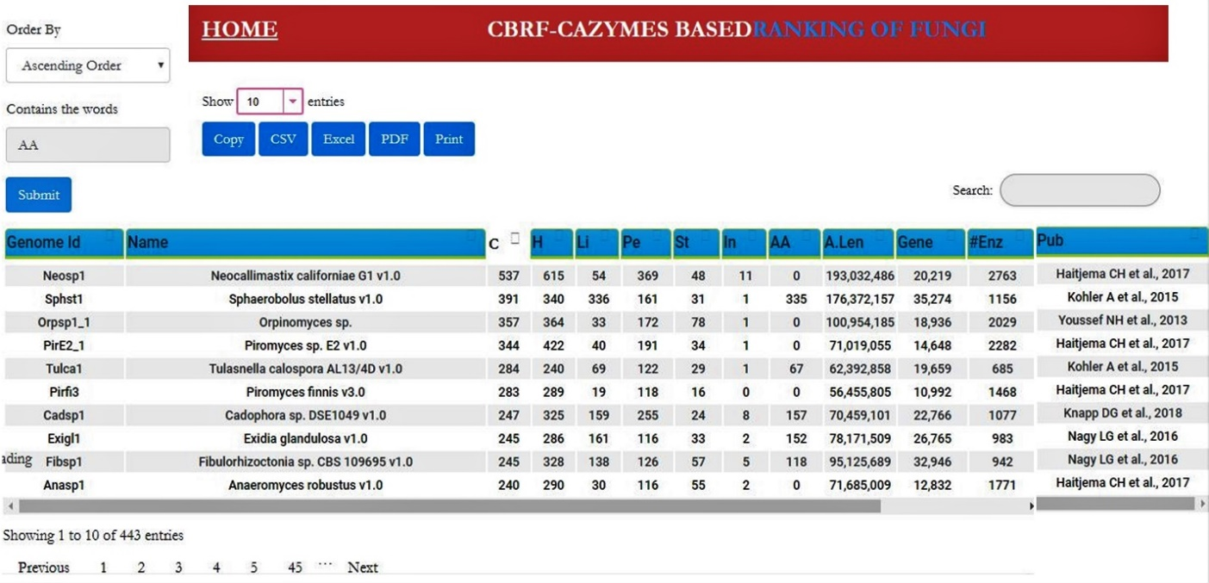
1
2
3
4
6
5
Pictorial Illustration of CBRF-CAZymes Based Ranking of Fungi Website

6
5
The importance for the biofuel and biorefining industries is significantly growing in the last decade. Several fungi were continuously being isolated and characterized around the world. Thus, we have specifically included the total fungal ability to degrade cellulose (C), Hemicellulose (H), Lignin (L), Pectin (P), Starch (S) and Inulin (In).
4
3
2
1

We have provided a “Search functionality” to quickly search for a specific fungus of user’s interest.

Lists the scientific names of all the top sorted fungi ex: in this window it only lists top 10 as we have selected only to show top 10 fungi.
Users can view the list of sorted fungi by selecting the number of number of fungi to be viewed.
The final sorted list of fungi can be exported in different file formats including: in .CSV, M.S. Excel, .PDF or print.
Sorting Functionality provides two options:
- Ascending order
- Descending order
Sorting is performed based on the selection of the specific enzyme class

