Additional Materials
Decolorization and Detoxification of Triphenylmethane Dyes by isolated endophytic fungus, Bjerkandera adusta SWUSI4 under non-nutritive conditions
Tiancong Gao ^{1,} , Dan Qin ^{1,} , Shihao Zuo^{1,} , Yajun Peng^{1,} , Jieru Xu^{1,} , Baohong Yu^{1,} , Hongchuan Song ² & Jinyan Dong ^{1,} *
¹ Chongqing Key Laboratory of Plant Resource Conservation and Germplasm Innovation, School of Life Sciences, Southwest University, Chongqing 400715, People's Republic of China
² School of Energy and Environment Science, Solar Energy Research Institute, Yunnan Normal University, Kunming 650092, People's Republic of China
Supporting Materials List:
Table S1 Decolourisation of CV, MV, MG and CB on agar plate by the fourteen isolated endophytic fungi after 14 days of cultivation
Fungal Isolates |  | TPM dyes （200mg/L）
 |  | CV | MV | MG | CB
SWUSI 1 |  | - | - | - | -
SWUSI 2 |  | + | + | - | -
SWUSI 3 |  | - | - | - | +
SWUSI 4 |  | ++ | ++ | ++ | ++
SWUSI 5 |  | - | - | - | -
SWUSI 6 |  | + | + | + | +
SWUSI 7 |  | - | - | - | -
SWUSI 8 |  | - | + | - | +
SWUSI 9 |  | + | + | + | +
SWUSI10 |  | - | - | - | -
SWUSI 11 |  | - | + | - | +
SWUSI12 |  | - | - | - | -
SWUSI 13 |  | + | + | + | +
SWUSI 14 |  | - | - | - | -
(-): no dye decolourisation; (+): Medium or low dye decolourisation; (++): High dye decolourisation
Fig. S1 Decolorization of SWUSI4 on a solid plate.
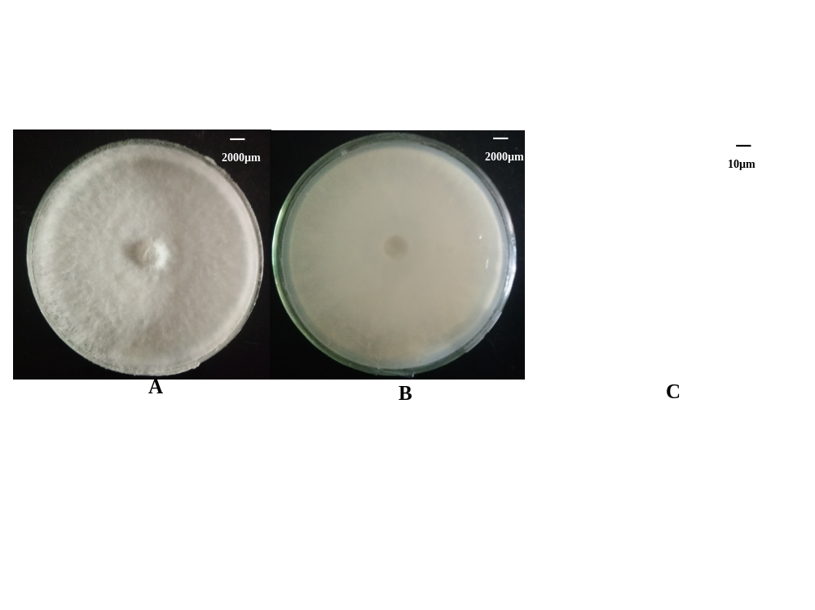
Fig. S2 Morphological characteristics and microscopic morphology of SWUSI4
A. Front view of SWUSI4 grown on PDA media
B. Back view of SWUSI4 grown on PDA media
C. Microscopic structures of SWUSI4

Fig. S3 Decolorization efficiency (DE%) of live and dead cells of SWUSI4 on A crystal violet (CV), B methyl violet (MV), C malachite green (MG) and D cotton blue (CB) throughout the 24h experimental period after the optimization.
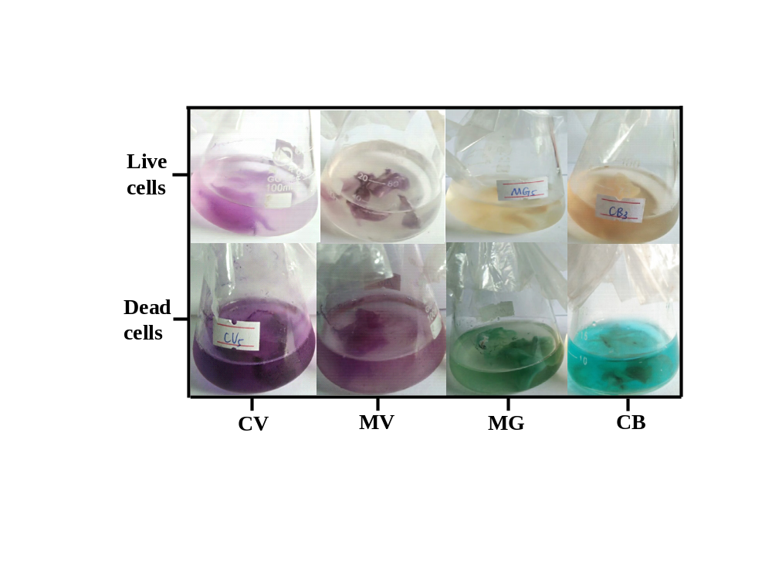
Fig. S4 Appearance of dye solution after decolorization

