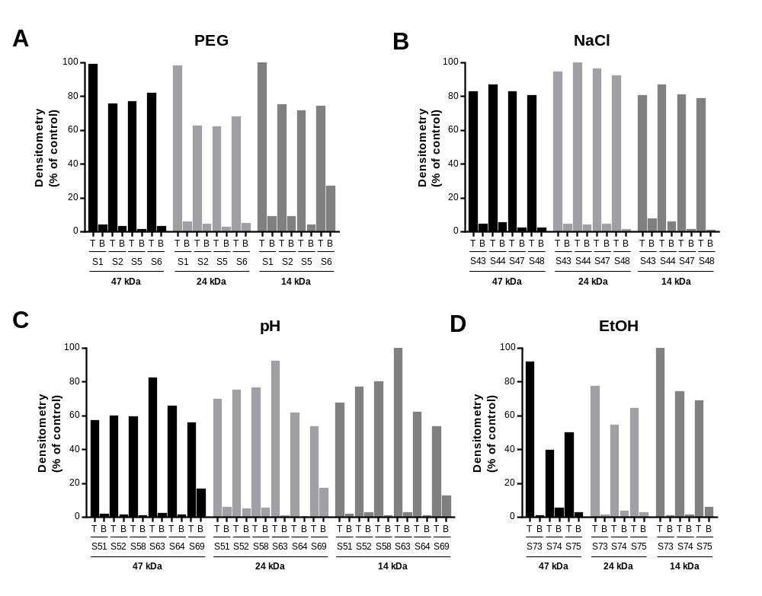
Figure S1. Densitometric analysis of MPs and PLA₂ bands from SDS-PAGE ATPS systems. A) densitometric analysis of the selected PEG-potassium phosphate systems, B) PEG-potassium phosphate systems at different NaCl concentrations, C) PEG-potassium phosphate systems at pH values and D) ethanol-salt systems. The 47 kDa band correspond to P-III MPs, 24 to P-I MPs and the 14 kDa to PLA₂.

