Additional materials
Selective biosynthesis of retinol in S. cerevisiae
Qiongyue Huª, Tanglei Zhangª, Hongwei Yu^{a *}, Lidan Ye^{a, b*}
ª Institute of Bioengineering, College of Chemical and Biological Engineering, Zhejiang University, Hangzhou 310027, China
^{b} Hangzhou Global Scientific and Technological Innovation Center, Zhejiang University, Hangzhou 311200, China

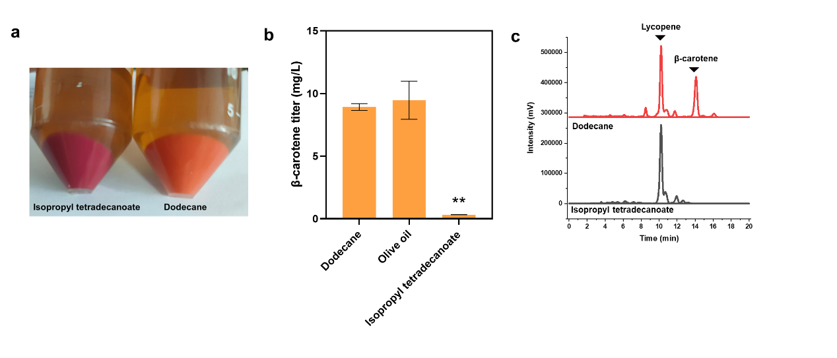
Additional Figure S1. Effect of isopropyl tetradecanoate as an extractant on the β-carotene formation in strain Y03. (a) Color change of strain Y03 in bi-phase fermentation systems with different organic solvents. (b) β-carotene accumulation of strain Y03 in bi-phase fermentation systems with different organic solvents. (c) HPLC results of strain Y03 cultured with dodecane and isopropyl tetradecanoate as the organic overlay respectively. Statistical significance of the different retinol levels in comparison with the dodecane culture was evaluated using Student’s t test (*, P < 0.05; **, P < 0.01).
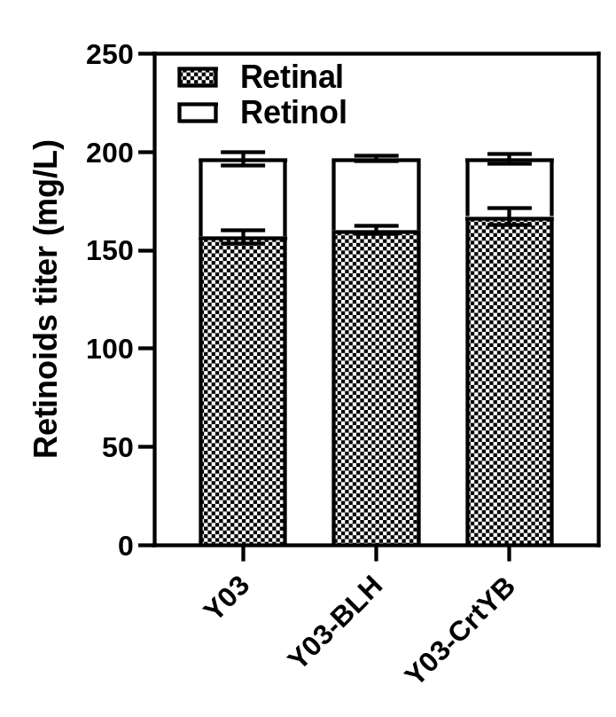
Additional Figure S2 Effect of increasing BLH and CrtYB copy number on retinoids production.

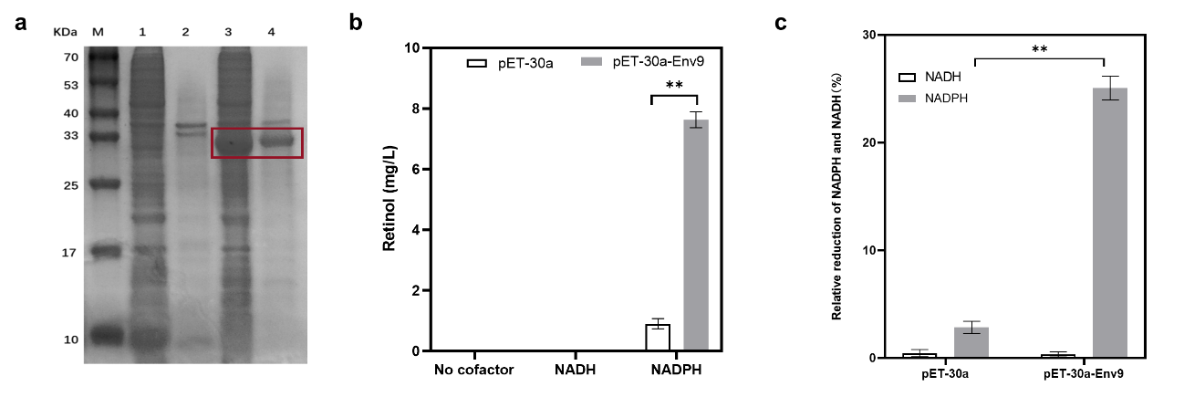
Additional Figure S3 In vitro activity of Env9 towards retinoids. (a) SDS-PAGE of Env9. M, protein marker. Lanes 1, 2, 3, 4 represent the supernatant and precipitate after disruption of E. coli cells harboring pET-30a and pET30a-Env9, respectively. (b) Retinol production by cell extracts of E. coli BL21(DE3) expressing pET30a or pET30a-Env9 in the presence of NADH or NADPH. (c) Relative reduction of NADH or NADPH at the end of reaction with the cell extract of E. coli harboring pET30a-Env9. The reaction system (1 mL) consisted of 400 μM NADPH or NADH, 120 μL crude enzyme, and 90 mg/L retinal in 100 mM sodium phosphate buffer solution (pH 7.0). The reaction was conducted at 30 ºC for 120 min. Statistical significance was evaluated using Student’s t test (*, P < 0.05; **, P < 0.01).
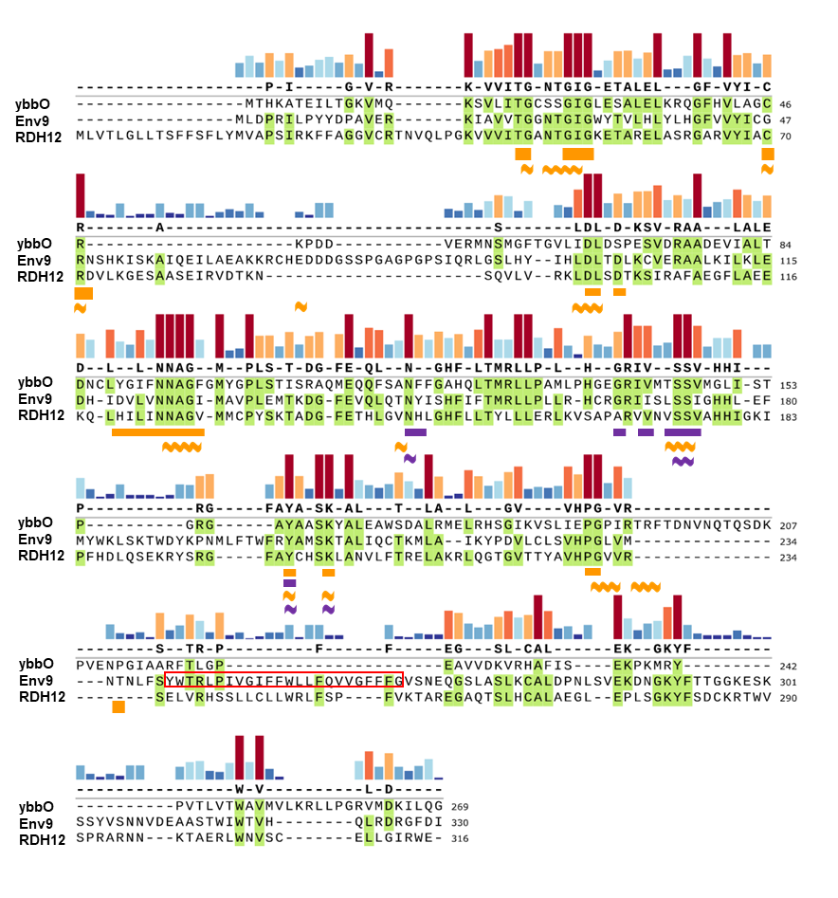
Additional Figure S4 Protein sequence alignment of ybbO, Env9 and RDH12. The similarity of the aligned residues is indicated by colored bars (with warm colors corresponding to high similarity and cool colors to low similarity, and the column height representing the degree of similarity). The thick orange lines below the sequences represent the reported coenzyme binding sites of Env9, and the thick purple lines represent its active center, and the predicted lipid droplets binding region (aa241-246) is shown in red box (Siddiqah et al., 2017). As for ybbO, the orange thick wavy lines represent the predicted coenzyme binding sites, and the purple thick wavy lines represent the active site residues.
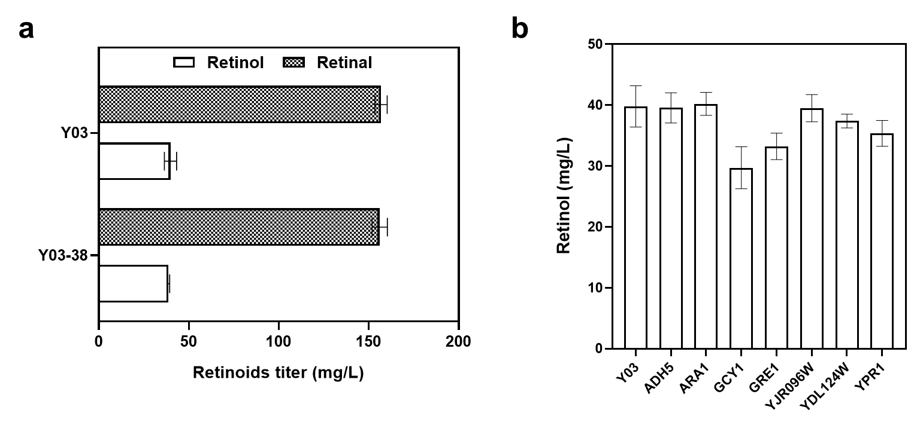
Additional Figure S5 Effects of ENV9 knockout (a) and overexpression of genes homologous to AKR and AKR1B10 (b) on retinol synthesis in Y03.

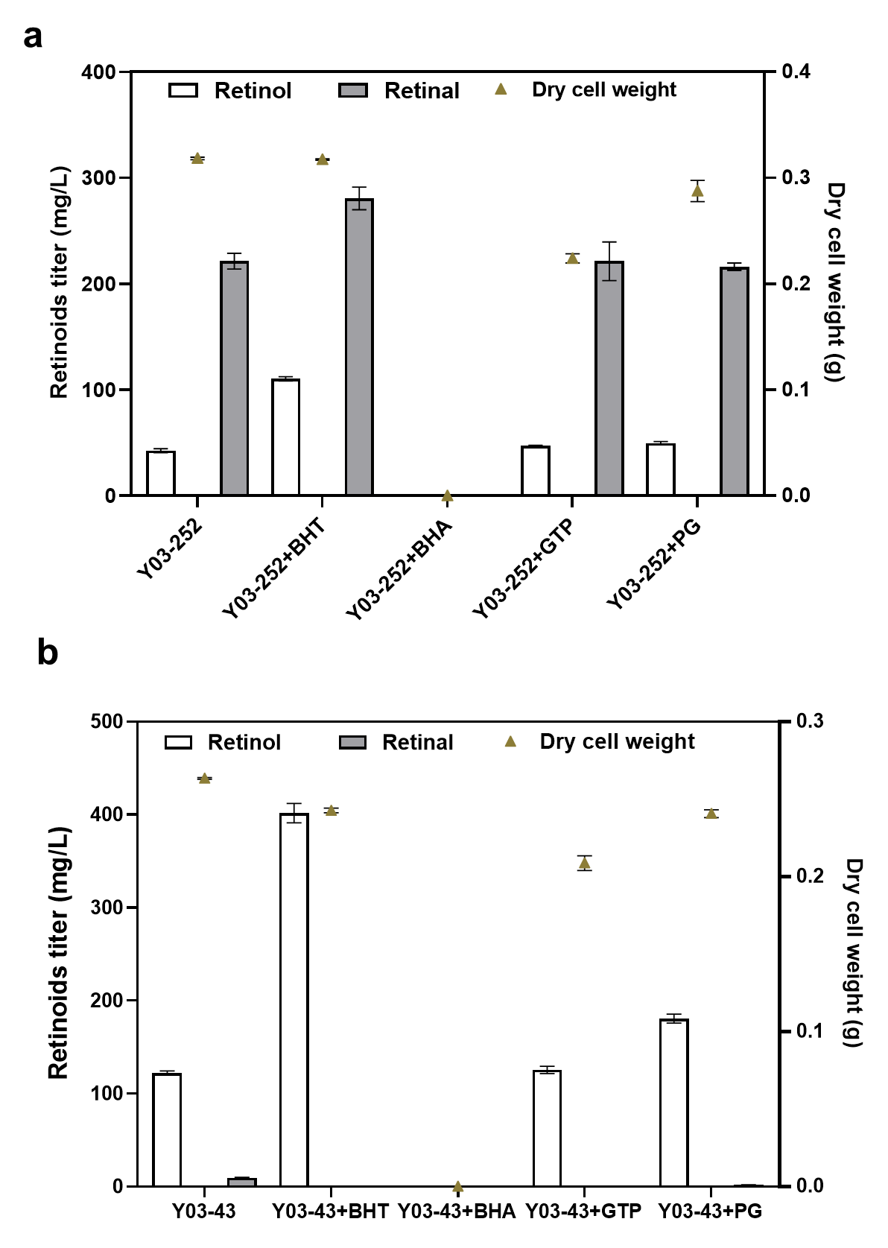
Additional Figure S6 Effects of different antioxidants on retinoids production by strains Y03-252 and Y03-43. The antioxidants and their concentrations were 1% BHT, 0.1% BHA, 0.1% GTP and 0.01% PG, respectively.

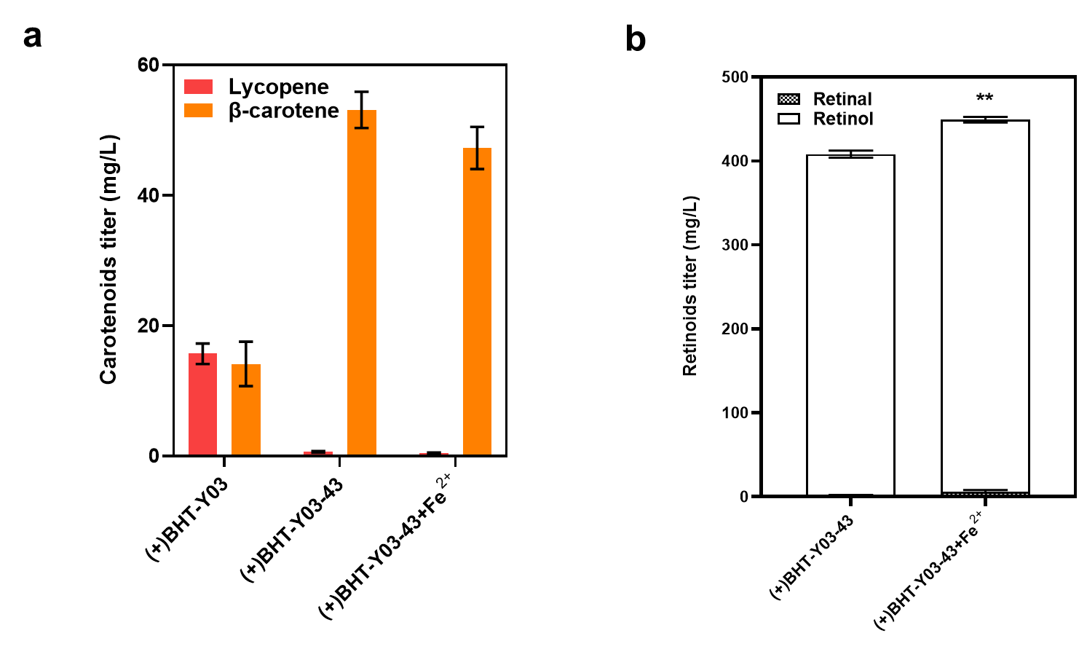
Additional Figure S7 Effects of additional Fe²⁺ supplementation after 36 hours of incubation on carotenoids accumulation (a) and retinoids production (b) of Y03-43. Statistical significance was evaluated using Student’s t test (*, P < 0.05; **, P < 0.01).

Additional Table S1. Plasmids and primers used in this study
Plasmid name | Genotype/ Description | Reference
pUMRI-LPP1 | loxp-KanMX-URA3-pbr322ori-loxp,  T_{ADH1}-MCS1-P_{GAL10}-P_{GAL1}-MCS2-T_{CYC1},  LPP1 homologous arm | (Shen et al., 2020)
pUMRI-DPP1 | loxp-KanMX-URA3-pbr322ori-loxp,  T_{PGK1}-MCS1-P_{GAL2}-P_{GAL7}-MCS2-T_{TPS1},  DPP1 homologous arm | This study
pUMRI-ROX1 | loxp-KanMX-URA3-pbr322ori-loxp,  T_{ADH1}-MCS1-P_{GAL10}-P_{GAL1}-MCS2-T_{CYC1},  ROX1 homologous arm | This study
pUMRI-MOT3 | loxp-KanMX-URA3-pbr322ori-loxp,  T_{ADH1}-MCS1-P_{GAL10}-P_{GAL1}-MCS2-T_{CYC1},  MOT3 homologous arm | This study
pUMRI-YPL062W | loxp-KanMX-URA3-pbr322ori-loxp,  T_{ADH1}-MCS1-P_{GAL10}-P_{GAL1}-MCS2-T_{CYC1},  YPL062W homologous arm | This study
pUMRI-ENV9 | loxp-KanMX-URA3-pbr322ori-loxp,  T_{ADH1}-MCS1-P_{GAL10}-P_{GAL1}-MCS2-T_{CYC1},  ENV9 homologous arm | This study
pUMRI-ERG9 | loxp-KanMX-URA3-pbr322ori-loxp,  P_{HXT1}-P_{TEF1}-MCS2-T_{CYC1},  ERG9 homologous arm | This study
pUMRI-LPP1-BLH | loxp-KanMX-URA3-pbr322ori-loxp,  T_{ADH1}-MCS1-P_{GAL10}-P_{GAL1}-BLH-T_{CYC1},  LPP1 homologous arm | This study
pUMRI-DPP1-CrtE03M | loxp-KanMX-URA3-pbr322ori-loxp,  T_{PGK1}-MCS1-P_{GAL2}-P_{GAL7}-CrtE03M-T_{TPS1},  DPP1 homologous arm | This study
pUMRI-DPP1-YMR315W | loxp-KanMX-URA3-pbr322ori-loxp,  T_{PGK1}-YMR315W-P_{GAL2}-P_{GAL7}-MCS2-T_{TPS1},  DPP1 homologous arm | This study
pUMRI-DPP1-YMR315W-tPOS5 | loxp-KanMX-URA3-pbr322ori-loxp,  TPGK1-tPOS5-PGAL2-PGAL7-YMR315W-TTPS1,  DPP1 homologous arm | This study
pUMRI-DPP1-POS5 | loxp-KanMX-URA3-pbr322ori-loxp,  T_{PGK1}-POS5-P_{GAL2}-P_{GAL7}-MCS2-T_{TPS1},  DPP1 homologous arm | This study
pUMRI-DPP1-tPOS5 | loxp-KanMX-URA3-pbr322ori-loxp,  T_{PGK1}-tPOS5-P_{GAL2}-P_{GAL7}-MCS2-T_{TPS1},  DPP1 homologous arm | This study
pUMRI-DPP1-ZWF1 | loxp-KanMX-URA3-pbr322ori-loxp,  T_{PGK1}-ZWF1-P_{GAL2}-P_{GAL7}-MCS2-T_{TPS1},  DPP1 homologous arm | This study
pUMRI-DPP1-ZWF1-tPOS5 | loxp-KanMX-URA3-pbr322ori-loxp,  T_{PGK1}-tPOS5-P_{GAL2}-P_{GAL7}-ZWF1-T_{TPS1},  DPP1 homologous arm | This study
pUMRI-DPP1-STB5 | loxp-KanMX-URA3-pbr322ori-loxp,  T_{PGK1}-STB5-P_{GAL2}-P_{GAL7}-MCS2-T_{TPS1},  DPP1 homologous arm | This study
pUMRI-DPP1-AKR | loxp-KanMX-URA3-pbr322ori-loxp,  T_{PGK1}-MCS1-P_{GAL2}-P_{GAL7}-AKR-T_{TPS1}, DPP1 homologous arm | This study
pUMRI-DPP1-AKR1B10 | loxp-KanMX-URA3-pbr322ori-loxp,  T_{PGK1}-MCS1-P_{GAL2}-P_{GAL7}-AKR1B10-T_{TPS1},  DPP1 homologous arm | This study
pUMRI-DPP1-ybbO | loxp-KanMX-URA3-pbr322ori-loxp,  T_{PGK1}-MCS1-P_{GAL2}-P_{GAL7}- ybbO -T_{TPS1},  DPP1 homologous arm | This study
pUMRI-DPP1-ybbO-ybbO | loxp-KanMX-URA3-pbr322ori-loxp,  T_{PGK1}-ybbO-P_{GAL2}-P_{GAL7}- ybbO -T_{TPS1},  DPP1 homologous arm | This study
pUMRI-DPP1-SPS19 | loxp-KanMX-URA3-pbr322ori-loxp,  T_{PGK1}-MCS1-P_{GAL2}-P_{GAL7}-SPS19-T_{TPS1},  DPP1 homologous arm | This study
pUMRI-DPP1-YMR226C | loxp-KanMX-URA3-pbr322ori-loxp,  T_{PGK1}-MCS1-P_{GAL2}-P_{GAL7}-YMR226C-T_{TPS1},  DPP1 homologous arm | This study
pUMRI-DPP1-IFA38 | loxp-KanMX-URA3-pbr322ori-loxp,  T_{PGK1}-MCS1-P_{GAL2}-P_{GAL7}-IFA38-T_{TPS1},  DPP1 homologous arm | This study
pUMRI-DPP1-ENV9 | loxp-KanMX-URA3-pbr322ori-loxp,  T_{PGK1}-MCS1-P_{GAL2}-P_{GAL7}-ENV9-T_{TPS1},  DPP1 homologous arm | This study
pUMRI-DPP1-ENV9-ENV9 | loxp-KanMX-URA3-pbr322ori-loxp,  T_{PGK1}-MCS1-P_{GAL2}-P_{GAL7}-ENV9-T_{TPS1},  DPP1 homologous arm | This study
pUMRI-DPP1-ENV9-ybbO | loxp-KanMX-URA3-pbr322ori-loxp,  T_{PGK1}-ybbO-P_{GAL2}-P_{GAL7}-ENV9-T_{TPS1},  DPP1 homologous arm | This study
pUMRI-MOT3-tPOS5 | loxp-KanMX-URA3-pbr322ori-loxp,  T_{ADH1}-tPOS5-P_{GAL10}-P_{GAL1}-MCS2-T_{CYC1},  MOT3 homologous arm | This study
pUMRI-MOT3-tPOS5-CrtE03M | loxp-KanMX-URA3-pbr322ori-loxp,  T_{ADH1}-tPOS5-P_{GAL10}-P_{GAL1}-CrtE03M-T_{CYC1},  MOT3 homologous arm | This study
pUMRI-MOT3-tPOS5-ENV9 | loxp-KanMX-URA3-pbr322ori-loxp,  T_{ADH1}-tPOS5-P_{GAL10}-P_{GAL1}-ENV9-T_{CYC1},  MOT3 homologous arm | This study
pUMRI-DPP1-ybbO-CrtE03M | loxp-KanMX-URA3-pbr322ori-loxp,  T_{PGK1}-CrtE03M-P_{GAL2}-P_{GAL7}-ybbO-T_{TPS1},  DPP1 homologous arm | This study
pET-30a | Kn^{R}, pBR322 ori, T7-promoter | Laboratory stock
pET-30a-Env9 | Kn^{R}, P_{T7}-ENV9-T_{T7} | This study
Primer name | Sequence (5’-3’) | Description
BLH-BamHI-F | CGCGGATCCATGGGTTTAATGTTAATTGATTGG | For amplification of genes
BLH-XohI-R | CCGCTCGAGTTAATTTTTAATTTTAATCCTTGAAGAATGTGGT | For amplification of genes
crtE03M-BamHI-F | AGGGGATCCATGGATTACGCGAACATCCTCAC | For amplification of genes
crtE03M-kpnI-R | CGTGGTACCTCACAGAGGGATATCGGCTAGCTT | For amplification of genes
crtE03M-EcoRI-F | CCGGAATTCATGGATTACGCGAACATCCTCACAGCAATTCCAC | For amplification of genes
crtE03M-SacI-R | CGCGAGCTCTCACAGAGGGATATCGGCTAGCTTTTTCAGGAT | For amplification of genes
POS5-NotI-F | ATTTGCGGCCGCATGTTTGTCAGGGTTAAATTGAATAAACCAG | For amplification of genes
POS5-SacI-R | CGCGAGCTCTTAATCATTATCAGTCTGTCTCTTGGTCAGCCTAA | For amplification of genes
STB5-NotI-F | ATTTGCGGCCGCATGGATGGTCCCAATTTTGCACATCAAGGC | For amplification of genes
STB5-SacI-R | CGCGAGCTCTCATACAAGTTTATCAACCCAAGAGACGTCAACA | For amplification of genes
YMR315W-NotI-F | ATTTGCGGCCGCATGTCCCCATTGAACGTCGGTATAGTTGGTA | For amplification of genes
YMR315W-SacI-R | CGCGAGCTCTCATGGCTGCTCAATTTTAACGTAGTCACCATTC | For amplification of genes
YMR315W-BamHI-F | CGCGGATCCATGTCCCCATTGAACGTCGGTATAGTTGGTA | For amplification of genes
YMR315W-XohI-R | CCGCTCGAGTCATGGCTGCTCAATTTTAACGTAGTCACCATTC | For amplification of genes
ZWF1-NotI-F | ATTTGCGGCCGCATGAGTGAAGGCCCCGTCAAATTCGAAAAA | For amplification of genes
ZWF1-SacI-R | CGCGAGCTCCTAATTATCCTTCGTATCTTCTGGCTTAGTCACGG | For amplification of genes
ZWF1-BamHI-F | CGCGGATCCATGAGTGAAGGCCCCGTCAAATTCGAAAAAAAT | For amplification of genes
ZWF1-XohI-R | CCGCTCGAGCTAATTATCCTTCGTATCTTCTGGCTTAGTCACGGG | For amplification of genes
tPOS5-NotI-F | ATTGCGGCCGCATGAGTACGTTGGATTCACATTCCCTAAAGTT | For amplification of genes
sthA-NotI-F | ATTGCGGCCGCATGCCACATTCCTACGATTACGATGCC | For amplification of genes
sthA-SacI-R | ACCGAGCTCTTAAAACAGGCGGTTTAAACCGTTTAA | For amplification of genes
AKR1B10-BamHI-F | CGCGGATCCATGGCAACTTTTGTTGAATTATCTACTAAAGCTA | For amplification of genes
AKR1B10-XhoI-R | CCGCTCGAGTTAATATTCTGCATCAAATGGATAATCTTCTAAAT | For amplification of genes
AKR-BamHI-F | CGCGGATCCATGAGGAAATTAACTTTTAGGAA | For amplification of genes
AKR-XhoI-R | CCGCTCGAGTTATTCACCCCACAAACCA | For amplification of genes
ybbO-BamHI-F | CGCGGATCCATGACTCATAAAGCAACGGAGATCCTGACAGGT | For amplification of genes
ybbO-XhoI-R | CCGCTCGAGTCACCCCTGCAATATTTTGTCCATCACGCGCCC | For amplification of genes
ybbO-EcoRI-F | CGCGAATTCATGACTCATAAAGCAACGGAGATCCTGACAGGTAAAGTTAT | For amplification of genes
ybbO-SacI-R | CCGGAGCTCTCACCCCTGCAATATTTTGTCCATCACGCGCCC | For amplification of genes
YMR226C-BamHI-F | CGCGGATCCATGTCCCAAGGTAGAAAAGCTGCAGAAAGATTG | For amplification of genes
YMR226C-SalI-R | CCGGTCGACTTATCCACGGAAGATATGATGAGGTGACGCTTG | For amplification of genes
ENV9-BamHI-F | CGCGGATCCATGTTAGACCCACGAATATTGCCATACTACGACC | For amplification of genes
ENV9-XhoI-R | CCGCTCGAGTTATATATCGAAACCACGGTCTCTTAGTTGATGA | For amplification of genes
ENV9-EcoRI-F | CGCGAATTCATGTTAGACCCACGAATATTGCCATACTACGACCCG | For amplification of genes
ENV9-SacI-R | CGGGAGCTCTTATATATCGAAACCACGGTCTCTTAGTTGATGA | For amplification of genes
IFA38-BamHI-F | CGCGGATCCATGACTTTTATGCAACAGCTTCAAGAGGCTGGG | For amplification of genes
IFA38-SalI-R | CCGGTCGACCTATTCCTTTTTAACCTGTCTTGCGGCTTTTT | For amplification of genes
SPS19-BamHI-F | CGCGGATCCATGAATACAGCAAACACTTTGGACGGCAAATT | For amplification of genes
SPS19-SalI-R | CCGGTCGACTTATAATTTAGATGTCATACTCTTTATTAAGGCTT | For amplification of genes
ADH5-BamHI-F | CGCGGATCCATGTCCGCCGCTACTGTTGGTAAACCTATT | For amplification of genes
ADH5-XhoI-R | CCGCTCGAGCTATTTTATTTCATCAGACTTCAAGACGGTT | For amplification of genes
ARA1-BamHI-F | CGCGGATCCATGTCTTCTTCAGTAGCCTCAACCGAAAACATAGTCG
ARA1-KpnI-R | CGGGGTACCTTAATACTTTAAATTGTCCAAGTTTGGTCCGTTACCAG
GCY1-BamHI-F | CGCGGATCCATGCCTGCTACTTTACATGATTCTACGAAAATCCTTTC
GCY1-XhoI-R | CCGCTCGAGTTACTTGAATACTTCGAAAGGAGACCAATTTGGATGT
YPR1-SalI-F | GCCGTCGACATGCCTGCTACGTTAAAGAATTCTTCTGCTACATTAAA
YPR1-XhoI-R | CCGCTCGAGTCATTGGAAAATTGGGAAGGATCCCCACTTCATATCA
GRE3-BamHI-F | CGCGGATCCATGTCTTCACTGGTTACTCTTAATAACGGTCTGAAAAT
GRE3-XhoI-R | CCGCTCGAGTCAGGCAAAAGTGGGGAATTTACCATCCAACCAGGT
YJR096W-BamHI-F | CGCGGATCCATGGTTCCTAAGTTTTACAAACTTTCAAACGGCTTCA
YJR096W-XhoI-R | CCGCTCGAGTTATGGCGCGTCTGTGCATTCCCAATCGGTAGGCTCA
YDL124W-BamHI-F | CGCGGATCCATGTCATTTCACCAACAGTTCTTTACCTTGAATAATGG
YDL124W-XhoI-R | CCGCTCGAGTTATACTTTTTGAGCAGCGTAGTTGTATTTACCGTAC
MOT3HO-UP-F | CGTCTGGATTTACTAAACTTTGTCTCTCTTTTGATGTAAAGTTAA | For verifying plasmids construction and gene integration
MOT3HO-DR-R | GTTGTAATCAGTTCCGTACCATACATAAACTATATGTATATA | For verifying plasmids construction and gene integration
ENV9HO-UP-F | GTACATGGGTATATATAAACAAATCATTATGGTGCATGATG | For verifying plasmids construction and gene integration
ENV9HO-DR-R | CATTACGTCAATGCTGACTGAATCTATCAATTGAATAAA | For verifying plasmids construction and gene integration
DPP1HO-UP-F | CTTCATAAAGGGACAACACGGCTTATAGCATT | For verifying plasmids construction and gene integration
DPP1HO-DR-R | GAAATAACAAGCAGGCCCTTGCACGTCAAGATTA | For verifying plasmids construction and gene integration
LPP1-UP-F | TTCGTTGTTTACCTATTTTCCTGCCAATTCA | For verifying plasmids construction and gene integration
LPP1-DR-R | TCCTTCTTATACGCCTCAAGACGACAGA | For verifying plasmids construction and gene integration
ROX1-UP-F | CCAGTTTTAATGTTTCTTCTCATTGCTTTC | For verifying plasmids construction and gene integration
ROX1-DR-2 | ACTTTTATTTGCTGTTATTTTACATATTTTTCAATTGTTC | For verifying plasmids construction and gene integration
HOR2 | ACTACGGCTACACTAGAAGGACAGTATTTG | For verifying plasmids construction and gene integration
GAL1-F | TTATTTCTGGGGTAATTAATCAGCGAAGC | For verifying plasmids construction and gene integration
GAL7-F | GGGCATTATTATGCAGAGCATCAACATGATAAAA | For verifying plasmids construction and gene integration
GAL10-F | TGATTATTAAACTTCTTTGCGTCCATCCAA | For verifying plasmids construction and gene integration
GAL2-F | TTTGGTGTTGTGAATTGCTCTTCATTATGCACCTT | For verifying plasmids construction and gene integration
HXT1-F | GATTTTACGTATATCAACTAGTTGACGATTATG | For verifying plasmids construction and gene integration
qtHMG1-F | TTCAAATTTTTCTTTTTTTTCTGTACAGACGCGTG | For verifying plasmids construction and gene integration
TPS1-F | CCCTCTTTTTCTCTCTCTTTCTTTCTCTCC | For verifying plasmids construction and gene integration
T7-F | TAATACGACTCACTATAGGGGAATTGTGAGCGGATAACAAT | For verifying plasmids construction and gene integration
HIS3-F | CGTTTTAAGAGCTTGGTGAGC | For complementation of auxotroph markers
HIS3-R | CGCCTCGTTCAGAATGACA | For complementation of auxotroph markers
URA3-F | GAAGAATTAATTGAGGGCGGATTACTACCGTTG | For complementation of auxotroph markers
URA3-R | AGATACATAATTAGATATATATACGCCAGT | For complementation of auxotroph markers
MET15-F | AAGTTCTCGTCGAATGCTAGGTC | For complementation of auxotroph markers
MET15-R | GGTGTTGACACCTTCTCCGC | For complementation of auxotroph markers

Additional references
Shen, B., Zhou, P., Jiao, X., et al., 2020. Fermentative production of Vitamin E tocotrienols in Saccharomyces cerevisiae under cold-shock-triggered temperature control. Nature Communications. 11, 5155-5169.
Siddiqah, I. M., Manandhar, S. P., Cocca, S. M., et al., 2017. Yeast ENV9 encodes a conserved lipid droplet (LD) short-chain dehydrogenase involved in LD morphology. Current Genetics. 63, 1053-1072.

