Additional file 1

Light-driven progesterone production by InP-(M. neoaurum) biohybrid system

Kun Liu, Feng-Qing Wang ⃰, Ke Liu, Yunqiu Zhao, Bei Gao, Xinyi Tao, and Dongzhi Wei ⃰

⃰ Corresponding authors,
E-mail: fqwang@ecust.edu.cn (Feng-Qing Wang),
dzhwei@ecust.edu.cn (Dongzhi Wei).
State Key Laboratory of Bioreactor Engineering, Newworld Institute of Biotechnology, East China University of Science and Technology, 130 Meilong Road, Shanghai, 200237, China.

Table S1

Table S1 The key plasmids and strains used in this paper.
Names | Descriptions
Plasmids | -
pMV261 | Shuttle vector of mycobacterium and E. coli, Promoter hsp60, Kan^{R}
pMV261-CYP11A1 | pMV261 carrying gene cyp11a1 under the hsp60 promoter, Kan^{R}
pMV261-CYP11A1-NT | pMV261 carrying gene cyp11a1-nt, N-terminal truncated 38 amino acids
pMV261-mCYP11A1 | pMV261 carrying gene mcyp11a1, N-terminal truncated 38 amino acids, deleted F-G loop, and K193E
pMV261-mCYP11A1-ADR-ADX | pMV261 carrying gene mcyp11a1-adr-adx via tandem expression
pMV261-mCYP11A1-pADR-ADX | pMV261 carrying gene mcyp11a1-padr-adx via tandem expression, the padr is from porcine
pMV261-mCYP11A1-ARH1-ADX | pMV261 carrying gene mcyp11a1-arh1-adx via tandem expression, arh1, adrenodoxin reductase-related homolog, is an essential yeast protein in mitochondrial inner membrane
pMV261-mCYP11A1-L-ADR-ADX | pMV261 carrying gene mcyp11a1-l-adr-adx via tandem expression, L:linker (GGGGSGGGGS)
pMV306-ARH1 | pMV306 carrying gene arh1 under the hsp60 promoter, Hyg^{R}
pMV306-G6PDH | pMV306 carrying gene g6pdh under the hsp60 promoter, Hyg^{R}
pMV261-mCYP11A1-GFP | pMV261 carrying gene mcyp11a1-gfp, these two genes were ligated directly into fusion protein
Strains | -
DH5α | E. coli cloning host
M. neoaurum ATCC 25795 | M. neoaurum type strain
MNR | KshA1, hsd4A, FadA5，kstD1，kstD2 and kstD3 deleted in M. neoaurum ATCC 25795
MNR-01 | MNR with plasmid pMV261
MNR-02 | MNR with plasmid pMV261-CYP11A1
MNR-03 | MNR with plasmid pMV261-mCYP11A1
MNR-04 | MNR with plasmid pMV261-mCYP11A1-ADR-ADX

Continued Table S1
MNR-05 | MNR with plasmid pMV261-mCYP11A1-pADR-ADX
MNR-06 | MNR with plasmid pMV261-mCYP11A1-ARH1-ADX
MNR-07 | MNR with plasmid pMV261-mCYP11A1-L-ADR-ADX
MNR-08 | MNR with plasmid pMV261-mCYP11A1-L-ADR-ADX, and plasmid pMV306-ARH1 (The expression cassette of the ARH1 gene was integrated into the corresponding attB sites of MNR genome.)
MNR-09 | MNR with plasmid pMV261-CYP11A1-GFP
MNR-10 | MNR with plasmid pMV261-mCYP11A1-GFP
MNR-11 | MNR with plasmid pMV261-mCYP11A1-L-ADR-ADX, and plasmid pMV306-G6PDH (The expression cassette of the G6PDH gene was integrated into the corresponding attB sites of MNR genome.)
MNR-InP | MNR-08 and InP nanoparticles were assembled into biohybrids
mnr-InP | MNR and InP nanoparticles were assembled into biohybrids
Tips: Fonts underlined indicate a fusion protein.

Table S2

Table S2 Main oligonucleotides used in this study.
Name（Primers） | DNA sequence （sequence 5` - 3`）
CYP11A1-UP | GGAATCACTTCGCAATGGCCAAGATGCTGGCCCGCGGCCTGCCG
CYP11A1-DOWN | ACGCTAGTTAACTACGTCGACGGCCTGCGGCGGGTCCTGGTT
Sequencing-UP | GGTGGTTGTGGTGATGTACGTG
Sequencing-DOWN | CTTGTGCAATGTAACATCAGAG
CYP11A1-NT-UP | AGGAATCACTTCGCAATGGCCAACTCGACCAAGACCCCGCG
CYP11A1-NT-DOWN | ACGCTAGTTAACTACGTCGACGGCCTGCGGCGGGTC
Infusion1-F | CCGCCGCAGGCCTGAGGAGGAAATGGCCCCGCGCTGCTG
Infusion1-R | GGGCCATTTCCTCCTCAGGCCTGCGGCGGGTCCTGGTTG
F-G loop-UP | GCGACATCAAGGAGATGCTGGAGGAGACCGTG
193E-DOWN | TCTCCTCCAGCATCTCCTTGATGTCGCCCACGAACTCG
F-ADX-F | ATGCTGGAGGAGACCGTGAACCCGG
Infusion2-R | GGGCCATTTCCTCCTCAGGCCTGCGGCGGGTCCTGGTTG
Infusion2-F | CCGCCGCAGGCCTGAGGAGGAAATGGCCCCGCGCTGCTG
Infusion3-F | ACCCGCCGCAGGCCTGAGGAGGAAATGTCGTTCGTGCAG
Infusion3-R | ACGAACGACATTTCCTCCTCAGGCCTGCGGCGGGTCCTGG
Infusion4-F | GGAGGGCATCTGAGGAGGAAATGGCCGCGCGCCT
Infusion4-R | GCCATTTCCTCCTCAGATGCCCTCCACGCCGGACCACA
ADX-DOWN | GCTAGTTAACTACGTCGACTCACTCGATCTTCGACGAGTTCATG
linker-ADR-UP | CCGCCGCAGGCCGGCGGCGGCGGCTCGGGCGGCGGCGGCTCGATGGCCCCGCGCTGCTG
linker-down | GAGCCGCCGCCGCCGGCCTGCGGCGGGTCCTGGTTGAACG
G6PDH-F | ATGAGCACAGCCGAGGCATC
G6PDH-R | TCACGGTCGCCGCCACTC
Tips: The key restriction enzyme recognition site is underlined.

Figure S1

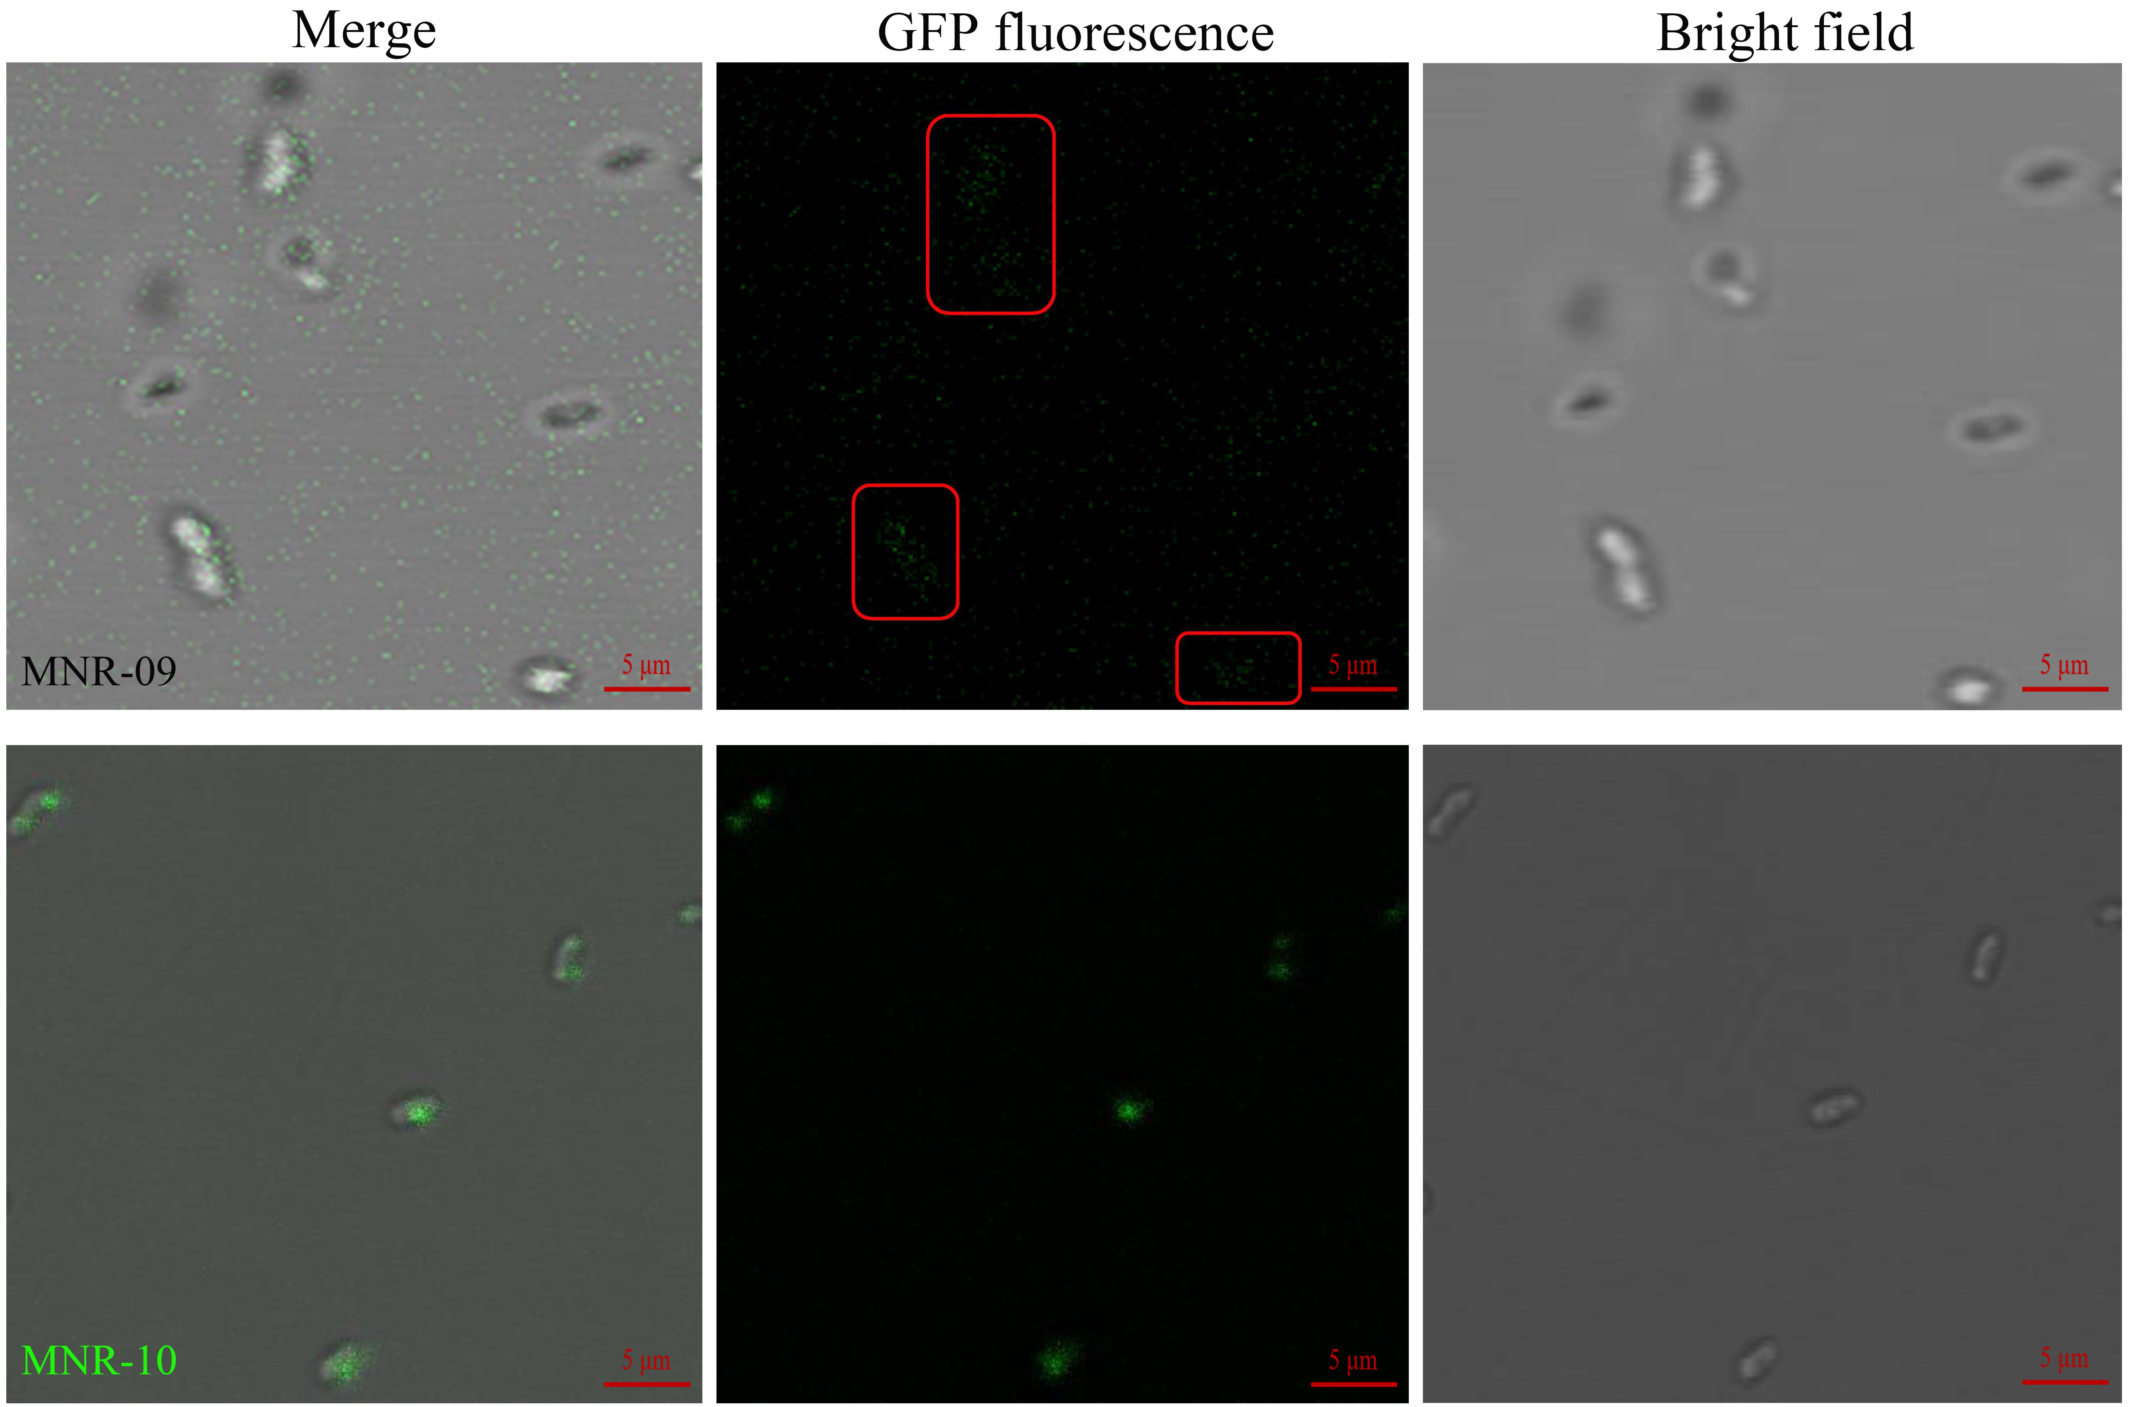
Fig. S1 Localization of CYP11A1 fused GFP were observed by laser scanning confocal microscope (LEICA TCS SP8, x60 water immersion objective). CYP11A1-GFP and mCYP11A1-GFP were expressed in MNR-09 and MNR-10, respectively.

Figure S2

Fig. S2 P450 N-terminal modifications, truncations, F-G loop deletions, site-mutations and sequence alignment.

Figure S3

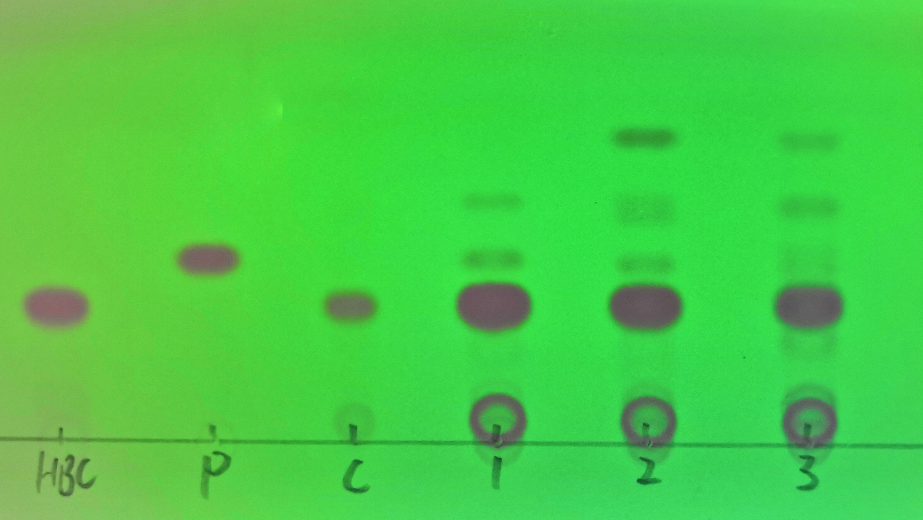
Fig. S3 Transformation results of HBC, ChO, and PS by MNR-04. The TLC spectrogram was showed under 254 nm. Lane HBC: standard HBC; Lane P: standard progesterone; Lane C (control group): the conversion result of PS (1 g/L) to HBC by the strain MNR-01. Lanes 1-3: The substrates were HBC, ChO, and PS, respectively. It needs to be mentioned that PS shows no color under 254 nm. The Rf value of progesterone was 0.43±0.05.

Figure S4

Fig. S4 Comparison of retention time (RT) of biotransformation products by HPLC (Original images). The blank (MNR-01) and control (MNR-01) were added 0 g/L and 1 g/L PS into medium, respectively. 1 g/L HBC was added into medium as conversion substrate of the recombination strain (MNR-04).
Figure S5

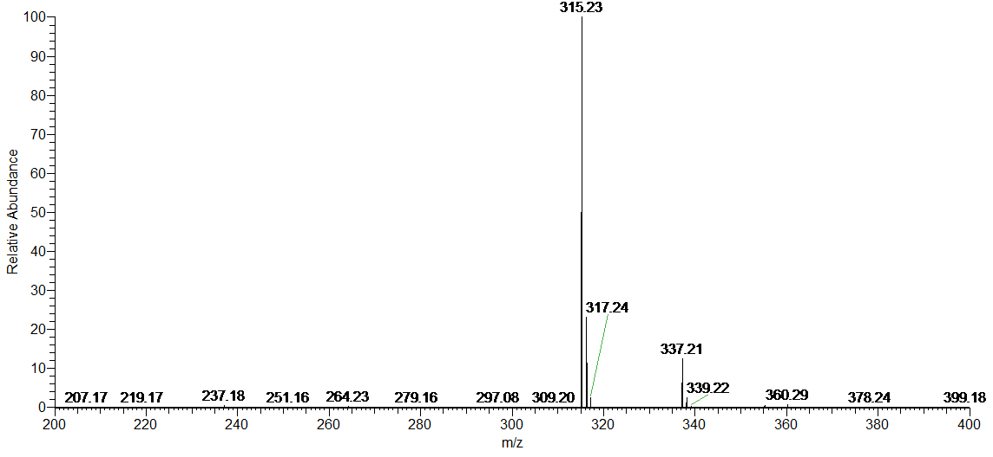
Fig. S5 UHPLC-MS for RT (retention time) 6.27 min. This was the standard progesterone (m/z=315.23 (M+H⁺).

Figure S6

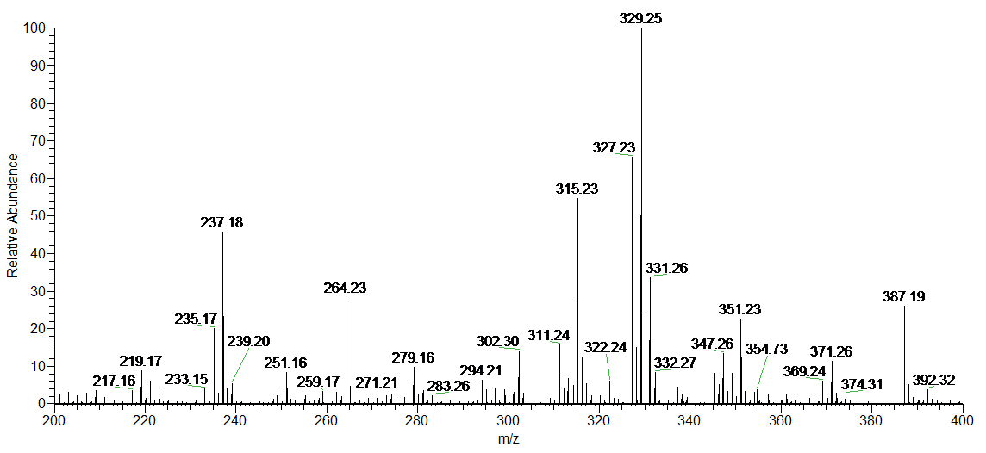
Fig. S6 UHPLC-MS for RT 6.27 min. This was the obtained progesterone by MNR-04 conversion HBC for 5 days [progesterone: (m/z=315.23 (M+H⁺), HBC: (m/z=331.26 (M+H⁺)].

Figure S7

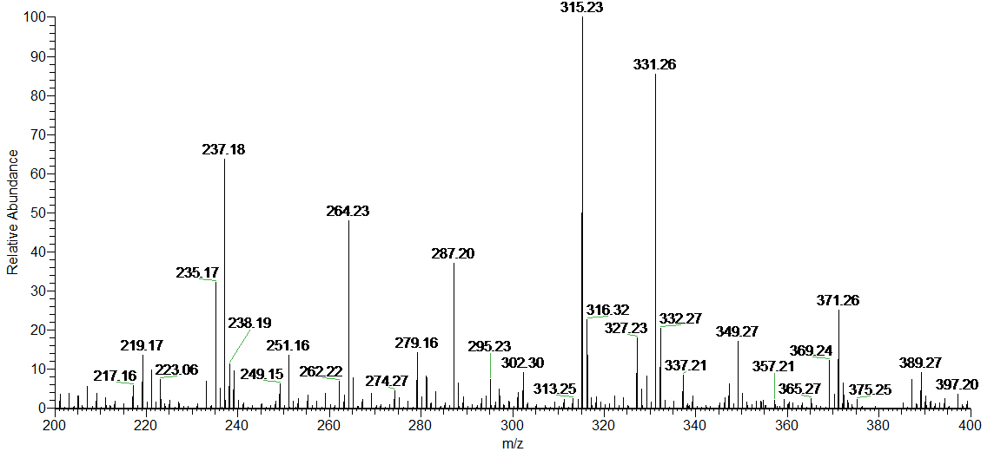
Fig. S7 UHPLC-MS for RT 6.27 min. This was the obtained progesterone by MNR-04 conversion cholesterol for 7 days [progesterone: (m/z=315.23 (M+H⁺), HBC: (m/z=331.26 (M+H⁺)].

Figure S8

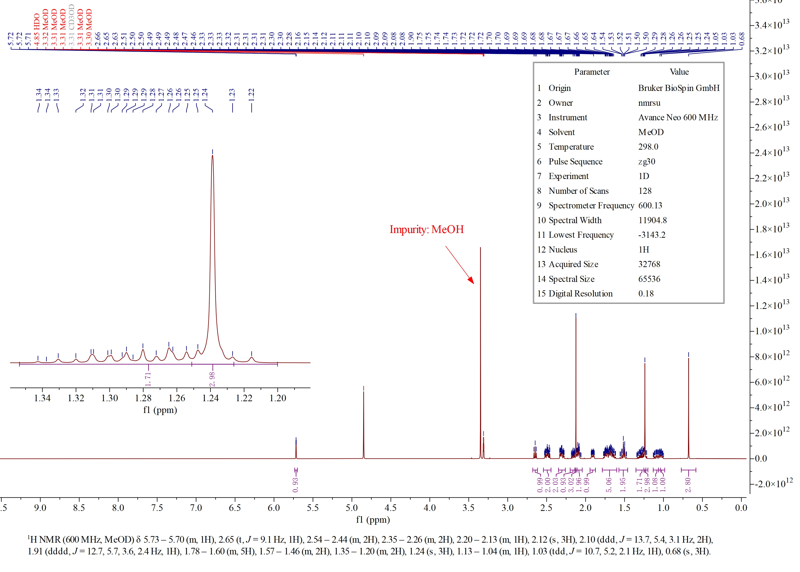
Fig. S8 ¹H-NMR (600 MHz, Methanol-d₄) spectrum of purified progesterone.

Figure S9

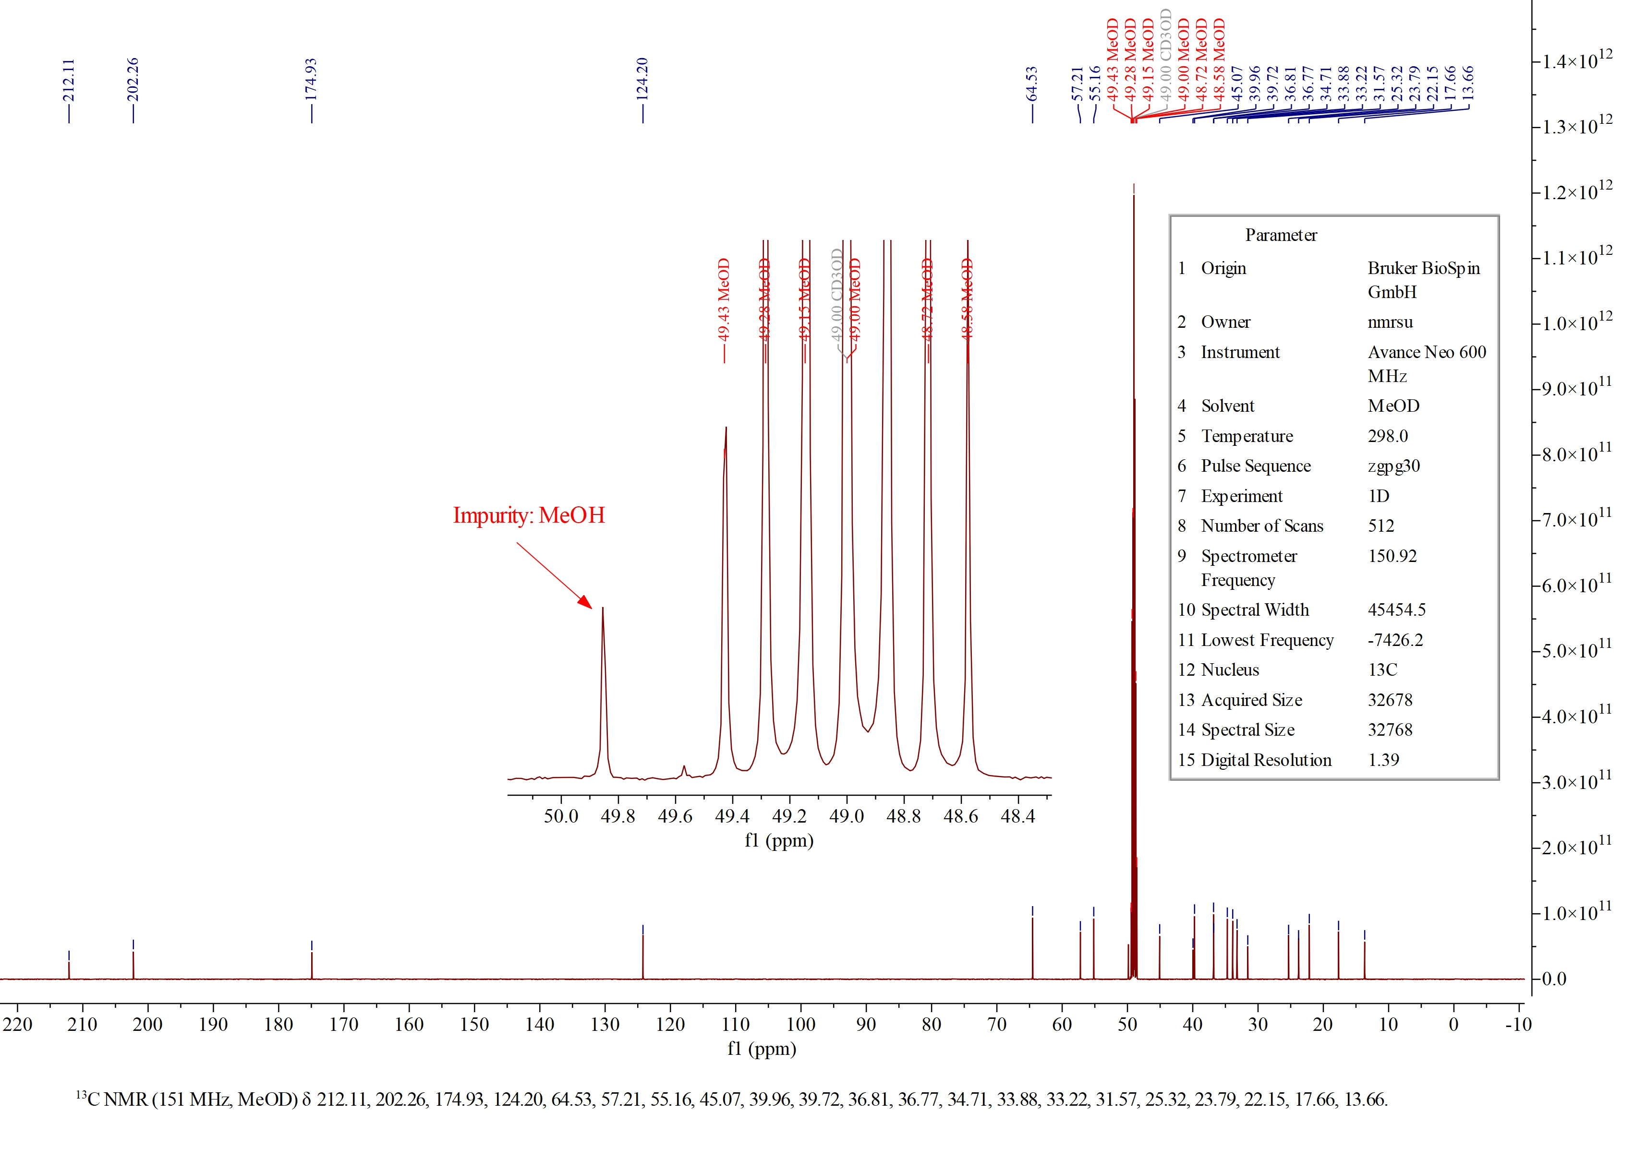
Fig. S9 ¹³C-NMR (151 MHz, Methanol-d₄) spectrum of purified progesterone.

Figure S10

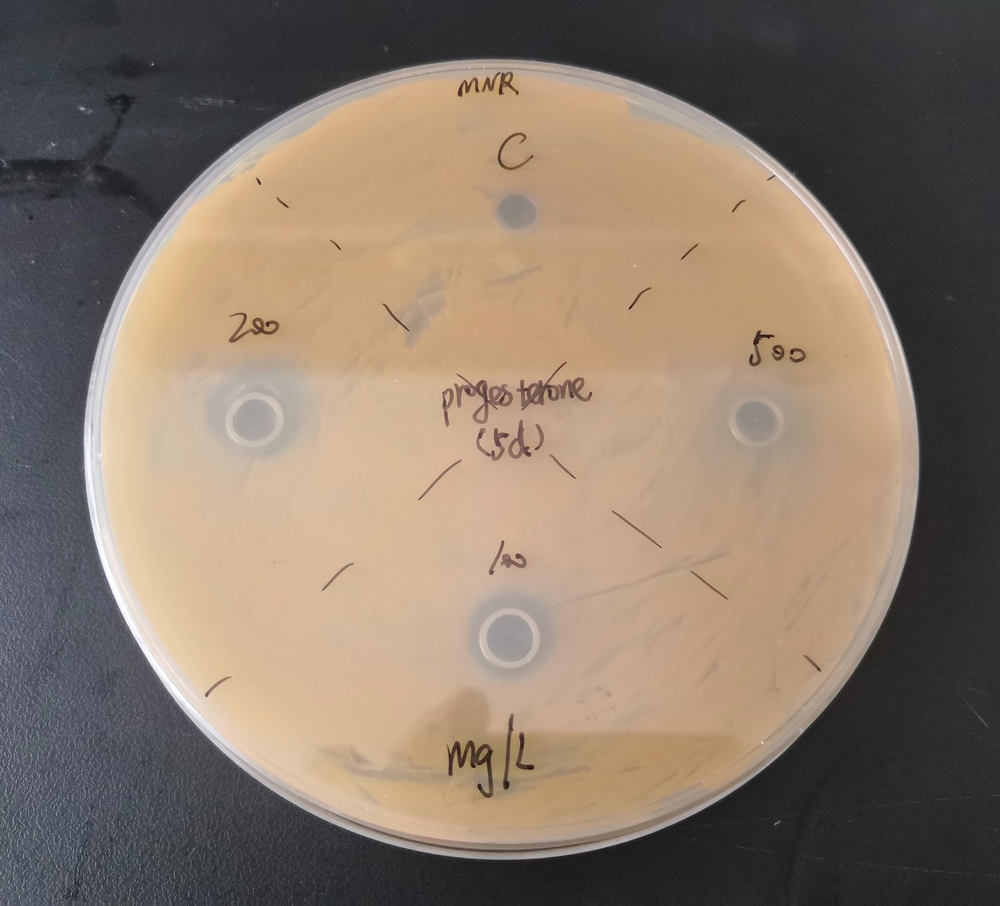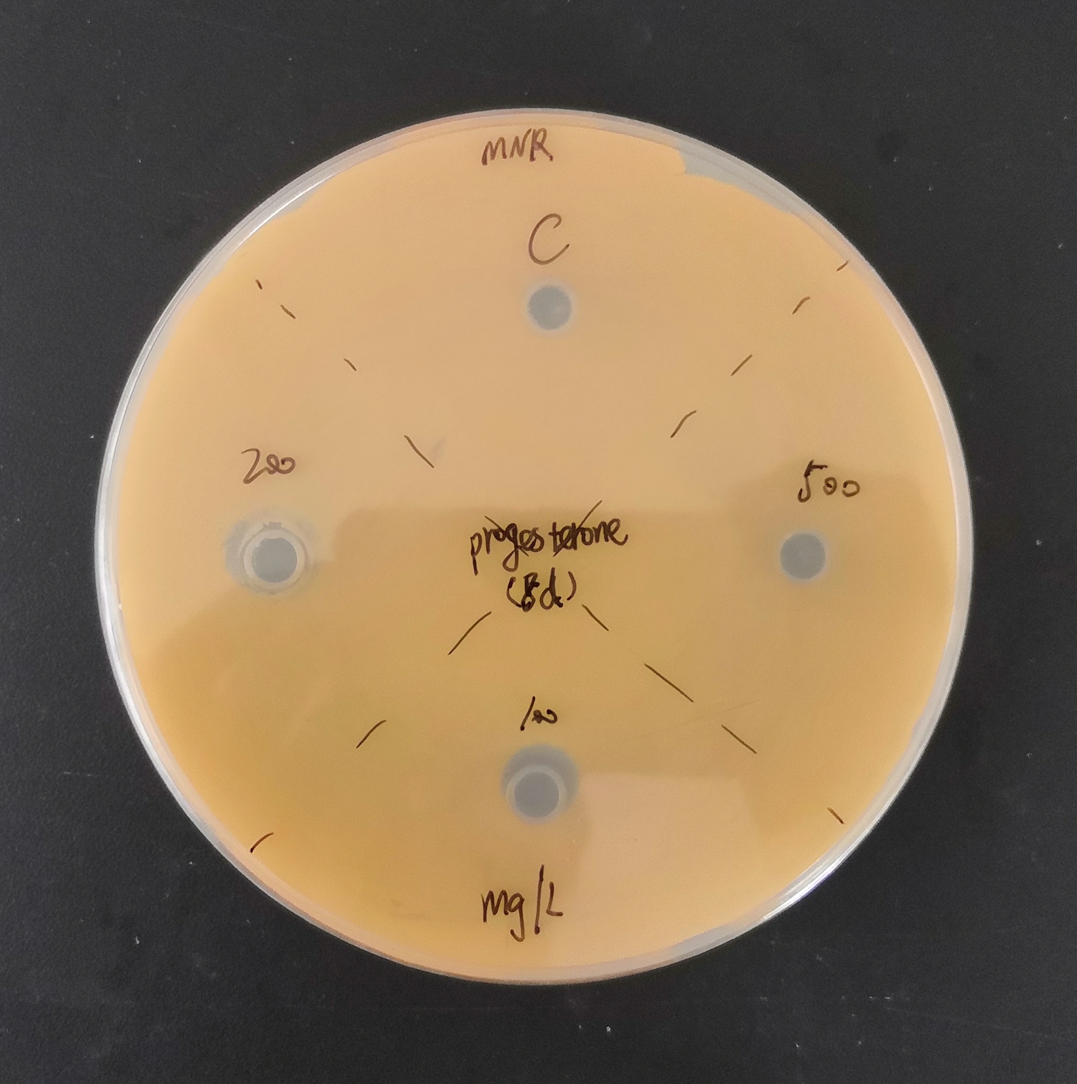
Fig. S10 Antibacterial effect of progesterone for MNR (Original images). The images show that the 5d inhibition zones (C: control, 8 mm, 100: >10 mm, 200: >10 mm, 500 mg/L: 8 mm) were more than 8d, these results indicated the progesterone was metabolized by MNR, exception for group 500 mainly because progesterone cannot be completely dissolved in the solvent, and maybe its precipitation at the bottom of the oxford cup (Ф8*6*10 mm) hindered the diffusion of the dissolved progesterone.

Figure S11

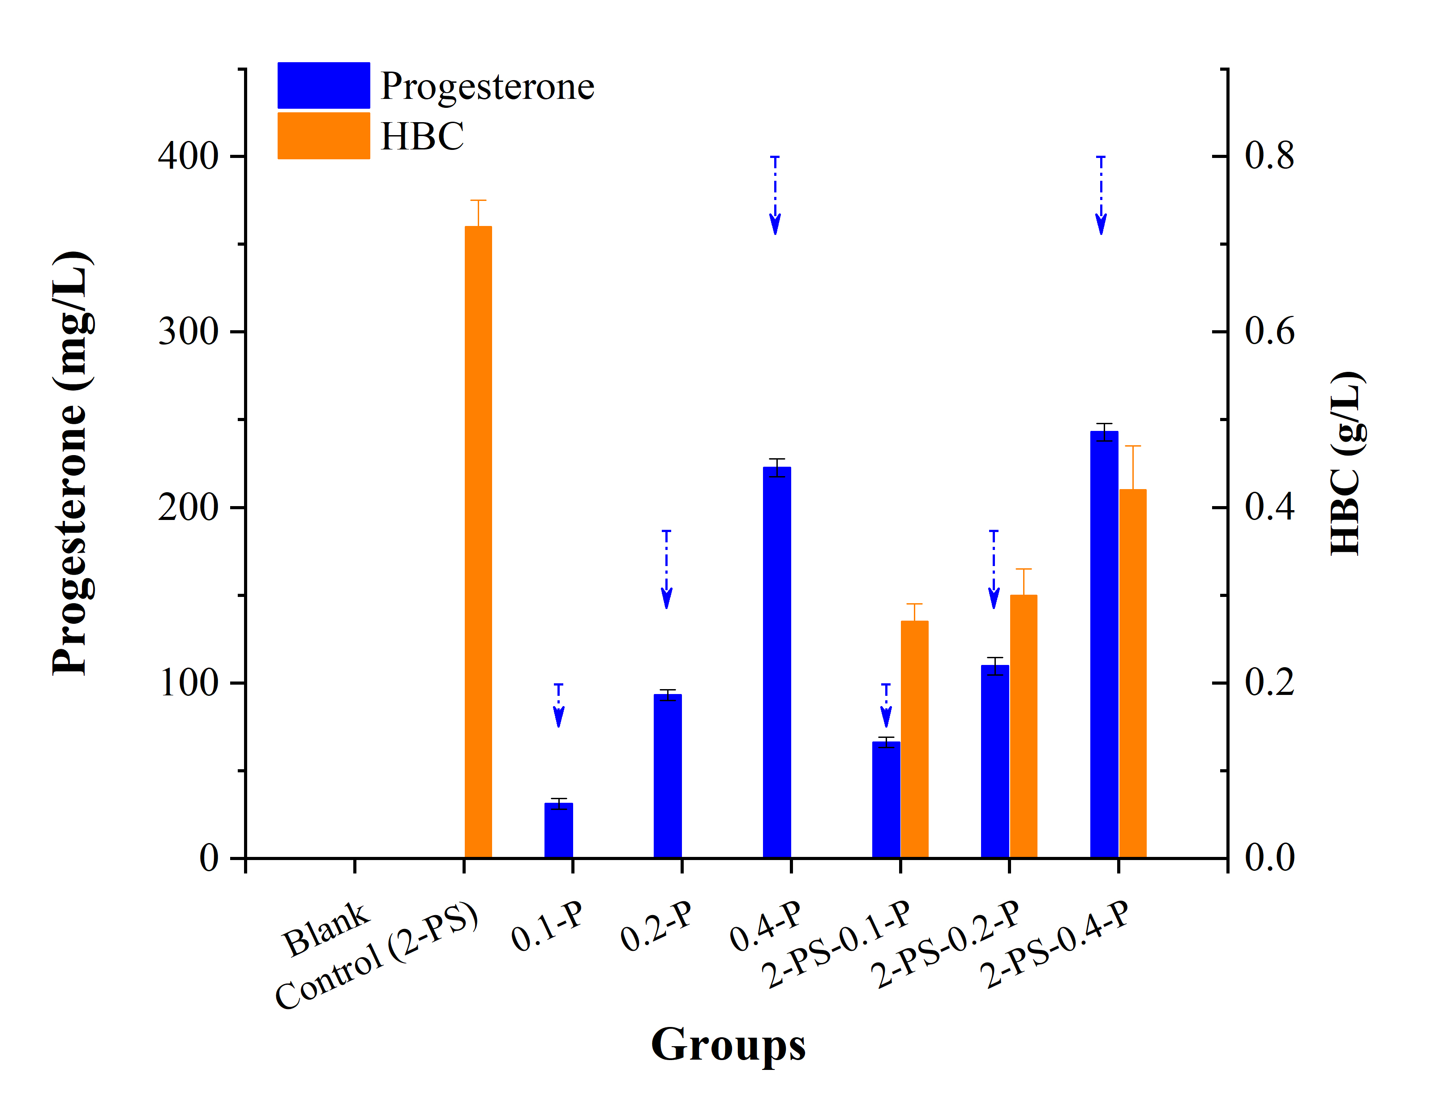
Fig. S11 Metabolic analysis of the effects of progesterone on steroids degradation by MNR fermentation for 5 days. The results suggested the MNR had metabolic pathways to degrade progesterone, and the progesterone severely inhibited the metabolic pathways from PS to HBC. The blank means only had the MNR in fermentation medium (MNR02); the control was that the addition of 2 g/L PS into MNR02 by MNR biotransformation. Homoplastically, group 0.1-P and 2-PS-0.1-P were the addition of 0.1 g/L progesterone and 2 g/L PS with 0.1 g/L progesterone into MNR02 by MNR biotransformation, respectively. The blue arrow points decrement of progesterone.

Figure S12

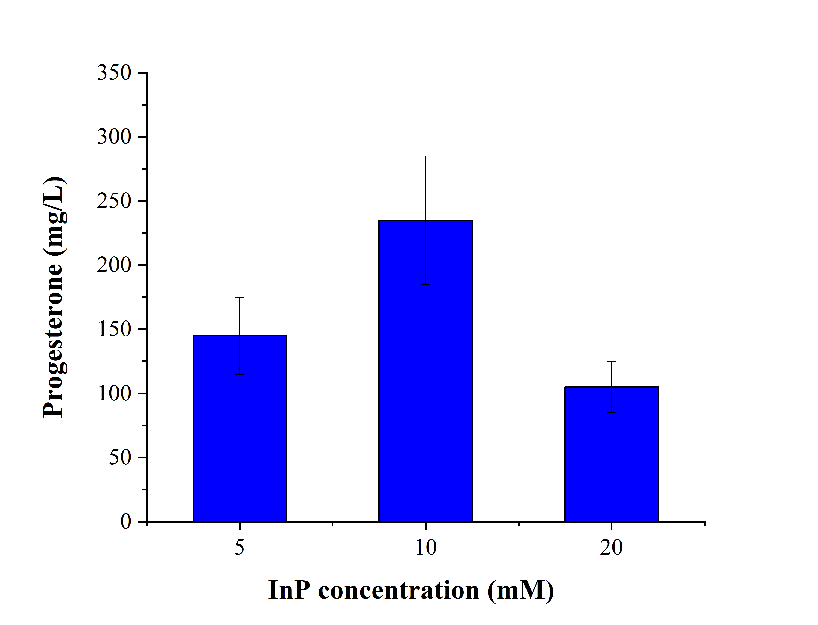
Fig. S12 Effects of InP concentrations on progesterone production by MNR-InP biohybrid assembly. The assembly of nanoparticles on cell surface can occur after mixing because of electrostatic adsorption. The concentrations of nanoparticles and 20 g/L MNR-08 were assembled after mixing in flasks. Combined with Fig. 6c, the concentration of InP nanoparticles was 20 mM, 10 mM InP nanoparticles and 20 g/L MNR-08 assembling MNR-InP biohybrids were chosen as further studies. Tips: The absorbance of a suspension at 570 nm was used to detect the content of indium phosphide.

Figure S13

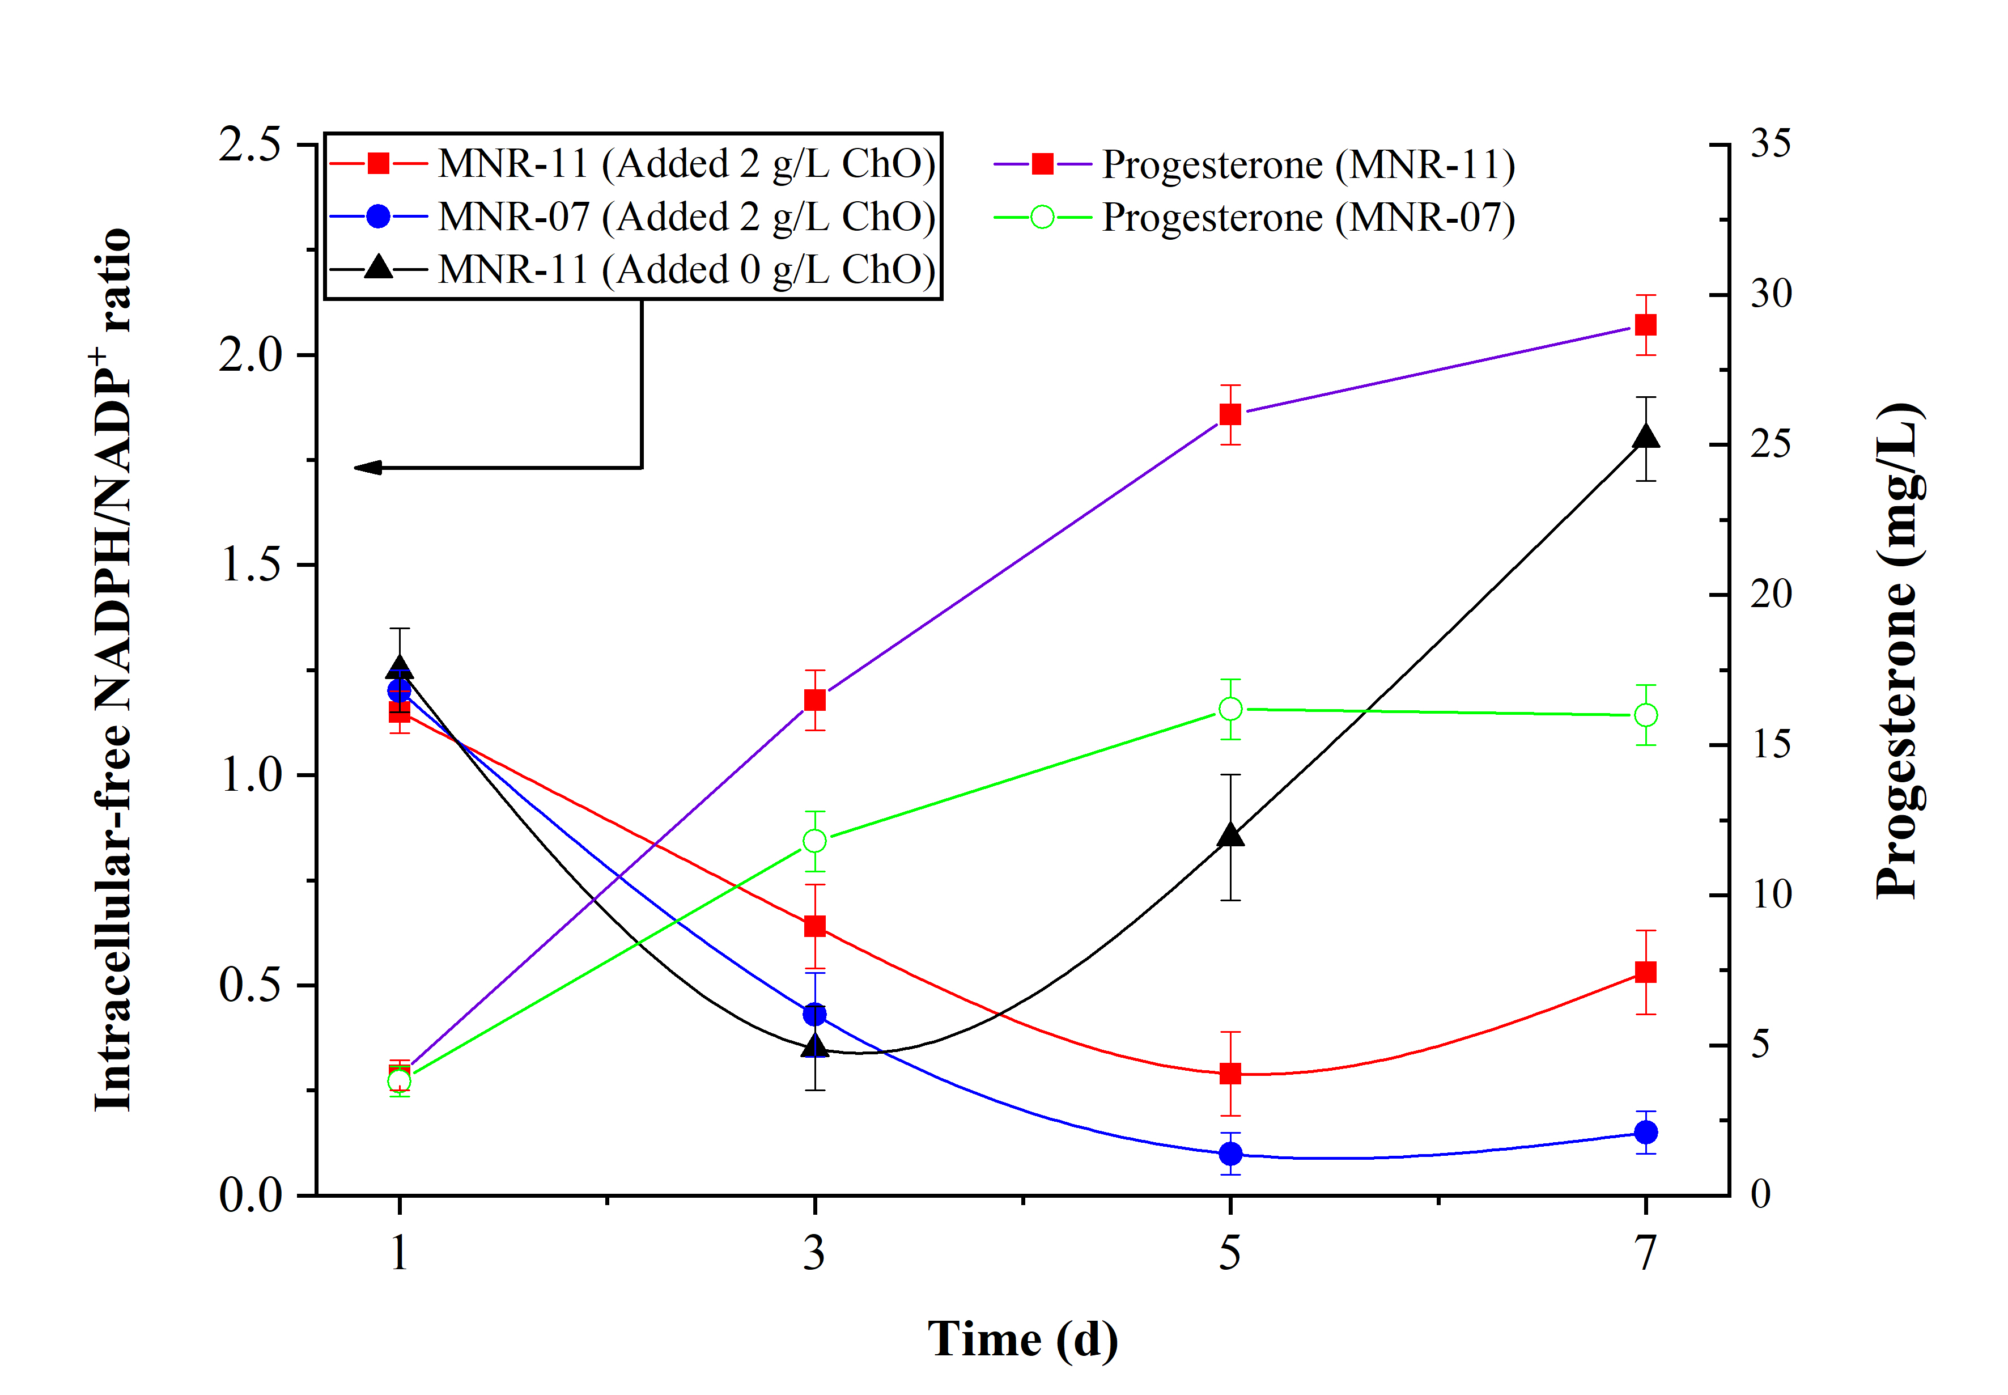
Fig. S13 Estimation and comparison of intracellular NADPH/NADP⁺ ratio, and corresponding to progesterone titer based on overexpressing gene g6pdh. In order to reduce the burden of plasmid pMV261, and we have only one expression plasmid pMV261 to use, strain MNR-07 was selected as the control strain and host in this enzymatic regeneration of NADPH. Therefore, the expression cassette of the G6PDH was integrated into the attB sites of genome by plasmid pMV306.

Figure S14

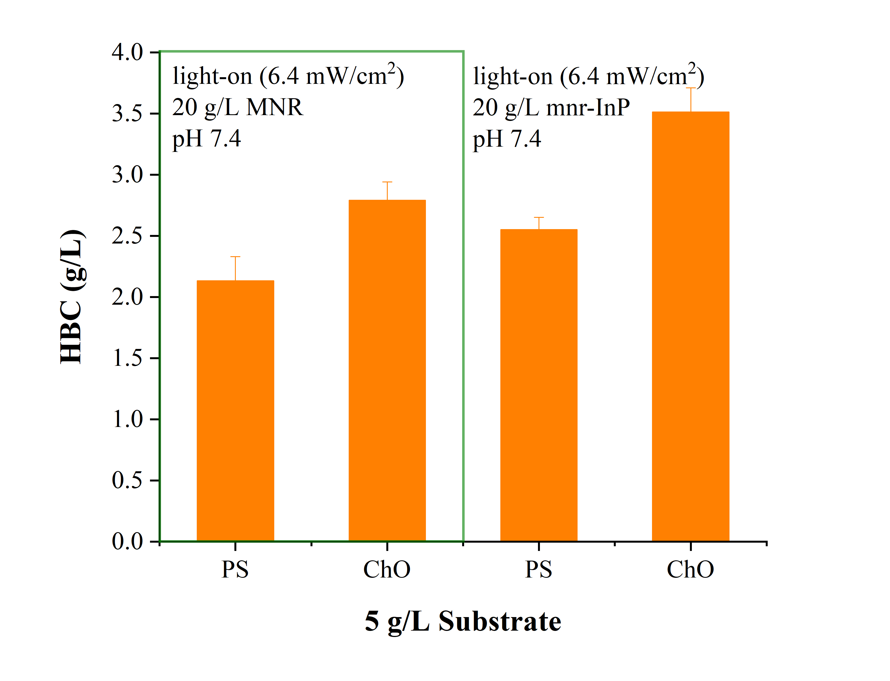
Fig. S14 Effect of illuminated resting mnr-InP biohybrids in the phosphate buffer on production HBC. The mnr was strain MNR. The result showed that regardless of PS or ChO, the light on mnr-InP enhanced the titer of HBC, which means illuminated InP semiconductor can transfer electrons for metabolic pathway from sterols to HBC to facilitate HBC production.

Figure S15

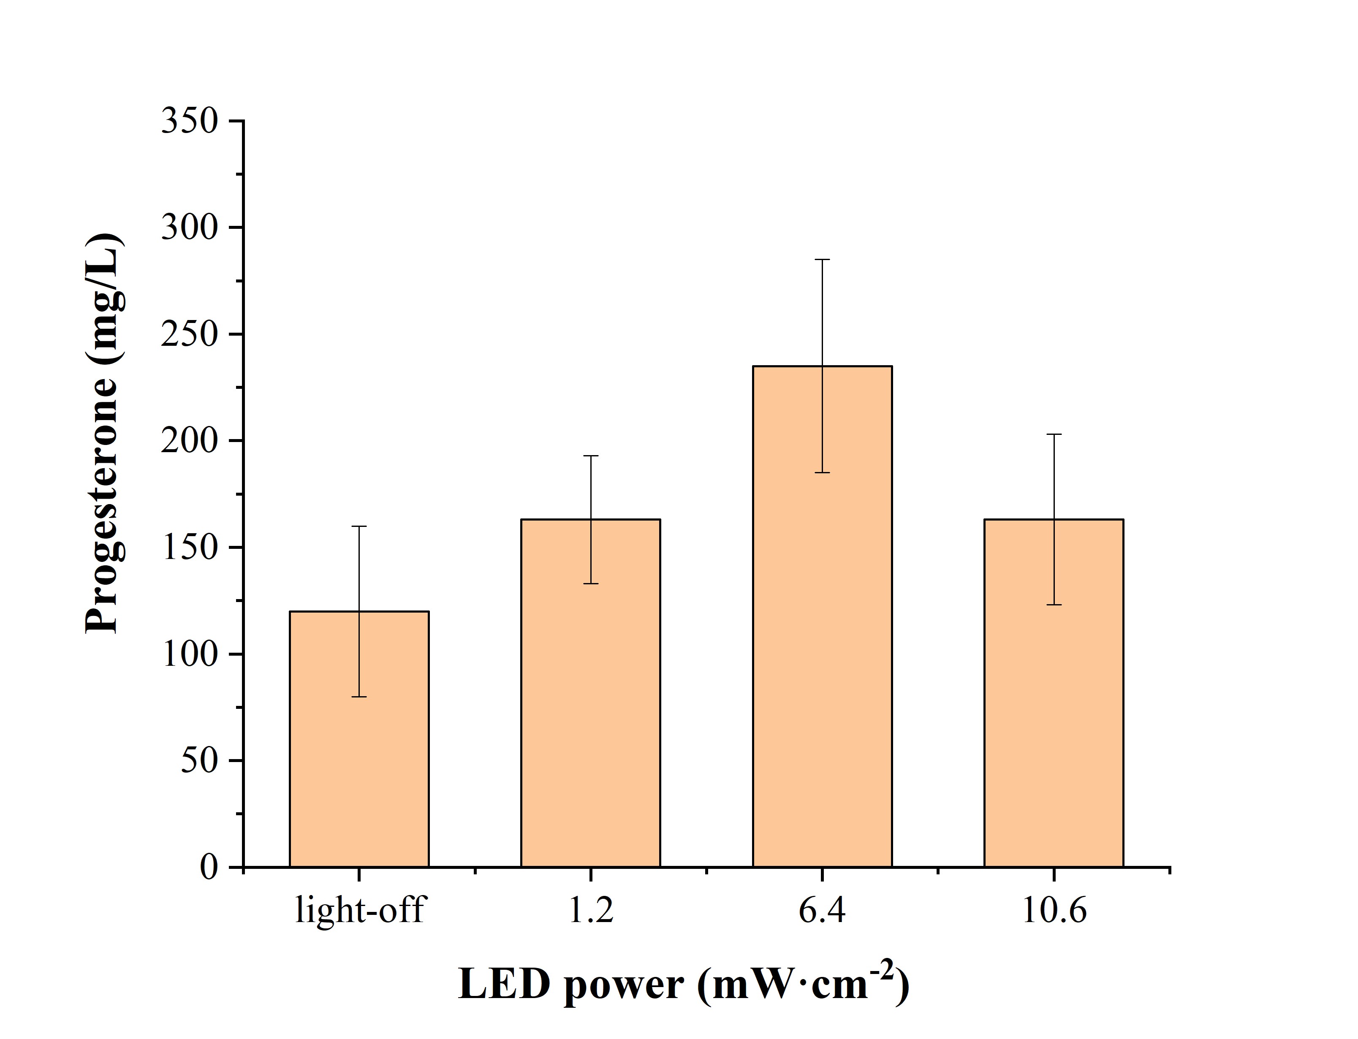
Fig. S15 Obtained progesterone in MNR-InP biohybrids under the illumination with different LED power intensities (Digital Lux Meter AS823).
Based on reported, we selected 400-760 nm as visible light wavelength, hence we identified that,
1 lux =0.01768 W·m⁻²,
Where lux (lx) is illuminance and the unit of radiant flux density is W·m⁻².

