Supporting Information
Table S1. List of primers involved in this work
Name | Nucleotide sequence (5’→3’)
IF-col | CGGAATTCAGAGGTCCACCCGGTGAGC (EcoR I)
IR-col | TTGCGGCCGCATGGTGATGGTGATGATGACCACCGGCTGGACCTTG (Not I)
IF-PADH3 | aactaattattcgaaggatccCGCACCCCCAATGATCACA
IR-PADH3 | gaaatctcatcgtttggatccTTTCGTAAAGTAAATAAGATAAAAGCTAGTAGC
IF-PDAS1 | aactaattattcgaaggatccAGCAATGATATAAACAACAATTGAGTGA
IR-PDAS1 | gaaatctcatcgtttggatccTTTGTTCGATTATTCTCCAGATAAAAT
IF-PDAS2 | aactaattattcgaaggatccAATGATATTTGAGGGTGTTAGTTACTTCG
IR-PDAS2 | gaaatctcatcgtttggatccTTTTGATGTTTGATAGTTTGATAAGAGTG
IF-PGCW14 | aactaattattcgaaggatccCAGGTGAACCCACCTAACTATTTTT
IR-PGCW14 | gaaatctcatcgtttggatccTTTTGTTGTTGAGTGAAGCGAGTG
IF-PLRA3 | aactaattattcgaaggatccAATTTCGGAAAAACTTTTGGAATT
IR-PLRA3 | gaaatctcatcgtttggatccATTTTTAGGAGATAAAAATTCTGGGG
IF-PSDH | aactaattattcgaaggatccAAGTTGTATATTATTAATGGCGGGG
IR-PSDH | gaaatctcatcgtttggatccGTTGGATAATAGTGAGTGTAATGAAGCG
IF-PGAP | aactaattattcgaaggatccAGATCTTTTTTGTAGAAATGTCTTGGTG
IR-PGAP | gaaatctcatcgtttggatccATAGTTGTTCAATTGATTGAAATAGGG
Note: the lowercase parts are sequence of homologous arm (20 bp).

Table S2. List of primers involved in RT-PCR
Name | Nucleotide sequence (5’→3’)
IFRT-col | AGCCTGGATCTAACGGTCCT
IRRT-col | GGCTTACCTTGCTCTCCAGG
IFRT-GAPDH | TTGACGGTCCATCCCACAAG
IRRT-GAPDH | CCTTAGCAGCACCAGTGGAA

Fig. S1. SDS-PAGE analysis of 2# recombinant strain. Lanes 1-3 were the blank control (GS115/pPIC9K), lanes 4-6 were the 2# recombinant strain (GS115/pPIC9K-col), and lane M was standard molecular weights.

Fig. S2. Target gene copy number of double-driving recombinant strain.

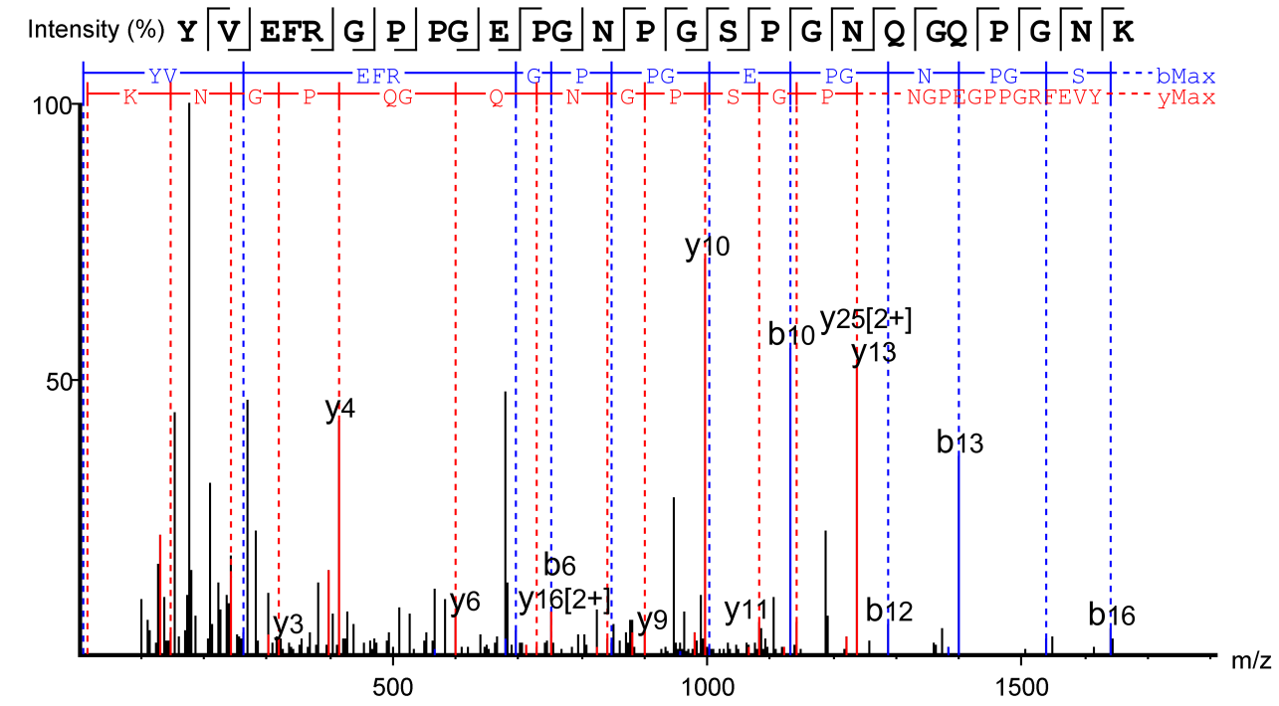Fig. S3. N-terminal sequencing results of the target protein.
H₃N-Y-V-E-F-R-G-P-P-G-E-P-G-N-P-G-S-P-G-N-Q-G-Q-P-G-N-K…

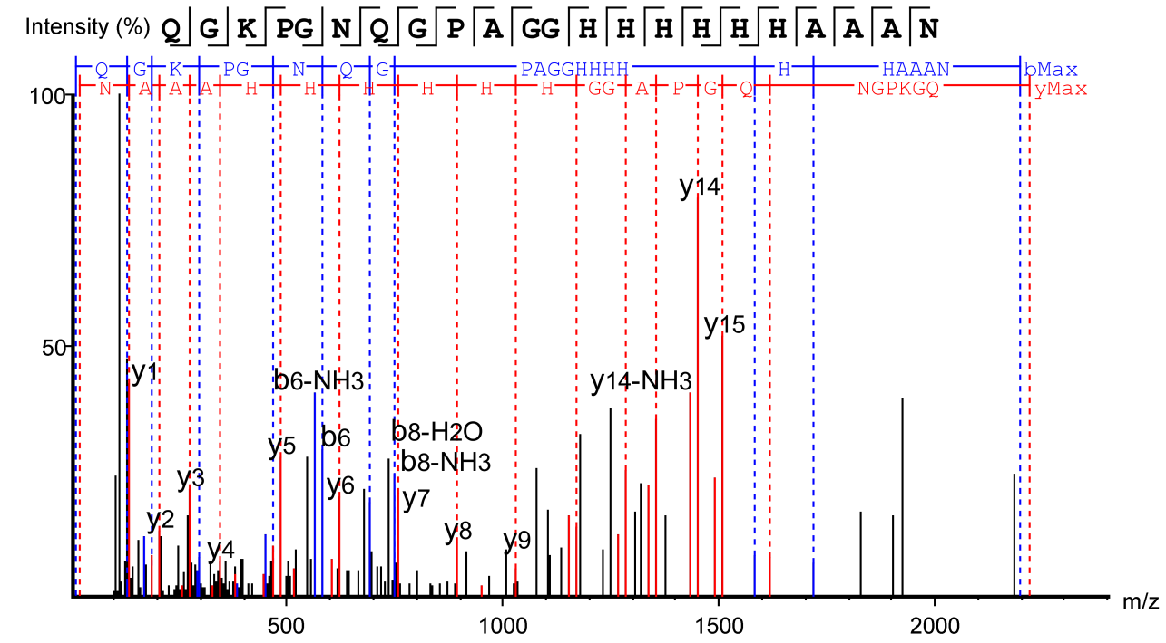Fig. S4. C-terminal sequencing results of the target protein
…Q-G-K-P-G-N-Q-G-P-A-G-G-H-H-H-H-H-H-A-A-A-N-COOH

Fig. S5. Western blotting analysis of the native hlCOLⅢ (after Native-PAGE). Lane 1 was the hlCOLⅢ, and lane M was standard molecular weights.

