Additional file for
Large-scale expansion of human umbilical cord derived-mesenchymal stem cells using PLGA@PLL nanofiber scaffold

Yujie Liu^{1, 2}, Obed Boadi Amissah^{1, 3}, Xiaoying Huangfang⁴, Ling Wang⁵, Habimana Jean de Dieu^{1, 3}, Linshuang Lv^{1, 3}, Xuanyan Ding^{1, 3}, Junyi Li^{1, 3}, Ming Chen⁵, Jinmin Zhu⁶, Omar Mukama¹, Yirong Sun¹, Zhiyuan Li^{1, 3, 5-8,} * and Rongqi Huang^{1, 7,} *

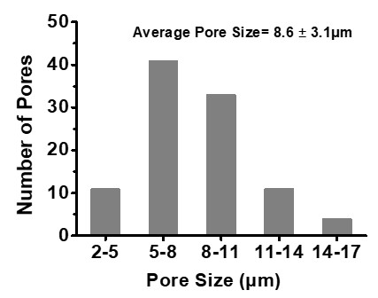

Fig. S1 Porosity of PLGA@PLL scaffold. Distributions of the size of 100 pores in SEM images of the 3D scaffold.

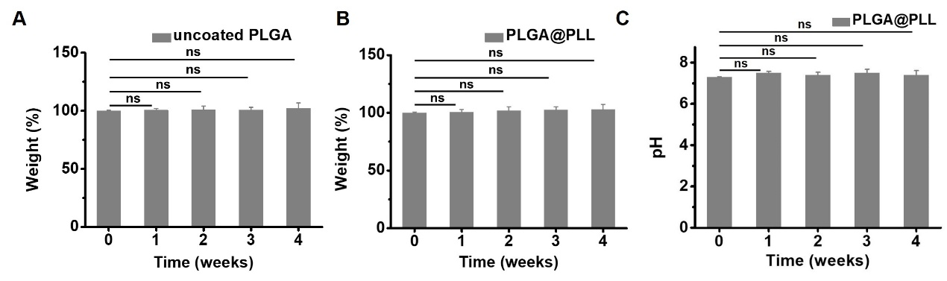

Fig. S2 Degradation profile of the PLGA@PLL scaffold. The changes in dry weight of (A) PLGA and (B) PLGA@PLL scaffolds incubated in the culture medium over a period of 4 weeks. The dry weights of the scaffolds were presented as the mean ± SEM (n=5). (C) The changes in pH value of the culture medium incubated with PLGA@PLL scaffolds over a period of 4 weeks were measured and presented as the mean ± SEM (n=5). ns indicated not significant (p > 0.05, one-way ANOVA tests).

Fig. S3 hUC-MSCs isolated from the human umbilical cord were cultured on a 10 cm dish and observed under a microscope.

Fig. S4 Pictures of newly-prepared PLGA scaffolds (A) before and (B) after PLL modification were captured using a Nikon camera.

Fig. S5 SEM images of hUC-MSCs seeded on the (A) PLGA scaffold and (B) PLGA@PLL scaffold.

Table S1. Primers used in this study

Primer | Sequence (5' to 3')
Ki67  Ki67-F  Ki67-R | GAAAGAGTGGCAACCTGCCTTC  GCACCAAGTTTTACTACATCTGCC
PCNA  PCNA-F  PCNA-R | CAAGTAATGTCGATAAAGAGGAGG  GTGTCACCGTTGAAGAGAGTGG
ICAM-1  ICAM-1-F  ICAM-1-R | AGCGGCTGACGTGTGCAGTAAT  TCTGAGACCTCTGGCTTCGTCA
VCAM-1  VCAM-1-F  VCAM-1-R | GATTCTGTGCCCACAGTAAGGC  TGGTCACAGAGCCACCTTCTTG
P21  P21-F  P21-R | AGGTGGACCTGGAGACTCTCAG  TCCTCTTGGAGAAGATCAGCCG
P16  P16-F  P16-R | CTCGTGCTGATGCTACTGAGGA  GGTCGGCGCAGTTGGGCTCC

