Supplementary material

Hyperproduction of extracellular polymeric substance in Pseudomonas fluorescens for efficient Chromium (Ⅵ) absorption
Lijie Yang^{1, 5}, Zhen Chen³, Ying Zhang², Fuping Lu⁴, Yihan Liu^{4*}, Mingfeng Cao^{1, 5}, Ning He^{1,5*}
¹Department of Chemical and Biochemical Engineering, College of Chemistry and Chemical Engineering, Xiamen University, Xiamen 361005, P. R. China
²Shandong Institute of Commerce and Technology, Jinan 251000, P.R. China
³College of Life Science, Xinyang Normal University, Xinyang 464000, P. R. China
⁴Key Laboratory of Industrial Fermentation Microbiology, Ministry of Education, Tianjin Key Laboratory of Industrial Microbiology, The College of Biotechnology, Tianjin University of Science and Technology, Tianjin 300457, China
⁵The key Lab for Synthetic Biotechnology of Xiamen City, Xiamen University, Xiamen 361005, P. R. China

*Correspondence: Ning He, Yihan Liu

E-mail address: hening@xmu.edu.cn, lyh@tust.edu.cn

Tel.: +86-592-2183751

Fax: +86-592-2184822

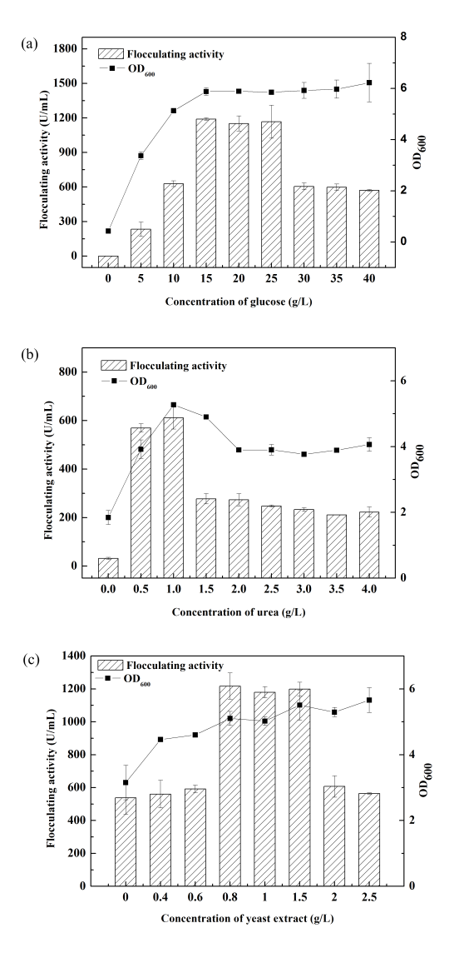
Figure S1 Effect of different concentration of glucose (a), urea (b) and yeast extract (c) on EPS production.
Figure S2 Effect of different concentration of phosphate (a), Mn²⁺ (b) and NaCl (c) on EPS production.

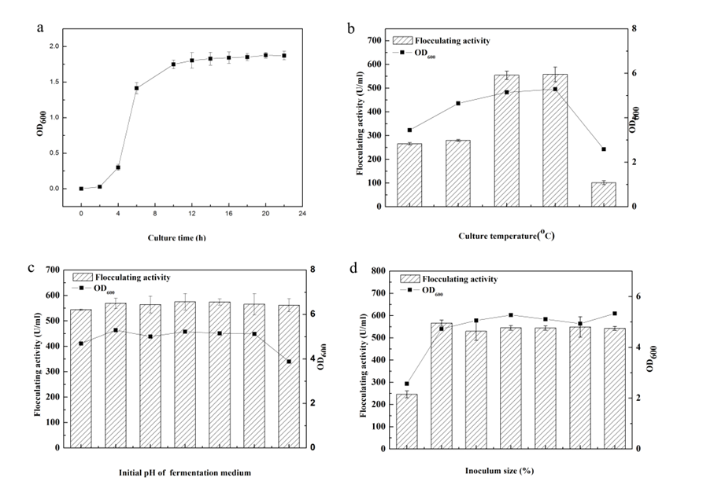
Figure S3 Optimization of culture conditions for EPS production. (a) Growth curves of P. fluorescens mutant T4-2; Effect of temperature (b), initial pH (c) and inoculums size (d) on EPS production.

Table S1. The models and equations used for the adsorption Cr (VI) of by EPS of P. fluorescens mutant T4-2
 | Model | Equation | Model parameters
Adsorption isotherm | Langmuir | $$\frac{1}{q_{e}}=\frac{1}{q_{m}}+\frac{1}{bq_{m}C_{e}}$$ | q_{e} = equilibrium capacity of Cr (VI) adsorbed onto EPS (mg g⁻¹), C_{e} = equilibrium concentration of Cr (VI) solution (mg L⁻¹), q_{m} = maximum adsorption capacity (mg g⁻¹), and b = energy of adsorption (L mg⁻¹);
Adsorption isotherm | Freundlich | $\log{q_{e}}$=$\log{K_{F}}+\frac{1}{n}\log{C_{e}}$ | q_{e} = equilibrium capacity of Cr (VI) adsorbed onto EPS (mg g⁻¹), C_{e} = equilibrium concentration of Cr (VI) solution (mg L⁻¹), K_{F} = Freundlich constant (mg g⁻¹), n = adsorption intensity of the EPS
Adsorption isotherm | Redlich-Peterson | $$q_{e}=\frac{KC_{e}}{1+αC_{e}^{β}}$$ | K and α are the Redlich−Peterson isotherm constants and β is the exponent
Adsorption kinetics | Pseudo-first order | $\log{(q_{e}-q_{t})}=\log{q_{e}}-\frac{k_{1}}{2.303}$t | q_{e} = equilibrium adsorption capacity (mg g⁻¹), q_{t} = adsorption capacity (mg g⁻¹) at any time t, k₁ = first-order rate constant(h⁻¹)
Adsorption kinetics | Pseudo-second order | $$\frac{t}{q_{t}}=\frac{1}{k_{2}{q_{e}}^{2}}+\frac{1}{q_{e}}t$$ | q_{e} = equilibrium adsorption capacity (mg g⁻¹), q_{t} = adsorption capacity (mg g⁻¹) at any time t, k₂ = the second-order rate constant (mg g⁻¹ h⁻¹)
Adsorption kinetics | Webber-Morris | $$q_{t=k_{i}t^{0.5}+c}$$ | q_{t} = adsorption (mg g⁻¹) at any time t, k_{i} = intra-particle diffusion rate constant (mg g⁻¹ h^{−0.5})
Adsorption thermodynamics | Vant Hoff’s equation | $$∆G^{0}=∆H^{0}-T∆S^{0}$$  $$∆G^{0}=-RTlnK_{0}$$  $$lnK_{0}=\frac{∆S^{0}}{R}-\frac{∆H^{0}}{RT}$$ | ΔG⁰= Gibbs free energy change (kJ mol⁻¹), R = the gas constant (J mol⁻¹ K⁻¹), T = temperature (K), k₀ = the equilibrium constant, ΔH⁰ = enthalpy change (kJ mol⁻¹), ΔS⁰ = entropy change (kJ mol⁻¹ K⁻¹)
Adsorption thermodynamics | Arrhenius equation | $$lnK=lnA-\frac{E_{a}}{RT}$$ | E_{a} =the Arrhenius activation energy (kJ mol⁻¹), A = the Arrhenius factor, R= the Arrhenius factor, K = the rate constant (k2) of the pseudo-second order kinetic mode

