Additional files
Exploiting a heterologous construction of the 3-hydroxypropionic acid carbon fixation pathway with mesaconate as an indicator in Saccharomyces cerevisiae
Shijie Xu^{1 &}, Weibo Qiao^{1 &}, Zuanwen Wang¹, Xiaoying Fu¹, Zihe Liu¹ and Shuobo Shi^{1 *}

¹Beijing Advanced Innovation Center for Soft Matter Science and Engineering, College of Life Science and Technology, Beijing University of Chemical Technology, Beijing 100029, China

Author Contributions:
& Weibo Qiao and Shijie Xu contributed equally.

Correspondence:
*E-mail: shishuobo@mail.buct.edu.cn

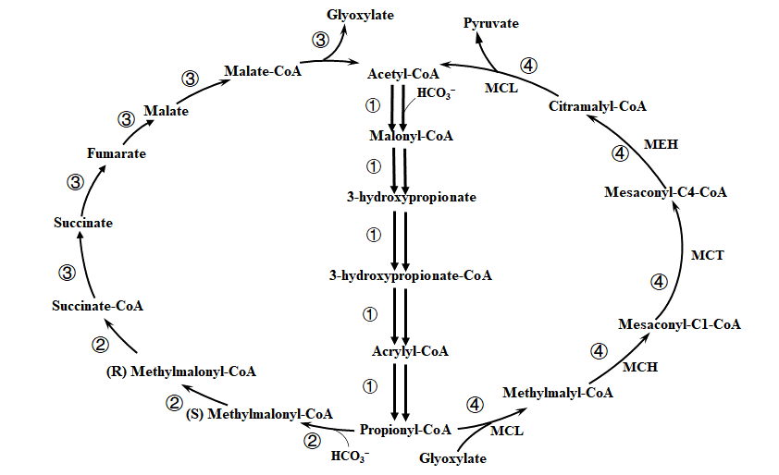
Fig. S1 The 3-HP pathway, with the bicycle divided into four functional sub-pathways (redrawn from ^{[1]}). Sub-pathway ①: Acetyl-CoA→Propionyl-CoA; Sub-pathway ②: Propionyl-CoA +Glyoxylate→Pyruvate+ Acetyl-CoA; Sub-pathway ③: Propionyl-CoA →Succinate-CoA; Sub-pathway ④: Succinate-CoA → Glyoxylate + Acetyl-CoA. Abbreviations: MCL, malyl-CoA/beta-methylmalyl-CoA/citramalyl-CoA lyase; MCH, 2-methylfumaryl-CoA hydratase; MCT, 2-methylfumaryl-CoA isomerase; MEH, 3-methylfumaryl-CoA hydratase.

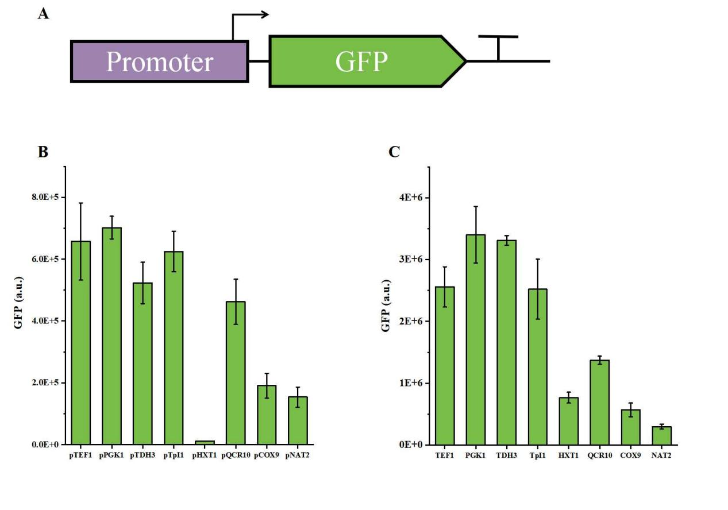
Fig. S2 A. Promoter optimization strategy for the expression of GFP under glucose or ethanol. The expression level of GFP under different promoters using glucose (B) or ethanol (C) as carbon source.

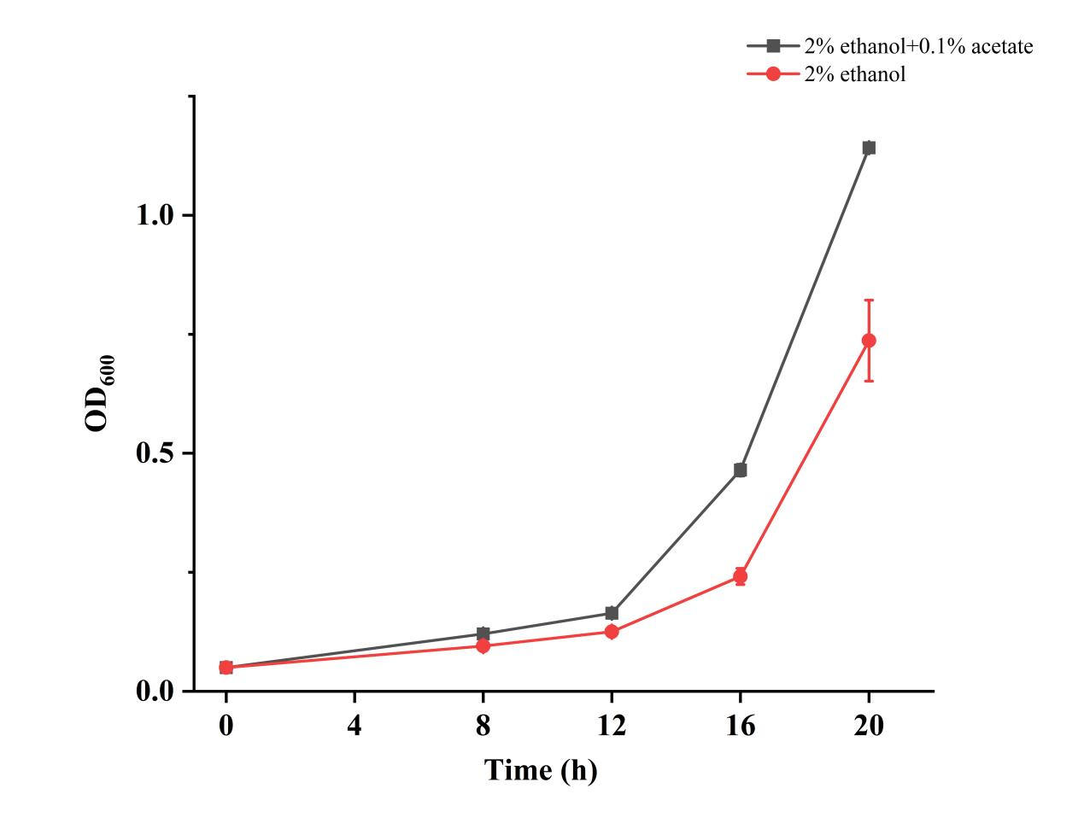
Fig. S3 Effects of adding 0.1% acetate on the growth of Saccharomyces cerevisiae with 2% ethanol

Table S1. List of plasmids used in this study.

Plasmid | Description | Source
pESC-HIS | Amp^{r}, HIS1, 2 μ ori, P_{GAL1}-T_{CYC1}, P_{GAL10}-T_{ADH1} | Thermo Fisher
pESC-TRP | Amp^{r}, TRP1, 2 μ ori, P_{GAL1}-T_{CYC1}, P_{GAL10}-T_{ADH1} | Thermo Fisher
pESC-URA | Amp^{r}, URA3, 2 μ ori, P_{GAL1}-T_{CYC1}, P_{GAL10}-T_{ADH1} | Thermo Fisher
pYX212 | Amp^{r}, URA3, 2 μ ori,TPI promoter | R & D Systems
pUGG1 | Amp^{r}, URA3 with truncated promoter, 2 μ ori; ultrahigh copy number plasmid | ^{[2]}
pET-28a | Expression plasmid; Km^{r} | Stratagene
pCas | Amp^{r}, P_{TEF1}-iCas9-T_{ADH1}, P_{SNR52}; Cas9 CRISPR vector for sequence-specific yeast genome integration | ^{[3]}
pScURA3 | PCR template for gRNA-URA3-SNR52p-tGly | ^{[3]}
pSC-HIS | pESC-HIS, P_{TEF1}-T_{CYC1}, P_{PGK1}-T_{ADH1} (replace P_{GAL1}-T_{CYC1}, P_{GAL10}-T_{ADH1}) | This study
pSC-TRP | pESC-TRP, P_{TEF1}-T_{CYC1}, P_{PGK1}-T_{ADH1} (replace P_{GAL1}-T_{CYC1}, P_{GAL10}-T_{ADH1}) | This study
pSC-URA | pESC-URA, P_{TEF1}-T_{CYC1}, P_{PGK1}-T_{ADH1} (replace P_{GAL1}-T_{CYC1}, P_{GAL10}-T_{ADH1}) | This study
pSC-HIS-SePrpE-RsMCL | pSC-HIS, P_{TEF1}-SePrpE-T_{CYC1}, P_{PGK1}-RsMCL-T_{ADH1} | This study
pSC-TRP-YciA | pSC-TRP, P_{TEF1}-YciA-T_{CYC1} | This study
pSC-TRP-ACH1 | pSC-TRP, P_{TEF1}-ACH1-T_{CYC1} | This study
pSC-TRP-EHD3 | pSC-TRP, P_{TEF1}-EHD3-T_{CYC1} | This study
pSC-TRP-TES1 | pSC-TRP, P_{TEF1}-TES1-T_{CYC1} | This study
pYX212-CaMCH | pYX212 with CaMCH | This study
pYX212-RsMCH | pYX212 with RsMCH | This study
pYX212-HmMCH | pYX212 with HmMCH | This study
pSC-URA-P_{TEF1}-GFP | pSC-URA, P_{TEF1}-GFP-T_{ADH1} | This study
pSC-URA-P_{PGK1}-GFP | pSC-URA, P_{PGK1}-GFP-T_{ADH1} | This study
pSC-URA-P_{TPI1}-GFP | pSC-URA, P_{TPI1}-GFP-T_{ADH1} | This study
pSC-URA-P_{TDH3}-GFP | pSC-URA, P_{TDH3}-GFP-T_{ADH1} | This study
pSC-URA-P_{COX9}-GFP | pSC-URA, P_{COX9}-GFP-T_{ADH1} | This study
pSC-URA-P_{NAT2}-GFP | pSC-URA, P_{NAT2}-GFP-T_{ADH1} | This study
pSC-URA-P_{QCR10}-GFP | pSC-URA, P_{QCR10}-GFP-T_{ADH1} | This study
pSC-URA-P_{HXT1}-GFP | pSC-URA, P_{HXT1}-GFP-T_{ADH1} | This study
pSC-HIS-MCR | pSC-HIS-P_{TEF1}-MCR_{mut}-T_{CYC1}; MCR_{mut}, mutation in N940V, K1106W and S1114R | This study
pSC-HIS-MCR-YciA | pSC-HIS-P_{TEF1}-MCR_{mut}-T_{CYC1,} P_{PGK1}-YciA_{t}-T_{ADH1} | This study
pSC-HIS-TDH | pSC-HIS-P_{TDH3}-MCR-C_{mut}-T_{ADH1}, P_{HXT1}-MCR-N-T_{CYC1} | This study
pSC-HIS-TDC | pSC-HIS, P_{TDH3}-MCR-C_{mut}-T_{ADH1}, P_{COX9}-MCR-N-T_{CYC1} | This study
pSC-HIS-TQ | pSC-HIS, P_{TDH3}-MCR-C_{mut}-T_{ADH1}, P_{QCR10}-MCR-N-T_{CYC1} | This study
pSC-HIS-TDN | pSC-HIS, P_{TDH3}-MCR-C_{mut}-T_{ADH1}, P_{NAT2}-MCR-N-T_{CYC1} | This study
pSC-HIS-PH | pSC-HIS, P_{PGK1}-MCR-C_{mut}-T_{ADH1}, P_{HXT1}-MCR-N-T_{CYC1} | This study
pSC-HIS-PC | pSC-HIS, P_{PGK1}-MCR-C_{mut}-T_{ADH1}, P_{COX9}-MCR-N-T_{CYC1} | This study
pSC-HIS-PQ | pSC-HIS, P_{PGK1}-MCR-C_{mut}-T_{ADH1}, P_{QCR10}-MCR-N-T_{CYC1} | This study
pSC-HIS-PN | pSC-HIS, P_{PGK1}-MCR-C_{mut}-T_{ADH1}, P_{NAT2}-MCR-N-T_{CYC1} | This study
pSC-HIS-TPH | pSC-HIS, P_{TPI1}-MCR-C_{mut}-T_{ADH1}, P_{HXT1}-MCR-N-T_{CYC1} | This study
pSC-HIS-TPC | pSC-HIS, P_{TPI1}-MCR-C_{mut}-T_{ADH1}, P_{COX9}-MCR-N-T_{CYC1} | This study
pSC-HIS-TPQ | pSC-HIS, P_{TPI1}-MCR-C_{mut}-T_{ADH1}, P_{QCR10}-MCR-N-T_{CYC1} | This study
pSC-HIS-TPN | pSC-HIS, P_{TPI1}-MCR-C_{mut}-T_{ADH1}, P_{NAT2}-MCR-N-T_{CYC1} | This study
pSC-HIS-TEH | pSC-HIS, P_{TEF1}-MCR-C_{mut}-T_{ADH1}, P_{HXT1}-MCR-N-T_{CYC1} | This study
pSC-HIS-TEC | pSC-HIS, P_{TEF1}-MCR-C_{mut}-T_{ADH1}, P_{COX9}-MCR-N-T_{CYC1} | This study
pSC-HIS-TEQ | pSC-HIS, P_{TEF1}-MCR-C_{mut}-T_{ADH1}, P_{QCR10}-MCR-N-T_{CYC1} | This study
pSC-HIS-TEN | pSC-HIS, P_{TEF1}-MCR-C_{mut}-T_{ADH1}, P_{NAT2}-MCR-N-T_{CYC1} | This study
pSC-URA-PH | pSC-URA, P_{PGK1}-MCR-C_{mut}-T_{ADH1}, P_{HXT1}-MCR-N-T_{CYC1} | This study
pSC-URA-TEQ | pSC-URA, P_{TEF1}-MCR-C_{mut}-T_{ADH1}, P_{QCR10}-MCR-N-T_{CYC1} | This study
pUGG-PH | pUGG1, P_{PGK1}-MCR-C_{mut}-T_{ADH1}, P_{HXT1}-MCR-N-T_{CYC1} | This study
pUGG-PH-SePrpE | pUGG1, P_{PGK1}-MCR-C_{mut}-T_{ADH1}, P_{HXT1}-MCR-N-T_{CYC1,} P_{FBA1}-SePrpE-T_{RPS2} | This study
pUGG-TEQ | pUGG1, P_{TEF1}-MCR-C_{mut}-T_{ADH1}, P_{QCR10}-MCR-N-T_{CYC1} | This study
pUGG-TEQ-SePrpE | pUGG1, P_{TEF1}-MCR-C_{mut}-T_{ADH1}, P_{QCR10}-MCR-N-T_{CYC1,} P_{FBA1}-SePrpE-T_{RPS2} | This study
pSC-HIS-MsHPCS-MsACR-StHPCD | pSC-HIS, P_{TEF1}-MsHPCS-T_{ADH2}, P_{PGK1}-StHPCD-T_{CYC1}, P_{TDH3}-MsACR-T_{PYK1}, | This study
pSC-HIS-SePrpE-MsACR-StHPCD | pSC-HIS, P_{TEF1}-SePrpE-T_{ADH2}, P_{PGK1}-StHPCD-T_{CYC1}, P_{TDH3}-MsACR-T_{PYK1}, | This study
pCas-ΔACH1 | pCas, P_{SNR52}-gRNA_{ACH1}-T_{SNR52}; Cas9 CRISPR vector for knockout of ACH1 | This study
pCas-ΔEHD3 | pCas, P_{SNR52}-gRNA_{EHD3}-T_{SNR52}; Cas9 CRISPR vector for knockout of EHD3 | This study
pCas-ΔTES1 | pCas, P_{SNR52}-gRNA_{TES1}-T_{SNR52}; Cas9 CRISPR vector for knockout of TES1 | This study
pCas-XII-1 | Cas9 CRISPR vector for integration at XII-1^{[4]} site | Stored in the Shi lab
pCas-XI-2 | Cas9 CRISPR vector for integration at XI-2^{[4]} site | Stored in the Shi lab
pCas-XI-3 | Cas9 CRISPR vector for integration at XI-3^{[4]}site | Stored in the Shi lab

Table S2. List of strains used in this study.
Name | Genotype | Source
CEN.PK 2-1D | MATα; ura3-52; trp1-289; leu2-3,112; his3Δ 1; MAL2-8C; SUC2 | EUROSCARF
TEF1p | CEN.PK 2-1D, pSC-URA-P_{TEF1}-GFP | This study
PGK1p | CEN.PK 2-1D, pSC-URA-P_{PGK1}-GFP | This study
TPI1p | CEN.PK 2-1D, pSC-URA-P_{TPI1}-GFP | This study
TDH3p | CEN.PK 2-1D, pSC-URA-P_{TDH3}-GFP | This study
COX9p | CEN.PK 2-1D, pSC-URA-P_{COX9}-GFP | This study
NAT2p | CEN.PK 2-1D, pSC-URA-P_{NAT2}-GFP | This study
QCR10p | CEN.PK 2-1D, pSC-URA-P_{QCR10}-GFP | This study
HXT1p | CEN.PK 2-1D, pSC-URA-P_{HXT1}-GFP | This study
TDH3-HXT1 | CEN.PK 2-1D, pSC-HIS-TDH | This study
TDH3-COX9 | CEN.PK 2-1D, pSC-HIS-TDC | This study
TDH3-QCR10 | CEN.PK 2-1D, pSC-HIS-TQ | This study
TDH3-NAT2 | CEN.PK 2-1D, pSC-HIS-TDN | This study
PGK1-HXT1 (PH1) | CEN.PK 2-1D, pSC-HIS-PH | This study
PGK1-COX9 | CEN.PK 2-1D, pSC-HIS-PC | This study
PGK1-QCR10 | CEN.PK 2-1D, pSC-HIS-PQ | This study
PGK1-NAT2 | CEN.PK 2-1D, pSC-HIS-PN | This study
TPI1-HXT1 | CEN.PK 2-1D, pSC-HIS-TPH | This study
TPI1-COX9 | CEN.PK 2-1D, pSC-HIS-TPC | This study
TPI1-QCR10 | CEN.PK 2-1D, pSC-HIS-TPQ | This study
TPI1-NAT2 | CEN.PK 2-1D, pSC-HIS-TPN | This study
TEF1-HXT1 | CEN.PK 2-1D, pSC-HIS-TEH | This study
TEF1-COX9 | CEN.PK 2-1D, pSC-HIS-TEC | This study
TEF1-QCR10 (TEQ1) | CEN.PK 2-1D, pSC-HIS-TEQ | This study
TEF1-NAT2 | CEN.PK 2-1D, pSC-HIS-TEN | This study
PH2 | CEN.PK 2-1D, pSC-URA-PH | This study
PH3 | CEN.PK 2-1D, pUGG-PH | This study
TEQ2 | CEN.PK 2-1D, pUGG-TEQ | This study
M0 | CEN.PK 2-1D, pSC-HIS-SePrpE-RsMCL | This study
M0-C | M0, pYX212 | This study
M0-CaMCH | M0, pYX212-CaMCH | This study
M01 | M0, pSC-TRP-YciA | This study
M01-C | M01, pYX212 | This study
M01-CaMCH | M01, pYX212-CaMCH | This study
M01-RsMCH | M01, pYX212-RsMCH | This study
M01-HmMCH | M01, pYX212-HmMCH | This study
M1 | CEN.PK 2-1D, XI-3::P_{TDH3}-RsMCL-T_{PYK1}, P_{TEF1}-CaMCH-T_{CYC1} | This study
M101 | M1, pSC-HIS-MsHPCS- MsACR-StHPCD, pUGG-PH | This study
M102 | M1, pSC-HIS-SePrpE- MsACR-StHPCD, pUGG-PH | This study
M103 | M102, XII-1::P_{PGK1}-SePrpE-T_{CYC1} | This study
M2 | M1, XI-2::P_{TEF1}-MsHPCS-T_{ADH2}, P_{PGK1}-StHPCD-T_{CYC1}, P_{TDH3}-MsACR-T_{PYK1} | This study
M201 | M2, pSC-HIS-MCR | This study
M202 | M2, pSC-HIS-MCR-YciA | This study
M203 | M2, pUGG-PH | This study
M204 | M2, pUGG-TEQ | This study
M3 | M1, XII-1::P_{PGK1}-SePrpE-T_{CYC1} | This study
M3-TRP | M3, pSC-TRP | This study
M3-YciA | M3, pSC-TRP-YciA | This study
M3-ACH1 | M3, pSC-TRP-ACH1 | This study
M3-EHD3 | M3, pSC-TRP-EHD3 | This study
M3-TES1 | M3, pSC-TRP-TES1 | This study
M3-ΔACH1 | M3, ach1Δ | This study
M3-ΔEHD3 | M3, ehd3Δ | This study
M3-ΔTES1 | M3, tes1Δ | This study
M4 | M3, XI-2::P_{TEF1}-SePrpE-T_{ADH2}, P_{PGK1}-StHPCD-T_{CYC1}, P_{TDH3}-MsACR-T_{PYK1} | This study
M403 | M4, pUGG-PH | This study
M404 | M4, pUGG-TEQ | This study
M405 | M4, pUGG-PH-SePrpE | This study
M406 | M4, pUGG-TEQ-SePrpE | This study

Table S3. List of primers used in this study.
Primer name | Primer Sequence (5'-3') | Description of the PCR product
psc-PGK1p-EcoRI-f | tttagtgagggttgaattcttgttttatatttgttgtaa | Construction of pSC-URA, pSC-HIS, pSC-TRP plasmid
psc-TEF1p-BamHI-r | gtgagtcgtattacggatccgttgtaattaaaacttagat | Construction of pSC-URA, pSC-HIS, pSC-TRP plasmid
psc-prpe-f | ctaagttttaattacaacggatccATGTCCTTCTCCGAATTTTA | Construction of pSC-HIS-SePrpE-RsMCL plasmid
psc-prpe-r | gccctatagtgagtcgtattacTTATTCCTCGATGGCCTGTCT | Construction of pSC-HIS-SePrpE-RsMCL plasmid
psc-rsmcl-f | caacaaatataaaacaagaattcAtgagcttccgccttcagc | Construction of pSC-HIS-SePrpE-RsMCL plasmid
psc-rsmcl-r | CTtgtaatccatcgatactagggccgagatcatttctGCC | Construction of pSC-HIS-SePrpE-RsMCL plasmid
MCR-C-PCSh-R | agaattgttaattaagagctcTTAGACTGTAATGGCTCTACCTCTGTG | Construction of pSC-HIS-MCR plasmid
MCR-K1106W-S1114R-F | gatggattgctttgtctgatggtgctagattagcattggtaaccccagaaac | Construction of pSC-HIS-MCR plasmid
MCR-K1106W-S1114R-R | tctagcaccatcagacaaagcaatccatctggcgactctgaagtga | Construction of pSC-HIS-MCR plasmid
MCR-N940V-R | caccggaaacaactctgtcagctaagtaatagacag | Construction of pSC-HIS-MCR plasmid
MCR-N940V-F | cttagctgacagagttgtttccggtgaaacttttca | Construction of pSC-HIS-MCR plasmid
MCR-C-PCSh-F | tagggcccgggcgtcgacGCGGCCGCACTAGTATGTCCGCTACCACTGGTG | Construction of pSC-HIS-MCR plasmid
M,N,C-CK-F | acttcaggttgtctaactcc | Construction of pSC-HIS-MCR plasmid
M,N,C-CK-R | aaatttctggcaaggtagac | Construction of pSC-HIS-MCR plasmid
MCR-N-PCSh-R | acatactagtgcggccgcGTCGACGCCCGGGCCCTATGAGTGGTACAGGTAGATTAGC | Construction of pSC-HIS-MCR plasmid
MCR-N-PCSh-F | gcggtaccaagcttactcgagTTAGATGTTGGCTGGTATGTTCAAT | Construction of pSC-HIS-MCR plasmid
L-TPI-F | gCACCAGTGGTAGCGGACATACTAGTtgtatgtgttttttgtagttatagatttaagc | Construction of pSC-HIS-TDH, pSC-HIS-TDC, pSC-HIS-TQ,  pSC-HIS-TDN,  pSC-HIS-PH,  pSC-HIS-PC,  pSC-HIS-PQ,  pSC-HIS-PN,  pSC-HIS-TPH,  pSC-HIS-TPC,  pSC-HIS-TPQ,  pSC-HIS-TPN,  pSC-HIS-TEH,  pSC-HIS-TEC,  pSC-HIS-TEQ,  pSC-HIS-TEN plasmid
L-TPI-R | GTAGGTCGATGGATCCATGCTGCAGgatctacgtatggtcattcttcttc
L-HXT1-F | CTGCAGCATGGATCCATCGACCTACGGCCACAATGAAACTTCAATTC
L-HXT1-R | CTAATCTACCTGTACCACTCATAGGGCCGATTTTACGTATATCAACTAGTTGACG
L-TDH3-F | gCACCAGTGGTAGCGGACATACTAGTTTTGTTTGTTTATGTGTGTTTATTCG
L-TDH3-R | GTAGGTCGATGGATCCATGCTGCAGATACTAGCGTTGAATGTTAGCG
L-COX9-F | CTGCAGCATGGATCCATCGACCTACGCTGGGCGATCTTCC
L-COX9-R | CTAATCTACCTGTACCACTCATAGGGCCGTCTGTGTAAGTCGC
L-TEF1-F | gCACCAGTGGTAGCGGACATACTAGTttgtaattaaaacttagattagattgctatgc
L-TEF1-R | GTAGGTCGATGGATCCATGCTGCAGgcacacaccatagcttcaaaa
L-PGK1-F | gCACCAGTGGTAGCGGACATACTAGTttgttttatatttgttgtaaaaagtagataattac
L-PGK1-R | GTAGGTCGATGGATCCATGCTGCAGggaagtaccttcaaagaatgg
L-NAT2-F | CTGCAGCATGGATCCATCGACCTACGATAATTAACTTTTGTTAGTTTTTTATTAATAATATATCATTACAAG
L-NAT2-R | CTAATCTACCTGTACCACTCATAGGGCCCACCCCAACTCTAGACCAAAAAAG
L-QCR-F | CTGCAGCATGGATCCATCGACCTACGCTTCTCATTCTATTTTAATTATACTAGTACG
L-QCR-R | CTAATCTACCTGTACCACTCATAGGGCCTGAGGTTAGTTTTAAGTCTTATGGATTG
GFP-Xhol1-F | gcggtaccaagcttactcgagatgtctaaaggtgaagaattattcac | Construction of pSC-URA-P_{COX9}-GFP plasmid
GFP-Bcu1-R | ccttgtaatccatcgatactagtttaTAGCTTGGAtttgtacaattcatcc | Construction of pSC-URA-P_{COX9}-GFP plasmid
ADH-CK-R | CCTGAGAAAGCAACCTGAC | Construction of pSC-URA-P_{COX9}-GFP plasmid
CYC-CK-F | CAAAACCTTCTCAAGCAAGG | Construction of pSC-URA-P_{COX9}-GFP plasmid
GFP-COX9-F | ttagagcggatcttagctagcGCTGGGCGATCTTCC | Construction of pSC-URA-P_{COX9}-GFP plasmid
GFP-COX9-R | CttcacctttagacatctcgagGTCTGTGTAAGTCGCTTGTAGTTAG | Construction of pSC-URA-P_{COX9}-GFP plasmid
GFP-TDH3-F | ttagagcggatcttagctagcagtttatcattatcaatactcgcc | Construction of pSC-URA-P_{TDH3}-GFP plasmid
GFP-TDH3-R | Cttcacctttagacatctcgagatccgtcg | Construction of pSC-URA-P_{TDH3}-GFP plasmid
GFP-HXT1-F | ttagagcggatcttagctagcGGCCACAATGAAACTTCAATTC | Construction of pSC-URA-P_{HXT1}-GFP plasmid
GFP-HXT1-R | CttcacctttagacatctcgagGATTTTACGTATATCAACTAGTTGACG | Construction of pSC-URA-P_{HXT1}-GFP plasmid
GFP-NAT2-F | ttagagcggatcttagctagcGATAATTAACTTTTGTTAGTTTTTTATTAATAATATATCATTAC | Construction of pSC-URA-P_{NAT2}-GFP plasmid
GFP-NAT2-R | CttcacctttagacatctcgagCACCCCAACTCTAGACCAAA | Construction of pSC-URA-P_{NAT2}-GFP plasmid
GFP-QCR10-F | ttagagcggatcttagctagcGCTTCTCATTCTATTTTAATTATACTAGTAC | Construction of pSC-URA-P_{QCR10}-GFP plasmid
GFP-QCR10-R | CttcacctttagacatctcgagTGAGGTTAGTTTTAAGTCTTATGGATTG | Construction of pSC-URA-P_{QCR10}-GFP plasmid
GFP-TPI-F | ttagagcggatcttagctagcGATCTACGTATGGTCATTCTTCTTC | Construction of pSC-URA-P_{TPI1}-GFP plasmid
GFP-TPI-R | CttcacctttagacatctcgagTGTATGTGTTTTTTGTAGTTATAGATTTAAGC | Construction of pSC-URA-P_{TPI1}-GFP plasmid
GFP-TEF1-F | ttagagcggatcttagctagcGCACACACCATAGCTTCAAA | Construction of pSC-URA-P_{TEF1}-GFP plasmid
GFP-TEF1-R | CttcacctttagacatctcgagTTGTAATTAAAACTTAGATTAGATTGCTATGC | Construction of pSC-URA-P_{TEF1}-GFP plasmid
GFP-PGK1-F | ttagagcggatcttagctagcGGAAGTACCTTCAAAGAATGGG | Construction of pSC-URA-P_{PGK1}-GFP plasmid
GFP-PGK-R | ttcacctttagacatctcgagTTGTTTTATATTTGTTGTAAAAAGTAGATAATTACTTC | Construction of pSC-URA-P_{PGK1}-GFP plasmid
TEQ-Sal1-R | gcacttttcggAACGGTCGACttcgatcatatgcttcgagcgtcccaaaac | Construction of pSC-URA-TEQ plasimd
TEQ-Bgl2-F | TTTACGGTTCCTGGCCAGATCTgagcgacctcatgctatacc | Construction of pSC-URA-TEQ plasimd
ycia-Nde1-F | ttgggacgctcgaagcatatggcacacaccatagcttcaaaatg | Construction of pSC-TRP-YciA plasmid
ycia-Sal1-R | gcacttttcggAACGGTCGACcttcgagcgtcccaaaac | Construction of pSC-TRP-YciA plasmid
Ura-F | ctgaagttcctatactttctagagaat | Construction of pSC-URA-PH, pUGG-PH, pUGG-TEQ plasmid
Ura-CK-F | catataaggaacgtgctgc | Construction of pSC-URA-PH, pUGG-PH, pUGG-TEQ plasmid
Ura-CK-R | gccgcatcttctcaaatatg | Construction of pSC-URA-PH, pUGG-PH, pUGG-TEQ plasmid
Ura-R | GCCATTACAGTCTAAgagctcttaattaacaattcttcgc | Construction of pSC-URA-PH, pUGG-PH, pUGG-TEQ plasmid
MCR-PH-Bgl2-F | TTACGGTTCCTGGCCAGATCTTgagcgacctcatgctatacc | Construction of pSC-URA-PH, pUGG-PH, pUGG-TEQ plasmid
MCR-PH-Sal1-R | gcacttttcggAACGGTCGACGCGAAGAGcttcgagcgtcccaaaacc | Construction of pSC-URA-PH, pUGG-PH, pUGG-TEQ plasmid
FBA-PH-sal1-F | ctcgaagCTCTTCGCGTCGACGGTGTGTGCATAACAATACTG | Construction of pUGG-PH-SePrpE plasimd
FBA-PH-sal1-R | gcacttttcggAACGGTCGACAACGCCCcTAAAATTTTGATC | Construction of pUGG-PH-SePrpE plasimd
FBA-TEQ-sal1-F | cgaagcatatgatcgaaGTCGACGGTGTGTGCATAACAATACTG | Construction of pUGG-TEQ-SePrpE plasimd
FB1-TEQ-sal1-R | ggcacttttcggAACGGTCGACAACGCCCcTAAAATTTTGATC | Construction of pUGG-TEQ-SePrpE plasimd
OVER-CSDR-F | GGGTACCGGGCCCCC | Construction of pSC-HIS-MsHPCS- MsACR-StHPCD plasmid
CS-F | GGGTACCGGGCCCCCCCTCGAGGTCGACaatgctactattttggagattaatct | Construction of pSC-HIS-MsHPCS- MsACR-StHPCD plasmid
CS-R | gcagatgttATAATATCTGTGCGTAGCTACTAATAGGATAAATTATAGGAATTtataac | Construction of pSC-HIS-MsHPCS- MsACR-StHPCD plasmid
CD-F | ACGCACAGATATTATaacatctgc | Construction of pSC-HIS-MsHPCS- MsACR-StHPCD plasmid
CD-R | CCGCAAATTAAAGCCTTCG | Construction of pSC-HIS-MsHPCS- MsACR-StHPCD plasmid
ACR-F | CGAAGGCTTTAATTTGCGGaaacagtttatcattatcaatactcgcc | Construction of pSC-HIS-MsHPCS- MsACR-StHPCD plasmid
ACR-R | TGGCGGCCGCTCTAGAACTAGTGGATCCcatttatgtacccatgtataacctt | Construction of pSC-HIS-MsHPCS- MsACR-StHPCD plasmid
OVER-CSDR-R | TGGCGGCCGCTCTAGAAC | Construction of pSC-HIS-MsHPCS- MsACR-StHPCD plasmid
prpe-3hp-Apa1-F | GGCGAATTGGGTACCGGGCCCgcacacaccatagcttcaaaatg | Construction of pSC-HIS-SePrpE- MsACR-StHPCD plasmid
prpe-3hp-Nco1-R | aaccgggtccgtctaccatggTTATTCCTCGATGGCCTGTCTG | Construction of pSC-HIS-SePrpE- MsACR-StHPCD plasmid
XI2-TEF-F | ttccacaagtaaacccttaagGCACACACCATAGCTTCAAAATG | Insertion of gene P_{TEF1}-MsHPCS-T_{ADH2}, P_{PGK1}-StHPCD-T_{CYC1}, P_{TDH3}-MsACR-T_{PYK1} and P_{TEF1}-SePrpE-T_{ADH2}, P_{PGK1}-StHPCD-T_{CYC1}, P_{TDH3}-MsACR-T_{PYK1} at XI2 site
XI2-PYK1t-R | ctagtcgtgtgtacccttaagCATTTATGTACCCATGTATAACCTTCC
XI2-CK-F | GGAAAGTCGCCACTCATC
XI2-CK-R | TAGCCACGAAAACTGCAAAG
Prpe-XII1-F1 | AAATTTTTTTGGCAAATCCCAGATTTGGCTTTGATTTTGGCATCGGTTCGGTTCgcacacaccatagcttcaaaat | Insertion of gene P_{PGK1}-SePrpE-T_{CYC1} at XII2 site
Prpe-XII1-F2 | TAATTTTCCTCGCCTTTCATATTTCGTATCTTTATTCTATATCCTAAAATTTTTTTGGCAAATCCCAG | Insertion of gene P_{PGK1}-SePrpE-T_{CYC1} at XII2 site
Prpe-XII1-R1 | TTACAGTCACTCAGACAGAGCACTAAACTGAACTAGTTATTAAGGTATGTGCAGTTGcttcgagcgtcccaaaac | Insertion of gene P_{PGK1}-SePrpE-T_{CYC1} at XII2 site
Prpe-XII1-R2 | CTTACCAATATATGTCATGAGAAGTGGCTTGTAAAATTTATTATTACAGTCACTCAGACAGAGC | Insertion of gene P_{PGK1}-SePrpE-T_{CYC1} at XII2 site
ACH1-F | gttttaattacaacccggatccATGACAATTTCTAATTTGTTAAAGCAG | Construction of pSC-TRP-ACH1 plasmid
ACH1-R | caacttctgttccatGTCAACTGGTTCCCAGCTGTCG | Construction of pSC-TRP-ACH1 plasmid
TES1-f | ctaatctaagttttaattacaacccggatccATGAGTGCTTCCAAAATGGCC | Construction of pSC-TRP-TES1 plasmid
TES1-r | gaaatcaacttctgttccatgtcgacGAACTTGGCTCGAATGTCTCGT | Construction of pSC-TRP-TES1 plasmid
EHD3-f： | ctaatctaagttttaattacaacccggatccATGCTCAGAAATACGCTAAAATGTG | Construction of pSC-TRP-EHD3 plasmid
EHD3-r： | cggaaatcaacttctgttccatatgTTTCCATCTTAAGCCATCGTTAAC | Construction of pSC-TRP-EHD3 plasmid
pSC-YciA-BamHI-f | ctaatctaagttttaattacaacccggatccatgtctacaacacataacgtccctc | Construction of pSC-HIS-MCR-YciA plasmid
pSC-YciA-SalI-r | gaaatcaacttctgttccatgtcgacctcaacgggtaaggcgcgag | Construction of pSC-HIS-MCR-YciA plasmid
gACH1-f | aaaGGTCTCAGATCGTCCCAGGTCCCTCTGTCGGGTTTTAGAGCTAGAAATAGCAAGTTA | Construction of pCas-ΔACH1, pCas-ΔTES1, pCas-ΔEHD3 plasmid
gRNA-r | aaaGGTCTCaAAACCTAGACACAGGGTAATAACTGATATAATTAAATTGAAGCTC | Construction of pCas-ΔACH1, pCas-ΔTES1, pCas-ΔEHD3 plasmid
gTES1-f | aaaGGTCTCAGATCCTCGTCGCCCGCGTGCTCCAGTTTTAGAGCTAGAAATAGCAAGTTA | Construction of pCas-ΔACH1, pCas-ΔTES1, pCas-ΔEHD3 plasmid
gEHD3-f | aaaGGTCTCAGATCACCAATGTCCATCTCGGGCAGTTTTAGAGCTAGAAATAGCAAGTTA | Construction of pCas-ΔACH1, pCas-ΔTES1, pCas-ΔEHD3 plasmid
donor-ACH1-f | AGGAAGCTCACGAGCTTATTCCATTGTTCAAGAATGGTCAGTACCTTGGGTGGTCCGGTTTGGTCACTGA | Donor of ΔACH1
donor-ACH1-r | CACGGGCTCTTTCCTTAGGCGATAGACCTCTTAGATCCGCCAAACCTTGGTCAGTGACCAAACCGGACCA | Donor of ΔACH1
donor-TES1-f | AATATTGGAACTGGTTCCTCTTTCGCCTACCAGTTTTGTCACAAAGTATCTGCCTGCCGCAC TGGGACAA | Donor of ΔTES1
donor-TES1-r | CCATGATGCGTCCCGACTGTGTGTCGAAATACTTGCCCTGTACGAGGTGCTTGTCCCAGTGCGGCAGGCA | Donor of ΔTES1
donor-EHD3-f | TACCACACGTACATTCATGACTACTCAACCCCAGCTAAATGTCACCGACGCACCACCTGTCGAAAGAGAA | Donor of ΔEHD3
donor-EHD3-r | CCCAGTTTCCCTCTTCTAGAAGGAATCACATTGGCAAAGTGATTTAGTACTTCTCTTTCGACAGGTGGTG | Donor of ΔEHD3

Table S4 Enzymatic properties of MCLs
Enzyme | Organism | Reactions | Commentary | Specific activity [µmol/min/mg]ª | Condensation/lyase activity ratio
CaMCL | Chloroflexus aurantacus | L-malyl-CoA ⇄ Acetyl-CoA + Glyoxylate | Cleavage of L-malyl-CoA | 2.3 | 0.2
CaMCL | Chloroflexus aurantacus | L-malyl-CoA ⇄ Acetyl-CoA + Glyoxylate | Acetyl-CoA condensation | 0.48 | 0.2
CaMCL | Chloroflexus aurantacus | β-methylmalyl-CoA ⇄ Propionyl-CoA + Glyoxylate | Cleavage of β-methylmalyl-CoA | 6.5 | 0.1
CaMCL | Chloroflexus aurantacus | β-methylmalyl-CoA ⇄ Propionyl-CoA + Glyoxylate | Propionyl-CoA condensation | 0.5 | 0.1
RsMCL | Rhodobacter sphaeroides | L-malyl-CoA ⇄ Acetyl-CoA + Glyoxylate | Cleavage of L-malyl-CoA | 4.1 | 3.4
RsMCL | Rhodobacter sphaeroides | L-malyl-CoA ⇄ Acetyl-CoA + Glyoxylate | Acetyl-CoA condensation | 14 | 3.4
RsMCL | Rhodobacter sphaeroides | β-methylmalyl-CoA ⇄ Propionyl-CoA + Glyoxylate | Cleavage of β-methylmalyl-CoA | 4.5 | 4.4
RsMCL | Rhodobacter sphaeroides | β-methylmalyl-CoA ⇄ Propionyl-CoA + Glyoxylate | Propionyl-CoA condensation | 20 | 4.4
RcMCL | Rhodobacter capsulatus | L-malyl-CoA ⇄ Acetyl-CoA + Glyoxylate | Cleavage of L-malyl-CoA | 18 | 2.1
RcMCL | Rhodobacter capsulatus | L-malyl-CoA ⇄ Acetyl-CoA + Glyoxylate | Acetyl-CoA condensation | 37 | 2.1
RcMCL | Rhodobacter capsulatus | β-methylmalyl-CoA ⇄ Propionyl-CoA + Glyoxylate | Cleavage of β-methylmalyl-CoA | 5.7 | -
RcMCL | Rhodobacter capsulatus | β-methylmalyl-CoA ⇄ Propionyl-CoA + Glyoxylate | Propionyl-CoA condensation | - | -

Reference:
1. Mattozzi M, Ziesack M, Voges MJ, et al. Expression of the sub-pathways of the Chloroflexus aurantiacus 3-hydroxypropionate carbon fixation bicycle in E. coli: Toward horizontal transfer of autotrophic growth. Metabolic Engineering. 2013;16:130–139.
2. Zhang Y, Su M, Qin N, et al. Expressing a cytosolic pyruvate dehydrogenase complex to increase free fatty acid production in Saccharomyces cerevisiae. Microb Cell Fact. 2020;19(1):226.
3. Zhang Y, Wang J, Wang Z, et al. A gRNA-tRNA array for CRISPR-Cas9 based rapid multiplexed genome editing in Saccharomyces cerevisiae. Nat Commun. 2019;10(1):1053.
4. Jessop-Fabre MM, Jakočiūnas T, Stovicek V, et al. EasyClone-MarkerFree: A vector toolkit for marker-less integration of genes into Saccharomyces cerevisiae via CRISPR-Cas9. 2016;11(8):1110-1117.

