Supporting Information

Super-Strong and High-Performance Electrical Film Heater Derived from Silver Nanowire/Aligned Bacterial Cellulose Film
Guichun Hu ^{1,2}, Amir Varamesh¹, Na Zhong¹, Fangong Kong², and Jinguang Hu¹*
¹ Department of Chemical & Petroleum Engineering, Schulich School of Engineering, Calgary, Alberta, T2N 1N4, Canada;
² State Key Laboratory of Biobased Material and Green Papermaking, Faculty of Light Industry, Qilu University of Technology, Shandong Academy of Sciences, Jinan 250353, P.R. China;

Experimental
Characterization
PerkinElmer FT-IR spectrometer Frontier (Frontier, Perkin Elmer, USA) were utilized to estimate the surface functional groups of different samples in the range of 4000–550 cm⁻¹ at 64 scans with an average scanning rate of 2 cm⁻¹. The density of the BC film was determined by dividing the sample weight by the sample volume as measured by a digital caliper.
Results and Discussion

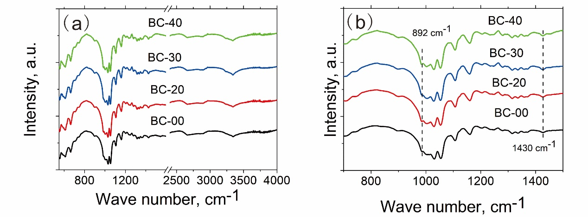
Fig. S1 FTIR spectra of BC films with different wet-stretching: (a) spectra from 550 to 4000 cm⁻¹ (b) spectra from 550 to 1500 cm⁻¹.

Fig. S2 The density of BC films with different wet-stretching.

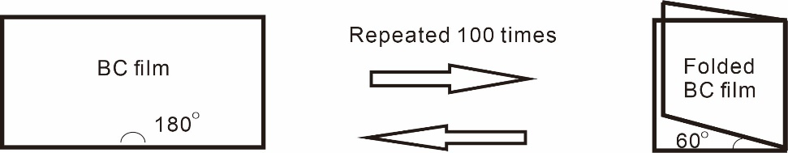
Fig. S3 The schematic diagram of the BC film fold and unfold.
Fig. S4 The tensile strength of BC films after folding 100 times (BC-00-F, BC-20-F, BC-30-F, and BC-40-F represent the BC-00, BC-20, BC-30, and BC-40 after folding 100 times).

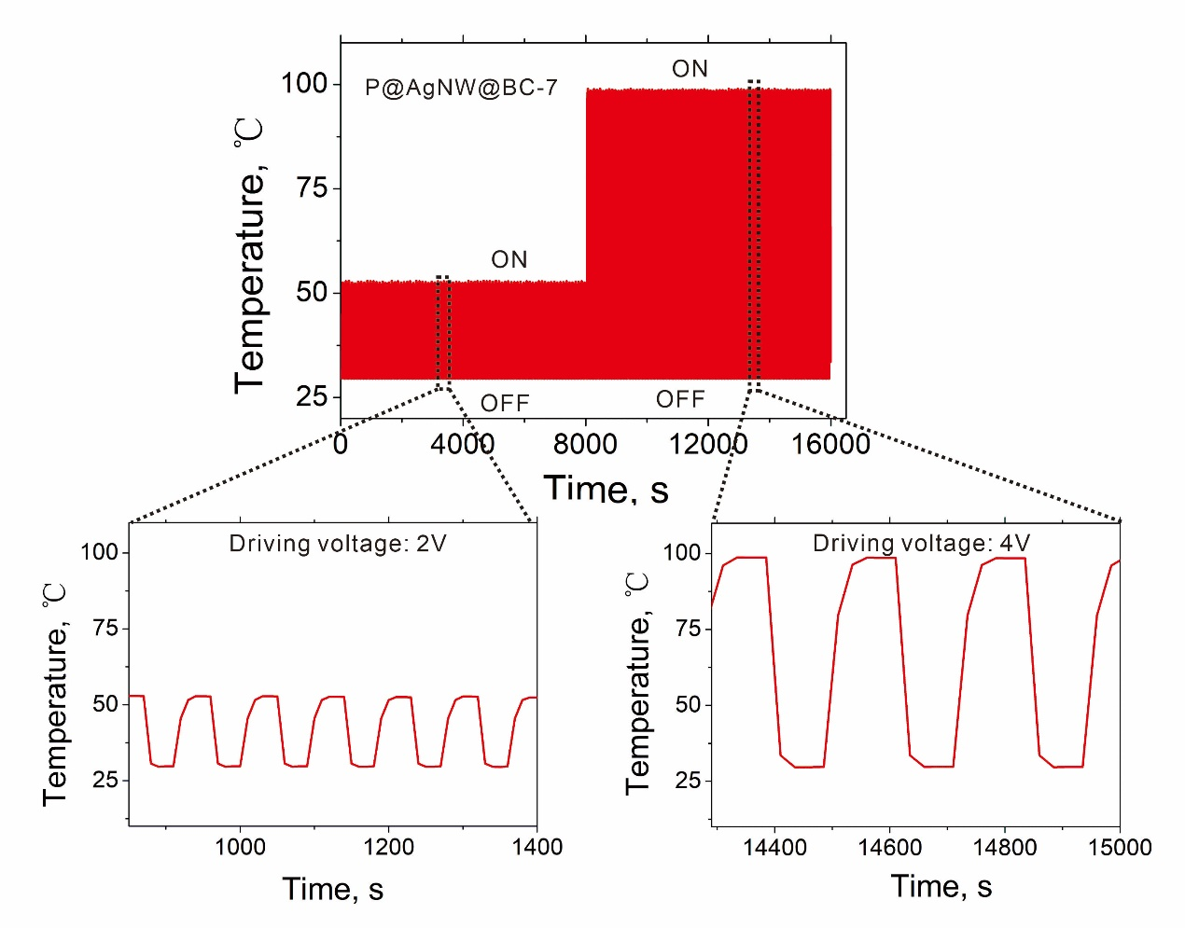
Fig. S5 Heating stability and repeatability of the P@AgNW@BC-7 film heater upon repeated driving voltages.

