Additional Material

Characterization of cold-active trehalose synthase from Pseudarthrobacter sp. for trehalose bioproduction

Srisakul Trakarnpaiboon¹, Benjarat Bunterngsook¹, Hataikarn Lekakarn², Daran Prongjit², Verawat Champreda^{1*}

¹Enzyme Technology Research Team, Biorefinery Technology and Bioproduct Research Group, National Center for Genetic Engineering and Biotechnology, 113 Thailand Science Park, Phahonyothin Road, Khlong Nueang, Khlong Luang, Pathumthani 12120, Thailand
²Department of Biotechnology, Faculty of Science and Technology, Thammasat University, Rangsit Campus, Khlong Nueang, Khlong Luang, Pathumthani 12120, Thailand

* Corresponding author. Address: National Center for Genetic Engineering and Biotechnology, 113 Thailand Science Park, Phahonyothin Road, Khlong Luang, Pathumthani 12120, Thailand. Tel.: +66 2564 6700 x 3446; fax: +66 2564 6707.
E-mail address: verawat@biotec.or.th (Verawat Champreda).
ORCID ID: 0000-0001-7768-1340

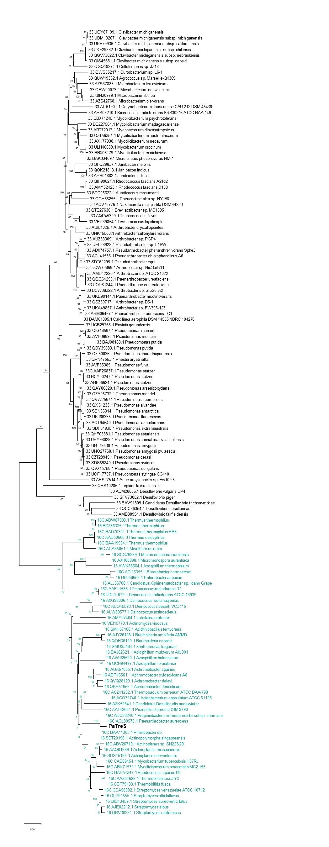

Fig. S1 Evolutionary analysis of PaTreS and homolog sequences classified in GH13 subfamily GH13_16 and GH13_33 subfamilies (Table S1).

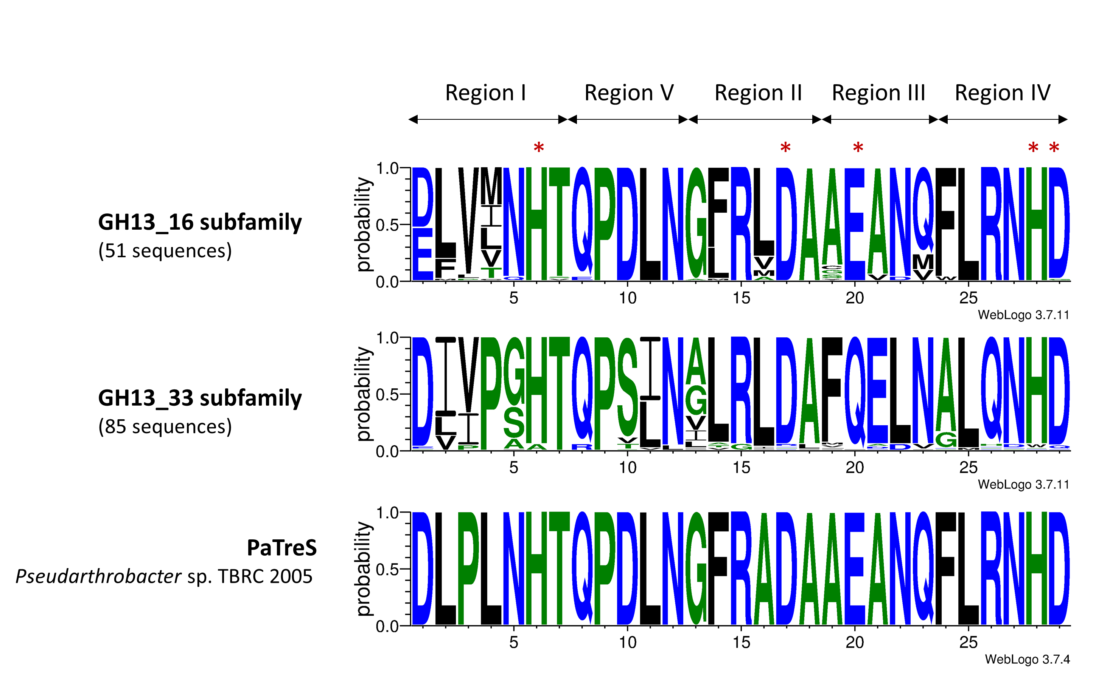

Fig. S2 Fiver conserved regions found in PaTreS compared with trehalose synthases from GH13_16 and GH13_33 subfamilies (Table S1). The key amino acids are marked with the asterisks.

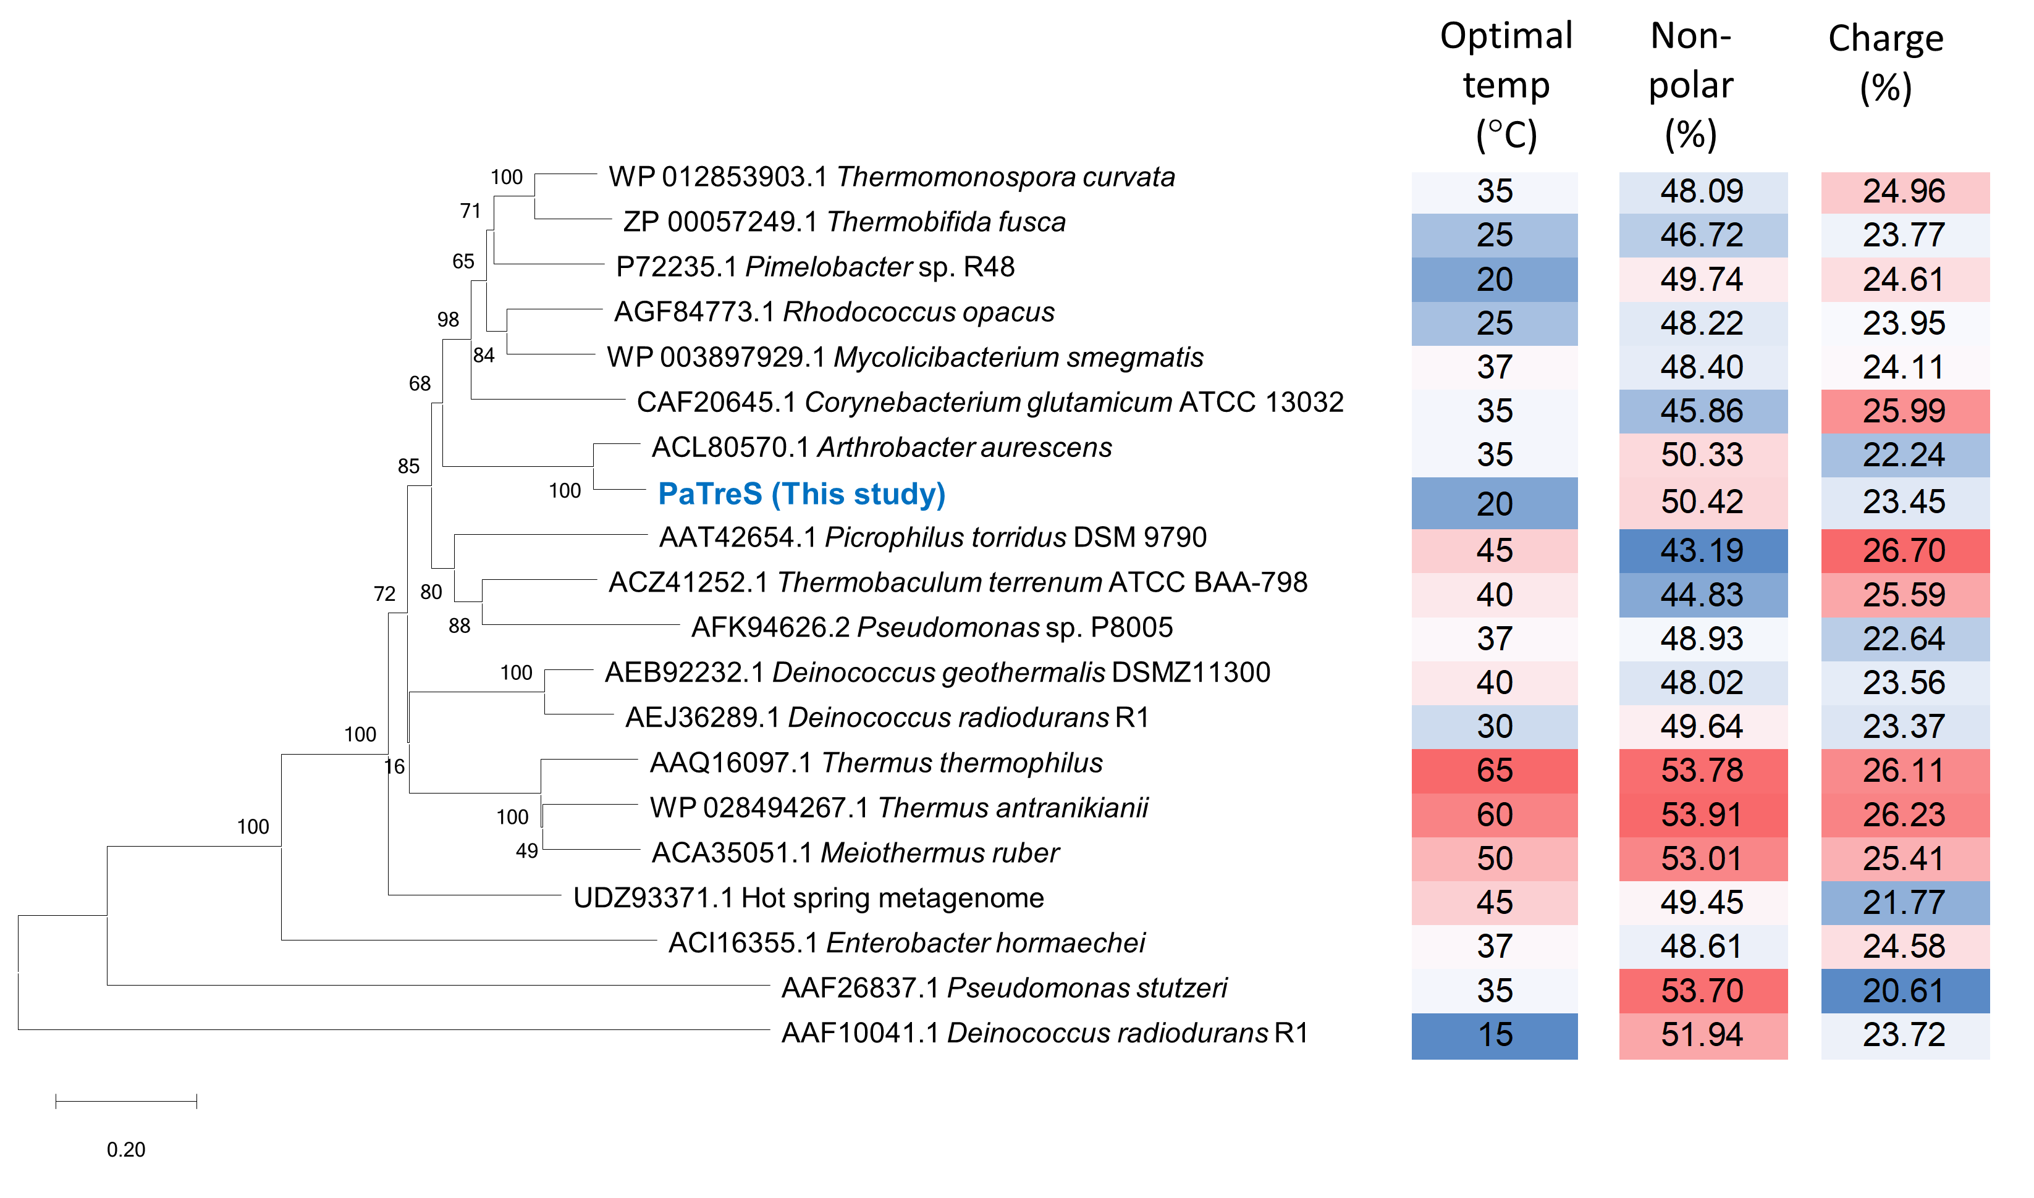

Fig. S3 Evolutionary analysis of PaTreS and biochemically characterized trehalose synthases. The optimal temperature and percentage of non-polar and charge residues were presented as heatmap color diagram.

Table S1. List of trehalose synthases from GH13_16 and GH13_33 subfamilies used in conserved region analysis
Subfamily | Accession no. | Species
16 | AAT42654.1 | Picrophilus torridus DSM 9790
16 | ABV26719.1 | Actinoplanes sp.
16 | ACO45593.1 | Deinococcus deserti
16 | AAF11586.1 | Deinococcus radiodurans
16 | ACI16355.1 | Enterobacter hormaechei
16 | ACA35051.1 | Meiothermus ruber
16 | CAB09454.1 | Mycobacterium tuberculosis
16 | ABK71531.1 | Mycolicibacterium smegmatis
16 | ACL80570.1 | Paenarthrobacter aurescens
16 | BAA11303.1 | Pimelobacter sp.
16 | ABC88240.1 | Propionibacterium freudenreichii subsp. Shermanii
16 | BAH54347.1 | Rhodococcus opacus
16 | CCA58382.1 | Streptomyces venezuelae ATCC 10712
16 | ACZ41252.1 | Thermobaculum terrenum ATCC BAA-798
16 | AAZ54622.1 | Thermobifida fusca
16 | BAA19934.1 | Thermus thermophilus
16 | AAD50660.3 | Thermus caldophilus
16 | BAD70301.1 | Thermusthermophilus
16 | ABW87308.1 | Thermus thermophilus
16 | QVQ28129.1 | Achromobacter deleyi
16 | QKH51656.1 | Achromobacter denitrificans
16 | AUA57805.1 | Achromobacter spanius
16 | ADP16561.1 | Achromobacter xylosoxidans
16 | BAJ82621.1 | Acidiphilium multivorum
16 | SMH67166.1 | Acidithiobacillus ferrivorans
16 | AMY07404.1 | Luteitalea pratensis
16 | ACO31740.1 | Acidobacterium capsulatum
16 | VEI15770.1 | Actinomyces viscosus
16 | SDS15185.1 | Actinoplanes derwentensis
16 | AAQ01689.1 | Actinoplanes missouriensis
16 | SDT20198.1 | Actinopolymorpha singaporensis
16 | AWJ89590.1 | Azospirillum baldaniorum
16 | QCN94497.1 | Azospirillum brasilense
16 | AWK86664.1 | Azospirillum thermophilum
16 | AJY26108.1 | Burkholderia ambifaria
16 | QOH36190.1 | Burkholderia cepacia
16 | AZK59341.1 | Candidatus Desulforudis audaxviator
16 | ALJ56766.1 | Candidatus Xiphinematobacter sp.
16 | ALW89577.1 | Deinococcus actinosclerus
16 | UDL01079.1 | Deinococcus radiodurans ATCC 13939
16 | AXG98006.1 | Deinococcus wulumuqiensis
16 | BBJ58658.1 | Enterobacter asburiae
16 | SCG76259.1 | Micromonospora siamensis
16 | AXH88898.1 | Micromonospora aurantiaca
16 | QLP91555.1 | Streptomyces albidoflavus
16 | AJE82212.1 | Streptomyces albus
16 | QIB43459.1 | Streptomyces aureoverticillatus
16 | QRV30231.1 | Streptomyces californicus
16 | CBF79133.1 | Thermobifida fusca
16 | BCZ86325.1 | Thermus thermophilus
16 | SMQ93484.1 | Xanthomonas fragariae
33 | AAF26837.1 | Pseudomonas stutzeri
33 | QUW19352.1 | Agrococcus sp.
33 | ABS27514.1 | Anaeromyxobacter sp.
33 | AUI51025.1 | Arthrobacter crystallopoietes
33 | AMB42226.1 | Arthrobacter sp. ATCC 21022
33 | QSZ50717.1 | Arthrobacter sp.
33 | UKA49857.1 | Arthrobacter sp.
33 | BCW73868.1 | Arthrobacter sp.
33 | AUZ33309.1 | Arthrobacter sp.
33 | BCW38322.1 | Arthrobacter sp.
33 | UNK45560.1 | Arthrobacter sulfonylureivorans
33 | SDD95622.1 | Auraticoccus monumenti
33 | QTE27630.1 | Brevilactibacter sp.
33 | BAM01395.1 | Caldilinea aerophila DSM 14535
33 | BAV91809.1 | Candidatus Desulfovibrio trichonymphae
33 | QGQ19274.1 | Cellulomonas sp.
33 | UGY87199.1 | Clavibacter michiganensis
33 | UKF79936.1 | Clavibacter michiganensis subsp. Californiensis
33 | QIS45681.1 | Clavibacter michiganensis subsp. Capsici
33 | UKF29882.1 | Clavibacter michiganensis subsp. Chilensis
33 | UDM13207.1 | Clavibacter michiganensis subsp. Michiganensis
33 | QGV73022.1 | Clavibacter michiganensis subsp. Nebraskensis
33 | AIT61901.1 | Corynebacterium doosanense
33 | QWS35217.1 | Curtobacterium sp.
33 | QCC86354.1 | Desulfovibrio desulfuricans
33 | AMD88954.1 | Desulfovibrio fairfieldensis
33 | SFV73052.1 | Desulfovibrio piger
33 | ABM28856.1 | Desulfovibrio
33 | UCB29768.1 | Erwinia gerundensis
33 | QOK21813.1 | Janibacter indicus
33 | QFQ29837.1 | Janibacter melonis
33 | APH01882.1 | Janibacter indicus
33 | ABS05210.1 | Kineococcus radiotolerans
33 | QBS10285.1 | Legionella israelensis
33 | UIN30979.1 | Microbacterium binotii
33 | QEW00073.1 | Microbacterium caowuchunii
33 | AZS37885.1 | Microbacterium lemovicicum
33 | AZS42768.1 | Microbacterium oleivorans
33 | BAK33469.1 | Microlunatus phosphovorus
33 | ULN40659.1 | Mycobacterium crocinum
33 | ART72017.1 | Mycobacterium dioxanotrophicus
33 | BBX06179.1 | Mycolicibacterium aichiense
33 | QZT56351.1 | Mycolicibacterium austroafricanum
33 | BBZ27504.1 | Mycolicibacterium madagascariense
33 | AXK77938.1 | Mycolicibacterium neoaurum
33 | BBX71245.1 | Mycolicibacterium psychrotolerans
33 | ACV78776.1 | Nakamurella multipartita DSM 44233
33 | ABM06467.1 | Paenarthrobacter aurescens
33 | UKE99144.1 | Paenarthrobacter nicotinovorans
33 | UOD81244.1 | Paenarthrobacter ureafaciens
33 | QQQ64295.1 | Paenarthrobacter ureafaciens
33 | QPN47553.1 | Priestia aryabhattai
33 | QGH68255.1 | Pseudactinotalea sp.
33 | ACL41536.1 | Pseudarthrobacter chlorophenolicus
33 | SDT62295.1 | Pseudarthrobacter equi
33 | ADX74757.1 | Pseudarthrobacter phenanthrenivorans
33 | UEL28923.1 | Pseudarthrobacter sp.
33 | QXI51233.1 | Pseudomonas alvandae
33 | UBT79530.1 | Pseudomonas amygdali
33 | UNO27768.1 | Pseudomonas amygdali
33 | SDN36314.1 | Pseudomonas antarctica
33 | QXI50036.1 | Pseudomonas anuradhapurensis
33 | QAY86820.1 | Pseudomonas arsenicoxydans
33 | QHF03381.1 | Pseudomonas asturiensis
33 | AQT94540.1 | Pseudomonas azotoformans
33 | UBY98028.1 | Pseudomonas cannabina
33 | CZT28949.1 | Pseudomonas cerasi
33 | QVX15758.1 | Pseudomonas congelans
33 | SDF01935.1 | Pseudomonas extremaustralis
33 | UKJ66335.1 | Pseudomonas fluorescens
33 | QVW25674.1 | Pseudomonas fluorescens
33 | AVF55385.1 | Pseudomonas fulva
33 | QZA95732.1 | Pseudomonas mandelii
33 | QIG18587.1 | Pseudomonas monteilii
33 | AVH38895.1 | Pseudomonas monteilii
33 | BAJ08163.1 | Pseudomonas putida
33 | QDY39083.1 | Pseudomonas putida
33 | ABF06624.1 | Pseudomonas stutzeri
33 | BCY00247.1 | Pseudomonas stutzeri
33 | SDS59840.1 | Pseudomonas syringae
33 | UOF17797.1 | Pseudomonas syringae
33 | QIH99621.1 | Rhodococcus fascians
33 | AMY52423.1 | Rhodococcus fascians
33 | AQP45399.1 | Tessaracoccus flavus
33 | VEP39854.1 | Tessaracoccus lapidicaptus

