Additional material

The bacterial succession and its role in flavor compounds formation during the fermentation of cigar tobacco leaves
Hongyang Si, Kun Zhou, Tingyi Zhao, Bing Cui*, Fang Liu, Mingqin Zhao*
College of Tobacco Science, Flavors and Fragrance Engineering & Technology Research Center of Henan Province, Henan Agricultural University, Zhengzhou, Henan 450000, China

* Corresponding author
Mingqin Zhao*
zhaomingqin@henau.edu.cn
Bing Cui*
bingcui@henau.edu.cn

Table S1 Dynamic changes of organic acids during the fermentation process.
Table S2 Dynamic changes of amino acids during the fermentation process.
Table S3 Dynamic changes of aromatic compounds during the fermentation process.
Table S4 Connectors in the bacterial co-occurrence network of Hainan tobacco leaves.
Table S5 Connectors in the bacterial co-occurrence network of Sichuan tobacco leaves.
Figure S1 Rarefaction curves of all samples. The abscissa represents the amount of randomly selected sequencing data; the ordinate represents the number of species observed.
Figure S2 Core bacterial microbiome in Hainan and Sichuan samples and their distribution in different samples.
Figure S3 VIP plot of the bacteria by O2PLS modeling during Hainan (A) and Sichuan (B) cigar tobacco fermentation.
Figure S4 Hainan bacterial community composition of each co-occurrence network module.
Figure S5 Sichuan bacterial community composition of each co-occurrence network module.

Table S1 Dynamic changes of organic acids during the fermentation process.
Organic acid (mg/g) | Hainan |  |  |  |  | Sichuan
Organic acid (mg/g) | H1 (0d) | H2 (7d) | H3 (14d) | H4 (21d) | H5 (28d) | S1 (0d) | S2 (7d) | S3 (14d) | S4 (21d) | S5 (28d)
Oxalic acid | 34.37±1.72b | 39.62±1.63a | 34.96±1.03b | 36.5±0.56b | 29.48±2.14c | 40.42±1.76a | 39.13±1.26a | 35.42±1.53b | 32.95±1.47b | 29.61±0.85c
Malic acid | 40.27±1.73c | 47.48±1.18a | 45.06±0.62b | 37.26±0.98d | 30.75±0.95e | 203.64±3.32a | 200.35±1.66a | 159.65±3.44c | 168.26±1.94b | 136.85±1.25d
Citric acid | 7.93±0.30c | 12.57±0.80a | 10.50±0.50b | 7.36±0.17c | 5.85±0.19d | 33.84±1.71a | 29.43±1.24bc | 28.52±0.55c | 30.73±0.28b | 17.24±0.98d
Malonic acid | 5.61±0.31a | 4.60±0.36b | 4.73±0.32b | 4.02±0.16c | 2.93±0.38d | 5.95±0.27a | 5.28±0.41b | 3.75±0.25c | 2.92±0.09d | 3.03±0.02d
Fumaric acid | 1.70±0.08b | 2.21±0.32a | 1.95±0.09ab | 2.11±0.19a | 1.65±0.10b | 6.27±0.24b | 6.82±0.15a | 4.96±0.08c | 4.89±0.09c | 3.69±0.21d
Succinic acid | 1.27±0.02d | 1.37±0.02c | 1.61±0.01a | 1.41±0.06c | 1.49±0.05b | 2.63±0.05a | 2.73±0.06ab | 2.56±0.03bc | 2.43±0.06c | 2.24±0.10d
Palmitic acid | 1.70±0.17a | 1.37±0.06b | 1.62±0.02a | 1.43±0.02b | 1.43±0.12b | 1.56±0.08bc | 1.88±0.03a | 1.41±0.09c | 1.58±0.14b | 1.48±0.30d
Linoleic acid | 0.77±0.02a | 0.61±0.03b | 0.74±0.05a | 0.66±0.02b | 0.73±0.04a | 0.53±0.02b | 0.64±0.06a | 0.59±0.06ab | 0.55±0.02b | 0.38±0.05c
Oleic acid | 3.55±0.08a | 2.70±0.16c | 3.44±0.10a | 2.99±0.20bc | 3.21±0.36ab | 2.68±0.21bc | 3.23±0.11a | 2.50±0.04c | 2.83±0.06b | 1.77±0.51d
Stearic acid | 0.50±0.05a | 0.42±0.02b | 0.49±0.02a | 0.45±0.01b | 0.43±0.01b | 0.50±0.04b | 0.58±0.06a | 0.42±0.04c | 0.48±0.01bc | 0.28±0.04d
Total | 97.67±0.97c | 112.95±2.28a | 105.1±0.81b | 94.19±1.19d | 77.9±2.3e | 298.02±3.86a | 290.07±2.42b | 239.78±4.76d | 247.62±2.81c | 196.57±1.69e
Note: Values are mean ± standard error of the mean; (n=3). Statistical significance was assessed by one-way ANOVA followed by LSD multiple comparison test. Different lowercase letters indicate significant difference (p < 0.05).

Table S2 Dynamic changes of amino acids during the fermentation process.
Amino  acid (mg/g) | Hainan |  |  |  |  | Sichuan
Amino  acid (mg/g) | H1 (0d) | H2 (7d) | H3 (14d) | H4 (21d) | H5 (28d) | S1 (0d) | S2 (7d) | S3 (14d) | S4 (21d) | S5 (28d)
Asp | 7.07±0.18b | 12.62±1.57a | 11.18±0.27a | 6.71±0.55b | 4.82±0.61c | 10.67±1.1a | 9.82±0.99a | 10.15±1.13a | 10.04±0.92a | 11.11±1.12a
Pro | 1.18±0.01b | 0.81±0.07c | 1.27±0.06a | 0.80±0.03c | 0.56±0.11d | 3.52±0.38a | 3.02±0.45ab | 2.11±0.1c | 3.62±0.6a | 2.96±0.68bc
Glu | 1.33±0.08b | 1.54±0.01a | 1.36±0.05b | 1.21±013c | 1.15±0.05c | 2.75±0.02a | 2.37±0.41ab | 2.57±0.12a | 2.55±0.26a | 2.10±0.12b
Thr | 2.11±0.12a | 0.45±0.05b | 1.08±0.04c | 0.20±0.02d | 0.12±0.01c | 2.36±0.16a | 1.06±0.23b | 0.55±0.12c | 0.60±0.1c | 0.64±0.09c
Phe | 0.41±0.01b | 0.67±0.05a | 0.68±0.05a | 0.24±0.01c | 0.17±0.04d | 1.27±0.03a | 0.69±0.13b | 0.54±0.07bc | 0.47±0.14bc | 0.71±0.31c
Ser | 0.04±0.01d | 0.24±0.02b | 0.44±0.01a | 0.11±001c | 0.08±0.02c | 1.27±0.07a | 0.76±0.11b | 0.67±0.11b | 0.8±0.11b | 0.76±0.01b
Ala | 0.42±0.01b | 0.39±0.04b | 0.55±0.03a | 0.32±0.02c | 0.34±0.02c | 0.92±0.08a | 0.87±0.1a | 0.79±0.13a | 0.85±0.07a | 0.87±0.09a
GABA | 0.39±0.04ab | 0.34±0.02bc | 0.43±0.04a | 0.28±0.08cd | 0.24±0.03d | 0.84±0.02a | 0.78±0.22a | 0.62±0.1a | 0.76±0.06a | 0.66±0.06a
His | 0.39±0.01a | 0.36±0.03a | 0.35±0.05a | 0.12±0.02b | 0.08±0.01b | 0.55±0.05a | 0.25±0.12b | 0.19±0.08b | 0.17±0.07b | 0.15±005b
Trp | 0.26±0.02b | 0.30±0.02a | 0.22±0.02c | 0.06±002d | 0.03±0d | 0.49±0.03a | 0.19±0.01b | 0.10±0.01c | 0.04±0d | 0.03±0d
Lys | 0.20±0.02b | 0.32±0.04a | 0.34±0.01a | 0.16±0.03b | 0.11±0.01c | 0.45±0.15a | 0.36±0.19a | 0.38±0.02a | 0.40±0.08a | 0.40±0.02a
Val | 0.09±0.01c | 0.19±0.02a | 0.21±0.01a | 0.13±0.01b | 0.12±0.01b | 0.41±0.01a | 0.31±0.01c | 0.33±0.05c | 0.38±0.02ab | 0.35±0bc
Arg | 0.11±0.01b | 0.18±0a | 0.20±0.02a | 0.12±0.02b | 0.10±0.02b | 0.23±0.03a | 0.20±0.02a | 0.24±0.04a | 0.23±0.03a | 0.22±0.02a
Gly | 0.13±0.03a | 0.35±0.3a | 0.22±0.05a | 0.18±0.03a | 0.18±0.02a | 0.22±0.04a | 0.25±0.01a | 0.25±0.06a | 0.25±0.05a | 0.26±0.06a
Cys | 0.17±0.01ab | 0.19±0.02a | 0.17±0.02ab | 0.15±0.01b | 0.12±0.02c | 0.20±0.02a | 0.16±0.04ab | 0.14±0.02b | 0.15±0.01b | 0.14±0.02b
Leu | 0.06±0a | 0.18±0.01b | 0.20±0.01a | 0.11±0c | 0.11±0.01c | 0.17±0.01c | 0.19±0.01bc | 0.23±0.03a | 0.22±0.02ab | 0.20±0.01ab
Iso | 0.02±0b | 0.08±0.01a | 0.10±0.01a | 0.08±0.01a | 0.09±0.03a | 0.10±0.01c | 0.11±0c | 0.13±0b | 0.38±0.01a | 0.14±0.01b
Tyr | 0.06±0.02d | 0.12±0.01c | 0.20±0.02b | 0.11±0.01c | 0.24±0.02a | 0.10±0a | 0.06±0.01c | 0.07±0.01c | 0.8±0.01b | 0.06±0.01c
Met | 0.10±0.01a | 0.06±0.01b | 0.08±0.01ab | 0.06±0.01b | 0.07±0.02b | 0.09±0.02a | 0.06±0.03a | 0.06±0.02a | 0.09±0.02a | 0.06±0a
Total | 14.53±0.56b | 19.18±1.56a | 19.88±0.47a | 11.15±0.98c | 8.74±0.97d | 26.60±0.38a | 21.51±0.71b | 20.11±0.49b | 22.19±2.27b | 21.58±1.92b
Note: Values are mean ± standard error of the mean; (n=3). Statistical significance was assessed by one-way ANOVA followed by LSD multiple comparison test. Different lowercase letters indicate significant difference (p < 0.05).

Table S3 Dynamic changes of aromatic compounds during the fermentation process.
Compounds (μg/g) |  | Hainan |  |  | Sichuan
 |  | H1 (0 d) | H3 (14 d) | H5 (28 d) | S1 (0 d) | S3 (14 d) | S5 (28 d)
Degradation products of chlorophyll | Neophytadiene | 431.19±16.52b | 505.28±12.80a | 346.25±11.14c | 472.81±3.41c | 543.67±7.26a | 506.61±4.05b
Degradation products of carotenoid | 6-Methyl-5-hepten-2-one | 1.80±0.44a | 1.20±0.07a | 1.68±0.19a | 2.75±0.26a | 2.75±0.13a | 2.23±0.25a
Degradation products of carotenoid | Isophorone | 1.49±0.11a | 0b | 0b | 0.93±0.06a | 0.15±0.001b | 0c
Degradation products of carotenoid | Keto-isophorone | 0.40±0.02a | 0.44±0.04a | 0.40±0.03a | 0.50±0.06a | 0.30±0.03b | 0.22±0.01b
Degradation products of carotenoid | β-Cyclocitral | 0.47±0.02ab | 0.54±0.06a | 0.36±0.03b | 0.23±0.04a | 0.20±0a | 0.19±0.01a
Degradation products of carotenoid | β-Damascenone | 22.20±0.51a | 17.02±0.44b | 13.84±0.32c | 17.17±0.26a | 13.15±1.16b | 4.07±0.17c
Degradation products of carotenoid | β-Dihydrodamarone | 12.33±0.26b | 13.87±0.31a | 11.94±0.14b | 10.70±0.31a | 8.44±0.32b | 5.29±0.23c
Degradation products of carotenoid | Geranyl acetone | 3.74±0.37a | 3.61±0.29a | 3.65±0.1a | 4.09±0.18a | 2.40±0.12b | 2.67±0.34b
Degradation products of carotenoid | Dihydroactinidiolide | 5.41±0.25a | 6.17±0.3a | 6.38±0.33a | 10.73±0.45a | 10.20±0.15a | 6.15±0.35b
Degradation products of carotenoid | Megastigmatrienone I | 5.27±0.24b | 7.07±0.40a | 5.21±0.14b | 4.44±0.25a | 3.53±0.29a | 1.64±0.53b
Degradation products of carotenoid | Megastigmatrienone Ⅱ | 21.83±0.41b | 26.29±0.06a | 22.54±0.71b | 17.80±0.04a | 14.15±0.33b | 5.50±0.22c
Degradation products of carotenoid | Megastigmatrienone Ⅲ | 4.06±0.13b | 5.48±0.29a | 2.73±0.26c | 1.34±0.20a | 1.10±0.1ab | 0.80±0.09b
Degradation products of carotenoid | Megastigmatrienone Ⅳ | 25.22±2.11b | 30.67±3.07a | 25.60±0.88b | 5.29±0.33a | 4.92±0.09a | 1.87±0.34b
Degradation products of carotenoid | 3-Hydrogen-dihydrodamascone | 5.13±0.11a | 6.32±0.5a | 5.11±0.29a | 18.18±0.26a | 14.10±0.58b | 6.72±0.30c
Degradation products of carotenoid | Farnesyl acetone | 9.77±0.36b | 14.62±0.34a | 11.6±0.72b | 11.36±0.31a | 12.27±0.43a | 11.38±0.40
Degradation products of Phenylalanine | Benzyl alcohol | 7.81±0.38b | 7.45±0.41b | 9.86±0.74a | 16.25±0.32a | 12.00±0.58b | 6.59±0.26c
Degradation products of Phenylalanine | Phenethyl alcohol | 14.22±0.62b | 15.36±0.34a | 14.44±1.22b | 15.52±0.23a | 12.63±0.36b | 9.09±0.38c
Degradation products of Phenylalanine | Benzaldehyde | 5.07±0.37a | 4.95±0.14a | 4.41±0.27a | 3.56±0.23b | 5.81±0.47a | 3.95±0.31b
Degradation products of Phenylalanine | Phenylacetaldehyde | 17.07±1.87b | 19.57±1.16a | 7.60±0.43c | 11.24±0.33a | 12.33±0.28a | 8.92±0.46b
Degradation products of Siebel alkane | Solanone | 38.30±2.9b | 53.73±3.81a | 34.10±0.4c | 37.99±2.74a | 30.90±0.59b | 23.58±0.08c
Maillard reaction products | Furfuryl alcohol | 2.70±0.27a | 2.56±0.27a | 3.46±0.41a | 5.57±0.12a | 4.63±0.36a | 3.01±0.4b
Maillard reaction products | 2-Acetylfuran | 0.74±0.06a | 0.17±0.02b | 0.18±0.01b | 0.37±0.04a | 0.23±0.03b | 0.12±0.01c
Maillard reaction products | 5-Methyl furfural | 3.43±0.3c | 8.89±0.30b | 12.50±0.24a | 2.50±0.26c | 3.11±0.07b | 4.26±0.12a
Maillard reaction products | 3,4-methyl-2,5-furanone | 1.56±0.11a | 1.33±0.24a | 1.82±0.16a | 3.35±0.29a | 3.0±0.06ab | 2.50±0.05b
Maillard reaction products | 2-Acetyl pyrrole | 0.13±0.03a | 0.13±0.02a | 0.07±0b | 0.13±0.03a | 0.18±0.02a | 0.18±0a
Others | Linalool | 1.04±0.44a | 1.19±0.17a | 0.89±0.36a | 2.46±0.47a | 1.89±0.19ab | 1.24±0.04b
Others | 2, 6-Nonadienal | 0.35±0.02a | 0.30±0.01b | 0.21±0.01c | 1.07±0.08a | 0.89±0.05b | 0.53±0.05c
Others | Guaiacol | 0.79±0.31a | 0.93±0.19a | 0.82±0.06a | 1.25±0.26a | 0.97±0.10ab | 0.63±0.02b
Others | Solavetivone | 0.52±0.06b | 0.73±0.02a | 0.51±0.01b | 0.37±0.06a | 0.49±0.01ab | 0.65±0.08a
Others | Safranal | 0.1±0.01a | 0.13±0.02a | 0.08±0.03a | 0.18±0.03a | 0.16±0.01a | 0.15±0.03a
Total |  | 644.14±6.11b | 756.00±18.53a | 548.25±4.79c | 680.13±6.22b | 720.55±9.30a | 620.74±7.00c
Note: Values are mean ± standard error of the mean; (n=3). Statistical significance was assessed by one-way ANOVA followed by LSD multiple comparison test. Different lowercase letters indicate significant difference (p < 0.05).

Table S4 Connectors in the bacterial co-occurrence network of Hainan tobacco leaves.
OTU | No. module | Zi | Pi | Genus | Relative abundance (%)
OTU19 | 2 | -1.92961 | 0.666667 | Comamonas | 0.16
OTU1980 | 3 | -0.52375 | 0.666667 | Pseudomonas | 1.42
OTU2308 | 3 | -0.1654 | 0.65625 | Bacillus | 0.85
OTU2595 | 3 | -0.88211 | 0.625 | Romboutsia | 0.75
OTU603 | 4 | -1.05328 | 0.72 | Microbacterium | 0.74
OTU518 | 3 | -0.88211 | 0.625 | Cutibacterium | 0.68
OTU3261 | 3 | -0.1654 | 0.65625 | Corynebacterium | 0.41
OTU2460 | 1 | 1.542816 | 0.702222 | Massilia | 0.32
OTU674 | 0 | -1.19452 | 0.75 | Bacteroides | 0.24
OTU2935 | 1 | -1.30546 | 0.666667 | Labilithrix | 0.23
OTU1875 | 2 | 0 | 0.642857 | Thauera | 0.23
OTU270 | 0 | -1.19452 | 0.75 | Enterococcus | 0.21
OTU43 | 4 | -1.05328 | 0.625 | Cloacibacterium | 0.19
OTU1356 | 3 | -0.1654 | 0.694215 | unclassified_f__Rhizobiaceae | 0.18
OTU954 | 3 | -0.52375 | 0.693878 | Enterobacter | 0.17
OTU107 | 1 | 2.492241 | 0.648199 | unclassified_f__Rhizobiaceae | 0.17
OTU343 | 4 | 0.247831 | 0.641975 | Tumebacillus | 0.16
OTU2423 | 4 | 0.247831 | 0.722222 | Lawsonella | 0.16
OTU537 | 2 | 0.385922 | 0.650888 | Parafrigoribacterium | 0.16
OTU580 | 0 | -0.92479 | 0.625 | Kocuria | 0.16
OTU682 | 2 | -0.38592 | 0.694215 | Balneola | 0.14
OTU2859 | 1 | -0.35603 | 0.693878 | Burkholderia-Caballeronia-Paraburkholderia | 0.13
OTU2128 | 2 | -1.92961 | 0.666667 | Clostridium_sensu_stricto_1 | 0.13
OTU474 | 3 | -0.1654 | 0.65625 | Tumebacillus | 0.13
OTU24 | 2 | 0 | 0.674556 | norank_f__Rhizobiaceae | 0.12
OTU71 | 0 | -0.92479 | 0.722222 | Solirubrobacter | 0.12
OTU838 | 4 | 0.247831 | 0.68 | Arthrobacter | 0.11

Table S5 Connectors in the bacterial co-occurrence network of Sichuan tobacco leaves.
OTU | No.Module | Zi | Pi | Genus | Relative abundance (%)
OTU3211 | 0 | -0.14704 | 0.625 | Delftia | 4.80
OTU1855 | 5 | -1.14485 | 0.666667 | Klenkia | 0.76
OTU2815 | 3 | -0.79077 | 0.625 | Pseudokineococcus | 0.57
OTU626 | 2 | -0.79862 | 0.72 | Nitrosomonas | 0.42
OTU1805 | 0 | -0.14704 | 0.625 | Massilia | 0.37
OTU2125 | 1 | 0.470592 | 0.693878 | Alicyclobacillus | 0.19
OTU1572 | 2 | -1.3754 | 0.666667 | Aureimonas | 0.14
OTU2911 | 3 | 0.431331 | 0.65625 | norank_f__67-14 | 0.13
OTU3162 | 0 | -0.80874 | 0.666667 | unclassified_c__  Gammaproteobacteria | 0.13
OTU3295 | 0 | 0.51465 | 0.666667 | Georgenia | 0.12
OTU765 | 2 | 0.354943 | 0.74 | norank_f__Steroidobacteraceae | 0.12

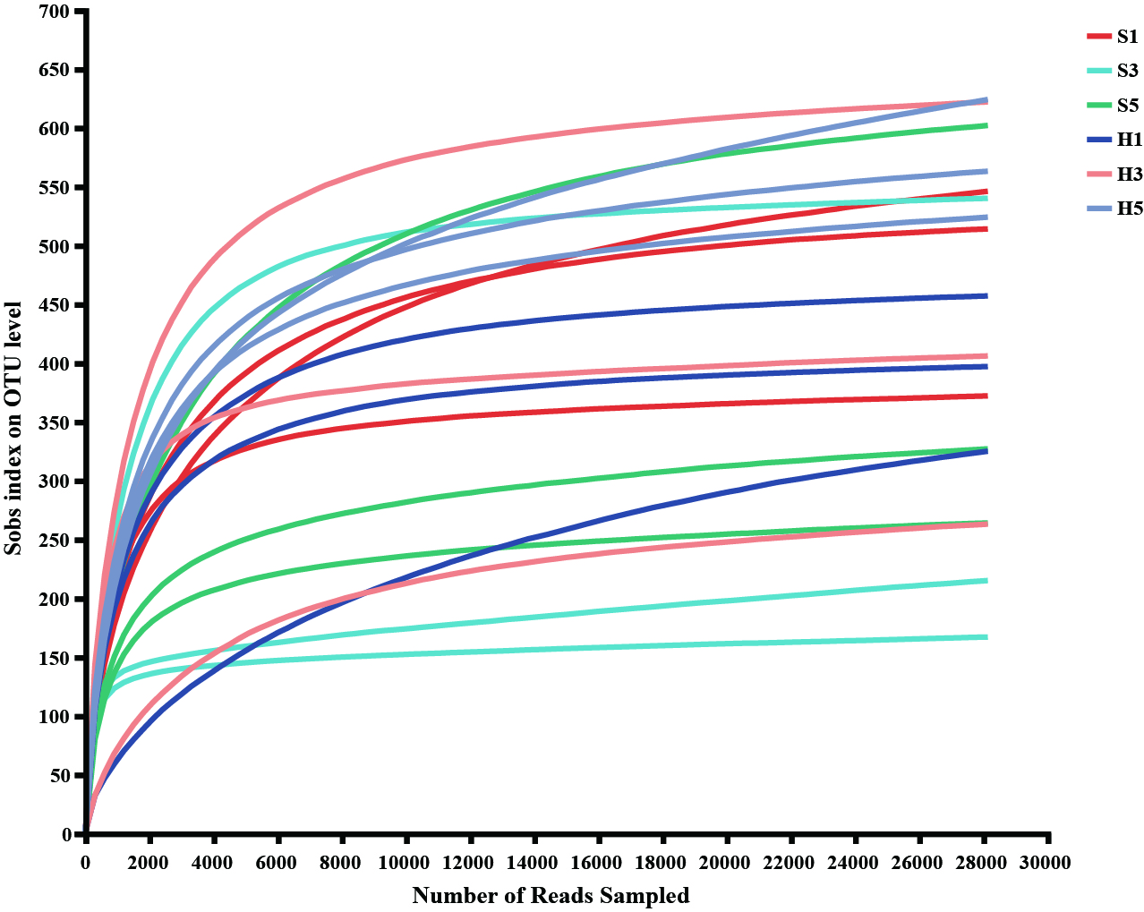
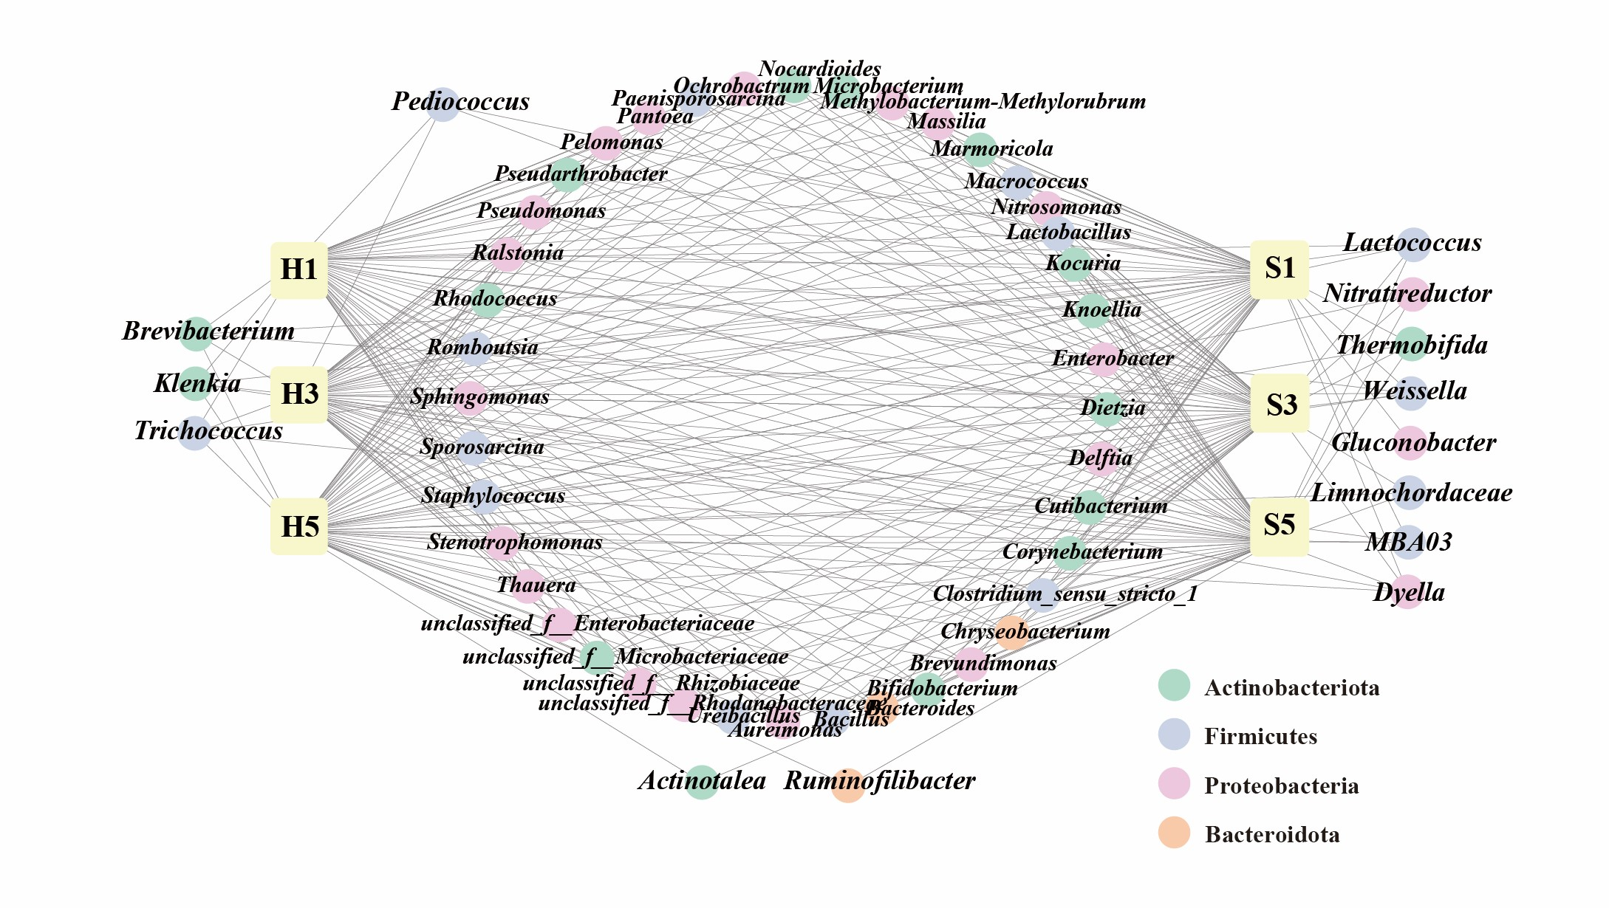
Figure S1 Rarefaction curves of all samples. The abscissa represents the amount of randomly selected sequencing data; the ordinate represents the number of species observed.
Figure S2 Core bacterial microbiome in Hainan and Sichuan samples and their distribution in different samples.

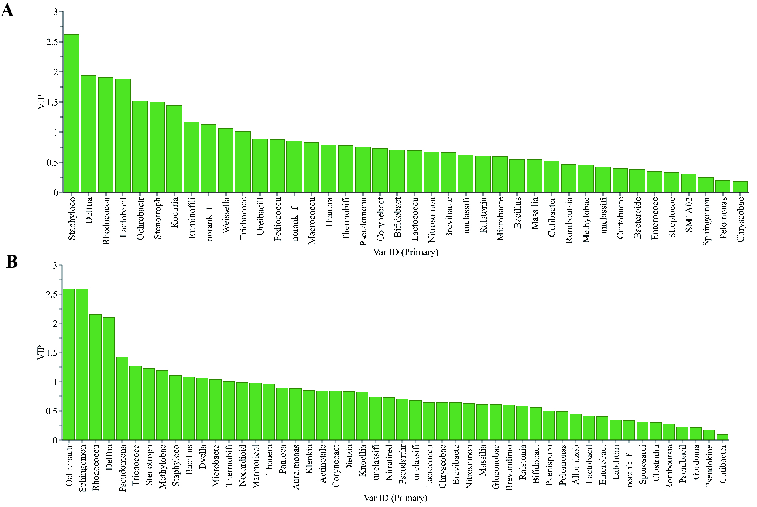
Figure S3 VIP plot of the bacteria by O2PLS modeling during Hainan (A) and Sichuan (B) cigar tobacco fermentation.

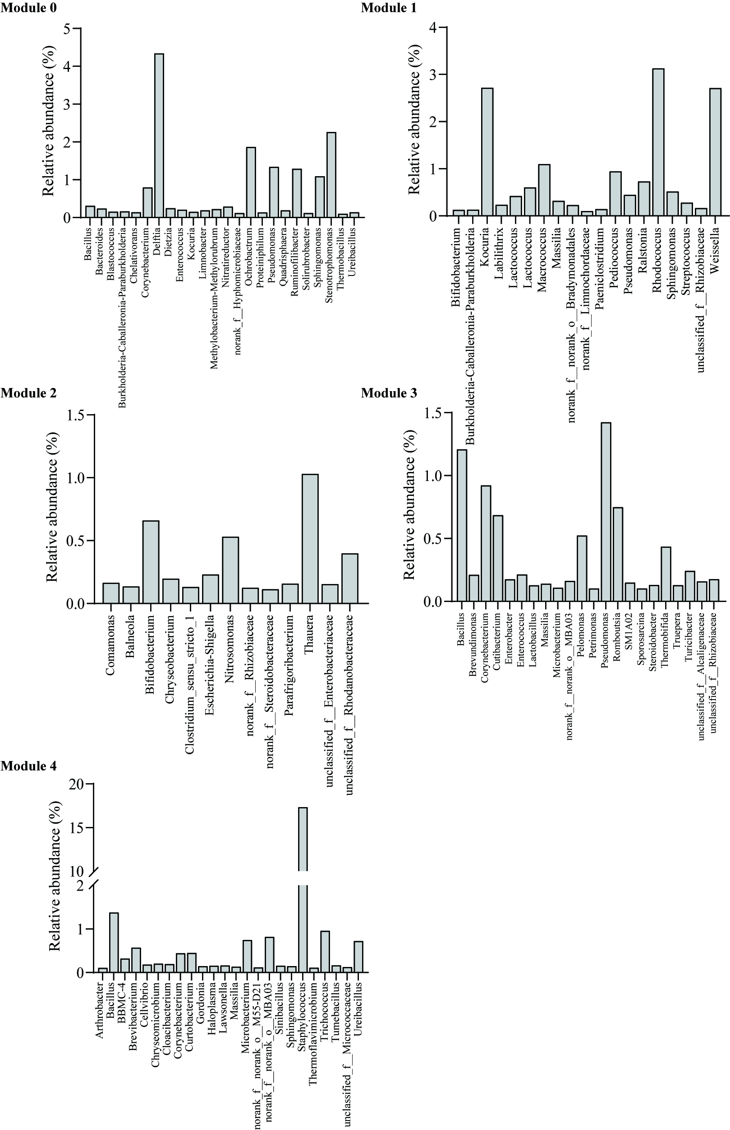
Figure S4 Hainan bacterial community composition of each co-occurrence network module.

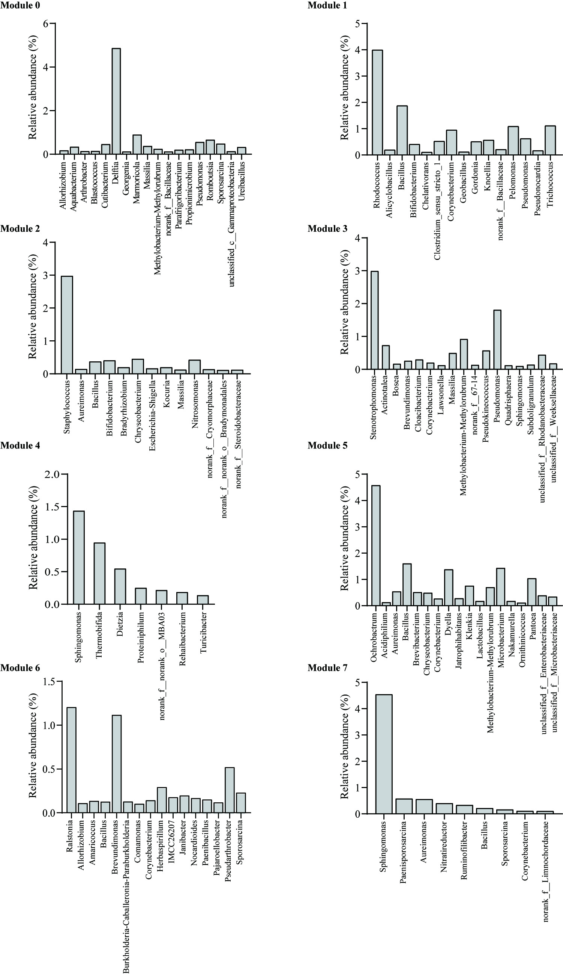
Figure S5 Sichuan bacterial community composition of each co-occurrence network module.

