Supporting information

Identification, Heterologous Expression and Characterization of a New Unspecific Peroxygenase from Marasmius fiardii PR-910
Xin Fu, Kexin Lin, Xiaodong Zhang, Zhiyong Guo, Lixin Kang*, Aitao Li*
State Key Laboratory of Biocatalysis and Enzyme Engineering, Hubei Key Laboratory of Industrial Biotechnology, School of Life Sciences, Hubei University, #368 Youyi Road, Wuhan, 430062 P.R. China.
*Correspondence: Lixin Kang, lixinkang2007@hubu.edu.cn; Aitao Li, aitaoli@hubu.edu.cn

Table of Contents
1 Table S1................................................................................................................................2
2 Table S2.................................................................................................................................2
3 Table S3.................................................................................................................................2
4 Fig. S1 …..............................................................................................................................3
5 Fig. S2 …..............................................................................................................................3
6 Fig. S3 …..............................................................................................................................3
7 Fig. S4 …..............................................................................................................................4
8 Fig. S5 …..............................................................................................................................4
9 Fig. S6 …..............................................................................................................................4
10 Fig. S7 …............................................................................................................................6

1 Table S1 GC analytical methods.
Substrate/products | Column | Temperature program/gradient | Retention time
1a  1b, 1c, 1d | GC  CP-Chirasil-DEX CB (Agilent)  (25 m × 0.25 mm, 0.25μm)  Carrier gas: N₂ | 100 ℃ hold 5 min  40 ℃/min to 140 ℃ hold 5 min  80 ℃/min to 180 ℃ hold 1 min | 3.18 min ethylbenzene  9.05 min (R)-1-phenylethanol  9.32 min (S)-1-phenylethanol  6.88 min acetophenone  7.42 min dodecane
2a  2b, 2c | GC  SH-Rtx-5  (30 m × 0.25 mm, 0.25μm)  Carrier gas: N₂ | 80℃ hold 5 min  10 ℃/min to 150 ℃ hold 10 min  80 ℃/min to 280 ℃ hold 2 min | 4.19 min phenol  8.38 min pyrocatechol  10.11 min hydroquinone  4.48 min decane
3a  3b | GC  SH-Rtx-5  (30 m × 0.25 mm, 0.25μm)  Carrier gas: N₂ | 90 ℃ hold 2 min  50 ℃/min to 150 ℃ hold 0 min  80 ℃/min to 210 ℃ hold 0 min  50 ℃/min to 280 ℃ hold 2 min | 9.37 min 4-OH β-ionone
4a  4b, 4c | GC  CP-Chirasil-DEX CB (Agilent)  (25 m × 0.25 mm, 0.25μm)  Carrier gas: N₂ | 100 ℃ hold 5 min  40 ℃/min to 140 ℃ hold 5 min  80 ℃/min to 180 ℃ hold 1 min | 4.17 min styrene  7.41 min (R)-styrene oxide  7.57 min (S)-styrene oxide
5a  5b, 5c, 5d | GC  SH-Rtx-5  (30 m × 0.25 mm, 0.25μm)  Carrier gas: N₂ | 80 ℃ hold 0 min  50 ℃/min to 135 ℃ hold 0 min  80 ℃/min to 240 ℃ hold 2 min | 4.38 min 2,3-isophorone epoxide  4.69 min isophorone  4.89 min 2,2,6-trimethylcyclo hexane-1,4-dione ketone  7.16 min 4-hydroxyisophoron

2 Table S2 Amino acid sequence of MfiUPO (accession code, KAF9267131.1) from M. fiardii PR910.
Site | Amino acid sequence
1-60  61-120  121-180  181-240  241-260 | mknllslifi avavtastds qvdwsahrwq apgpsdtrgp cpglntlanh gflprngrni  sipmilqagh egyhiepsil tiaakvgllt spsdqpttfs ledikahgvi ehdaslsrqd  ialgdnvhfn etifstlans npgsdvyntt sagqvlqarl adslknnpnv tntdlthvir  gaesafylsv mgdpiqgvap kkfvqiffre erlpieegwk rtnisitldv vgalvdktfe  adpaweptgk ncpgiqlpdv

3 Table S3 The NBD activities of rMfiUPO in recombinant strains constructed with pPICZ-A and pHBM905M vectors, respectively.

Vector | NBD activity (U L⁻¹)
Vector | 1-copy | 2-copy | 3-copy | 4-copy
pPICZ-A | 457 | 912 | 705 | 685
pHBM905M | 275 | 459 | 596 | 703

4 Fig. S1 Construction and confirmation of multi-copy expression cassette plasmid.
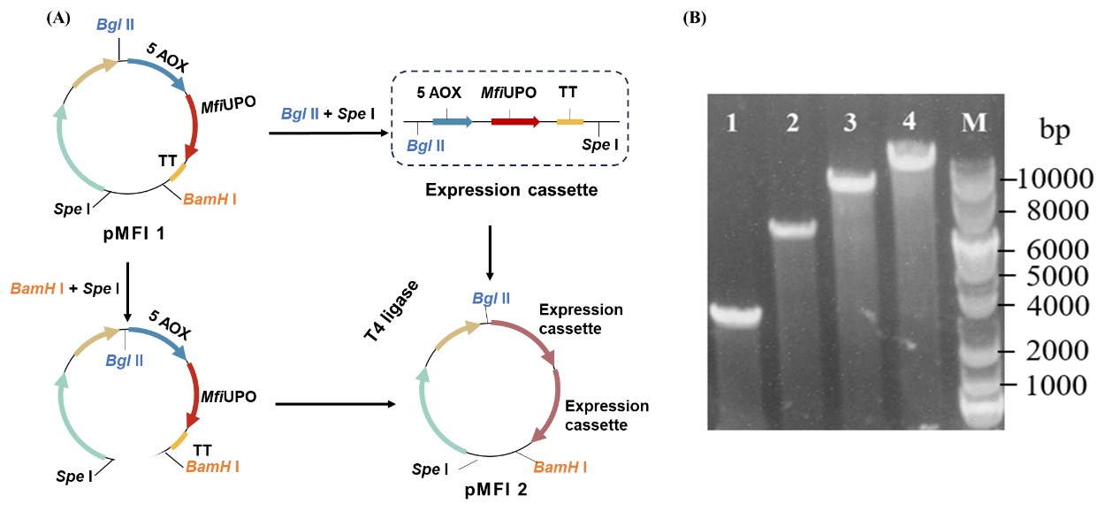
Fig. S1 A Construction of multi-copy expression cassette plasmid. B Multiple-copy recombinant plasmids confirmed by Bgl II digestion. 1, 2, 3 and 4 were single copy, 2-copy, 3-copy and 4-copy, respectively.

5 Fig. S2 Activity determination of rMfiUPO and deglycosylated rMfiUPO.
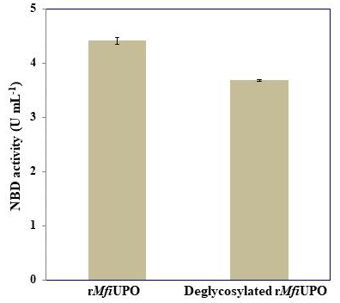
Fig. S2 After appropriate dilution, the NBD activities of rMfiUPO and deglycosylated rMfiUPO were 4.41 U mL⁻¹ and 3.68 U mL⁻¹, respectively.

6 Fig. S3 GC analysis of ethylbenzene and conversion products.
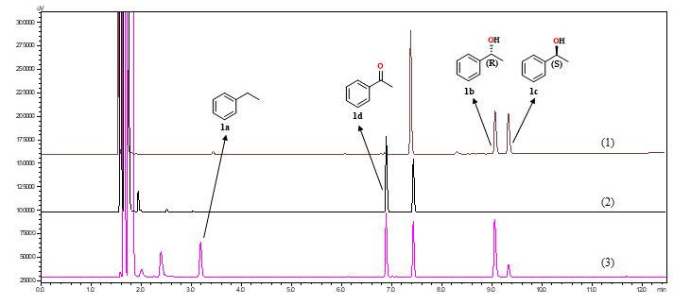
Fig. S3 Stacked GC-FID traces of the biotransformation of ethylbenzene (1a) with rMfiUPO. (1) (R)- and (S)-phenylethanol standards, (2) acetophenone standard, (3) reaction mixture.

7 Fig. S4 GC analysis of phenol and conversion products.
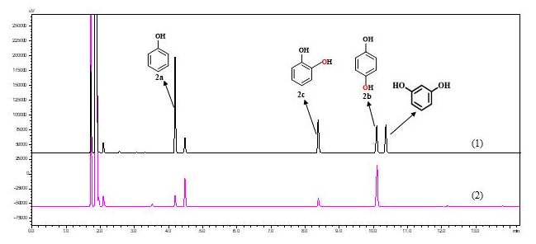
Fig. S4 Stacked GC-FID traces of the biotransformation of phenol (2a) with rMfiUPO. (1) phenol, catechol, hydroquinone and resorcinol standards, (2) reaction mixture.

8 Fig. S5 GC analysis of styrene and conversion products.
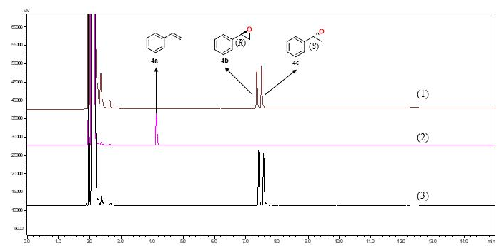
Fig. S5 Stacked GC-FID traces of the biotransformation of styrene (4a) with rMfiUPO. (1) (R)- and (S)-styrene oxide standards, (2) styrene standard, (3) reaction mixture.

9 Fig. S6 GC/GC-MS analysis of isophorone and conversion products.
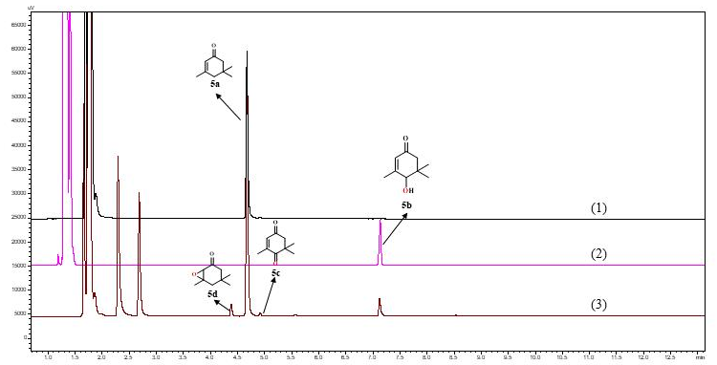
Fig. S6a Stacked GC-FID traces of the biotransformation of isophorone (5a) with rMfiUPO. (1) Isophorone standard, (2) 4-hydroxyisophoron standard, (3) reaction mixture.

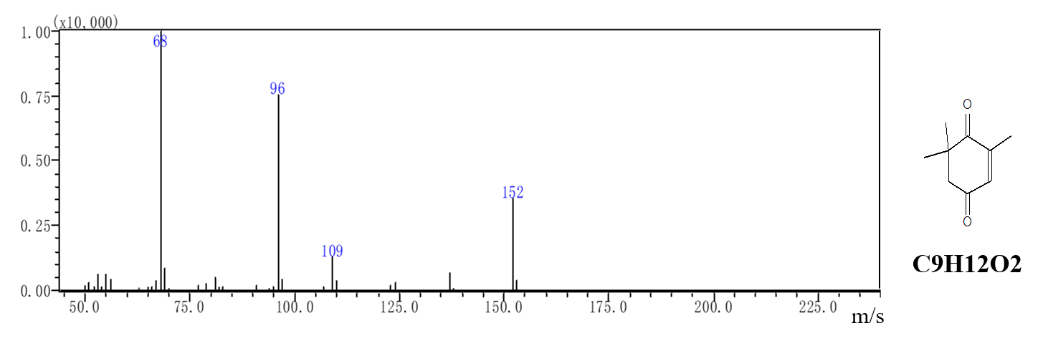
Fig. S6b GC-MS analysis of 2,2,6-trimethylcyclo hexane-1,4-dione ketone (5c) structural assignment. Analytical method: SH-Rtx-5 (SHIMADZU) (30 m × 0.25 mm, 0.25μm), Carrier gas: He, temperature program: 100 ℃ hold 2 min, 10 ℃/min to 190 ℃ hold 2 min, 40 ℃/min to 280 ℃ hold 3 min.

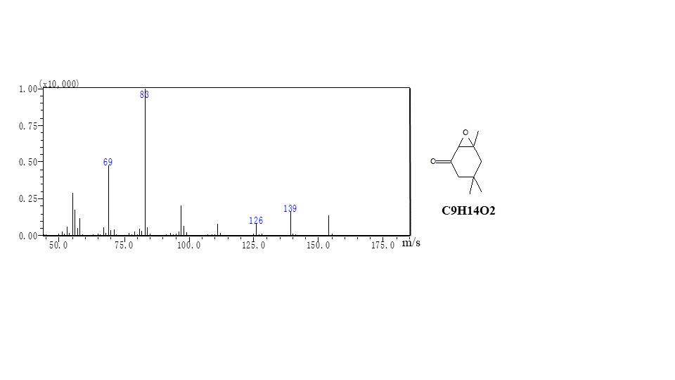
Fig. S6c GC-MS analysis of 2,3-isophorone epoxide (5d) structural assignment. Analytical method: SH-Rtx-5 (SHIMADZU) (30 m × 0.25 mm, 0.25μm), Carrier gas: He, temperature program: 100 ℃ hold 2 min, 10 ℃/min to 190 ℃ hold 2 min, 40 ℃/min to 280 ℃ hold 3 min.

10 Fig. S7: NMR spectra of 4-OH-β-ionone (3b), isolated from semi-preparative scale biotransformation.
Fig. S7 Top: ¹H NMR (400 MHz, DMSO-d₆): δ_{H} 7.18 (1H, d, J = 16.5 Hz), 6.03 (1H, d, J = 16.5 Hz), 4.81 (1H, d, J = 6.2 Hz), 2.26 (3H, s), 1.76 (3H, s), 1.75 (1H, m), 1.61 (1H, m), 1.57 (1H, m), 1.35 (1H, m), 1.03 (3H, s), 1.00 (3H, s). Bottom: ¹³C NMR (100 MHz, DMSO-d₆): δ_{C} 197.9, 142.2, 137.1, 136.4, 132.3, 68.1, 34.9, 34.2, 28.5, 28.2, 27.7, 27.2, 18.3.

