Additional file 2 Amplification of target gene (gel6)
The target gene (gel6) was amplified from pUC57-gel6 using the gel6-F/gel6-R primers (Additional file1 2: Table S1) and DNA polymerase. The PCR program consisted of 30 cycles, with each cycle lasting for 40 seconds at 95ºC, followed by 50 seconds at 54ºC and then 120 seconds at 72 ºC. As a result, a 1301bp gene fragment was obtained, which contained restriction enzyme cutting sites, and a 6×His tag, consistent with the predicted results (Fig. S 1).
Table S1 List of the primers
Prime | Prime sequence（5′→3′）
gel6-F | CTCGAGAAAAGA GGTGAAAGAGGTGATCCAGGTTCTCCAGGTAATCAAGGTCAAC
gel6-R | GCGGCCGCTTAATGGTGATGGTGATGATGAGAAGCGCCTCTCTCACCACGTTCG

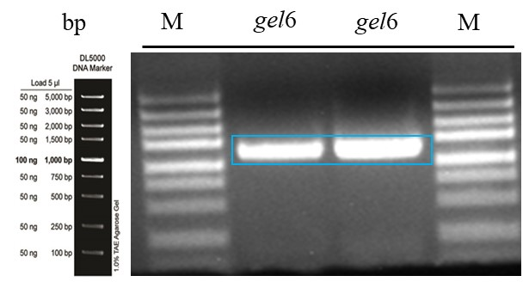
Fig. S1 Gel electrophoresis results for the amplification products of the target gene (gel6)

