Supporting Information

Production of rare ginsenosides by biotransformation of Panax notoginseng saponins using Aspergillus fumigatus
Lian Yang¹, Dongmei Lin¹, Feixing Li¹, Xiuming Cui¹, Dengji Lou^{2*}, Xiaoyan Yang¹*
Abstract
Panax notoginseng saponins (PNS) are the main active components of Panax notoginseng. But after oral administration, they need to be converted into rare ginsenosides by human gut microbiota and gastric juice before they can be readily absorbed into the bloodstream and exert their effects. The sources of rare ginsenosides are extremely limited in P. notoginseng and other medical plants, which hinders their application in functional foods and drugs. Therefore, the production of rare ginsenosides by the transformation of PNS using Aspergillus fumigatus was studied in this research. During 50 days at 25 ℃ and 150 rpm, A. fumigatus transformed PNS to 14 products (1-14). They were isolated by varied chromatographic methods, such as silica gel column chromatography, Rp-C₁₈ reversed phase column chromatography, semi-preparative HPLC, Sephadex LH-20 gel column chromatography, and elucidated on the basis of their ¹H-NMR, ¹³C-NMR and ESIMS spectroscopic data. Then, the transformed products (1-14) were isolated and identified as Rk₃, Rh₄, 20 (R)-Rh₁, 20 (S)-Protopanaxatriol, C-K, 20 (R)-Rg₃, 20 (S)-Rg₃, 20 (S)-Rg₂, 20 (R)-R₂, Rk₁, Rg₅, 20 (S)-R₂, 20 (R)-Rg₂, and 20 (S)-I, respectively. In addition, all transformed products (1-14) were tested for their antimicrobial activity. Among them, compounds 5 (C-K) and 7 [20 (S)-Rg₃] showed moderate antimicrobial activities against Staphylococcus aureus and Candida albicans with MIC values of 6.25, 1.25 μg/mL and 1.25, 25 μg/mL, respectively. This study lays the foundation for production of rare ginsenosides.
Keywords Panax notoginseng saponins, biotransformation, rare ginsenosides, Aspergillus fumigatus, antimicrobial activity
Content

Figure S1. Proposed possible biosynthetic pathways of major ginsenosides Rg₁, Re, Rb₁ and notoginsenoside R₁ of PNF by A. fumigatus 3
Figure S2. HPLC analysis of transformation products of PNF by A. fumigatus 4
Figure S3. ¹H-NMR and ¹³C-NMR spectra of compound 1 5
Figure S4. ¹H-NMR and ¹³C-NMR spectra of compound 2 6
Figure S5. ¹H-NMR and ¹³C-NMR spectra of compound 3 7
Figure S6. ¹H-NMR and ¹³C-NMR spectra of compound 4 8
Figure S7. ¹H-NMR and ¹³C-NMR spectra of compound 5 9
Figure S8. ¹H-NMR and ¹³C-NMR spectra of compound 6 10
Figure S9. ¹H-NMR and ¹³C-NMR spectra of compound 7 11
Figure S10. ¹H-NMR and ¹³C-NMR spectra of compound 8 12
Figure S11. ¹H-NMR and ¹³C-NMR spectra of compound 9 13
Figure S12. ¹H-NMR and ¹³C-NMR spectra of compound 10 14
Figure S13. ¹H-NMR and ¹³C-NMR spectra of compound 11 15
Figure S14. ¹H-NMR and ¹³C-NMR spectra of compound 12 16
Figure S15. ¹H-NMR and ¹³C-NMR spectra of compound 13 17
Figure S16. ¹H-NMR and ¹³C-NMR spectra of compound 14 18
Figure S17. Separation flow diagram of compounds 1-14 19
Figure S18. TLC analysis of transformation products at different times during the conversion process 19
Table S1. ¹H and ¹³C NMR spectral data of 1-2 20
Table S2. ¹H and ¹³C NMR spectral data of 3-4 21
Table S3. ¹H and ¹³C NMR spectral data of 5-6 22
Table S4. ¹H and ¹³C NMR spectral data of 7-8 23
Table S5. ¹H and ¹³C NMR spectral data of 9-10 24
Table S6. ¹H and ¹³C NMR spectral data of 11-12 25
Table S7. ¹H and ¹³C NMR spectral data of 13-14 26

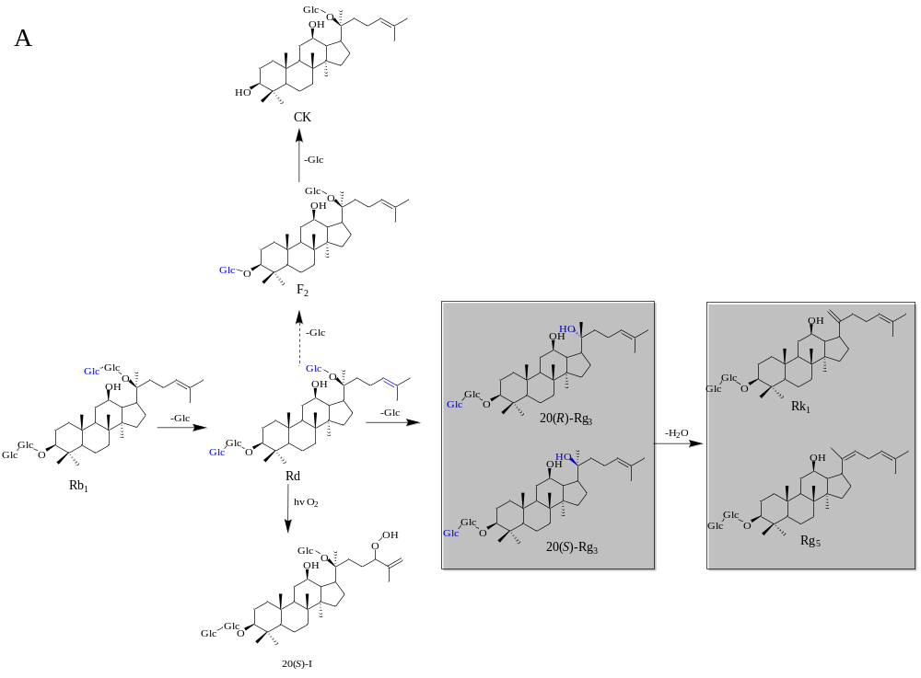
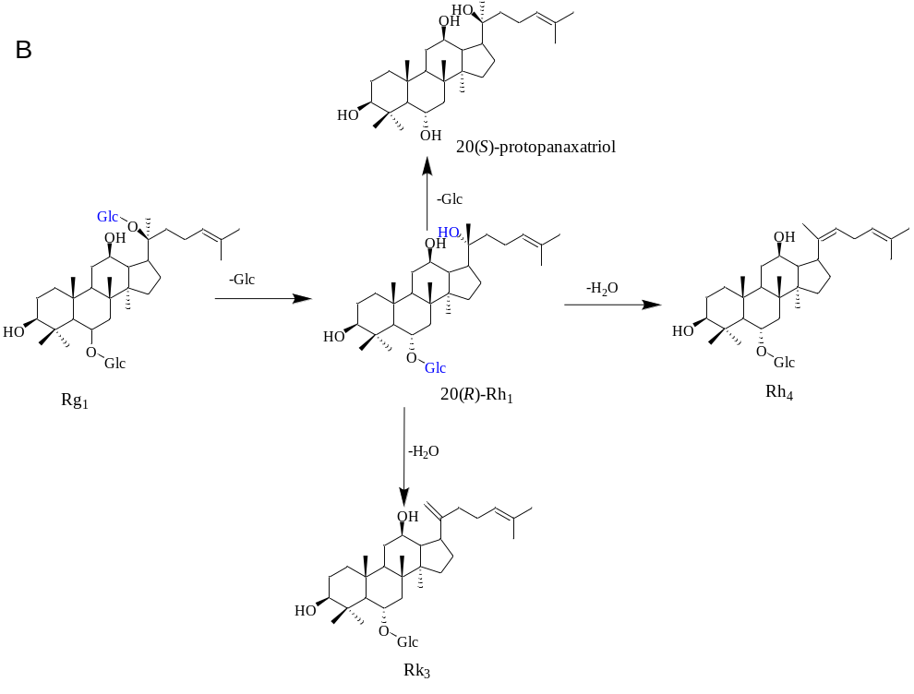
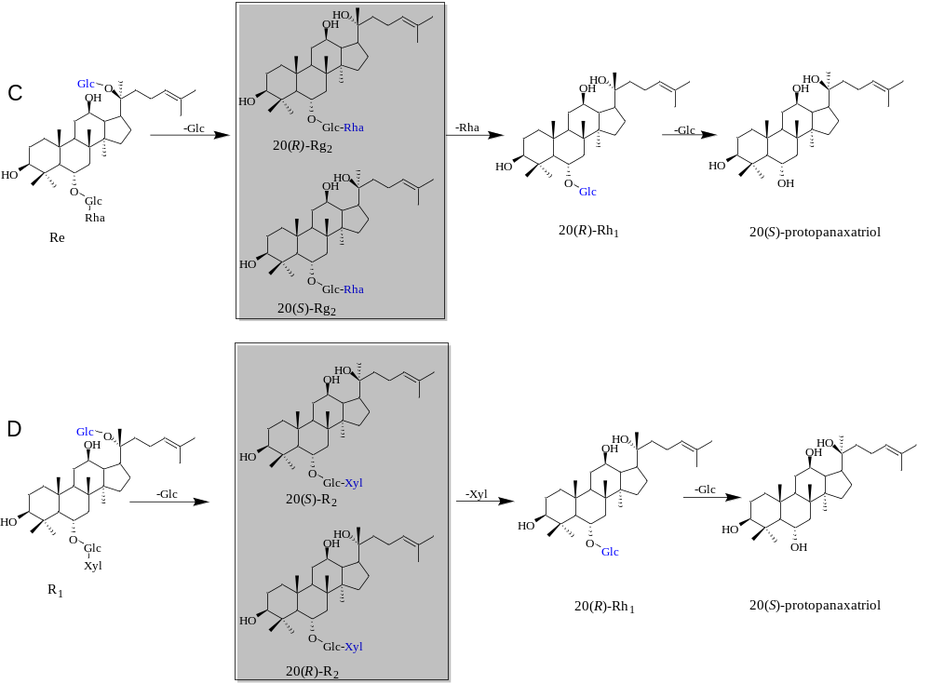
Fig. S1 Proposed possible biosynthetic pathways of major ginsenosides Rg₁, Re, Rb₁ and notoginsenoside R₁ of PNF by A. fumigatus. The solid line represents the determined path, and the dashed line represents the speculated path.

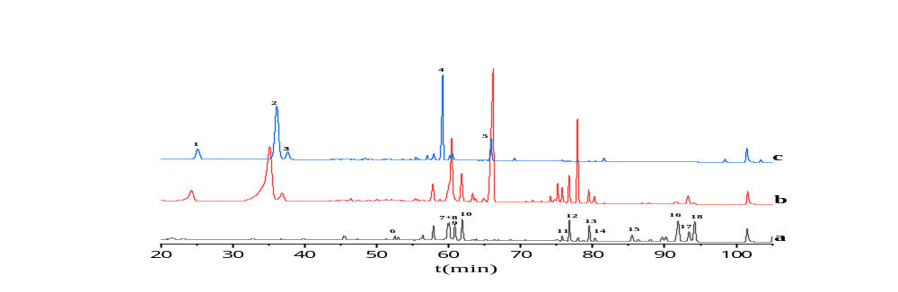
Fig. S2 HPLC analysis of transformation products of PNF by A. fumigatus. a, Rare ginsenosides mixed; b, Sample of PNS after transformation; c: PNS. 1-5, R₁, Rg₁, Re, Rb₁, Rd. 6, 20 (S)-I; 7+8, 20 (S)-R₂+20 (S)-Rg₂; 9, 20 (R)-Rg₂+20 (R)-R₂; 10, 20 (R)-Rh₁; 11, Rk₃; 12, Rh₄; 13, 20 (R)-Rg₃; 14, 20 (S)-Rg₃; 15, 20 (S)-Protopanaxatriol; 16, Rk₁; 17, Rg₅; 18, CK.

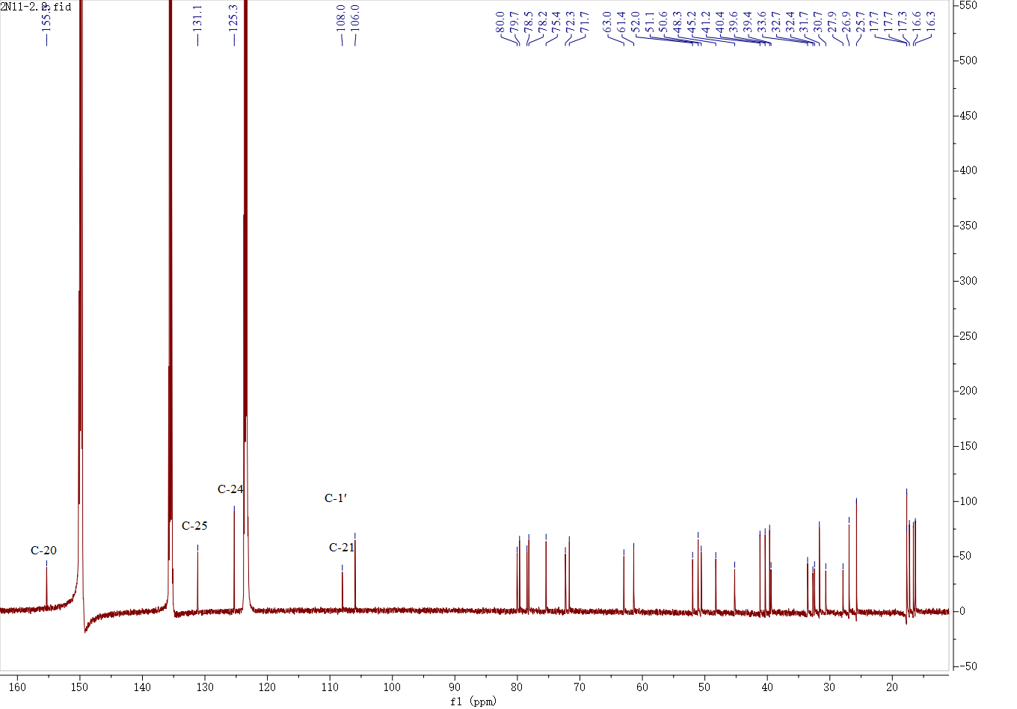
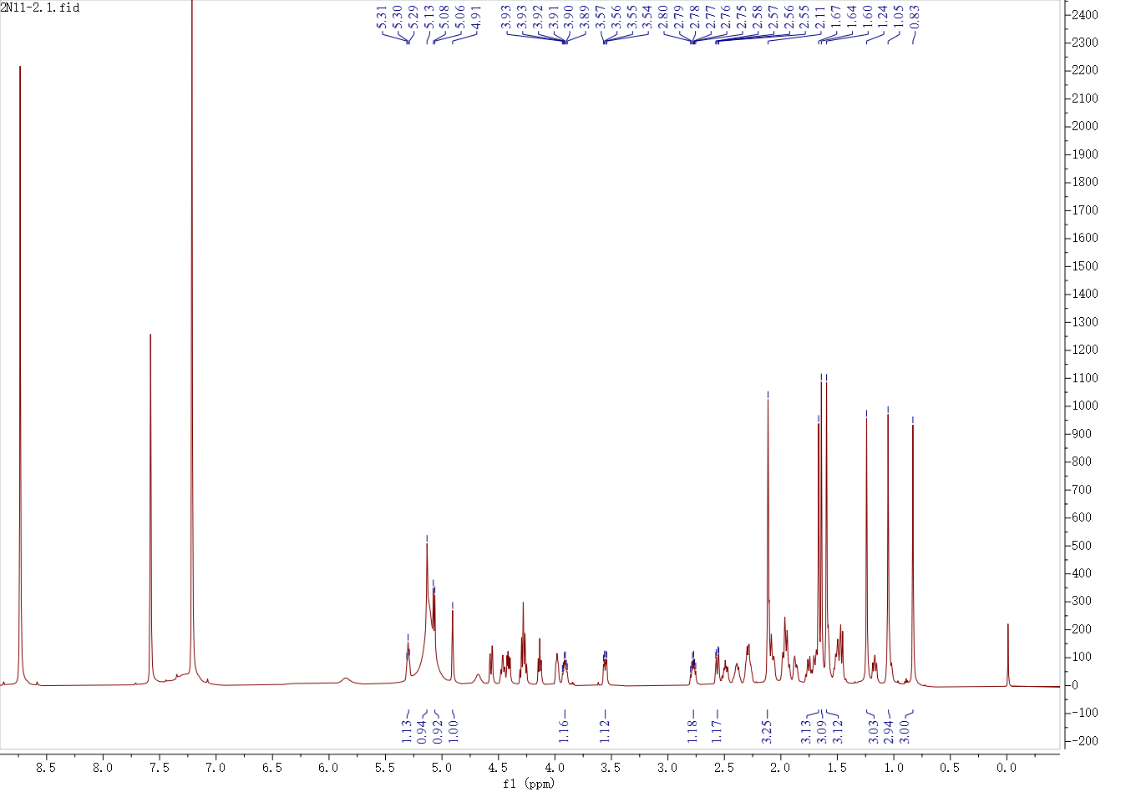

Fig. S3 ¹H-NMR and ¹³C-NMR spectra of compound 1

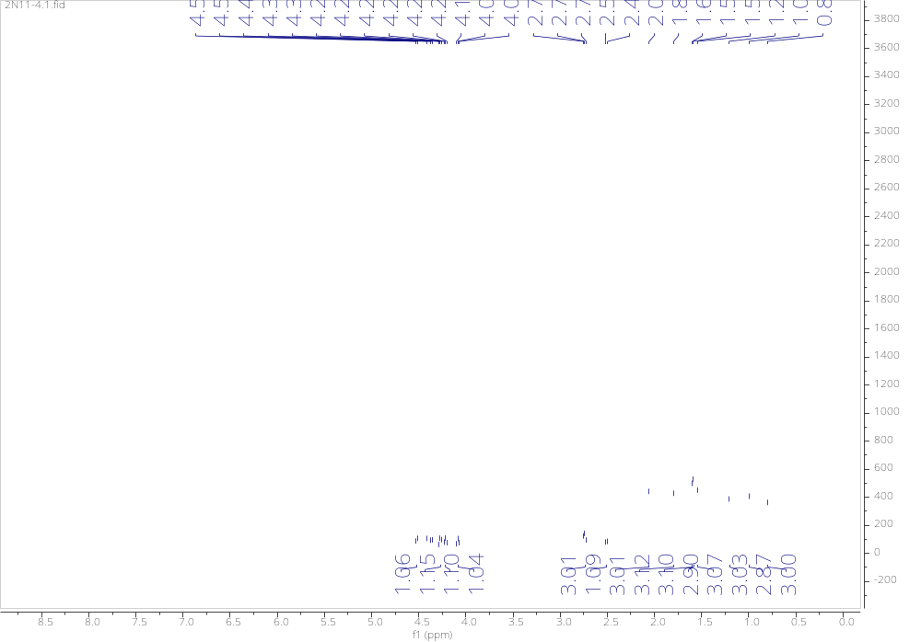
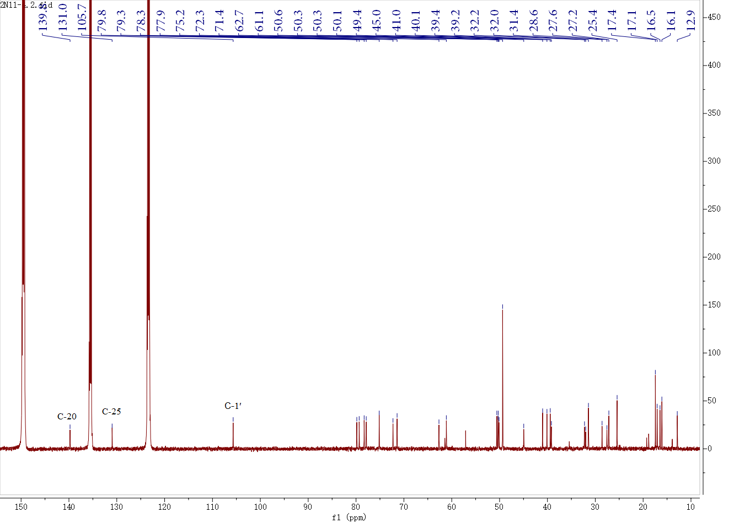
Fig. S4 ¹H-NMR and ¹³C-NMR spectra of compound 2

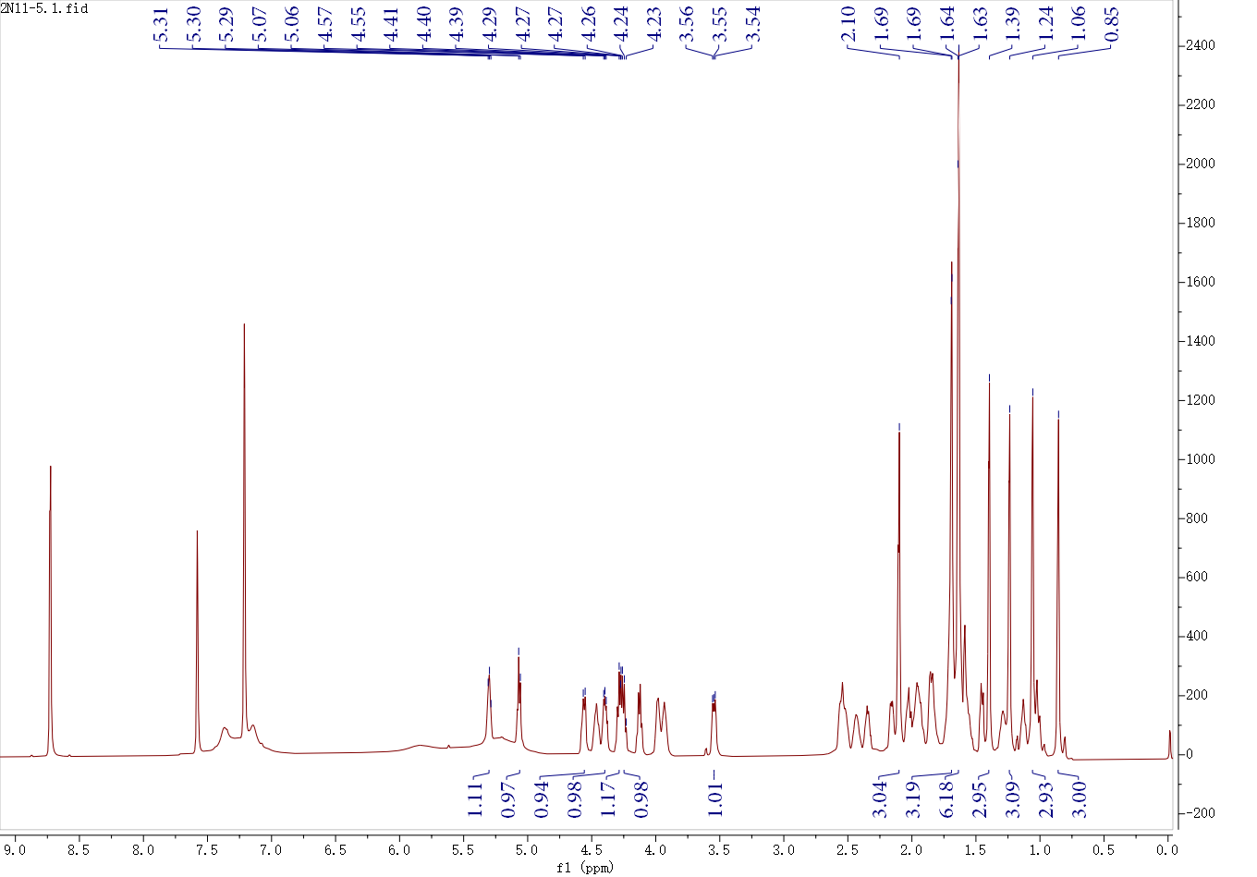

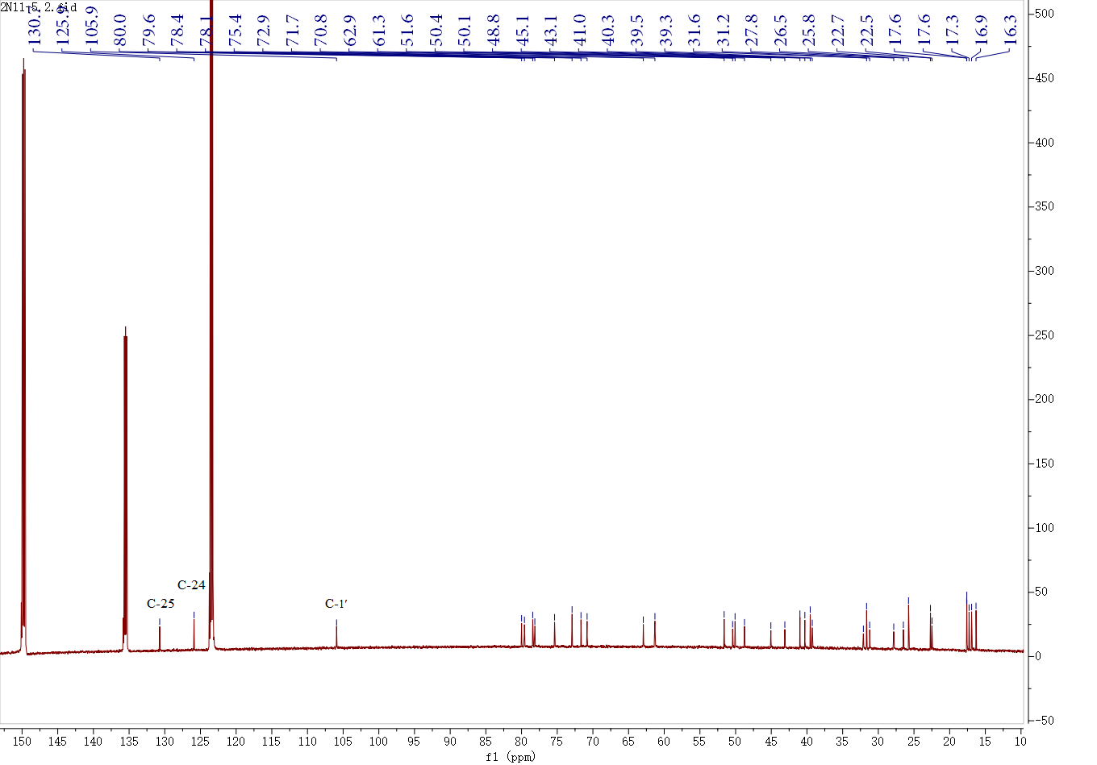
Fig. S5 ¹H-NMR and ¹³C-NMR spectra of compound 3

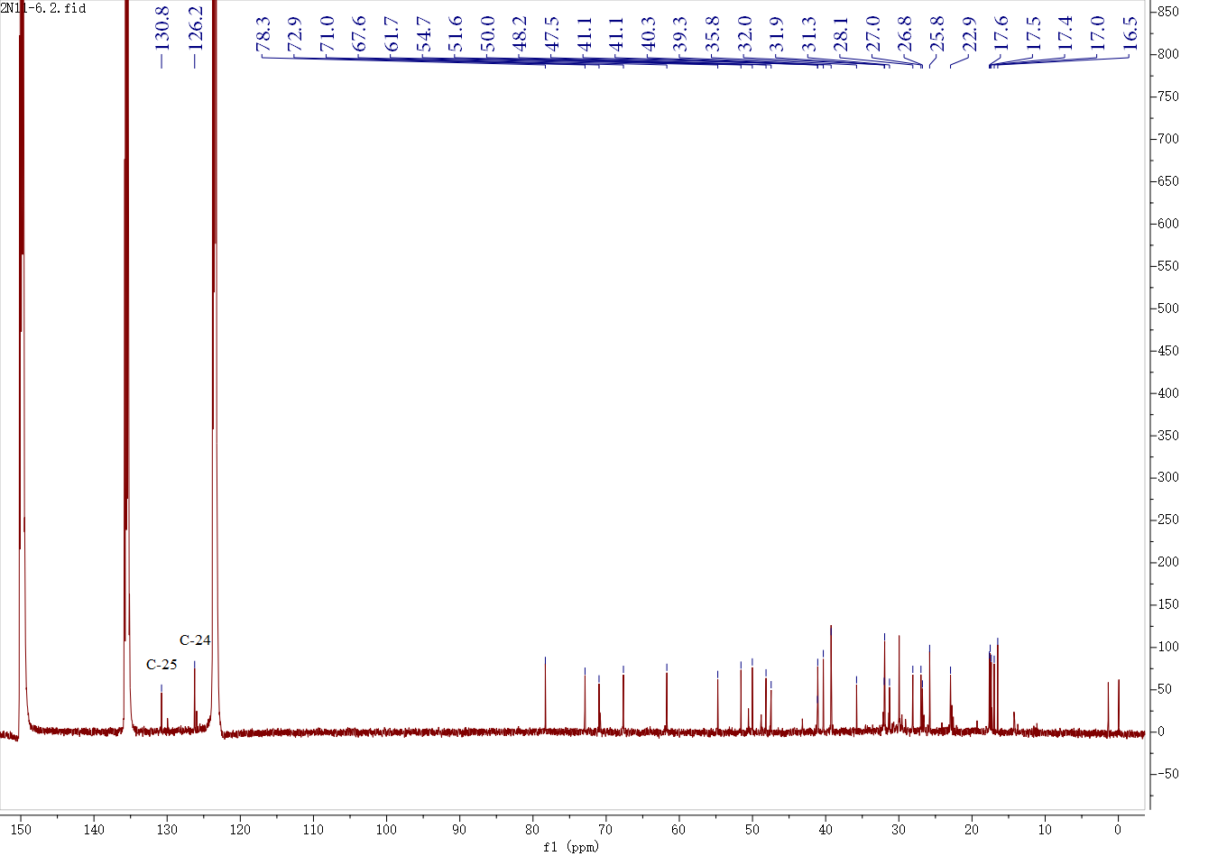
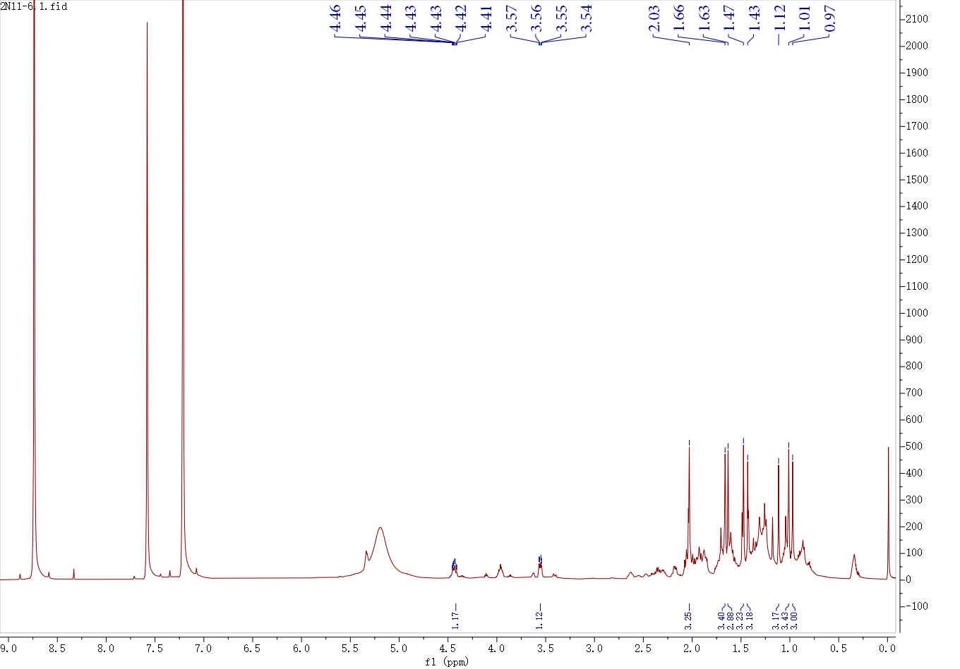
Fig. S6 ¹H-NMR and ¹³C-NMR spectra of compound 4

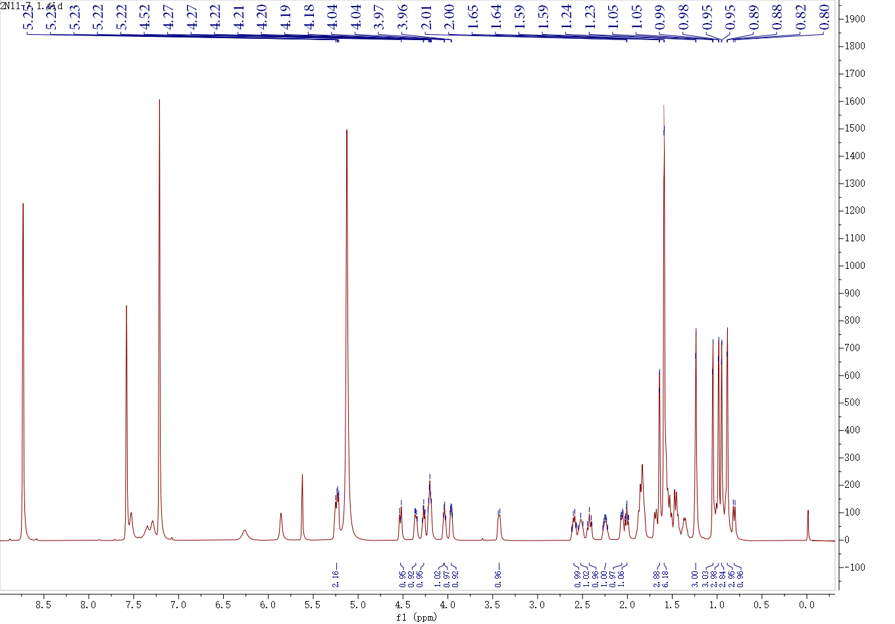
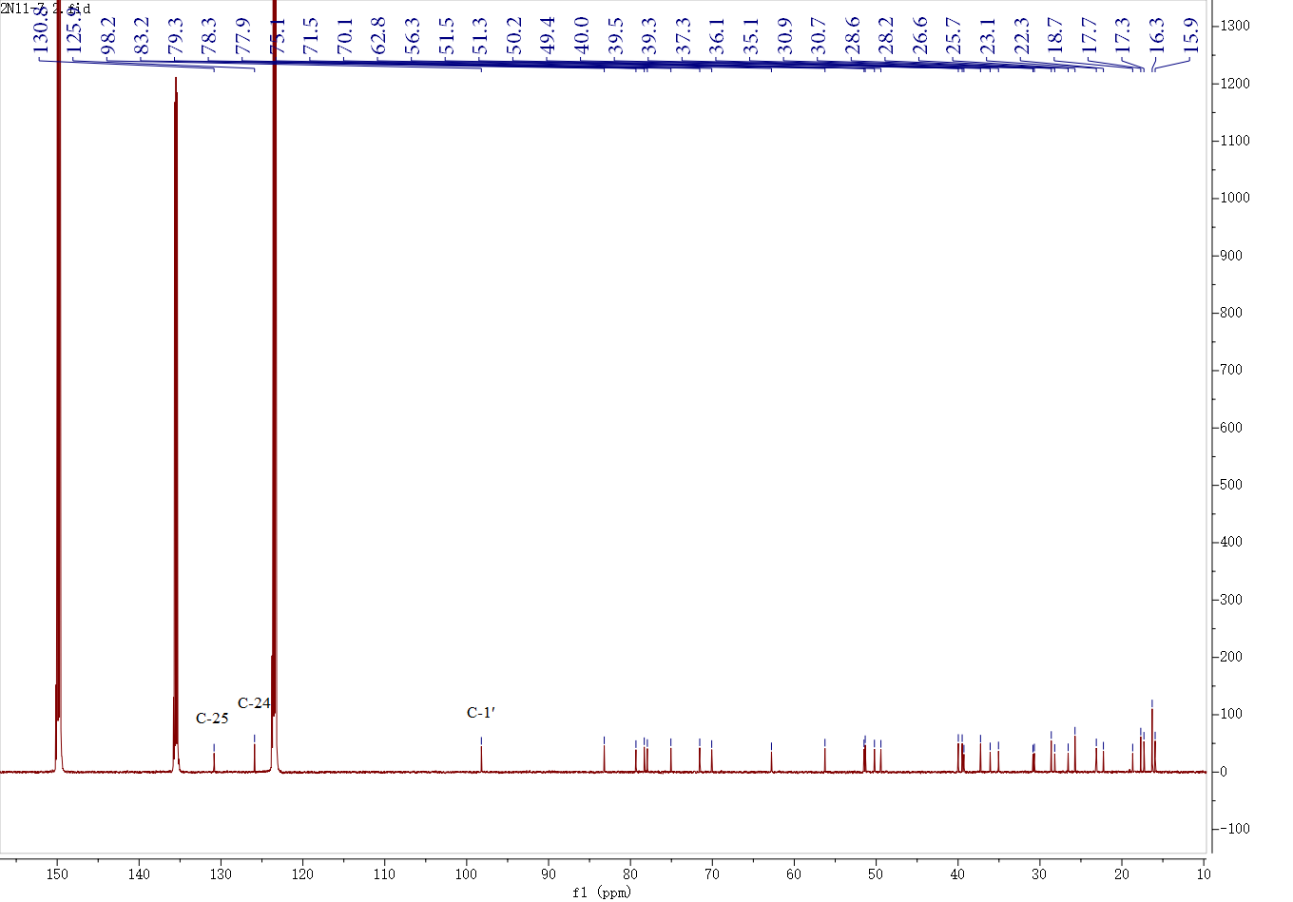

Fig. S7 ¹H-NMR and ¹³C-NMR spectra of compound 5

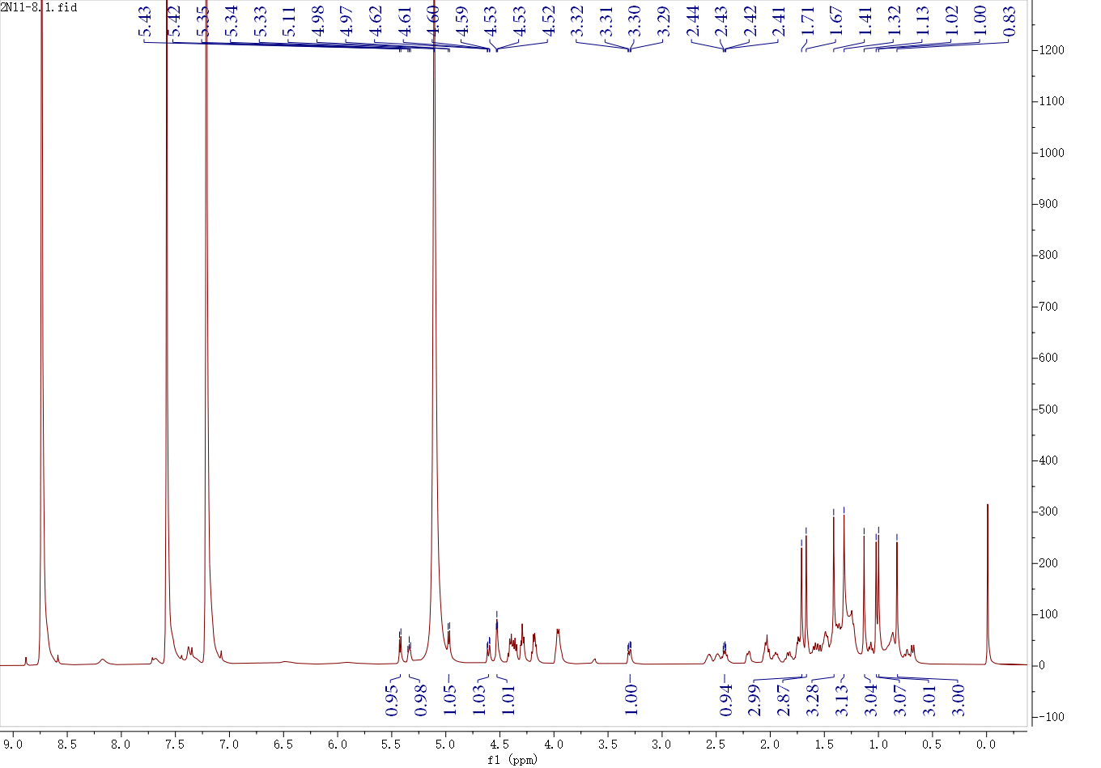
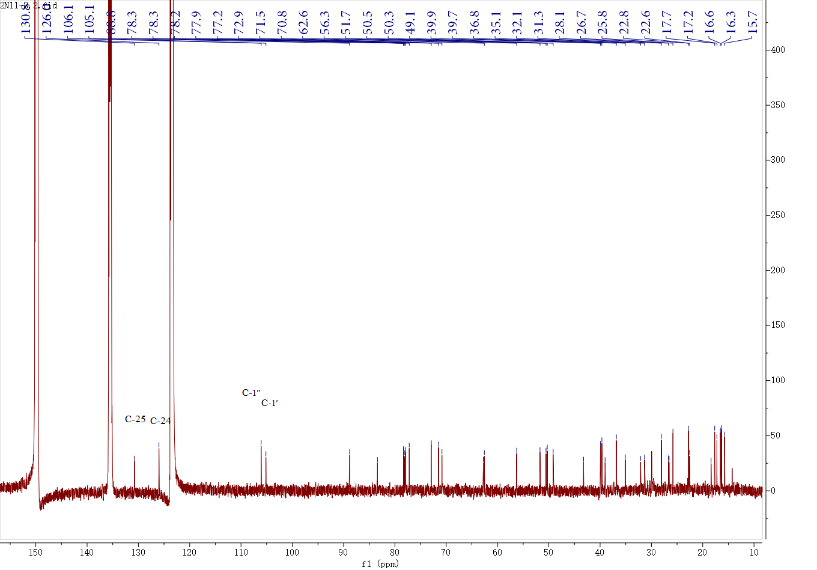

Fig. S8 ¹H-NMR and ¹³C-NMR spectra of compound 6

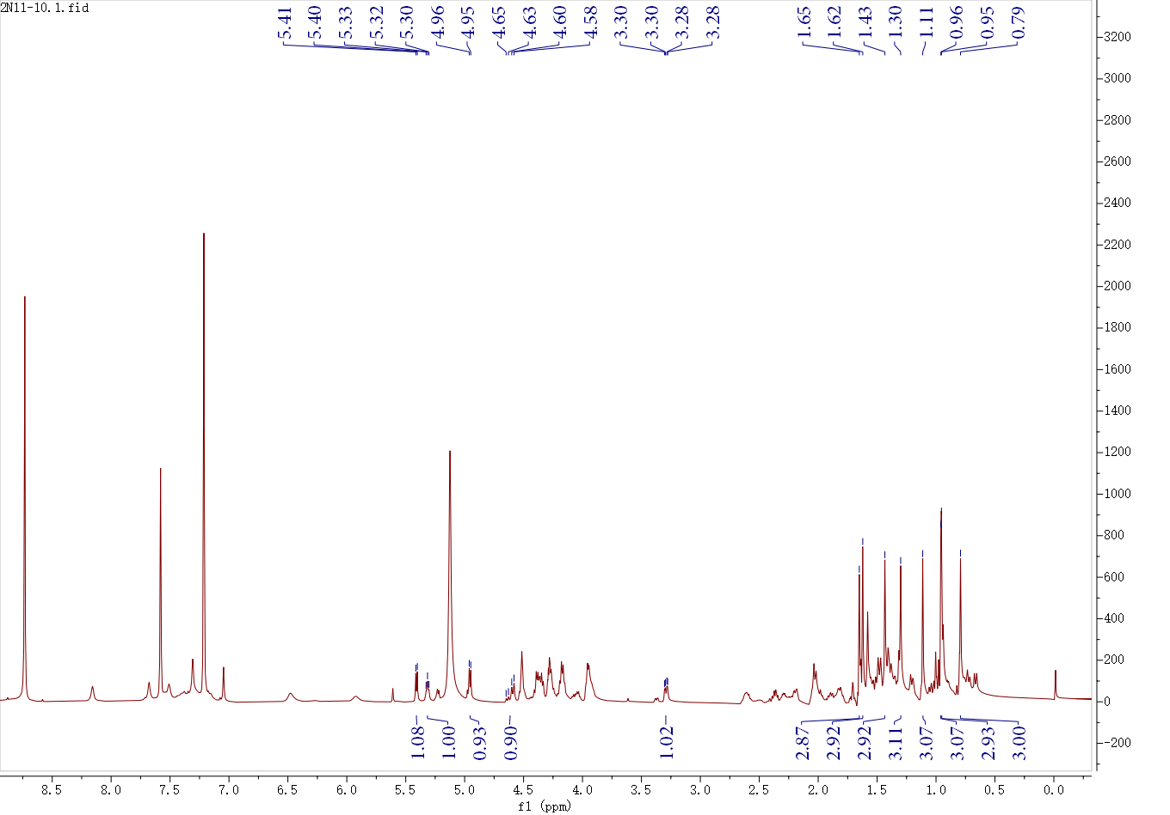
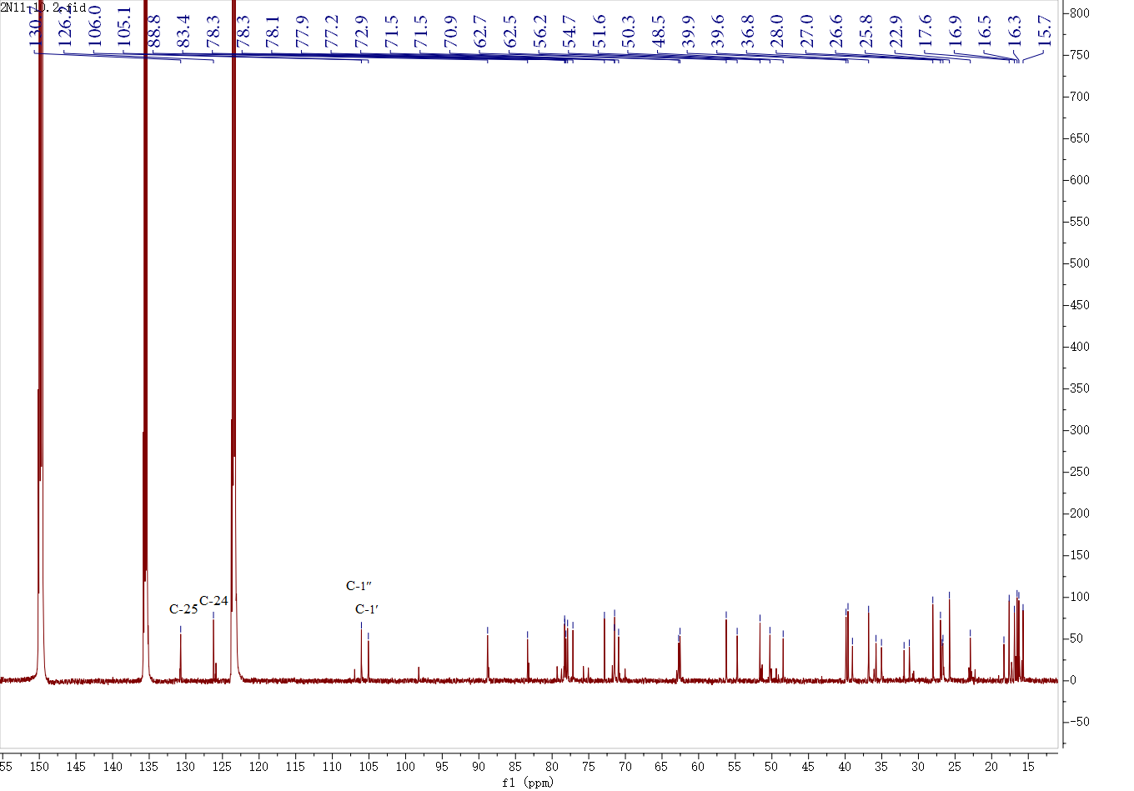

Fig. S9 ¹H-NMR and ¹³C-NMR spectra of compound 7

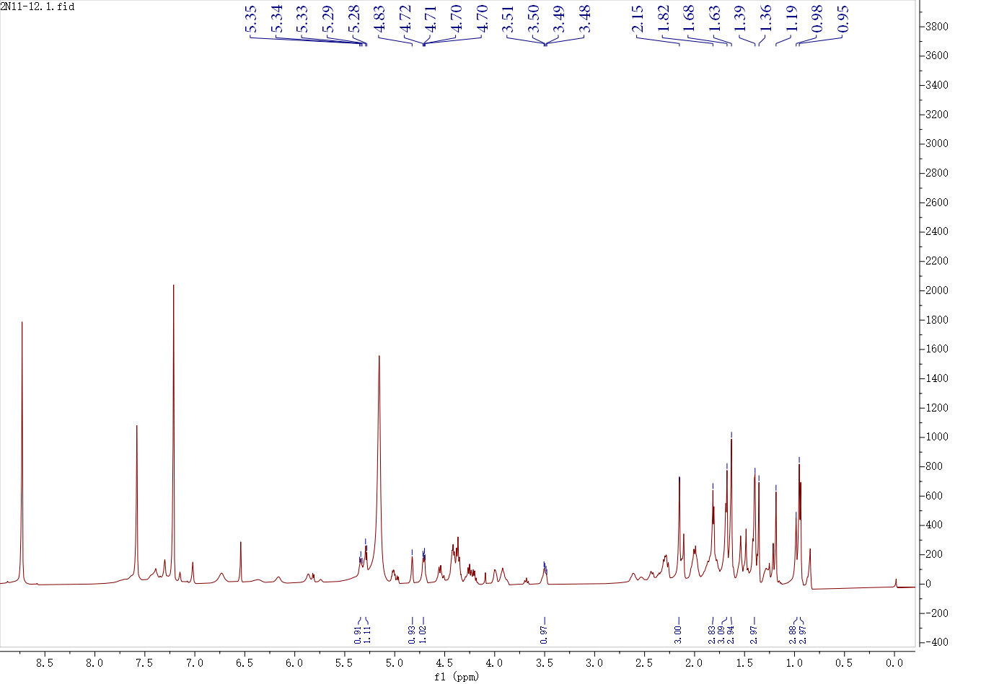
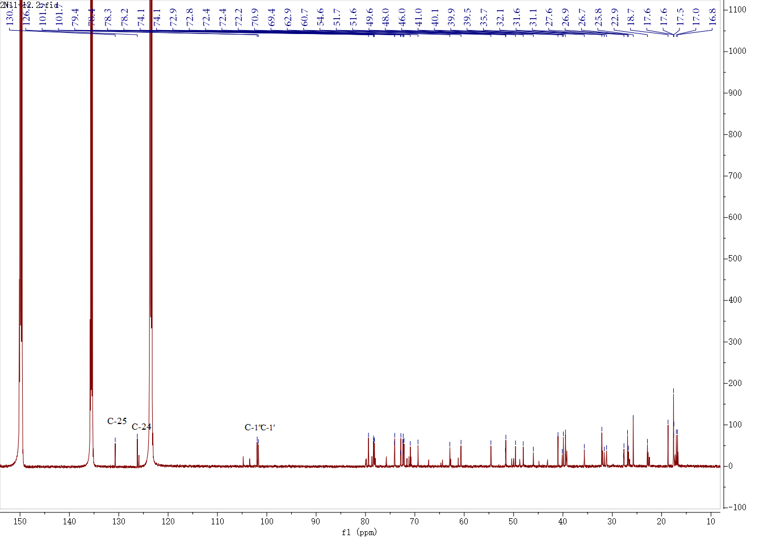

Fig. S10 ¹H-NMR and ¹³C-NMR spectra of compound 8

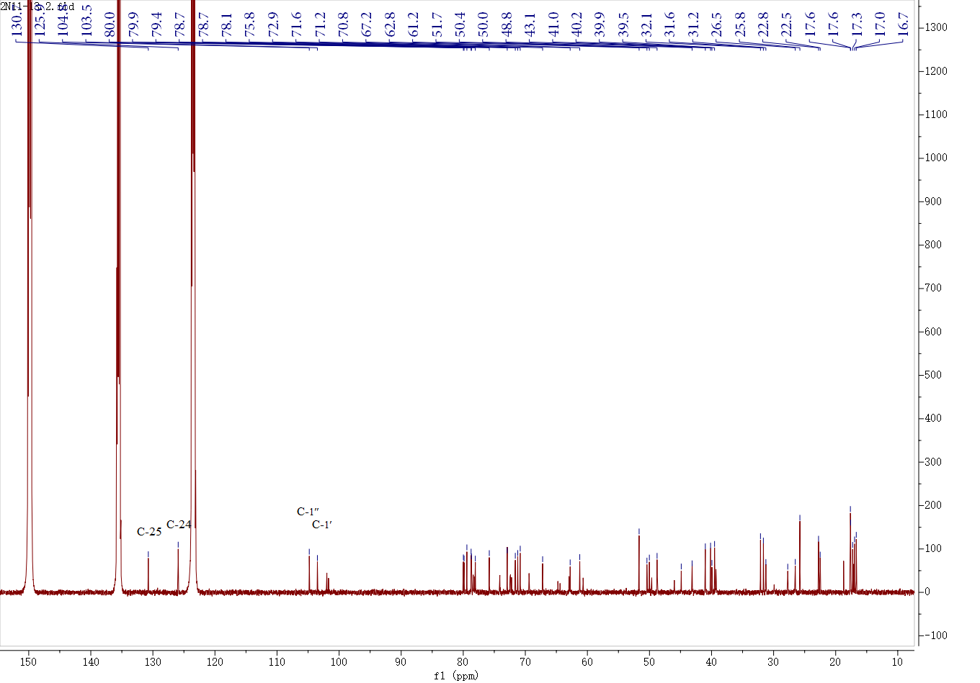
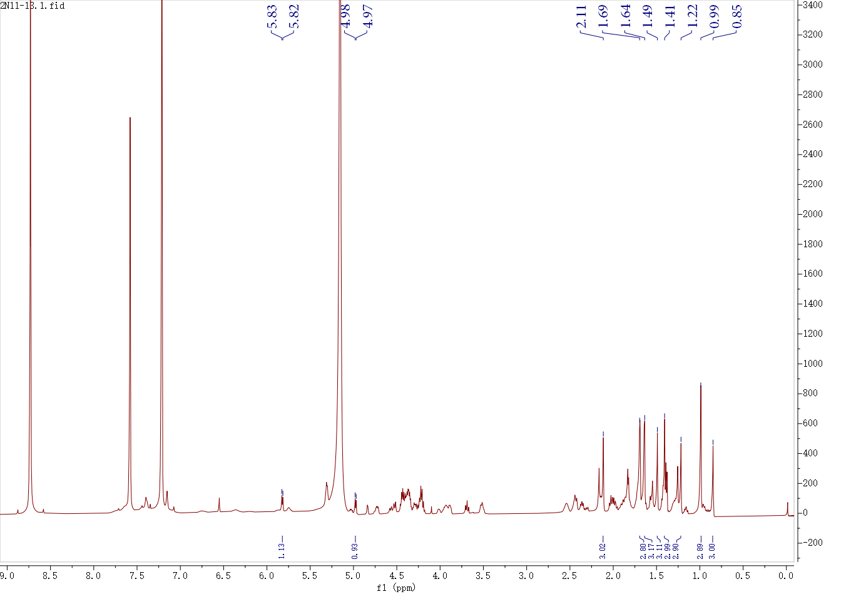
Fig. S11 ¹H-NMR and ¹³C-NMR spectra of compound 9

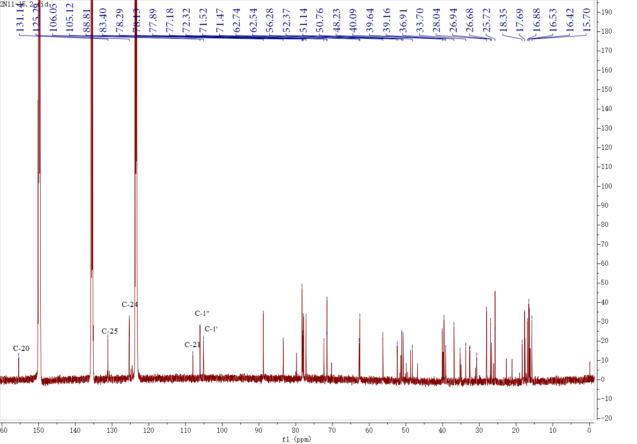
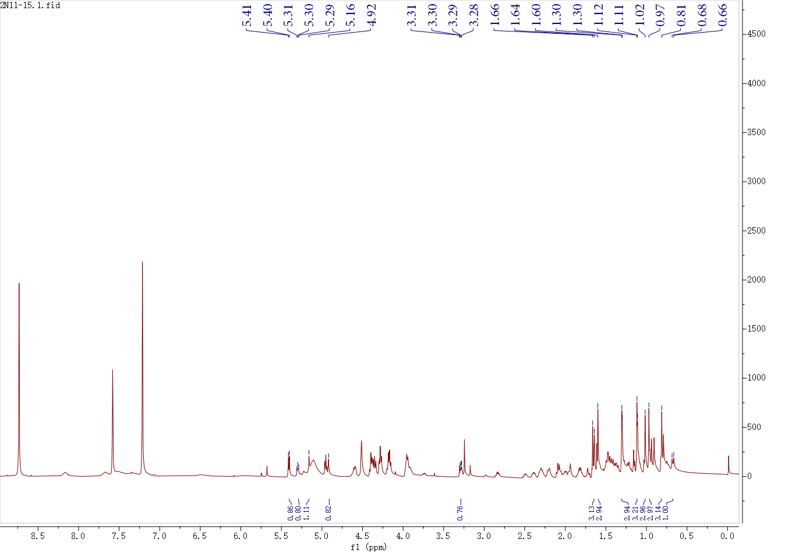
Fig. S12 ¹H-NMR and ¹³C-NMR spectra of compound 10

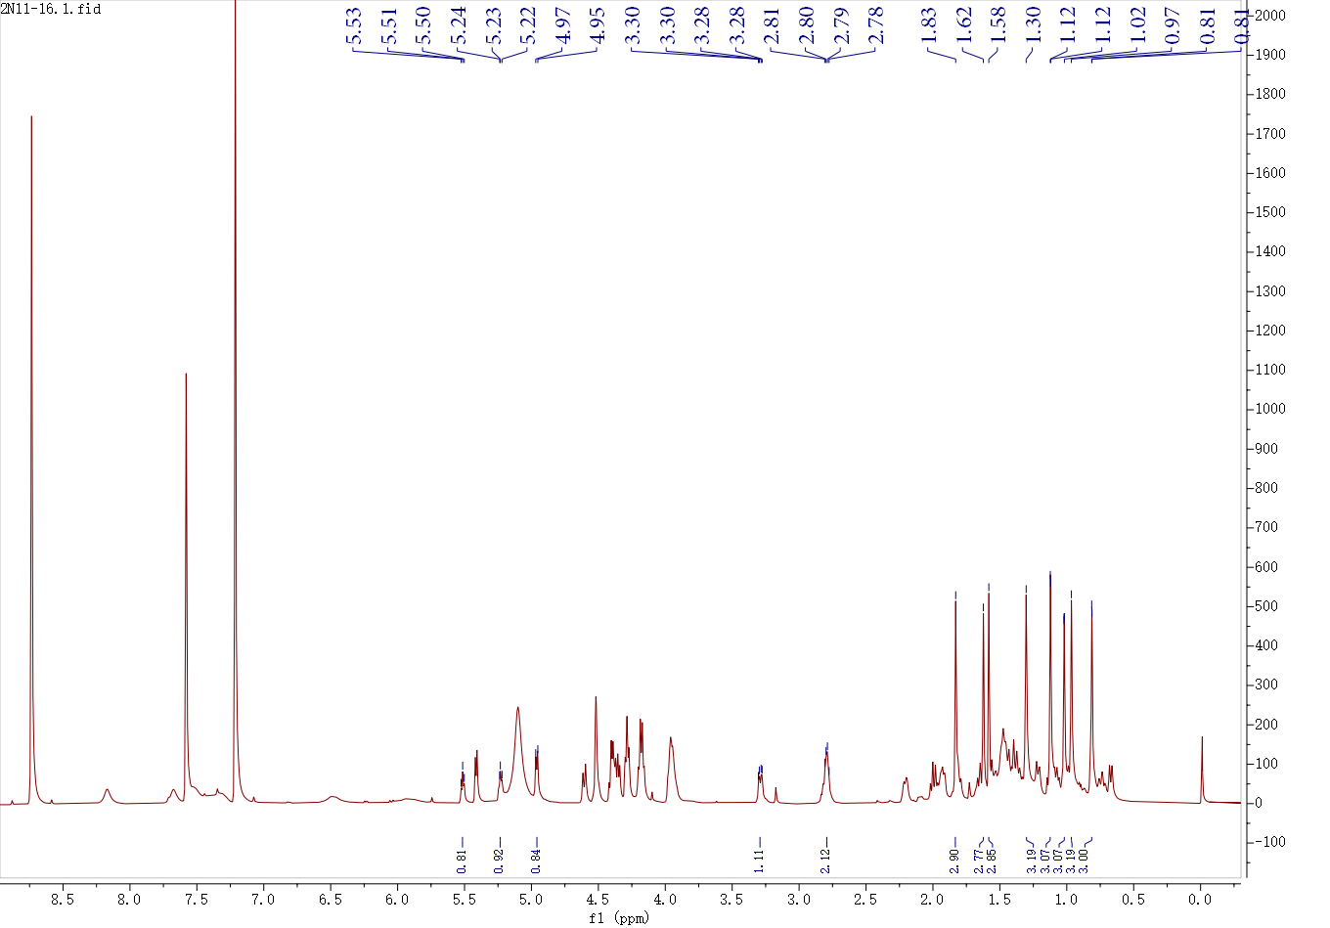
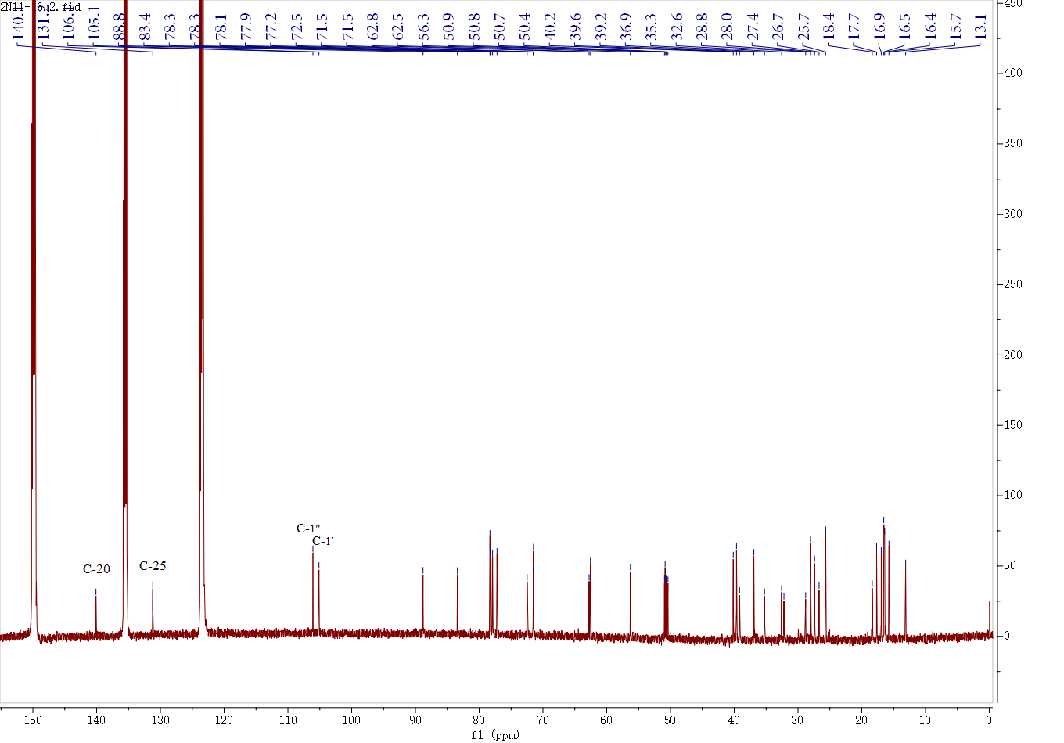

Fig. S13 ¹H-NMR and ¹³C-NMR spectra of compound 11

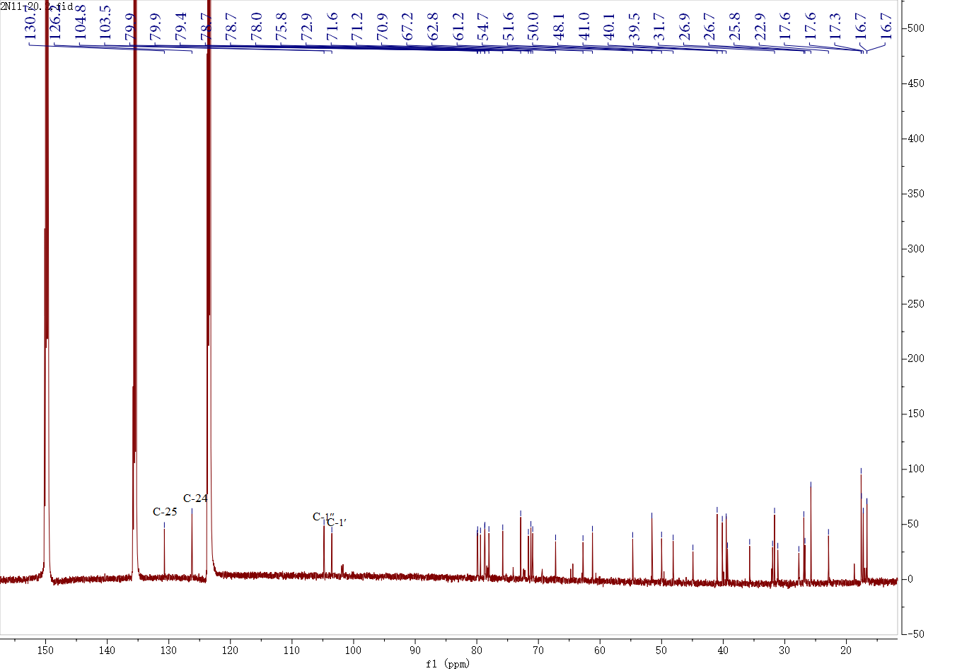
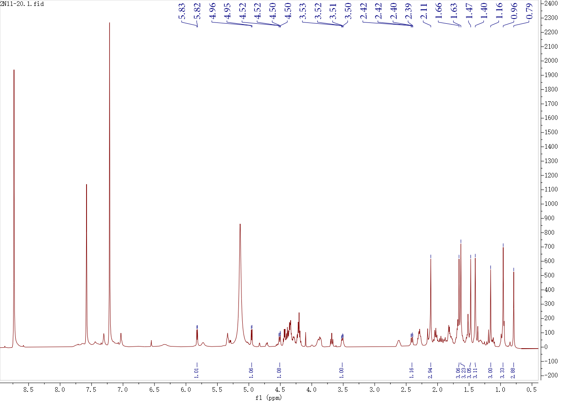
Fig. S14 ¹H-NMR and ¹³C-NMR spectra of compound 12

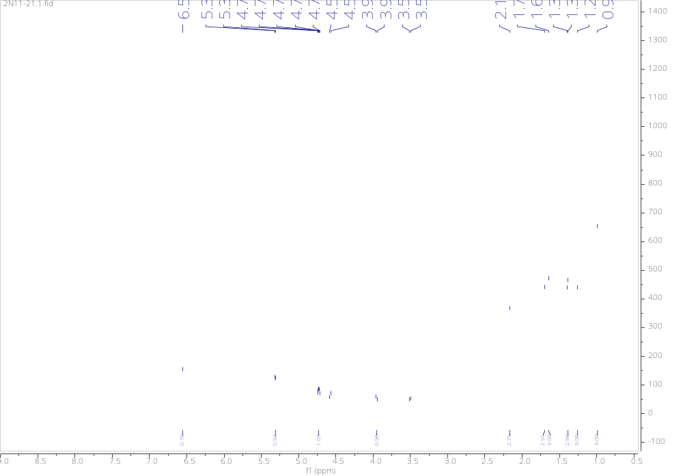
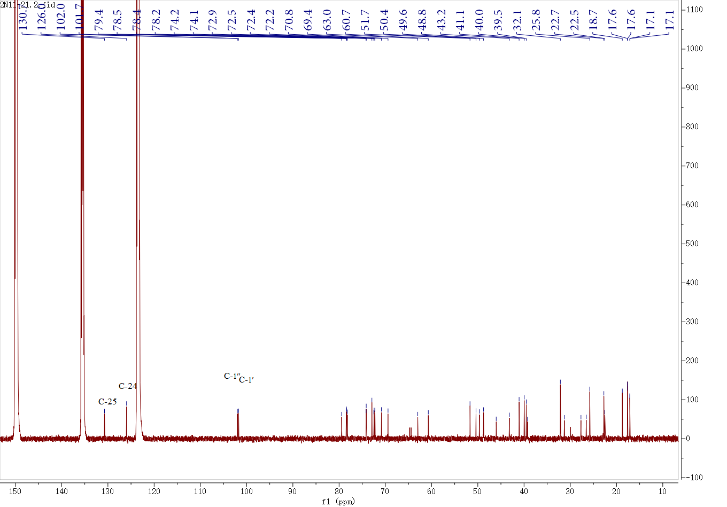
Fig. S15 ¹H-NMR and ¹³C-NMR spectra of compound 13

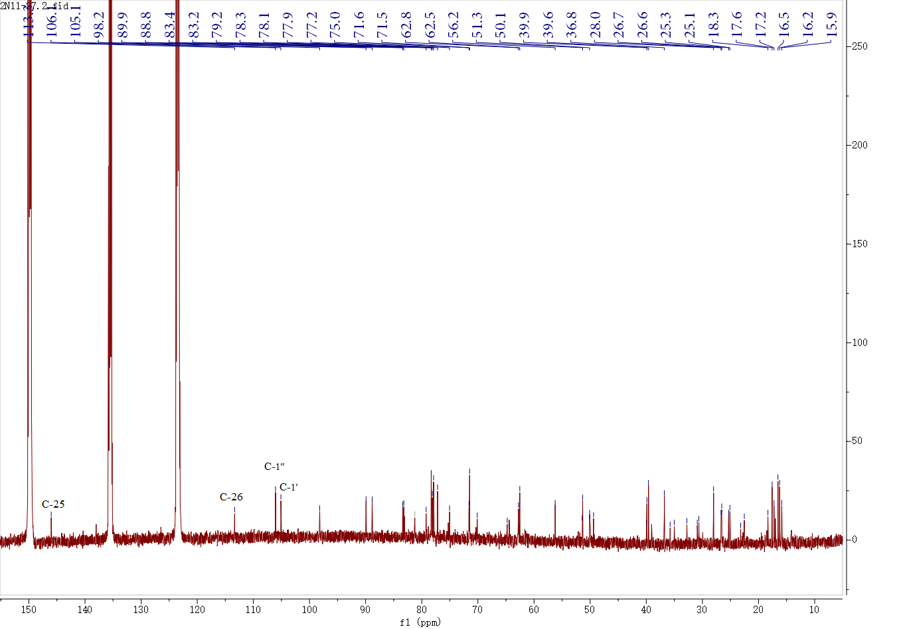
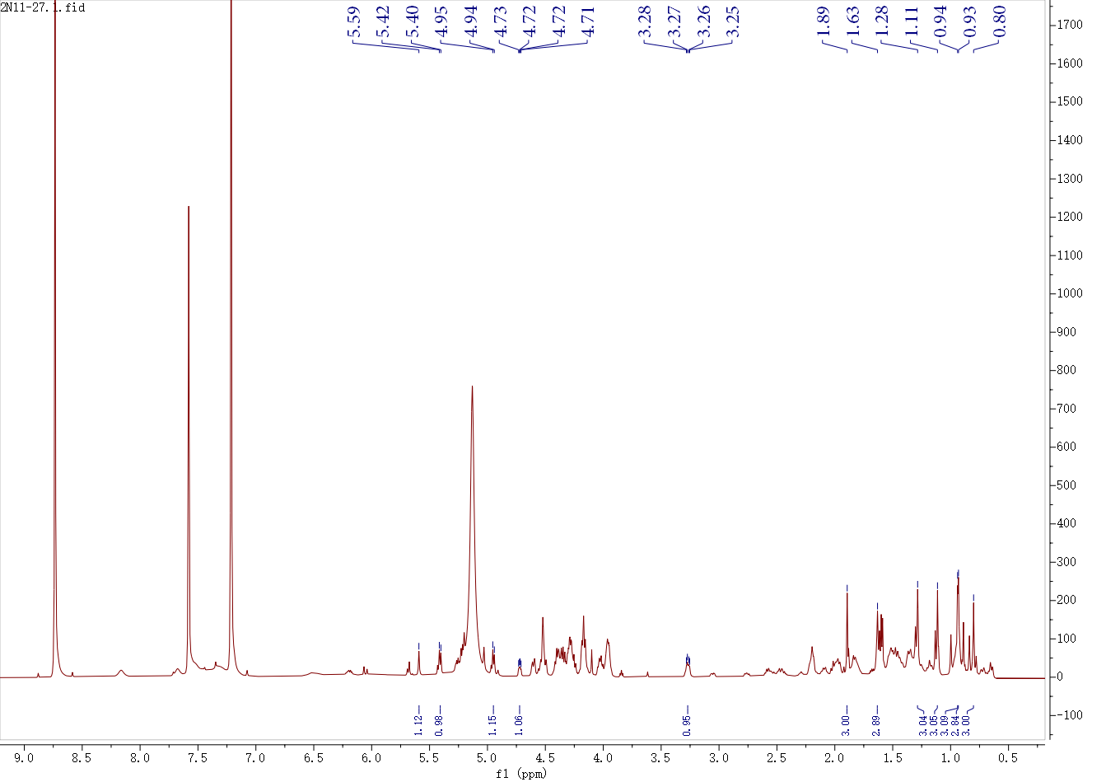
Fig. S16 ¹H-NMR and ¹³C-NMR spectra of compound 14

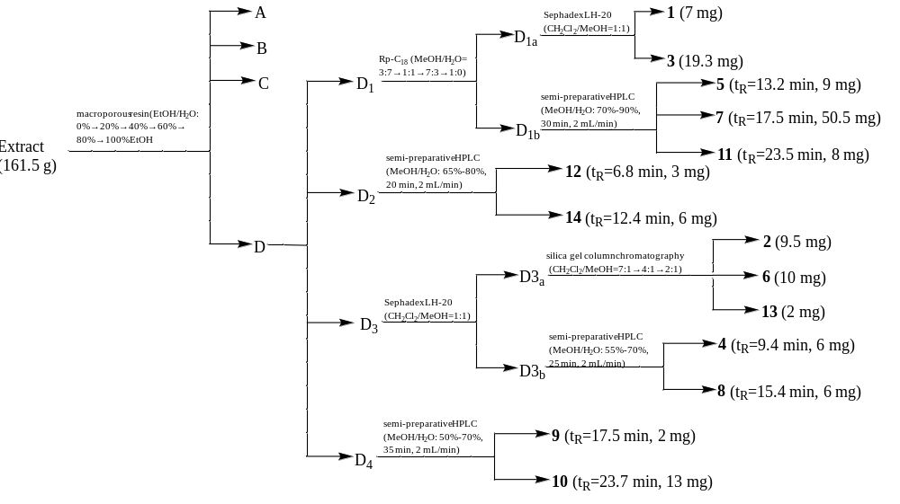
Fig. S17 Separation flow diagram of compounds 1-14

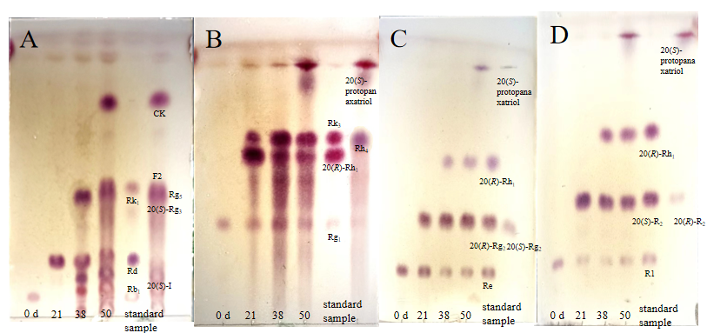
Fig. S18 TLC analysis of transformation products at different times during the conversion process. A, B, C, D are the TLC analysis of transformation products of Rb₁/Rd, Rg₁, Re and R₁, respectively.

Table S1 ¹H and ¹³C NMR spectral data of 1-2 (600 MHz, C₅D₅N, δ in ppm, J in Hz).
1 |  |  | 2
NO. | δ_{H} (J Hz) | δ_{C} | NO. | δ_{H} (J Hz) | δ_{C}
1 | - | 39.4 | 1 | - | 39.2
2 | - | 27.9 | 2 | - | 28.6
3 | 3.56 (dd, 11.7, 4.7 Hz) | 78.5 | 3 | 3.55 (d, 11.5, 4.2 Hz) | 78.3
4 | - | 40.4 | 4 | - | 40.1
5 | - | 61.4 | 5 | - | 61.1
6 | - | 80.0 | 6 | 4.44 (d, 11.5 Hz) | 79.8
7 | - | 45.2 | 7 | - | 45.0
8 | - | 41.2 | 8 | - | 41.0
9 | - | 50.6 | 9 | - | 50.3
10 | - | 39.6 | 10 | - | 39.4
11 | - | 32.7 | 11 | - | 32.2
12 | 3.91 (m) | 72.3 | 12 | 3.97 (m) | 72.3
13 | - | 52.0 | 13 | - | 50.3
14 | - | 51.1 | 14 | - | 50.1
15 | - | 32.4 | 15 | - | 32.0
16 | - | 30.7 | 16 | - | 27.2
17 | - | 48.3 | 17 | - | 50.6
18 | 1.24 (s) | 17.7 | 18 | 1.25 (s) | 17.4
19 | 1.05 (s) | 17.7 | 19 | 1.04 (s) | 17.1
20 | - | 155.3 | 20 | - | 139.8
21 | 5.13 (br s), 4.91 (br s) | 108.0 | 21 | 1.84 (s) | 12.9
22 | - | 33.6 | 22 | 5.45 (overlapped) | 123.0
23 | - | 26.9 | 23 | - | 27.6
24 | 5.29 (t, 6.8 Hz) | 125.3 | 24 | 5.19 (overlapped) | 125.4
25 | - | 131.1 | 25 | - | 131.0
26 | 1.67 (s) | 25.7 | 26 | 1.64 (s) | 25.4
27 | 1.64 (s) | 17.3 | 27 | 1.63 (s) | 17.4
28 | 2.11 (s) | 31.7 | 28 | 2.10 (s) | 31.4
29 | 1.60 (s) | 16.3 | 29 | 1.64 (s) | 16.1
30 | 0.83 (s) | 16.6 | 30 | 0.84 (s) | 16.5
1′ | 5.06 (d, 7.8 Hz) | 106.0 | 1′ | 5.05 (d, 7.8 Hz) | 105.7
2′ | - | 75.4 | 2′ | - | 75.2
3′ | - | 79.7 | 3′ | - | 79.3
4′ | - | 71.7 | 4′ | - | 71.4
5′ | - | 78.2 | 5′ | - | 77.9
6′ | - | 63.0 | 6′ | - | 62.7

Table S2 ¹H and ¹³C NMR spectral data of 3-4 (600 MHz, C₅D₅N, δ in ppm, J in Hz).
 | 3 |  |  | 4
NO. | δ_{H} (J Hz) | δ_{C} | NO. | δ_{H} (J Hz) | δ_{C}
1 | - | 39.3 | 1 | - | 39.3
2 | - | 27.8 | 2 | - | 28.1
3 | - | 78.4 | 3 | 3.56 (dd, 11.6, 4.6 Hz) | 78.3
4 | - | 40.3 | 4 | - | 41.1
5 | - | 61.3 | 5 | - | 61.7
6 | 4.56 (m) | 80.0 | 6 | 4.42 (m) | 67.6
7 | - | 45.1 | 7 | - | 47.5
8 | - | 41.0 | 8 | - | 41.1
9 | - | 50.1 | 9 | - | 50.0
10 | - | 39.5 | 10 | - | 40.3
11 | - | 32.1 | 11 | - | 32.0
12 | - | 70.8 | 12 | 3.97 (m) | 71.0
13 | - | 48.8 | 13 | - | 48.2
14 | - | 51.6 | 14 | - | 51.6
15 | - | 31.2 | 15 | - | 31.3
16 | - | 26.5 | 16 | - | 26.8
17 | - | 50.4 | 17 | - | 54.7
18 | 1.24 (s) | 17.3 | 18 | 1.01 (s) | 17.5
19 | 1.06 (s) | 17.6 | 19 | 1.12 (s) | 17.4
20 |  | 72.9 | 20 | - | 72.9
21 | 1.40 (s) | 22.7 | 21 | 1.43 (s) | 27.0
22 | - | 43.1 | 22 | - | 35.8
23 | - | 22.5 | 23 | - | 22.9
24 | 5.30 (t, 6.8 Hz) | 125.9 | 24 | 5.33 (t, 7.2 Hz) | 126.2
25 | - | 130.7 | 25 |  | 130.8
26 | 1.69 (s) | 25.8 | 26 | 1.66 (s) | 25.8
27 | 1.64 (s) | 17.6 | 27 | 1.63 (s) | 17.6
28 | 2.10 (s) | 31.6 | 28 | 2.03 (s) | 31.9
29 | 1.63 (s) | 16.3 | 29 | 1.47 (s) | 16.5
30 | 0.86 (s) | 16.9 | 30 | 0.97 (s) | 17.0
1′ | 5.06 (d, 7.9 Hz) | 105.9
2′ | - | 75.4
3′ | - | 79.6
4′ | - | 71.7
5′ | - | 78.1
6′ | - | 62.9

Table S3 ¹H and ¹³C NMR spectral data of 5-6 (600 MHz, C₅D₅N, δ in ppm, J in Hz).
 | 5 |  |  | 6
NO. | δ_{H} (J Hz) | δ_{C} | NO. | δ_{H} (J Hz) | δ_{C}
1 | - | 39.3 | 1 | - | 39.0
2 | - | 28.2 | 2 | - | 26.6
3 | 3.43 (d, 10.9 Hz) | 77.9 | 3 | 3.30 (dd, 11.8, 4.5 Hz) | 88.8
4 | - | 39.5 | 4 | - | 39.7
5 | - | 56.3 | 5 | - | 56.3
6 | - | 18.7 | 6 | - | 18.4
7 | - | 35.1 | 7 | - | 35.1
8 | - | 40.0 | 8 | - | 39.9
9 | - | 50.2 | 9 | - | 50.3
10 | - | 37.3 | 10 | - | 36.8
11 | - | 30.7 | 11 | - | 32.1
12 | - | 70.1 | 12 | - | 70.8
13 | - | 49.4 | 13 | - | 49.1
14 | - | 51.3 | 14 | - | 51.7
15 | - | 30.9 | 15 | - | 31.3
16 | - | 26.6 | 16 | - | 26.7
17 | - | 51.5 | 17 | - | 50.5
18 | 0.95 (s) | 16.3 | 18 | 1.02 (s) | 15.7
19 | 0.89 (s) | 15.9 | 19 | 0.83 (s) | 16.3
20 | - | 83.2 | 20 | - | 72.9
21 | 1.64 (s) | 22.3 | 21 | 1.41 (s) | 22.8
22 | - | 36.1 | 22 | - | 43.2
23 | - | 23.1 | 23 | - | 22.6
24 | 5.23 (t, 7.3 Hz) | 125.9 | 24 | 5.33 (t, 7.5 Hz) | 125.9
25 | - | 130.8 | 25 | - | 130.8
26 | 1.59 (s) | 25.7 | 26 | 1.71 (s) | 25.8
27 | 1.59 (s) | 17.7 | 27 | 1.67 (s) | 17.7
28 | 1.24 (s) | 28.6 | 28 | 1.32 (s) | 28.2
29 | 1.05 (s) | 16.3 | 29 | 1.13 (s) | 16.6
30 | 0.98 (s) | 17.3 | 30 | 1.00 (s) | 17.2
1′ | 5.22 (d, 7.3 Hz) | 98.2 | 1′ | 4.97 (d, 7.6 Hz) | 105.1
2′ | - | 75.1 | 2′ | - | 83.4
3′ | - | 79.3 | 3′ | - | 77.9
4′ | - | 71.5 | 4′ | - | 71.5
5′ | - | 78.3 | 5′ | - | 78.2
6′ | - | 62.8 | 6′ | - | 62.8
 |  |  | 1′′ | 5.42 (d, 7.7 Hz) | 106.1
 |  |  | 2′′ | - | 77.2
 |  |  | 3′′ | - | 78.3
 |  |  | 4′′ | - | 71.5
 |  |  | 5′′ | - | 78.3
 |  |  | 6′′ | - | 62.6

Table S4 ¹H and ¹³C NMR spectral data of 7-8 (600 MHz, C₅D₅N, δ in ppm, J in Hz).
 | 7 |  |  | 8
NO. | δ_{H} (J Hz) | δ_{C} | NO. | δ_{H} (J Hz) | δ_{C}
1 | - | 39.0 | 1 | - | 39.9
2 | - | 26.6 | 2 | - | 27.6
3 | 3.29 (dd, 11.8, 4.5 Hz) | 88.8 | 3 | 3.49 (dd, 11.9, 4.8 Hz) | 78.3
4 | - | 39.7 | 4 | - | 40.1
5 | - | 56.3 | 5 | - | 60.7
6 | - | 18.4 | 6 | 4.72 (m) | 74.1
7 | - | 35.1 | 7 | - | 46.0
8 | - | 39.9 | 8 | - | 41.0
9 | - | 50.3 | 9 | - | 49.6
10 | - | 36.8 | 10 | - | 39.5
11 | - | 32.1 | 11 | - | 31.6
12 | 3.95 (m) | 70.8 | 12 | - | 70.9
13 | - | 48.5 | 13 | - | 48.0
14 | - | 51.7 | 14 | - | 51.6
15 | - | 31.3 | 15 | - | 31.1
16 | - | 26.7 | 16 | - | 26.9
17 | - | 54.8 | 17 | - | 54.6
18 | 0.96 (s) | 15.7 | 18 | 1.19 (s) | 17.5
19 | 0.79 (s) | 16.3 | 19 | 0.98 (s) | 17.0
20 | - | 72.9 | 20 | - | 72.9
21 | 1.43 (s) | 28.1 | 21 | 1.39 (s) | 22.7
22 | - | 35.8 | 22 | - | 35.7
23 | - | 22.9 | 23 | - | 22.9
24 | 5.32 (t, 7.4 Hz) | 126.0 | 24 | 5.34 (t, 7.0 Hz) | 126.2
25 | - | 130.8 | 25 | - | 130.7
26 | 1.65 (s) | 25.8 | 26 | 1.68 (s) | 25.8
27 | 1.62 (s) | 17.2 | 27 | 1.63 (s) | 17.6
28 | 1.30 (s) | 27.0 | 28 | 2.15 (s) | 27.7
29 | 1.11 (s) | 16.6 | 29 | 1.36 (s) | 16.8
30 | 0.95 (s) | 17.7 | 30 | 0.95 (s) | 17.6
1′ | 4.95 (d, 7.9 Hz) | 105.1 | 1′ | 5.29 (d, 7.3 Hz) | 101.9
2′ | - | 83.4 | 2′ | - | 78.2
3′ | - | 77.9 | 3′ | - | 79.4
4′ | - | 71.5 | 4′ | - | 72.8
5′ | - | 78.2 | 5′ | - | 78.4
6′ | - | 62.8 | 6′ | - | 62.9
1′′ | 5.41 (d, 7.6 Hz) | 106.1 | 1′′ | 6.54 (s) | 101.7
2′′ | - | 77.2 | 2′′ | - | 72.4
3′′ | - | 78.3 | 3′′ | - | 72.2
4′′ | - | 71.5 | 4′′ | - | 74.1
5′′ | - | 78.3 | 5′′ | - | 69.4
6′′ | - | 62.6 | 6′′ | 1.82 (d, 7.0 Hz) | 18.7

Table S5 ¹H and ¹³C NMR spectral data of 9-10 (600 MHz, C₅D₅N, δ in ppm, J in Hz).
 | 9 |  |  | 10
NO. | δ_{H} (J Hz) | δ_{C} | NO. | δ_{H} (J Hz) | δ_{C}
1 | - | 39.5 | 1 | 4.95 (t, 7.4 Hz) | 39.2
2 | - | 27.7 | 2 | - | 26.7
3 | - | 78.7 | 3 | 3.29 (dd, 11.6, 4.9 Hz) | 88.8
4 | - | 40.2 | 4 | - | 39.6
5 | - | 61.2 | 5 | - | 56.3
6 | - | 79.4 | 6 | - | 18.4
7 | - | 44.9 | 7 | - | 35.2
8 | - | 41.0 | 8 | - | 40.1
9 | - | 50.0 | 9 | - | 48.2
10 | - | 39.9 | 10 | - | 36.9
11 | - | 32.1 | 11 | - | 32.5
12 | - | 70.8 | 12 | 3.95 (m) | 72.3
13 | - | 48.8 | 13 | - | 52.4
14 | - | 51.7 | 14 | - | 51.1
15 | - | 31.2 | 15 | - | 32.7
16 | - | 26.5 | 16 | - | 30.7
17 | - | 50.4 | 17 | - | 50.8
18 | 1.22 (s) | 17.3 | 18 | 1.65 (s) | 16.4
19 | 0.99 (s) | 17.6 | 19 | 0.81 (s) | 15.7
20 | - | 72.9 | 20 | - | 155.4
21 | 1.41 (s) | 22.8 | 21 | 5.16 (br s) 4.92 (br s) | 108.0
22 | - | 43.1 | 22 | - | 33.7
23 | - | 22.5 | 23 | - | 26.9
24 | - | 125.9 | 24 | 5.23 (br t, 6.7 Hz) | 125.3
25 | - | 130.7 | 25 | - | 131.1
26 | 1.69 (s) | 25.8 | 26 | 1.60 (s) | 25.7
27 | 1.64 (s) | 17.6 | 27 | 1.30 (s) | 17.7
28 | 2.11 (s) | 31.6 | 28 | 1.12 (s) | 28.0
29 | 1.49 (s) | 16.7 | 29 | 1.02 (s) | 16.5
30 | 0.85 (s) | 17.0 | 30 | 0.97 (s) | 16.9
1′ | 4.98 (d, 7.3 Hz) | 103.5 | 1′ | - | 105.1
2′ | - | 80.0 | 2′ | - | 83.4
3′ | - | 78.1 | 3′ | - | 78.1
4′ | - | 71.6 | 4′ | - | 71.5
5′ | - | 79.9 | 5′ | - | 77.9
6′ | - | 62.8 | 6′ | - | 62.5
1′′ | 5.82 (d, 7.1 Hz) | 104.8 | 1′′ | 5.29 (d, 7.3 Hz) | 106.1
2′′ | - | 75.8 | 2′′ | - | 77.2
3′′ | - | 78.7 | 3′′ | - | 78.3
4′′ | - | 71.2 | 4′′ | - | 71.5
5′′ | - | 67.2 | 5′′ | - | 78.1
 |  |  | 6′′ | - | 62.7

Table S6 ¹H and ¹³C NMR spectral data of 11-12 (600 MHz, C₅D₅N, δ in ppm, J in Hz).
 | 11 |  |  | 12
NO. | δ_{H} (J Hz) | δ_{C} | NO. | δ_{H} (J Hz) | δ_{C}
1 | - | 39.2 | 1 | - | 39.3
2 | - | 28.0 | 2 | - | 26.9
3 | 3.30 (dd, 11.6, 4.0Hz) | 88.8 | 3 | 3.51 (dd, 11.5, 4.8 Hz) | 78.7
4 | - | 40.2 | 4 | - | 40.1
5 | - | 56.3 | 5 | - | 61.2
6 | - | 18.4 | 6 | - | 79.9
7 | - | 35.3 | 7 | - | 44.9
8 | - | 39.6 | 8 | - | 41.0
9 | - | 50.7 | 9 | - | 50.0
10 | - | 36.9 | 10 | - | 39.5
11 | - | 32.2 | 11 | - | 32.0
12 | 3.96 (m) | 72.5 | 12 | - | 70.9
13 | - | 50.4 | 13 | - | 48.1
14 | - | 50.9 | 14 | - | 51.6
15 | - | 32.6 | 15 | - | 31.1
16 | - | 26.7 | 16 | - | 27.7
17 | - | 50.8 | 17 | - | 54.7
18 | 1.12 (s) | 16.4 | 18 | 1.16 (s) | 17.6
19 | 1.02 (s) | 16.5 | 19 | 0.96 (s) | 17.6
20 | - | 140.1 | 20 | - | 72.9
21 | 1.83 (s) | 13.1 | 21 | 1.40 (s) | 25.8
22 | 5.51 (t, 7.3 Hz) | 123.2 | 22 | - | 35.7
23 | - | 27.4 | 23 | - | 22.9
24 | 5.23 (t, 6.4 Hz) | 123.5 | 24 | - | 126.2
25 | - | 131.2 | 25 | - | 130.7
26 | 1.62 (s) | 25.7 | 26 | 1.66 (s) | 26.7
27 | 1.58 (s) | 17.7 | 27 | 1.63 (s) | 17.3
28 | 1.30 (s) | 28.8 | 28 | 2.11 (s) | 31.7
29 | 0.81 (s) | 15.7 | 29 | 1.47 (s) | 16.7
30 | 0.97 (s) | 16.9 | 30 | 0.79 (s) | 16.7
1′ | 4.95 (d, 7.4Hz) | 105.1 | 1′ | 4.96 (d,7.5 Hz) | 103.5
2′ | - | 83.4 | 2′ | - | 79.9
3′ | - | 78.3 | 3′ | - | 78.0
4′ | - | 71.5 | 4′ | - | 71.6
5′ | - | 77.9 | 5′ | - | 79.4
6′ | - | 62.5 | 6′ | - | 62.8
1′′ | 5.41 (d, 7.8 Hz) | 106.1 | 1′′ | 5.82 (d, 7.0 Hz) | 104.8
2′′ | - | 77.2 | 2′′ | - | 75.8
3′′ | - | 78.3 | 3′′ | - | 78.7
4′′ | - | 71.5 | 4′′ | - | 71.2
5′′ | - | 78.1 | 5′′ | - | 67.2
6′′ | - | 62.8

Table S7 ¹H and ¹³C NMR spectral data of 13-14 (600 MHz, C₅D₅N, δ in ppm, J in Hz).
 | 13 |  |  | 14
NO. | δ_{H} (J Hz) | δ_{C} | NO. | δ_{H} (J Hz) | δ_{C}
1 | - | 39.5 | 1 | - | 39.6
2 | - | 27.7 | 2 | - | 26.7
3 | 3.51 (m) | 78.5 | 3 | 3.27 (dd, 4.6, 11.3 Hz) | 88.8
4 | - | 40.0 | 4 | - | 39.9
5 | - | 60.7 | 5 | - | 56.2
6 | 4.73 (m) | 74.1 | 6 | - | 18.3
7 | - | 46.0 | 7 | - | 35.8
8 | - | 39.2 | 8 | - | 39.9
9 | - | 50.4 | 9 | - | 50.1
10 | - | 41.1 | 10 | - | 36.8
11 | - | 32.1 | 11 | - | 30.9
12 | 3.95 (m) | 70.8 | 12 | - | 70.1
13 | - | 48.8 | 13 | - | 49.4
14 | - | 51.7 | 14 | - | 51.3
15 | - | 30.0 | 15 | - | 30.6
16 | - | 26.5 | 16 | - | 26.6
17 | - | 49.6 | 17 | - | 51.4
18 | - | 17.6 | 18 | 0.94 (s) | 16.2
19 | 1.26 (s) | 17.6 | 19 | 0.80 (s) | 15.9
20 | - | 72.9 | 20 | - | 83.4
21 | 1.38 (s) | 22.7 | 21 | 1.63 (s) | 22.5
22 | - | 43.2 | 22 | - | 32.8
23 | - | 22.5 | 23 | - | 25.3
24 | - | 126.0 | 24 | 4.72 (dd, 8.1, 4.3 Hz) | 89.9
25 | - | 130.7 | 25 | - | 146.0
26 | 1.70 (s) | 25.8 | 26 | 5.20 (br s), 5.04 (br s) | 113.3
27 | 1.65 (s) | 17.6 | 27 | 1.89 (s) | 17.6
28 | 2.17 (s) | 31.3 | 28 | 1.28 (s) | 28.0
29 | 1.39 (s) | 17.1 | 29 | 1.11 (s) | 16.5
30 | 0.99 (s) | 17.1 | 30 | 0.93 (s) | 17.2
1′ | 5.31 (d, 6.8 Hz) | 101.7 | 1′ | 4.95 (d, 7.3 Hz) | 105.1
2′ | - | 79.4 | 2′ | - | 83.2
3′ | - | 78.4 | 3′ | - | 78.3
4′ | - | 72.2 | 4′ | - | 71.5
5′ | - | 78.2 | 5′ | - | 78.1
6′ | - | 63.0 | 6′ | - | 62.8
1′′ | 6.49 (s) | 102.0 | 1′′ | 5.40 (d, 7.0 Hz) | 106.1
2′′ | - | 72.5 | 2′′ | - | 77.2
3′′ | - | 72.4 | 3′′ | - | 78.3
4′′ | - | 74.2 | 4′′ | - | 71.6
5′′ | - | 69.4 | 5′′ | - | 77.9
6′′ | 1.83 (d, 6.3 Hz) | 18.7 | 6′′ | - | 62.5
 |  |  | 1′′′ | 5.22 (d, 7.0 Hz) | 98.2
 |  |  | 2′′′ | - | 75.0
 |  |  | 3′′′ | - | 79.2
 |  |  | 4′′′ | - | 71.5
 |  |  | 5′′′ | - | 77.9
 |  |  | 6′′′ | - | 64.8

*Correspondence: Xiao-Yang Yang yangxiaoyan9999@163.com Deng-Ji Lou loudengji@yxnu.edu.cn Full list of author information is available at the end of the article

