Supplementary Information
Public Health Implications of Antibiotic Resistance in Sewage Water: An Epidemiological Perspective
Kashif Rahim¹, Muhammad Naveed Nawaz², Mazen Almehmadi³, Meshari A. Alsuwat³, Luo Liu¹, Changyuan Yu¹ and Shahin Shah Khan^{1*}

¹ College of Life Science and Technology, Beijing University of Chemical Technology, Beijing 100029, China.
²Department of Biological Sciences and Technology, China University of Geosciences, Wuhan, China.
³Department of Clinical Laboratory Sciences, College of Applied Medical Sciences, Taif University, P.O. Box 11099, Taif 21944, Saudi Arabia.
*Correspondence: shahinshah@buct.edu.cn

Table S1
Primers used to detect Aminoglycosides, Cephalosporins, Tetracyclines, Sulfonamides, and 16SrRNA.
Antibiotics | Genes | Primers (5’-3’) | Temp | Size
Aminoglycosides  Tetracyclines  Sulfonamides  Cephalosporins  Universal Primers | aadA  Tet (A/B/D)  Sul1  Sul3  Bla_CTM.X  16s rRNA | F-GGAGGTTGAGCAAAAAGCGG  R-CGCTTCCGTTTGGCATTGAA  F-TGCCTTGCAGTTCTCCCTG  R-CACCCACTACGGCATCCTG  F-CGATCGAAATGCTGCGAGTC  R-GCGGGGCTCAAGAAAAATCC  F-AGCATGCTCTGCATTTGGTTG  R-ACGCTTTACACCAGCCTCAA  F-AACTTTTACAGGAGGTGCATTG  R-TCATATCCTTTCGGTCCGCC  F-CACCCTCTGCAAAATCAAAAGGT  R-TCAAATTCGTAAAGGGCCTAATAAA | 60  59  59  60  57  59 | 703  893  457  413  426  518

Figure S1. Antibiotic resistance of bacterial strains using filter diffusion method.

Figure S2. PCR detection of AMR gene in isolates from waste water as visualized using agarose gel electrophoresis. Bp base pair, M molecular weight standard, (A) Bla-CTMX (426 Bp), (B) 16S RNA (518 Bp), (C) aadA (703 Bp), (D) Sul 1 (457 Bp) and (E) Sul 3 (413 Bp).

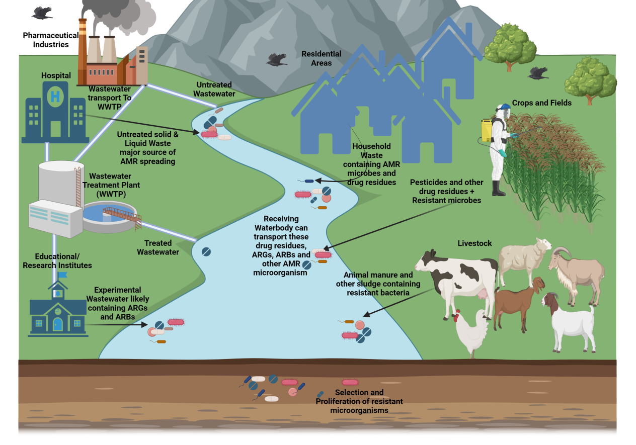
Figure S3. The image depicts how Antimicrobial Resistance (AMR) spreads, effluent from hospitals, pharmaceutical businesses, and residential areas, as well as experimental effluent from educational institutions, transfer AMR microorganisms, ARGs (antibiotic resistance genes), and ARBs (antibiotic-resistant bacteria) to bodies of water. Untreated solid and liquid waste from such sources has a key role in AMR propagation. Livestock and agriculture are vulnerable to AMR via animal waste and pesticide usage, which also spreads resistant bacteria.

