Supplementary Figure caption

Supplementary Figure 1 Plasmid maps of used in this study (a) pKM212::yahK::patA::ldcC, (b) pKM212::yihU::patA::ldcC, (c) pKM212::yqhD::patA::ldcC, (d) pET24ma::ldcC, (e) pCDFDuet-1::yqhD::patA, (f) pET21b(+)::patA

Supplementary Figure 1
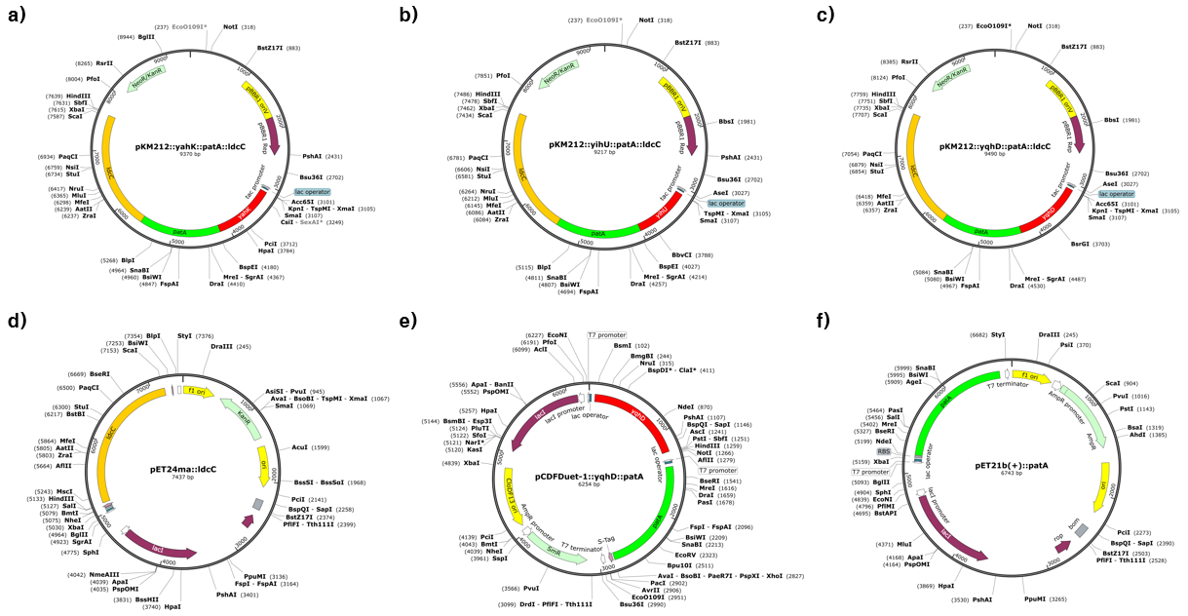

Supplementary Table caption

Supplementary Table 1 Information of genes used in this study
Supplementary Table 2 List of primers used this study
Supplementary Table 3 List of strains and plasmids used in this study

Supplementary Table 1
Genes | Organism | Accession number
ldcC | Escherichia coli str. K-12 substr. MG1655 | NC_000913.3  Region: 209679…211820
patA | Escherichia coli | N/A
yahK | Escherichia coli str. K-12 substr. MG1655 | NC_000913.3  Region: 342884…343933
yihU | Escherichia coli str. K-12 substr. MG1655 | NC_000913.3  Region: 4072675…4073571
yqhD | Escherichia coli str. K-12 substr. MG1655 | NC_000913.3  Region: 3155355…3156518

Supplementary Table 2
Genes & vectors | Primers sequence (5’ to 3’) | Used enzyme | Ref
ldcC | F: GGATCC TTTCACACAGGAAACAGACC ATGAACATCATTGCCATTATGGGACCG  R: CCTGCAGG TTATCCCGCCATTTTTAGGACTCGTACG | F: BamHI  R: SbfI | This study
ldcC | F: CGTCGT AAGCTT GCATGAACATCATTGCCATTATGGA  R: CGTCGT CTCGAG TCCCGCGATTTTTAGGACTCG | F: HindIII  R: XhoI | (Shin et al. 2018)
patA | F: GGTACC TTTCACACAGGAAACAGACC ATGATACGCGAGCCTCCGGAG  R: GGATCC TCACGCTTCTTCGACACTTACTCGC | F: KpnI  R: BamHI | This study
patA | F: gaaggagatatacatatgatacgcgagcctcc  R: AGCAGCCGGATCTCACGCTTCTTCGACACTTAC | Gibson Assembly®  Master Mix | This study
yahK | F: GAATTC ATGAAGATCAAAGCTGTTGGTGCATATTCC  R: GGTACC TTAGTCTGTTAGTGTGCGATTATCGATAACAAAAC | F: EcoRI  R: KpnI | This study
yihU | F: GAATTC ATGGCAGCAATCGCGTTTATCGG  R: GGTACC TTACATTTTTACTTTGGCAGTCATCCCGG | F: EcoRI  R: KpnI | This study
yqhD | F: GAATTC ATGAACAACTTTAATCTGCACACCCCAAC  R: GGTACC TTAGCGGGCGGCTTCGTATATACG | F: EcoRI  R: KpnI | This study
yqhD | F: actttaataaggagatatacCatgaacaactttaatctgcaca  R: acctgcaggcgcgccgagctTTAGCGGGCGGCTTCGTA | Gibson Assembly®  Master Mix | This study
pCDFDuet-1 | F: gtataagaaggagatatacaatgatacgcgagcctccg  R: tttaccagactcgagggtacTCACGCTTCTTCGACACTTA | Gibson Assembly®  Master Mix | This study
pET21b(+) | F: tgagatccggctgctaac  R: ATGTATATCTCCTTCTTAAAGT | Gibson Assembly®  Master Mix | This study

Supplementary Table 3
Strains and plasmids | Genotype of strain and plasmid | Strategies | Ref or source
Strains
E. coli DH5α | F’ Φ80lacZ• ΔM15 •ƒ(lacZYAargF) U169 deoR recA1 endA1 hsdR17(rk-, mk+) phoA supE44 thi-1 gyrA96 relA1 | Gene manipulation | Enzynomics
E. coli BL21(DE3) | F- dcm ompT hsdS(rB- mB-) gal λ(DE3) | Preparation of whole-cell bioconversion | Enzynomics
E. coli AP_{YahK} | E. coli BL21(DE3) harboring pKM212::yahK::patA::ldcC | Development of 5-AP conversion system and reductase screening | This study
E. coli AP_{YihU} | E. coli BL21(DE3) harboring pKM212::yihU::patA::ldcC | Development of 5-AP conversion system and reductase screening | This study
E. coli AP_{YqhD} | E. coli BL21(DE3) harboring pKM212::yqhD::patA::ldcC | Development of 5-AP conversion system and reductase screening | This study
E. coli AP_{T7_Dual} | E. coli BL21(DE3) harboring pET24ma::ldcC and  pCDFDuet-1::yqhD::patA | Expression system change | This study
E. coli AP_{T7_Triple} | E. coli BL21(DE3) harboring pET24ma::ldcC,  pCDFDuet-1::yqhD::patA, pET21b(+)::patA | Enhancing PatA mediated transamination | This study
Plasmids
pKM212::yahK:: patA::ldcC | pKM212 derivative; yahK, patA, ldcC, Km^{R} | Development of 5-AP conversion system and reductase screening | This study
pKM212::yihU:: patA::ldcC | pKM212 derivative; yihU, patA, ldcC, Km^{R} | Development of 5-AP conversion system and reductase screening | This study
pKM212::yqhD:: patA::ldcC | pKM212 derivative; yqhD, patA, ldcC, Km^{R} | Development of 5-AP conversion system and reductase screening | This study
pET24ma::ldcC | pET24ma derivative; ldcC, Km^{R} | Expression system change | (Shin et al. 2018)
pCDFDuet-1:: yqhD::patA | pCDFDuet-1 derivative; yqhD and patA, Sm^{R} | Expression system change | This study
pET21b(+)::patA | pET21b(+) derivative; patA, Amp^{R} | Enhancing PatA mediated transamination | This study

