Supporting Information for Sustainable β-Carotene Production by Engineered S. cerevisiae Using Sucrose and Agricultural By-Products

Table S1: Sugar composition of M-molasses

Figure S1: Visual progression of shake-flask cultures in yeast medium. Panel A (top row: Sp_Bc, bottom row: Sp_Bc ∆gal80) with a mixed carbon source (sucrose and galactose at 1:2 ratio, 2% total sugar concentration) shows an intensifying orange hue, indicative of increasing beta-carotene concentration. Panel B (top row: Sp_Bc, bottom row: Sp_Bc ∆gal80) with 2% sucrose as the sole carbon source demonstrates the orange hue only in Sp_Bc ∆gal80, signaling beta-carotene production, while Sp_Bc lacks this hue, indicating its absence. All experiments were conducted in triplicate.
Figure S2. High-performance liquid chromatography (HPLC) chromatograms recorded at 450 nm for β-carotene analysis. A: β-carotene authentic standard. B: Sp_Bc ∆gal80 cultured in fed-batch mode with sucrose as carbon source and yeast extract (YE) + peptone as nitrogen source, sampled at 120 h. C: Sp_Bc ∆gal80 cultured in fed-batch mode with M-molasses as carbon source and YE + peptone as nitrogen source, sampled at 120 h. D: Sp_Bc ∆gal80 cultured in fed-batch mode with M-molasses as carbon source and fish extract:YE + peptone (80:20) as nitrogen source, sampled at 120 h. UV–visible spectra of the β-carotene peak for each sample are shown to the right of each chromatogram.

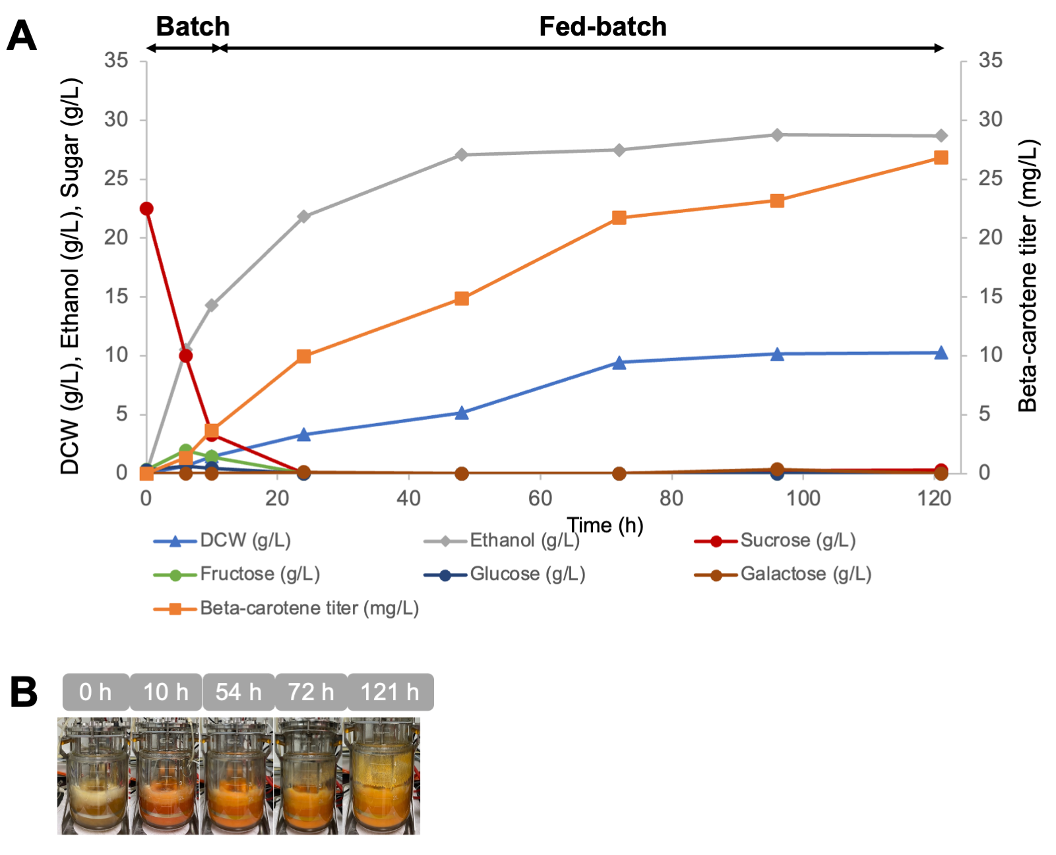

Fig. S3 Fed-batch fermentation of Strain Sp_Bc ∆gal80 in a 5-L fermenter using sucrose and galactose as mixed carbon sources. (A) Fermentation profile including beta-carotene titer, biomass as dry cell weight, ethanol production, and residual sugars (sucrose, galactose, fructose, and glucose) over time. The fermentation began with a 2-L batch phase using a basal salt medium supplemented with 20 g/L sucrose. Subsequent fed-batch stages initiated at the 10th hour involved periodic additions of a solution of sucrose, galactose and yeast extract (at concentrations of 50, 50, and 15 g/L, respectively) at 5-hour intervals across 20 cycles, cumulatively reaching 120 g/L total sugars. (B) Visual progression of the bioreactor culture over time, with the intensifying orange hue reflecting the increasing beta-carotene concentration, a visual confirmation of successful carotenoid biosynthesis.

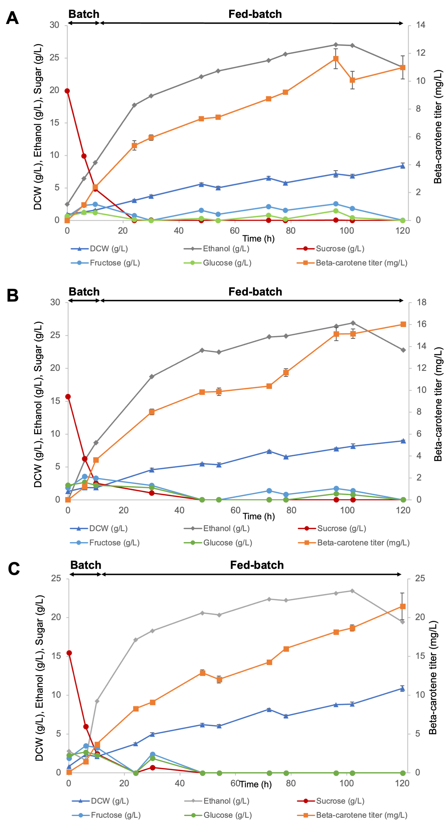
Fig S4. Fed-batch fermentation of Strain Sp_Bc ∆gal80 in a 5-L fermenter with fish meal as an alternative nitrogen source.
The figures depict fermentation profiles including β-carotene titer, biomass as dry cell weight (DCW), ethanol production, and residual sugars (sucrose, fructose, and glucose), with averages and standard deviations from duplicate runs. Panel A shows 100% nitrogen substitution with 30 g/L fish meal, Panel B shows 90% substitution with 27 g/L fish meal, and Panel C shows 70% substitution with 21 g/L fish meal out of a total of 30 g/L nitrogen source. Error bars reflect standard deviations.

