Mechanistic insights into promoted biogas-production and reduced antibiotic resistance genes risks of biowaste dry anaerobic co-digestion with biochar addition

Zhenqi Wang ^{1,2}, Min Zhang ²*, Xiaoyong Qian²*, Yuanzhi Ni², Xuefei Zhou¹, Jingren Yang²

1College of Environmental Science and Engineering, Tongji University, Shanghai 200092, China
2Shanghai Academy of Environmental Sciences, Shanghai 200233, China

*Corresponding author. Email: qianxy@saes.sh.cn

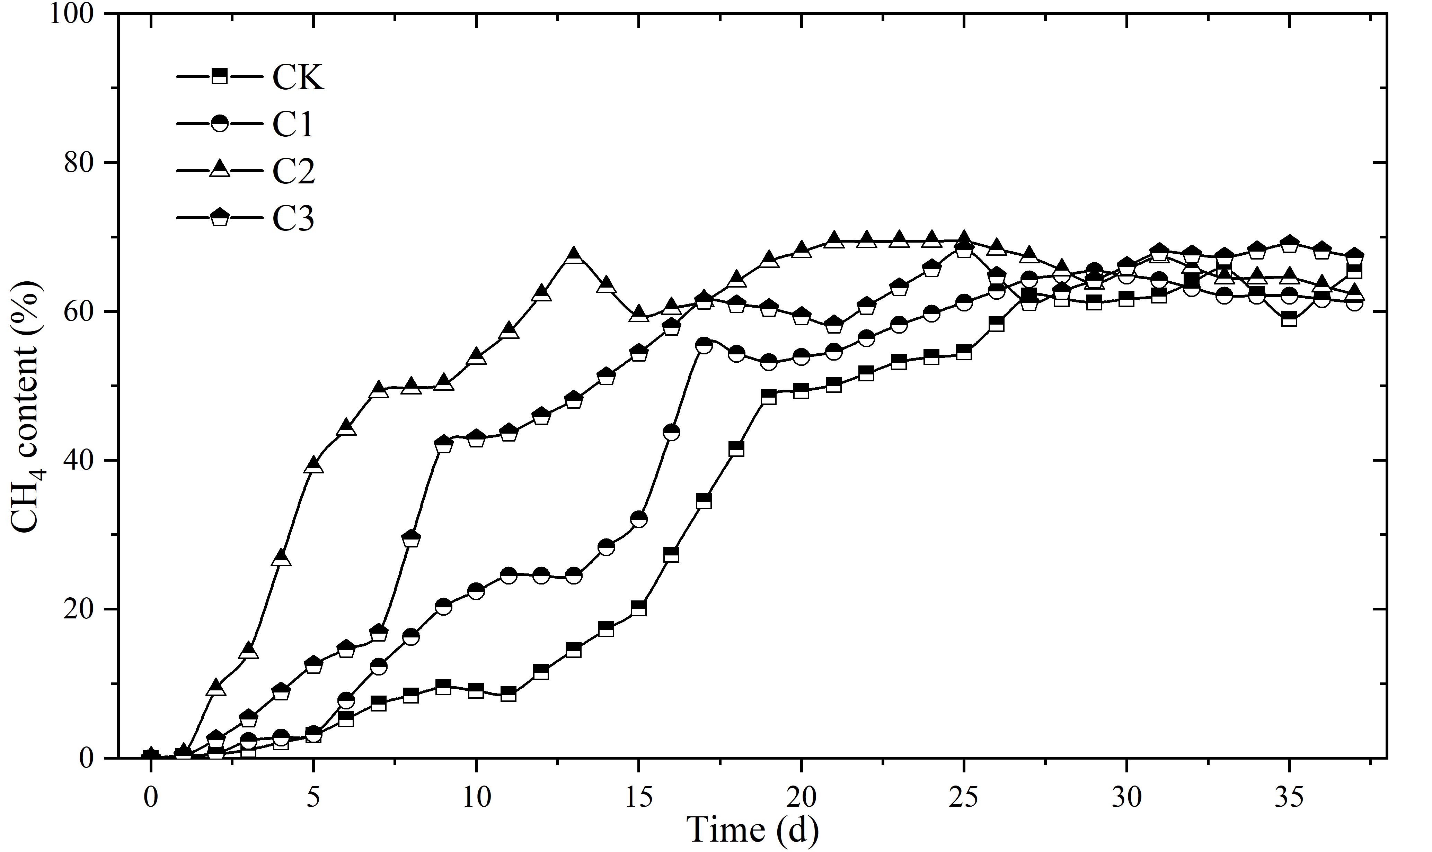
Fig. S1. Daily Methane Percentage Content Across Different Treatment Groups

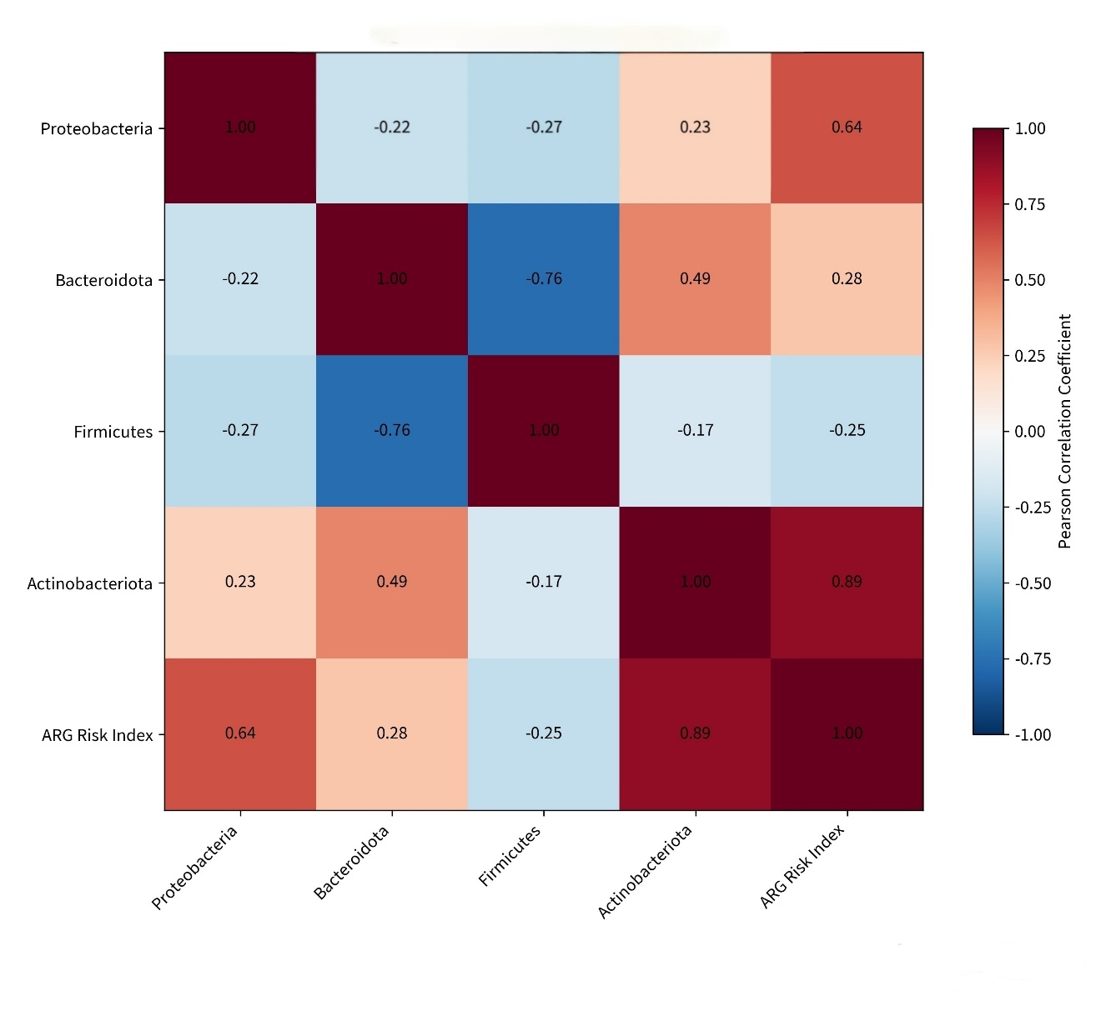
Fig. S2. Pearson correlation analysis was performed to assess the relationship between core phylum abundance and ARG potential risk.

